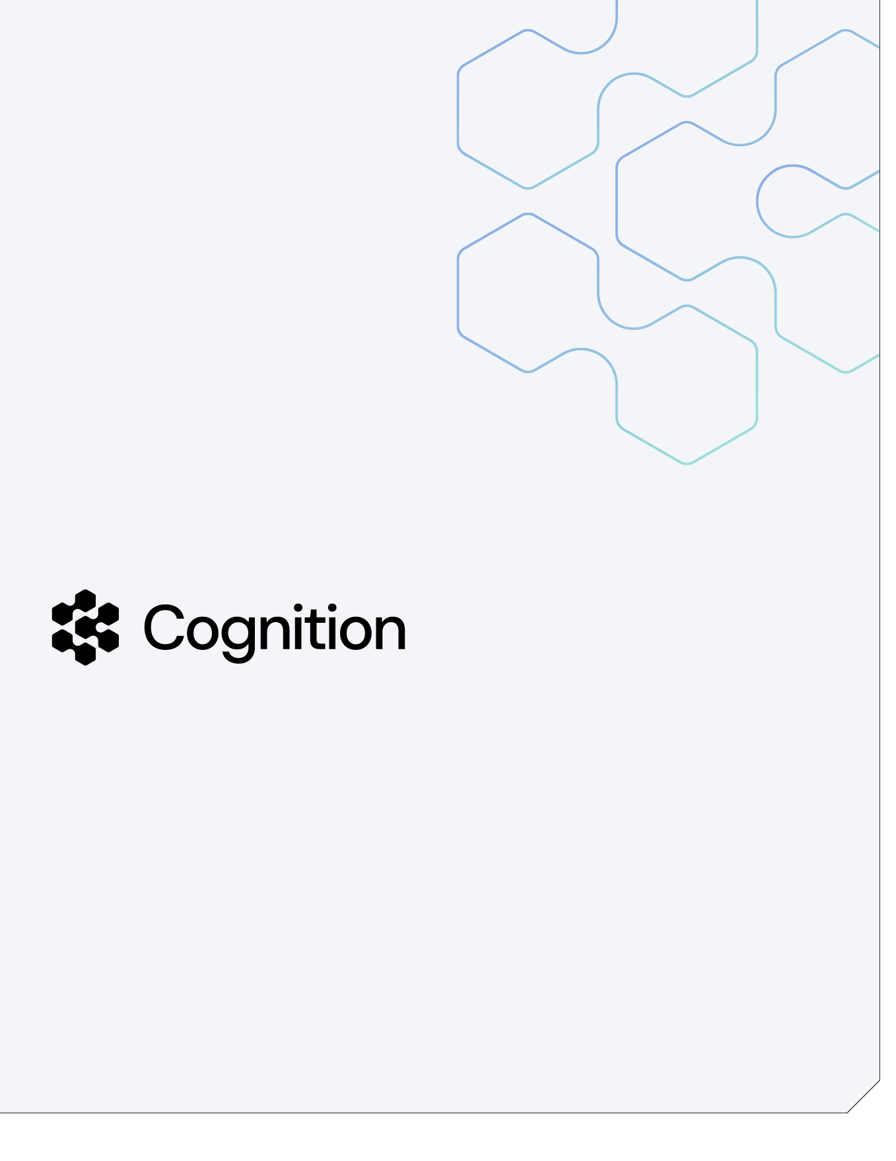
From Natural and ADABAS to Oracle HCM
A requirements-first modernization baseline — executive value brief for SMX and the Department of the Interior, Interior Business Center (FPPS)
Prepared by Cognition AI, Inc.

September 2026

Table of Contents

The challenge and our approach 4
What was built: three core work streams 5
Discover and extract (Demonstrated) 5
Baseline and decide (Demonstrated for the sample; Designed at FPPS scale) 5
Prove (Demonstrated on synthetic data) 5
The rule a naive converter loses 5
A complete audit trail 5
An evolving knowledge base 6
Roadmap, responsibilities, and outcomes 6


About Cognition
Cognition AI builds production-grade autonomous software engineering systems, empowering thousands of developers across the largest organizations in the U.S. Government — NASA JPL, the Social Security Administration, and every Department of War branch: U.S. Army, U.S. Navy, U.S. Air Force, U.S. Marine Corps — as well as the defense industrial base, including Palantir, Anduril, Lockheed Martin, and BAE Systems. The platform is security-first by design: FedRAMP High authorized (via Palantir FedStart on AWS GovCloud) and DoD IL4, IL5, and IL6 compliant.

At the core is Devin: cloud-based autonomous software engineering that plans and executes complex, multi-step engineering work across real codebases — autonomous, parallel, and effectively infinite in scale — in production with customers today.

Devin anchors the broader Cognition platform — DeepWiki for codebase intelligence, CLI and IDE developer tools, and Devin Review for lifecycle, CI, and change management — combined with federal audit and compliance automation (NIST, STIG) and Devin Security Swarm: complex, multi-threaded security analysis and remediation built for the hardest problems in the federal market.

The challenge and our approach
FPPS is a Software AG Natural estate, and the path to a modern HCM runs through its requirements, not through its syntax. FPPS is roughly 7 million lines of Natural 9.x across more than 100,000 modules on ADABAS 8.6 and z/OS 2.5, driven by about 7,800 JCL jobs. It is not COBOL, and it will not be "converted." The destination is Oracle HCM or an alternate HCM platform — a configured product, not a rewritten program. What the implementing integrator needs is the thing that has historically been the most expensive and least reliable part of any such program: a complete, verified statement of what the legacy system actually does, what it must keep doing, and what should be left behind.
Direct code conversion — pointing a general-purpose AI tool at legacy source and asking for a new language — has already been tried against this class of system and does not produce that statement. It reproduces accidents alongside intent, carries dead paths forward, and hands the integrator a second system to reverse-engineer. A traditional interview-driven requirements engagement for an estate of this size has been quoted at roughly $30 million and would take years.
Our approach is requirements-first extraction, proven on a real Natural/ADABAS application before it is proposed for FPPS. Devin reads the Natural sources, ADABAS data definitions, STEPLIB configuration, and deployment descriptors; extracts every rule, data element, process, and interface with a citation to the exact source line; separates the logic that must be carried from the logic that must not; and packages the result as a requirements baseline with acceptance criteria and executable reconciliation harnesses. Everything in this package was produced from the Sunny Islands Cruise sample — a public Software AG Natural for AJAX / ADABAS application that structurally mirrors FPPS — on synthetic data. No production system, production data, or FPPS source was touched or is required to reproduce it.
Devin is a force multiplier for the payroll and integration experts, not a replacement for them. The AI does the exhaustive, repeatable work — reading every module, citing every line, regenerating every artifact when the source changes — and surfaces only the exceptions that need human judgement. The integrator's analysts and the agency's subject-matter experts keep ownership of every design decision and every sign-off.
FIGURE 1. The requirements-first path. Legacy sources are read, never rewritten; the requirements baseline drives both HCM configuration and the pre- and post-load tests that prove it, and every test exception feeds back into the baseline — all on synthetic data.
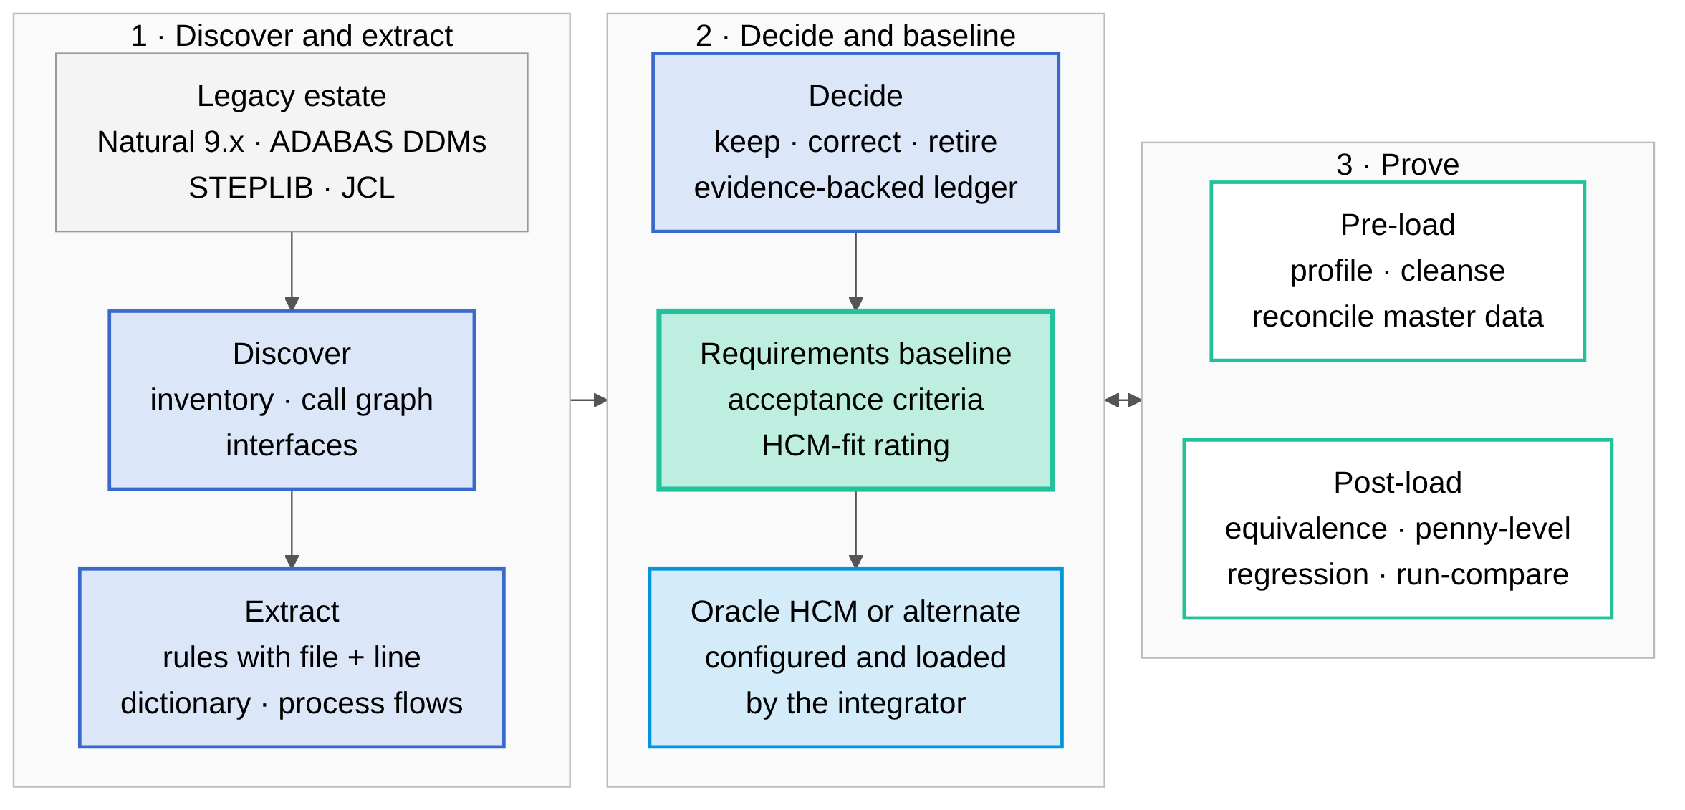
Every statement below carries a maturity label. Demonstrated means it runs in the repository today and its output is checked in and reproducible. Designed means the method is specified against the sample but has not yet been executed at FPPS scale. Roadmap means it depends on inputs the repository does not contain — real FPPS JCL, Natural Predict/XRef exports, runtime traces, or subject-matter-expert sign-off.

What was built: three core work streams

Discover and extract (Demonstrated)
You cannot scope, price, or configure what you cannot see. The package opens with a discoverability baseline — module inventory, call graph, and interface map across the business-logic and presentation libraries — generated from the sources rather than drawn by hand. On that map sits the business-rule catalogue: sixty rule entries, each stated in the plain language a payroll analyst uses for an eligibility or validation edit, each citing file and line in the real Natural source, each carrying a confidence score, an HCM analog, and a disposition. The four ADABAS data definitions become a field-level data dictionary — the definition of master data that HCM Data Loader mapping starts from — and the transaction flows become BPMN-oriented process definitions an Oracle HCM configuration team can map directly.

Baseline and decide (Demonstrated for the sample; Designed at FPPS scale)
The requirements baseline is the strategic prize. It restates the extracted behaviour as twenty-nine numbered requirements — functional, data, integrity, interface, and non-functional — with fifty-nine Given/When/Then acceptance criteria, an HCM-fit rating for each (standard, configured, extension, integration, or out of scope), and generated cross-checks that fail the build if a rule loses its requirement or a requirement loses its rule. Alongside it sits the artifact most modernization programs never produce: a migration-disposition ledger of what not to build. A static analyzer over the Natural sources finds the unreferenced objects, unreachable paths, never-emitted message codes, never-populated interface fields, and commented-out logic; the ledger binds every finding to evidence, a confidence score, a proposed disposition, and an SME sign-off column, so nothing is retired by guesswork and nothing dead is re-implemented at Oracle HCM prices.

Prove (Demonstrated on synthetic data)
Testing is the deliverable. Before load, a master-data cleansing harness profiles the legacy data, applies cleansing rules, and reconciles the result so that dirty master data — the leading cause of failed HCM loads — is caught on the legacy side. After load, an equivalence harness compares the HCM's own output files to the legacy behaviour transaction by transaction: control totals, penny-level amounts, record-level audit trail, and an exception report, demonstrated on a clean batch and a deliberately broken batch. A regression suite and JCL run-compare generator protect the pay run during and after cut-over. The Python in these harnesses validates the HCM; it is never the target of a rewrite.

The rule a naive converter loses
Differentiator: the booking service CONEW-N, the sample's analog of a pay or personnel transaction. It originally read the cruise availability counter outside a record hold and generated the contract identifier as "highest existing value plus one" without holding the highest record. Under concurrent users it silently oversells the cruise and raises duplicate-key errors. A line-by-line converter carries that defect into the new platform unchanged, because the code is syntactically correct. Requirements-first extraction surfaces it as what it is: an integrity requirement — a held test-and-set on a balance and a platform-generated identifier — that Oracle HCM satisfies by configuration, not by translated code. In a payroll, this is exactly the class of defect that silently corrupts a pay run and is discovered by an employee, not by a test.
The same extraction found what the sample must not carry: twenty of its thirty-one catalogued message codes are never emitted by executable code, including a hard-coded chain of 2015–2020 year edits; the user, password, and language parameters passed to every service are never set, so the "security" contract is inert and the German message catalogue is unreachable; and a first-name field is read from one variable and written from another, so typed first names are never persisted. Each is a static candidate with a confidence score, not a verdict — runtime evidence and SME confirmation close each one — and each is a line an HCM program should never pay to build.

A complete audit trail
Every claim in the package traces to a source line, and every generated number is checked against its generator. Rules cite file and line in the real Natural source; requirements cite rules; acceptance criteria cite requirements. The disposition ledger claims every analyzer finding exactly once, and the regression suite regenerates every artifact in memory and fails on drift. For a CIO who has watched a modernization attempt fail on undocumented behaviour, this is the difference between "the vendor says the requirements are complete" and "anyone with the repository can prove it."

An evolving knowledge base
The analyzer, the ledger schema, and the acceptance-test patterns are reusable assets, not a one-time report. Each FPPS library tranche runs through the same pipeline; each SME decision recorded in a ledger row becomes a rule the next tranche inherits; each reconciliation exception corrects either the baseline or the HCM configuration, and the harness records which. At FPPS scale the static candidates gain confidence from Natural Predict/XRef exports, JCL and scheduler evidence, and profiler traces and ADABAS logs across a full pay year (Roadmap). The result is a living requirements baseline that the SI configures against and the agency owns after go-live, with DeepWiki as the codebase intelligence layer over the legacy estate and Devin Review governing every change.

Roadmap, responsibilities, and outcomes
Phase 0 — sample proof (Demonstrated, this package). End-to-end pipeline on the Sunny Islands Cruise application, reproducible from the repository with one test command. Phase 1 — FPPS pilot tranche (Designed). One Natural library tranche and its ADABAS files, on masked or synthetic data within the agency's boundary; the same generators and drift gates; first SME-signed dispositions; a measured rate of rules per module to price the full estate honestly. Phase 2 — estate-wide baseline (Roadmap). Parallel Devin sessions across the remaining libraries and the JCL inventory, feeding the Oracle HCM configuration workbooks and HCM Data Loader mappings. Phase 3 — HCM acceptance (Roadmap). Equivalence and penny-level reconciliation against the HCM's outputs for each parallel pay period, closing the baseline before cut-over.
Work stream | Cognition (sub-prime, AI software-engineering scope) | SMX / Navancio (prime, payroll and SI backbone)
Discovery, rules, data dictionary, process flows | Owns — generation, traceability, confidence scoring | Validates payroll semantics; names the HCM analog
Requirements baseline and disposition ledger | Owns — drafting, evidence binding, drift gates | Owns SME sign-off, agency requirements governance
Master-data cleansing and reconciliation | Owns — harness build and execution on synthetic/masked data | Owns data-sharing agreements, extracts, load execution
Equivalence, regression, and run-compare | Owns — harness build, exception analysis | Owns HCM output extraction, defect triage in the HCM
HCM configuration, HDL loads, integrations, ATO | Advises; supports FedRAMP High boundary evidence | Owns
Honest scope. Cognition expects to own roughly 50–60 percent of the program's AI software-engineering scope as sub-prime — the extraction, baseline, evidence, and validation-harness work above. Payroll subject-matter expertise, the authority-to-operate path, HCM configuration, and the systems-integration backbone belong with SMX and Navancio.
Outcome. The integrator receives a requirements baseline it can configure against, a disposition ledger that keeps dead and defective logic out of the new platform, and executable harnesses that let the agency verify the HCM's output for itself — from synthetic data, reproducible by anyone with the repository, in a fraction of the time and cost of an interview-driven requirements program.
This brief describes work on a public Software AG sample application using synthetic data; statements about FPPS are analogies from the sample, labelled by maturity. Oracle HCM is a trademark of Oracle Corporation; Natural and ADABAS are trademarks of Software AG. Cognition AI, Inc. — cognition.ai

