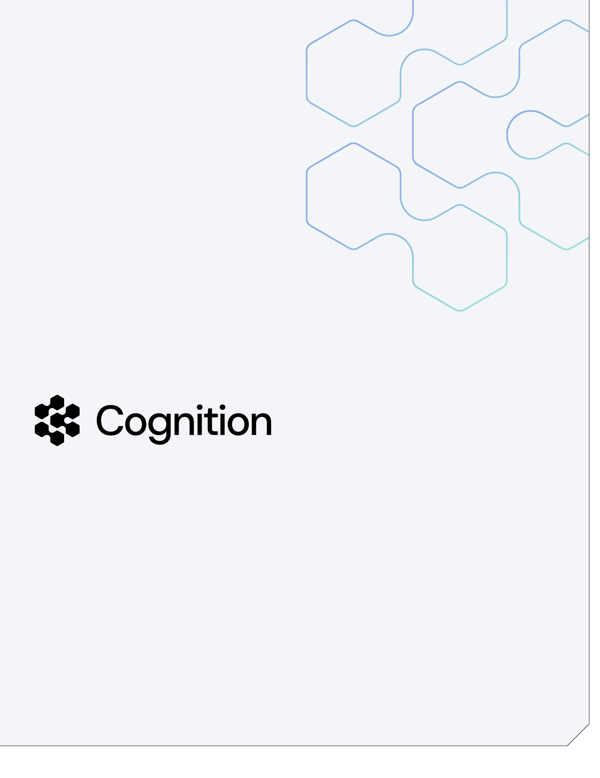
Governance and human control for the VA FMBT Integration & Conversion Factory
A Guidehouse and Cognition white paper
Prepared by Guidehouse and Cognition · for the U.S. Department of Veterans Affairs (OIT / FSC) — Financial Management Business Transformation program

June 2026

Table of Contents

1 Executive summary
2 Governance philosophy — “fail forward, come back fast”
3 The five human control points
4 Two process flows — development vs. execution
5 The auditability layer
6 Automated analyze sessions
7 Integration with VA's existing processes
8 Governance in federal financial systems
9 Summary — the control matrix
About Guidehouse · About Cognition


About Cognition
Cognition AI is an applied AI company building production-grade autonomous systems for enterprise use, empowering thousands of developers across large organizations, including teams at Infosys and Itaú, through a security-first, enterprise-ready platform.

At the core of Cognition's offerings is Devin, an autonomous software engineering agent designed to plan and execute complex, multi-step engineering workflows across real codebases and tools, and used by customers in production environments.

Devin is part of a broader Cognition ecosystem — including Windsurf, DeepWiki, CLI tooling, and pull request review — that integrates seamlessly into existing developer workflows while emphasizing reliability, safety, and control.

1. Executive summary
VA's FMBT program is replacing a three-decade-old financial management system with iFAMS, VA's implementation of CGI Momentum®, the FM QSMO-approved federal core financial platform. The remaining work is delivered wave by wave across the program's twelve deployment waves, and each wave stands up 50–100 interfaces (inbound and outbound) and a one-time conversion of the active financial data drawn from roughly 100 legacy source tables. Today that work is hand-coded by a workforce of more than 135 people.
Doing that work with AI-driven automation changes the throughput problem. It also raises the governance question that every federal financial executive asks first: if AI is producing the conversions and the interfaces, who is in control, and how do I prove it to an auditor?
This paper answers that question. The factory is AI-governed, human-controlled: the system is AI-powered, but every consequential action passes through a human gate, and the evidence that each step was correct is produced as a first-class output rather than reconstructed after the fact. The governance model is engineered so that control does not bottleneck throughput — the gates sit at the few checkpoints that actually carry financial and audit risk, not on every line of generated code.
The contrast with the program's current posture is deliberate. A waterfall approach discovers failure late, when it is expensive and hard to unwind. This architecture makes failure cheap, visible, and recoverable: a mapping that is wrong is caught by an automated reconciliation gate the moment it is produced, logged with a typed reason, and fixed in the next iteration. We call this "fail forward, come back fast" — the speed of AI automation, with the control rigor federal financial systems demand.
Three claims anchor the rest of this document, and each is backed by an artifact a reviewer can open today:
1. Governance is concrete, not a label. Control here means a reconciliation gate that balances the money to the cent, a per-record provenance trail, role-based human review of exceptions, and immutable run logs — not a protocol badge. (See §2 and the critique in factory/design/AIE-CRITIQUE.md.)
2. There are five explicit human control points. No code reaches main, and no data is declared load-ready, without a named human approving it (§3).
3. The auditability layer is the deliverable. Per interface, per wave, the program produces row accounting, dollar control totals, a typed reject ledger, and a provenance trail — the same evidence an auditor's control test would demand (§5, §8).

2. Governance philosophy — "fail forward, come back fast"
In a waterfall delivery model, validation is a phase near the end. By the time it runs, the expensive work has already been done on assumptions that may be wrong, and a defect found at that point is catastrophic: it is late, it is costly, and it often forces a re-plan. The instinct to treat conversion as the deliverable and testing as a closing phase is exactly the instinct this architecture inverts.
For a financial conversion, the reconciliation evidence is the deliverable — the converted file is just the thing that produces it. So the factory is built testing-first. Every interface runs the same continuous pass in which mapping, validation, and reconciliation happen together, and the question "did the money survive?" is answered automatically on every run rather than negotiated in a meeting. (This is the whole thesis of factory/design/TESTING-AS-THE-PRODUCT.md.)
The reconciliation gate is the mathematical proof. The conversion program returns a non-zero status when a batch is not load-ready — when rows do not account (lines_in == lines_loaded + lines_rejected), when dollar control totals do not tie to the cent, or when a journal does not balance. A deliberately-unbalanced fixture is kept in the suite precisely to prove the gate fails when it should. That pass/fail is deterministic and machine-checked; it is not a sign-off ceremony, and it cannot be talked past. When the gate trips, the finding routes into VA's existing change control process for disposition — the factory's automation produces the evidence; VA's governance bodies make the call.
A note on terminology. The reconciliation gate is an engineering control inside the factory. VA itself operates change control (a Change Control Board), not an automated deploy pipeline, and gate results feed that process. Throughout this paper, "gate" means the factory's deterministic correctness check, and "change control" means VA's governing process — the two are connected, not conflated.
This is also where we are explicit about what governance is not. A tooling or data-access protocol — the plumbing an agent uses to reach a system — is not a governance, control, or compliance framework, and presenting it as one will not survive an ATO or security review. Governance for a financial conversion is concrete: the reconciliation gate (does the money balance?), the per-record audit/provenance trail, role-based human review of exceptions, and immutable run logs. The access protocol may be how an agent connects to Momentum or a file share; it is not why the conversion is trustworthy. (This is critique #3 in factory/design/AIE-CRITIQUE.md: treating an access protocol as the governance layer is a category error.)

The governance architecture at a glance
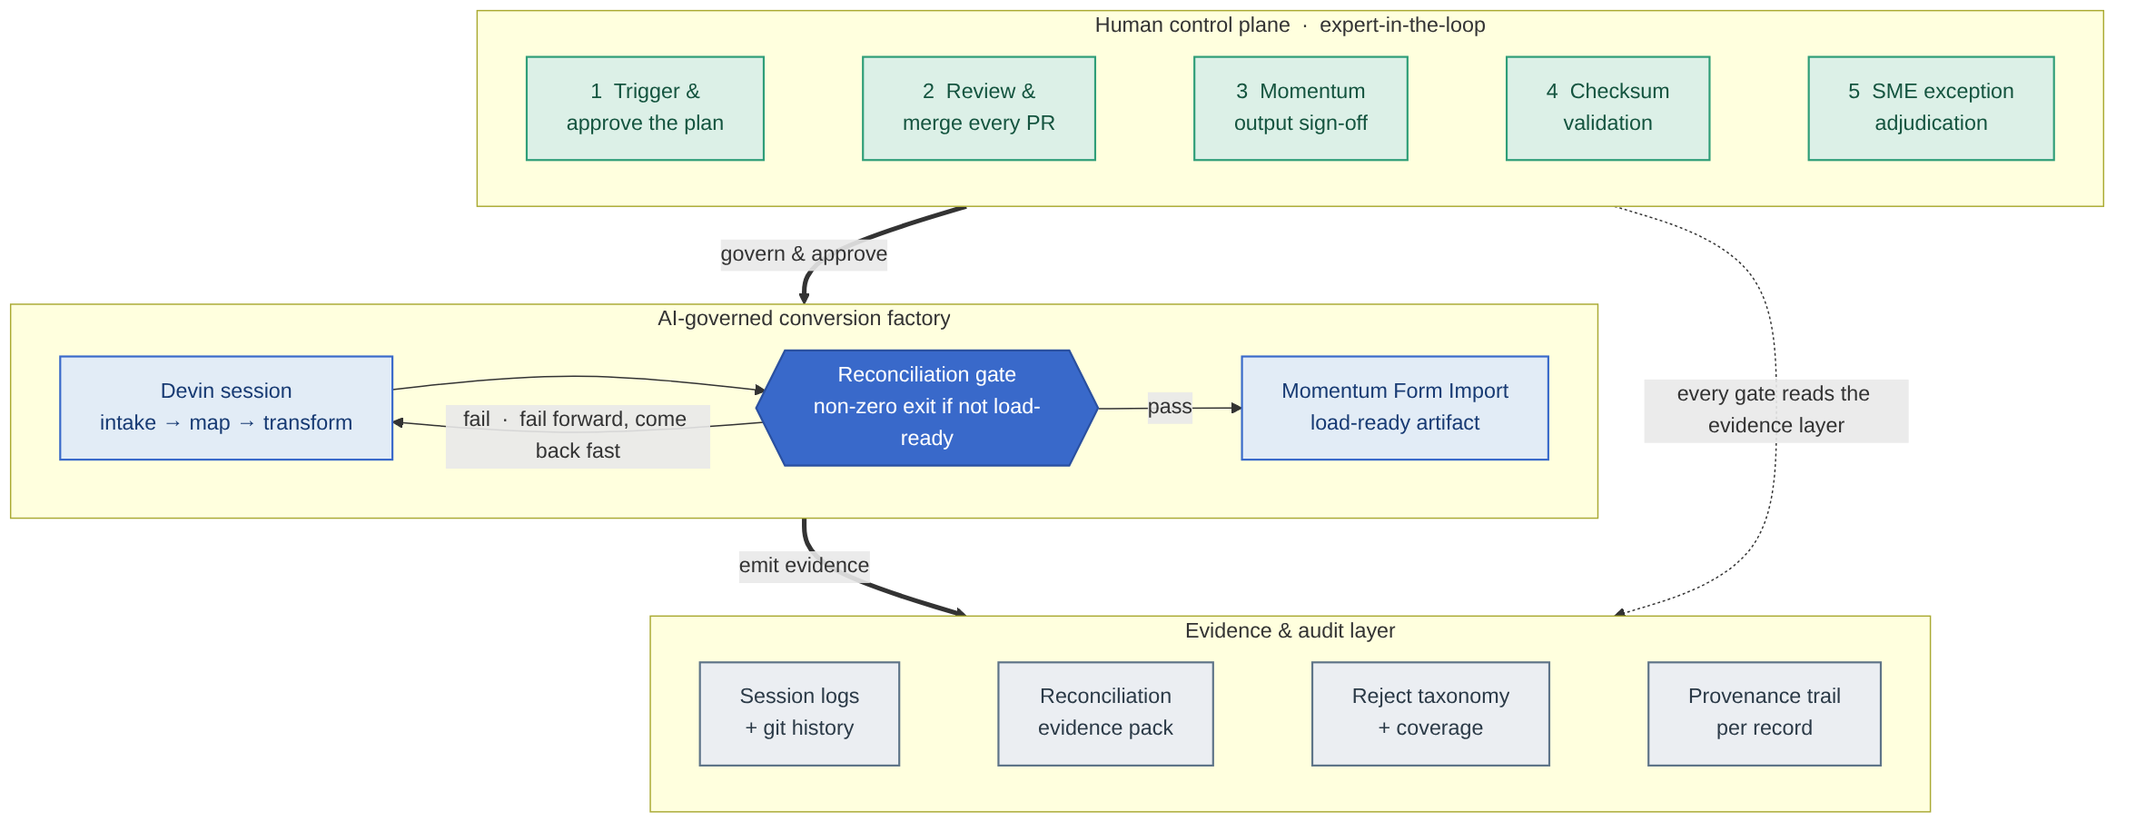
Figure 1. The governance architecture. Devin performs the high-volume engineering inside the factory; humans hold the five control points around it; and every step emits evidence to the audit layer. Speed and control operate on different things — automation on throughput, humans on judgment.
The shape is the point: AI does the high-volume engineering inside the factory box; humans hold the gates around it; and the evidence layer captures everything for audit. Speed and control are not in tension because they operate on different things — automation on throughput, humans on judgment.

3. The five human control points
The strength of this model is expert-in-the-loop, designed in from the start and presented as a feature, not a caveat (this is the fix for critique #7 in factory/design/AIE-CRITIQUE.md). Federal financial conversion cannot be sold as fully unattended, and shouldn't be. Devin does the volume; VA and Guidehouse experts hold the decisions. There are five explicit human control points.
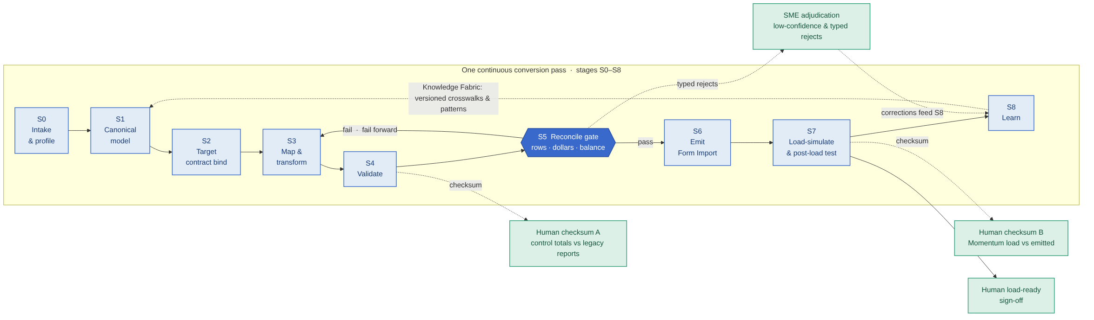
Figure 2. One continuous conversion pass (stages S0–S8). The reconciliation gate at S5 blocks any batch that is not load-ready; the human checkpoints — checksum validation, load-ready sign-off, and SME exception adjudication — sit directly on the pipeline.

Control point 1 — A human triggers the playbook
Devin never runs on its own schedule. A human initiates every session, selects the interface to convert, and approves the conversion plan before execution begins. The orchestrator session does intake, builds the interface inventory, and plans waves, but it fans out child sessions only when a human has authorized the wave (the orchestration model is in factory/design/FACTORY-DESIGN.md §4). There is no standing process that converts production financial data without a person starting it.

Control point 2 — A human reviews and merges every pull request
Devin produces code and artifacts as pull requests, never as direct writes to the trunk. Before any merge, two things happen in order:
1. Devin for Review runs automated bug, vulnerability, and security checks on the diff, surfacing issues before a human spends attention on them.
2. A human engineer reviews the diff, approves, and merges.
No code reaches main without human approval. This is the same disciplined change-control posture VA already expects of any contractor touching a financial system — made faster because the machine-checkable issues are caught before review, not during it.

Control point 3 — A human reviews Momentum interface outputs (the third gate)
After the factory emits a Momentum-loadable artifact and the automated reconciliation gate passes — rows balance, dollars balance to the cent, every reject is typed — the output is not simply pushed. A human subject-matter expert reviews the emitted artifact against the target contract (the Momentum Form Import layout / ICD) before sign-off. This is the "load-ready" decision: a person with financial-system judgment confirms that the artifact is not just internally consistent but correct against what Momentum will accept. Because Momentum loads through Form Import (which applies its own business-logic validation), the SME is confirming the record will both post and be accepted, not merely that it is well-formed.

Control point 4 — A human-controlled test phase with checksum validation
The test phase is two-part, and each part has a checksum (control-total) validation point that requires human sign-off:
• (a) After the initial ETL conversion — do the control totals match the legacy system's own reports? Before the data is considered ready to load, a human confirms that row counts and dollar totals reconcile against the legacy system's authoritative totals. This is the pre-load validation half of the test harness.
• (b) After form-import execution — does the Momentum load match what was emitted? Once Form Import has run, a human confirms the loaded result reconciles against the emitted artifact. This is the post-load verification half, where the majority of the testing value is realized because it proves the system actually works, not merely that data moved.
Both checksum points are human gates. A green machine result is necessary but not sufficient; a person signs the control totals.

Control point 5 — Human SME adjudication of exceptions
Not every record maps cleanly, and the factory never pretends otherwise. Low-confidence mappings and typed reject categories route to COBOL and finance SMEs for adjudication. This is where the two most important test angles do their work:
• Confidence scoring on every mapping (test angle #10 in factory/design/TESTING-AS-THE-PRODUCT.md): a deterministic crosswalk match scores high; an inferred mapping scores low. Low-confidence maps are routed to SME review instead of being trusted silently.
• Audit/provenance trail per record (test angle #11): every target record can name the source byte-row, the rules applied, and the wave/run that produced it — so an SME can trace any exception to its origin in seconds.
Crucially, the SME's corrections do not stop at the fix. They feed back into the Knowledge Fabric through the factory's S8 "learn" loop, so the next interface and the next wave start smarter. Human judgment is captured as durable institutional knowledge, not spent once.

4. Two process flows — development vs. execution
The factory operates in two distinct modes, with deliberately different control postures. Conflating them is how programs either move too slowly (production-grade ceremony on exploratory work) or too dangerously (ad-hoc changes on production financial data). The model keeps them separate.

Flow 1 — Playbook creation (development phase)
This is where the factory gets built and refined, and it runs like a disciplined dev shop: lighter, iterative, fast-failing. Devin builds the vertical-slice conversion for an interface (Playbook 01, factory/playbooks/01-vertical-slice-conversion.md), the reconciliation and test harness (Playbook 02, factory/playbooks/02-reconciliation-test-harness.md), and the Knowledge Fabric entries that make the next interface faster.
Human intervention here is the dev-shop kind: a person reviews PRs, runs the test suite, and checks the reconciliation evidence. The philosophy is fail forward — if a mapping is wrong, the gate catches it, the reject taxonomy logs it with a typed reason, and the next iteration fixes it. The cost of a wrong guess is one cheap, visible, recoverable cycle. Work is organized on a two-week sprint cadence, with Devin sessions running inside sprint stories.

Flow 2 — Playbook execution (execution mode)
This is production conversion with real financial data, and the controls tighten accordingly. The orchestrator (Playbook 03, factory/playbooks/03-interface-wave-fanout.md) fans out one child session per interface across the interfaces in a wave. Every child runs the proven playbook — no ad-hoc changes. Execution mode is not where the factory gets redesigned.
The rule that makes this safe: if an execution reveals a new pattern or gap, it does not fix it inline. It logs the finding (a new typed reject category, a coverage regression, a schema-drift alert) and the fix loops back into a development-phase sprint, where it is built, reviewed, and proven before it is ever run against production data again. Wave sign-off requires every interface to be accepted or consciously deferred with a documented reason, and the per-wave reconciliation evidence pack is the auditable deliverable that VA and auditors sign before that wave's cutover.
The diagram below shows the discipline that keeps the two modes honest — issues found in execution loop back to development rather than being patched live:
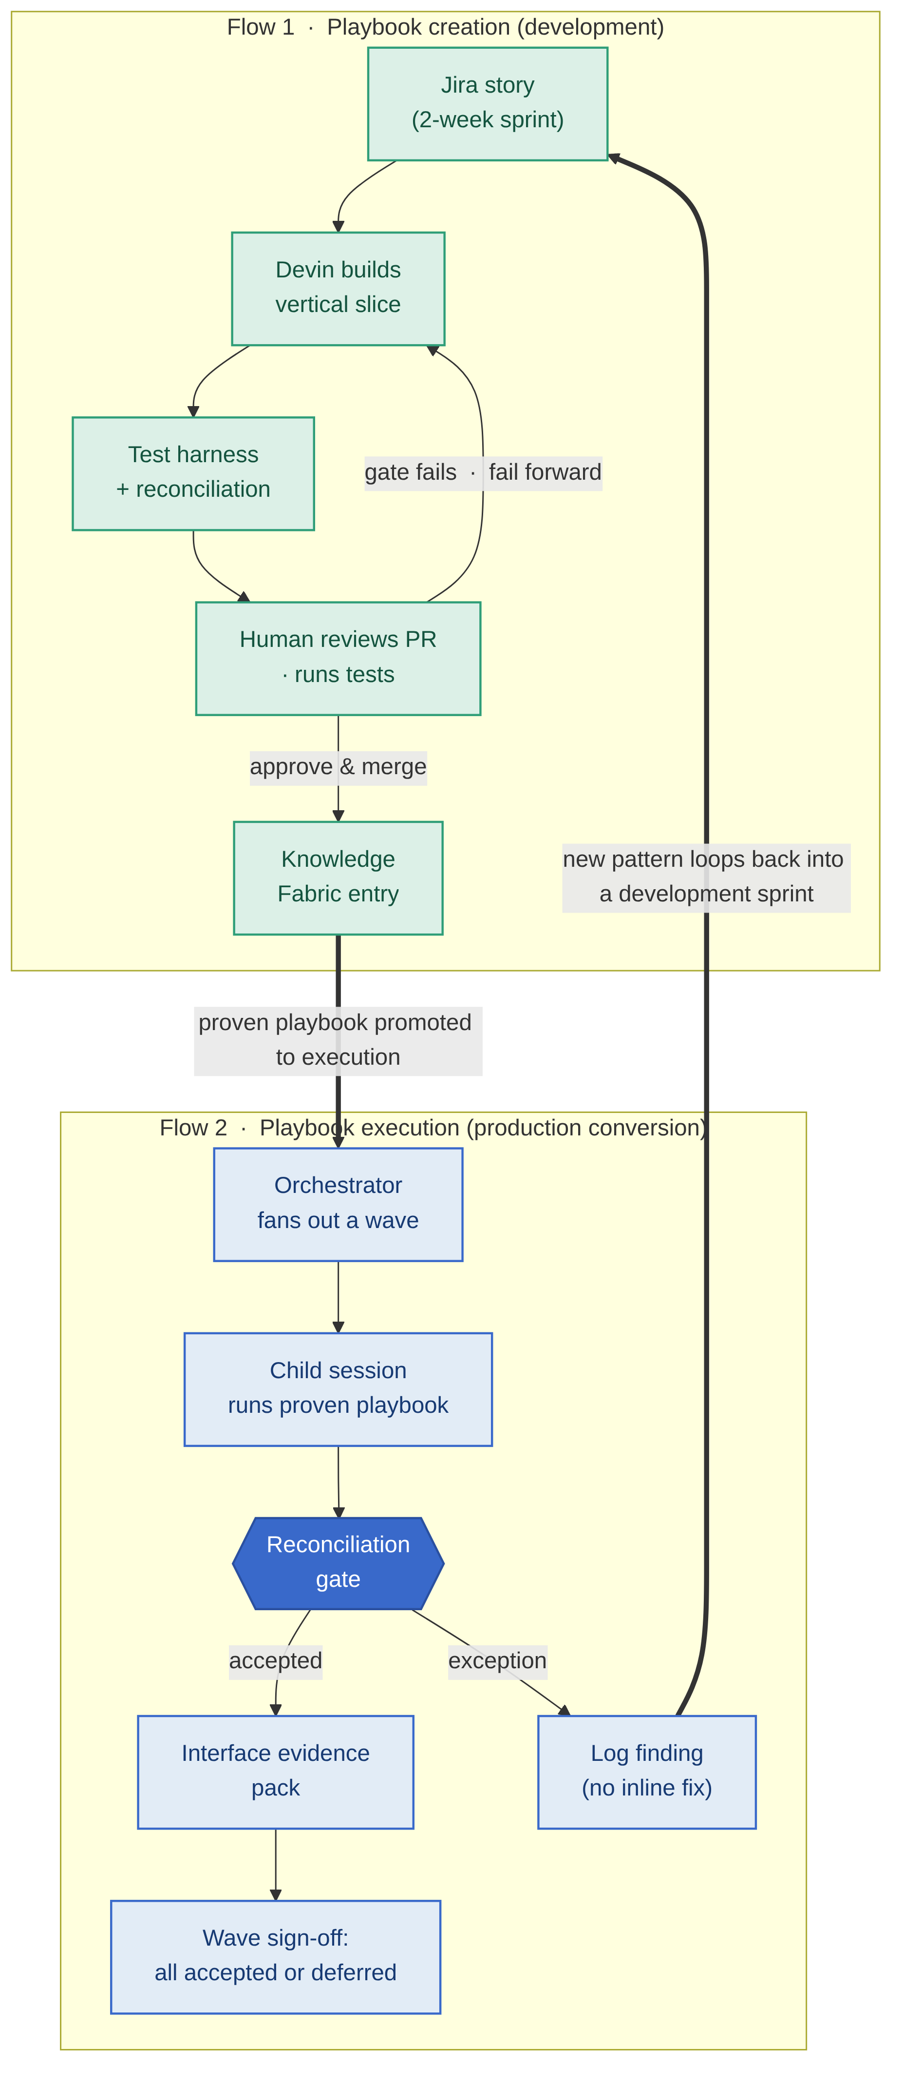
Figure 3. Two process flows. Development iterates and fails forward; execution runs only proven playbooks against production data, and any new pattern or gap loops back into a development sprint rather than being fixed inline.
The heavy dashed-then-bold path is the governance contract: execution never mutates the playbook; it feeds development, which re-proves the change before it returns to production.
Within a wave, execution mode fans out horizontally: one orchestrator session spawns a child session per interface, each runs the same proven playbook and emits its own reconciliation evidence, and a single human wave sign-off gates the cutover — any new pattern logged, not patched live.
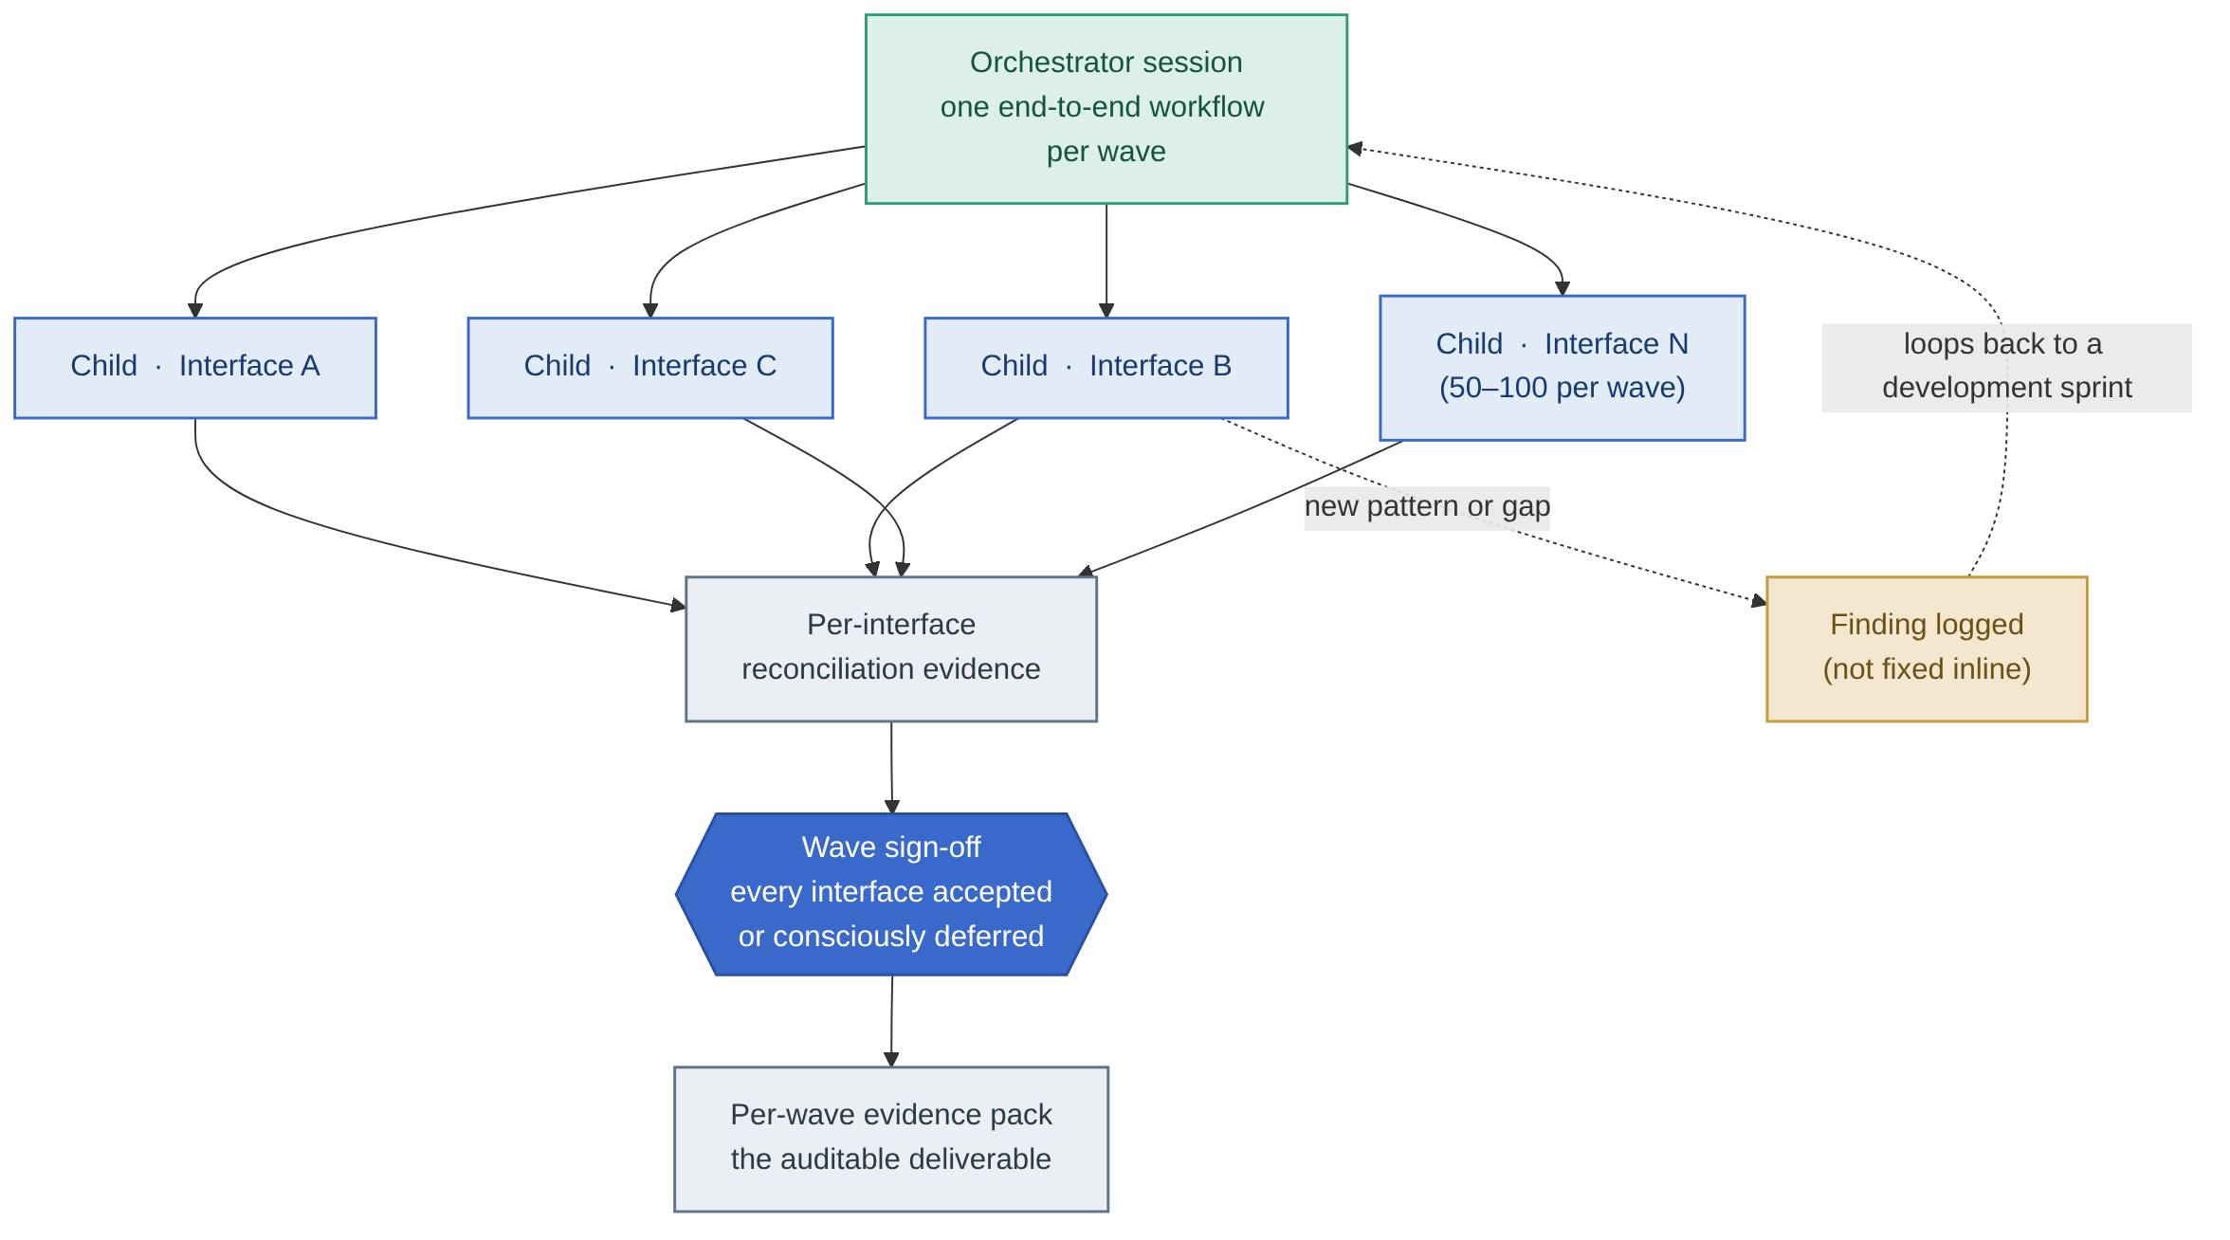
Figure 4. Wave orchestration. One orchestrator session fans out a child session per interface; each emits per-interface reconciliation evidence; wave sign-off requires every interface to be accepted or consciously deferred before cutover.

5. The auditability layer
Auditability is not a report generated at the end; it is a property of every step. The factory produces a continuous, immutable record that lets VA answer any "what happened to this record?" question in seconds rather than reconstructing it months later.
• Full session audit trail. Every Devin session is logged — the prompts that started it, the actions it took, the outputs it produced, and the code it changed. The work is observable, not opaque.
• Git history as an immutable record. Every change is a commit with provenance: author, timestamp, diff, and the review that approved it. There is no path to main that bypasses this record.
• Reconciliation evidence per interface, per wave. Row accounting, dollar control totals, per-document balance, the typed reject ledger, and mapping-coverage metrics are emitted for every interface and rolled up per wave. A worked example runs today in the GL/journal slice (factory/conversion-datasets/gl-journal-extract/python/reconciliation.py), and the per-record provenance is demonstrated in the audit-trail viewer (factory/demos/audit-trail-viewer/).
• "Request in / request out." VA can request any artifact or any piece of evidence from any point in the pipeline — the source byte-row a target record came from, the rule that flagged a reject, the run that produced a wave — without needing to understand the factory's internals. The evidence is addressable by the questions auditors actually ask.
• Hooks and sinks. Session logs, gate results, and reconciliation reports can be pushed to VA's preferred monitoring, audit, and documentation infrastructure. The factory does not ask VA to adopt a new system of record; it emits into the ones VA already trusts.
The eleven test angles in factory/design/TESTING-AS-THE-PRODUCT.md are the audit-coverage model — round-trip / reverse reconciliation, cutover-window performance proof, schema-drift detection, idempotent restart, mapping-coverage as a tracked release gate, the typed reject taxonomy and trend, fiscal-calendar boundary cases, referential-integrity checks against Momentum master data, duplicate/replay detection, confidence scoring (#10), and the per-record provenance trail (#11). Together they are what separate "we converted the data" from "we can stand behind the conversion in an audit and a cutover window."

6. Automated analyze sessions (continuous improvement)
The learn loop (S8) is operationalized as a recurring analyze session — itself reviewed by a human, never self-approving.
• Schedule. Weekly, aligned to the two-week sprint window (or per-sprint), so improvement tracks the program's existing cadence.
• Trigger. Cron-based on the sprint clock, or fired after a Devin session completes, so no session's lessons are lost.
• Process. An automated analyze session reviews the previous session's output against a rubric:
– What worked well — mappings that passed first try; reject categories that decreased.
– What failed — new reject categories, gate failures, coverage regressions.
– What is new knowledge — patterns, edge cases, and SME corrections worth keeping.
• Human review. The analyze output is reviewed by a human — this is continuous improvement under control, not a system that rewrites its own rules unattended.
• Feedback targets. Findings feed back into (a) playbook refinements, (b) Knowledge Fabric updates (factory/knowledge/), and (c) reject-taxonomy expansion (factory/knowledge/reject-taxonomy.md). The learning-agent demo (factory/demos/learning-agent-demo/) shows the loop concretely: a reject seen once becomes a recognized, pre-empted pattern on the next run.
• Ties into sprint reporting. The analyze output becomes part of the sprint report, so the program's improvement is visible to leadership in the artifacts they already read.
This is the mechanism behind the program's efficiency trajectory: the work compounds wave over wave rather than restarting each time, which is what makes a maturing first-pass success rate and a reduction in manual effort achievable as a trend the harness drives toward, not a day-one promise.

7. Integration with VA's existing processes
The governance framework is designed to operate inside VA's existing toolchain — it asks VA to adopt no new governance tools.
• Jira and sprints. VA already runs Jira and two-week sprints. The factory piggybacks on that mechanism rather than replacing it:
– Each interface conversion is a Jira story.
– Devin sessions execute within stories — both development and test-harness execution.
– Sprint reports include interfaces converted, reconciliation evidence, reject trends, coverage metrics, and Knowledge Fabric growth — the governance signal arrives in the report leadership already reviews.
• Confluence (or equivalent). Artifacts produced along the way — sprint reports, knowledge docs, findings docs, and per-wave evidence packs — are published to VA's documentation platform, where they live as part of the program record.
• Change control, not CI/CD. Gate results and failed tests route into VA's existing Change Control Board process for review and disposition. The factory provides the evidence; VA's governing bodies make the decisions, consistent with how the program governs change today.
• No new tools required. The governance framework adds discipline and evidence, not a parallel system of record. Everything lands in Jira, Confluence, and VA's audit infrastructure.

8. Governance in the context of federal financial systems
This architecture is built for the standards VA's financial systems are actually held to.
• A-123 and audit readiness. OMB Circular A-123 requires management to establish and assess internal controls over financial reporting. The factory's reconciliation gate, typed reject ledger, and provenance trail are exactly the kind of control evidence an A-123 assessment looks for — produced continuously, per interface and per wave, rather than assembled for an annual review.
• The reconciliation gate as an auditor's control test. An auditor's control test asks: does this process reliably prevent and detect error? The reconciliation gate answers it mathematically on every run — row accounting with no silent drops, dollar control totals to the cent using exact decimal arithmetic, and per-document balance. The deliberately-failing fixture in the suite is the documented proof that the control detects error when it occurs.
• Provenance satisfies traceability. Test angle #11 — the per-record audit/provenance trail — means any finding can be traced from a Momentum record back to its source byte-row, the rules applied, and the run that produced it. This is the traceability that closes the audit-finding class around weak lineage and undocumented change.
• Inside VA-approved boundaries. All processing runs within VA-approved boundaries: agents run as secure containerized services with inference provided entirely inside VAEC using FedRAMP High services in Microsoft Azure Government, with VAEC-hosted retrieval components, and no external AI endpoints. Artifacts, embeddings, and evidence remain within VA boundary controls, and the factory feeds VA's existing interface release and approval pathways rather than bypassing them (see the customer's own architecture framing in docs/reference/AIE-iFAMS-Modernization-Slicksheet.md).
The remaining production dependencies — the authoritative Momentum Form Import layouts, the USSGL chart and fund crosswalk, the legacy extract layouts, and the governance sign-off format — are tracked as answerable customer questions in docs/va-fmbt-open-questions.md, so the single biggest schedule risk (the target contracts) is foregrounded, not assumed.

9. Summary — the control matrix
Every gate in one view. The five human control points, the automated gates that feed them, and the analyze loop that keeps the system improving under supervision.
Control point | Who | When | What they see | What they approve
1. Trigger the playbook | VA / Guidehouse operator | Before any session runs | The interface, the wave plan, the conversion plan | That the session may start and the plan is sound
2. PR review & merge | Human engineer (after Devin for Review) | Before any code reaches main | The diff, plus automated bug/vuln/security findings | The code change — merge to trunk
3. Load-ready review | Finance / Momentum SME | After emit + gate pass, before load | The emitted Momentum artifact vs. the target contract/ICD | That the artifact is load-ready against Momentum Form Import
4a. ETL checksum | Finance SME | After initial ETL conversion | Control totals vs. the legacy system's own reports | That pre-load control totals reconcile
4b. Import checksum | Finance SME | After Form Import execution | Loaded result vs. the emitted artifact | That the post-load totals match
5. Exception adjudication | COBOL / finance SME | On every low-confidence map or typed reject | The reject ledger, confidence scores, provenance trail | The correction — which feeds the Knowledge Fabric (S8)
Wave sign-off | VA / Guidehouse program leadership | Before a wave's cutover | The per-wave reconciliation evidence pack | That the wave may go live (all interfaces accepted/deferred)
Automated gate — reconciliation | Machine (deterministic) | Every run, inline | rows balance? dollars balance? rejects typed? load-ready? | — (gates input to control points 3, 4, 5; failures route to change control)
Automated gate — Devin for Review | Machine | Every PR | bug / vulnerability / security findings on the diff | — (gates input to control point 2)
Analyze session | Machine, then human review | Weekly / per-sprint | what worked, what failed, what is new knowledge | Human approves findings before they update playbooks/knowledge
The matrix is the one-line summary of the whole paper: AI-governed, human-controlled. The machine runs continuously and proves correctness deterministically; humans hold every consequential decision; and the evidence that each gate was satisfied is produced as the program's deliverable — engineered for federal audit standards, not retrofitted to them.

About Guidehouse
Guidehouse is a global AI-led professional services firm delivering advisory, technology, and managed services to the commercial and government sectors. On FMBT, Guidehouse provides program leadership, Momentum subject-matter expertise, the business design documents and interface inventory, and business-rule validation and final sign-off.

© 2026 Guidehouse Inc. and Cognition AI. This document is for general information purposes only. All demonstrations referenced herein use obfuscated, synthetic data and do not require access to production systems.

