Salesforce High Level Design Document
Nonprofit Success Pack (NPSP)



Department of Veteran Affairs
23rd January 2026

Table of Contents
Section 1: Business & Application Overview 4
Section 2: Solution Overview 7
Section 3: Design 17
Section 4: Application Monitoring and Resiliency 21
Section 5: Technical Review Notes & Action Items (Filled out by DTC) 25

- INTRODUCTION -
This High-Level Design (HLD) document is intended to help your team think through the design of secure, scalable and sustainable applications for the Salesforce platform. The questions will surface the critical architectural considerations made by your team and your answers will become the foundation of the Technical Review process.
This is a living document, and we ask SIs to make updates as they learn more throughout the development lifecycle.

The High-level Design document (HLD) provides an overview of the application’s architecture, focusing on major components, their interactions and overall structure. The HLD is different from the Technical Design Document (TDD) which focuses on the detailed implementation of individual components, modules and their internal workings. See this table for a comparison of the HLD and TDD.

The HLD and TDD documents are Critical and Mandatory milestones in the Salesforce Intake process.

High Level Intake process snapshot for reference.

-INSTRUCTIONS -
Replace given examples in < > with your inputs. Answer with N/A for any questions that do not apply. The provided examples are loosely based on an existing application and represent portions of its high-level design.

- QUESTIONS? -
If you have questions about these instructions, the HLD document, or the Technical Review process, please reach out to your Service Manager or open an Architecture Support Request ASR.

For the latest Salesforce HLD – find it here

Section 1: Business & Application Overview

1.1 VA Application System ID (VASI)

Guidance: Once you have the VASI for your application, please update this section.
Response: TBD — Pending VASI Assignment
System | VASI | Purpose
<CARMA> | <2475> | <The Caregiver Records Management Application (CARMA) is designed to support the needs of an expanded Caregiver Support Program under the Mission Act.>

Reference: VA System Inventory

1.2 Business Objectives

Response: The Nonprofit Success Pack (NPSP) provides a comprehensive CRM solution for nonprofit organizations built on the Salesforce platform. Key business objectives include:
1. Donor Management: Enable nonprofits to track and manage donor relationships, giving history, and engagement through household and organizational account models.
2. Fundraising Automation: Streamline donation processing with Gift Entry, Batch Data Import (BDI), and automated payment handling including integration with Salesforce Elevate payment services.
3. Recurring Giving: Support sustaining donor programs through Enhanced Recurring Donations (RD2) with flexible schedules, pause capabilities, and Elevate payment commitments.
4. Financial Reporting: Provide customizable rollup summaries (CRLP) for donor statistics, GAU allocations for fund accounting, and soft credit attribution.
5. Constituent Engagement: Automate donor cultivation through Engagement Plans, Levels-based scoring, and relationship tracking.
6. Data Quality: Maintain accurate constituent data with address verification services (SmartyStreets, Cicero, Google Geocoding) and duplicate management.
<To enhance the VA's Program of Comprehensive Assistance for Family Caregivers (PCAFC) by implementing the Salesforce-based Caregiver Records Management Application (CARMA), thereby streamlining caregiver support processes, ensuring consistent eligibility determinations, and improving the overall experience for both caregivers and Veterans.
Key Goals:
- Automate Caregiver Documentation: Enable Caregiver Support Coordinators to efficiently create and manage electronic health records for family caregivers, capturing clinical interactions with a single click.
- Standardize Stipend Calculations: Implement systematic adjustments to the VA’s stipend payment calculations, ensuring consistency and accuracy across the program.
- Enhance Program Oversight: Provide automated alerts to VA users for timely annual reassessments of PCAFC participants, promoting proactive program management.>

1.3 Major business processes

Guidance: List the major business processes implemented or supported by your application. A Business Process Flow diagram is only required for the Technical Design Document.

Response:

Business Process | Description | Triggering Event (input) | Business Outcome (output) | Design will support peak event volume of
Donation Processing | End-to-end gift entry, matching, and payment allocation | Gift submission via UI or batch import | Opportunity created with associated Payment, Allocation, and Contact Roles | 500-10,000 gifts/month
Recurring Donation Management | Create, modify, pause, and close recurring gifts with Elevate integration | Donor enrollment or schedule change | Installment Opportunities auto-created per schedule | 100-2,000 active schedules
Batch Data Import | Map and import flat-file donation/contact data into complex object graphs | CSV upload or API batch submission | Matched or new Contacts, Accounts, Opportunities created | 1,000-50,000 records/batch
Customizable Rollups | Aggregate donation statistics across Contact, Account, GAU, and RD objects | Opportunity insert/update/delete trigger or scheduled batch | Rollup fields updated (Total Gifts, Largest Gift, etc.) | Continuous + nightly batch
Household Management | Group contacts into households with shared addresses and combined naming | Contact create/update | Household Account with merged naming and primary address | Ongoing with contact changes
Engagement Plan Execution | Auto-create task sequences for donor cultivation workflows | Plan template applied to Contact/Account/Opportunity | Tasks created and assigned per template schedule | 10-500 plans/month
Address Verification | Validate and standardize mailing addresses via external APIs | Address record creation or batch verification job | Verified addresses with standardized format | On-demand + batch
Level Assignment | Categorize donors into tiers based on giving metrics | Scheduled batch job | Level field updated on Contact/Account records | Nightly batch

Reference: See Appeals Business Process for additional examples.

1.4 Risks

Guidance: Identify the risks for your application design. Do not include project risks.

Examples of risks
- We have a batch job that needs to process 1 million records daily but must also complete in less than 3 hours. There's a risk the job will exceed 3 hours.
- We use Platform Events. Event Ordering is not guaranteed so some events may be delivered out of sequence.

Response:

Risk ID | Description | Probability (Unlikely, Possible, Likely) | Severity  (High, Medium, Low) | Mitigation  (May include assumption of risk)
R-001 | Governor Limit Exposure: CRLP rollup batches process large data volumes; skew accounts with 10K+ Opportunities may hit SOQL row limits | Possible | High | Skew-mode batch processing with chunked queries
R-002 | Elevate Payment Dependency: RD2 commitment management depends on external Elevate API availability | Possible | Medium | Retry mechanisms in RD2_QueueableService; error logging via Error__c
R-003 | Data Import Volume: BDI batch imports with 50K+ records may cause timeout or locking issues | Likely | Medium | Configurable batch sizes; async processing via BDI_DataImport_BATCH
R-004 | Address Verification API Limits: External geocoding APIs (Google, SmartyStreets) have rate limits | Unlikely | Low | Batch scheduling with ADDR_Seasonal_SCHED; configurable batch sizes
R-005 | Custom Metadata Deployment: CRLP rollup definitions stored in Custom Metadata require deployment for changes | Possible | Medium | CMT_MetadataAPI provides programmatic deployment capability

Reference: Authorization Process for Acceptance of Risk

1.5 HLD Authors

Response: Auto-generated by Devin AI — Review Required
Name | Role | Contact Info (Email address, Phone)
Devin AI | Auto-Generator | N/A — Review Required

Section 2: Solution Overview

2.1 System Landscape

Guidance: Provide a high-level system landscape diagram including the major system components and integrations.
Response: 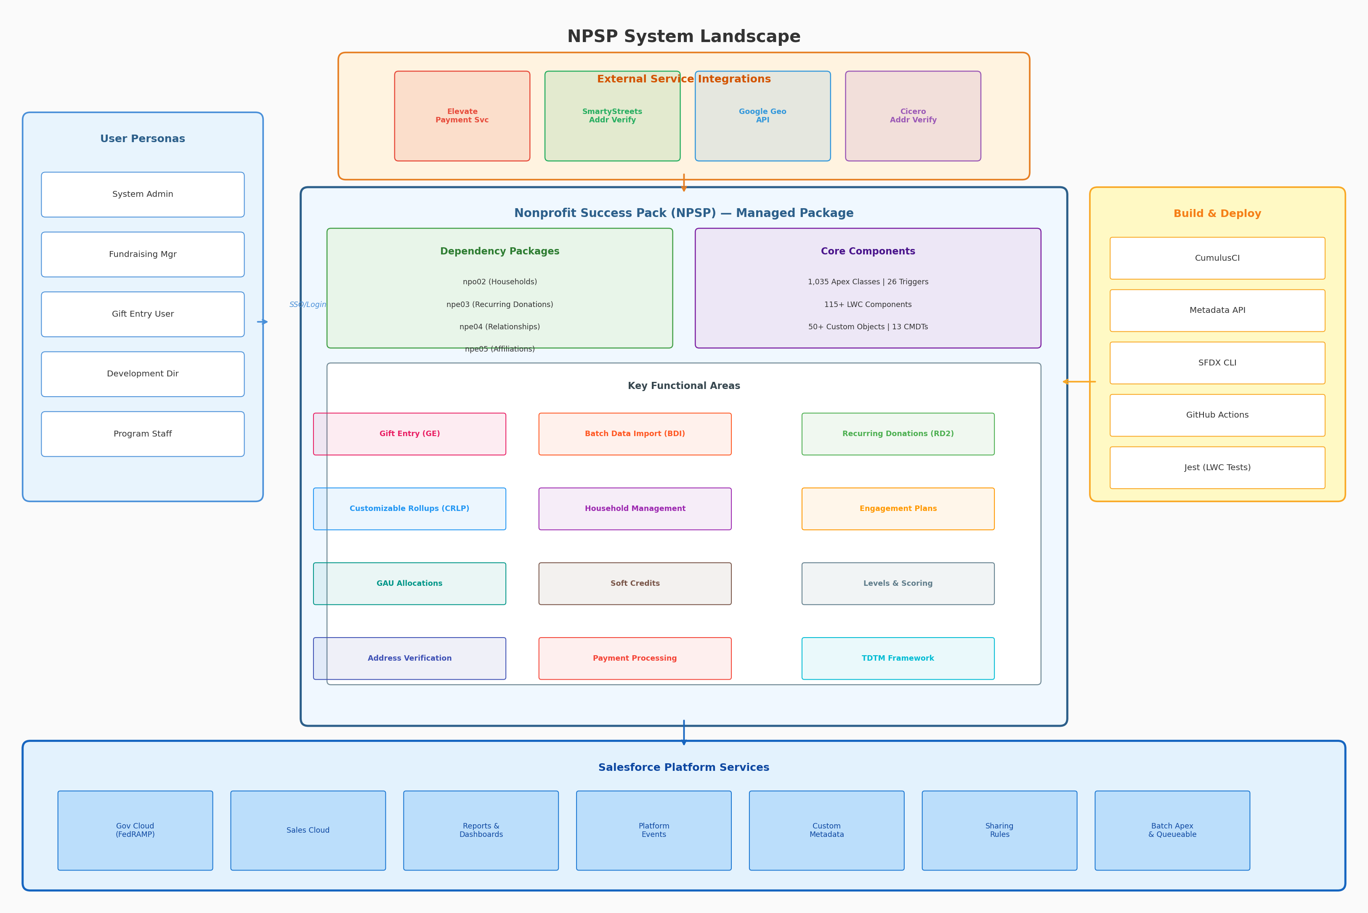
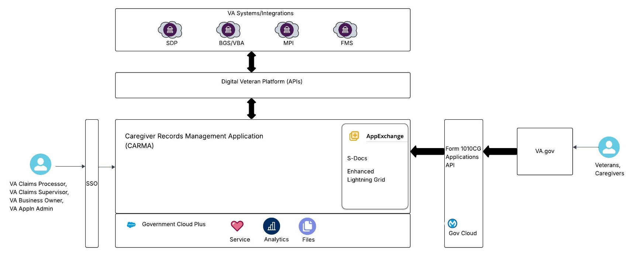

Reference: Salesforce Well Architected

2.2 VASIs for applications that this application depends upon

Guidance: Provide VASIs for all dependent applications shown in the System Landscape. Include any applications that are slated to be replaced and decommissioned.
Response: 

System | VASI | Description
Salesforce Elevate | TBD | Payment processing platform for credit card and ACH transactions
SmartyStreets | N/A — External | US address verification and standardization service
Google Geocoding API | N/A — External | Address geocoding and validation
Cicero | N/A — External | Legislative district and address verification
Salesforce Households (npo02) | TBD | Household account model and naming
Salesforce Recurring Donations (npe03) | TBD | Base recurring donation object and framework
Salesforce Relationships (npe04) | TBD | Contact-to-contact relationship tracking
Salesforce Affiliations (npe05) | TBD | Organization affiliation management

Reference: VA System Inventory

2.3 Managed Packages

Guidance: List the managed packages that will be used by the application. In the description, note the licensing model.

Response:

Package | Description
Nonprofit Success Pack (npsp) | Core NPSP package — fundraising automation, gift entry, rollups, engagement
Households (npo02) | Household account model with automatic naming and address management
Recurring Donations (npe03) | Recurring donation scheduling and installment generation
Relationships (npe04) | Contact-to-contact relationship and reciprocal relationship tracking
Affiliations (npe05) | Contact-to-organization affiliation management

Reference: DTC Policy for Managed Packages

2.4 Entity Relationship Diagram

Guidance: Include the major standard and custom objects in your application. Call out any proposed deviations from the VA DTC policy for Org-wide defaults.

Response: 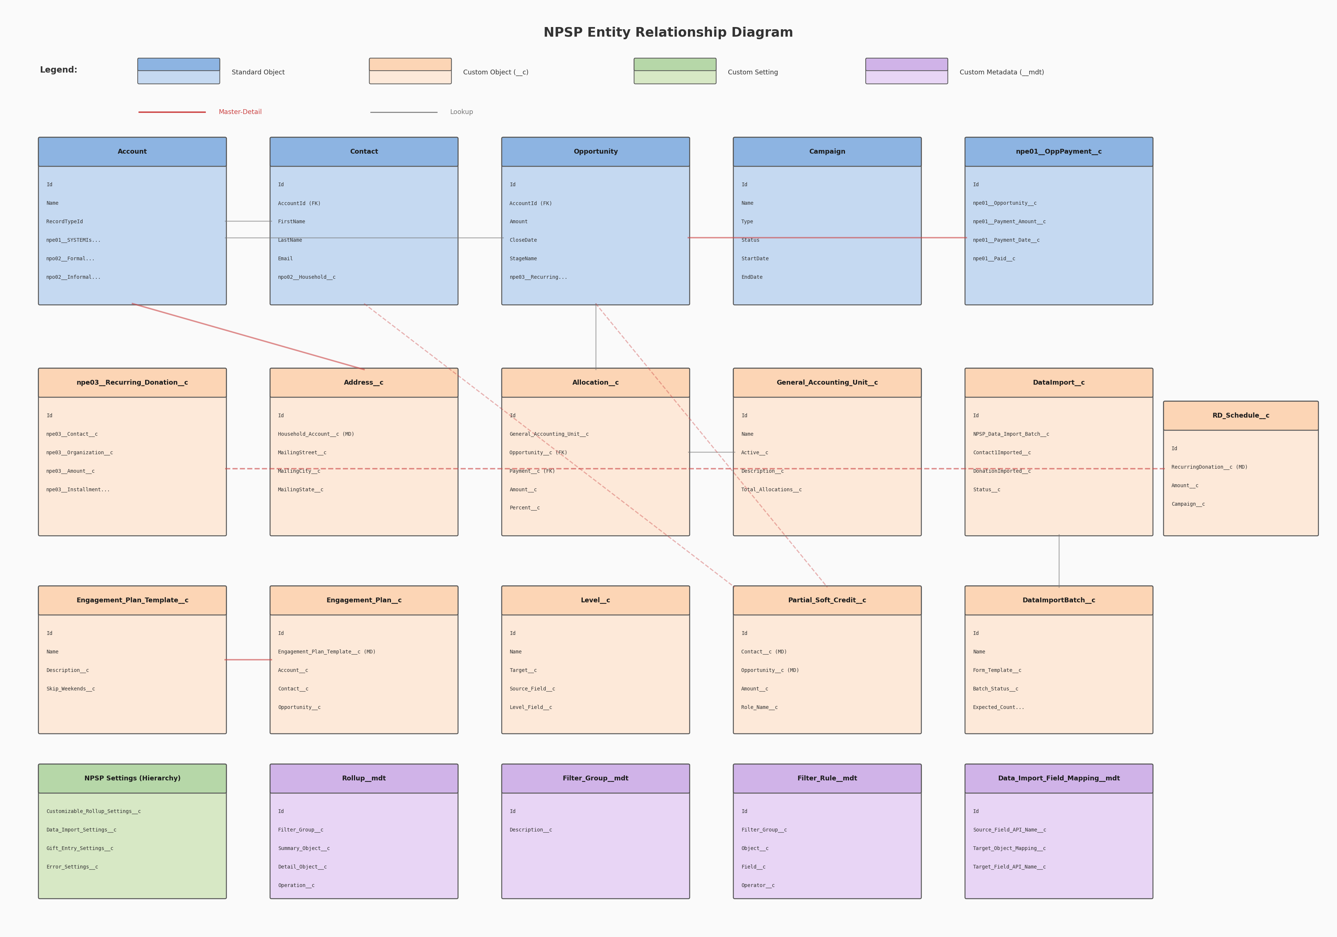
<
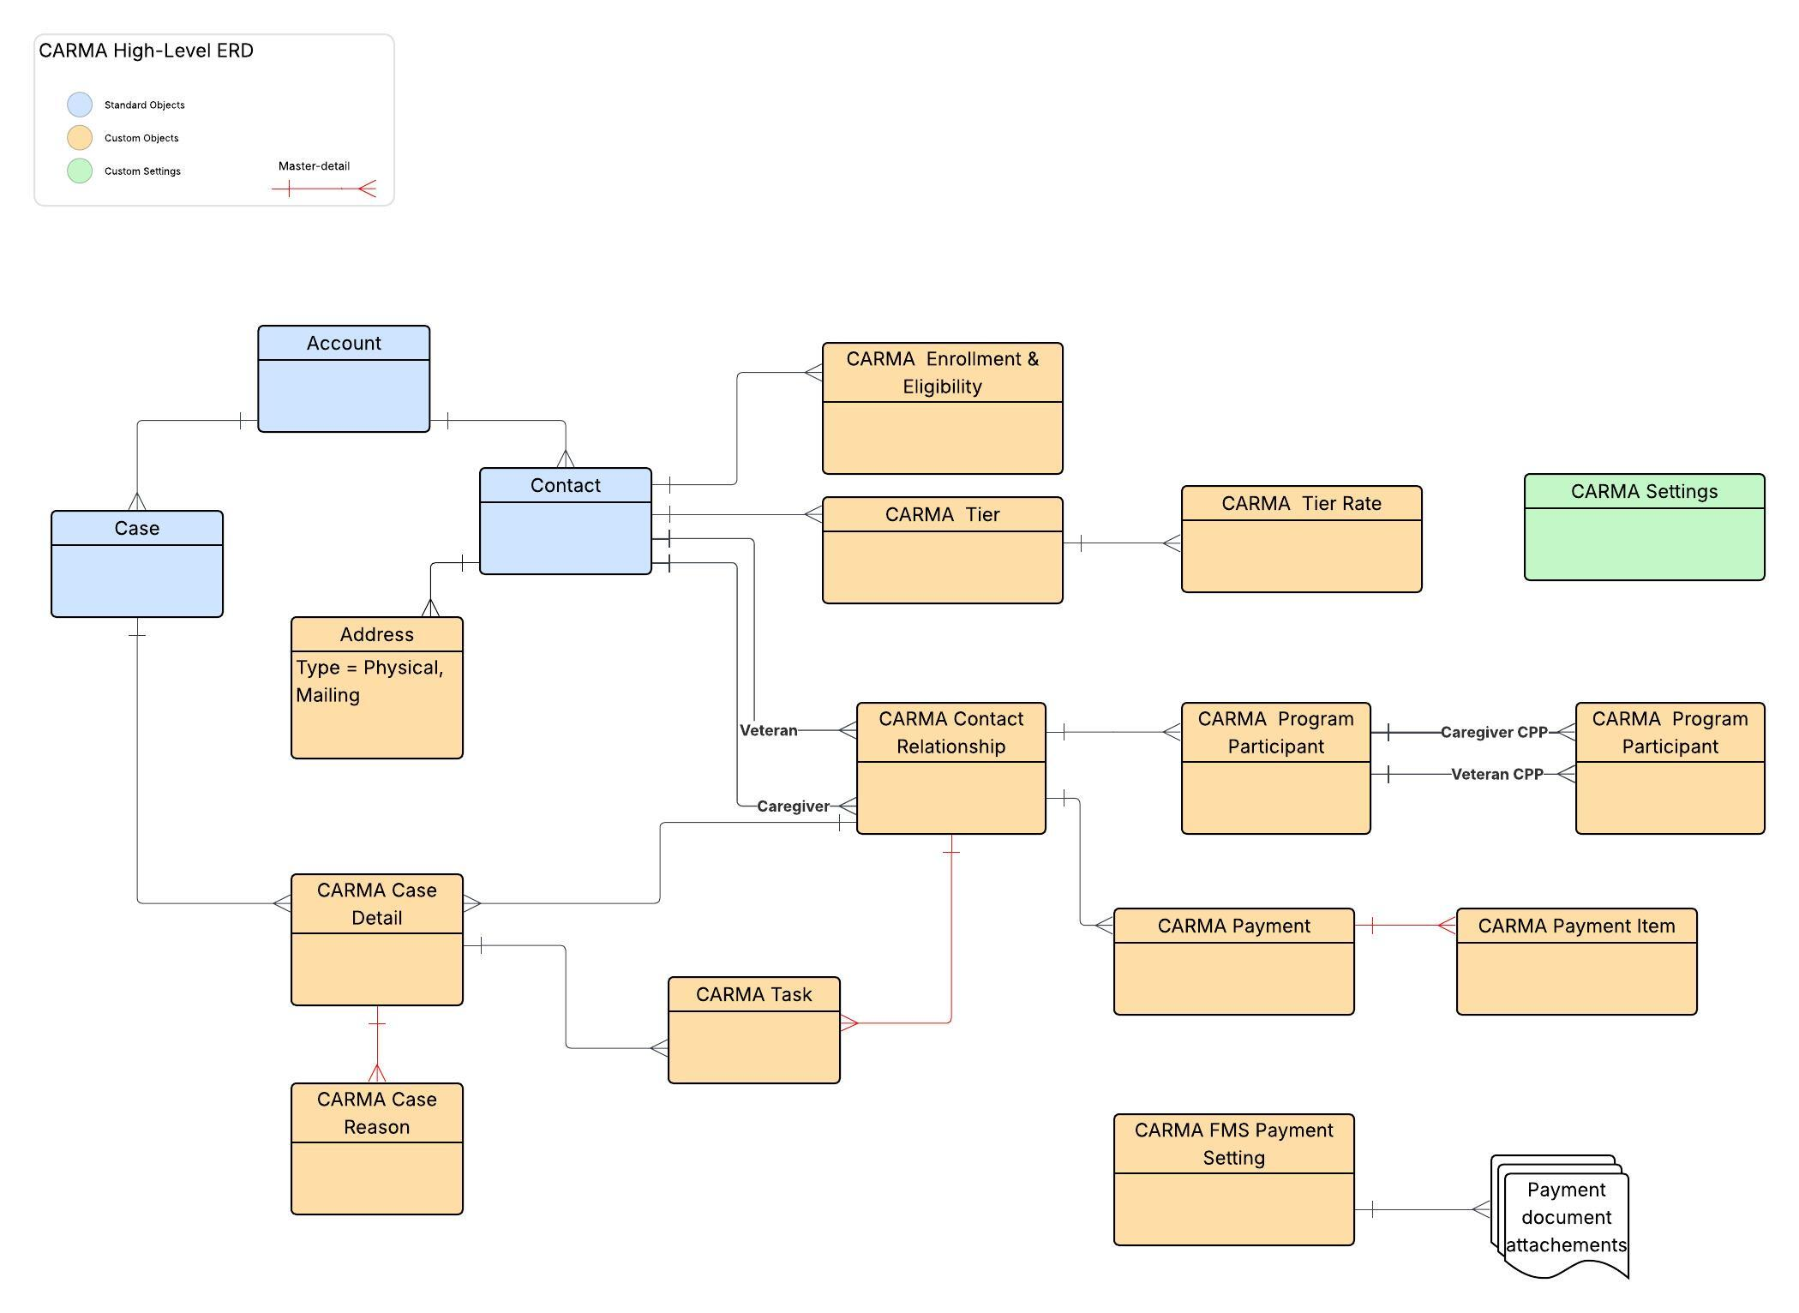
>

Reference: Object Definition in DTC Salesforce Governance and Architecture

2.5 Estimated Data Volume Growth

Guidance: If any object will exceed 1 million records growth per year, provide an explanation that includes the calculation.

Response:

Entity | Initial Volume | Volume Year 1 | Volume Year 2 | Volume Year 3 | Notes
Contact | 10,000 | 50,000 | 150,000 | 300,000 | Primary constituent records
Account | 8,000 | 40,000 | 120,000 | 240,000 | Household + Organization accounts
Opportunity | 25,000 | 125,000 | 400,000 | 800,000 | Individual donations and pledges
npe01__OppPayment__c | 25,000 | 125,000 | 400,000 | 800,000 | Payment records per Opportunity
npe03__Recurring_Donation__c | 2,000 | 10,000 | 25,000 | 50,000 | Active recurring giving schedules
Allocation__c | 30,000 | 150,000 | 500,000 | 1,000,000 | Fund allocation per gift
DataImport__c | 5,000 | 25,000 | 50,000 | 75,000 | Transient staging records (archivable)
Address__c | 10,000 | 50,000 | 150,000 | 300,000 | Verified constituent addresses

<*Case and related CARMA claim-processing record volumes based on estimated number of claims per month: 10% of veterans/2 claims per month, 40% of veterans/1 claim per month, 50% of veterans/0 claims per month>

Reference: Search for “Large Data Size” in DTC Salesforce Governance and Architecture

2.6 Application Personas

Guidance: Provide details of the personas for your application including user personas, integration users, and process users.
Response:

Persona | Number  of Users | Frequency of Use | How will this persona use the Application
System Administrator | 1-3 | Daily | Full system configuration, NPSP Settings management, user provisioning, data management
Fundraising Manager | 2-10 | Daily | Gift Entry, batch donation processing, recurring donation management, donor reporting
Development Director | 1-3 | Weekly | Reporting dashboards, engagement plan oversight, donor level review, campaign management
Gift Entry Clerk | 3-15 | Daily | High-volume gift entry via batch UI, payment matching, data import operations
Program Staff | 5-50 | Weekly | View donor information, engagement plan tasks, relationship management
Executive | 1-5 | Monthly | Dashboard reporting, aggregate giving summaries, campaign ROI analysis

2.7 Personas to VA Base Profile Mapping

Guidance: Identify VA base profiles and summarized object permissions required for each persona. Should there be a need for a new VA Base profile, provide a justification. Note that the TDD will include a detailed breakdown of object and field level permissions required for each object by persona as well as sharing model.
VA business users are not given platform level permissions.

Response:

Persona | Existing VA Base Profiles or  NEW VA Base Profile | Why New VA Base Profile is needed
System Administrator | System Administrator | Full access to all NPSP objects, settings, and configuration
Fundraising Manager | Custom: NPSP Fundraising | CRUD on Opportunities, Payments, RDs, Campaigns; Read on settings
Development Director | Custom: NPSP Development | Read/Report on all donation objects; Edit Engagement Plans
Gift Entry Clerk | Custom: NPSP Gift Entry | Create/Edit on DataImport__c, Opportunity, Payment; limited Account/Contact edit
Program Staff | Custom: NPSP Read Only+ | Read on most objects; Edit on assigned Tasks and Engagement Plans
Executive | Custom: NPSP Executive | Read access with Dashboard visibility; no edit permissions

<Public groups and sharing rules will be used for providing record access to VA users, integration users, and process users according to DTC guidelines.>

References:
- DTC Standard Operation Procedures for Salesforce. (Platform User Access Model, Account Management)
- DTC Technical Architecture and Guidelines (Profiles, Sharing)

2.8 Licenses
Guidance: In table a, list the Salesforce user, permission set, package and product licenses needed for each persona. In table b, list the estimated consumption of resources by the application, such as data storage, file storage, inbound API calls, and platform events published and consumed.
Tables a and b are to estimate the licenses and resources to be consumed by the application and are not the list of licenses and add-ons to be purchased for the target org. Determining additional licenses and add-ons that may be needed for the target org will be part of the TDD.

Response:
- Required user persona licensing

Persona | Salesforce Licenses, Permission Set Licenses, Package Licenses | Required number of licenses | Will Automated User Provisioning be used
Salesforce Platform | 60-80 | Core platform access for all personas
Salesforce CRM | 15-25 | Full CRM for Fundraising Managers and Directors
Elevate (Gift Processing) | 5-15 | Payment gateway access for Gift Entry users

- Resource consumption by type

Type | Estimated Reasonable Worst Case Quantity | Notes
<Data Storage> | <30 GB, end of year 3> | Estimate considers that additional custom objects will be defined in TDD.
<File Storage> | <150 GB, end of year 3> | Calculation: 2 files per claim, 50kb per file
<High Volume Platform Events Published > | <10K/24 hrs>
<High Volume Platform Events Delivered> | <10K/24 hrs> | Single subscriber per event type.
<API Calls> | <Less than 100/24 hrs> | Inbound API usage is limited to nightly integrations using Bulk API.

References:
- Architecture guidelines for User Profiles and Permissions
- Salesforce org Data Storage Resources
- Calculate data storage size
- Salesforce Licensing Overview
- VA DTC Salesforce License Management,
- DTC Salesforce: Features, Licenses and Usage,
- VA Product Market Place
- VA LCNC (Low-Code No-Code) Marketplace

2.9 Data Migration Strategy

Guidance: If data migration is required, explain the tooling that you will use, such as integrations or Data Loader. Consider the initial data load and any ongoing requirements throughout the application lifecycle.

The data migration solution needs to be developed and tested by the System Integrator in non-production environments. For application enhancements or modifications, ensure that data migration solutions are updated as necessary to remain fully functional and effective.

Response: NPSP provides the Batch Data Import (BDI) framework for data migration. The BDI engine maps flat staging records (DataImport__c) to complex object graphs including Contacts, Accounts, Opportunities, Payments, and Allocations. Migration tooling includes: BDI_DataImport_BATCH for processing, configurable field mappings via Data_Import_Field_Mapping__mdt, and dry-run validation mode. For large-scale migrations, CumulusCI provides dataset loading via SQL/YAML definitions. Detailed migration planning is TBD pending specific source system analysis.
<There is a requirement for an initial load of legacy claim data. No ongoing data migration is needed. A one-time integration will be developed using MuleSoft and tested in sandboxes. Instructions will be provided for running the integration in production.>
Or
<The application does not have a Data Migration requirement.>

References:
- Policy and SOP - Data Loader on Company Devices
- DTC Integration COE

2.10 Data Archival Strategy

Guidance: Explain the application data archival and retention plan.
Data archival solutions need to be developed and tested by the System Integrator in non-production environments. For application enhancements or modifications, ensure that data migration solutions remain fully functional and effective.

Response: Data archival strategy is TBD. Key candidates for archival include: DataImport__c records (transient staging data post-processing), Error__c records older than 90 days, RecurringDonationChangeLog__c historical entries. NPSP does not include a built-in archival framework; implementation will depend on Salesforce Big Objects, external archival tools, or scheduled purge batch jobs.

Entities | Archival Trigger | Archival Frequency
<Account, Contact, Case> | <No updates and no related records updated or created in 7 years> | <Quarterly>
<Other standard objects> | <No updates and no related records updated or created in 5 years> | <Quarterly>
<CARMA custom objects> | <No updates in 10 years> | <Yearly>

References:
- VA Salesforce Data Archival Guide
- VA Data Archival Strategy & Retention Policy
- DTC Standard Operating Procedures for the VA Salesforce Platform (See Data Management section for information on Salesforce Data Backups)
- General VA Policy Library

Section 3: Design

3.1 API Integration

- Guidance: Provide details on your outbound (from Salesforce) and inbound (to Salesforce) API Integration details More specifically:
  - For Inbound, what type of API - Standard Salesforce API or custom APEX?
  - For outbound, what initiates the outbound call?
Response:

Name | Description | Direction (Inbound, Outbound) | API Detail  For Inbound, what type of API - Standard or custom APEX?  For outbound, what initiates the call? | Volume | Is this monitored by Application Monitoring? (Yes / No)
Elevate Payment Services | Create/update payment commitments, process charges, refunds | Outbound | REST API via PS_Request / PS_CommitmentRequest | 100-1,000/day | Error__c logging + retry via RD2_QueueableService
SmartyStreets Address Verification | Validate and standardize US mailing addresses | Outbound | REST API via ADDR_SmartyStreets_Gateway | On-demand batch | Error__c logging
Google Geocoding API | Geocode addresses for verification | Outbound | REST API via ADDR_GoogleGeoAPI_Validator | On-demand batch | Error__c logging
Cicero Legislative Districts | District-level address verification | Outbound | REST API via ADDR_Cicero_Validator | On-demand batch | Error__c logging
Salesforce Metadata API | Deploy Custom Metadata (CRLP rollup definitions) | Outbound | Metadata API via CMT_MetadataAPI | Low (config changes) | DeploymentEvent__e platform event
<*Exception monitoring is N/A for callouts in the context of UIs. Users will be presented with an error message if an outbound API call fails. Users can retry UI actions and raise a helpdesk ticket for recurring errors.>

References:
- DTC Integration CoE
- DTC Integration Mulesoft API Inventory.
- DTC Integration Mulesoft ARB Design Review Requests
- DTC Integration Architecture Review Board

3.2 Platform Events Integration

Guidance: Complete this section if you are using custom platform events or Nebula logger, which uses platform events, in your solution.

Response:

Platform Event Name | Description | Volume and Subscribers | Is this monitored by Application Monitoring? (Yes / No)
DeploymentEvent__e | Signals completion of Custom Metadata deployments for CRLP rollup configuration | Internal | Low — config changes only

References:
- Use of Platform Events requires an Architecture Support Request ASR and SecRisk to enable to functionality for an org. This is considered an Integration as data is leaving the Salesforce boundary. Salesforce Platform Events Allocation
- Nebula Logger. DTC provides a slightly customized version of this open-source library .

3.3 Change Data Capture

Guidance: Complete this section if you are planning to use Change Data Capture for on platform processing or data replication to external systems.

Response: NPSP does not currently implement Change Data Capture (CDC). Event-driven patterns are limited to the DeploymentEvent__e Platform Event for Custom Metadata deployment notifications. CDC could be considered for future integration patterns if external systems need real-time donation event streaming. TBD.

Change Data Capture Entity | Description | Volume, External Subscribers
N/A — CDC not implemented | NPSP uses Platform Events (DeploymentEvent__e) rather than CDC | N/A

References:
- Salesforce Well-Architected for CDC integration patterns and recommendations.
- DTC Integration COE

3.4 Apex or Flow Batch Processing

Guidance: Complete this section if your application requires batch processing.
Response:

Batch Process | Description | Estimated Batch Size & Frequency | Batch Processing Method | Is this monitored by Application Monitoring? (Yes / No)
CRLP_Account_BATCH | Recalculate rollup fields for Account records | Scheduled + On-demand | All Accounts with Opportunity children | Nightly or triggered
CRLP_Contact_BATCH | Recalculate rollup fields for Contact records | Scheduled + On-demand | All Contacts with donation history | Nightly or triggered
CRLP_GAU_BATCH | Recalculate rollup fields for General Accounting Units | Scheduled | All active GAU records | Nightly
BDI_DataImport_BATCH | Process staged DataImport__c records into target objects | On-demand (user-initiated) | DataImport__c records in a batch | Per batch submission
RD2_OpportunityEvaluation_BATCH | Create/update installment Opportunities for Recurring Donations | Scheduled + On-demand | Active npe03__Recurring_Donation__c records | Nightly
ADDR_Validator_Batch | Batch verify addresses via external APIs | On-demand | Unverified Address__c records | User-initiated
LVL_LevelAssign_BATCH | Assign donor levels based on rollup values | Scheduled | Contacts/Accounts with level criteria | Nightly
HH_HouseholdNaming_BATCH | Recalculate household names after bulk changes | On-demand | Household Account records | Triggered by bulk ops
UTIL_OrgTelemetry_BATCH | Collect org usage statistics for product telemetry | Scheduled | Org-wide metadata counts | Weekly
OPP_OpportunityNaming_BATCH | Apply naming conventions to Opportunity records | On-demand | Opportunities missing standard names | User-initiated

Reference: Salesforce Batch Management

3.5 Other Asynchronous Processing

Guidance: Identify any other asynchronous processing required for your application such as Future Methods or Queueable Apex.
Response:
Async Process | Description | Frequency | Is this monitored by Application Monitoring? (Yes /No)
RD2_QueueableService | Queueable | Process Elevate commitment API calls asynchronously with retry logic
GiftEntryProcessorQueue | Queueable | Process Gift Entry submissions asynchronously for better UI responsiveness
CRLP_RollupQueueable | Queueable | Process incremental rollup calculations triggered by DML operations
CRLP_ResetRollupFieldsQueueable | Queueable | Reset rollup fields when rollup definitions change
ElevateBatchCapturer | Queueable/Batch | Capture authorized Elevate batch payments
ERR_AsyncErrors | Queueable | Process and store async operation errors

Reference: Asynchronous Processing section in VA DTC Salesforce Governance and Architecture

Section 4: Application Monitoring and Resiliency

4.1 Business Hours

Guidance: Specify operational business hours for the application. Call out any holidays or deviations.

Response: TBD — Business hours to be defined based on organizational operating schedule. NPSP batch jobs (CRLP rollups, RD evaluation) are typically scheduled during off-peak hours.
< Monday through Friday, 8:00AM EST to 5:00PM EST. No operations on federal holidays.>

4.2 Application Monitoring

Guidance: Salesforce platform level monitoring is the responsibility of the DTC Customer Success Center, while the System Integrator or Citizen Developer is responsible for the development of application-level monitoring. Explain the monitoring plan for application services and integrations.

Response: NPSP implements application monitoring through the following mechanisms:
1. Error__c Custom Object: Central error logging repository. All caught exceptions across NPSP trigger handlers, batch jobs, and async processes are logged as Error__c records with full stack traces, context, and timestamps.
2. ERR_Handler Framework: Centralized error handling utility (ERR_Handler.cls) that captures errors from TDTM trigger execution, batch processing, and queueable jobs. Supports error notification via email.
3. ERR_AsyncErrors Queueable: Processes async errors that cannot be logged synchronously (e.g., during trigger rollback).
4. Error_Settings__c: Configurable settings for error notification recipients, error handling behavior (store vs. email), and error record retention.
5. Batch Job Monitoring: UTIL_JobProgress_CTRL provides real-time batch progress tracking. UTIL_BatchJobService provides batch job status querying.
6. Telemetry: UTIL_OrgTelemetry_BATCH collects usage metrics (object counts, feature adoption) and reports via Salesforce Feature Management.
7. Health Check: GetStartedChecklist components provide configuration validation and setup verification.

An application-specific setup UI will be available for the VA Application Admin persona to configure which users should receive error notification emails.
>

Monitoring Target | Type (e.g. success, failure) | Alert Condition or Observation | Monitoring Tool | Responsible Persona
Error__c Records | Failure | New Error__c records created (count > threshold) | Custom Error Dashboard | System Administrator
Batch Job Status | Success/Failure | Batch Apex job failures or extended runtime | Salesforce Setup > Apex Jobs | System Administrator
Elevate API Calls | Failure | HTTP 4xx/5xx responses from Payment Services | Error__c + Custom Report | Fundraising Manager
CRLP Rollup Completion | Success | Batch completion within SLA timeframe | UTIL_JobProgress_CTRL | System Administrator
Org Telemetry | Success | Weekly telemetry batch completion | UTIL_OrgTelemetry_BATCH logs | System Administrator

References:
- Dynatrace
- Nebula Logger. DTC provides a slightly customized version of this open-source library .
- DTC Customer Success Center Offering
- Create a Architectural Support Request (ASR) to Salesforce Platform Ops for implementing Dynatrace. The Salesforce Platform Ops team and the Enterprise Command Center team support the roll out.
- Splunk and Splunk and Salesforce

4.3 Resiliency Plan

Guidance:
- Consider all aspects of your application where processing could fail, such as dependencies on async processing or integrations.
- For each possible failure point, describe how the failure will be managed.
- It is expected that recovery tasks will be performed by supervisory or superuser types of application personas.

Response: NPSP resiliency patterns include:
1. Queueable Retry: RD2_QueueableService implements retry logic for failed Elevate API calls with configurable retry counts and backoff.
2. Batch Error Isolation: CRLP batch jobs process records in chunks; failures in one chunk do not prevent processing of subsequent chunks. Errors are logged per-record.
3. TDTM Framework Isolation: Table-Driven Trigger Management allows disabling individual trigger handlers without code deployment, enabling rapid mitigation of problematic logic.
4. Graceful Degradation: Gift Entry continues to function for offline gifts even if Elevate payment services are unavailable.
5. Error Notification: Configurable email alerts on error thresholds via Error_Settings__c.
6. Data Validation: BDI dry-run mode validates imports without committing, preventing bad data ingestion.
Failure Point | Recovery Approach | Recovery Owner
<Outbound integration failures in the context of application user actions will result in an error displayed to the user.> | <Users can retry these actions and open help desk tickets should errors persist. > | End user
<Asynchronous process failures> | <The failure will be recorded in the Nebula log and an error notification email will be sent to one or more users> | <Application Admin>
<Resiliency for the inbound integrations will be part of the integration's design and will include configurable retry limits and error logs> | <Details for which monitoring tool will be used and which platform monitoring team will be responsible for the health of the integrations is TBD> | <TBD>

References:
- Salesforce Application Resiliency
- Business Continuity Process Manual
- Building Resiliency and Highly Available Applications
- DTC Integration COE
- Enterprise Command Center

4.4 Contingency plan for government shutdowns

Guidance: Does the application need to behave differently in the event of a government shutdown?
If so, describe your how your application will behave during a shutdown and the plan to test it.

Response: TBD — Contingency plan to be developed based on organizational disaster recovery requirements and Salesforce platform SLA.

<A shutdown could impact the critical “Pay out claims” capability. The VA Application Admin persona will have the ability to disable the FMS integration for specific runs by editing a checkbox field on CARMA_Payment_Setting__c records. This custom object will contain settings for each monthly and ad hoc FMS payment run that will occur for the fiscal year. After a disruption, the FMS integration will pick up any pending payments to be processed that were skipped during the disruption.>

4.5 Salesforce Sandbox Refresh

Guidance: Sandbox setup instructions are not required for Gateway 1. They are only required for Gateway 2. The System Integrator is accountable and responsible for sandbox post refresh steps to ensure the application is fully functional.

Response: TBD — Sandbox refresh schedule and procedures to be defined. NPSP configuration (Custom Settings, Custom Metadata) should be validated post-refresh. CumulusCI provides scratch org and sandbox setup automation.

<Sandbox post refresh instructions and scripts will be tested in non-production environments. Documentation will be provided for the complete application setup in sandboxes post refresh.>

References:
- DTC Release Management
- See Sandbox Refresh Steps for examples of existing procedures and scripts.

Section 5: Technical Review Notes & Action Items (Filled out by DTC)

5.1 Notes and action items captured during Technical Review calls.

Notes
Action Items | Completed by

5.2 DTC notes and action items captured during Architecture Reviews.

DTC Notes
DTC Action Items | Completed by

Appendices

