Nonprofit Success Pack (NPSP)
Technical Design Documentation



Department of Veterans Affairs
May 2026
1.0

Revision History

Version | Date | Author | Description
1.0 | 05/14/2026 | Devin AI | Initial TDD generation from codebase analysisersion
1.1 | 03/01/17 | CoE Team | Revised
1.2 | 5/31/18 | DTC Team | Added
2.0 | 12/9/21 | DTC Team | Added Analytics sub-sections and Network Diagram sections
2.1 | 5/30/23 | DTC Team | Added Business Continuity Plan and DTC Policy Compliance Agreement
2.2 | 4/17/24 | DTC Team | Added System and Org-Wide Permissions

Table of Contents
Introduction 6
1.1 Objective of the Document 6
1.2 Linked Documents 6
1.3 Glossary 6
Data and Visibility 7
2.1 The Data Model 7
2.1.1 The XXX object 7
2.1.2 The YYY object 7
2.2 The Security Model 8
The Users and the User Permissions 9
3.1 The User Roles 9
3.2 User Permissions 9
3.2.1 Data Access Permissions 9
3.3 The User Configuration 10
3.3.1 The Permission Sets 10
3.3.2 The Profiles 10
3.3.3 The User Detail Screen 10
3.4 Access to the Application and User login 11
3.4.1 SSO 11
3.4.2 Community 11
Process 11
4.1 The Macro-Process 11
4.1.1 The Schema of the Process for Module XXX 11
4.1.2 Description of Steps 11
4.1.3 The XXX Processing Permissions 12
4.2 Step by Step Process (needed if process is complex and needs further details) 13
4.2.1 The Process XXX and Sub-Processes 13
4.2.2 The Process XXX 13
4.3 Workflows 14
4.4 Process Flows 14
4.5 Apex Triggers 14
4.6 Visual Force Pages 14
4.7 Report Types 14
4.8 Apex Classes 14
4.9 Visual Flows 14
4.10 Custom Metadata 14
4.11 Page Layouts 14
4.12 Record Types 14
4.13 EinStein Analytics Dataflows/Dashboards 15
4.13.1 Dataflows 15
4.13.2 Recipes 15
4.13.3 DataSets 15
4.13.4 Connected Data 15
4.13.5 Dashboards 15
4.13.6 Custom Defined Attributes/Measures 15
4.13.7 Visibility & Security 15
4.13.8 Jobs 15
4.14 Batch Jobs 15
4.15 Other Custom Components 15
4.16 The Custom Settings 15
4.16.1 Custom Setting 1 15
4.16.2 Custom Setting 1 Picklist Dependency 16
4.17 The Custom Labels 16
Other Components 17
4.18 Any other custom components not covered above. 17
Managed Packages 17
4.19 Describe any dependent managed packages that will be used by this app (Appexchange). 17
Integrations 17
4.20 The technical interfaces 17
4.21 The schema of the data flows for the interfaces 17
4.22 The web service calls 18
4.23 The interfaces managed by the ETL 18
4.24 Other documentation about the interfaces 18
4.24.1 Documentation for the web service calls from Salesforce 19
4.24.2 Documentation of the ETL interfaces 19
4.24.3 Documentation for the web services 19
4.24.4 Documentation for XXX interfaces 19
4.25 Integration Resiliency and Business Continuity Plan 19
4.25.1 Plan for disaster recovery and high availability of integrated systems 19
4.25.2 Plan for integration and data recovery due to system failure 19
4.25.3 Plan for end users and stakeholder communication 19
4.26 Network Diagram 19
DTC Architecture Review Board Compliance 19

Introduction

Objective of the Document
This Technical Design Document (TDD) provides a comprehensive technical specification of the Nonprofit Success Pack (NPSP), Salesforce's open-source CRM solution for nonprofit organizations. NPSP extends Salesforce with specialized data models, automation, and user interfaces for fundraising, donor management, recurring donations, gift entry, engagement planning, and financial allocations. The package namespace is 'npsp' and it depends on four upstream managed packages: Households (npo02/npe01), Recurring Donations (npe03), Relationships (npe4), and Affiliations (npe5). This document covers the data architecture, security model, user permissions, business processes, automation components, integrations, and batch processing infrastructure of the NPSP codebase.

Linked Documents
Linked Documents:
- NPSP Documentation: https://powerofus.force.com/s/article/NPSP-Documentation
- - CumulusCI Documentation: https://cumulusci.readthedocs.io/
- - NPSP GitHub Repository: https://github.com/SalesforceFoundation/NPSP

Glossary
Table 1
Word | Definition
NPSP | Nonprofit Success Pack - Salesforce open-source CRM for nonprofits
BDI | Batch Data Import - Engine for mapping flat staging records to object graphs
GE | Gift Entry - High-volume UI for donation batching and real-time processing
RD2 | Enhanced Recurring Donations - Modernized framework for sustaining gifts
CRLP | Customizable Rollups - Configurable engine for aggregate donor statistics
TDTM | Table-Driven Trigger Management - Framework for trigger execution order
GAU | General Accounting Unit - Fund accounting for donation allocations
Elevate | External payment platform integration for credit card/ACH tokenization

Data and Visibility

The Data Model
The NPSP data model extends standard Salesforce objects (Account, Contact, Opportunity, Campaign) with 30+ custom objects and 765 custom fields. The core architecture uses the Household Account model where Contacts are grouped under Household Accounts. Key custom objects include: DataImport__c (175 fields, staging table for BDI), DataImportBatch__c (batch processing), Address__c (33 fields, address management), General_Accounting_Unit__c (fund tracking), Allocation__c (donation allocations), Recurring Donation Schedule/Change Log, Level__c (donor levels), Engagement_Plan__c/Task__c (cultivation workflows), Error__c (error tracking), and Partial_Soft_Credit__c. The model also includes 7 Custom Metadata Types (Rollup__mdt, Filter_Rule__mdt, Filter_Group__mdt, Data_Import_Field_Mapping__mdt, Data_Import_Object_Mapping__mdt, etc.) and 12+ Custom Settings for configuration. The platform event DeploymentEvent__e supports async deployment tracking.
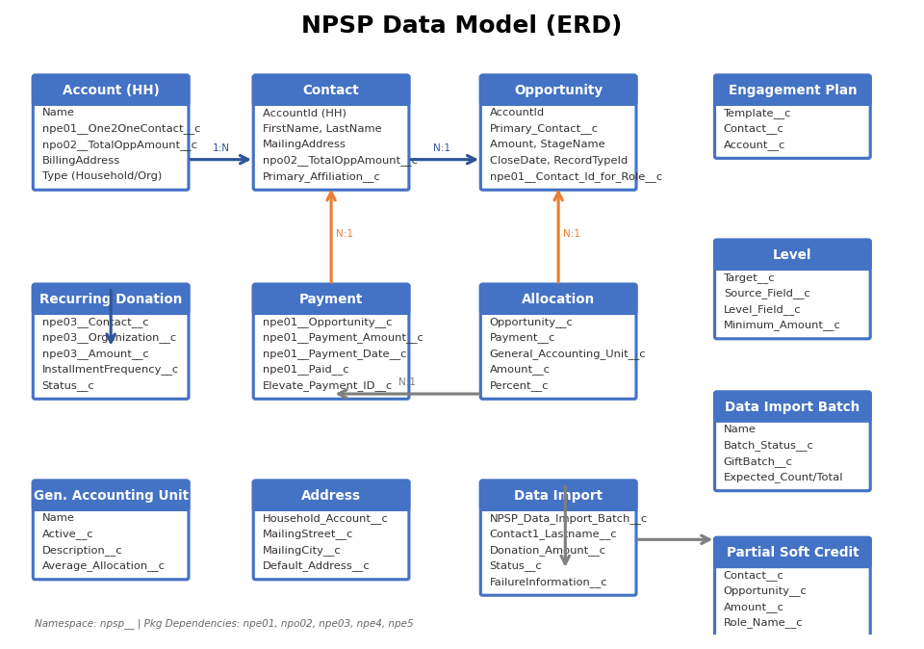
Figure 1: Data Model
See the NPSP Data Dictionary in the Salesforce Power of Us Hub for complete field-level specifications.

Core Objects: Account (Household), Contact, Opportunity, npe01__OppPayment__c, npe03__Recurring_Donation__c, Campaign, CampaignMember, Lead, Task
NPSP Custom Objects: DataImport__c, DataImportBatch__c, Address__c, General_Accounting_Unit__c, Allocation__c, Level__c, Error__c, Batch__c, Form_Template__c, Fund__c

Engagement & Soft Credit: Engagement_Plan__c, Engagement_Plan_Task__c, Engagement_Plan_Template__c, Partial_Soft_Credit__c, Account_Soft_Credit__c, Grant_Deadline__c
Configuration: Rollup__mdt, Filter_Rule__mdt, Filter_Group__mdt, Data_Import_Field_Mapping__mdt, Data_Import_Object_Mapping__mdt, Trigger_Handler__c, Schedulable__c, Custom_Column_Header__c

NPSP uses a combination of OWD settings, sharing rules, and the Household Account model to manage data visibility. As a managed package, NPSP respects the org's security model and provides permission sets for different user personas. The TDTM framework enforces trigger execution order through the Trigger_Handler__c custom setting. Field-Level Security is managed through permission sets rather than profiles. The package includes protected custom labels and uses the WITH SHARING keyword pattern in Apex classes for SOQL enforcement.
The Salesforce object’s visibility is controlled at the top level by the security model of visibility defined for the object.
The object visibility may be:
- Public read only
- Public read write
- Private (only visible by its owner)
- Controlled by parent
A private object is preferred and can be shared to public groups to grant read and write access. The table below shows the security model defined for each object:
Table 2: Security Model
Object | Public read only | Private | Controlled by parent  (Opportunity)
Account | Private | Sharing Rules | X
Contact | Controlled by Parent | Account Sharing | X
Opportunity | Private | Sharing Rules | X
npe01__OppPayment__c | Controlled by Parent | Opp Sharing | X
npe03__Recurring_Donation__c | Private | Sharing Rules | X
DataImport__c | Public Read/Write | N/A
Address__c | Controlled by Parent | Account Sharing
General_Accounting_Unit__c | Public Read Only | N/A

The Users and the User Permissions

The User Roles
Three user roles are involved in the special-order process:
Table 3:User Roles
Role | Who | Action
System Administrator | Org Admin | Full CRUD on all NPSP objects, manage NPSP Settings, run batch jobs
Fundraiser/Gift Processor | Development Staff:  - Leather goods  - Accessories  - Watches | Create/Edit Opportunities, Payments, Gift Entry batches, run BDI
Read Only User | Board/Volunteer | Read access to Contacts, Accounts, Donations, Reports

User Permissions

Data Access Permissions
In Salesforce, each user is linked to only one profile. The profile defines the kinds of operations a user can apply on each object (create, read, write, delete).
Table 4:Permission Sets
Permission | R | C | M | D | R | C | M | D | R | C | M | D | R | C | M | D
Objectct
Account | X | X | X | X | X | X | X |  | X |  | X |  | X
Contact | X | X | X | X | X | X | X |  | X |  | X |  | X
Opportunity | X | X | X | X | X | X | X | X | X | X | X |  | X
Payment | X | X | X | X | X | X | X |  | X |  | X |  | X
Recurring Donation | X | X | X | X | X | X | X |  | X | X | X |  | X
GAU | X | X | X | X | X |  |  |  | X |  |  |  | X
Allocation | X | X | X | X | X | X | X | X | X |  | X |  | X
Data Import | X | X | X | X | X | X | X | X | X | X | X |  | X

The User Configuration

The Permission Sets
Permissions sets give the users permissions on all the components elements of the module (objects, pages, module) and defines the role of the user.
NPSP provides permission-based access control through a combination of managed package permissions and custom permission sets. Key permission sets include NPSP Admin, Gift Entry Admin, Gift Entry User, and NPSP Fundraiser.
- NPSP Admin: Full access to all NPSP objects, settings, and batch operations
- NPSP Fundraiser: Create/Edit access to Opportunities, Payments, Contacts, and Gift Entry

The Profiles
NPSP users are assigned the Standard User or Minimum Access - Salesforce profile, with NPSP-specific access granted through permission sets.

The User Detail Screen
All the information which defines the permissions and the role of the user are updated in the user form:
- The Profile
- Role
- The Permission Set
Here are different permission sets available according the user role & profile for this module:
Table 5:User Roles and Permission
User role | Salesforce Profile | Salesforce Permission set
System Administrator | System Administrator | NPSP Admin, Gift Entry Admin
Fundraiser | Standard User | NPSP Fundraiser, Gift Entry User
Read Only | Minimum Access | NPSP Read Only

Please note:
- Any special notes.

Access to the Application and User login

SSO configuration is org-specific and not defined within the NPSP package.
NPSP does not include SSO metadata; SSO is configured at the org level per VA DTC standards.

N/A - NPSP does not include Community/Experience Cloud configurations.

Process

The NPSP macro-process revolves around the nonprofit donation lifecycle: from constituent management (household creation, address verification) through gift entry and data import, donation processing (payment allocation, soft credits, GAU allocations), recurring donation management (Elevate integration, schedule management), rollup calculations (CRLP engine, level assignment), and finally reporting and analytics. The TDTM framework orchestrates all trigger-based automation across 26 triggers covering Account, Contact, Opportunity, Payment, Recurring Donation, Allocation, Address, and other objects.

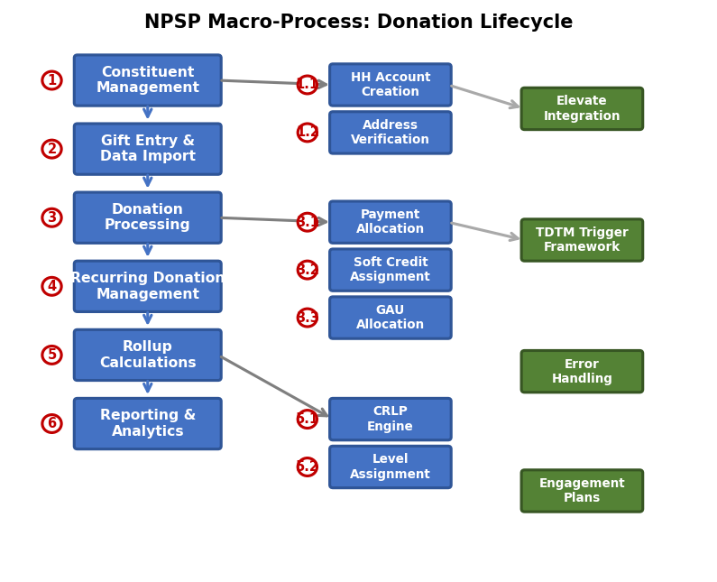
Figure 2:Macro-Process

Step 1 - Constituent Management: Contacts are created and organized into Household Accounts. The HH_Households and ACCT_IndividualAccounts_TDTM handlers manage automatic household creation. Address__c records track mailing addresses with ADDR_Addresses_TDTM handling validation.
Step 2 - Gift Entry & Data Import: Donations enter via Gift Entry UI (LWC-based geFormRenderer) or Batch Data Import (BDI_DataImport_BATCH). DataImport__c staging records are validated, matched against existing donors, and processed into Opportunities/Payments.
Step 3 - Donation Processing: Opportunities trigger payment creation (PMT_PaymentCreator), soft credit assignment (OPP_AutomatedSoftCreditsService), and GAU allocation (ALLO_Allocations_TDTM). The Elevate integration handles credit card tokenization.
Step 4 - Recurring Donations: RD2 framework manages installment schedules, creates future Opportunities, and syncs with Elevate commitments via RD2_CommitmentService.
Step 5 - Rollup Calculations: CRLP engine (CRLP_RollupProcessor) computes aggregate statistics on Accounts, Contacts, and GAUs. Level assignment (LVL_LevelAssign_BATCH) categorizes donors.
Step 6 - Reporting: Custom report types and standard reports provide fundraising analytics.
The main steps are described in the table below.
The steps may be skipped depending on the type of special order.
Table 6:Macro-Process
# | Main process features | Comment | Ref.
1 | Constituent Management | HH Account creation, Contact merge, Address verificationspecial order is created with the mandatory information: the store, the CA code | HH_*, ADDR_*, CON_*
2 | Gift Entry & Data Import | Batch Data Import processing, Gift Entry UI, donation matching | BDI_*, BGE_*, GE_*
3  3.2  3.3 | Donation Processing | Payment creation, soft credits, GAU allocations | PMT_*, ALLO_*, OPP_*
4 | Recurring Donation Mgmt | Schedule management, Elevate sync, opportunity creation | RD2_*, PS_*
5 | Rollup Calculations | CRLP engine, level assignment, batch rollups | CRLP_*, LVL_*, RLLP_*

The NPSP Donation Processing Permissions
The permissions are described in the table below. All users have the same permissions as the store user if they created a product order and they are consequently the owner of the special order.
Table 7:User Permissions
Action / Users | User type 1 | User type 2 | All others
Create Gift Batch | X | X
Enter Gift Records | X | X
Process Data Import | X | X
Manage Recurring Donations | X | X
Run Rollup Calculations | X

- Footnotes for anything above
- Footnote 2

System and Org-Wide Permissions
This section describes any System-level or potentially sensitive App/Org-Wide permissions that your module implements or makes use of:
Permission | Permission Set(s) | SecRisk # / Justification
Customize Application | NPSP Admin | Low
Modify All Data | System Administrator | High
View All Data | NPSP Admin | Medium
Manage Custom Metadata Types | NPSP Admin | Medium
API Enabled | All NPSP Users | Low

Step by Step Process (needed if process is complex and needs further details)

The Gift Entry and Batch Data Import Sub-Processes
The client selection and creation process is described in the schema below.
EXAMPLE:
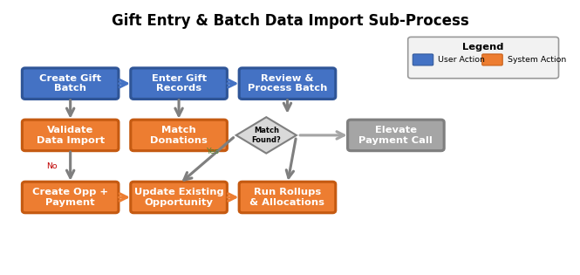
Figure 3:Selection Process

The Gift Entry Process
Table 8: Gift Entry Process Steps
User | XXXX | Description
1 | User Action | User creates a new Gift Batch via Gift Entry LWC (geGiftEntryFormApp)
2 | User Action | User enters gift records with donor info, amount, and payment details
3 | Systemthere is a case already in the system | BDI validates DataImport__c records against field mappings and FLS
4 | System  Error received if the case already exists,  User enters following details for the case:  X, y, z. | BDI_MatchDonations matches incoming gifts to existing Opportunities  Following fields are required, etc.
5 | System  Ex. Case | BDI creates/updates Opportunity, Payment, Contact, Account records
6 | System | ALLO_Allocations_TDTM creates GAU allocations per configured defaults
7isual force page, Workflow, Process Builder, Visual Flow | System | CRLP_Rollup_TDTM triggers rollup recalculation on parent records

Workflows
N/A - NPSP does not use declarative Workflow Rules. All automation is implemented via the TDTM (Table-Driven Trigger Management) framework with Apex trigger handlers.

Process Flows
N/A - NPSP does not include declarative Flows or Process Builders. All process automation is handled through Apex TDTM handlers and batch classes.

Apex Triggers
NPSP uses 26 TDTM (Table-Driven Trigger Management) triggers. Each trigger delegates to handler classes configured in Trigger_Handler__c records. Triggers: TDTM_Account, TDTM_Contact, TDTM_Opportunity, TDTM_Payment (npe01__OppPayment__c), TDTM_RecurringDonation, TDTM_Allocation, TDTM_Address, TDTM_Lead, TDTM_Relationship, TDTM_DataImport, TDTM_DataImportBatch, TDTM_User, TDTM_GrantDeadline, TDTM_Task, TDTM_PartialSoftCredit, TDTM_EngagementPlanTask, TDTM_Level, TDTM_CampaignMember, TDTM_OpportunityContactRole, TDTM_HouseholdObject, TDTM_Campaign, TDTM_AccountSoftCredit, TDTM_GeneralAccountingUnit, TDTM_EngagementPlan, TDTM_FormTemplate, TDTM_Affiliation. Key handler classes include: ACCT_IndividualAccounts_TDTM, ADDR_Addresses_TDTM, ALLO_Allocations_TDTM, OPP_CampaignMember_TDTM, REL_Relationships_TDTM, CRLP_Rollup_TDTM, PMT_Payment_TDTM, RD2_RecurringDonations_TDTM, EP_EngagementPlans_TDTM.

Visualforce Pages
NPSP includes 80 Visualforce pages primarily for the NPSP Settings UI and administrative functions: STG_SettingsManager (main settings hub), STG_PanelHome, STG_PanelContacts, STG_PanelHouseholds, STG_PanelRel (Relationships), STG_PanelRelAuto, STG_PanelRelReciprocal, STG_PanelAffiliations, STG_PanelOpps, STG_PanelOppNaming, STG_PanelOppRollups, STG_PanelContactRoles, STG_PanelPaymentMapping, STG_PanelMembership, STG_PanelAllocations, STG_PanelRD, STG_PanelBDE, STG_PanelERR, STG_PanelTDTM, STG_PanelHealthCheck, STG_PanelCustomizableRollup, STG_PanelSchedule, STG_PanelAddrVerification, STG_PanelDataImportAdvancedMapping, STG_PanelGatewayManagement. Other key pages: CON_ContactMerge, ALLO_ManageAllocations, BDI_DataImport, EP_ManageEPTemplate, HH_ManageHousehold, PSC_ManageSoftCredits, PMT_PaymentWizard, LD_LeadConvertOverride, NPSP_Resources, RP_Resources.

Report Types
NPSP includes 1 custom report type: Contacts_Only - provides a report type for Contact records without requiring Account relationship.

Apex Classes
NPSP contains approximately 650 non-test Apex classes organized into the following categories:
TDTM Handlers (~40 classes): ACCT_Accounts_TDTM, ACCT_IndividualAccounts_TDTM, ACCT_AccountMerge_TDTM, ACCT_CascadeDeleteLookups_TDTM, ADDR_Account_TDTM, ADDR_Addresses_TDTM, ADDR_Contact_TDTM, ADDR_Validator_TDTM, AFFL_Affiliations_TDTM, ALLO_Allocations_TDTM, ALLO_Multicurrency_TDTM, ALLO_PaymentSync_TDTM, AN_AutoNumber_TDTM, BDI_DataImportBatchStatus_TDTM, BDI_DataImportBatch_TDTM, BGE_FormTemplate_TDTM, CAM_CascadeDeleteLookups_TDTM, CDL_CascadeDeleteLookups_TDTM, CON_CascadeDeleteLookups_TDTM, CON_ContactMerge_TDTM, CON_DoNotContact_TDTM, CRLP_Rollup_TDTM, EP_EngagementPlans_TDTM, EP_EngagementPlanTaskValidation_TDTM, EP_TaskDependency_TDTM, EP_TaskRollup_TDTM, HH_HHObject_TDTM, MTCH_Opportunity_TDTM, OPP_AccountSoftCredit_TDTM, OPP_CampaignMember_TDTM, REL_Relationships_TDTM, REL_Relationships_Cm_TDTM, REL_Relationships_Con_TDTM, USER_InActiveUser_TDTM.
Batch Classes (~41 classes): BDI_DataImport_BATCH, CRLP_Account_BATCH, CRLP_Contact_BATCH, CRLP_GAU_BATCH, CRLP_RD_BATCH, CRLP_SkewDispatcher_BATCH, CRLP_Account_SoftCredit_BATCH, CRLP_Contact_SoftCredit_BATCH, CRLP_AccountSkew_BATCH, CRLP_ContactSkew_BATCH, RLLP_OppAccRollup_BATCH, RLLP_OppContactRollup_BATCH, RLLP_OppHouseholdRollup_BATCH, RD2_OpportunityEvaluation_BATCH, RD2_DataMigration_BATCH, LVL_LevelAssign_BATCH, HH_HouseholdNaming_BATCH, HH_CampaignDedupe_BATCH, ADDR_Validator_Batch, DeceasedBatch, ALLO_MakeDefaultAllocations_BATCH, CONV_Account_Conversion_BATCH, OPP_PrimaryContact_BATCH, PMT_PaymentCreator_BATCH, OPP_OpportunityNaming_BATCH, UTIL_OrgTelemetry_BATCH.
Controllers (~30 classes): BDI_DataImport_CTRL, BGE_DataImportBatchEntry_CTRL, BGE_BatchGiftEntryTab_CTRL, CRLP_RollupSetup_CTRL, CON_ContactMerge_CTRL, EP_ManageEPTemplate_CTRL, STG_PanelHealthCheck_CTRL, HH_Container_LCTRL, DonationHistoryController, RP_GettingStartedController.
Services (~50 classes): AddressService, ContactService, HouseholdService, DonationService, DonationHistoryService, HouseholdNamingService, ContactMergeService, PMT_ValidationService, PMT_RefundService, ALLO_AllocationsService, RD2_CommitmentService, RD2_ElevateIntegrationService, ElevateBatchService, GE_PaymentServices, PS_IntegrationService, BDI_DataImportService.
Selectors (~15 classes): ContactSelector, HouseholdSelector, DonationSelector, DonationHistorySelector, FieldMappingSelector, ContactMergeSelector, AllocationSelector, LegacyHouseholdSelector.
fflib Framework: Application.cls, plus fflib_AppBinding__mdt for dependency injection.

Visual Flows
N/A - NPSP does not include declarative Screen Flows. Gift Entry and other user interactions are implemented as Lightning Web Components.

Custom Metadata
NPSP includes 7 Custom Metadata Types with 193 records:
- Data_Import_Field_Mapping__mdt (135 records): Maps DataImport__c fields to target object fields for BDI processing
- GetStartedChecklistItem__mdt (34 records): Configures the NPSP Getting Started wizard checklist items
- Data_Import_Object_Mapping__mdt (13 records): Maps DataImport__c to target SObjects (Account, Contact, Opp, Payment, etc.)
- GetStartedChecklistSection__mdt (8 records): Sections for the Getting Started wizard
- Rollup__mdt: Defines customizable rollup calculation definitions
- Filter_Rule__mdt / Filter_Group__mdt: Filtering rules for CRLP rollup calculations
- Custom_Notification__mdt: Custom notification type configurations
- fflib_AppBinding__mdt (7 fields): Application layer dependency injection bindings
- Opportunity_Stage_To_State_Mapping__mdt: Maps Opportunity stages to forecast states
- RecurringDonationStatusMapping__mdt: Maps RD status values

Page Layouts
NPSP includes 46 page layouts covering all custom and customized standard objects. Key layouts include: Account-Household Layout, Account-Organization Layout, Contact-Contact Layout, Opportunity-Donation Layout, Opportunity-Grant Layout, Opportunity-Matching Gift Layout, plus layouts for all NPSP custom objects (DataImport, DataImportBatch, Allocation, GAU, Level, Engagement Plan, Address, etc.).

Record Types
NPSP does not define custom Record Types in its metadata. Record Types for standard objects (e.g., Account: Household Account, Organization) are created during package installation via the STG_InstallScript install handler.

EinStein Analytics Dataflows/Dashboards
N/A - NPSP does not include Einstein Analytics (CRM Analytics) components. Reporting is handled through standard Salesforce reports and dashboards.

Dataflows

Recipes

DataSets

Connected Data

Dashboards

Custom Defined Attributes/Measures

Visibility & Security

Jobs

Batch Jobs
NPSP includes 41+ batch/schedulable classes for large-volume data processing:
Rollup Batches: CRLP_Account_BATCH, CRLP_Contact_BATCH, CRLP_GAU_BATCH, CRLP_RD_BATCH, CRLP_Account_SoftCredit_BATCH, CRLP_Contact_SoftCredit_BATCH, CRLP_AccountSkew_BATCH, CRLP_ContactSkew_BATCH, CRLP_SkewDispatcher_BATCH, CRLP_Account_AccSoftCredit_BATCH, CRLP_AccountSkew_AccSoftCredit_BATCH, CRLP_AccountSkew_SoftCredit_BATCH, CRLP_ContactSkew_SoftCredit_BATCH, CRLP_RDSkew_BATCH, RLLP_OppAccRollup_BATCH, RLLP_OppContactRollup_BATCH, RLLP_OppHouseholdRollup_BATCH, RLLP_OppSoftCreditRollup_BATCH, RLLP_OppPartialSoftCreditRollup
Data Processing Batches: BDI_DataImport_BATCH, BDI_DataImportBatch_SCHED, HH_HouseholdNaming_BATCH, HH_CampaignDedupe_BATCH, OPP_PrimaryContact_BATCH, OPP_PrimaryContactRoleMerge_BATCH, OPP_OpportunityNaming_BATCH, PMT_PaymentCreator_BATCH, DeceasedBatch, ADDR_Validator_Batch, ADDR_Seasonal_SCHED
Migration/Setup Batches: RD2_DataMigration_BATCH, RD2_OpportunityEvaluation_BATCH, CONV_Account_Conversion_BATCH, LVL_LevelAssign_BATCH, ALLO_MakeDefaultAllocations_BATCH, RD_RecurringDonations_BATCH, RD_InstallScript_BATCH
Telemetry: UTIL_OrgTelemetry_BATCH, UTIL_OrgTelemetry_SObject_BATCH
Scheduling: UTIL_MasterSchedulable orchestrates scheduled execution of batch jobs.

Other Custom Components (LWC, Aura, Static Resources)
Lightning Web Components (122 components):
Gift Entry (GE) Suite: geGiftEntryFormApp, geFormRenderer, geFormField, geFormSection, geFormWidget, geFormWidgetAllocation, geFormWidgetSoftCredit, geFormWidgetTokenizeCard, geBatchGiftEntryHeader, geBatchGiftEntryTable, geBatchWizard, geHome, geListView, geDonationMatching, geElevateBatch, geModalRecurringDonation, gePaymentGatewayManagement, geRecurringGiftInfo, geReviewDonations, geSettings, geTemplateBuilder, geTemplates
Recurring Donations (RD2): rd2EntryForm, rd2EntryFormDonorSection, rd2EntryFormScheduleSection, rd2EntryFormCustomFieldsSection, rd2PauseForm, rd2RecurringDonation, rd2ElevateCreditCardForm, rd2ElevateInformation, rd2ChangeLog, rd2ChangeEntry, rd2StatusAutomationSettings, rd2StatusMappingSettings, rd2EditPaymentInformationModal, rdScheduleVisualizer, rdActiveSchedule, stopRecurringDonationModal
Donation History: donationHistory, donationHistoryFilter, donationHistoryTable, givingSummary, givingSummaryForDetailPage
BDI Configuration: bdiFieldMappings, bdiFieldMappingModal, bdiObjectMappings, bdiObjectMappingModal, bdiBatchNumberSettings
Getting Started: gsChecklist, gsChecklistItem, gsChecklistSetup, gsChecklistIcon, gsApplicationStatus, gsResources, gseuHeader, gseuTrailhead, gsVideoHeader
Utilities: utilAlertBanner, utilCard, utilInput, utilDualListbox, utilExpandableSection, utilIllustration, utilPageHeader, utilProgressBar, utilPrompt, utilSearchableCombobox, utilStencil, modal, potentialDuplicates, refundPayment, relationshipsNavigator, psElevateTokenHandler
Static Resources: NPSP includes CumulusStaticResources for JavaScript libraries and Aura components.

The Custom Settings
NPSP uses 12+ hierarchy and list custom settings for package configuration:
- Custom Setting 1
- Custom Setting 2

Custom Setting 1
(screen shot ok)
Table 9
Name | Value | Comment
npe01__Contacts_And_Orgs_Settings__c | 15 fields | Contact and Org model configuration
npo02__Households_Settings__c | Multiple | Household naming and management settings
npe03__Recurring_Donations_Settings__c | 20 fields | Recurring donation behavior configuration
Customizable_Rollup_Settings__c | 22 fields | CRLP engine configuration and thresholds
Data_Import_Settings__c | 15 fields | BDI processing configuration

Custom Setting 1 Picklist Dependency
Table 10
Name | Category | Referential Category | Record Type
Allocations_Settings__c | Default allocations, GAU settings | GAU allocation defaults | Special Order Accessory
Error_Settings__c | 10 fields | Error handling and notification settings | Special Order Leather Good
Gift_Entry_Settings__c | Multiple | Gift Entry UI configuration | Special Order Watch

Custom Labels
NPSP includes 2,046 custom labels covering UI text, error messages, and help text across all NPSP features. Labels are organized by feature area (Addr_*, BDI_*, CRLP_*, EP_*, GE_*, HH_*, OPP_*, PMT_*, RD_*, REL_*, STG_*, etc.). All labels use en_US as the base language with protected=true for managed package protection.

Other Components

Additional components not covered above:
- Platform Event: DeploymentEvent__e (tracks async metadata deployments with Status__c, CompletedDate__c, DeploymentId__c fields)
- Trigger Handler Framework: Trigger_Handler__c custom setting stores handler class registrations with Object__c, Class__c, Load_Order__c, Active__c fields
- Schedulable__c: Custom setting for managing scheduled job configurations
- Custom_Column_Header__c: Stores user-defined column configurations for list views
- Relationship_Sync_Excluded_Fields__c: Fields excluded from relationship sync
- AutoNumber__c: Auto-numbering configuration for NPSP objects
- GetStartedCompletionChecklistState__c: Tracks Getting Started wizard completion state

Managed Packages

NPSP depends on four upstream managed packages (defined in cumulusci.yml):
1. Households (npo02) - includes Contacts & Organizations (npe01): Provides the Household Account model, Contact-to-Account relationships, OppPayment__c object, and donation rollup fields. Source: https://github.com/SalesforceFoundation/Households
2. Recurring Donations (npe03): Provides the Recurring_Donation__c object and original recurring donation framework. Source: https://github.com/SalesforceFoundation/Recurring_Donations
3. Relationships (npe4): Provides the Relationship__c object for tracking inter-Contact relationships (spouse, employer, etc.). Source: https://github.com/SalesforceFoundation/Relationships
4. Affiliations (npe5): Provides the Affiliation__c object for Contact-to-Account affiliations (employment, board membership, etc.). Source: https://github.com/SalesforceFoundation/Affiliations

Integrations

NPSP includes several integration points:
1. Elevate Payment Services: Integration with Salesforce.org Elevate platform for credit card and ACH payment processing. Classes: PS_IntegrationService, PS_Request, PS_CommitmentRequest, GE_PaymentServices, ElevateBatchService, RD2_ElevateIntegrationService, RD2_CommitmentService, RD2_CancelCommitmentService, RD2_UpdateCommitmentBulkService.
2. Address Verification Services: Outbound HTTP callouts to third-party address verification APIs. Providers: SmartyStreets (ADDR_SmartyStreets_Validator, ADDR_SmartyStreets_Gateway), Cicero (ADDR_Cicero_Validator), Google Geocoding (ADDR_GoogleGeoAPI_Validator). Remote Site Settings: SmartyStreets, SmartyStreetsZip, Cicero, GoogleAPI.
3. Salesforce Metadata API: CMT_MetadataAPI class for deploying Custom Metadata Type records (CRLP rollup definitions, BDI field mappings) via the Metadata API.
4. CumulusCI / Callable API: Callable_API provides a generic invocable interface for external tools (CumulusCI, flow actions) to trigger NPSP operations.
Three kinds of interfaces are used:
- Web services used by NPSP: Elevate Payment API (REST), SmartyStreets Address API (REST), Cicero Legislative API (REST), Google Geocoding API (REST)
- The ETL Stage Database
- The BDI (Batch Data Import) connector used by NPSP for importing external donation data into Salesforce via DataImport__c staging records.

The schema of the data flows for the interfaces
Table 11:Table of the interfaces
N° | Source | Destination | Type | Responsible | Comment
1 | Salesforce | Elevate | REST API | System | Payment tokenization and commitment management
2 | Salesforce | SmartyStreets | REST API | System | Address verification and standardization
3 | Salesforce | Cicero | REST API | System | Legislative district lookup for addresses
4 | Salesforce | Google Geocoding | REST API | System | Address geocoding and validation
5 | Salesforce | Metadata API | SOAP API | System | Custom Metadata Type deployment
6 | External | Salesforce BDI | Data Import | ETL Tool | Batch data import via DataImport__c staging

Outbound callouts: ADDR_SmartyStreets_Gateway (address verification), ADDR_Cicero_Validator (legislative district lookup), ADDR_GoogleGeoAPI_Validator (geocoding), PS_Request (Elevate payment services), ElevateBatchService (batch payment processing), RD2_CommitmentService (recurring donation commitments), RP_HTTPClient (resource page content). All callouts use the UTIL_Http utility class for standardized HTTP request/response handling.

The interfaces managed by the ETL
Table 12
Source | Salesforce
External Donor DB | DataImport__c | Contact, Account, Opportunity, Payment fields via BDI field mappings
CSV/Excel | DataImport__c | Bulk gift import via Data Import Wizard or API
Payment Gateway | npe01__OppPayment__c | Elevate transaction records synced to Payment object
Address Service | Address__c__c | Verified/standardized address data from SmartyStreets/Cicero
CRM Analytics | Reports__c (key)  YYY__c  Object XXX. Abc__c | Standard Salesforce reporting on NPSP objects

Integration references and documentation:
- Elevate API: Managed by Salesforce.org, accessed via PS_IntegrationService with JWT authentication
- SmartyStreets API: https://www.smartystreets.com/docs/cloud/us-street-api

- Cicero API: Legislative district lookup service

- Google Geocoding API: https://developers.google.com/maps/documentation/geocoding

- Salesforce Metadata API: Used internally for CMT deployments

NPSP implements several resiliency patterns:
- Error Handling: ERR_Handler framework captures and logs all errors to Error__c records. ERR_Notifier sends email/Chatter notifications for critical errors.
- Batch Recovery: All batch classes implement Database.Batchable with AllowsCallouts where needed. Failed batch records are logged to Error__c with context information.
- Integration Retry: UTIL_Http provides standardized HTTP error handling. Elevate integration includes retry logic for transient failures.
- Data Integrity: TDTM framework ensures trigger execution order. Cascade delete handlers (CDL_CascadeDeleteLookups) maintain referential integrity.
The detailed documentation on the business continuity plan such as disaster recovery and high availability architecture, reliability of the integration, and testing of business continuity plan of the integrated system(s).

Plan for disaster recovery and high availability of integrated systems

Plan for integration and data recovery due to system failure

Plan for end users and stakeholder communication

NPSP network topology:
- Salesforce Platform (core): Hosts all NPSP metadata, Apex, LWC components
- Elevate Payment Services: External Salesforce.org service for payment processing (REST API)
- Address Verification APIs: SmartyStreets, Cicero, Google (outbound REST via Remote Site Settings)
- External Data Sources: Connect via BDI DataImport__c staging table (API or Data Loader)
- Client Browsers: Access NPSP via Salesforce Lightning Experience
The documentation that provides a detailed overview of the module with respect to Salesforce, TIC and related VA or Non-VA environments and all their connections and connection types, if applicable.
If your module does not include any connections, please add a ‘Not Applicable’ statement below, otherwise a diagram must be included.

DTC Architecture Review Board Compliance
By submitting this document to the DTC Architecture Review Board, you acknowledge and agree to comply with the following policy:
Accuracy and Authenticity: You affirm that the document being submitted is accurate, authentic, and represents your own work or the work of individuals who have provided appropriate permission for its submission.
Timeliness: You understand that document submission deadlines may apply, and it is your responsibility to ensure timely submission. Late or delayed submissions may not be accepted or may incur penalties at the discretion of the receiving entity.
Compliance with Policies and Guidelines: You agree to adhere to all DTC policies, guidelines, and requirements provided by DTC which is accessible at https://confluence.devops.va.gov/display/VAExternal/DTC+Salesforce and https://confluence.devops.va.gov/display/VAExternal/DTC+Integration. Failure to comply may result in the rejection of the submitted document or out of compliance with additional required action to be determined by DTC.
Revisions and Modifications: Once a document is submitted, you acknowledge that it may not be possible to make changes or revisions to the solution without additional document version approval. Therefore, it is essential to review and verify the document's accuracy before submission.

