NAME: COLLINS AMADI
STUDENT ID: FWSD2511357
STUDENT EMAIL: fwsd2511357@students.icdfa.edu.ng
COURSE CODE: SBT-DF204
LAB NAME: CASE STUDY 3 INDIVIDUAL MEMORY FORENSICS INVESTIGATION
DATE: 19/10/2026
INSTRUCTOR: AMINU IDRIS

This individual case study asks you to examine a Windows 7 memory image and reconstruct an evidence-based account of a suspected illegal file transfer. Use Volatility 2 to identify relevant processes, network artefacts, command history, removable-media records, user-profile evidence, and File Explorer traces. Your report must clearly separate direct observations from inferences about a transfer or the person who used the workstation.

Case scenario
Investigators obtained a Windows 10 memory image from a workstation after a confidential document may have been transferred without authorization. The inquiry is whether browser activity, a command prompt, a removable device, and a user profile form a defensible sequence. This is an offline examination of the supplied material. It does not authorize contact with any address, host, account, file-sharing service, or person that may appear in the image.

Case materials
The supplied case file is a Windows 7 memory image named memdumpWin7.mem. The teaching deck demonstrates Volatility 2 methods. In the ICDFA Kali lab, start Volatility 2 with python2 vol.py. Create a working copy before analysis. Record the source, original file name, file size, SHA-256 value, and tool version. Select and justify the memory profile from the actual image output instead of assuming one from a screenshot.

What you must submit
Item | Required output | What to provide
1 | Forensic working copy | Acquire the supplied memory image. Record its source, original file name, byte size, SHA-256 value, and the location of your read-only original and working copy.
2 | Volatility evidence set | Preserve output from profile identification, process and network analysis, command history, USB registry and MountPoints2 checks, and ShellBag analysis. Label every output with the plugin, profile, and command used.
3 | Reconstructed timeline | Build a time-ordered account of the suspected transfer. Cite process IDs, registry paths, offsets or record details, timestamps, and evidence-log IDs where relevant.
4 | Student report | Submit one report in PDF or DOCX format with labelled screenshots, a completed evidence log, and a timeline appendix.

Investigation task
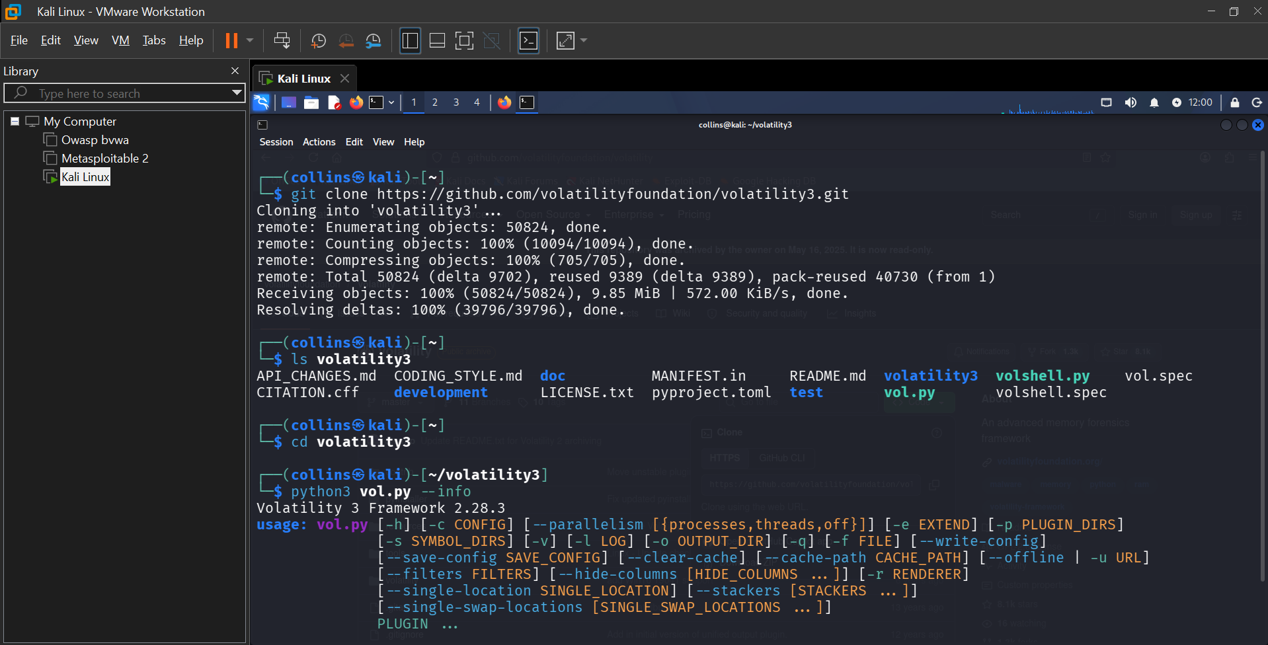
Examine the memory image methodically. Base every finding on identifiable Volatility output, including the plugin, profile, command, timestamp, record, registry path, process ID, or offset that supports it. A recovered string, process name, command, or registry key can be important, but it may not prove that a transfer completed or that a particular person performed it. Use the questions below to structure your report.
No | Investigation question | Minimum evidence to discuss
1 | What evidence image did you acquire and how did you preserve it? | Record the source, file name, file size, SHA-256 value, working-copy method, file-access precautions, and tools used.
2 | What operating-system profile and image time are supported? | Provide imageinfo output, the candidate and selected profile, the image time, and the time zone. Explain how you validated the profile.
3 | What user and account artefacts are relevant? | Identify the account or profile records examined, their SIDs or registry-hive paths, and the limit between profile evidence and proof of a person at the keyboard.
4 | What process and network evidence relates to a potential download or transfer? | Identify relevant process IDs, process names, local and foreign endpoints, connection state, and memory strings or output records. Do not contact any endpoint.
5 | What does command history show? | Use cmdscan or consoles output to identify relevant commands, the command process, path or drive references, and the timing or correlation evidence. Explain any limit on proving success.
6 | What removable-media evidence is present? | Use USBSTOR, DeviceClasses, MountedDevices, and MountPoints2 evidence as available to identify device, drive-letter, and user-profile relationships. State what each artefact does and does not establish.
7 | What File Explorer evidence supports the sequence? | Use ShellBags to identify material folder paths and recorded access or preference times. Distinguish folder-view evidence from a file-modification timestamp.
8 | What conclusion can you defend? | Create a UTC timeline and state a cautious conclusion with a confidence level and at least three limitations or alternative explanations.
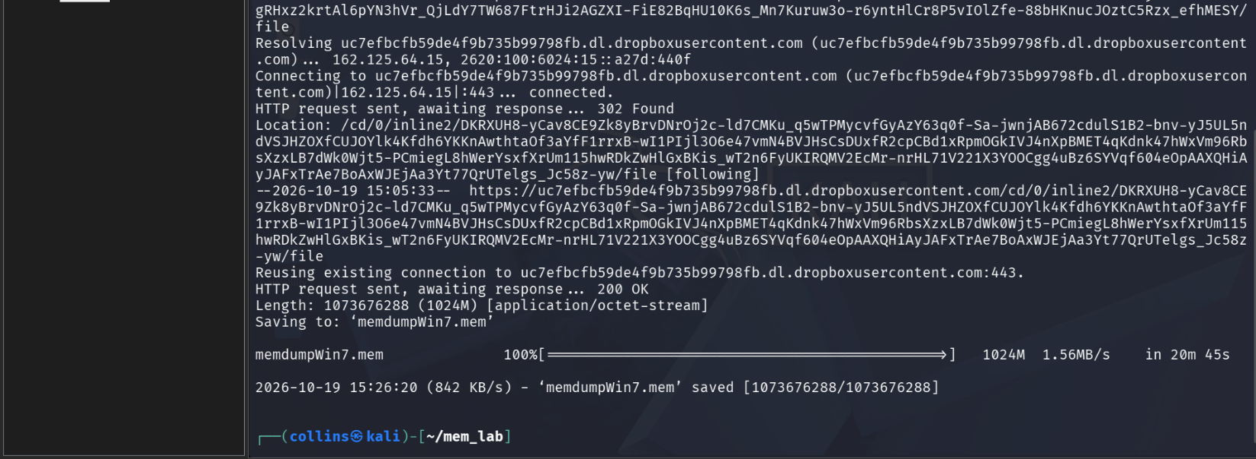
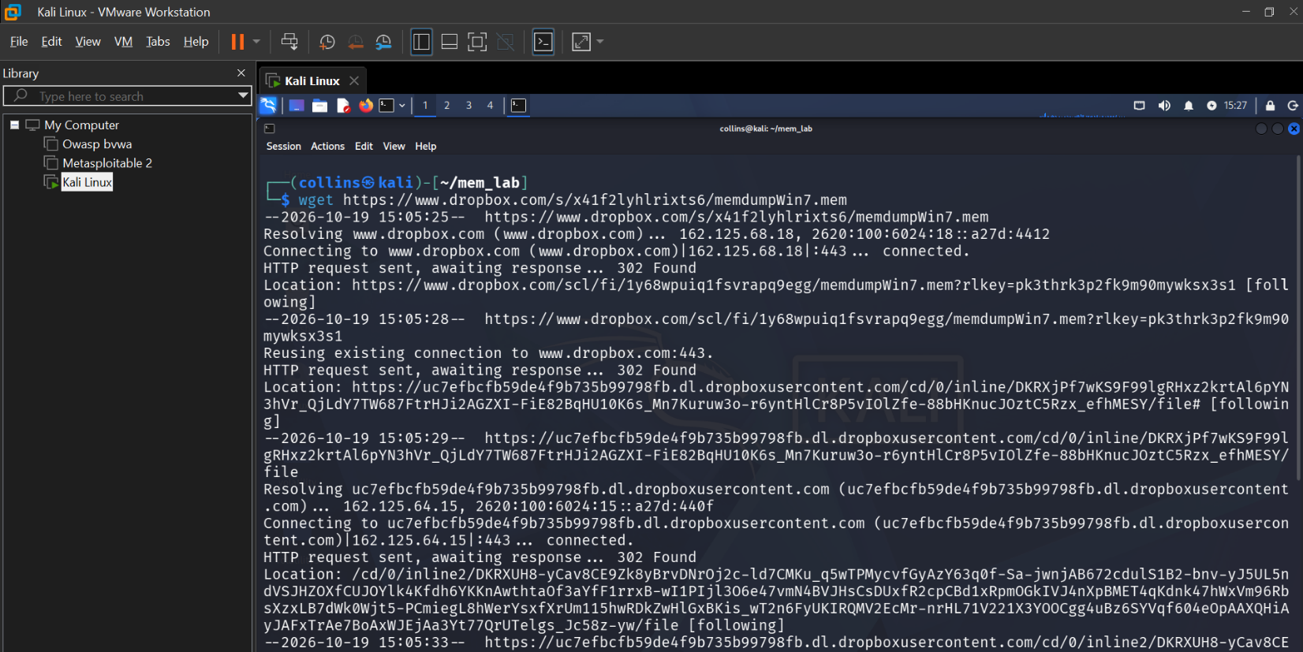

Volatility 2 examination starting points
Use the commands below as starting points. Replace <profile> with the profile you select from imageinfo and record any variation needed for the authorised lab environment. The commands guide your examination; the returned records provide the evidence.
Purpose | Starting command
Identify the image profile and capture time | python2 vol.py -f memdumpWin7.mem imageinfo
List active and residual processes | python2 vol.py -f memdumpWin7.mem --profile=<profile> pslist  python2 vol.py -f memdumpWin7.mem --profile=<profile> psscan
Review network artefacts | python2 vol.py -f memdumpWin7.mem --profile=<profile> netscan
Review command history | python2 vol.py -f memdumpWin7.mem --profile=<profile> cmdscan  python2 vol.py -f memdumpWin7.mem --profile=<profile> consoles
Locate USB and drive-mapping artefacts | python2 vol.py -f memdumpWin7.mem --profile=<profile> hivelist  python2 vol.py -f memdumpWin7.mem --profile=<profile> printkey -K "ControlSet001\Enum\USBSTOR"  python2 vol.py -f memdumpWin7.mem --profile=<profile> printkey -K "Software\Microsoft\Windows\CurrentVersion\Explorer\MountPoints2"
Review File Explorer history | python2 vol.py -f memdumpWin7.mem --profile=<profile> shellbags --output=html --output-file=shellbags.html

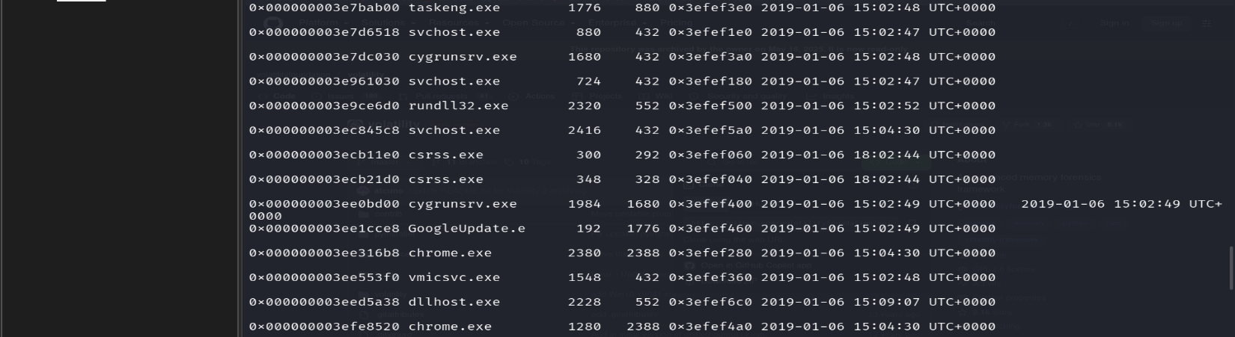
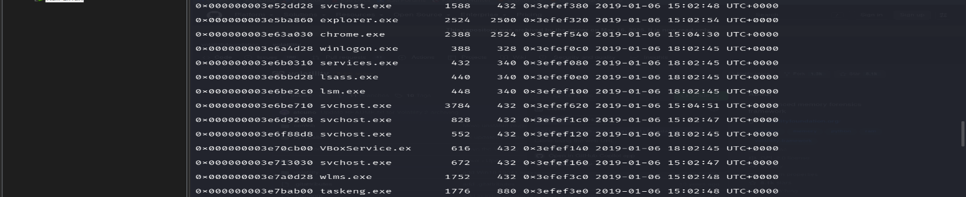
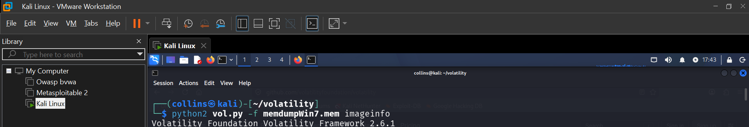
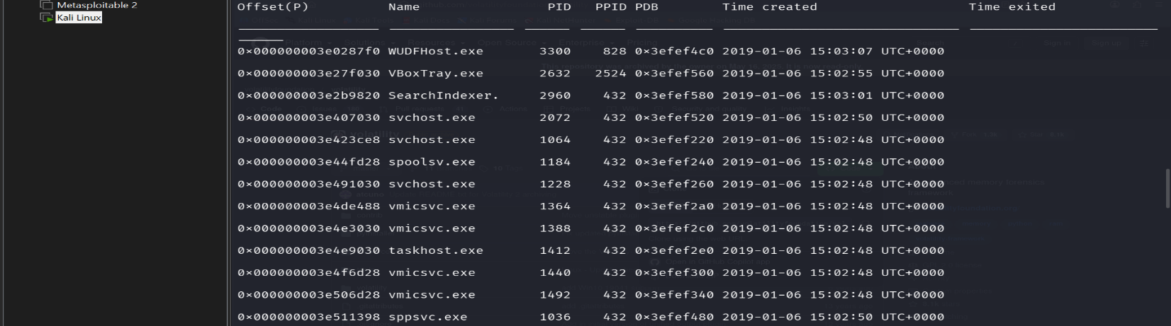
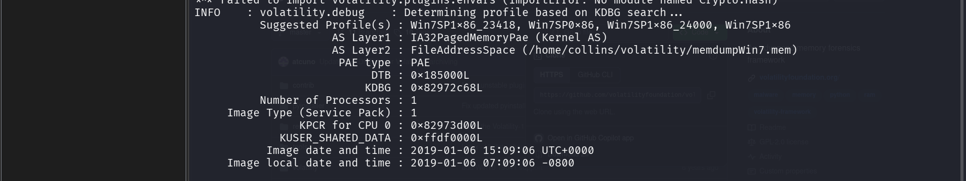
ANSWER:
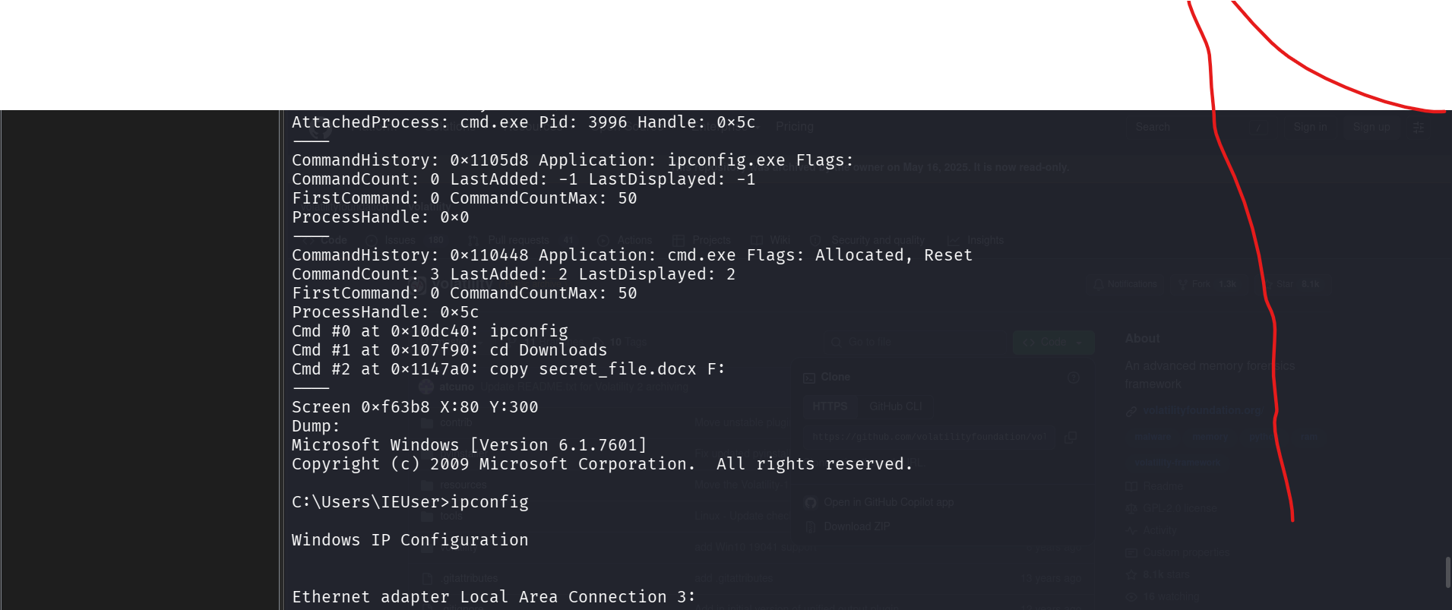
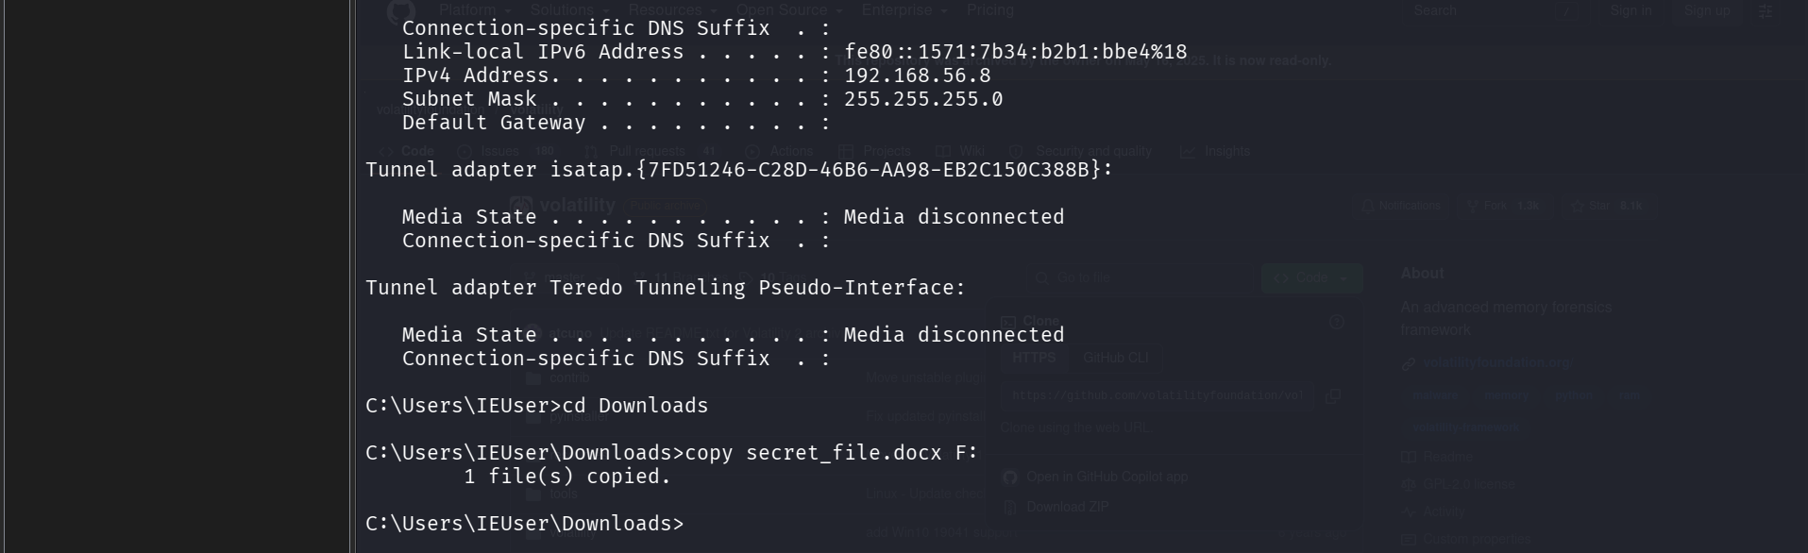
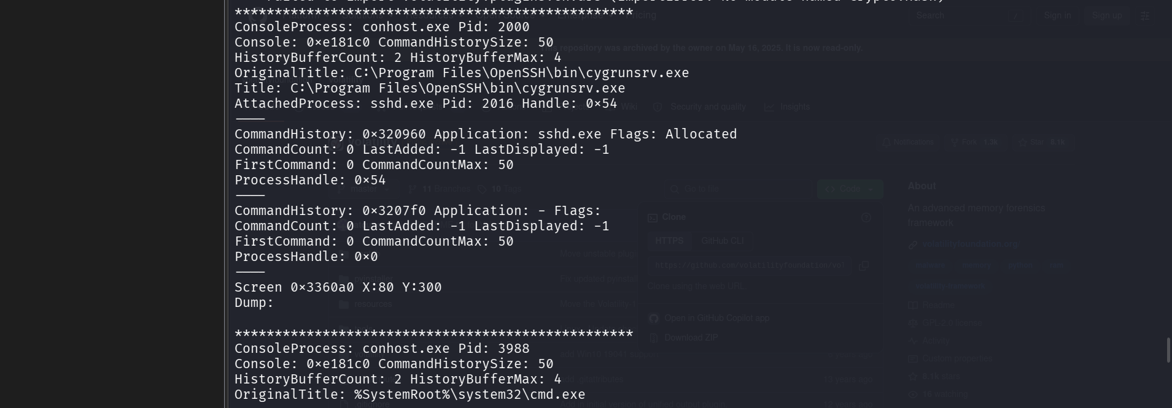
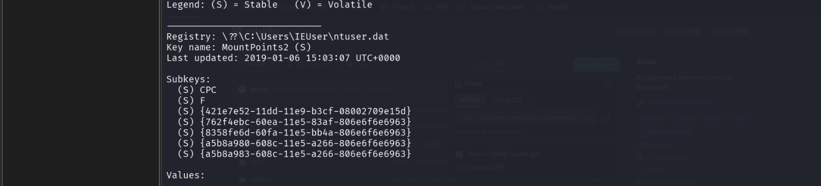
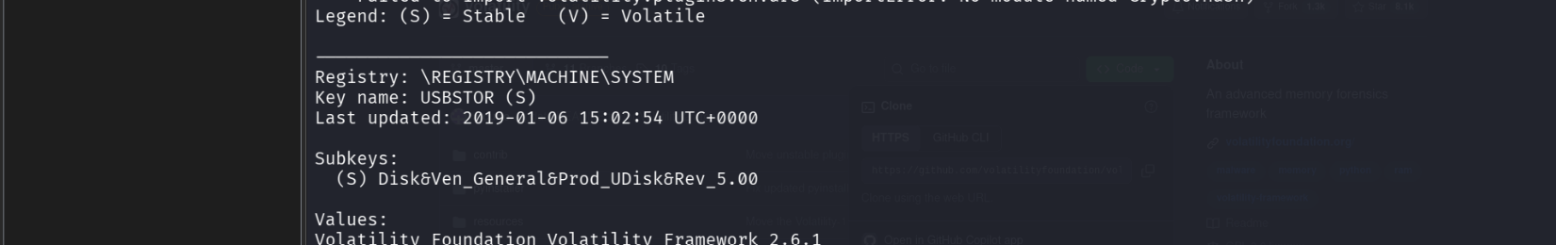
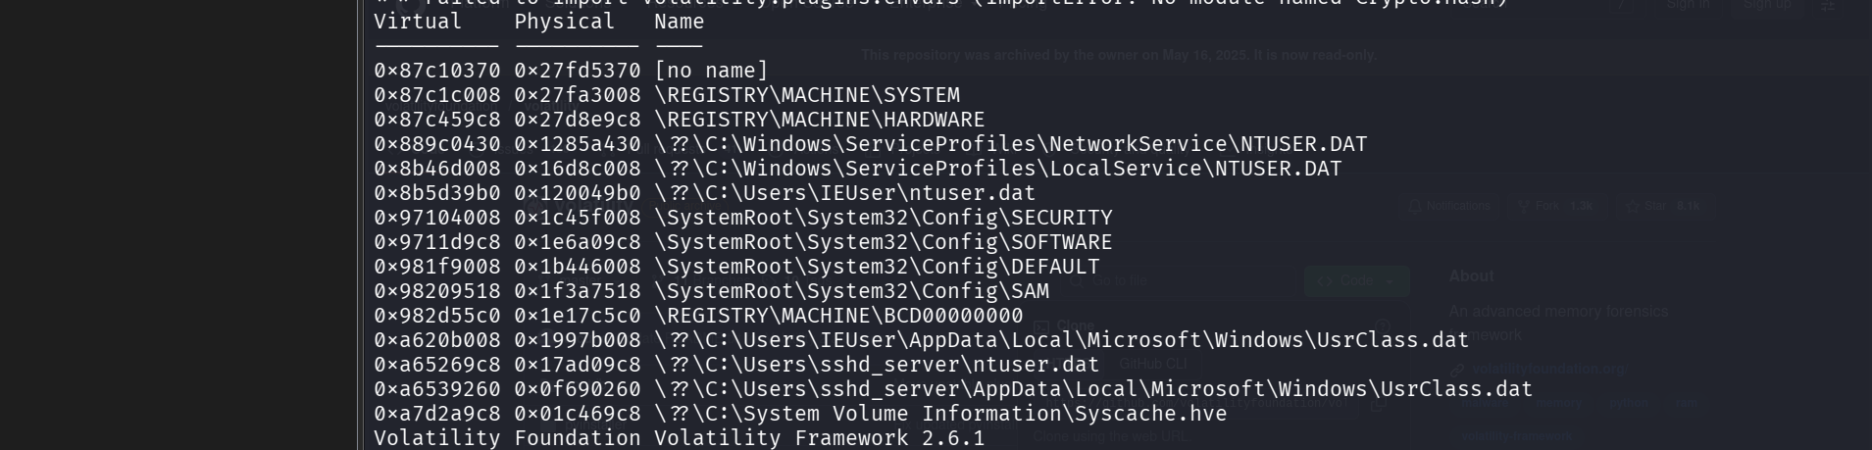

Evidence interpretation safeguards
- Validate a profile suggested by imageinfo with usable output from multiple relevant plugins and record the profile you selected.
- Treat network endpoints and process ownership as artefacts to corroborate. A closed connection or an unidentified PID needs careful interpretation.
- Assess a command-history entry with its process, timing, and related artefacts. A command string alone may not demonstrate that the copy operation completed.
- Use USBSTOR, MountedDevices, DeviceClasses, and MountPoints2 records to explain device, drive, and profile relationships. These records alone may not prove physical possession or a user identity at a particular time.
- Treat ShellBag times as folder-view or preference evidence unless other artefacts establish a different event.

Required report structure
- Case reference and student identification. Include your full name, registration number, course code, and case title.
- Executive conclusion. State the supported conclusion in a short, cautious paragraph and include a confidence level.
- Evidence acquisition and integrity. Record the memory-image source, file name, size, hash, working-copy method, and tools used.
- Method and profile selection. Explain the imageinfo result, selected profile, Volatility version, plugin commands, and time-zone treatment.
- Findings. Answer each investigation question with Volatility output, registry paths, process IDs, offsets or records, timestamps, and evidence-log IDs.
- Timeline. Present the material sequence in UTC and distinguish each observed artefact from your interpretation of its meaning.
- Attribution assessment. Explain limitations, including memory-capture timing, profile versus human identity, command success, shared access, and incomplete or overwritten evidence.
- Appendices. Include labelled screenshots, selected Volatility output, the completed timeline table, and the completed evidence log.

Timeline template
Use a completed version of this table in your report or evidence appendix. Add rows for all material events and keep the main timeline in UTC.
Stage | UTC timestamp | Evidence ID | Source artefact | Observed fact | Interpretation and limit
Browser or process evidence
Download-folder review
Removable-device evidence
Drive mapping
Command-history evidence
Supported conclusion

Evidence log template
Use an evidence log that lets an assessor locate the exact Volatility plugin, command, output, registry path, process record, or screenshot supporting each finding.
Evidence ID | Tool and plugin | Source record or path | Observed fact | Screenshot or appendix reference
E01
E02
E03
E04
E05
E06

