**Causal Interaction Annotation – draft annotation rules**

1. Interactions to which this annotation is added should be ‘interaction type = direct’ (or child term), with the exception of Ch-IP, which must follow existing limitations i.e. cross-linked data will be captured only.
2. Causality must be experimentally demonstrated in the same paper. Inferred causality, or references to external publications, should not be captured.
3. Causality will be captured at the Interaction level, using the annotation comment ‘Causality Statement’
4. Causality statements will be made using the following controlled vocabulary

activates

increases activity of (Up-regulates)

increase quantity of

increase expression of

increase expression at RNA level of

increase expression at protein level of

decreases degradation of

decreases degradation of RNA level of

decreases degradation of protein levels of

inhibits

decreases activity of (Down-regulates)

decreased quantity of

decreases expression of

decreases expression at RNA level of

decreases expression at protein level of

increases degradation of

increases degradation of RNA level of

increases degradation of protein levels of

Is required for

1. Causality statements should be made using UniProtKB, ChEBI or Ensembl identifiers as appropriate

Template

Identifier [causality statement] identifier

Identifier [is required for] the [CV term/causality statement] of Identifier by Identifier

1. When an interaction results in a PTM being added to the substrate, capture this using the following syntax

Annotation topic ‘resulting-ptm’ free text Identifier amino acid-three letter code-residue number [MOD CV term]

e.g. P12345 ser-99 O-phospho-L-serine

**Examples**

**PMID: 23706744** EBI-8764995

P48084 is required for phosphorylation of P38074 by P22204

P22204 increases activity of P38074

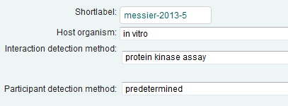

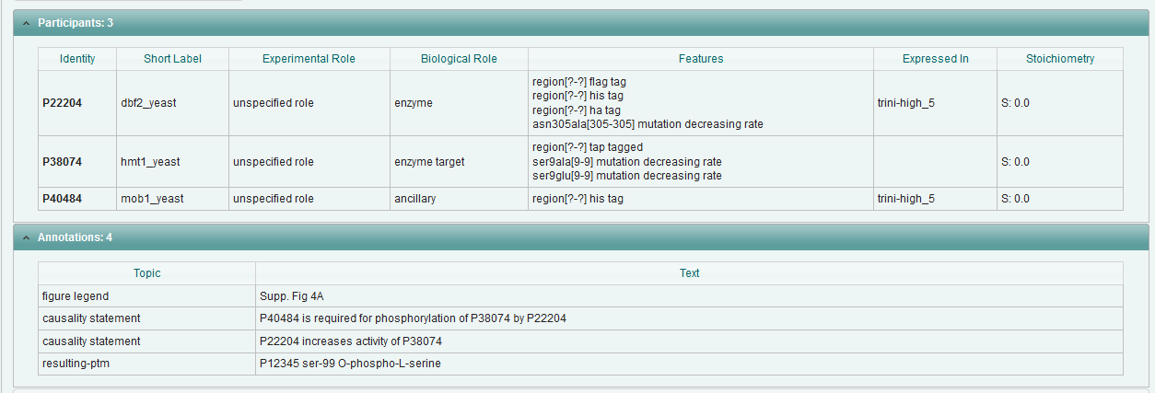

**PMID: 20478527** EBI-2678807

P11308 inhibits expression at RNA level of ENSG00000167751

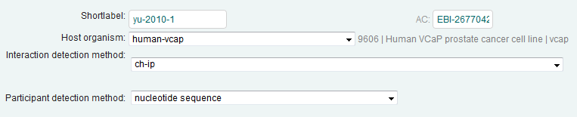

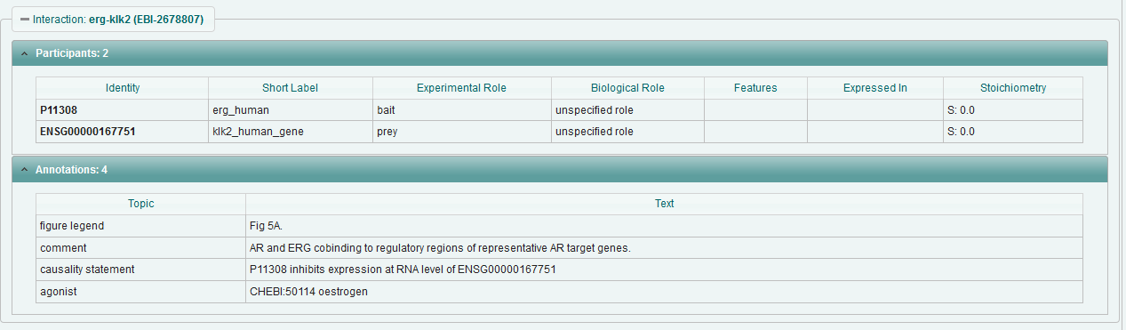

**PMID: 23910378** EBI-8795658

CHEBI:75947 activates Q86WV6

**PMID: 10390359** EBI-8764357

P27958-PRO_0000037570 inhibits activity of P19525