Dentistry Manager System – Team Report

**Introduction**

As soon as the team was declared we set up a slack group and organised a first meeting. We briefly discussed ideas and how to progress, and ultimately got stuck in. We made sure to set up a GitHub organisation and repository, as well as find good software we could all use for continuity.

Once the use case diagram was done and we were more familiar with each other, we split up and delegated tasks, such as a pair working on the next model, one of us transferring our drafted use case diagram onto a neater, digital copy and someone else reading and researching ahead to prepare the rest of us later.

When it came to coding, we once again split up, where one of us handled the database side, so the rest of us could work on the GUI directly with the java classes, without having to overload ourselves with how they worked with the server.

Despite regular meetings and continual progress, as we approached the deadline we realised the current path wouldn’t get it done in time. We had an emergency meeting and powered on. As a result of our hectic mindset and implicit stress, our efficiency took a dip due the fact we would be working on our respective tasks then either realise something else that needed to be done or someone would call on the help of another and we would branch off, forgetting what we were originally focussing on until we ‘branched-off’ back to it. After a few hours of this we began noting down things to do as they arose on a white-board and pad of paper, listing them under each person as task to do. In hindsight, we should’ve used Trello or some similar software.

Use case diagram

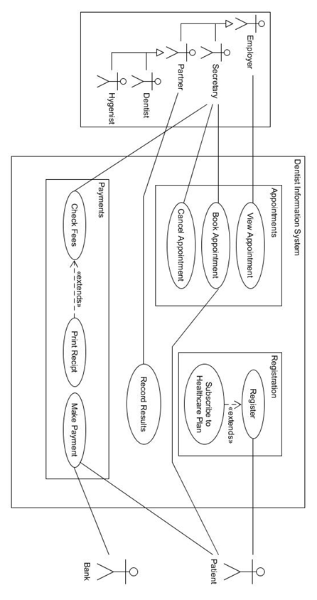

Information model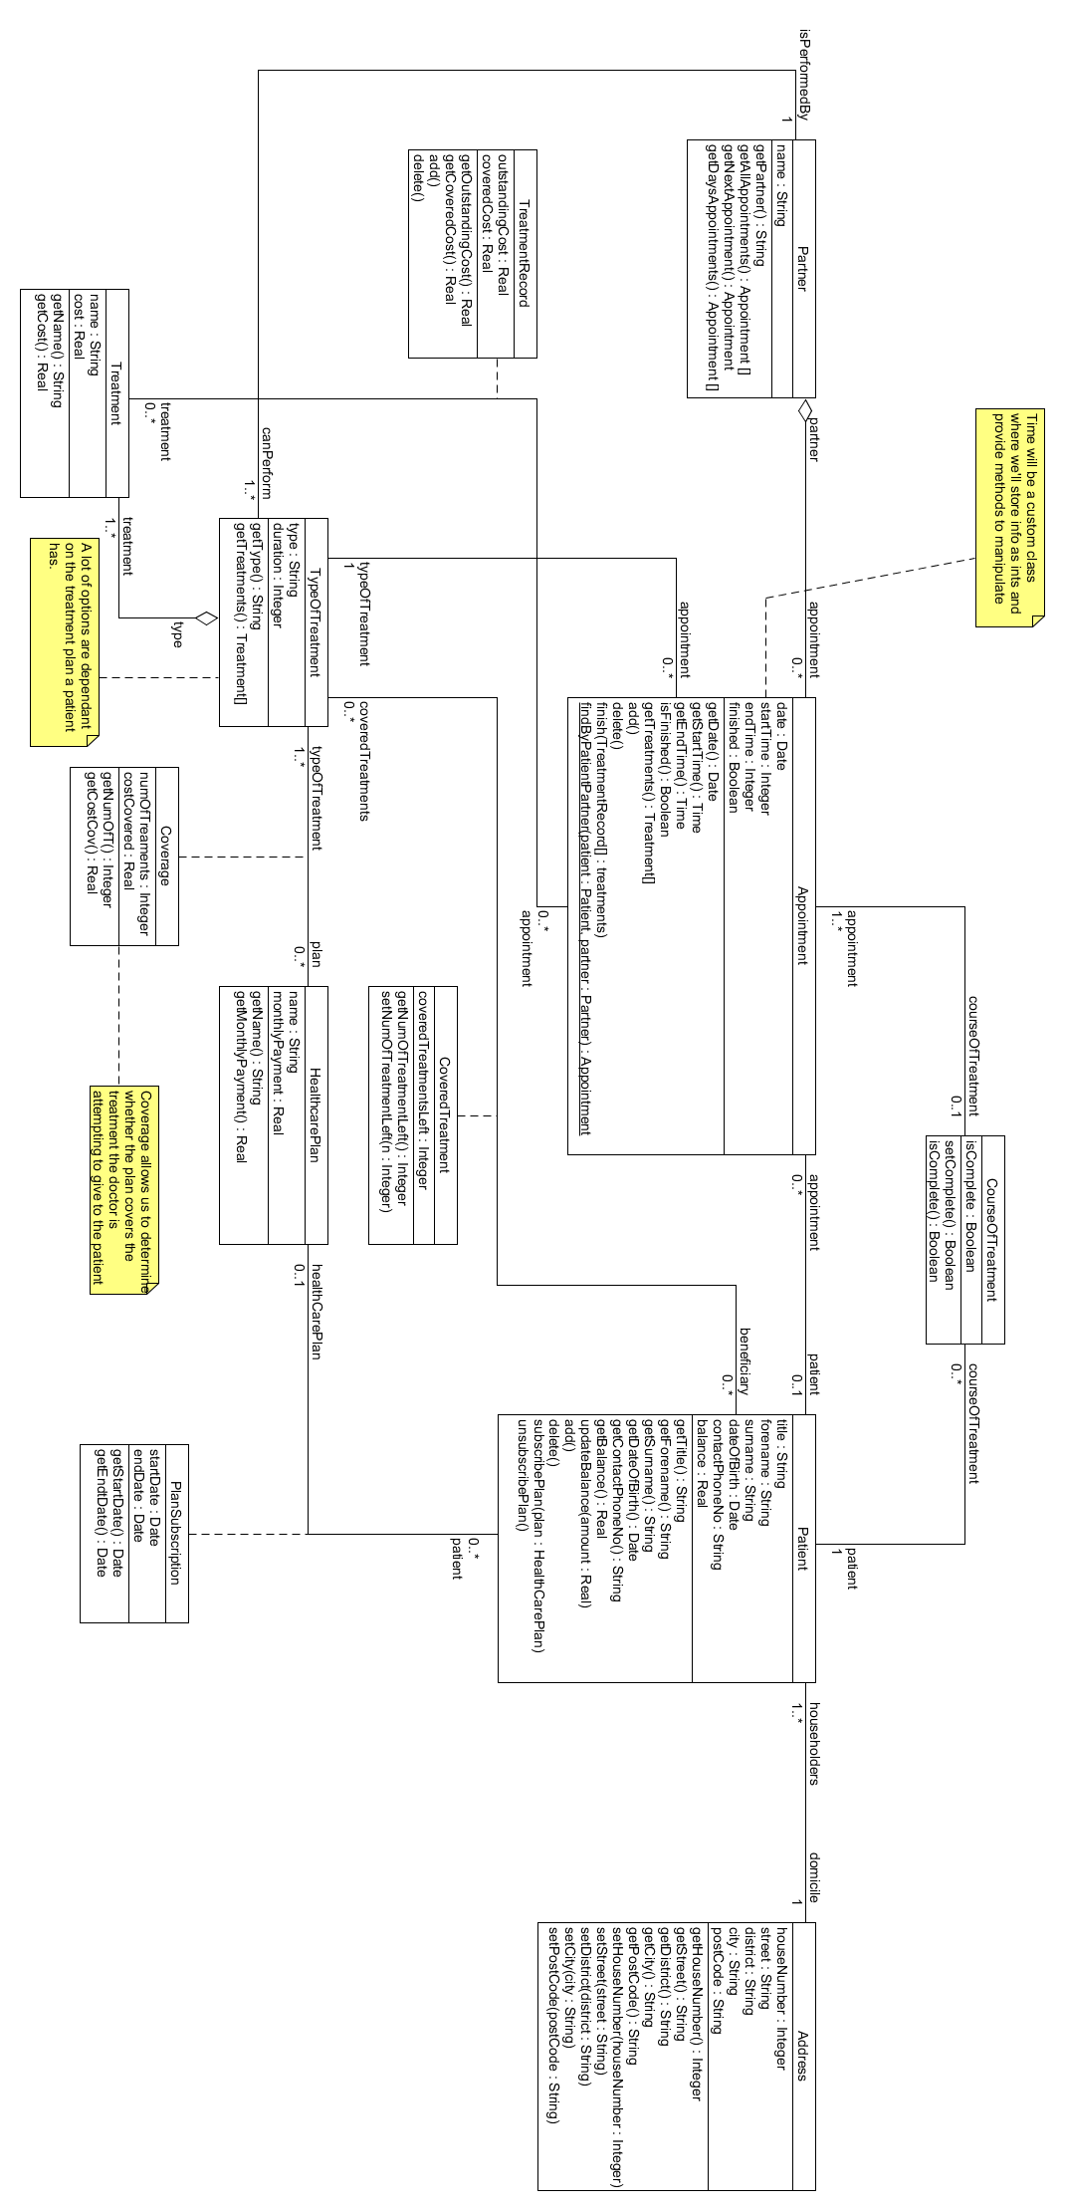

Normalised data model

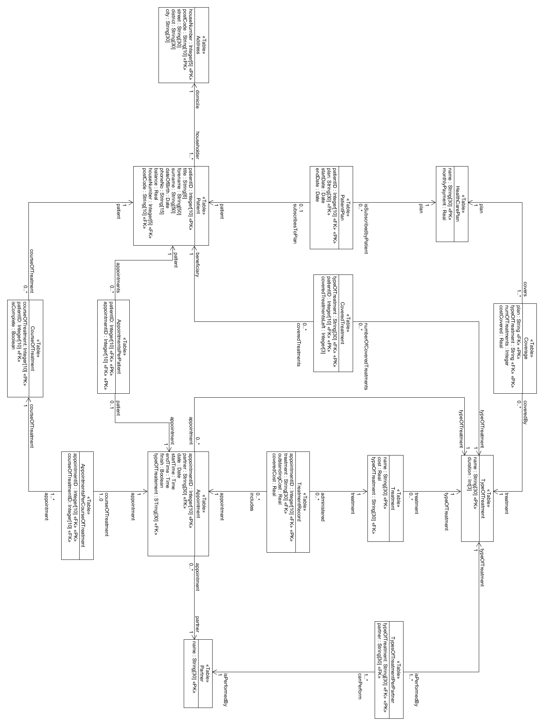

Secretary UI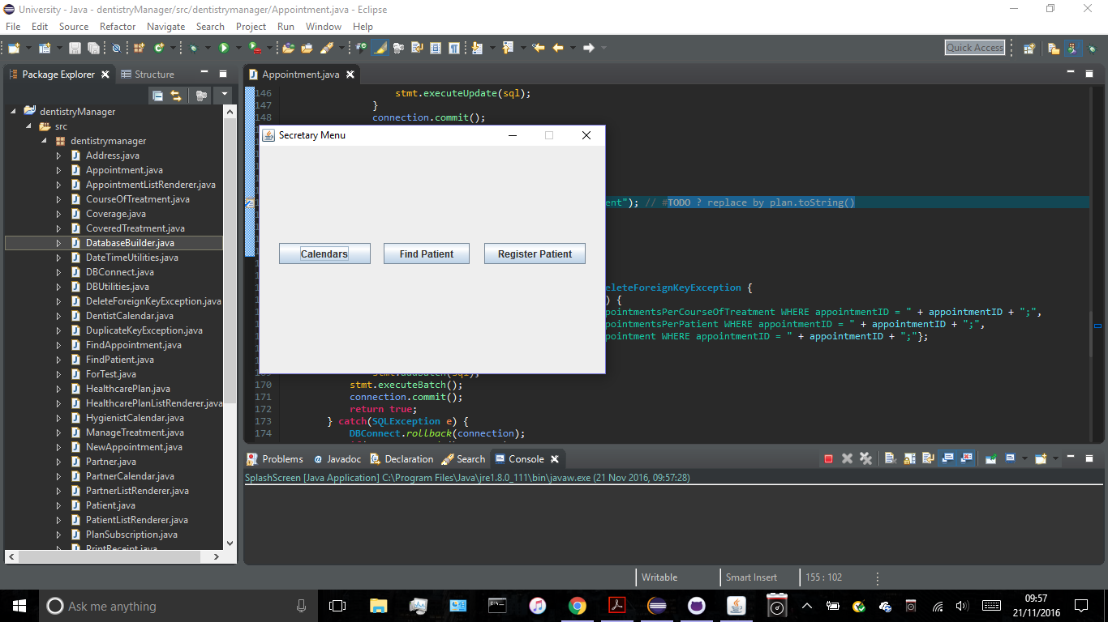

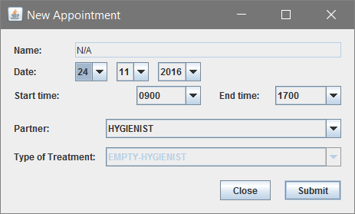



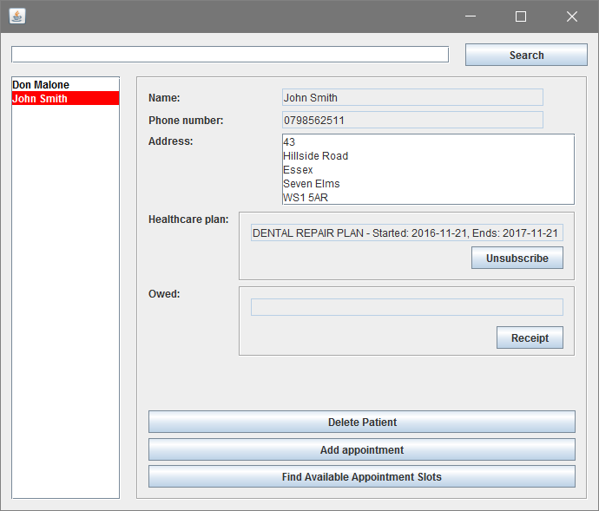

Partner UI

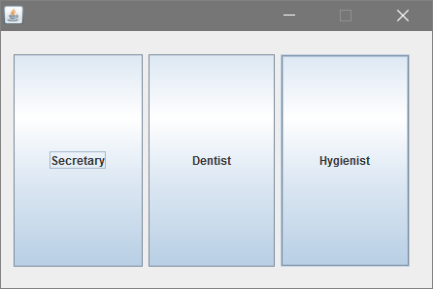

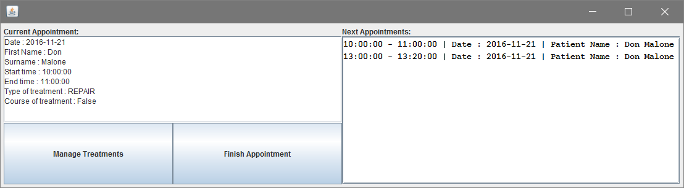

**Query Processing Evidence**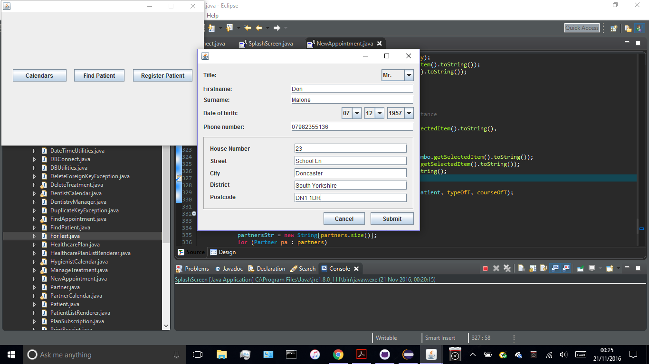

*Register a Patient:*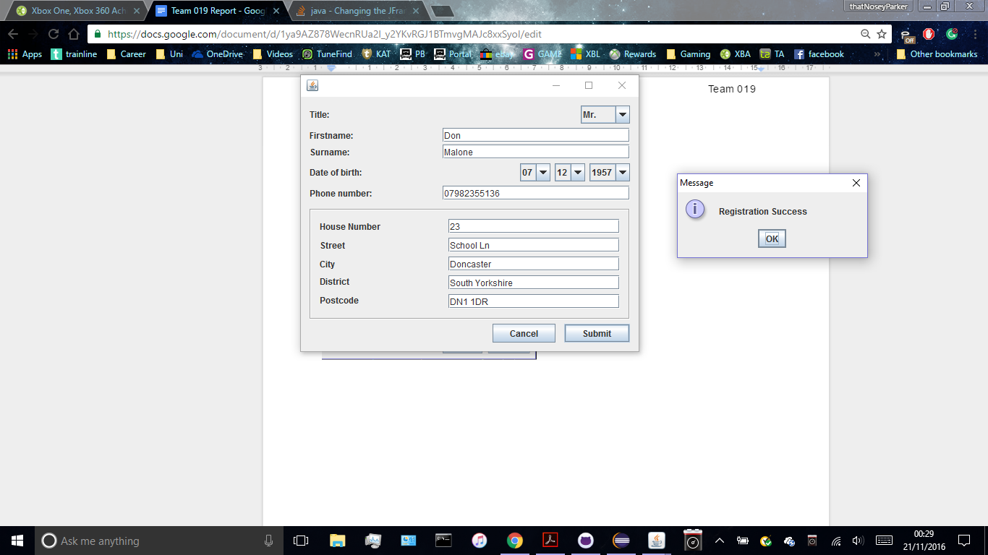

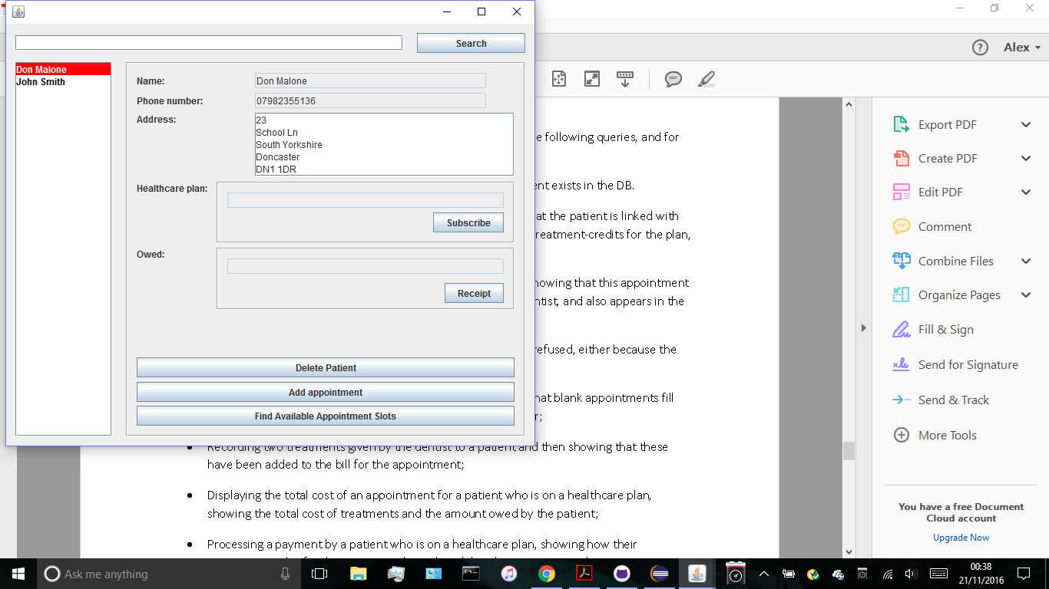

*Subscribing to a health plan:*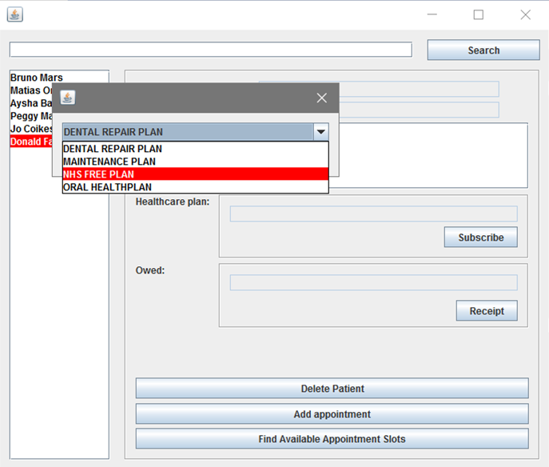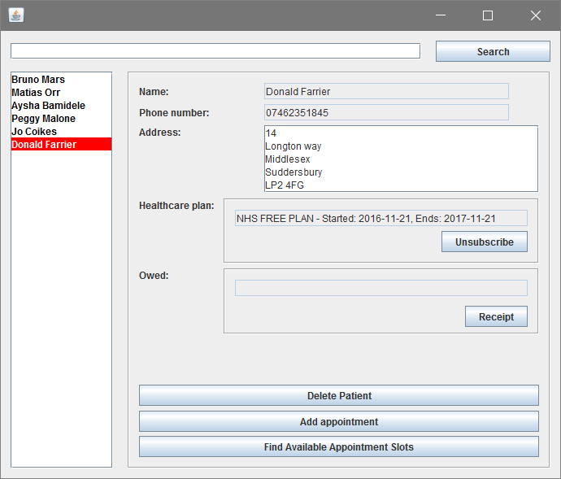

Demonstrating creation of Appointment :

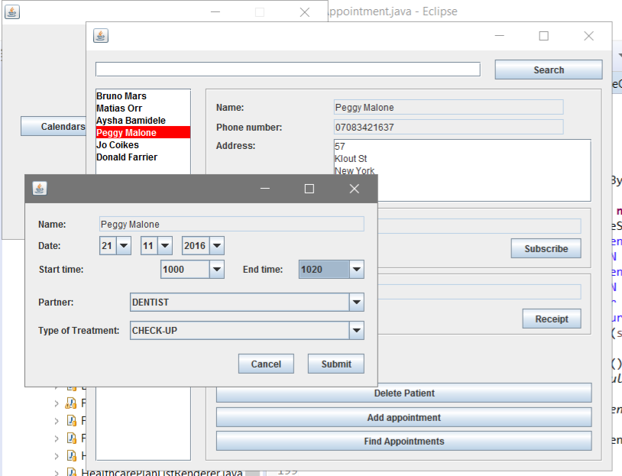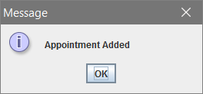

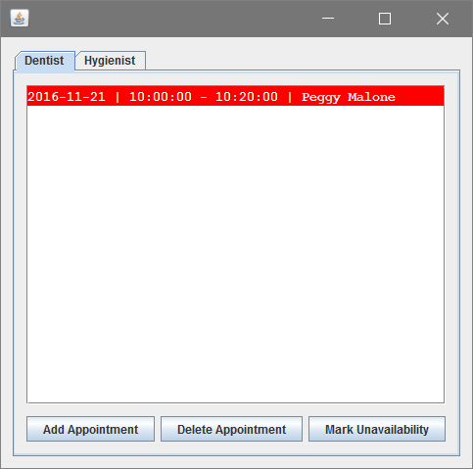

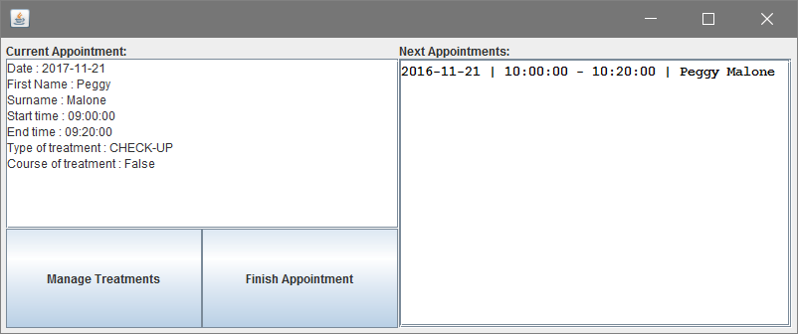

Don’t allow two appointments at the same time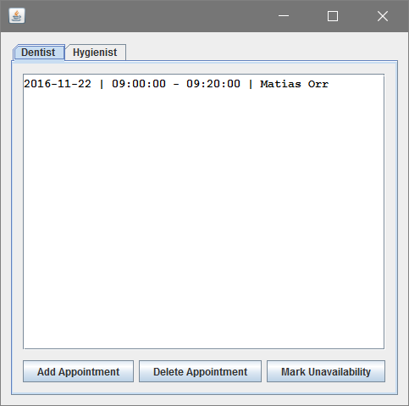

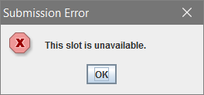

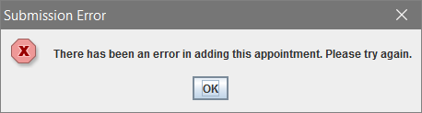

Demonstrate two treatments administered by the dentist, and that these were added to bill for appointment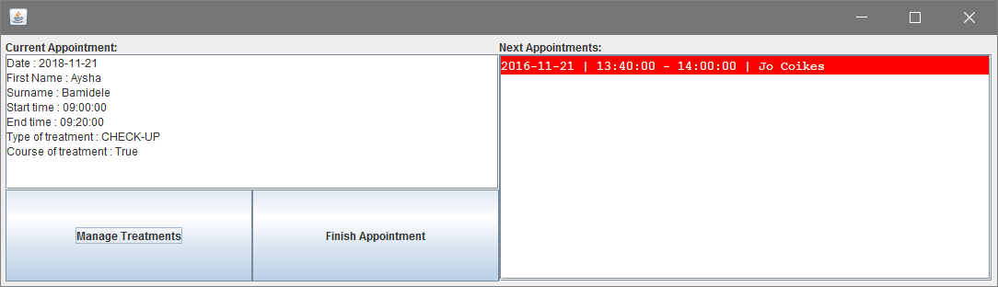

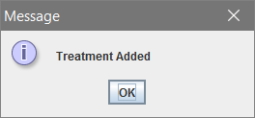

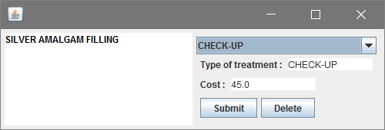

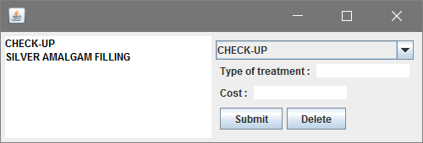

Demonstrate booking of 2 days of holidays

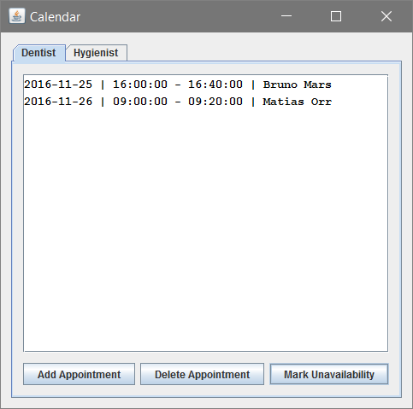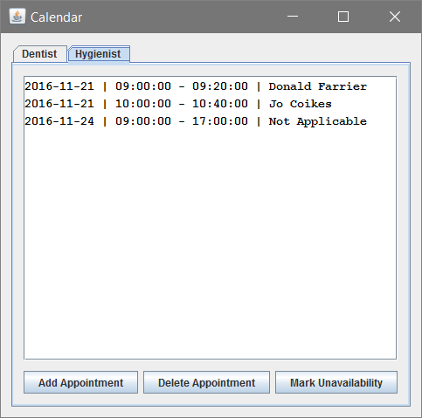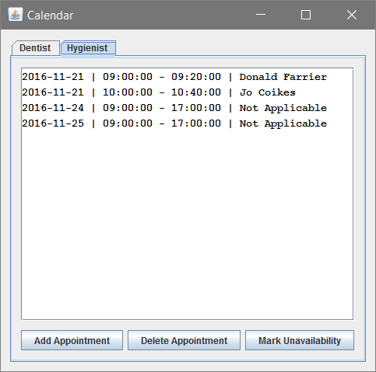

Demonstrate query processing altering the database using a command line database viewer

The real database can be obscured by our UI. This example will demonstrate the query’s effect on the database itself, proving that we are altering the database through our code.

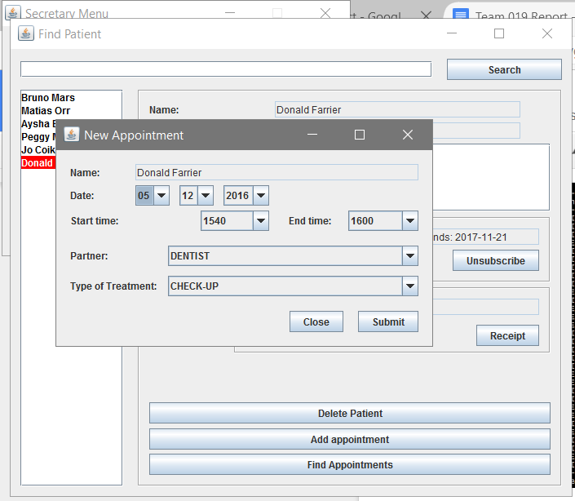

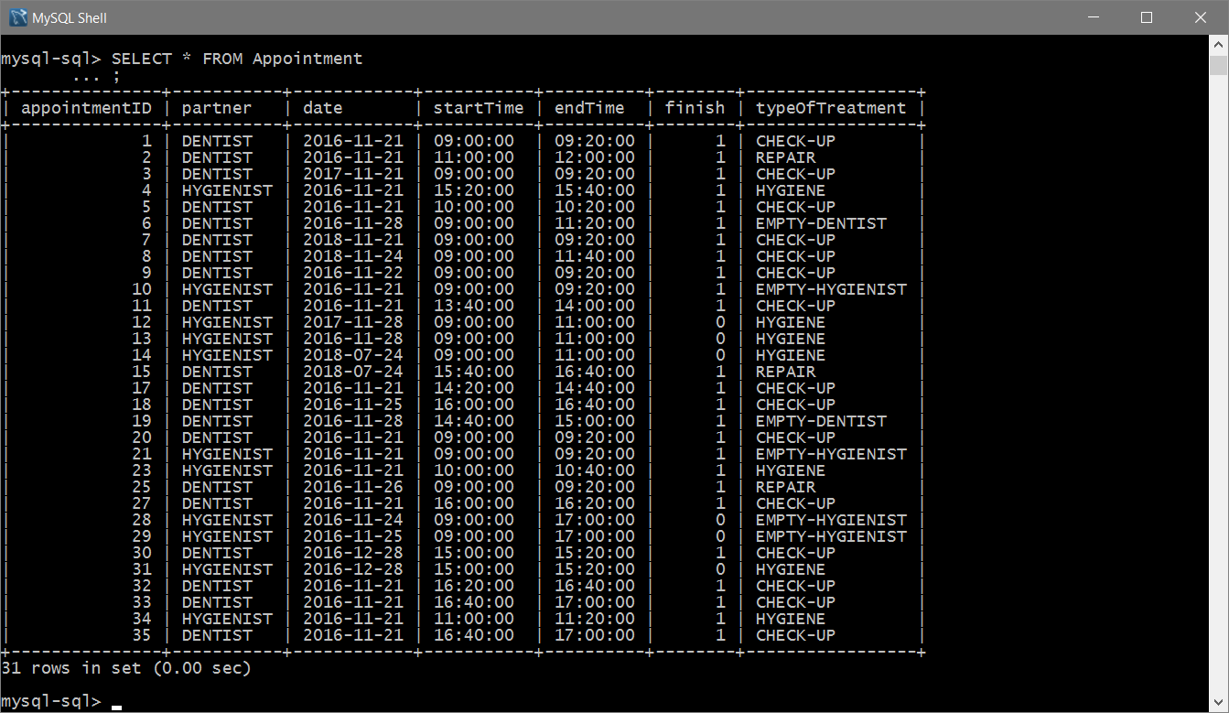

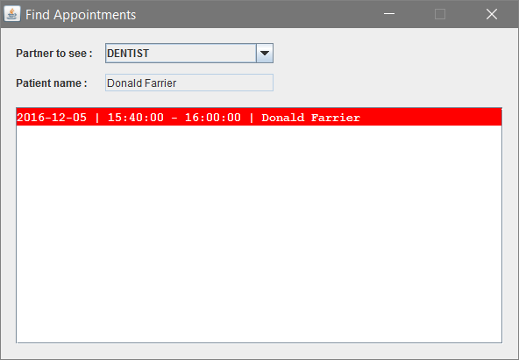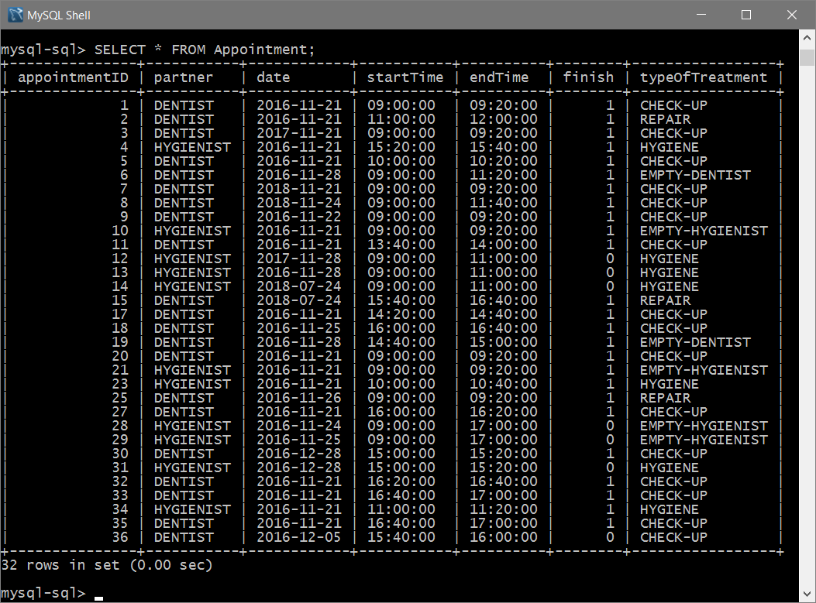

Demonstrate the processing of payment

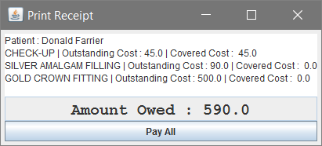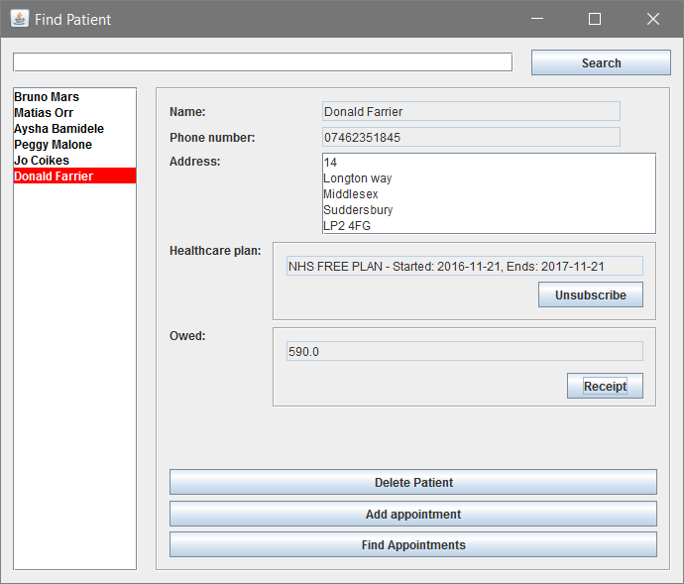

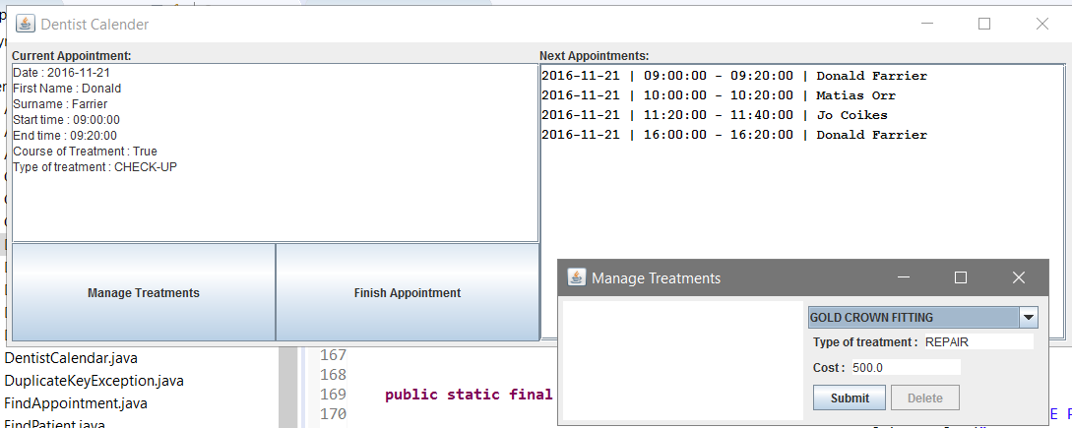

Then the Dentist has to push the button to finish the appointment. As the Gold Crown Fitting isn’t covered on the NHS free plan, the amount owed goes up.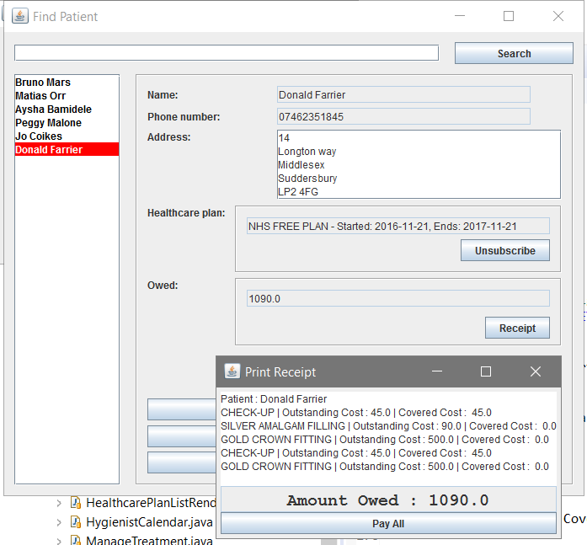

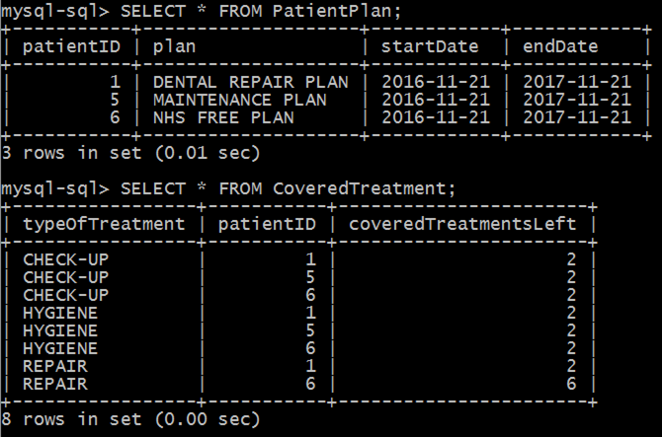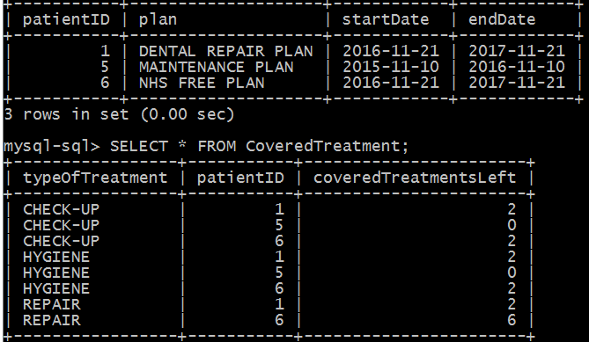

Proving HealthCarePlan has a period of validity, credits and that it updates when expired.

These are the database tables of

Effort Declaration

Nuno, Joe and I (Alex) communicated constantly via Slack, occasionally Facebook, and during meetings. We delegated tasks, overviewing each other’s work and providing feedback on said work. We also openly engaged in frequent discussions on the best course of action or ‘correct answer’ until we were all in agreement on the conclusion. We ensured to meet at least twice a week to present what work we had done and discuss our next move. Sebastian was very difficult in that he rarely got involved in Slack, only attended 2 meetings total and essentially took a back seat for the project. On the Friday before he reappeared and started to get involved.

|  |  |
| --- | --- |
| **Name** | **Contribution** |
| Alex Parker | Use case diagram  Oversaw/Edited Information Model  UI Design  Refactoring  UI Creation/Implementation  UI Linking/Controlling code  Team Report |
| Joe Mason | Information Model  Data Model  UI Creation/Implementation  UI Linking/Controlling code |
| Nuno Frias | Use case diagram  Information Model  Data Model  MySQL methods  UI Initial design  UI Linking/Controlling code |
| Sebastian Bastidas | UI design  UI Linking/Controlling code  Team report |

|  |  |
| --- | --- |
| **Name** | **Percent of Effort** |
| Nuno Frias | 136 |
| Alex Parker | 117 |
| Joe Mason | 117 |
| Sebastian Bastidas | 30 |