# **Azure Cloud App setup**

## **Prerequisites**

Setup an Azure for Students (not Azure for Students Starter) account. If based in Ireland at time of signup: <https://azure.microsoft.com/en-ie/free/students/>

## **2. Create a new Azure Web App**

1. Login to your account: <https://portal.azure.com>

2. Click the App Services link

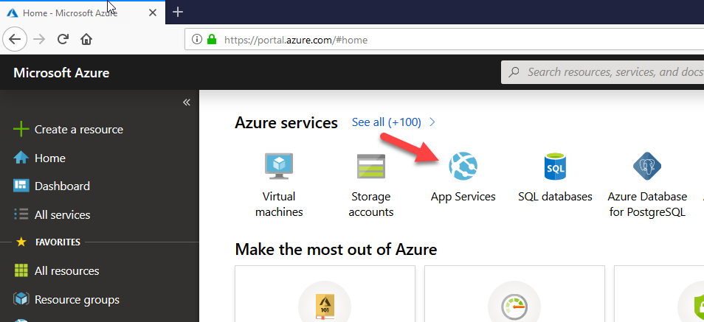

2. Click + Add to start creating a new app

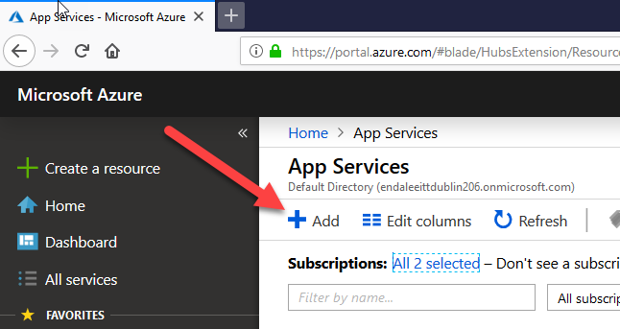

3. Choose Web App

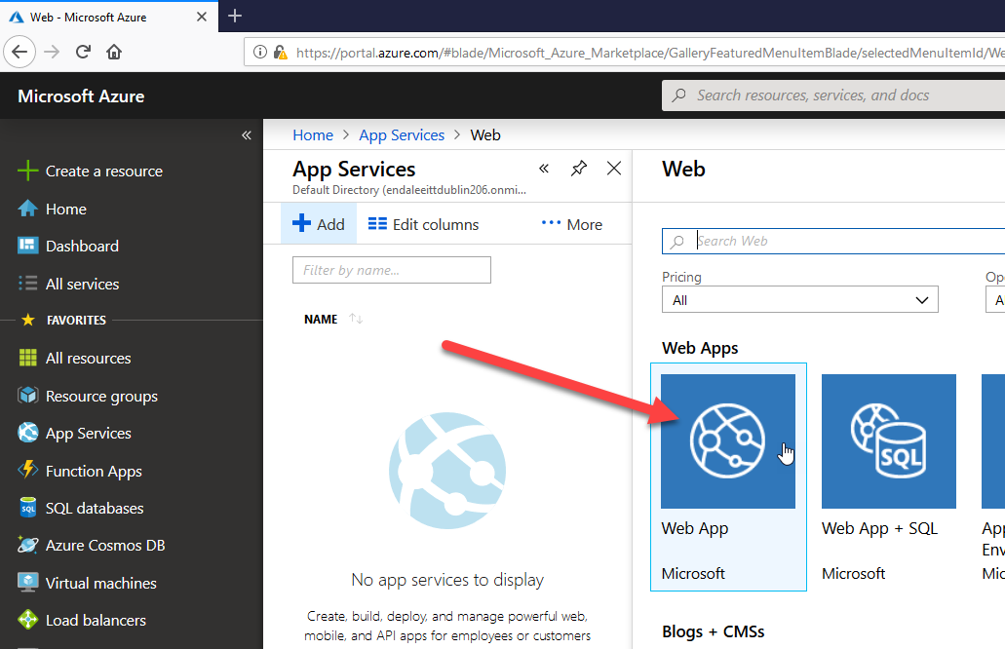

4. Click the Create button (bottom of page)

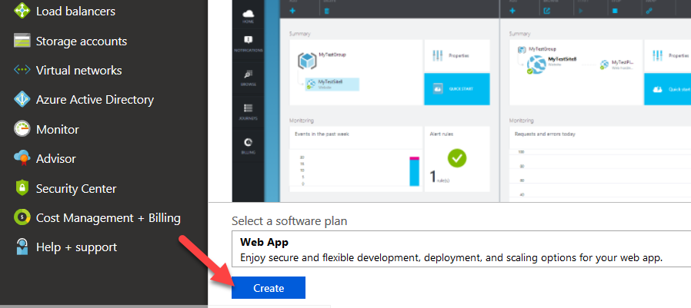

5. Configure your new Web App – prove a unique name and use settings 2 – 5 below:

**Note: do not click create yet!!**

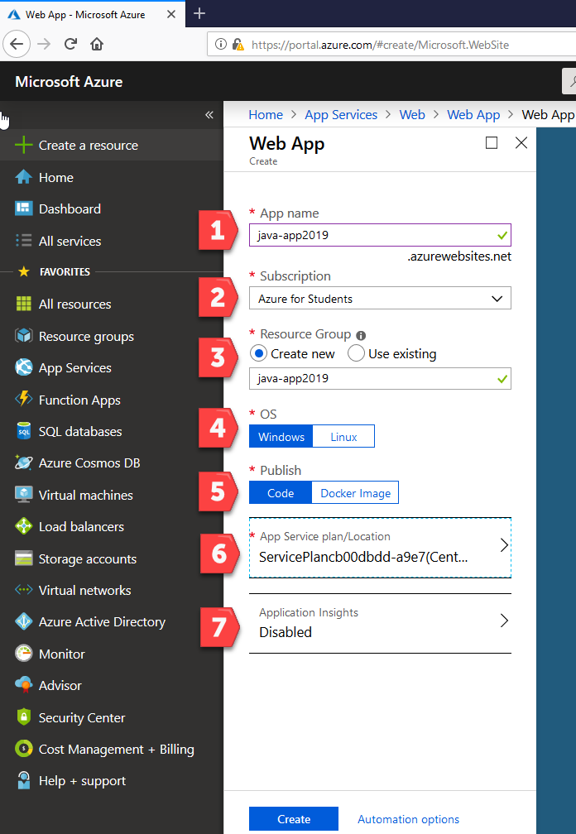

6. Choose a Service Plan/ Location. See arrow 6 above

click the link (1) and then Create new in the App Service plan section:

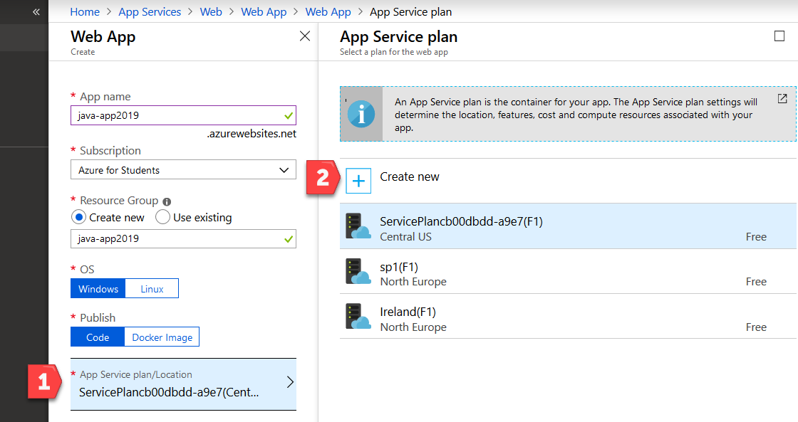

Give the new service plan a name, choose North Europe for location, and a free pricing tier:

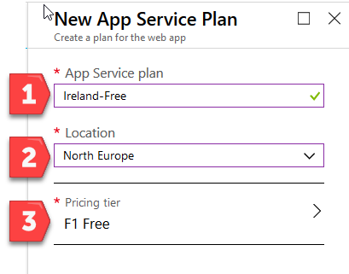

7. Disable Application Insights and click the Create Button.

8. Wait for the Web App deployment to complete:

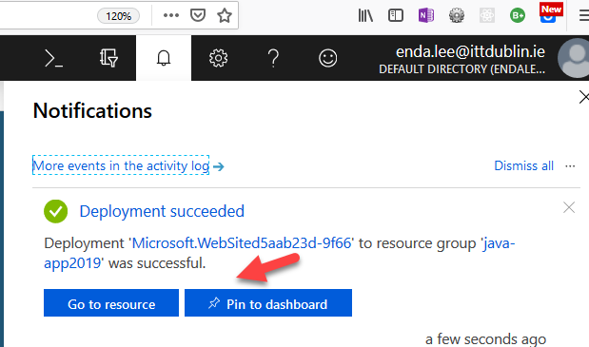

## 2. Modify the Application Settings

1. Go back to the Home page and choose App Services again. You should see your newly created app, similar to below. Click the App name to open:

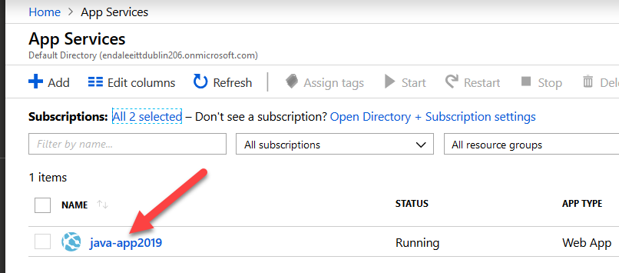

2. Open Application Settings

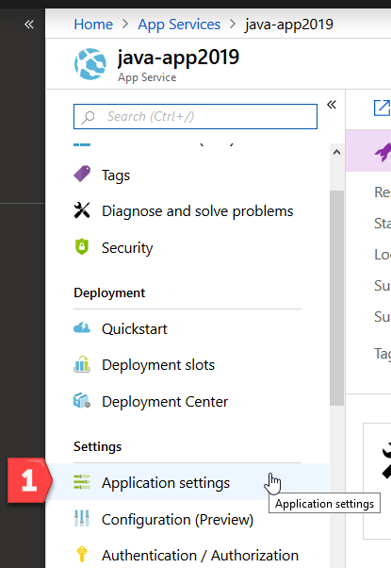

3. Configure the App for Java and Netty, then save:

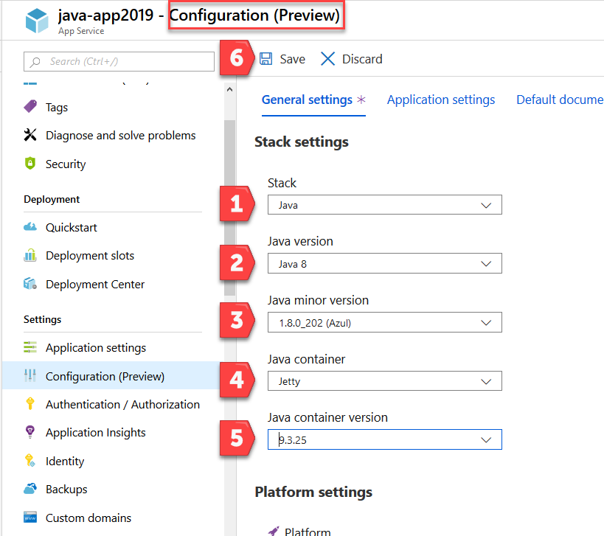

4. The application configuration is now complete

