# **Create a Java Web App and Deploy to Azure**

## **1. Open PowerShell or CMD in your java-apps folder.**

Easiest method is to open the folder in Explorer, then press shift + right click to see this menu (then chose ‘open PowerShell window here’):

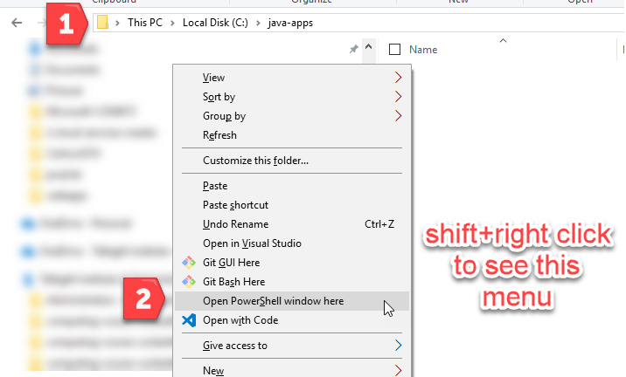

## **2. Use Maven to generate a Vaadin Java App**

**mvn archetype:generate -DarchetypeArtifactId="vaadin-archetype-application" -DarchetypeGroupId="com.vaadin"**

When prompted, enter values for groupId, artifactId, and package. *Press enter to except defaults for other options.*

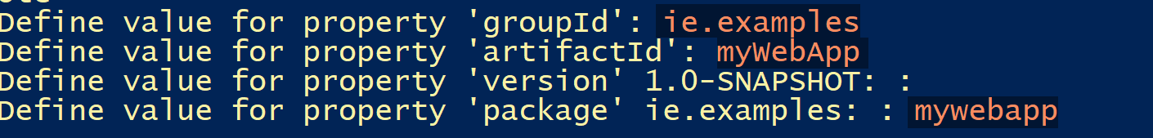

You should see ‘build success’ when completed:

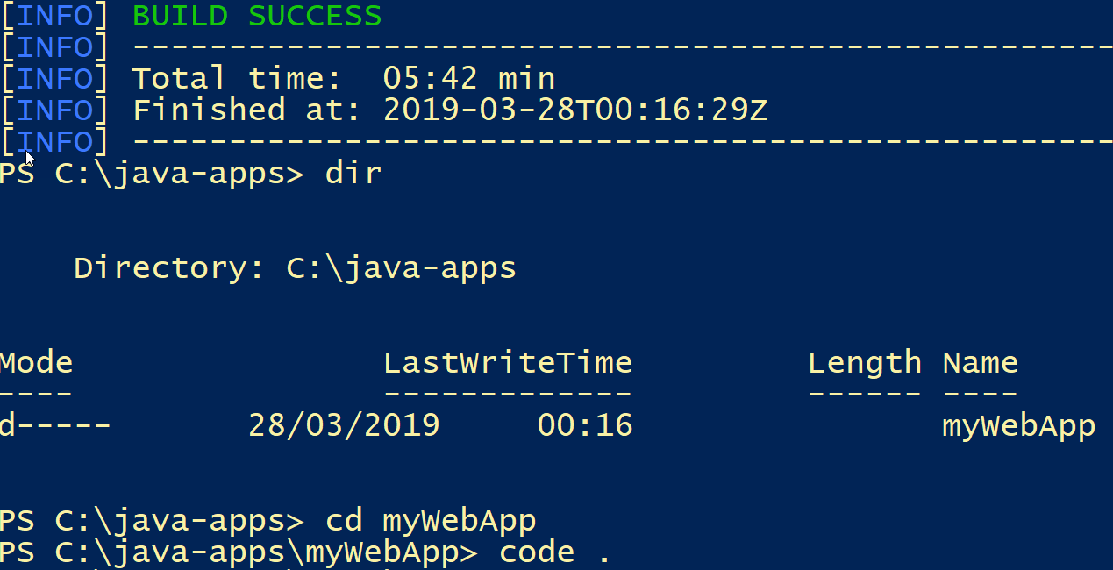

Open the new app folder in VS Code.

## **3. Build and Run the Application**

Open a terminal in VS Code and enter mvn install to build the web app

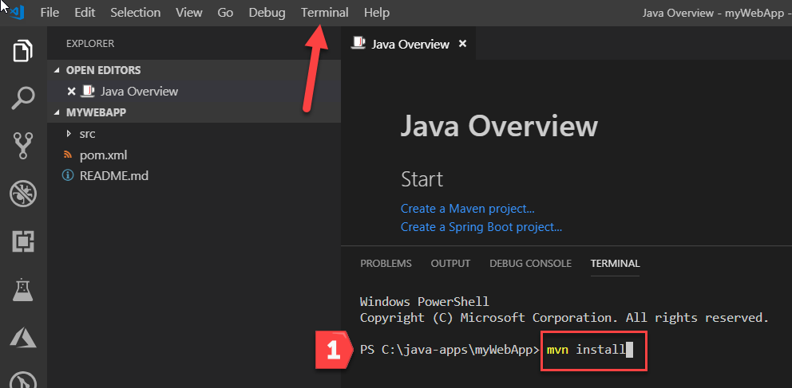

If the build succeeds, start the application using mvn jetty:run

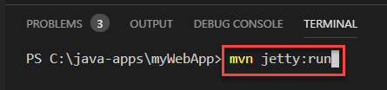

After the command completes, you should see:

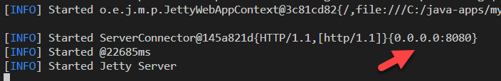

Open <http://localhost:8080> in a web browser to see the result:

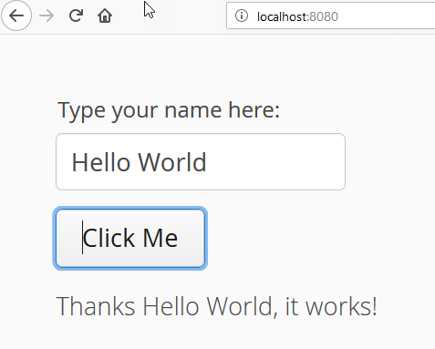

## 4. Deploy the Application

1. First locate the WAR file in the target folder of your application.

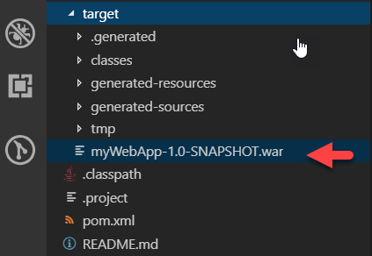

Rename to **ROOT.war**

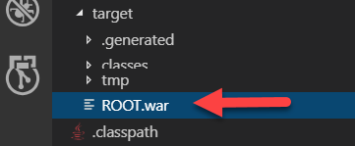

2. Configure Deployment Options in the Azure Web App. Open the Application in the Azure Portal and select from the options:

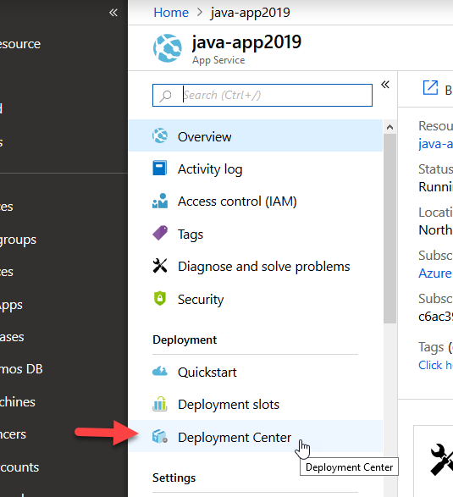

Choose FTP from the options, then click Dashboard

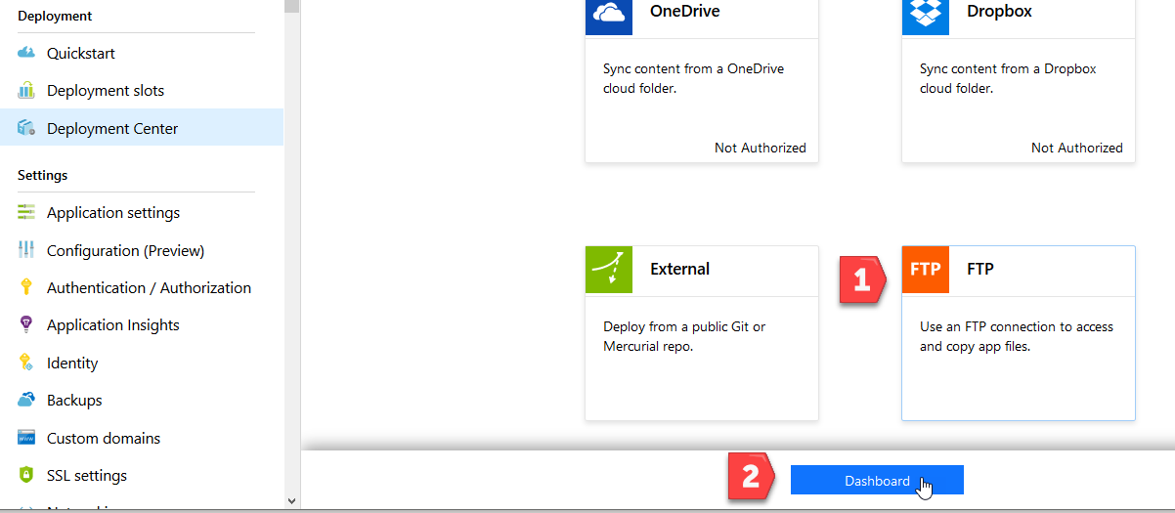

Configure User Credentials – a username and password. Copy the FTPS endpoint address and note the full username (red box):

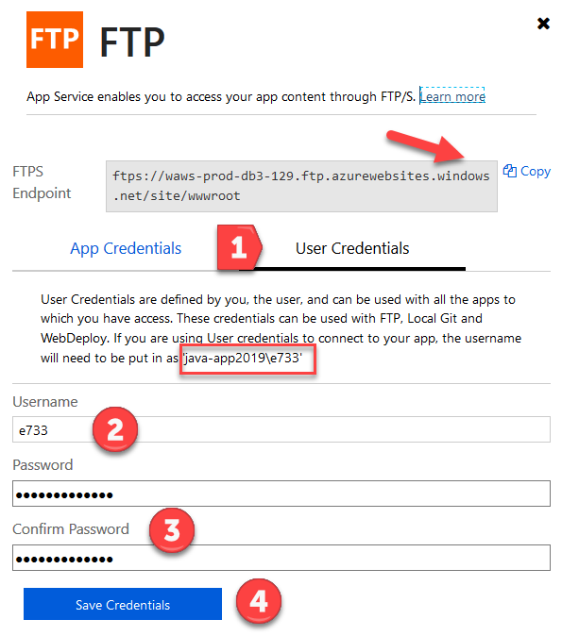

3. Connect to the App via FTP

Use FTP client such as WinSCP, to connect. Download from <https://winscp.net> Install with defaults the configure the connection:

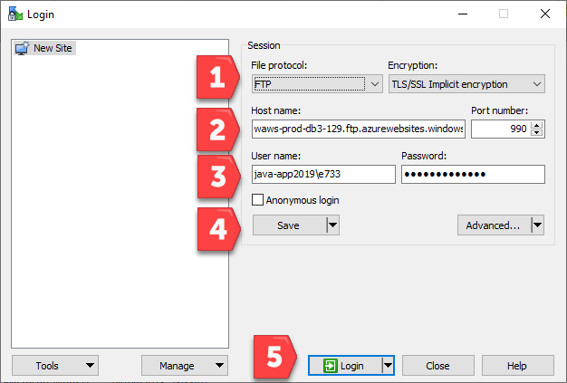

Save the site then Login. The FTP connection will open and display the Azure Web App files:

Navigate to the /site/wwwroot/webapps/ folder on the remote site and copy ROOT.jar:

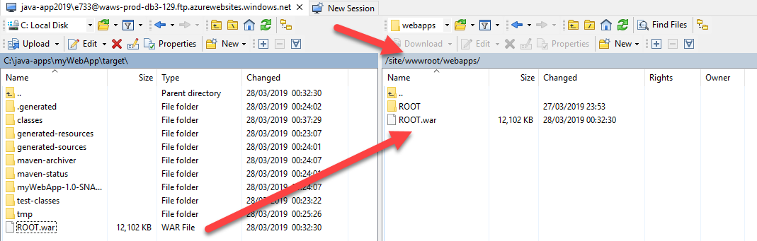

## 5. Test the Application

Open the Azure Web App address in a web browser

