**Classification and use of topological data**

By V. A. Blatov, D. M. Proserpio and Robert. M. Hanson

**1. Introduction**

Raw crystallographic data obtained from experiment or theoretical modeling contain no information on the crystal structure connectivity. However, this information, which might describe all sorts of interatomic bonding, is crucial for many tasks of crystal chemistry and materials science, such as classification, comparative analysis, modeling of crystal growth and assembling, as well as search for correlations among crystal composition, structure and properties. Similar to molecular graphs, which are widespread in organic chemistry, crystal structure can be represented as a three-periodic graph, which is usually called a *net* (Delgado-Friedrichs & O’Keeffe, 2005; Delgado-Friedrichs *et al*., 2005). Unlike molecular graphs, nets are infinite and require special methods of description. Such descriptions have become increasingly common in routine crystal structure determinations and usually follow the conventional crystallographic description, which includes atomic coordinates, space group, unit cell dimensions, and other geometrical information, but does not concern the structure connectivity. Many topological descriptors have been proposed for nets; all of these descriptors are determined from the initial crystallographic data using algorithms. Software implementing these algorithms (Delgado-Friedrichs & O’Keeffe, 2003; Blatov *et al*., 2014) has made topological analysis available for the general crystallographic community and has already led to the development of special databases (O'Keeffe *et al*., 2008; Blatov *et al*., 2014) that collect the topological parameters of crystal structures. This work will be facilitated by an extension of the CIF format that makes it possible to store topological information along with a crystal structure and to describe the crystal architecture at different levels of organization.

Although the core CIF dictionary contains some topological information in the CHEMICAL_CONN, GEOM_BOND, and GEOM_CONTACT categories, this information is limited and does not cover all topological aspects of a crystal. The core CIF dictionary does not have the ability to describe a plethora of non-valence intra- or intermolecular interactions (hydrogen bonds, halogen and other specific bonds, van der Waals interactions, *etc*.). Moreover, structures that contain polyatomic building units, such as molecules, metal complex groups, clusters, *etc*., can be simplified to underlying nets, which bear the general topological motif of these units, and these nets should also be formalized in an appropriate format. The topoCIF dictionary solves all of these issues, making the exchange of the topological information easier.

**2. Dictionary design considerations**

**2.1 Overall format** The topoCIF dictionary can be expressed in either CIF 1 or CIF 2 format. Where there is a difference, it is in the use of CIF 2 lists for just a few data items. The discussion below lists the CIF 2 data keys; ⱡ indicates the availability of CIF 1 equivalents, which are discussed where appropriate.

**2.1 Categories and scope**

The topoCIF dictionary contains categories for the description of connectivity and topological properties of periodic nets. Since the corresponding terminology is still under development, only conventional terms and descriptors defined by Delgado-Friedrichs & O’Keeffe (2005) and Blatov *et al*. (2010) are included. The TOPOL_ENTANGL category has been left empty until the terminology on entanglements gains consistency. The categories can be divided into two groups: (i) descriptors of crystal structure connectivity, and (ii) descriptors of topological properties of a periodic net. The descriptors of the first group can be computed directly from the initial crystallographic data; the descriptors of the second group are determined based on that connectivity information. Thus, the topoCIF dictionary enables one to generate two new levels of the crystal structure description: a connected net without any further detailing and a topological description of that connected net.

**3. Classification of data definitions**

**3.1. Underlying net description**

The *underlying net* is the net of centroids of structural units. The edges of the net represent the links between these units. The underlying net describes the topology of a particular representation of a crystal structure. This representation is said to be *complete* if the underlying net coincides with the initial structure (that is, maps all atoms in the ATOM_SITE block), and partial if not. For example, diamond and SiO2 (cristobalite) can be represented by the same underlying net **dia**. For diamond, this net is complete, because all the bonding we would normally associate with the diamond structure are represented by the net. But for cristobalite, **dia** is only a partial net, since it only represents the silicon atoms. The oxygen atoms can be considered to be bridges (links) between silicon atoms, but those links are represented just by edges of the **dia** net. In the discussion below, bullet (∙) indicates the category key, typically an integer, and arrow (→) indicates a reference to another category’s key having the same value.

TOPOL_LINK

A basic net that only references nodes that are single crystallographic atoms requires only the TOPOL_LINK category.

* _topol_link.id

_topol_link.atom_label_1 → _atom_site.label

_topol_link.atom_label_2 → _atom_site.label

_topol_link.symop_1 → _space_group_symop.id

_topol_link.translation_1ⱡ

_topol_link.symop_2 → _space_group_symop.id

_topol_link.translation_2ⱡ

_topol_link .id is the unique category key, an integer, typically starting with 1. It is only required if TOPOL_ATOM is present, as that is where it is referenced. Similar to the GEOM_BOND category, TOPOL_LINK allows for a general reference to an ATOM_SITE atom along with a symmetry operation and a translation to be applied to that atom’s reference position. The syntax, however, is slightly different. Like _geom_bond.symmetry_*, _topol_link.symop_* references _space_group_symop.id, but the added translational component is indicated as a list [ i j k ] with [1 0 0] representing a unit translation along the *a* axis. (This allows for a more general representation than the “555” notation used in _space_gorup_symop.id.) Both the identity operation (*x,y,z*, always 1), and no translation, [0 0 0], can be represent using the CIF “default” indicator, an unquoted full stop (period) character. The CIF 1 equivalents for _topol_link.translation_* are _topol_link.translation_*_x, _topol_link.translation_*_y, and _topol_link.translation_*_z, where * is 1 or 2. Thus, the simplest of nets, for diamond, can be described simply with:

loop_

_topol_link.atom_label_1

_topol_link.atom_label_2

_topol_link.symop_1

_topol_link.translation_1

_topol_link.symop_2

_topol_link.translation_2

C1 C1 1 . 13 .

where the only data record in atom_site is for atom_site.label = C1. When the TOPOL_NODE category is present, two additional items referencing those nodes are required:

_topol_link.node_id_1 → _topol_node.id

_topol_link.node_id_2 → _topol_node.id

Additional items describing links include

_topol_ link.net_id → _topol_net.id

_topol_link.distance

_topol_link.distance

_topol_link.type

_topol_link.order

_topol_link.multiplicity

_topol_link.special_details

_topol_link.Voronoi_solidangle

These items are described more fully in the dictionary descriptions. _topol_link.net_id is only required if the TOPOL_NET category is present and more than one net is listed. topol_link.Voronoi_solidangle item designates the solid angle of an interatomic contact A-X, which corresponds to a common face of the Voronoi polyhedra of A and X atoms (Blatov, 2004; Fig. 1).

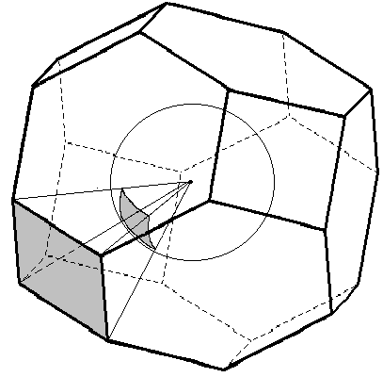

**Figure 1:** The solid angle of the shaded Voronoi polyhedron face in the body-centered cubic lattice is equal to the shaded segment of the unit sphere being cut off by the pyramid with the Voronoi polyhedron atom A at the vertex and the face in the base. The shaded face is shared between Voronoi polyhedra of A and X atoms and corresponds to the bond A-X.

TOPOL_NODE

A succinct alternative to directly describing the atoms and symmetry in the TOPOL_LINK category is to move that information to a TOPOL_NODE loop and simply point to nodes involved in the link. This provides a better separation between the mathematical abstraction of a net of links and nodes and the geometry associated with that net. Thus, the above diamond example could be described as follows, where the TOPOL_LINK section reduces to a simple n x 2 matrix:

loop_

_topol_link.node_id_1

_topol_link.node_id_2

1 2

loop_

_topol_node.id

_topol_node.atom_label

_topol_node.symop

_topol_node.translation

1 C1 1 .

2 C1 13 .

And a mix of these two modes is also possible:

loop_

_topol_link.node_id_1

_topol_link.node_id_2

_topol_link.symop_1

_topol_link.translation_1

_topol_link.symop_2

_topol_link.translation_2

1 1 . . 13 .

loop_

_topol_node.id

_topol_node.atom_label

1 C1

More generally, the TOPOL_NODE category involves the following primary keys:

* _topol_node.id

_topol_node.label

_topol_node.net_id → _topol_net.id

_topol_node.atom_label → _atom_site_label

_topol_node.symop

_topol_node.translationⱡ

_topol_node.fract_x

_topol_node.fract_y

_topol_node.fract_z

_topol_node.symmetry_multiplicity

_topol_node.Wyckoff_symbol

_topol_node.id is a required tag, as it is the category key, referenced by TOPOL_LINK and TOPOL_ATOM. Its integer value must be unique and typically the series starts with the value 1. _topol_node.label is optional and is used for readability or representational labeling only; it does not have to be unique and therefore should never be referenced by any other category. _topol_node.net_id refers to a particular net described in the TOPOL_NET category, only required if there is more than one net. Note that any number of nodes may correspond with a given net, but each node must correlate with only one net. _topol_node.atom_label is required only if all nodes correspond to single crystallographic atoms. Otherwise, that reference can be moved to TOPOL_ATOM (below). In general, when _topol_node.atom_label is present, _topol_node.fract_x, _topol_node.fract_y, and _topol_node.fract_z, _topol_node.symmetry_multiplicity, and _topol_node.Wyckoff_symbol should not be present or indicated as the default ‘.’ value, as that information can be extracted from the corresponding items of the ATOM_SITE category. However, when a node does not correlate with an atom position in ATOM_SITE, then these fields can be used, and _topol_node.atom_label should be indicated using ‘.’.

Additional TOPOL_NODE descriptors include:

_topol_node.net_id

_topol_node.chemical_formula_iupac

_topol_node.chemical_formula_moiety

_topol_node.chemical_formula_sum

_topol_node.structural_formula_InChI

_topol_node.structural_formula_SMILES

_topol_node.coordination_sequence

_topol_node.coordination_sequence_plain

_topol_node.point_symbol

_topol_node.extended_point_symbol

_topol_node.vertex_symbol

[describe?]

TOPOL_ATOM

When some of the nodes of a net do not correspond with an atom of the crystal structure, or links themselves are abstractions of atoms or groups of atoms (*building units*, Alexandrov *et al*. 2011; Bonneau *et al.* 2018; Shevchenko & Blatov, 2021) the TOPOL_ATOM category is required along with TOPOL_NODE and TOPOL_LINK. These three categories, then, describe the full chemical constitution and connectivity of the underlying net. The TOPOL_ATOM category is quite simple:

* _topol_atom.id

_topol_atom.atom_label

_topol_atom.node_id → _topol_node.id

_topol_atom.link_id → _topol_link.id

_topol_atom.symop

_topol_atom.translationⱡ

_topol_atom.elemental_symbol

Of these items, only _topol_atom.atom_label is absolutely required. Though _topol_atom.id is a key, within the current specification it is not referenced. Exactly one of _topol_atom.node_id or _topol_atom.link_id is required, pointing to the node or link that this atom is associated with. Note that this allows any number of atoms to be associated with a give node or link. _topol_atom.elemental_symbol is strongly recommended, as there is no other location in a CIF file where a specific element symbol is required. In the case that for some reason the atom does not relate to a specific element (due to occupational disorder or some other reason), this field should be left as unquoted ‘.’.

Using TOPOL_ATOM, our simple diamond example could be described as follows:

loop_

_topol_link.node_id_1

_topol_link.node_id_2

1 2

loop_

_topol_node.id

1

2

loop_

_topol_atom.atom_label

_topol_atom.symop

_topol_atom.translation

C1 1 .

C1 13 .

For such a simple case, the use of TOPOL_ATOM and TOPOL_NODE are clearly unnecessary. But consider the following pair of nets:

         loop_

         _topol_net.id

         _topol_net.label

         _topol_net.special_details

         _topol_net.overall_topology_TOPOS

         1 Net_1 'Atomic net' 'Unknown'

         2 Net_2 'Underlying net with carbonyl ligands as nodes' '2,4T3'

We describe the links as a simple topological matrix, with additional descriptive information:

         loop_

         _topol_link.id

         _topol_link.net_id

         _topol_link.node_id_1

         _topol_link.node_id_2

         _topol_link.distance

         _topol_link.type

         _topol_link.multiplicity

         1 1 1 2   1.9121 v 4  # Li1 - O1

         2 1 2 3   1.1452 v 4  # O1 - C1

         3 1 2 4   1.7422 v 4  # C1 - Co1

         4 2 5 6   2.4032 v 4  # Li1 - CO

         5 2 6 7   2.3963 v 4  # CO - Co

Adding the nodes, with labels and chemical formulas:

         loop_

         _topol_node.id

         _topol_node.net_id

         _topol_node.label

         _topol_node.chemical_formula_sum

         1 1 Li1 Li

2 1 O1  O

         3 1 C1  C

         4 1 Co1 Co

         5 2 ZA1 Li

         6 2 ZB1 CO

         7 2 ZC1 Co

Note that Node 6 has two atoms associated with, the carbon and oxygen atoms of a carbonyl group. Finally, specifying the positions of those nodes that have special labels:

loop_

_topol_atom.id

_topol_atom.node_id

_topol_atom.label

_topol_atom.chemical_formula_sum

1 5 Li1  Li

2 6 C1   C

3 6 O1   O

4 7 Co1  Co

Scheme I shows the overall relationship among TOPOL_NET, TOPOL_LINK, TOPOL_NODE, and TOPOL_ATOM. The key category is TOPOL_LINK, with references to TOPOL_NET and TOPOL_NODE. TOPOL_ATOM provides coordinates for atoms associated with nodes and links. All three categories can reference ATOM_SITE directly, depending upon the complexity of the net.

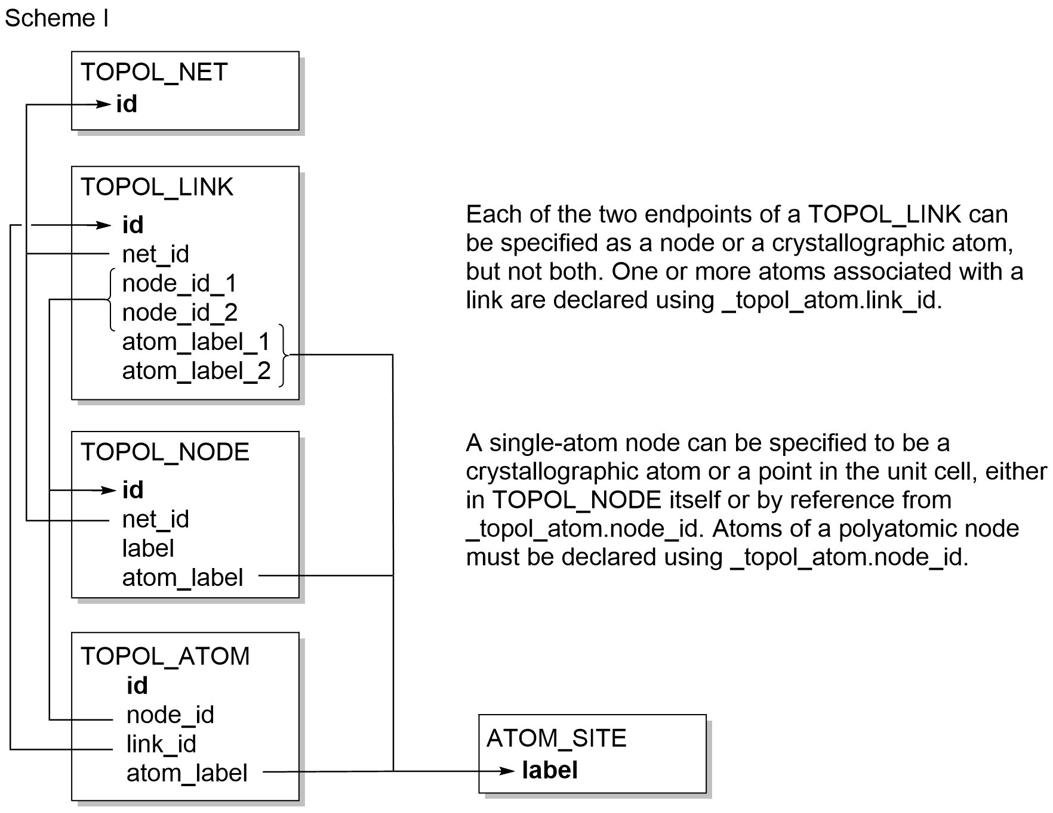

For a much more involved example, see the metal-organic framework MOF5 example at GitHub (<https://github.com/COMCIFS/TopoCif/blob/master/more_examples/mof5-v2d-three_nets.cif>), involving three distinct nets, ten links, eleven nodes, and sixty atoms.

**3.2. Underlying net topological properties**

The topological properties of underlying nets described by the TOPOL_LINK, TOPOL_NODE and TOPOL_ATOM categories are collected in the remaining TOPOL categories, namely TOPOL_NET, TOPOL_ENTANGL, TOPOL_TILING (including TOPOL_TILING_FACES and TOPOL_TILING_TILE), and TOPOL_OCCURRENCE categories. These categories are discussed below.

TOPOL_NET

If several nets are described, or additional net-level descriptions are needed, the TOPOL_NET category is necessary. Its items include:

* _topol_net.id

_topol_net.name

_topol_net.overall_topology_EPINET

_topol_net.overall_topology_RCSR

_topol_net.overall_topology_SP

_topol_net.overall_topology_TOPOS

_topol_net.period

_topol_net.special_details

_topol_net.td10

_topol_net.total_point_symbol

_topol_net.genus

_topol_net.occurrence_total

_topol_net.id, again a serial integer, is required if there is more than one net, as it is the key referenced from TOPOL_LINK and TOPOL_NODE. _topol_net.name allows for an optional arbitrary name for the net. The overall topology of the net can be described in accordance with four known nomenclatures, or given in an arbitrary format. The followingnomenclatures are used to designate the overall topologies of periodic nets:

* RCSR lower-case bold three-letter symbols, see O'Keeffe *et al*. (2008) and http://rcsr.net/ for details. Example: **dia** (see http://rcsr.net/nets/dia)
* EPINET *sqc*XXXXX symbols, see Ramsden *et al*. (2009) and http://epinet.anu.edu.au/ for details.
* SP (sphere packing) symbols *k*/*m*/*fn* as proposed by Koch *et al*. (2006).
* TOPOS symbols N*D*n (Aman *et al*., 2014), where N is a sequence of degrees (coordination numbers) of all independent nodes; *D* is one of the letters *C*, *L*, or *T* designating the dimensionality of the net (*C* – chain, *L* – layer, *T* – three-periodic); n enumerates non-isomorphic nets with a given N*D* sequence. For instance, the symbol 3,3,4*T*3 denotes the 3rd (by the order) three-periodic trinodal net with two 3-coordinated and one 4-coordinated independent nodes. For finite (molecular) graphs the symbols N*M*k-n are used, where k is the number of vertices (atoms) in the graph.
* Zeolite capital three-letter symbols, see http://www.iza-structure.org/databases/ for details.
* Subnet **s**-d-*G*-n symbols (Blatov, 2007; Blatov & Proserpio 2009), where **s** is a conventional name of the initial net, d is a set of ascending integers equal to degrees of all inequivalent nodes in the subnet, *G* is the space group for the most symmetrical embedding of the subnet, n is optional and enumerates non-isomorphic subnets with a given **s**-d-*G* sequence. Examples: **scu**-3,6-*P*42/*mnm*-2 (is a 3,6-c net derived from 4,8-c **scu**); **acs**-4-*Pbcn* (is a 4-c net derived from 6-c **acs**)
* Subnet transformation symbols **s**/*G*→*S*1→…→*S*n;BS (Blatov, 2007), where **s** is a conventional name of the initial net, *G* is the space group of the initial net, *S*1, …, *S*n is the sequence of group-subgroup transformations to obtain the symmetry of the resulting subnet, *S*n, BS is the set of numbers of non-equivalent edges to be retained in the subnet. For instance, the notation fny/P 63/m c m->P 63 2 2 (0,0,1/4);Bond sets: 2,3,4,5 means that the subnet is derived from the RCSR net **fny** by decreasing its space-group symmetry from *P*63/*mcm* to *P*6322 with shifting the origin by (0, 0, 1/4) vector and breaking all non-equivalent edges in the resulting net except the edges No 2, 3, 4 and 5.

The _topol_net.occurrence_total item specifies the total occurrence of the net topology in crystal structures. An arbitrarily detailed description of the net can be provided in the _topol_net.special_details item.

TOPOL_ENTANGL

This category contains no items, because the descriptors of entanglements in crystal structures have not been standardized yet. However, the importance of entanglements in the topological description is acknowledged , and this category is expected to be developed in future versions of the dictionary.

TOPOL_TILING, TOPOL_TILING_FACES, and TOPOL_TILING_TILE

These three categories describe a tiling, which is carried by the underlying net. Since only a single unentangled net can carry tilings, these data can be included only if a single net is described in the TOPOL_NET section. As a rule, natural tiling (Blatov *et al*., 2007) is described, since it contains minimal cages, which can be combined to provide all other larger cages, including infinite channels.

Items in these categories include:

_topol_tiling.vertices

_topol_tiling.edges

_topol_tiling.faces

_topol_tiling.tiles

_topol_tiling.signature

_topol_tiling.Dsize

_topol_tiling.dual

_topol_tiling_faces.tile_id

_topol_tiling_faces.size

_topol_tiling_tile.count

_topol_tiling_tile.id

TOPOL_OCCURRENCE

The TOPOL_OCCURRENCE category stores information on the occurrences of a particular net topology in other crystal structures and can be used together with the _topol_net.overall_topology_* items for developing topological databases. Items include:

* _topol_occurrence.id

_topol_occurrence.net_id → _topol_net.id

_topol_occurrence.citation_id → _citation.id

Reference or collection codes of crystal structure determinations can be used as _topol_occurrence.id values, for example, reference codes from the Cambridge Structural Database or collection codes from the Inorganic Crystal Structure Database.

**3.3. Development of the supporting software and databases**

The CIF topological data can be read and generated by the *ToposPro* program package (Blatov *et al*., 2014) and online service *TopCryst* (https://topcryst.com). Jmol/JSmol software (https://jmol.sourceforge.net) can also read and visualize the nets specified in the topoCIF format. The topological databases Reticular Chemistry Structure Resource (RCSR, http://rcsr.net/) and ToposPro Collections (TTD and TTO, https://topospro.com) use the topoCIF topological descriptors and, hence, one can use the topoCIF format for exporting or importing information to or from these databases. Thus, the crystallographic information on old and new structure determinations can be supplemented with the connectivity data, stored and shared.

**4. Net Reconstruction from CIF Data**

The periodic net described by a topoCIF file is fully defined by its set of TOPOL_ATOM, TOPOL_NODE, and TOPOL_LINK data. The method of constructing a net for visualization or analysis from this data is not trivial, since generally a CIF file only provides locations for the asymmetric unit. Below we describe a sketch of the corresponding algorithm as implemented in Jmol. This algorithm presumes that we first want to start with a set of nodes based on some sort of finite spatial boundaries (one or more unit cells, for example), and then add to that the relevant links. Net construction proceeds in the following order:

* Reading relevant _cell, _symmetry, _symmetry_equiv_pos, _atom_site, _topol_net, _topol_link, _topol_node, and _topol_atom data (which could come in any order within a CIF file).
* Processing the _topol_atom associations by
  + applying indicated symmetry operations and translations, and
  + associating each atom with its designated link or node.
* Creating any nodes needed for links that have not been already defined from _topol_atom
* Processing all additional node symmetry operations and translations.
* Processing all additional link symmetry operations and translations.
* Applying all space group symmetry operations for all identified points, whether atoms, nodes, or link end-points.
* Removing any unconnected atoms, nodes, or links.

A reference dual Java/JavaScript implementation can be found at SourceForge (<https://sourceforge.net/p/jmol/code/HEAD/tree/trunk/Jmol/src/org/jmol/adapter/readers/cif/TopoCifParser.java>) or GitHub (<https://github.com/BobHanson/Jmol-SwingJS/blob/master/src/org/jmol/adapter/readers/cif/TopoCifParser.java>).

**References**

Alexandrov, E. V., Blatov, V. A., Kochetkov, A. V. & Proserpio, D. M. (2011). *Underlying nets in three-periodic coordination polymers: topology, taxonomy and prediction from a computer-aided analysis of the Cambridge Structural Database. CrystEngComm*, **13**, 3947-3958.

Aman, F., Asiri, A. M., Siddiqui, W. A., Arshad, M. N., Ashraf, A., Zakharov, N. S. & Blatov, V. A. (2014). *Multilevel topological description of molecular packings in 1,2-benzothiazines. CrystEngComm*, **16**, 1963-1970.

Blatov, V.A. (2004). *Voronoi-Dirichlet polyhedra in crystal chemistry: theory and applications. Cryst. Rev.* **10**, 249-318.

Blatov, V. A. (2007). *Topological relations between three-dimensional periodic nets. I. Uninodal nets. Acta Cryst.* **A63**, 329–343.

Blatov, V. A., Delgado-Friedrichs, O., O’Keeffe, M. & Proserpio, D. M. (2007). *Three-periodic nets and tilings: natural tilings for nets. Acta Cryst*. **A63**, 418-425.

Blatov, V.A., O’Keeffe, M. & Proserpio, D. M. (2010). *Vertex-, face-, point-, Schläfli-, and Delaney-symbols in nets, polyhedra and tilings: recommended terminology*. *CrystEngComm*, **12**, 44-48.

Blatov, V. A., & Proserpio, D. M. (2009). *Topological relations between three-dimensional periodic nets. I. Binodal nets. Acta Cryst.* **A65**, 202-212.

Blatov, V.A., Shevchenko, A.P. & Proserpio, D.M. (2014). *Applied topological analysis of crystal structures with the program package ToposPro. Cryst. Growth Des.* **14**, 3576-3586.

Bonneau, C., O’Keeffe, M., Proserpio, D. M., Blatov, V. A., Batten, S. R., Bourne, S. A., Lah, M. S., Eon, J.-G., Hyde, S. T., Wiggin, S. B. & Öhrström, L. (2018) *Deconstruction of Crystalline Networks into Underlying Nets: Relevance for Terminology Guidelines and Crystallographic Databases. Cryst. Growth Des.*, **18**, 3411–3418

Delgado-Friedrichs, O. & O’Keeffe, M. (2003). *Identification of and symmetry computation for crystal nets. Acta Cryst.* **A59**, 351-360.

Delgado-Friedrichs, O. & O’Keeffe, M. (2005). *Crystal nets as graphs: terminology and definitions. J. Solid State Chem*. **178**, 2480-2485.

Delgado-Friedrichs, O., Foster, M. D., O'Keeffe, M., Proserpio, D. M., Treacy, M. M. J. & Yaghi, O. M. (2005). *What do we know about nets? J. Solid State Chem*. **178**, 2533-2554.

O'Keeffe, M., Peskov, M. A., Ramsden, S. J. & Yaghi, O. M. (2008). *The reticular chemistry structure resource (RCSR) database of, and symbols for, crystal nets. Acc. Chem. Res.* **41**, 1782-1789.

Koch, E., Fischer, W. & Sowa, H. (2006). *Interpenetration of homogeneous sphere packings and of two-periodic layers of spheres. Acta Cryst.* **A62**, 152-167.

Ramsden, S. J., Robins, V., Hyde, S. T. (2009). *Three-dimensional Euclidean nets from two-dimensional hyperbolic tilings: kaleidoscopic examples. Acta Cryst.* **A65**, 81–108.

Shevchenko, A.P. & Blatov, V.A. (2021). *Simplify to understand: how to elucidate crystal structures? Struct. Chem.* **32**, 507-519.