Appendix A: Requirements Specification

## Product Backlog:

Below I am providing the product backlog based on their priority of this e-CourseMonitoring application.

|  |  |
| --- | --- |
| Priority | Item |
| 1 | As an administrator I want to maintain the data about courses, staffs and roles. |
| 2 | As a CL I want to do CMR for one or more courses. |
| 3 | In database all the CMRs should be stored. |
| 4 | As a CL, I can access and modify my own CMR before approve. |
| 5 | The system emails and notified to CM when a CMR is submit by CL. |
| 6 | As a CM, I want to approve the CMR. |
| 7 | As a CM, I can access my CMR before approve. |
| 8 | The system emails and notified to PVC & DLT when a CMR is approved by CM. |

|  |  |
| --- | --- |
| 9 | As a PVC, I can see the list of approved CMR for Faculties. |
| 10 | As a DLT, I can see the list of approved CMR for Faculties. |
| 11 | As a DLT, I can comment on every CMR reports. |
| 12 | As a guest from each faculty, I want to see the list of approved CMRs, statistical reports and exception reports. |
| 13 | Commented and responded CMR’s copy emails to CL and CM of this specific course and to PVC and DLT of the faculty of this course. |
| 14 | As a teacher/admin, I want to note about my events for alarming myself about a specific day’s events. |
| 15 | The user Interface must be suitable for all devices. |

## Sprint Planning:

Sprint Panning included the Sprint Backlog, Effort Estimation Chart, Burndown Chart, Velocity Chart and Minutes of Meetings.

All of this is given below based on serial of sprint number.

Group ID: BIT 33-B

Group Name: R.I.P. Network

Language Platform: PHP

Server: Apache

Website: HTML, CSS, JavaScript, Bootstrap

Dbms: MySql

Member description:

|  |  |  |
| --- | --- | --- |
| ID | NAME | ROLE |
| 576 | Nusrat Ahmed Asha | Programmer, Database Designer |
|  | Kazi Golam Kibria | Web designer |
|  | Md. Sumon | Information Architect |
|  | Redwan | Tester |
|  | Akhi | Tester |

Sprint One- 2 Weeks

|  |  |  |  |
| --- | --- | --- | --- |
| Sprint Backlog Item | Sprint Task | Volunteer | Initial Estimate Of Effort |
| 1. As an administrator I want to maintain the data about courses, staffs and roles. | Analysis the admin tasks thorough | Sumon | 10 |
| Create ERD & Create Database | Nusrat | 10 |
| Data insertion to database | Nusrat | 5 |
| Create admin related Webpages (UI) | Kazi | 10 |
| Create and complete access level code for  Administrator. | Nusrat | 15 |
| Test the tasks. | Redwan & Akhi | 5 |
| 1. As a CL I want to do CMR for one or more courses. | Analysis the CL tasks | Sumon | 8 |
| Create CL related webpages | Kazi | 5 |
| Create and complete code for accessibility of CL. | Nusrat | 12 |
| Modify UI for insertion data to CMR filed. | Kazi | 5 |
| Test the tasks. | Redwan & Akhi | 2 |
| 1. In database all the CMRs should be stored. | Create and complete code for storing data. | Nusrat | 5 |
| Test the tasks. | Redwan & Akhi | 2 |
| 1. As a CL, I can access and modify my own CMR before approved by CM. | Create and complete code for accessibility of CM. | Nusrat | 6 |
| Test the tasks. | Redwan & Akhi | 5 |
| Total | | | 105 |

Daily Update of Work Remaining on the Sprint One Backlog

|  |  |  |  |  |  |  |  |  |  |
| --- | --- | --- | --- | --- | --- | --- | --- | --- | --- |
| Sprint Task | Volunteer | Initial Estimate Of Effort | Day 2 | Day 4 | Day  5 | Day  8 | Day  10 | Day  12 | Day  14 |
| Analysis the admin tasks thorough | Sumon | 10 | 9 | 6 | 4 | 3 | 2 | 0 | 0 |
| Create ERD & Create Database | Nusrat | 10 | 10 | 8 | 5 | 3 | 0 | 0 | 0 |
| Data insertion to database | Nusrat | 5 | 0 | 5 | 7 | 5 | 1 | 0 | 0 |
| Create admin related Webpages (UI) | Kazi | 10 | 9 | 5 | 3 | 0 | 0 | 0 | 0 |
| Create and complete access level code for  Administrator. | Nusrat | 15 | 12 | 10 | 6 | 4 | 3 | 1 | 0 |
| Test the tasks. | R& A | 5 | 5 | 5 | 3 | 1 | 1 | 1 | 0 |
| Analysis the CL tasks | Sumon | 8 | 8 | 6 | 5 | 3 | 2 | 0 | 0 |
| Create CL related webpages | Kazi | 5 | 5 | 3 | 2 | 0 | 0 | 0 | 0 |
| Create and complete code for accessibility of CL. | Nusrat | 12 | 10 | 7 | 5 | 4 | 3 | 1 | 0 |
| Modify UI for insertion data to CMR filed. | Kazi | 5 | 5 | 0 | 0 | 0 | 0 | 0 | 0 |
| Test the tasks. | R & A | 2 | 2 | 2 | 1 | 1 | 1 | 1 | 0 |
| Create and complete code for storing data. | Nusrat | 5 | 0 | 8 | 2 | 0 | 0 | 0 | 0 |
| Test the tasks. | R & A | 2 | 2 | 2 | 1 | 0 | 0 | 0 | 0 |
| Create and complete code for accessibility of CM. | Nusrat | 6 | 5 | 5 | 4 | 3 | 1 | 0 | 0 |
| Test the tasks. | R & A | 5 | 3 | 3 | 2 | 2 | 1 | 1 | 0 |
| Total | | 105 | 85 | 75 | 50 | 30 | 15 | 5 | 0 |

**Burndown Chart of Sprint One**

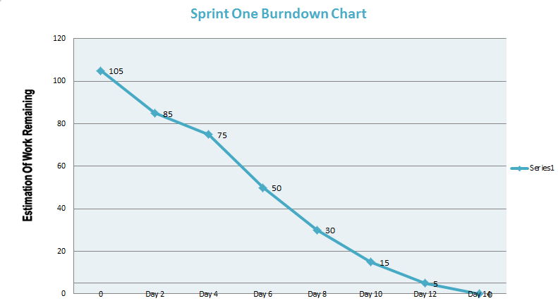

Figure: 7.1.2.1 Burndown chart (Sprint one)

Table: Minutes of Meetings of Sprint One

|  |  |  |  |  |
| --- | --- | --- | --- | --- |
| Sunday | Monday | Tuesday | Wednesday | Thursday |
|  |  | 1 (February, 16)  Sprint Planning  Up to 4 hours | 2  Daily Scrum  15minutes | 3  Daily Scrum  15minutes |
| National Holiday (Feb,21)  Shaheed Day / International Mother Language Day | 4  Daily Scrum  15minutes | 5  Daily Scrum  15minutes | 6  Daily Scrum Grooming  30minutes | 7  Daily Scrum  15minutes |
| 8  Daily Scrum  15minutes | 9  Daily Scrum  15minutes | 10  Daily Scrum  15minutes | 11  Daily Scrum  15minutes | 12  Daily Scrum  15minutes |
| 13  Daily Scrum  All code in QA  30minutes | 14 (March,7)  Daily Scrum Review  Retrospective  45minutes |  |  |  |

Sprint Two- 5 Days

|  |  |  |  |
| --- | --- | --- | --- |
| Sprint Backlog Item | Sprint Task | Volunteer | Initial Estimate Of Effort |
| 1. The system emails and notified to CM when a CMR is submit by CL. | Create and complete code for emailing and notifying the CM of CMR. | Nusrat | 10 |
| Test the tasks. | Sumon | 2 |
| 1. As a CM, I want to approve the CMR. | Analysis the CM level of tasks | Sumon | 5 |
| Modify UI vision for CM. | Kazi | 5 |
| Create and complete code for approving of CMR by CM. | Nusrat | 8 |
| Test the tasks. | Akhi & Redwan | 2 |
| 1. As a CM, I can access and modify my on CMR before approved by PVC & DLT. | Create and complete code for accessibility of CM. | Nusrat | 6 |
| Test the tasks. | Akhi & Redwan | 2 |
| 1. The system emails and notified to PVC & DLT when a CMR is approved by CM. | Create and complete code for emailing and notifying the PVC & DLT of CMR. | Nusrat | 8 |
| Test the tasks. | Sumon | 2 |
| 1. As a PVC, I can see the list of approved CMR for Faculties. | Analysis the tasks of PVC | Sumon | 5 |
| Modify UI vision for PVC | Kazi | 5 |
| Create and complete code for accessibility of PVC | Nusrat | 8 |
| Test the tasks | Akhi & Redwan | 2 |
| Total | | | 70 |

Daily Update of Work Remaining on the Sprint Two Backlog

|  |  |  |  |  |  |  |  |
| --- | --- | --- | --- | --- | --- | --- | --- |
| Sprint Task | Volunteer | Initial Estimate Of Effort | Day  1 | Day  2 | Day  3 | Day  4 | Day  5 |
| Create and complete code for emailing and notifying the CM of CMR. | Nusrat | 10 | 8 | 5 | 5 | 2 | 0 |
| Test the tasks. | Sumon | 2 | 4 | 2 | 2 | 1 | 0 |
| Analysis the CM level of tasks | Sumon | 5 | 6 | 4 | 4 | 2 | 0 |
| Modify UI vision for CM. | Kazi | 5 | 3 | 3 | 3 | 0 | 0 |
| Create and complete code for approving of CMR by CM. | Nusrat | 8 | 6 | 3 | 3 | 0 | 0 |
| Test the tasks. | A & R | 2 | 2 | 2 | 2 | 1 | 0 |
| Create and complete code for accessibility of CM. | Nusrat | 6 | 5 | 4 | 4 | 1 | 0 |
| Test the tasks. | A & R | 2 | 2 | 3 | 3 | 1 | 0 |
| Create and complete code for emailing and notifying the PVC & DLT of CMR. | Nusrat | 8 | 6 | 4 | 4 | 2 | 0 |
| Test the tasks. | Sumon | 2 | 2 | 1 | 1 | 1 | 0 |
| Analysis the tasks of PVC | Sumon | 5 | 5 | 0 | 0 | 0 | 0 |
| Modify UI vision for PVC | Kazi | 5 | 3 | 3 | 3 | 0 | 0 |
| Create and complete code for accessibility of PVC | Nusrat | 8 | 6 | 4 | 4 | 2 | 0 |
| Test the tasks | A & R | 2 | 2 | 2 | 2 | 2 | 0 |
| Total | | 70 | 60 | 40 | 40 | 15 | 0 |

Burndown Chart of Sprint Two

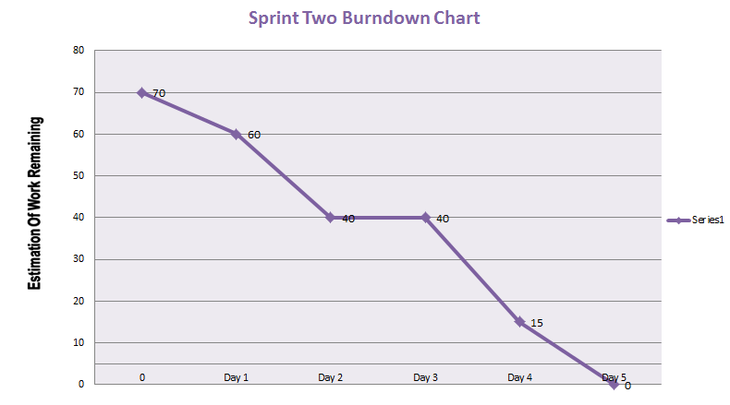

Figure: 7.1.2.2 Burndown Chart (Sprint Two)

Table: Minutes of Meetings of Sprint Two

|  |  |  |  |  |
| --- | --- | --- | --- | --- |
| Sunday | Monday | Tuesday | Wednesday | Thursday |
|  |  | 1 (March,8)  Sprint Planning  Up to 4 hours | 2  Daily Scrum  15minutes | 3  Daily Scrum  15minutes |
| 4  Daily Scrum  All code in QA  30minutes | 5 (March,14)  Daily Scrum Review  Retrospective  45minutes |  |  |  |

Sprint Three- 1 Week, 2 Days

|  |  |  |  |
| --- | --- | --- | --- |
| Sprint Backlog Item | Sprint Task | Volunteer | Initial Estimate Of Effort |
| 1. As a DLT, I can see the list of approved CMR for Faculties. | Analysis the DLT task level | Sumon | 5 |
| UI modification for DLT | Kazi | 2 |
| Create and complete code for accessibility of DLT | Nusrat | 8 |
| Test the tasks. | Akhi & Redwan | 2 |
| 1. As a DLT, I can comment on every CMR reports. | Create and complete code for responding of CMR by DLT. | Nusrat | 5 |
| Test the tasks. | Akhi & Redwan | 2 |
| 1. As a guest from each faculty, I want to see the list of approved CMRs, statistical reports and exception reports. | Analysis the task of guest thorough | Sumon | 5 |
| Guest UI vision create | Kazi | 5 |
| Create and complete code for accessibility of Guest. | Nusrat | 20 |
| Test the tasks. | Akhi & Redwan | 2 |
| 1. Commented and responded CMR’s copy emails to CL and CM of this specific course and to PVC and DLT of the faculty of this course. | Create and complete code for emailing and notifying the PVC, DLT, CM and CL of CMR. | Nusrat | 10 |
| Test the tasks. | Sumon | 2 |
| 1. As a teacher/admin, I want to note about my events for alarming myself about a specific day’s events. | Analysis the task related with event. | Sumon | 2 |
| Design the UI related with event page. | Kazi | 2 |
| Create and complete code about event tasks. | Nusrat | 5 |
| Test the tasks | Akhi & Redwan | 2 |
| 1. The user interface must be suitable for all devices. | Make the all pages responsive. | Kazi | 10 |
| Test the tasks. | Redwan & Akhi | 6 |
| Total | | | 95 |

Daily Update of Work Remaining on the Sprint Three Backlog

|  |  |  |  |  |  |  |  |  |  |  |  |
| --- | --- | --- | --- | --- | --- | --- | --- | --- | --- | --- | --- |
| Sprint Task | Volunteer | Initial Estimate Of Effort | Day  1 | Day  2 | Day  3 | Day  4 | Day  5 | Day  6 | Day  7 | Day  8 | Day  9 |
| Analysis the DLT tasks level | Sumon | 5 | 2 | 5 | 2 | 2 | 0 | 0 | 0 | 0 | 0 |
| UI modification for DLT | Kazi | 2 | 2 | 2 | 2 | 2 | 0 | 0 | 0 | 0 | 0 |
| Create and complete code for accessibility of DLT | Nusrat | 8 | 4 | 5 | 5 | 2 | 2 | 0 | 0 | 0 | 0 |
| Test the tasks. | A & R | 2 | 1 | 1 | 1 | 4 | 1 | 0 | 0 | 0 | 0 |
| Create and complete code for responding of CMR by DLT. | Nusrat | 5 | 3 | 3 | 4 | 2 | 2 | 1 | 0 | 0 | 0 |
| Test the tasks. | A & R | 2 | 2 | 2 | 1 | 1 | 1 | 2 | 0 | 0 | 0 |
| Analysis the task of guest thorough | Sumon | 5 | 6 | 6 | 5 | 4 | 4 | 5 | 4 | 3 | 0 |
| Guest UI vision create | Kazi | 5 | 5 | 5 | 5 | 4 | 6 | 6 | 5 | 4 | 0 |
| Create and complete code for accessibility of Guest. | Nusrat | 20 | 10 | 14 | 12 | 10 | 8 | 5 | 3 | 1 | 0 |
| Test the tasks. | A & R | 2 | 4 | 4 | 2 | 2 | 1 | 3 | 2 | 4 | 0 |
| Create and complete code for emailing and notifying the PVC, DLT, CM and CL of CMR. | Nusrat | 10 | 8 | 8 | 5 | 2 | 1 | 0 | 0 | 0 | 0 |
| Test the tasks. | Sumon | 2 | 3 | 3 | 2 | 1 | 1 | 0 | 0 | 0 | 0 |
| Analysis the task related with event. | Sumon | 2 | 2 | 2 | 1 | 0 | 0 | 0 | 0 | 0 | 0 |
| Design the UI related with event page. | Kazi | 2 | 1 | 1 | 1 | 0 | 0 | 0 | 0 | 0 | 0 |
| Create and complete code about event tasks. | Nusrat | 5 | 5 | 5 | 1 | 0 | 0 | 0 | 0 | 0 | 0 |
| Test the tasks | R & A | 2 | 2 | 2 | 1 | 0 | 0 | 0 | 0 | 0 | 0 |
| Make the all pages responsive. | Kazi | 10 | 6 | 8 | 6 | 6 | 5 | 5 | 3 | 1 | 0 |
| Test the tasks. | R & A | 6 | 4 | 4 | 4 | 4 | 3 | 3 | 3 | 2 | 0 |
| Total | | 95 | 70 | 80 | 60 | 45 | 35 | 30 | 20 | 15 | 0 |

Burndown Chart of Sprint Three

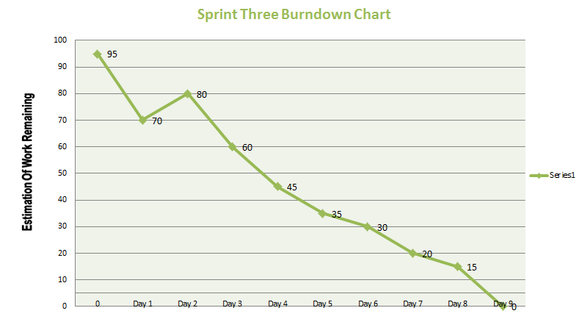

Figure: 7.1.2.3 Burndown Chart (Sprint Three)

Table: Minutes of Meetings of Sprint Three

|  |  |  |  |  |
| --- | --- | --- | --- | --- |
| Sunday | Monday | Tuesday | Wednesday | Thursday |
|  |  | 1 (March, 15)  Sprint Planning  Up to 4 hours | 2  Daily Scrum  15minutes | National Holiday (March,17)  Birthday of the Nation,  Bangabandhu Sheikh Mujibur Rahman |
| 3  Daily Scrum  15minutes | 4  Daily Scrum  15minutes | 5  Daily Scrum  15minutes | 6  Daily Scrum Grooming  30minutes | 7  Daily Scrum  15minutes |
| 8  Daily Scrum  All code in QA  30minutes | 9 (March,28)  Daily Scrum Review  Retrospective  45minutes |  |  |  |

Velocity chart of sprints:

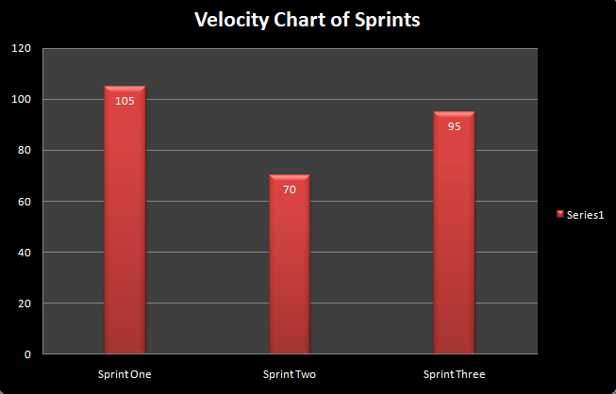

Figure: 7.1.2.4 Velocity chart

## Use case Diagrams

Use case diagram for admin

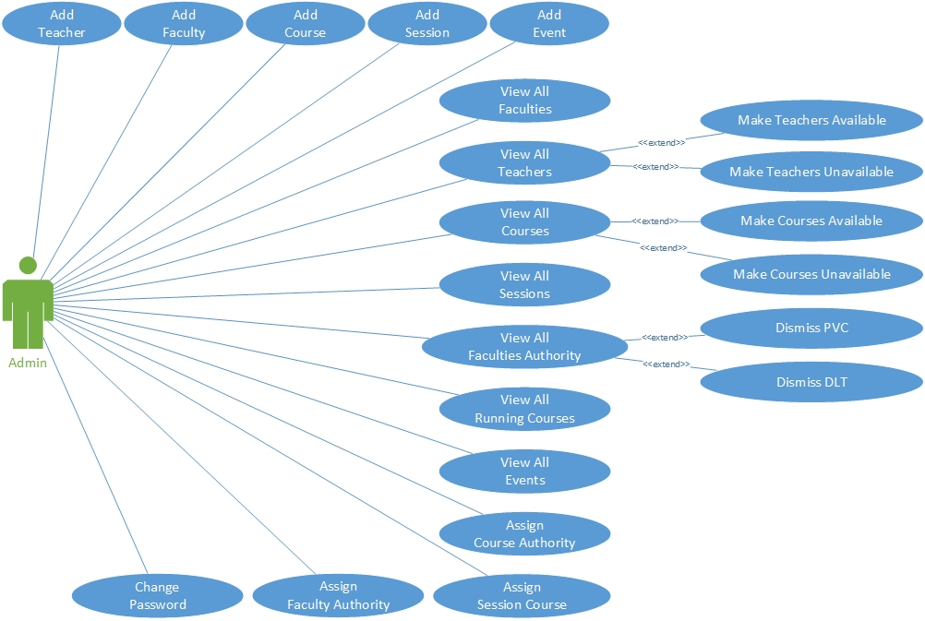  
 Figure: 1 Admin use case

Use case diagram for Course Leader and Course Moderator:

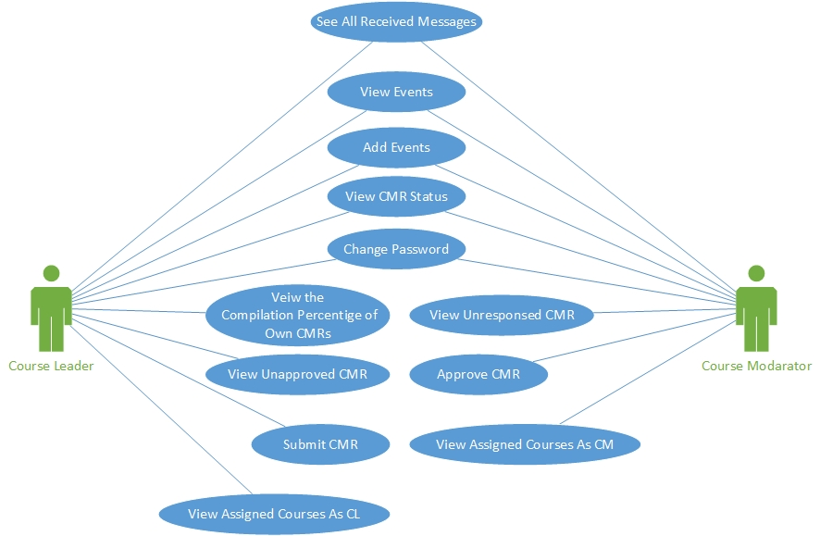  
 Figure: 2 CL/CM use case

Use case diagram for Pro-vice Chancellor and Director of Learning & Quality:

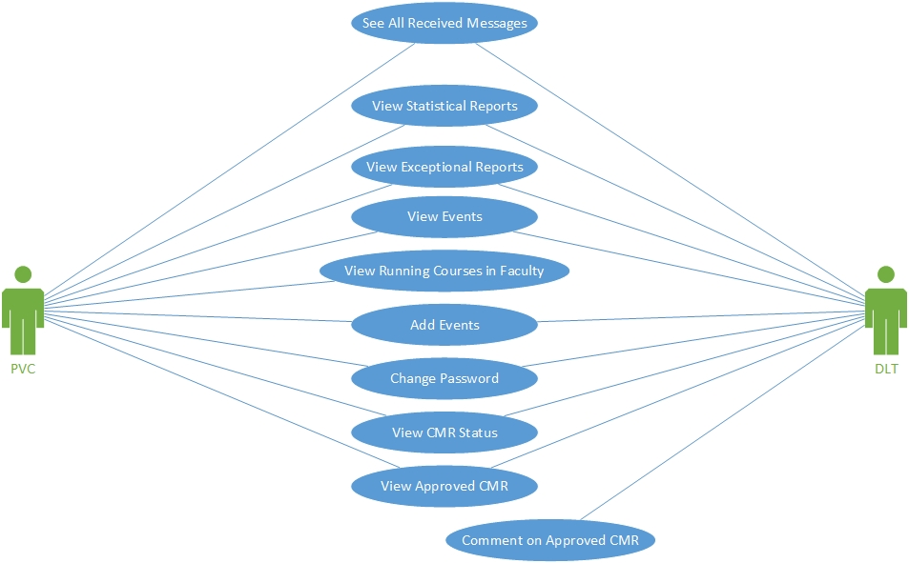  
 Figure: 3 PVC/DLT use case

Use case diagram for guest account:

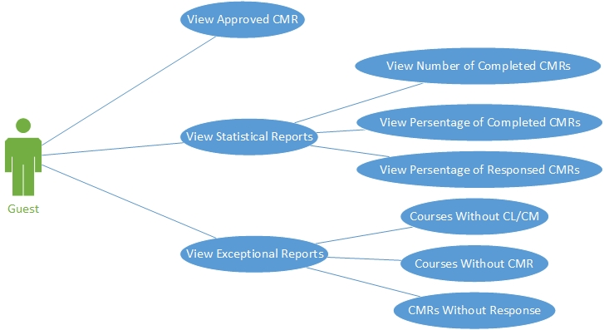  
 Figure: 4 guest use case

Use case diagram for any teacher:

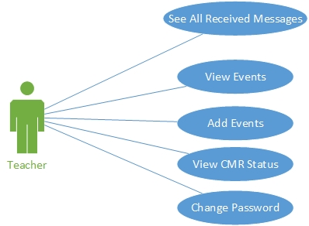  
 Figure: 5 all teacher use case

Appendix B: Database Design

# Extended Entity Relationship Diagram:

The entity relationship diagram of e-CourseMonitoring system is given below:

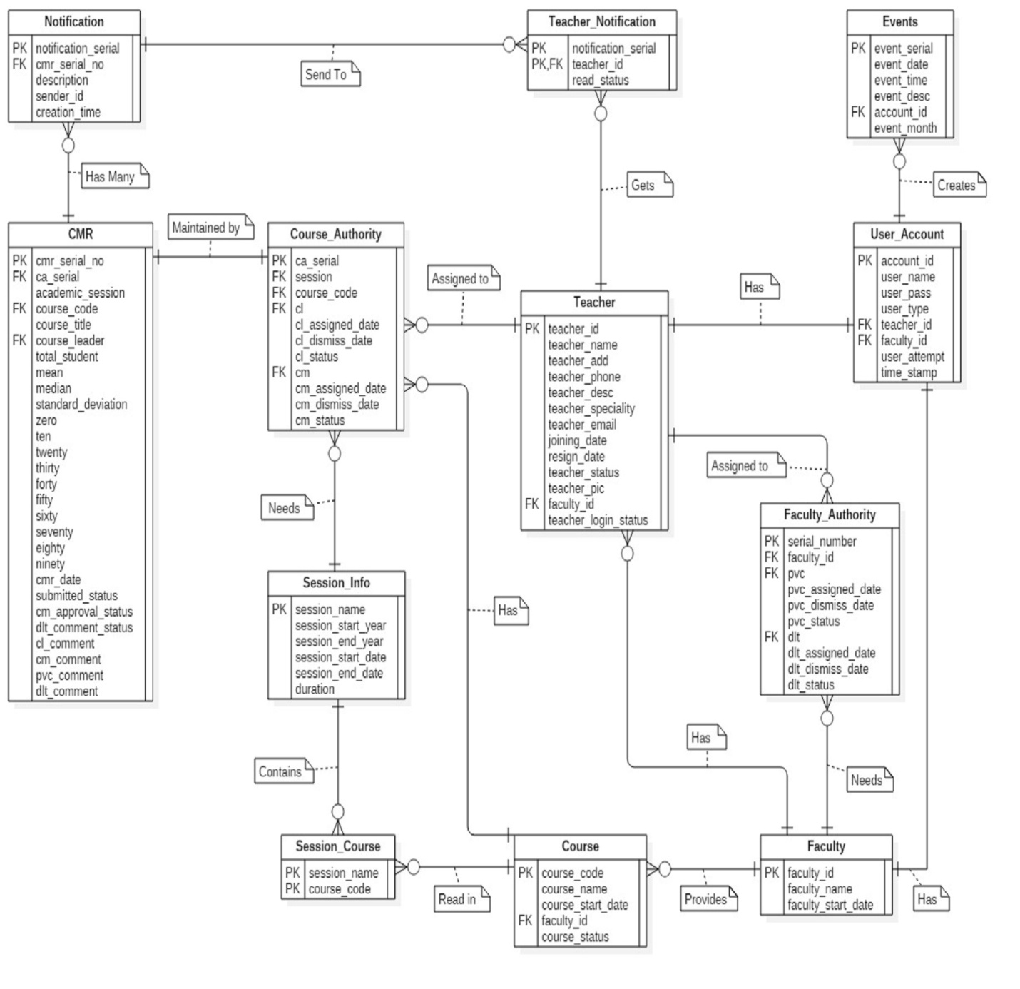

Figure: 7.2.4.1 ERD of e-CourseMonitoring

# Physical Data Model:

The physical data model of e-CourseMonitoring system is given below:

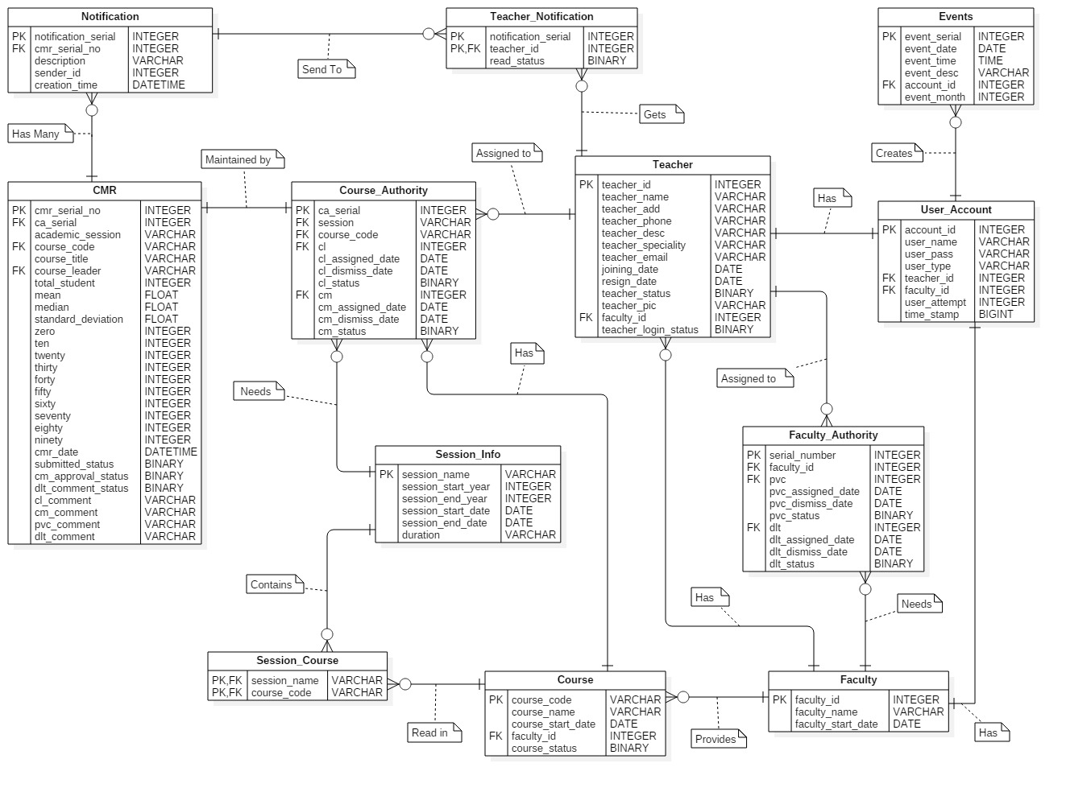

Figure: 7.2.5.1 PDM of e-CourseMonitoring