Name: Himanshu Deshmukh

Project Name: Management Website Development

Relationship Schema: A comprehensive relationship schema, ensuring a scalable and efficient structure for managing project data. The schema establishes clear connections between various entities, enhancing the overall database organization.

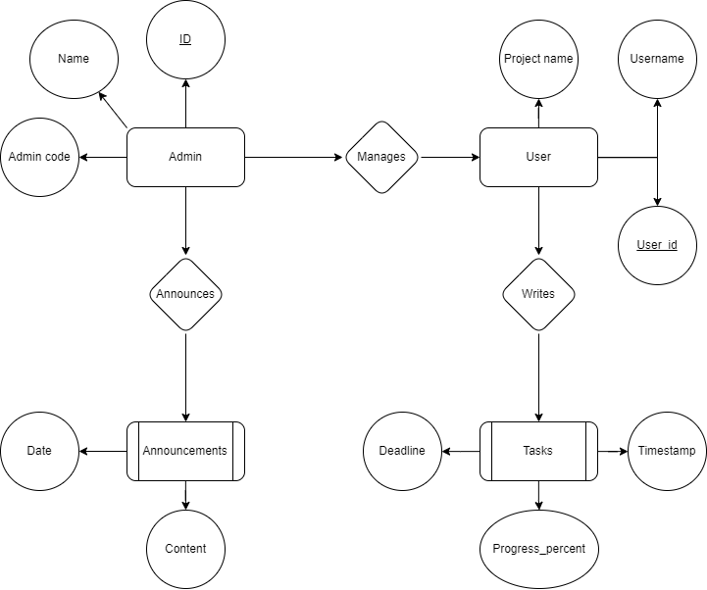

User Flow Design: The user flow prioritizes a seamless experience, guiding users through the platform with logical and user-friendly navigation.

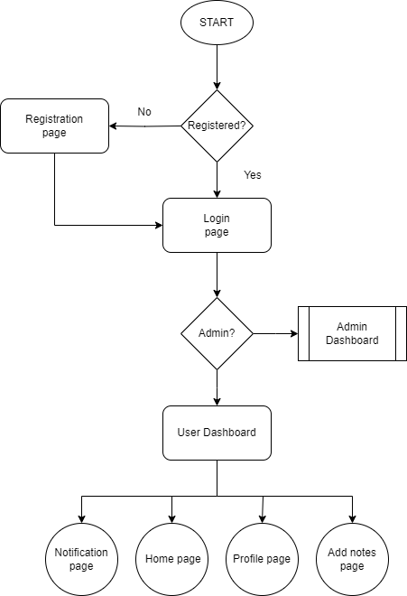

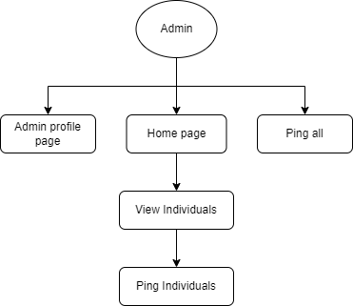

Django Models Initialization: Integrated essential models into Django, laying the groundwork for seamless database interaction. This step ensures proper data storage and retrieval, setting the stage for dynamic content generation.

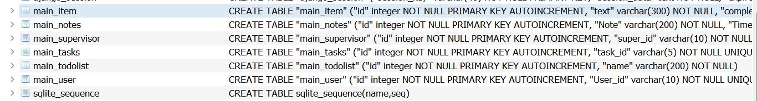

Views done:

User:

* Home  
  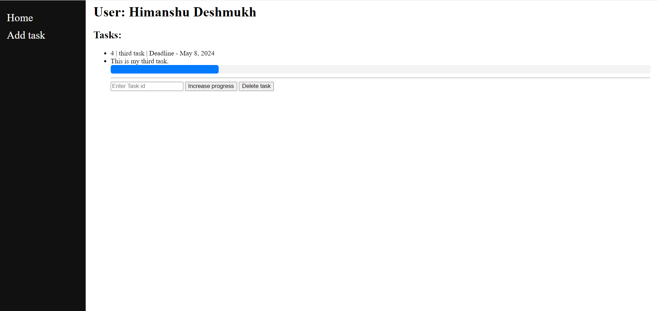
* Task creation page  
  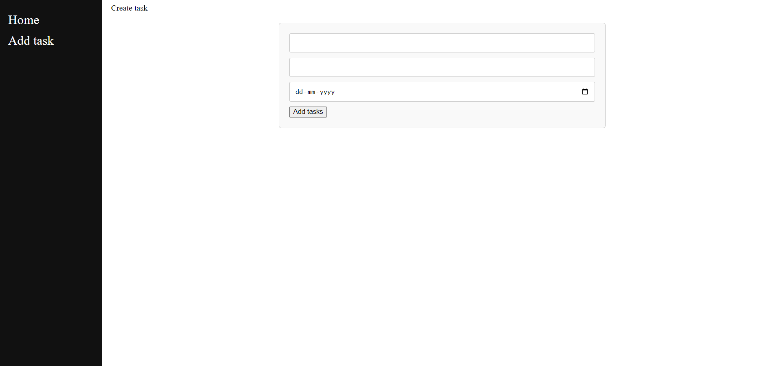

Remaining pages:

* Notification page

Supervisor:

* Home
* User specific
* Send notification

Login functionality