COMP1682 Final Report

**Project Name**

**Student Name**

**Supervisor: **name\*\***

**Final Year Report**

**COMP1682 Final Year Project**

**Program Title: BSc Hons Computing**

**Word count: 10.000 (Minimum)**

**Abstract**

**Words: 200 - 350**

An abstract is a brief summary of your project: for Endeavor abstracts, from **200 to 350 words**. It is used typically for academic presentations to give the reader a synopsis of the research project, and it can also be used to summarize a creativity project.

Sample’s abstract:

Project Name: **Using GIS Site Suitability Analysis to Study Adaptability and Evolution of Life: Locating Springs in Mantle Units of Ophiolites**

GIS is a powerful tool that can be used to locate springs sourced in ophiolites. The unique features associated with these springs include a reducing subsurface environment reacting at low temperatures producing high pH, Ca-rich formation fluids with high dissolved hydrogen and methane. Because of their unique chemical characteristics, these areas are often associated with microbes and are thought to be similar to the features that enabled life to evolve on Earth. Locating and sampling these springs could offer a deeper look into Earth's deep biosphere and the history of life on Earth. Springs have traditionally been located using expensive and time-consuming field techniques. Field work can be dangerous. The goal of this study was to develop a model that could locate these unique geological features without first going into the field, thus saving time, money and reducing the risks associated with remote field localities. A GIS site suitability analysis works by overlaying existing geo-referenced data into a computer program and adding the different data sets after assigning a numerical value to the important fields. For this project, I used surface and ground water maps, geologic maps, a soil map, and a fault map for four counties in Northern California. The model has demonstrated that it is possible to use this time of model and apply it to a complex geologic area to produce a usable field map for future field work.

**Acknowledgements**

Words: 200 - 500

I would like to express my deepest appreciation to all those who provided me the possibility to complete this report. A special gratitude I give to our final year project manager, [Ms/Mr/Dr Surname], whose contribution in stimulating suggestions and encouragement, helped me to coordinate my project especially in writing this report.

Furthermore, I would also like to acknowledge with much appreciation the crucial role of the staff of [Ms/Mr/Dr Surname], who gave the permission to use all required equipment and the necessary materials to complete the task “SPECIFY NAME”. A special thanks goes to my team mate, [Ms/Mr/Dr Surname], who help me to assemble the parts and gave suggestion about the task “SPECIFY NAME”. Last but not least, many thanks go to the head of the project, [Ms/Mr/Dr Surname] whose have invested his full effort in guiding the team in achieving the goal. I have to appreciate the guidance given by other supervisor as well as the panels especially in our project presentation that has improved our presentation skills thanks to their comment and advices.

*Note: cái này là tham khảo, không sử dụng lại vì sẽ dính đạo văn*

Table of contents

1. Introduction 6

1.1 Background 6

1.2 Aim 6

2. Objectives 7

3. Approach 8

3.1 Justification of the suitability of a Methodology or a Framework followed. 8

4. Literature Review 9

4.1 Overview 9

4.2 Technology A 9

4.3 Technology B 9

4.4 Technology C 9

4.5 Market analysis 9

4.5.1 Survey Introduction / Research Activity / Research Methods 9

4.5.2 Result Analysis 9

4.5.3 Conclusion 9

4.5.4 User Persona 9

5. Legal, Social, Ethical and Professional Issues and Considerations 11

6. Requirements 12

6.1 Analysis of requirements 12

6.2 Existing Solutions 12

6.2.1 Product A 12

6.2.2 Product B 12

6.2.3 Product C 12

6.2.4 Conclusion 12

7. Business Requirements 13

7.1 Overall Picture 13

7.2 Functional Requirements with MoSCoW prioritisation 13

7.3 Non-functional Requirements 14

8. Analysis and Design 15

8.1 Context Diagram 15

8.2 Container Diagram 15

8.2.1 Assumptions 16

8.2.2 3rd party Services 16

8.2.3 Programming language 16

8.2.4 Front End technology 16

8.2.5 Back End technology 16

8.2.6 Database 16

8.2.7 Mobile App (opt.) 16

8.2.8 Operation System 16

8.2.9 Hosting ( AWS, GCloud, Heroku, Azure … ) 17

8.3 Component Diagram 17

8.3.1 API Endpoints 17

8.4 Code Diagram 17

8.4.1 Use Case diagram 17

8.4.2 Entity Relationship Diagrams 17

8.4.3 Class Diagram 17

8.4.4 Activity Diagram 17

9. Implementation 18

9.1 Database 18

9.2 Project Overview 18

9.3 Front End 19

9.3.1 Project Folder Structure 19

9.3.2 Source code samples 19

9.4 Back End 20

9.4.1 Project Folder Structure 20

9.4.2 Swagger Documentation 20

9.4.3 Source code samples 20

9.5 GitHub 20

9.6 Project Management (Trello, Jira, GitHub Projects, etc.. ) 20

9.7 Deployment 21

9.8 Images 21

10. Testing 22

11. Evaluation 23

11.1 Summarised Key findings from the project 23

11.2 Recommendations for future development 23

11.3 Project Evaluation 23

11.4 Personal Evaluation 23

11.5 Conclusion 23

12. References 24

13. Appendix A – Project Proposal 25

14. Appendix B - Planning 26

15. Appendix C 27

# Introduction

## Background

Words: 200 - 300

## Aim

Note: triển khai thêm từ Project Proposal

Words: 30 – 50

# Objectives

*Note: lấy từ project proposal, chỉnh sửa và triển khai thêm sau quá trình chạy dự án*

Words: 300 - 500

# Approach

## Justification of the suitability of a Methodology or a Framework followed.

*Note: lựa chọn và giải thích mô hình SDLC nào được sử dụng trong việc chạy dự án: Waterfall, DSDM, Scrum …*

Words: 500 – 700

* Introduce chosen framework (100 – 200 words)
* Reason 1 (100 – 150 words)
* Reason 2 (100 – 150 words)
* Reason 3 (100 – 150 words)
* Conclusion (50 – 100 words)

# Literature Review

## Overview

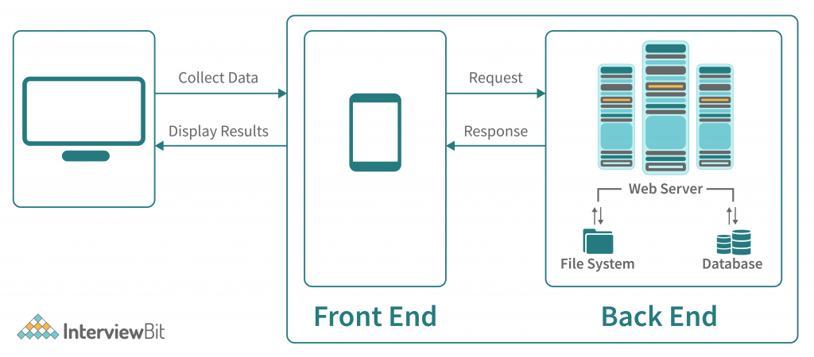

Figure 1 – Overview

Introduce the Overview of the System Technology ( 150 – 200 words)

## Technology A

150 – 200 words

## Technology B

150 – 200 words

## Technology C

150 – 200 words

## Market analysis

### Survey Introduction / Research Activity / Research Methods

Words: 200 – 300 words

### Result Analysis

Words: 700 – 1000 words

### Conclusion

Words: 200 – 400 words

### User Persona

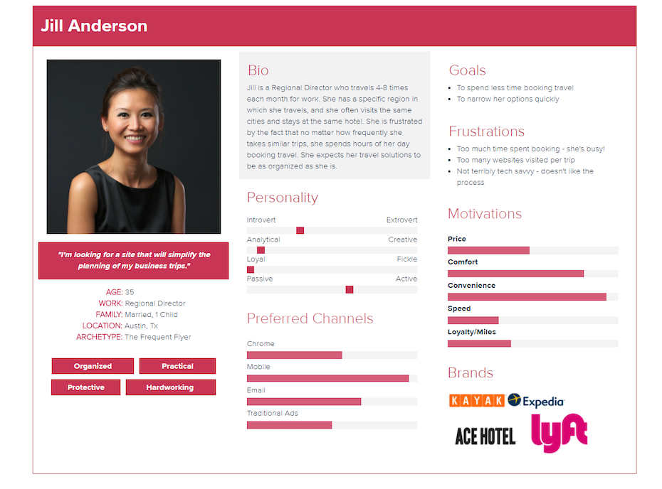

Figure 2 - User Persona

Persona explanation: 150 – 200 words

# Legal, Social, Ethical and Professional Issues and Considerations

*Note: được học kỹ ở môn Requirements Management*

# Requirements

## Analysis of requirements

*Note: sẽ chỉ nêu general về yêu cầu của sản phẩm*

Words: 100 – 200 words

## Existing Solutions

### Product A

Introduction

Pros

Cons

*Words: 100 – 200 words*

### Product B

Introduction

Pros

Cons

*Words: 100 – 200 words*

### Product C

Introduction

Pros

Cons

*Words: 100 – 200 words*

*Note: từ yêu cầu, đi so sánh với những sản phẩm / giải pháp đang tồn tại trên thị trường, chỉ ra điểm mạnh / yếu*

### Conclusion

*Note: sau khi đã so sánh, rút ra kết luận là sản phẩm của minh sẽ có những ưu điểm gì vượt trội so với những sản phẩm đang có trên thị trường*

*Words: 150 words*

# Business Requirements

## Overall Picture

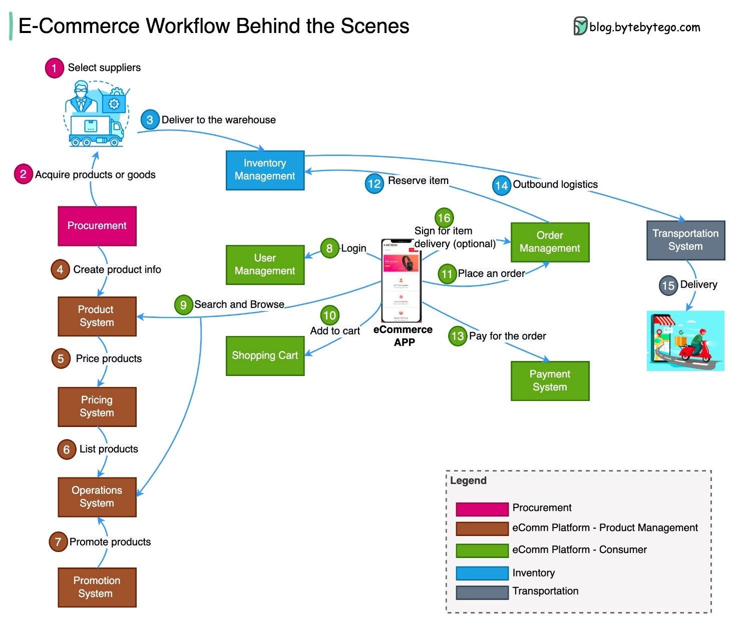

Figure 3 - Rich picture

*Note: include hình miêu tả tổng về dự án của minh*

Words: 100 - 150

## Functional Requirements with MoSCoW prioritisation

*Note: học kỹ hơn ở môn Requirements Management*

Words: 300 - 500

|  |  |  |  |
| --- | --- | --- | --- |
| ID | Description | Priority  (Must – Should – Could -Won’t) | Estimation  (2 – 3 – 5- 8 days) |
| USR_01 | As an *<user>,* I want *<something>¸* so that *<why>* | Must | 8 days |
| USR_02 | As an *<user>,* I want *<something>¸* so that *<why>* | Should | 2 days |
| ADM_01 | As an *<user>,* I want *<something>¸* so that *<why>* | Could | 2 days |

|  |  |  |
| --- | --- | --- |
| SUMMARY | | |
| Priority | **Number of features** | **Number of days** |
| Must | 1 | 8 |
| Should | 1 | 2 |
| Could | 1 | 2 |
| TOTAL | 3 | 14 |

## Non-functional Requirements

*Note: học kỹ hơn ở môn Requirements Management*

|  |  |
| --- | --- |
| ID | Description |
| NF_01 | Description |
| NF_02 | Description |
| NF_03 | Description |

Words: - 50 – 100 words

# Analysis and Design

## Context Diagram

*Here is an example of a system context diagram that describes an Internet banking system that you may be building:*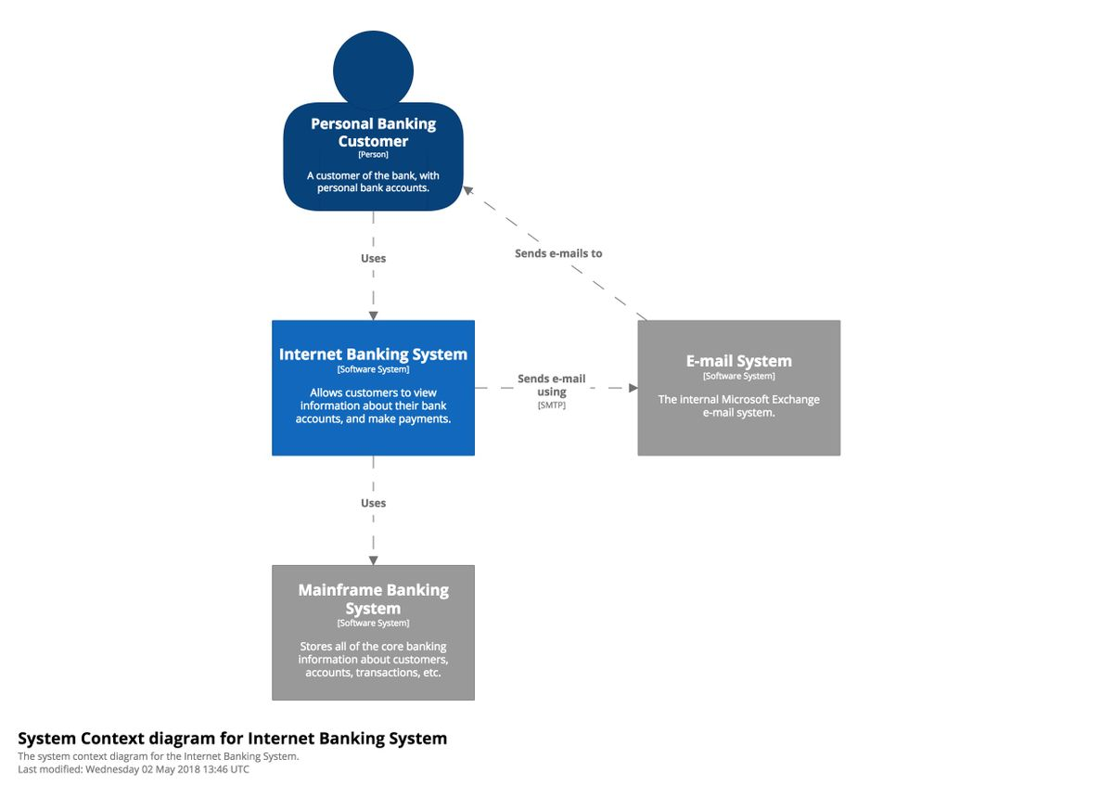

Figure 4 – System Context Diagram

Introduction the chosen architecture: 100 – 150 words

## Container Diagram

Below is a sample container diagram for the Internet banking system.

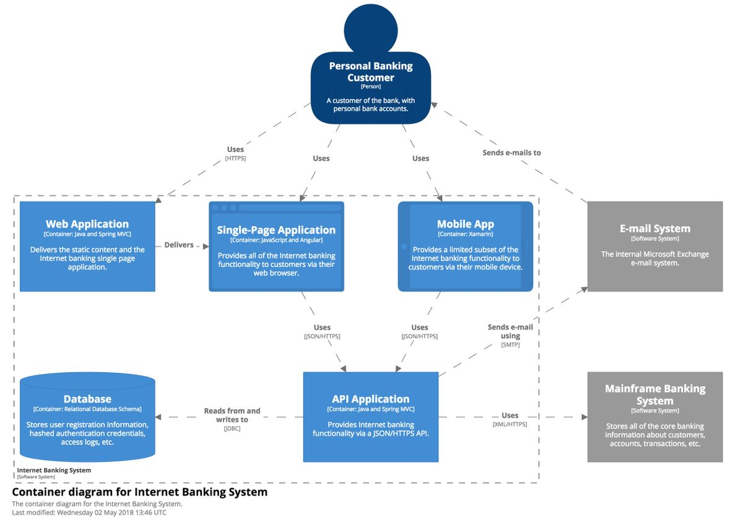

Figure 5 – Container Diagram for Internet Banking System

### Assumptions

*Words: 300 - 500*

### 3rd party Services

*Note: làm rõ là dự án có dùng những Service bên thứ 3 ví dụ: login với Google, Payment với paypal hay VNPay*

Words: 100 – 150 words

### Programming language

Words: 50 - 70

### Front End technology

Words: 50 - 70

### Back End technology

Words: 50 - 70

### Database

Words: 50 - 70

### Mobile App (opt.)

Words: 50 - 70

### Operation System

Words: 50 - 70

### Hosting ( AWS, GCloud, Heroku, Azure … )

Words: 50 - 70

## Component Diagram

Here is a sample component diagram for the fictional Internet banking system that shows some (rather than all) of the components within the API application.

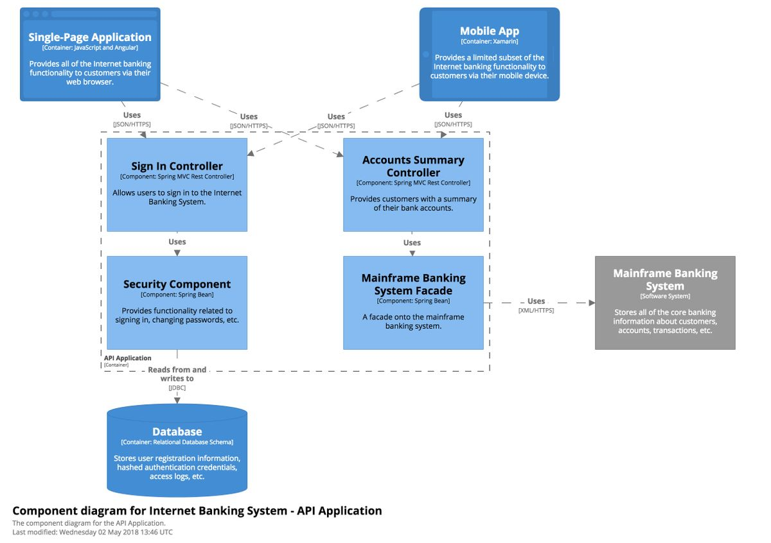

Figure - Component diagram for Internet Banking System

### API Endpoints

|  |  |  |  |  |  |
| --- | --- | --- | --- | --- | --- |
| Id | URL | Method | Description | Params | Returns |
| 1 | /reservation | POST | Users reserve parking slot | user_id, garage_id, slot_id | reservation_id |
|  |  |  |  |  |  |
|  |  |  |  |  |  |

## Code Diagram

### Use Case diagram

### Entity Relationship Diagrams

### Class Diagram

### Activity Diagram

# Implementation

## Database

*Note: đưa những dẫn chứng những thứ mình đã dev.*

*Database: final ERD + giải thích implement như thế nào*

## Project Overview

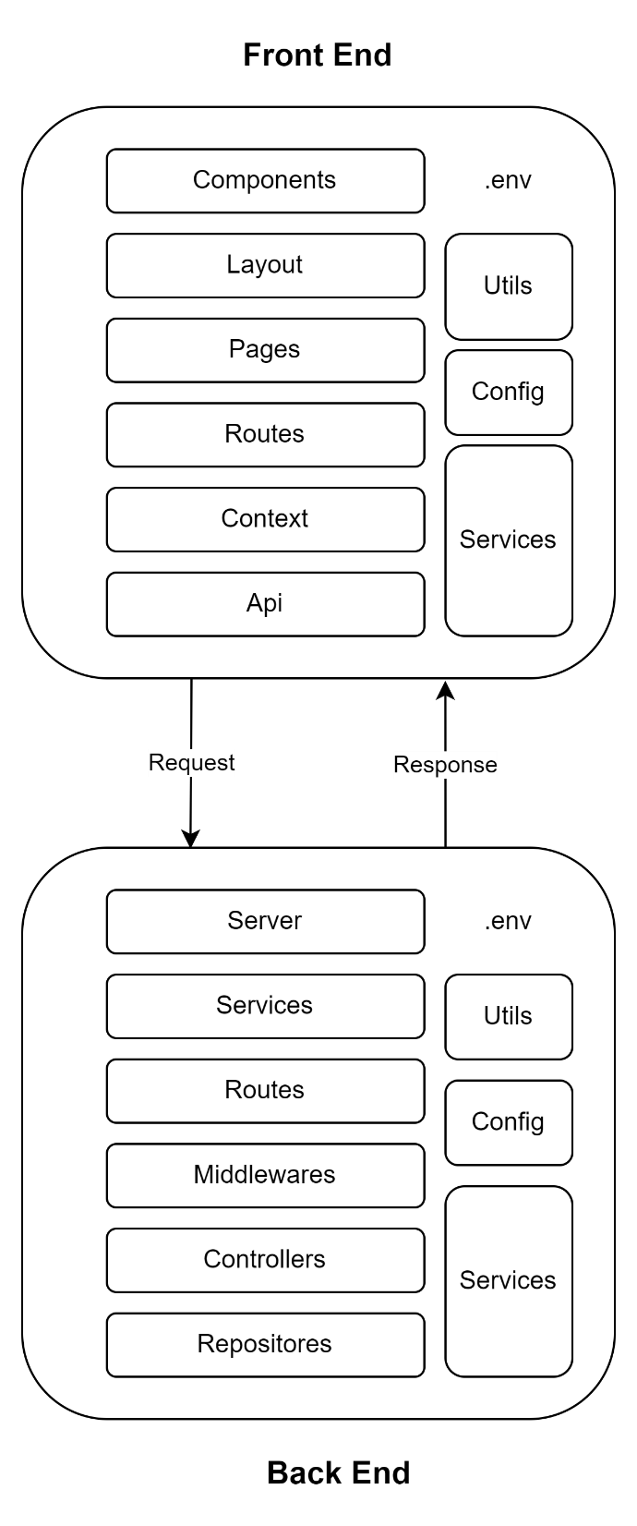

Figure 7 - Project overview

Explanation: 200 – 300 words

## Front End

### Project Folder Structure

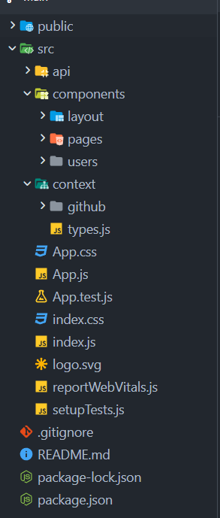

Figure 8 - Front end folder structure

Explanation: 200 – 300 words

### Source code samples

*Note: đưa ra samples những đoạn code hay component quan trọng của front end*

Words: 300 – 500 words

## Back End

### Project Folder Structure

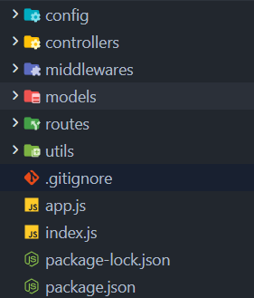

Figure 9 - Back end folder structure

Explanation: 200 – 300 words

### Swagger Documentation

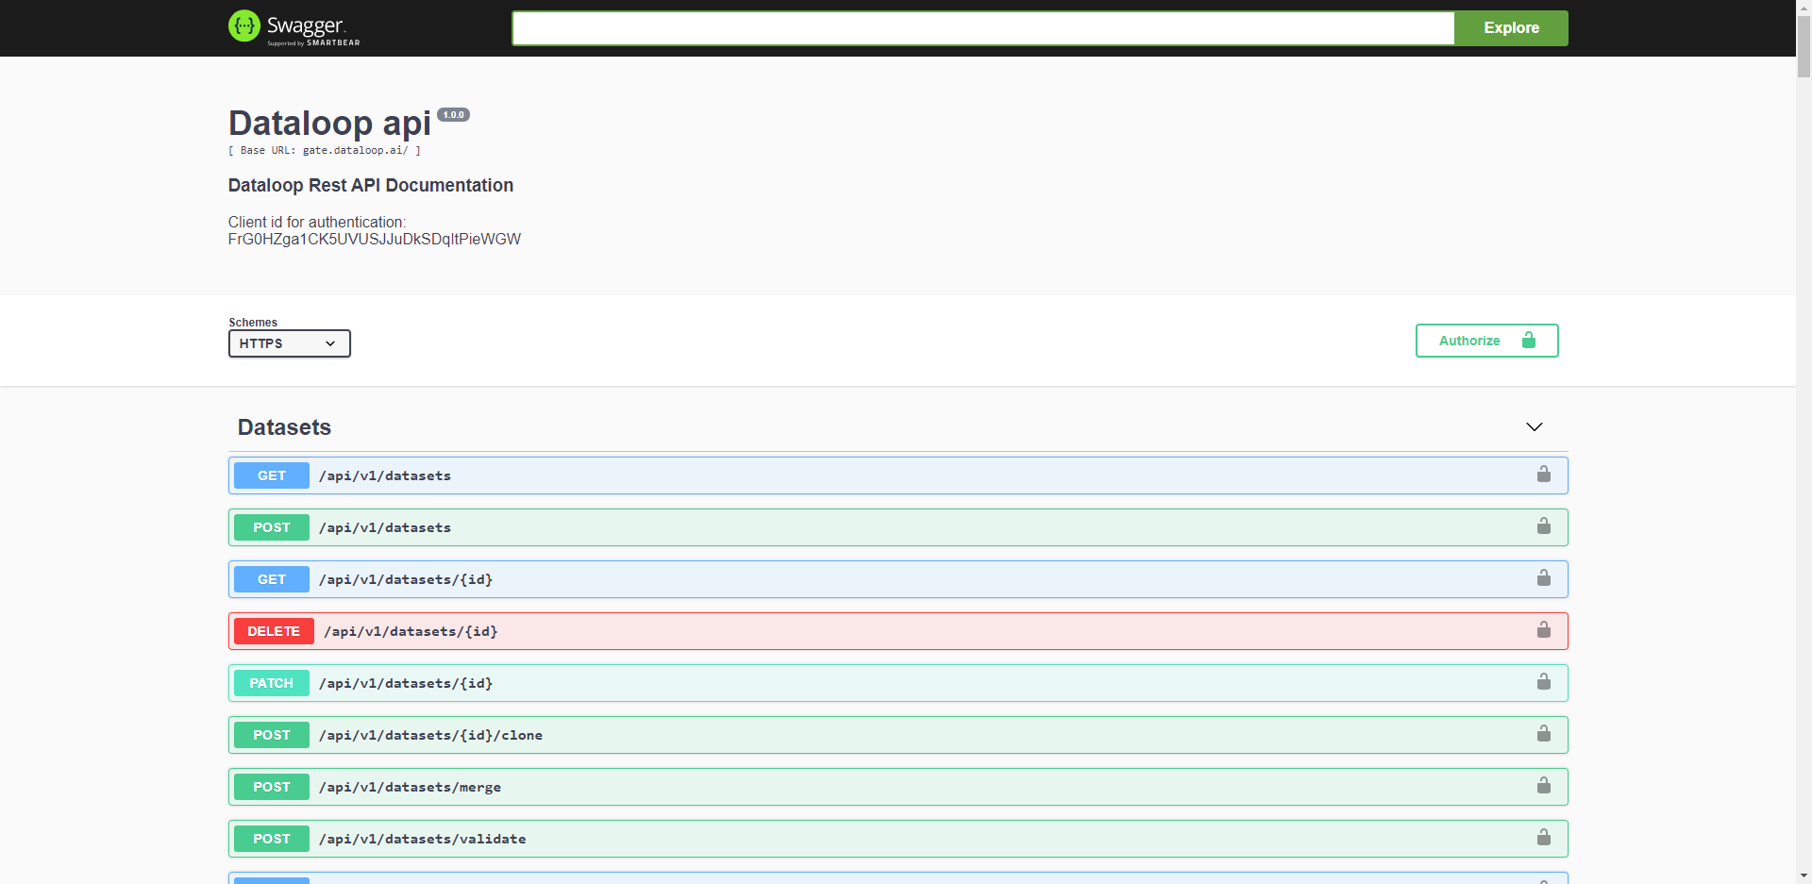

Figure 10 - Swagger Documentation

### Source code samples

*Note: đưa ra samples những đoạn code hay component quan trọng của front end*

Words: 300 – 500 words

## GitHub

Words: 100 - 150

## Project Management (Trello, Jira, GitHub Projects, etc.. )

Words: 100 - 150

## Deployment

*Note: đưa ra những hình ảnh mô tả việc deploy + kết quả cuối cùng*

## Images

*Note: đưa ra kết quả cuối cùng của dự án (screenshots + giải thích 2 – 3 dòng)*

# Testing

Words: 300 - 500

# Evaluation

## Summarised Key findings from the project

*Note: tóm tắt lại những gì minh đã khám phá được trong quá trình chạy dự án*

* *Về mặt tech*
* *Về mặt business*
* *150 – 200 words*

## Recommendations for future development

*Note: nêu ra những gì có thể được phát triển thêm trong tương lai*

*150 – 200 words*

## Project Evaluation

* *Review lại dự án*
* *Những gì đã hoạt động tốt*
* *Những gì chưa hoạt động*
* *150 – 200 words*

## Personal Evaluation

* *Những gì tốt*
* *Những gì chưa tốt*
* *Những gì đã học được trong quá trình dự án*
* *150 – 200 words*

## Conclusion

150 words

# References

# Appendix A – Project Proposal

# Appendix B - Planning

# Appendix C