**COMP2005 - Team Project**

**Group L**

**Processes and Management Documentation**

**Management:**

At the start of the project, we opted for having a Project Manager, and agreed on allocating that role to Sajid. At the start of every work day, we will discuss what we should be working on for that day, review our timeline, and Sajid will go over task allocation for each of the team members.

**Version Control:**

We used Git and GitHub as a platform for source version control, following a workflow of feature branching (for every feature a new branch is created, code is committed to it, then a pull request is made back to master). Often, Moustafa and Sajid will be responsible for reviewing pull requests, unless there is someone else familiar with the committed code, where in that case they will be assigned as a reviewer instead. All team members contributed to development of the prototype equally.  
  
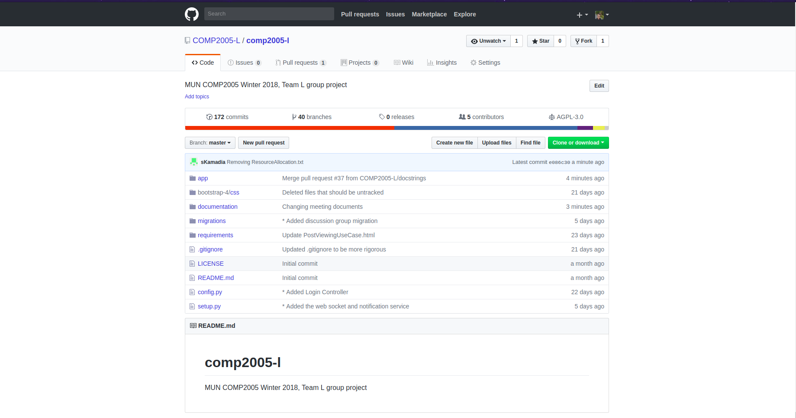  
  
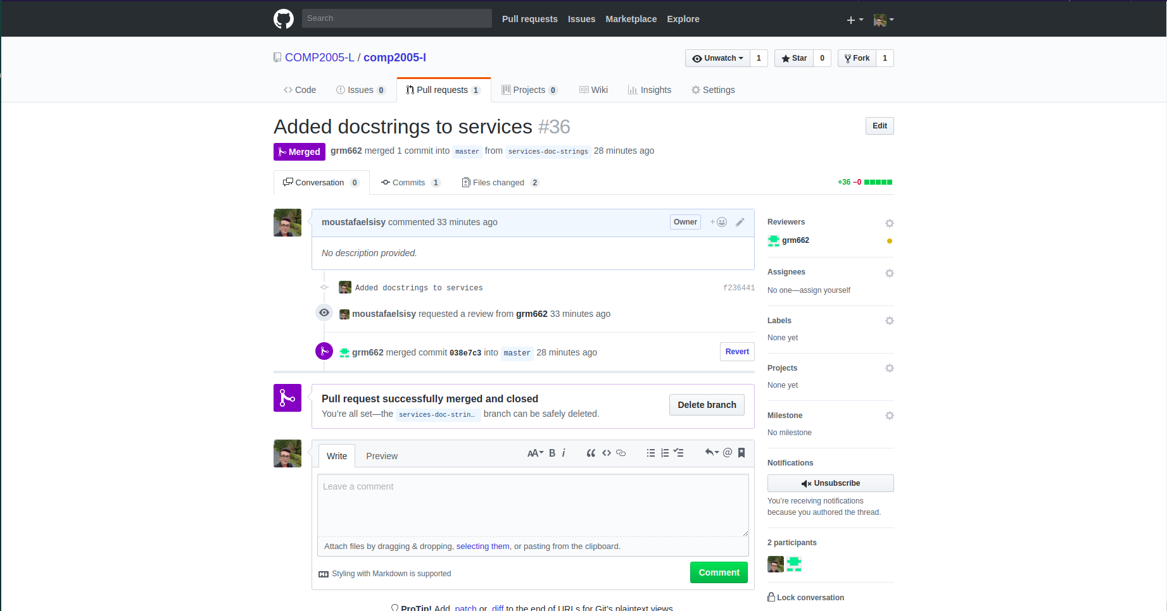

**Communication:**

We used Slack for instant messaging and keeping all our discussions, polls and notifications in one place. We added a GitHub integration for our repository to our slack channel, in order to notify us whenever a pull request is created, and whenever it is closed.  
  
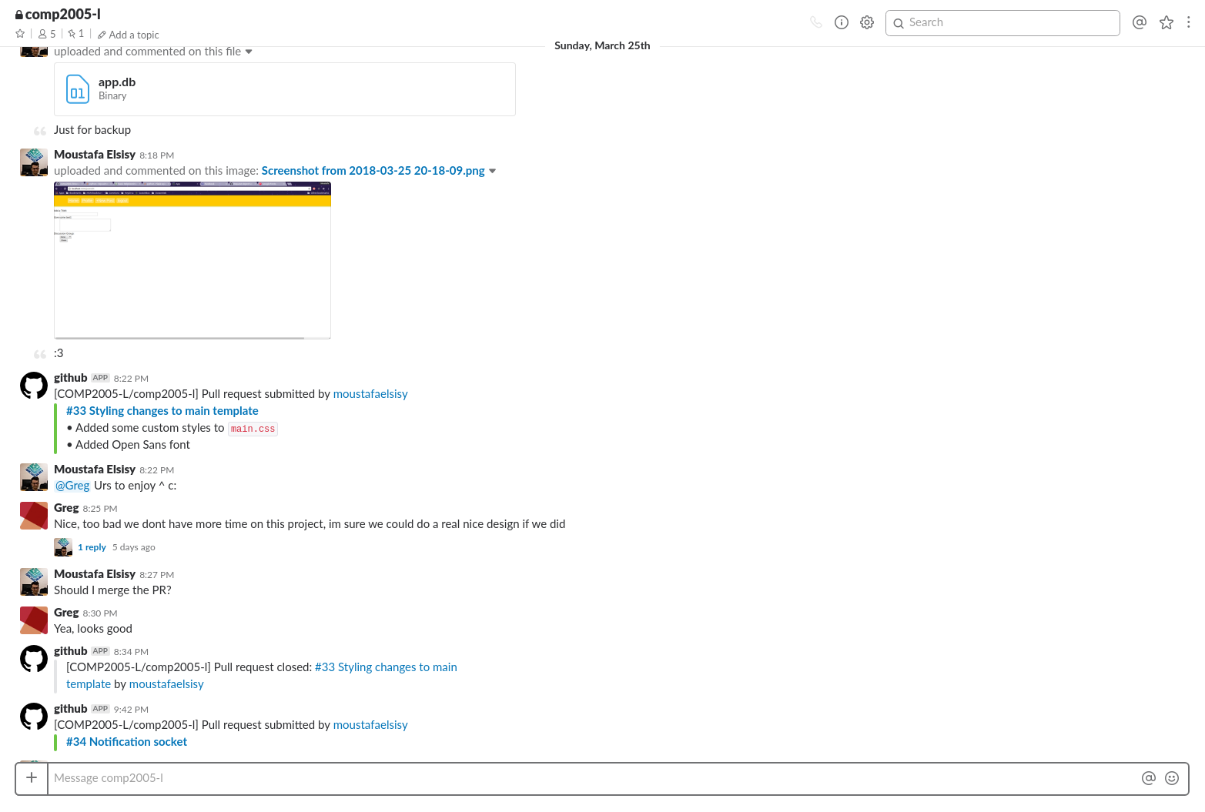

**Meetings:**

At the start of every feature, we will have a meeting to perform the Low Level Design for that feature. We would first discuss together a rough idea of how the structure of the feature should look like, then we would draw a UML diagram on a board, and have everyone contribute parts of the interface that they think are missing, until we have an architecture that all team members are content with.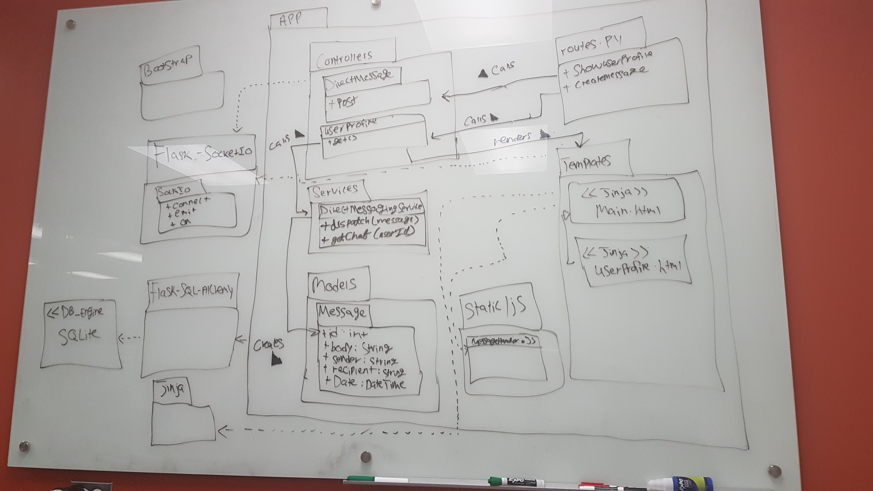  
After that, one of the team members will be responsible to transform the design on the board to a digital UML diagram, that can be reviewed and distributed easily.