**Food Tinder**

Mobile Application

Administrative Assistant Manual and Handbook



Food Tinder

November, 2020

Last Revised: 10.0-4, December, 2020

|  |  |
| --- | --- |
| 1. Introduction | 4 |
| * 1. Purpose of Administrative Manual …………………………………… | 4 |
| * 1. Preliminary reading ……………………………… | 4 |
| * 1. Structure of this Manual ……………………………………………..   2. About the manuals in general…………………………………………… | 4 |
| 1. Overview ………………………………………… | 5 |
| * 1. App download Instructions …………………………………………………. | 5 |
| * 1. Is Food Tinder free? …………………………………………………………... | 6 |
| * 1. Signing up and getting started ……………………………………………………… | 6 |
| 1. Installation ……………………………………………………………. | 7 |
| * 1. Android Studio ………………………………………... | 7 |
| * 1. Firebase ………………………………………………………... | 8 |
| 1. Android Studio …………………………………………………. | 9 |
| * 1. Features of Login/signup/Guest login ……………. | 9 |
| * 1. Features of Add Menu………………………… | 10 |
| * 1. Features of Add Restaurant………………….. | 10 |
| * 1. Features of View Account Information   Find a Match ……………… | 10 |
| Edit………………………………………………………………….. | 11 |
| Reset Password…………………………………………... | 12 |
| 1. Android Studio Developer guide……………………………………………………… | 14 |
| * 1. Fundamentals…………………………………….   2. Components………………………………………   3. Activity Classes ……………………….   4. Food Tinder Resources………………………   5. User Interface…………………………………...   6. Manifest file………………………………………………………….. | 16 |
| 1. How to run Food Tinder app……………………………………………………………… | 21 |
| 1. Deploying Food Tinder Application…………………………………………………... | 22 |
| * 1. Release Preparation……………… | 22 |
| * 1. Testing………………………………… | 22 |
| * 1. Refreshing app assets for release…………………………… | 23 |
| * 1. Keeping a check on all remote services………………….. | 24 |
| 1. Appendix |  |
| * 1. Frequently asked questions………………………. | 25 |
| * 1. Index……………………… | 28 |

CONTENTS

**COPYRIGHT, TRADEMARKS, AND DISCLAIMER**

Copyright

Centennial College (educational purpose).

##### Trademarks

Food Tinder is a registered trademark of Centennial College for educational purposes.

App Store is a service mark of Apple Inc. Android is a trademark of Google Inc.

All other trademarks mentioned in this document are trademarks of their respective owners.

##### Disclaimer

This text is intended for general information purposes only, and due care has been taken in its preparation.

Any risk arising from the use of this information rests with the recipient, and nothing herein should be construed as constituting any kind of warranty.

Food Tinder team reserve the right to make adjustments without prior notification.

All names of people and organizations used in the examples in this text are fictitious. Any resemblance to any actual organization or person, living or dead, is purely coincidental and unintended.

This app may make use of third party software for which specific terms and conditions may apply. When that is the case, you can find more information in the description provided on the application installation page on app store.

1.0 Introduction

* 1. **Purpose of Administrative Manual**

The purpose of this administrative manual is to provide guidance and information to the users for the effective and efficient implementation and administration of the Food Tinder Application from developer’s point of view. The Administrative Manual includes how to make the application requirements, create/edit/delete profile, preference, selecting right restaurant, and joining a chat room using proper libraries and tools.

**1.2 Preliminary reading**

In order to understand this manual, you need to have a basic understanding of the Java language.

Since, this application adheres to android studio, this guide also assumes that you understand the basics of database and coding. Especially,

* Android Studio
* Firebase

**1.3 Structure of this manual**

To assist you with exploring this guide, it is separated into a few big parts. Each part tends to a specific wide topic concerning Food Tinder application development. The parts of this manual are in the following order:

Step by step explanation

1. Installing android studio and learning how to use different methods that helped in the creation of our application
2. To understand the functionalities of firebase that our team used to manage, create, and store data as well as pictures for Food Tinder application.

**1.4 About the Manuals in general**

The Administrative Manual fills in as a manual to help representatives in their everyday execution of managerial and the board capacities. The manual contains directions for finishing structures, shows software connections and necessities, gives methods for mentioning administrator services and portrays responsibilities and work.

**OVERVIEW**

The Food Tinder application was developed by the students of Centennial College. They have created this application for course needs. The application is about adding a fun element for users to search and navigate food information by using a mobile phone.

**APP DOWNLOAD INSTRUCTIONS**

Food Tinder is currently available on iOS and Android devices. It currently supports iOS 10.0 and up, and Android 6.0 and up.

Apple

• Click on the Apple app store button and search the application’s name.

• This takes you to the download page of the Apple App Store.

• Click on the Download Now button.

• Follow the prompts.

Google Android

• Click on the Google app store button and search the application’s name.

• This takes you to the Food Tinder page of the Google App Store.

• Click on the Install button.

• Follow the prompts.

Blackberry

• Click on the Blackberry app store button and search the application’s name.

• This takes you to the Food Tinder page of the Blackberry App Store.

• Click on the Install Right Now link.

• Follow the prompts.

**Is Food Tinder Free to use?**

Food Tinder is accessible for free in the App Store and Google Play Store.

The rudiments: Swipe. Match. Join chat room. Visit. That is our mantra. It's simple and enjoyable to discover individuals on Food Tinder to dine with. We made our application stand apart with providing best restaurants and pictures and a bit of something about you to enjoy by adding a matchmaking feature. Swipe right on a picture to like, swipe left to pass. On the off chance that somebody likes the same dish as you, it's a Match!!!

**SIGNING UP AND GETTING STARTED**

Welcome to Food Tinder!

Before you start swiping, matching, chatting in a group room, you will have to make a food tinder account by following the steps below. These steps may vary as per your device compatibility and version.

### **iOS**

1. Download the Food Tinder app for IOS
2. Tap “Create Account”
3. Enter and verify your phone number
4. Enter your email address
5. Set up your profile
6. Allow Food Tinder access to all required permissions
7. Get started!

### **Android**

1. Download the Tinder app for Android
2. Select a login method
3. Enter and verify your phone number
4. Set up your profile
5. Allow Food Tinder access to all required permissions
6. Get started!

**Installing Android Studio**

Android Studio is the authority incorporated development environment for Google's Android working framework, based on JetBrains' IntelliJ IDEA software and programmed explicitly for Android advancement.

Operating system: Windows, macOS, Linux

Stable release: 3.1.3 (June 2018; 1 month ago)

Preview release: 3.2 Beta 5 (July 30, 2018; 1 day ago)

License: Freeware +Source code

Size: 854 MB compressed

Developed by: Google, JetBrains

How to install?

1. Go to this link <https://developer.android.com/studio/#downloads> for zip file.
2. Click DOWNLOAD ANDROID STUDIO button as shown in the picture below.

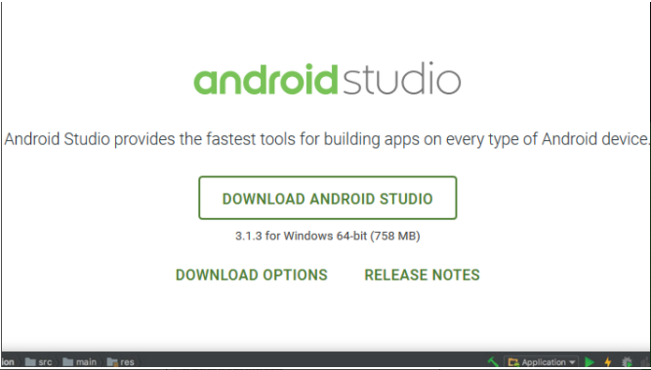

1. Agree the terms and conditions
2. After the downloading has finished, open the file from downloads and run it.
3. In the next prompt it’ll ask for a path for installation. Choose a path and hit next.
4. Once everything is installed, click on ‘Open an existing project’ and select FoodTinder-development and now you have the authority to view all the files and run it.

**Getting connected to firebase using android studio**

Firebase is a versatile mobile platform that helps you rapidly grow top notch applications, develop your client base, and bring in more cash. Firebase is comprised of integral highlights that you can blend all together to meet your requirements, with Google Analytics for Firebase at the core.

You can search and coordinate Firebase services into your application straightforwardly from Android Studio as shown in the picture below using Assistant tool window in android studio.

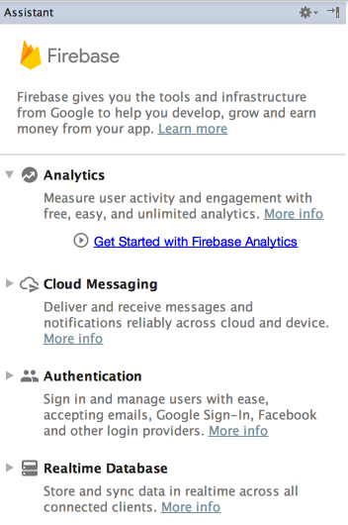

First ensure you have introduced Google Repository version 26 or higher, by following these:

* Snap Tools, it will open the SDK Manager.
* Snap the SDK Tools tab.
* Check the Google Repository checkbox, and press OK.
* Snap OK to install.
* Wait for the installation to end and snap Finish.

You would now be able to open and use the Assistant window in Android Studio by following these means:

* Snap Tools it will redirect to Firebase to open the Assistant window.

Snap to extend one of the given features (for instance, Analytics), at that point click the Get Started to join Firebase and add the vital code to your application.

This is where you will find all the databse for Food Tinder application.

4.0 Android Studio

All the features of the Food Tinder application explained below are executed using Android studio.

**4.1 Features of Login/Signup/Guest login Page**

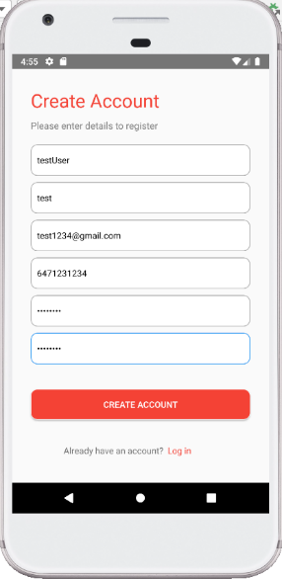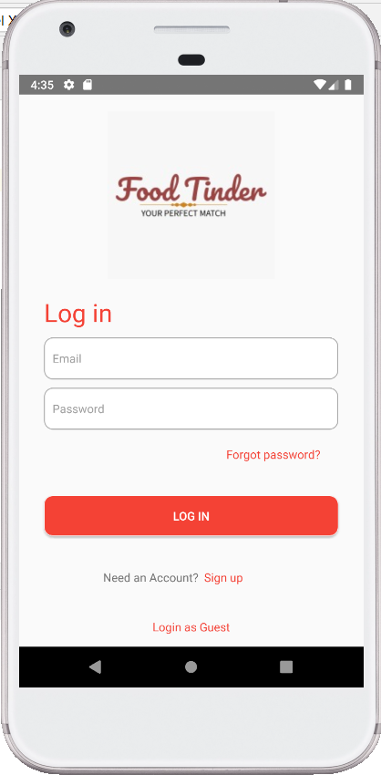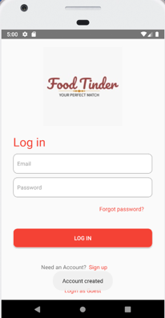

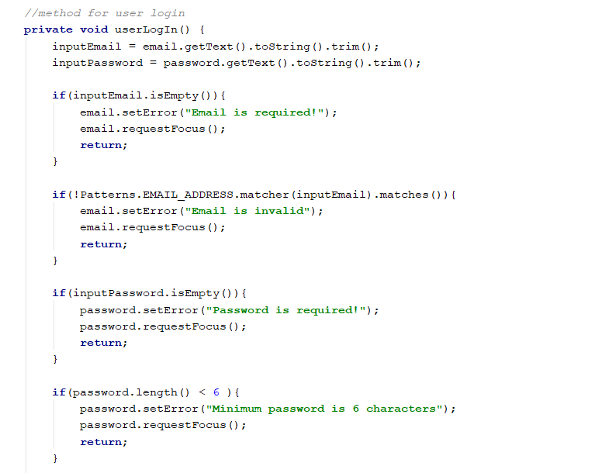

In android studio, first we created the Signup/login page for simple users as well as the guest users. We used some components such as Viewpager, Fragment, Image view, Textview, Button, and Edittext.

There is only one restriction, that the user should enter the details for every input in the correct format without leaving anything blank otherwise it will show an error.

* For email, standard email format
* For password, alphabets, numbers, and special characters(minimum-6).
* For phone number, only digits no more than 10
* For name, only aplhabets

If the account is successfully created so the app will through a small pop-up toast message. All the information added by the user will automatically get stored in the database.

If not then we have created Toast.mainText message as seen in the picture below:

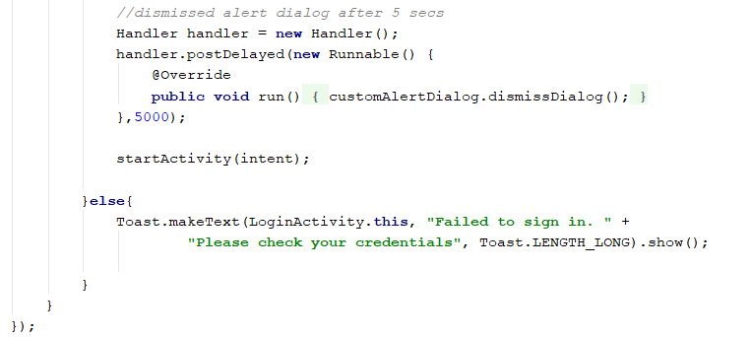

**4.2 Features used in Add Menu**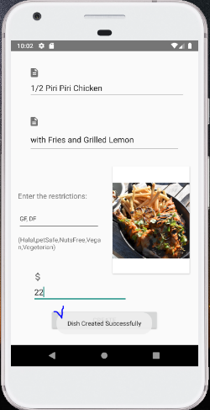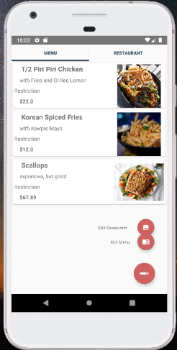

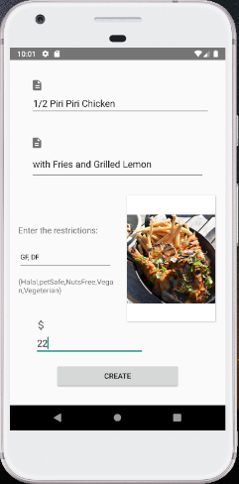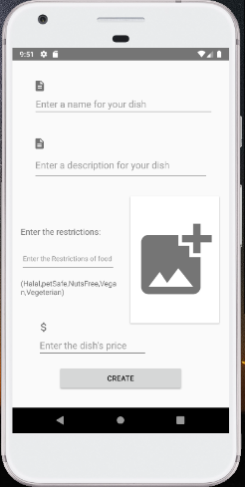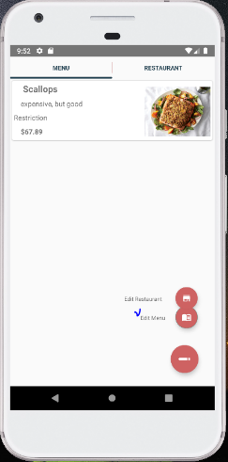

In add a new menu, open the ‘See existing menu’ page which has the pencil button on the right corner intended for the restaurant owners to add a new menu.

The ‘Edit Menu’ button is connected to the edit page where a text box will accept the alphabets, an image view created for displaying the picture of the specific menu in jpeg and png format, a food restriction textview that will also accept alphabets, and finally to enter the price that accepts numbers only.

If the menu is successfully added then the toast message will pop up. The menu which was

added will be shown in the menu list page.

ADD RESTRICTION

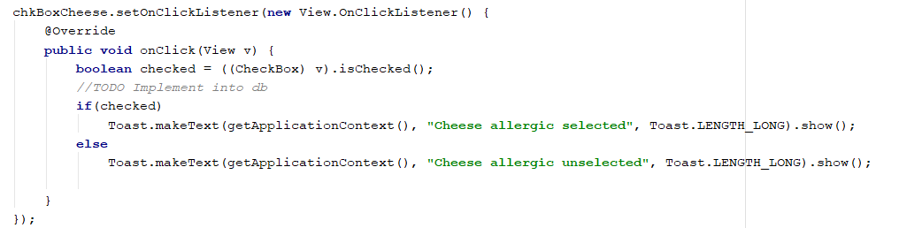

These restrictions allow users to add any preference they want to add. Here our developers have created four restrictions such as cheese, nuts, vegan, and vegetarian. If a user selects any restriction, then the toast message will pop up. Toast is the object with makeTest() method which in the picture showed above took three parameters: context, message, and the duration for the toast message.

**4.3 Features used in Add Restaurant**

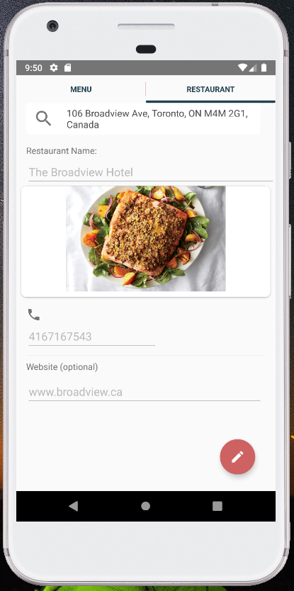

In add a new restaurant, open the ‘See existing Restaurant’ page which has the pencil button on the right corner intended for the restaurant owners to add a new Restaurant.

The ‘Edit Restaurant’ button is connected to the edit page where a text box will accept the alphabets, an image view created for displaying the picture of the specific restaurant in jpeg and png format, and finally to enter the website name which accepts the standard format as required to build a website.

If the restaurant is successfully added then the toast message will pop up. The restaurant which was added will be shown in the restaurant list page.

**4.4 Features used in View Account Information**

1. Find a match

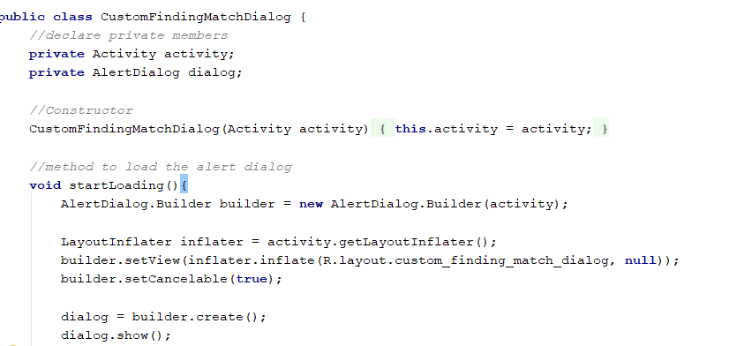

Here we have used the inflater that initiates the layout file converting them into view objects. These objects are then used to draw the finding a match screen.

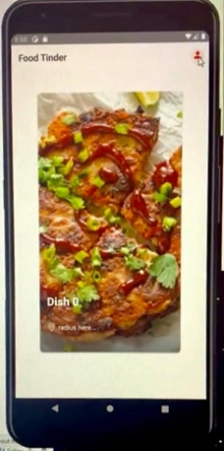 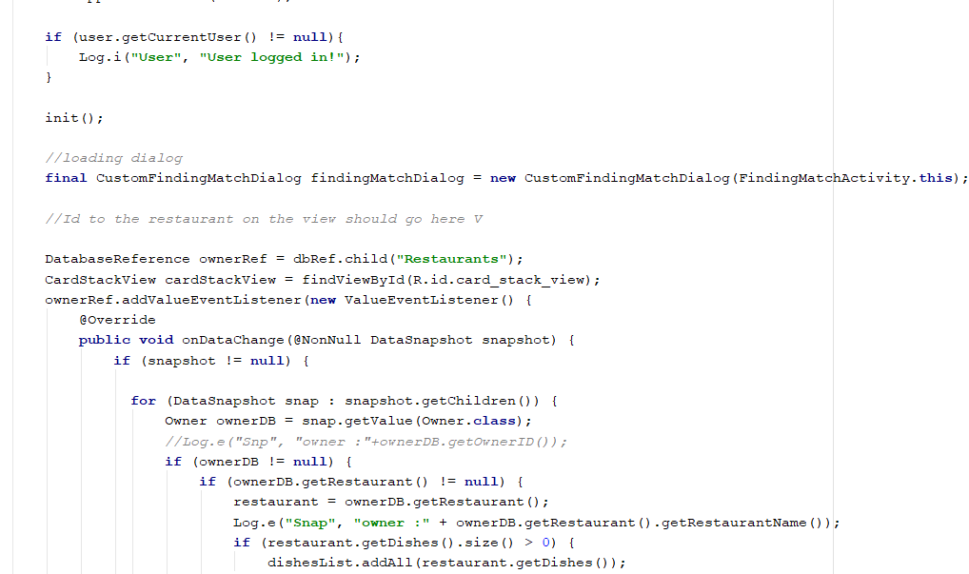

On the ‘Finding Match’ screen button in the form of an icon is created so that the user can navigate to the ‘Account View’ screen. This screen shows all the details already stored in the database.

EDIT ACCOUNT

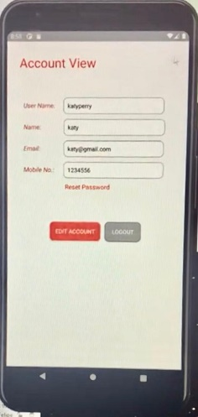

Here we have created four textviews which has pre-defined meanings and for each a textbox where the user needs to input the correct values with proper format. For email, a proper email address, and for mobile number, only digits will be accepted otherwise the user will not be able to edit the account and save the changes made using ‘SAVE’ button

In case the user doesn’t wish to edit the account details, he/she can logout the application using the Logout button.

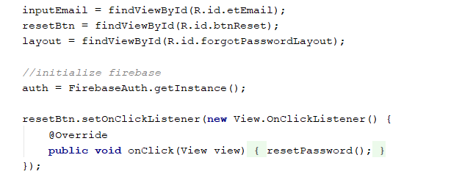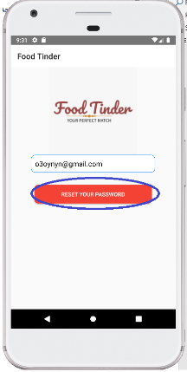

RESET PASSWORD

If by chance the user forgets the password, then we have created a password reset functionality using reset button which will find the username by viewID for hassle free experience. The user just needs to enter the pre-registered email so that the system’s database can identify the stored email successfully in order to send the recovery link.

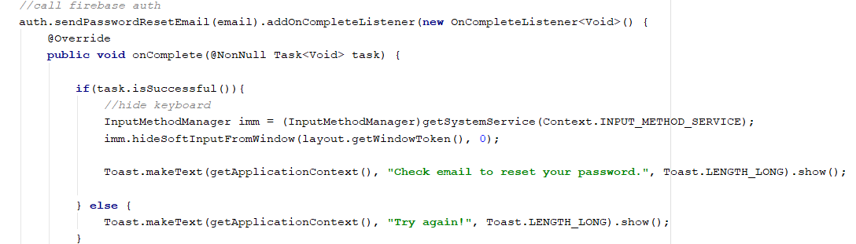

Once the user clicks the link a dialog window will appear asking for a new password which will get saved after the user presses the ‘Save’ button. All these functions are added in android Studio with Firebase as a database tool to store all the information.

5.0 Android Studio Developer Guide

**5.1 Fundamentals**

Android applications can be composed utilizing Java, Kotlin, and C++ languages. The Android SDK instruments assembled our code in Java alongside any information and asset records into an APK, an Android bundle, which is a file document with an .apk postfix. One APK document contains every content of Food Tinder application and is the record that Android-controlled gadgets use to introduce this application.

1.The Android working framework is a multi-client Linux framework in which Food Tinder is an alternate client.

2. Naturally, the framework allows Food Tinder application an exceptional Linux client ID (the ID is utilized simply by the framework and is obscure to the application). The framework sets authorizations for all the records in an application so just the client ID relegated to that application can get to them.

3.Each cycle has its own virtual machine (VM), so an application's code runs uniquely.

4.By default, our application runs in its own Linux cycle. The Android framework begins the cycle when any of the application's segments should be executed, and afterward closes the cycle when it's not, at this point required or when the framework must recuperate memory for other applications.

**5.2 Components**

They are known as the building blocks of Android application. The components may ddepend on one another and thus act as an entry point through this the user as well as the system can enter Food Tinder application.

They can be categorized in four types:

* Activities
* Services
* Broadcast receivers
* Content providers

**5.3 Activity Classes**

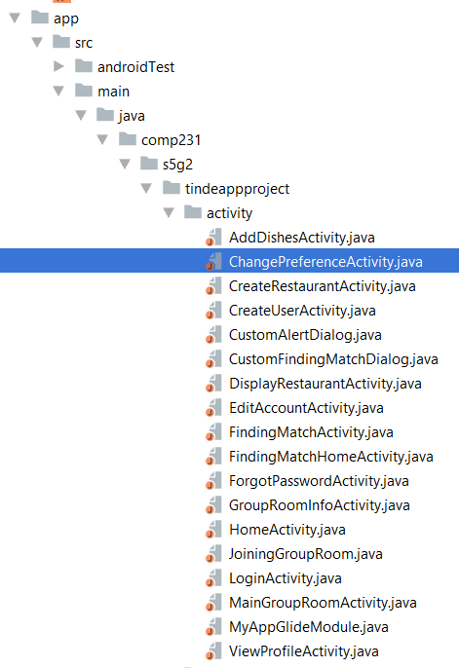

When you open the application in Android Studio then follow this path app > resource > main > java > comp231 > s5g2 > tinderappproject > activity, you can see the eighteen activities that are used in the development of Food Tinder Application.

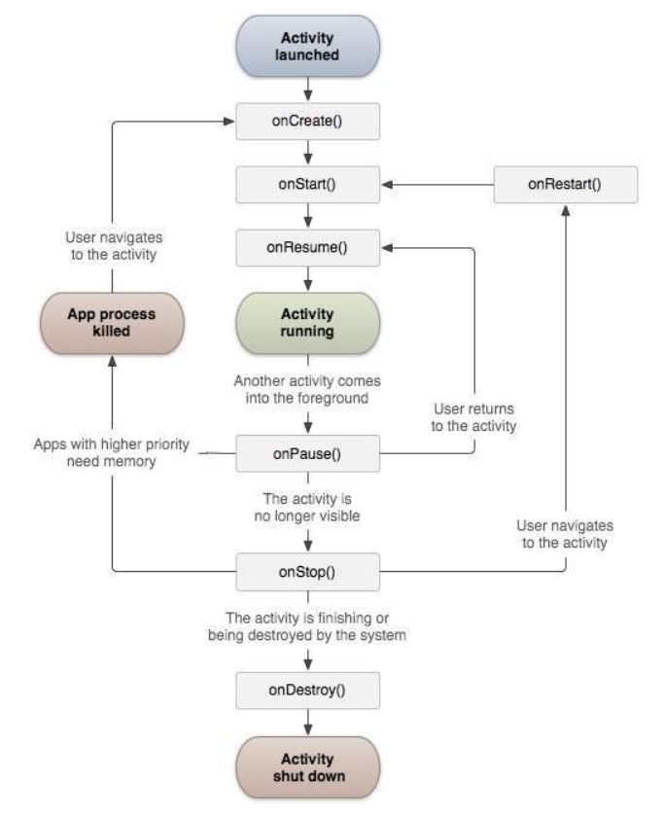

Activity life cycle diagram

1. Activity Class

It characterizes the following callbacks for example events. We implemented a lot of methods in our project. In any case, it is significant that you understand every method and actualize those that guarantee our application carries in the way users anticipate.

|  |  |
| --- | --- |
| **S.No** | **Callback method and its importance** |
| 1 | **onCreate()**  When the activity is first created, this method is called hence it’s the first callback. |
| 2 | **onStart()**  When the activity becomes visible to the user, this method is called. |
| 3 | **onResume()**  When the user starts interacting with the application, this method is called. |
| 4 | **onPause()**  The paused activity does not receive user input and cannot execute any code and called when the current activity is being paused and the previous activity is being resumed. |
| 5 | **onStop()**  When the activity is no longer visible, this method is called. |
| 6 | **onDestroy()**  Before the system destroy any selected activity, this method is called. |
| 7 | **onRestart()**  When the activity restarts again after a stop, this method is called. |

The MAIN action or LAUNCHER category are declared for one of our activities, so our app icon will appear in the few screens of the application.

**5.4 Food Tinder Resources**

Resources are the extra files and static substance that your code utilizes, for example, bitmaps, UI strings, animation guide, layout files, and the sky is the limit from there.

We have placed each kind of resource in a specific subdirectory of Food Tinder's res/ directory. For example, here is the file hierarchy:

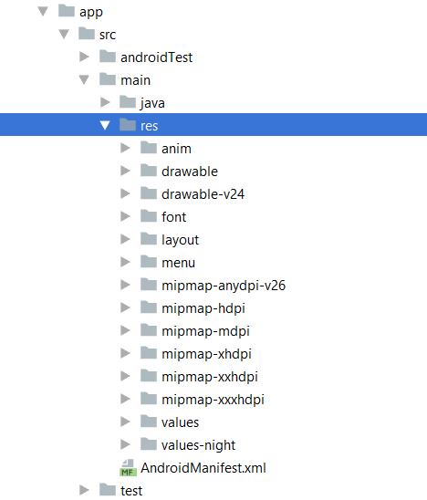

As you can look, the res/ directory contains all the resources (in subdirectories): an image resource, layout resource, mipmap/ directories for launcher icons, and a string resource file etc. The resource directory names are essential and are described below:

|  |  |
| --- | --- |
| **Directory** | **Resource Type** |
| animator/ | It is an xml file that defines property animations that changes the value of an object for longer time. |
| anim/ | It is an xml file that define tween animations that calculates size, start point, rotation etc. |
| color/ | It is an xml file that define a state list of colors. |
| drawable/ | Bitmap files (png or jpeg) and an xml file is compiled into the following drawable resource subtypes:   * Bitmap files * Animation drawables * Others |
| mipmap/ | This drawable file is for different launcher icon densities. |
| layout/ | It is an xml file that define a user interface layout |
| menu/ | It is an xml file that define app menus, such as an Options Menu, Context Menu |
|  |  |
| values/ | XML files that contain simple values, such as strings, integers, and colors. The filenames such as colors.xml, string.xml, themes.xml, we have created for resources. |
| xml/ | Arbitrary XML files that can be read at runtime by calling resource xml method. |
| font/ | Font files with extensions such as .ttf, .ttc, and xml files that have a <font-family> element. |

**5.5 User Interface**

Everything you see and interact with in this application is known as the user Interface.

1. LAYOUT

The main structure of User Interface. All the elements follow a certain pattern in this category such as shown below:

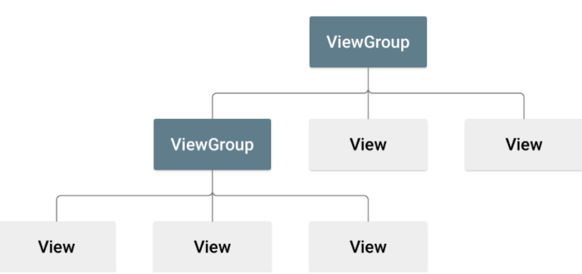

In Food Tinder Application the layout is declared in UI elements in xml e.g.

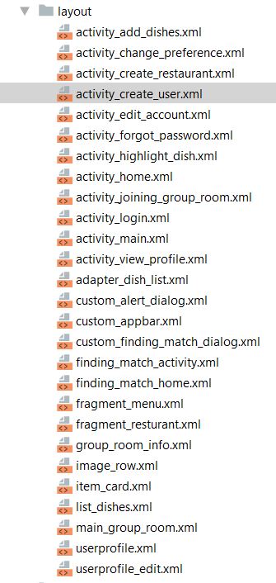 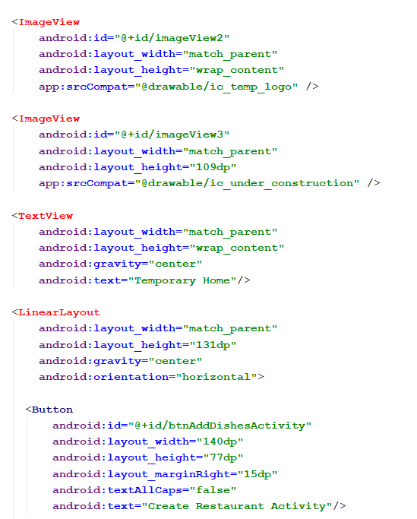

This xml layout uses a vertical LinearLayout to hold a Button, ImageView, and TextView after which the compilation process begins.

**5.6 Manifest File**

In Food Tinder application it describes the important information of our application to Android build tools, the android operation system, and google play. This file declares the Food Tinder package name, its components, and the permissions requires to open certain parts of the app and the system.

The following snippet from our code shows the root<manifest> with the package name as "comp231.s5g2.tindeappproject"

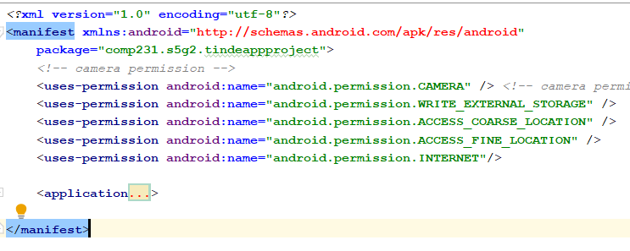

While building Food Tinder application into the final application package (APK), the Android build tools use the package attribute for two things:

This name is being used as the namespace for our app's generated R.java class for [app resources](https://developer.android.com/guide/topics/resources/overview).

Example: With the above manifest, the R class is created at comp231.s5g2.tindeappproject.R.

It uses this name to resolve any relative class names that are declared in the manifest file.

Example: With the above manifest, an activity declared as <activity android:name=".MainActivity"> is resolved to be comp231.s5g2.tindeappproject.MainActivity.

* 1. How to run Food Tinder application

There are two ways to run Food Tinder application.

1. Emulator

Create an Android Virtual Device (AVD) which your emulator can install and run Food Tinder app. From the target device drop-down menu select an AVD as you like.

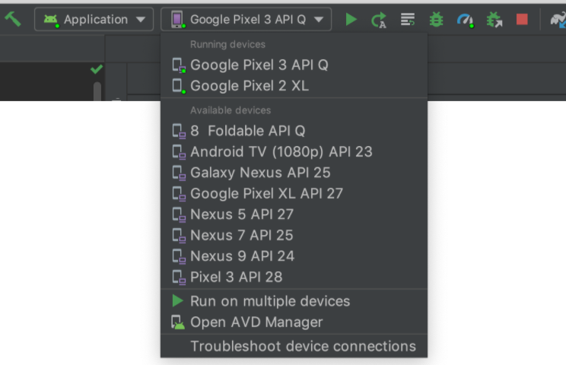

1. Real device

Connect your gadget to your computer with a proper USB cable. Then follow these points to enable USB debugging:

* Open developer options window > settings
* Select System
* Select About phone
* Tap build number at least seven times
* Go back and tap developer options
* Enable USB debugging

Again, choose the device from the drop-down as shown in the image above.

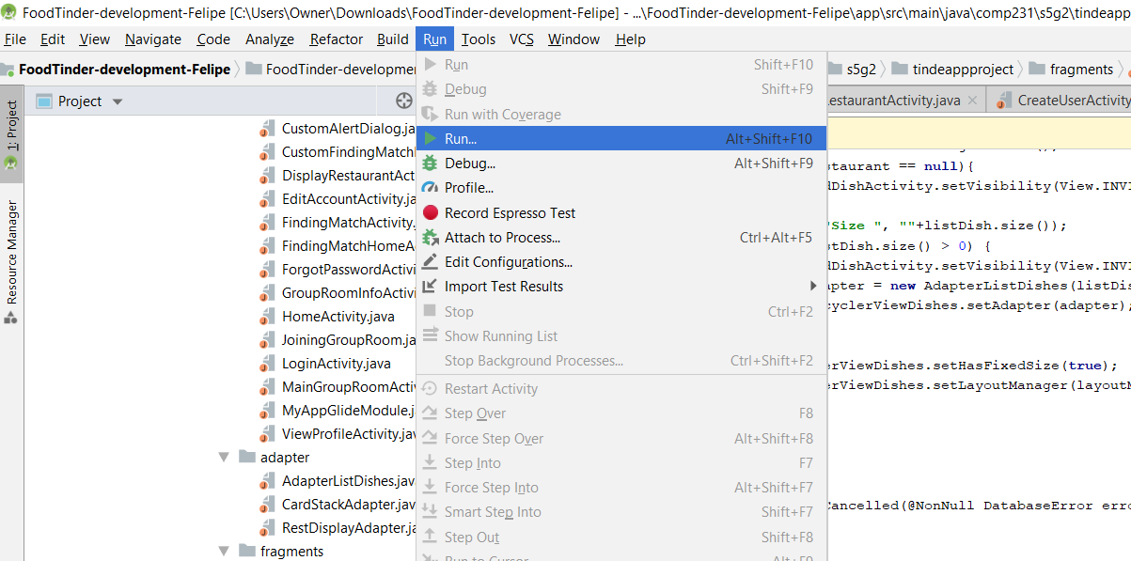

You can Run the project using the green button as showed in the picture above or using a shortcut Shift+F10.

7.0 Deploying Food Tinder Application

7.1 Release Preparation

At the very least we will eliminate Log calls and the android:debuggable trait from our manifest file. We have given esteems to the android:versionCode and android:versionName ascribes, which are situated in the <manifest> component. We have done a few settings to meet Google Play Store as well as iOS app store necessities or oblige methods that were utilized to deliver our application.

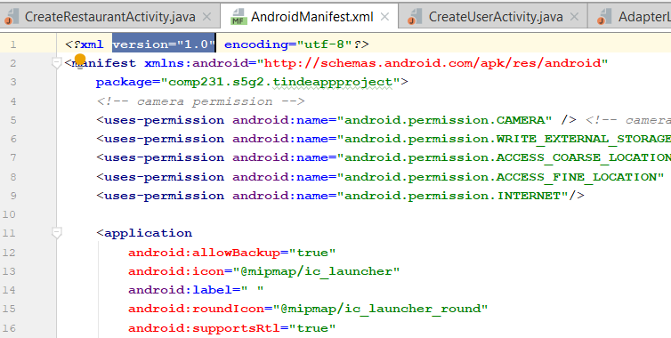

We have meticulously changed Gradle build files with release build type for publishing the updated version our application.

7.2 Testing the delivery adaptation of your application.

Before releasing our application, we have thoroughly tested the release version of Food Tinder application. It helped in the enhancement of software and hardware compatibility. For example, the tester introduces our app on Android, Apple iOS, and Blackberry to measure the performance on each.

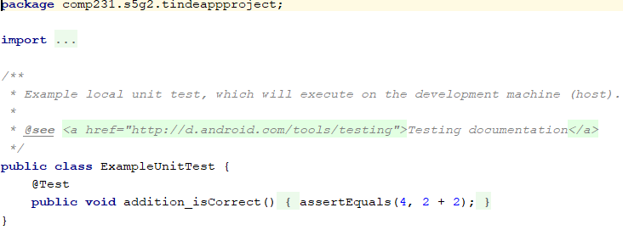

Here we have created the android ExampleUnitTest class in tinderappproject folder under the test folder.

7.3 Refreshing application assets for release.

We are certain that all application assets, for example, user manual, technical report and all the necessary documents are included with our application and rest is also well organized by our Customer and developers.

7.4 Keeping a check on every remote service our application relies upon.

Our application is well secured as only the people who worked in building this project can access it. We also gave our application a proper logo that differentiates our app.

Moreover, one of the unique features of using android studio is location awareness. The location APIs available in Google Play services facilitate adding location awareness to your app with automated location tracking, geofencing, and activity recognition with saves a lot of time as the device can be taken anywhere with you.

8.0 Appendix

**8.1 Frequently asked questions**

1. **Can I download Food Tinder application from Microsoft Store?**

Food Tinder application is only released on play store and iOS app store. Besides, you can download it in your android cell phones and iOS devices.

1. **How do I configure the Food Tinder activities for specific display?**

Use FoodTinderController, which intercepts all activity launches and permits a system segment to change the parameters utilized for launch. It's at present accessible within system_server.

1. **In the lifecycle of an activity why have you used onResume() and onStart in Food Tinder application?**

onResume() is used when its activity have started interacting with the user. At this stage, Food Tinder activity is at the top of the activity stack, with user input going inside it. Moreover, onStart() is used when an activity such as Edit account activity is becoming visible to the user.

1. **I have installed firebase but I am not able to connect it to the application code?**

You have to click to extend Assistance tool feature (for instance, Analytics), at that point click the Get Started to join Firebase and connect the Food Tinder code with it.

1. **When I add firebase to my Food Tinder project, I get a ‘could not find error’ without any mistake from my end?**

This error generally means that the application is missing one or more references to Google's Maven repository. In this **project-level** build.gradle file, make sure to include Google's Maven repository (google()) in both your buildscript and allprojects sections as it may be due to the android studio version you are using.

1. **Where are all the pictures saved?**

All the pictures in the Food Tinder application are saved in the firebase (database) from where you can add and select the pictures as and when required.

1. **If someone has a certain food allergy, Is there any addition for it?**

In Add Menu we have an option to enter the food restrictions for a particular food item. You can added the allergy in comma separate inputs from the user. In our FindingmatchActivity.java we have included four restrictions on food such as cheese, nuts, vegan, and vegetarian.

1. **Does this application provide food ordering as well?**

Food Tinder is not a food ordering application. It is just for selecting a dish and a restaurant for dining out.

1. **What is Finding Match?**

When there are multiple users in a connection, it continues until they manually like food from the same restaurant. This is called ‘Match’. In this case, the selected food can be the same or different. Once there is a Match, the app will show information about the corresponding restaurant such as name, address, phone number, etc.

1. **Where can I receive updates in Android Studio and get the support?**

There are guides and reference information document available for the developers. They can follow the android developers blog for latest updates and news. If you have a specific issue to be addressed then use the *Send Feedback* link on the Android Console and will be routed to the support team.

INDEX-----------------------------------------------------------------------------------------------------------------------

A

**About the Manuals in general**, 5

Android Studio

Add menu, 2

Add Menu, 10

Add Restaurant, 2, 10

Login, 2

View account info, 2

View Account Information, 10

Android Studio Developer guide

Activity Classes, 2

Components, 2

Food Tinder Resources, 2

Fundamentals, 2

Manifest File, 2

User Interface, 2

Android Studio Developer guide:, 2

**APP DOWNLOAD INSTRUCTIONS**, 6

Apple, 6

Blackberry, 6

Google Android, 6

Appendix

FAQ's, 3

D

Deploying Food Tinder Application

Kepping a check on remote services, 2

Refereshing release assets, 2

Release Preperation, 2

Testing, 2

F

**Frequently asked questions**, 25

G

**Getting connected to firebase using android studio**, 9

H

How to run Food Tinder app, 2

I

Installation

Android Studio, 2

Firebase, 2

**Installing Android Studio**, 8

Introduction, 2

Preliminary reading, 2

Purpose of Administrative Manual, 2

Structure of this Manual, 2

**Is Food Tinder Free to use?**, 7

O

Overview, 2

App download instructions, 2

Is Food Tinder Free, 2

Signing up and Getting started, 2

**OVERVIEW**, 6

P

**Preliminary reading**, 5

**Purpose of Administrative Manual**, **5**

S

**SIGNING UP AND GETTING STARTED**, 7

Welcome to Food Tinder, 7

**Structure of this manual**, 5