1. Setup user and user group on development machine

|  |  |  |
| --- | --- | --- |
| User name | Password | User group |
| student | password | FeedbackUsers |
| visitor | visitor |  |

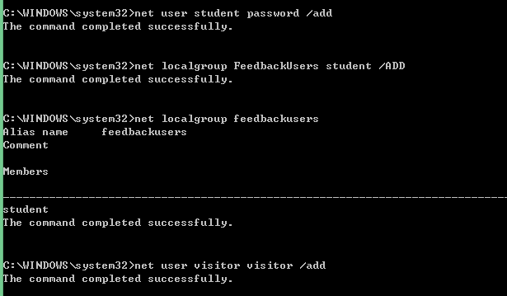

1. Restrict service contract to “FeedbackUsers” group only

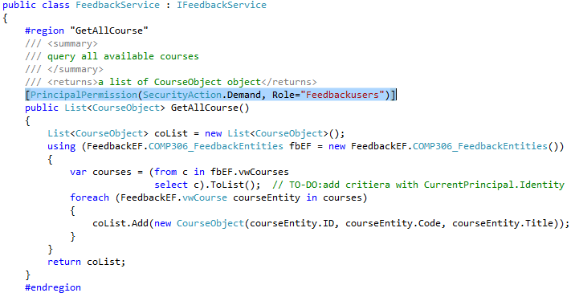

1. Call web service from client with user from FeedbackUsers group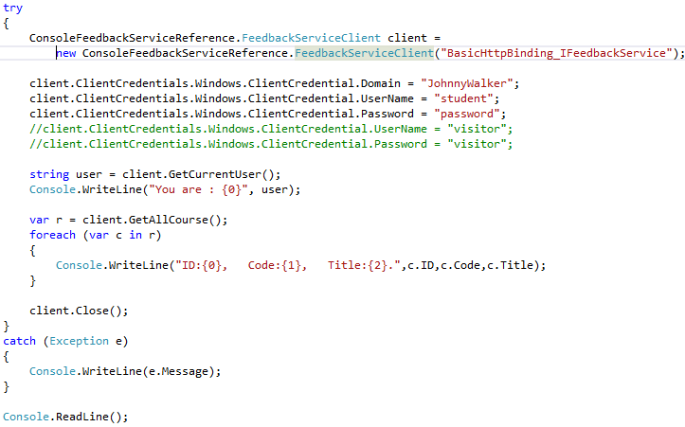

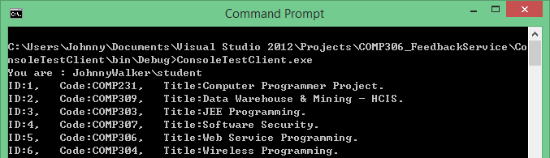

1. Call web service from client with user NOT from FeedbackUsers group

