LWJGL Coding exercise – 2D Transformations

Download the week 3 prac project from GitHub classroom:

https://classroom.github.com/a/-Pqv2bnk

REMEMBER TO FETCH AND PULL THE MOST RECENT VERSION OF THE COMP3170 LWJGL LIBRARY

The package contains four files:
- Week3.java – the main program, implementing IWindowListener
- Plane.java – code to model and draw a simple plane (shown below)
- vertex.glsl – a basic vertex shader with vertex colours
- fragment.glsl – a basic fragment shader with vertex colours

If you run the code as is, it should draw the plane without any transformation:
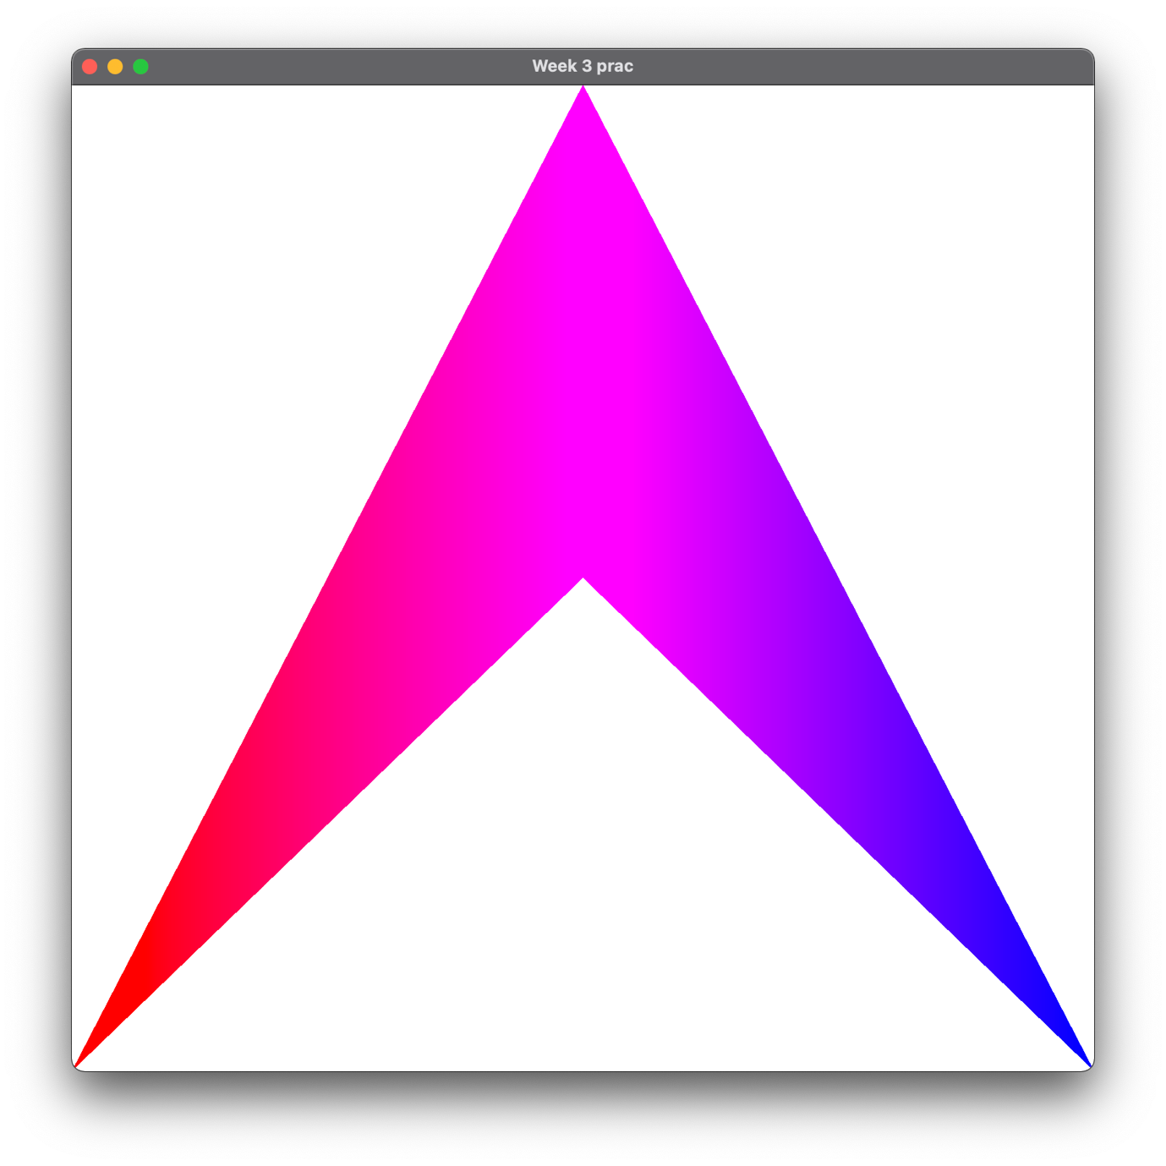

Step 1 – Complete the matrix code

The Plane class defines three static methods:
- translationMatrix()
- rotationMatrix()
- scaleMatrix()

Each of these methods writes the specified kind of matrix form into a pre-allocated destination matrix. You will want to use these methods to create your model matrix.

The code for translationMatrix has been provided. Complete the other two methods.

Step 2 – Add a model matrix

In vertex.glsl: Add code to the vertex shader to allow a model matrix to be passed as a uniform. Use this code to transform the vertex before writing it to gl_Position.

In Plane.java: Create a model matrix and pass it to the shader using setUniform when drawing the plane.

How would you set the matrix to achieve the following output?
a)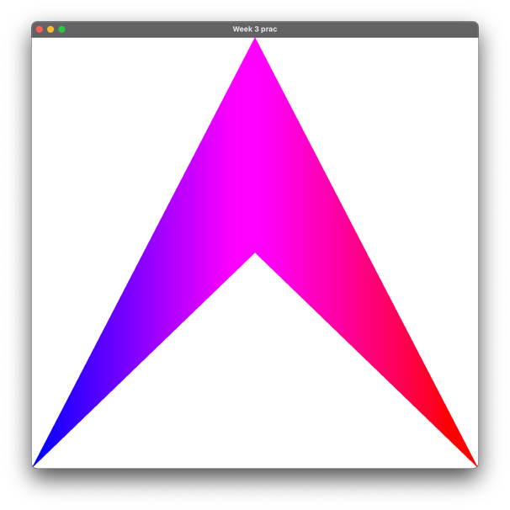b)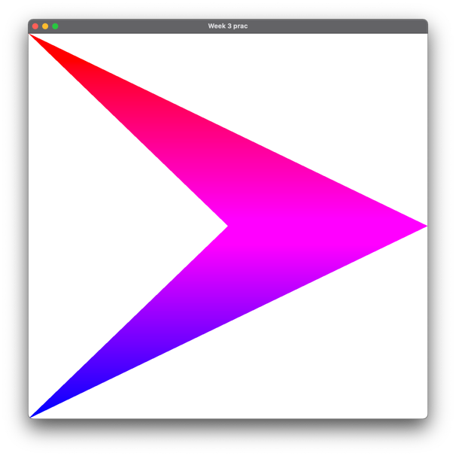
c)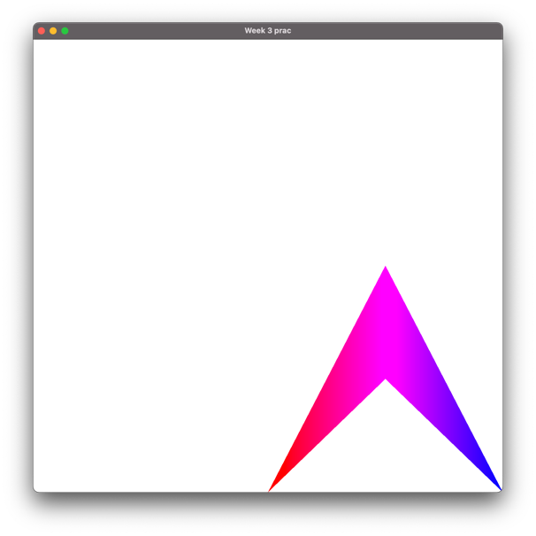d)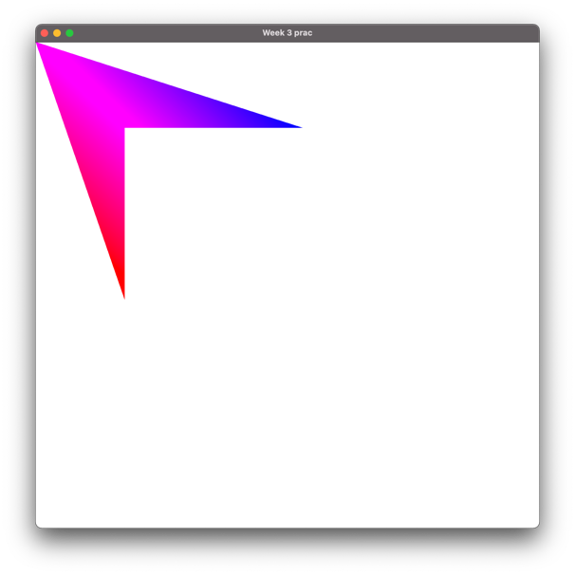

Step 3 – Add animaton

Following the example in lectures, for adding and using deltaTime, update the code to make the ship move along a circular path like this:

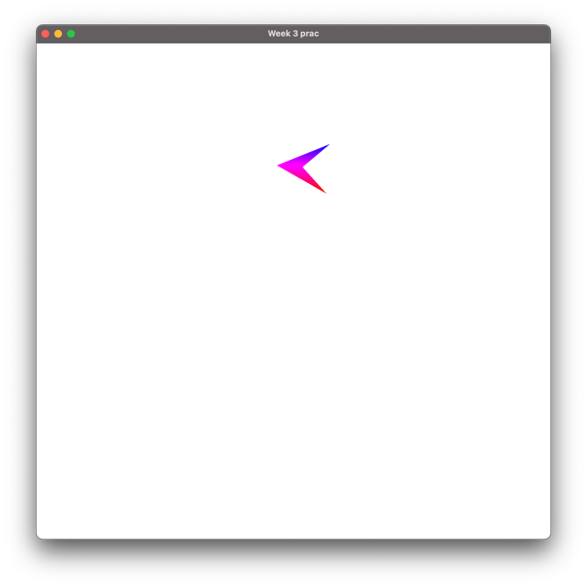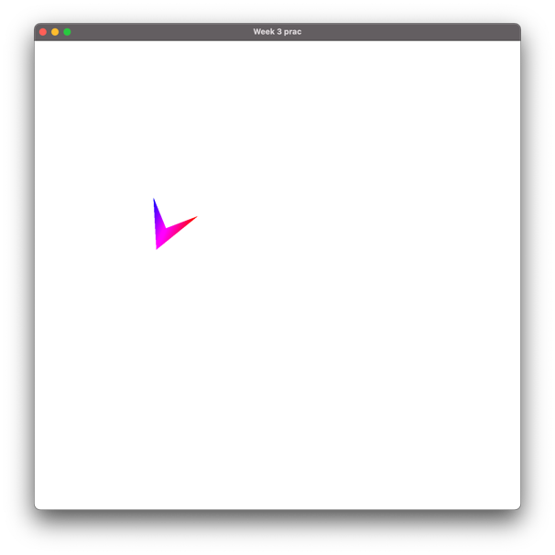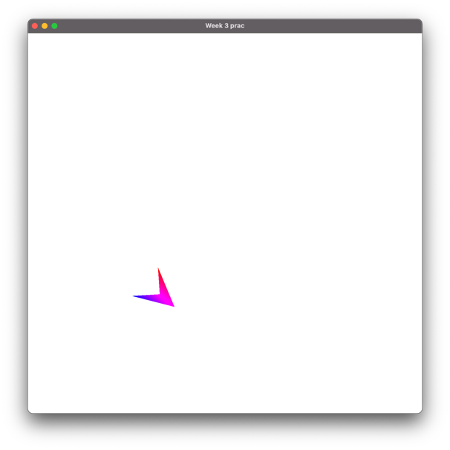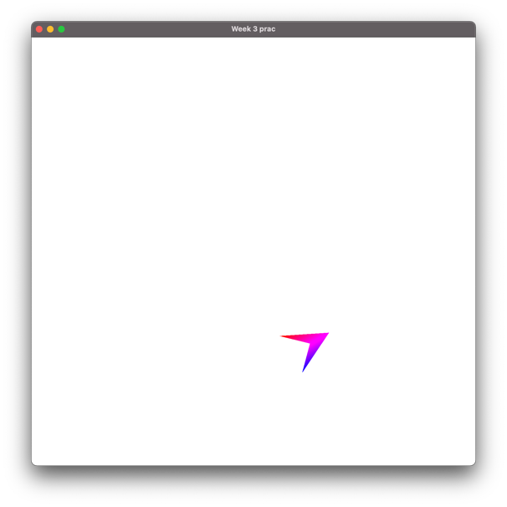

Hints:
- Initialise the plane with its starting position, angle and size.
- On every frame:
  - Make the plane rotate on the spot
  - Add forward motion in the plane’s local coordinate space.

