Scenario 1: A manager wants to add a product to the database.

* Manager inputs the product id, name, price, and quantity.

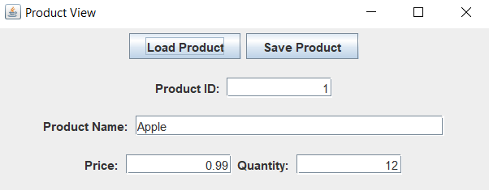

* System then stores the value of the new product in the database.

Scenario 2: A manager wants to update the price, quantity, and name of an item.

* Manager inputs the product id of the product to update.

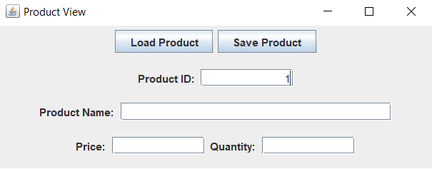

* System returns the name, price, and quantity of the product or it returns that the product does not exist.
* Manager updates the desired fields (name, price, etc.).
* Manager submits the fields to be updated.
* System updates the desired fields in the database.



Scenario 3: A employee wants to checkout a customer.

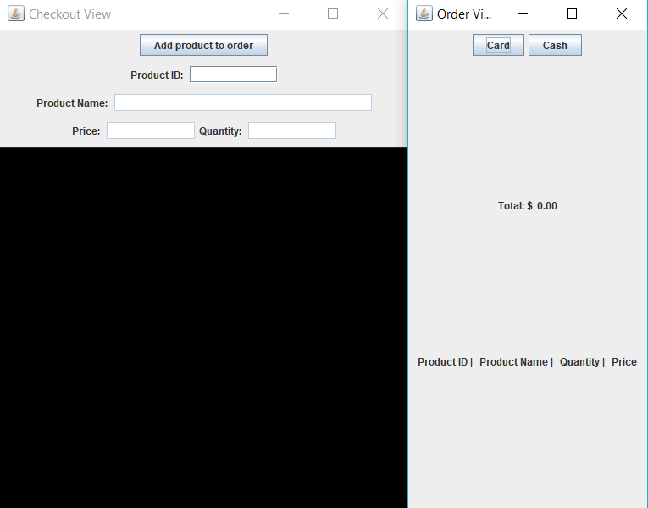

* The customer tells the employee what items they want to buy.

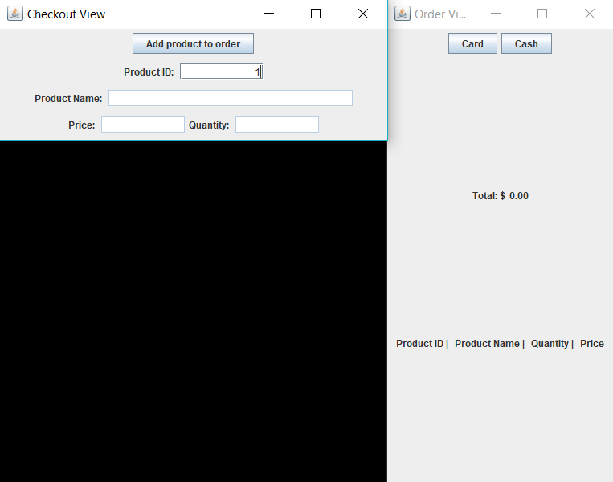

* The employee looks up the product in the database.

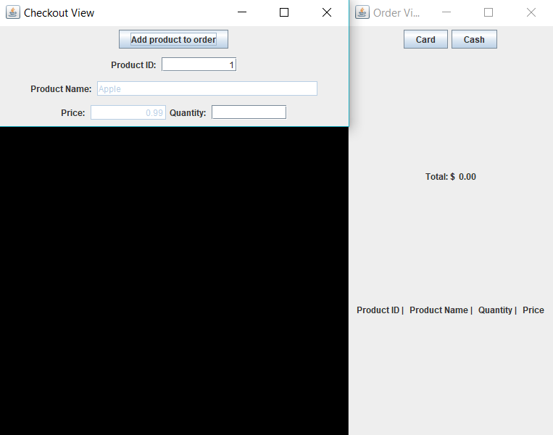

* The Employee inputs the quantity of the items.

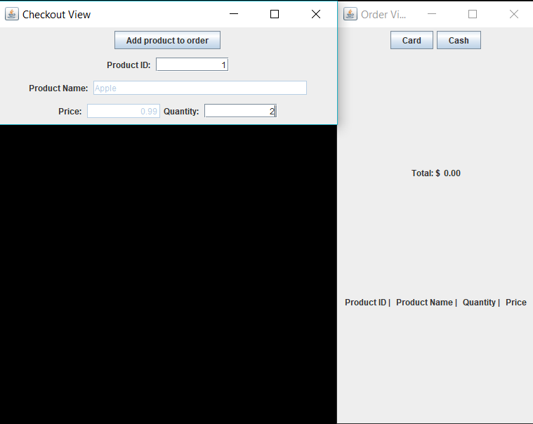

* The system returns the value of the products and updates the order view with the product info.

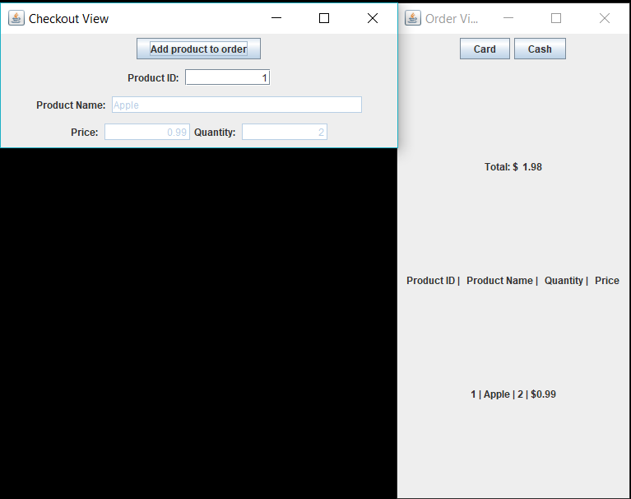

* The employee finishes up the checkout and askes the customer for the payment (card or cash)

