Use Case 1: Signing in

User wishes to sign in.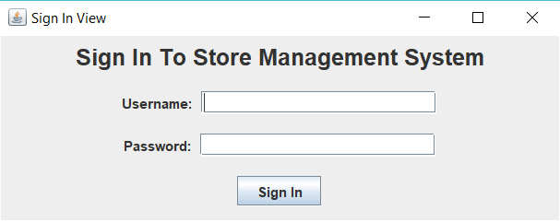

Administrator signs in with administrator username and password.

And continues to the main screen.

Use Case 2: New main screen options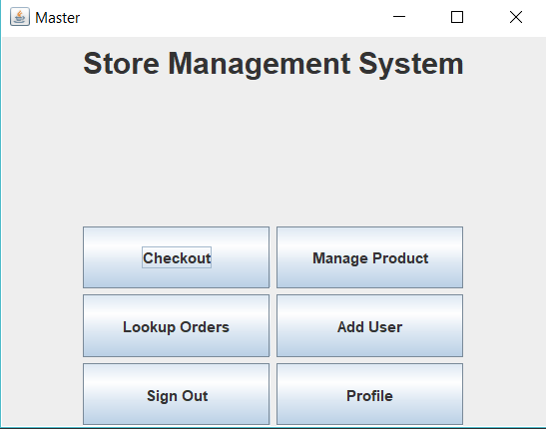

2.1 User wishes to update profile info

User clicks on profile

2.1.1 User wishes to change password

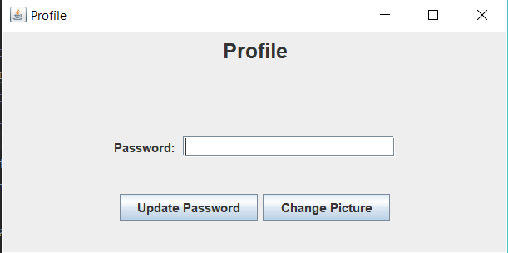

2.1.1 cont. type in new desired password and click update password

2.1.2 User wishes to change their profile picture.

Click on change picture

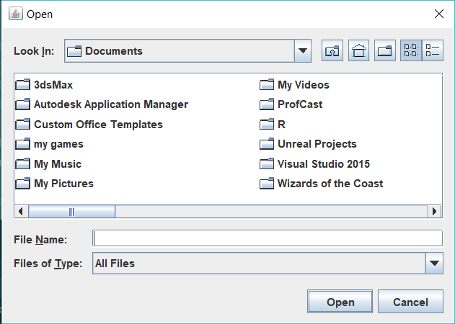

Browse to the location of the image.

Click open. 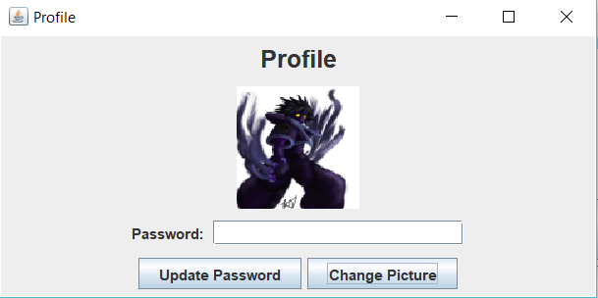

2.2 User wishes to load orders

Click load orders and enter order #

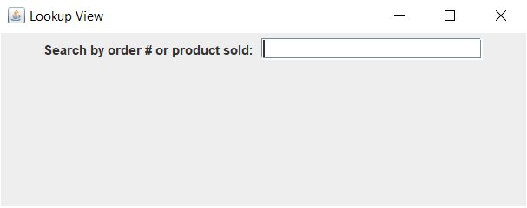

2.3 User wishes to add a user

Click add new user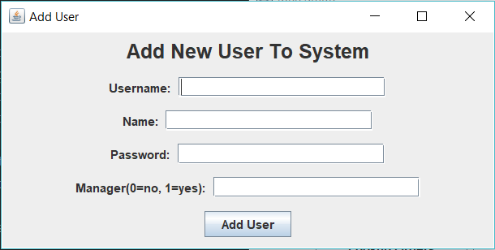

Enter all new user info and click add user