|  |
| --- |
| Krazy Kats & Incline studios |
| COMP397 - Final Project – Side Scroller |
| **Voyage of Outlaws**  C:\Users\Faim\Desktop\Rockman.exe\(Centennial) Semester 3.2 - (Fall - 2015)\gameCompanyLogo.fw.png  C:\Users\Jason\Documents\Year_2\COMP397 - 001 - Web Game Programming\_Assignments\Incline_Studios_Logo.png |
| Version 1.0  All work Copyright © 2012 byIncline Studios and KrazyKatz.  All rights reserved. |
| **Jason Pearson & Khandker Faim Hussain** |
|  |

**Table of Contents**

[Your Table of Contents should go here. Make sure that your document’s sections are hyperlinked to their corresponding pages.]

Table of Contents

[Game Overview 3](#_Toc437201218)

[Version Control 3](#_Toc437201219)

[Game Play Mechanics 3](#_Toc437201220)

[Camera 4](#_Toc437201221)

[Controls 4](#_Toc437201222)

[Interface Sketch 4](#_Toc437201223)

[Levels 6](#_Toc437201224)

[Enemies 6](#_Toc437201225)

[Weapons 6](#_Toc437201226)

[Scoring 7](#_Toc437201227)

[Sound Index 7](#_Toc437201228)

[Story Index 7](#_Toc437201229)

[Art / Multimedia Index 8](#_Toc437201230)

[Future Features 8](#_Toc437201231)

## Game Overview

The goal of the game is to dodge into as many ships and enemy fire as possible while obtaining the fusion cores needed to travel past each level (the amount of fusion cores needed depends on the level). You can shoot various blasts and lasers to defend yourself, and pickup loose elements of value to increase your score. You have five lives, and it will prompt a game over when you lose all of them, but if you have at least 1 life, intact when obtaining all the fusion cores, you win each level and ultimately the entire game.

## Version Control

For version control, we used Github to track our progress throughout the making of this project.

[Link]

<https://github.com/COMP397-Final-Project/COMP397_FinalProject_Jason_Faim>

## Game Play Mechanics

*(how does your game work?)*

You have vertical movement of your ship within the canvas, and if incorporated, the player can shoot various blasts and lasers from the front of the ship to fend off your pursuers. The player can pick up the fusion cores and loose elements simply by having the ship make contact with them. When the ship encounters the enemy or enemy fire, it warrants losing one life.

## Camera

*(Point of View)*

2-Dimensional, flat. Camera does not move, the background image scrolls left and resets to project a constant, moving terrain.

## Controls

*(Which keys does your game use? Does it use the mouse or a joystick?)*

The vertical movement of the ship is attached to the vertical movement of the mouse, having movement as sensitive as your reflexes with the mouse. If incorporated, the shooting mechanic is mapped to the left mouse click.

## Interface Sketch

*(What does the game interface look like? Provide a screen shot or sketch)*

**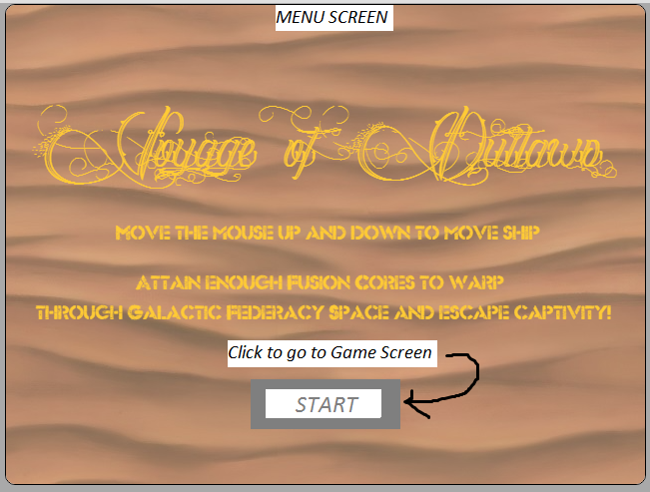**

**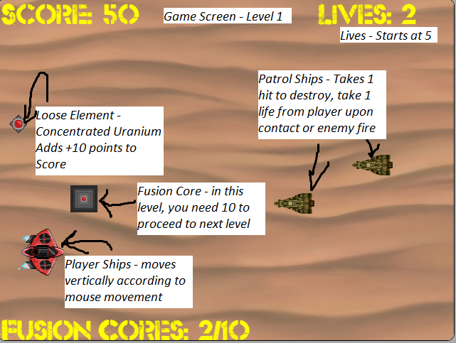**

**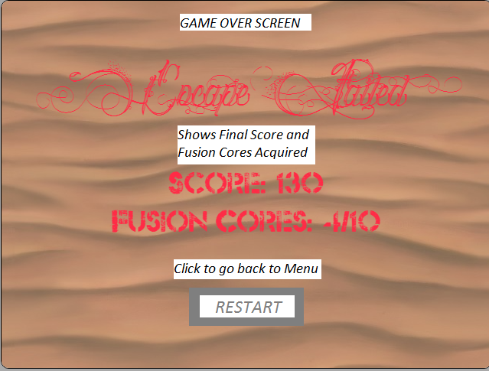**

**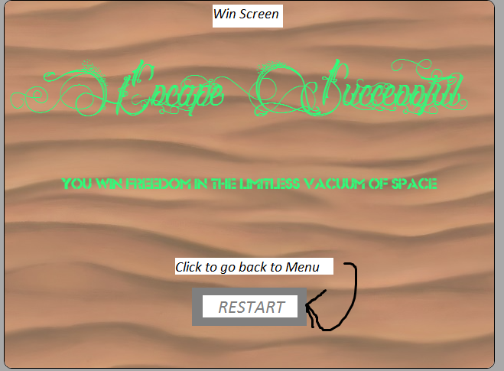**

## Levels

Level 1 – Desert Planet of K’troth with Patrol Ships trying to apprehend a loose convict

Level 2 – Forest Eco-Sphere – Uncharted Planet 281-KB – Bounty Hunter Ships and Federacy Ships

Level 3 – Space – Boss Battle – Galactic Federacy Military War Ships

## Enemies

**Patrols Ships – take 1 hit to kill (normal weapon), takes 1 life from player upon collision or enemy fire. Fires the same kind of blast the player does.**

**Bounty Hunter – takes 2 hits to kill (with normal weapon), takes 1 life from player upon collision or enemy fire. They blasts at a quicker firing rate.**

**Federacy Ships – takes 3 hits to kill (with normal weapon), takes 1 life from player upon collision or enemy fire. They fire long (in width) blasts.**

**Galactic Federacy Military Warships – takes 5 hits to kill (with normal weapons), takes 1 life from player upon collision or enemy fire. Fires 3 blasts in a radius.**

## Weapons

Standard green blast, can upgrade to a longer one that goes through enemy in its path.

## Scoring

**Pickups**

Concentrated Uranium (+10)

Pure Lithodite (+30)

Solid Dark Matter (+50)

## Sound Index

*(Include an index of all your sound clips)*

**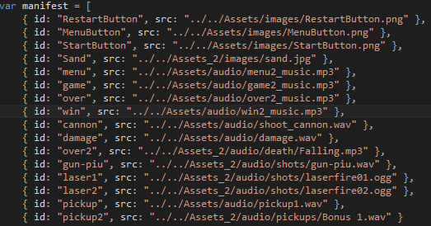**

## Story Index

Wrongfully accused of treason, the Galactic Federacy locked you in a high imprisonment facility in the desert planet of K’troth, within the edge of the north part of the galaxy known as Federacy Space. With all hope lost in clearing your name, you receive instruction in your cell to an escape route and space ship ready to sortie. With nothing to lose and curious as to whom would necessitate your escape, you venture through the prison, following the letter with acute timing, but when deploying your ship the shuttle alarm was not disabled upon opening. You now dash out of the planet of K’troth, following Plan-B of your instructions to obtain the hidden fusion cores to FTL drive out of parts of Federacy Space, as you know have patrols, bounty hunters, and the entire galactic military defense out for your head.

## Art / Multimedia Index

*(Include an index of all your graphic and video assets here)*

**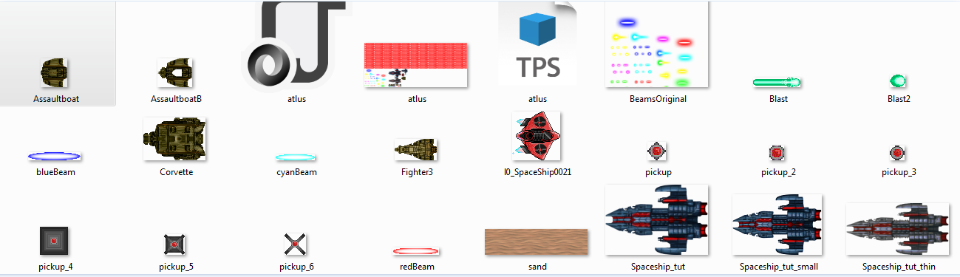**

## Future Features

* *The next 2 levels*
* *The enemies previously mentioned in the Enemies section*
* *Shooting mechanics*
* *Extra Scenes between Levels to give context to the Story via exposition text.*
* *Rest of the Pickups*