**Regional variability in surface water dissolved organic matter chemistry from freshwater and saltwater coastal systems**

J. Alan Roebuck, Jr.1, Allison N. Myers-Pigg1,2*, Peter Regier3, Nicholas D. Ward3, Matthew J. Cooper4, Kenneth M Kemner5, Amy M. Marcarelli6, Elizabeth C. Minor7, Michael Philben8, Bongkeun Song9, Rodrigo Vargas10, Jianqiu Zheng1, Exchange Consortium

1Biological Sciences Division, Pacific Northwest National Laboratory

2Department of Environmental Sciences, College of Natural Sciences & Mathematics, University of Toledo

3Coastal Sciences Division, Pacific Northwest National Laboratory

4Department of Biology, Grand Valley State University

5Bioscience Division, Argonne National Laboratory

6Department of Biological Sciences, Michigan Technological University

7Department of Chemistry and Biogeochemistry and Large Lakes Observatory, University of Minnesota

8Geological and Environmental Science Department, Hope College

9Ecosystem Health Section, Virginia Institute of Marine Science

10Department of Plant and Soil Sciences, University of Delaware

Correspondence email: allison.myers-pigg@pnnl.gov

**Abstract**

Dissolved organic matter (DOM) in coastal surface waters influences local water quality and is an important component of biogeochemical cycling in coastal terrestrial to aquatic interfaces (TAIs). Many studies have highlighted transformations of DOM along longitudinal river to estuary transects, however, processes that alter DOM composition along lower reaches of rivers and estuarine waters is poorly understood. The high productivity of coastal environments and limited representation in Earth System Models further highlights a need for better understanding of DOM coalescence along coastal reaches. Here we present results from a spatially distributed community sampling effort to identify broad spatial drivers of surface water DOM composition and identify transferable trends between saltwater and freshwater coastal TAIs. Samples were collected from 47 locations within the mid-Atlantic and Great Lakes coastal regions, represented by sampling efforts of small tidal and seiche driven streams and rivers and nearshore estuarine/lacestuarine environments. The DOM was characterized by excitation-emission fluorescence and Fourier transform ion cyclotron resonance mass spectrometry (FTICR-MS). We observed that optically active DOM did not display systematic regional trends, but instead was primarily distinguishable across water sources being notably lower in nearshore estuarine/lacestuarine environments compared to the terrestrial endmembers. At the molecular scale, DOM was again regionally similar between freshwater and saltwater coastal systems, whereas heteroatom containing DOM (e.g., nitrogen, sulfur) further distinguished water sources. We further observed strong linkages between DOM and surface water quality parameters, such as pH, that further indicate potential for upscaling transferable linkages in processing across coastal domains. Collectively, our results highlight a broad similarity and transformation of terrestrial signatures that may be conserved in coastal TAIs across regional scales. Such results have important implications for making scalable predictions of coastal biogeochemical processes and their responses to future perturbations.

**1. Introduction**

Dissolved organic matter (DOM) in coastal surface waters influences biogeochemical cycles and local water quality, as determined by human perceptions and use (Lønborg et al., 2024). DOM found in estuarine and coastal waters represents a heterogeneous collection of organic molecules whose composition is reflective of various sources, including the upstream catchment (i.e., rivers and streams), *in-situ* primary production, lateral inputs from vegetative coastal ecosystems, and subterranean groundwater discharge (Ward et al., 2023). While the chemical composition of DOM partially determines its reactivity and environmental fate, processes occurring in coastal waters can influence the fate and transport of DOM in the aquatic environment. For example, highly aromatic compounds can interact with metals and are important for pollutant transport (Yamashita and Jaffé, 2008; McIntyre and Guéguen, 2013). Similarly, high amounts of chromophoric DOM (CDOM), to which many aromatic DOM components contribute, absorb UV radiation and alter water column autotrophic activity (Lin Zhang et al., 2007; Cory et al., 2015; Creed et al., 2018). Bioavailable DOM can be transformed into carbon dioxide and other metabolites by heterotrophic decomposition or assimilated into biomass (Eiler et al., 2003). Weak organic acids within the DOM pool are also important components of aquatic carbon cycles and can be quantitatively significant components of alkalinity in coastal systems (Kerr et al., 2021).

In coastal regions, terrestrial-aquatic interfaces (TAIs) are considered “hotspots” for the biogeochemical cycling of DOM, including both export and microbial and photochemical transformation (Bauer et al., 2013; Grunert et al., 2021; Ward et al., 2023). These TAIs are characterized by their sharp spatio-temporal dynamics that modulate the source and transport of DOM to and through coastal areas (Bailey et al., 2017). For instance, vegetative inputs in addition to sediment deposition are contributing to the increased carbon accumulation in coastal zones with climate change (Wang et al., 2021), whereas tidal porewater exchange is directly linked with the export of DOM to adjacent estuaries (Bouillon et al., 2007; Regier and Jaffé, 2016; Santos et al., 2021). Many studies have linked DOM source and transformation along coastal estuarine gradients, often finding a mix of conservative or non-conservative behavior between riverine and estuarine endmembers (Cawley et al., 2014; Medeiros et al., 2015; Canuel and Hardison, 2016). Generally, these studies report a depletion of highly aromatic terrestrial signatures with increasing distance from the coast in favor of more heteroatom rich DOM (Minor et al., 2012; Osterholz et al., 2016; Del Vecchio et al., 2017). However, these studies are often limited to longitudinal sampling along main-stem estuarine gradients, and there is a need to better characterize processes that alter the composition and reactivity of DOM in lower reaches (small streams and tributary rivers) of coastal TAIs (Ward et al., 2017).

Small streams represent an important component of coastal TAIs. They are spatially dominant in tidal reaches within the coastal US accounting for >12,000 km2 and are 30% more productive than adjacent nontidal ecosystems (Tagestad et al., 2021). Direct lateral connectivity with coastal wetlands makes them a conduit for transport of carbon, nutrients, and DOM within the coastal zone (Megonigal and Neubauer, 2009). As such, these systems contribute significantly to nearshore and inner shelf dissolved organic carbon (DOC) (Moran et al., 1991), and the quality of materials play a crucial role in regulating key microbial processes, such as nitrogen fixation (Benavides et al., 2018; Eberhard et al., 2023) and denitrification (Bartoli et al., 2020; Gao et al., 2022). Despite the importance of these systems, the coalescence of DOM sources and transformations in downstream coastal reaches remains poorly represented in Earth system models (Ward et al., 2020; Zhang et al., 2022). The extent to which DOM is transformed in coastal TAIs is critical for linking within coastal biogeochemical fluxes at a landscape scale (Santos et al., 2021), and a basic understanding of how DOM composition varies along coastal gradients within lower reaches across diverse regional settings is required to better assess such linkages.

In this study, we present a spatially variable comparison of DOM composition in the lower reaches (small tributaries, tidal streams, and near-shore estuarine/lacestuarine) of mid-Atlantic (Chesapeake Bay and Delaware Bay) saltwater estuaries and Great Lakes freshwater estuaries (also termed lacestuaries). Our goal was to describe broad spatial drivers and identify transferable trends across each coastal TAI. In this context, we asked the following questions:

1) How does DOM composition change in lower reaches of coastal TAIs along terrestrial-estuarine gradients?

2) Is there a difference in DOM composition among seiche-driven (freshwater) and tidal (saltwater) coastal systems?

3) Can relationships between DOM composition and surface water chemistry (e.g. salinity, pH) be regionally transferable across coastal domains?

To answer these questions, the chemical composition of DOM from surface waters in mid-Atlantic and Great Lakes coastal TAIs was characterized by 3D fluorescence excitation-emission matrices (EEM). Ultra-high resolution Fourier transform ion cyclotron resonance mass spectrometry (FTICR-MS) was also used to gain a molecular-level understanding of surface water DOM composition. We further measured various water quality indicators including salinity and pH. We hypothesized that tidal/seiche-driven streams and rivers would provide a more aromatic DOM signature that is depleted in favor of more heteroatom (nitrogen, sulfur) rich DOM in nearshore estuarine/lacusturine areas. As such, transformations of DOM were expected to shift in a general way across the coastal TAIs, although the extent of such differences was hypothesized to be regionally dependent given variable wetland/marsh sources of DOM between freshwater and saltwater coastal systems. Similarly, water chemistry patterns vary regionally along coastal regions (e.g., changing salinity/conductivity in saltwater estuaries vs freshwater lacestuaries) and may challenge an ability to directly tie with DOM composition at regionally broad spatial scales.

**2. Methods**

The data used for this study were collected as part of the EXploration of Coastal Hydrobiogeochemistry Across a Network of Gradients and Experiments (EXCHANGE) program. Data are freely available at the Environmental System Science Data Infrastructure for a Virtual Ecosystem (ESS-DIVE) data repository (Pennington et al., 2023) with full sampling and analytical methodologies also available (Myers-Pigg et al., 2023), which are described briefly below.

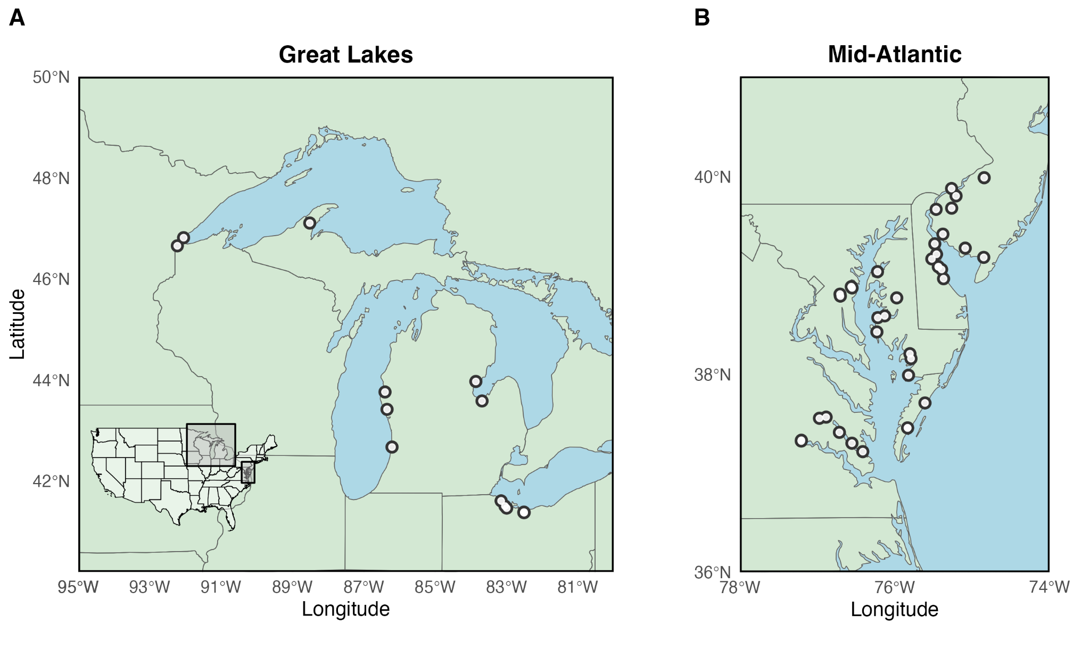

**Figure 1:** Map of sample locations for the A) mid-Atlantic and B) Great Lakes region

*2.1 Sample Collection & Processing*

Samples were collected by the EXCHANGE consortium during the Fall of 2021 (August to October) from 47 surface waters within the coastal Great Lakes and mid-Atlantic (Chesapeake Bay and Delaware Bay regions) (Figure 1). Consortium members were provided kits and instructions to ensure standardized sample collection. Field metadata, including site locations and water source type, were collected. Water sources ranged from wetland-adjacent small coastal streams and rivers to near-shore estuarine and lacustrine samples in the mid-Atlantic and Great Lakes regions.

Water samples were collected and field-filtered through 0.2 µm Sterivex syringe filters and dispersed into amber glass vials for dissolved organic carbon (DOC), total dissolved nitrogen (TDN), and chromophoric dissolved organic matter (CDOM) analyses. An additional 125 mL of unfiltered surface water was collected in an amber high-density polyethylene (HDPE) bottle with no headspace for pH, oxidation-reduction potential (ORP), conductivity, and alkalinity measurements. Finally, 1L of filtered water was collected in an amber HDPE bottle to be further subject to solid phase extraction (SPE) and ultra-high resolution molecular analyses. Samples were shipped immediately to the Pacific Northwest National Laboratory-Sequim, where pH, ORP, and alkalinity measurements were recorded within 48-hour of sample collection. Samples for DOC, TDN, and CDOM were stored at 4 °C and analyzed within 2 weeks of collection. Samples subject to SPE were also stored at 4 °C and processed within 1 week of collection as described by Dittmar 2008. Briefly, samples were acidified to pH 2 with hydrochloric acid 24-hours before extraction and then passed through 6mL/1g Bond-Elut PPL cartridges (Agilent) that were first conditioned with methanol followed by pH 2 Milli-Q water. After sample loadings, cartridges were rinsed again with pH 2 Milli-Q water, and samples were eluted with methanol. Methanol extracts were stored at -80 °C until further analysis.

*2.2 Physicochemistry, dissolved organic carbon, and optical analyses*

Water quality measurements, including pH, ORP, and alkalinity, were measured simultaneously with a Mettler Toledo T7 auto-tritrator. The pH was calibrated to a 3-point standard curve (pH 4, 7, 10), and conductivity was calibrated with a 50,000 µS/cm solution. Alkalinity was determined via titration with 0.2N HCl to an endpoint at pH 4 following protocols set forth by the United States Geological Survey (Rounds and Wilde, 2012).

Samples were analyzed simultaneously for DOC and TDN using a Shimadzu Total Organic Carbon Analyzer (TOC-L) equipped with a Total Nitrogen detector. Samples were first subject to in-line acidification with 1:12 hydrochloric acid and purging to remove inorganic carbon, and DOC was measured as non-purgeable organic carbon via catalytic combustion. Total dissolved nitrogen was measured by chemiluminescence.

Absorbance and fluorescence measurements were collected simultaneously with an Aqualog800 (Horiba Scientific) to describe the CDOM fraction. UV-VIS absorbance scans were collected from 250 to 800 nm in 3 nm intervals and blank-corrected with a Milli-Q water reference. The Specific UV Absorbance at 254 nm (SUVA254) was calculated as the DOC normalized decadic absorbance at 254 nm and used as a relative indicator of CDOM aromaticity (Weishaar et al., 2003). Fluorescence measurements were recorded as 3D excitation-emission matrices (EEM) with scans recorded in 3 nm intervals. All EEMs were blank corrected, inner-filter corrected (Ohno 2002), and normalized to Raman scatter units (RSU) using daily water Raman scans recorded at an excitation of 350 nm. EEMs were further deconvoluted via parallel factor analysis (PARAFAC) into statistically discreet fluorescence components using the drEEM toolbox v6 (Murphy et al., 2013) for Matlab (v 2020b). The final PARAFAC model was built with non-negativity constraints and split-half validated with peaks identified based on commonly observed fluorophores for aquatic systems (Wünsch et al., 2019).

**Table 1:** Description of 5 component PARAFAC model derived from excitation-emission matrices of surface water DOM from the mid-Atlantic and Great Lakes regions (Wunsch et al., 2019)

|  |  |  |  |  |
| --- | --- | --- | --- | --- |
| **Component** | **Excitation (nm)** | **Emission (nm)** | **Peak Assignment** | **Description** |
| C1 | <260 | 457 | A | Ubiquitous terrestrial humic-like |
| C2 | <260 (308) | 397 | M | Microbial humic-like |
| C3 | <260 (401) | 501 | D | Representative of soil or other reduced environments |
| C4 | 281 | 328 | T | Protein-like (Tryptophan) |
| C5 | 347 | 445 | C | Terrestrial Humic-like – Highly impacted by photodegradation |

*2.3 Fourier transform ion cyclotron resonance mass spectrometry*

High-resolution mass spectrometry measurements were performed on SPE aliquots normalized to a DOC concentration of 50 mgC/L, assuming an average DOC recovery of 60% across the dataset. Samples were continuously injected at a flow of 4 µl/min into a 12 Tesla (12T) Bruker SolariX Fourier transform ion cyclotron mass spectrometer (FTICR-MS) (Bruker, SolariX, Billerica, MA) located at the Environmental Molecular Sciences Laboratory in Richland, WA. The FTICR-MS was equipped with a standard electrospray ionization (ESI) source where data were collected in negative mode at 220 K resolution at 418.185 m/z and a needle voltage set to +4kV. Scans were collected within a mass range from 150 m/z to 1000 m/z at 8M. Three-hundred scans were collected and co-added with internal calibration using an OM homologous series separated by 14 Da. Mass measurement accuracy was typically within 1 ppm. Raw spectra were converted to a list of m/z peaks using the Bruker Data Analysis software (version 5) with a S/N threshold set to seven and the absolute intensity threshold set to 100. Molecular formulae were assigned to peaks using Formularity (Tolić et al., 2017), where S/N > 7 and mass measurement < 0.5 ppm thresholds were applied. The Compound Identification Algorithm was set to consider C, H, O, N, S, and P while excluding other elements (Kujawinski and Behn, 2006). Additional constraints required at least 1 O and a maximum of 3 N, 2S, and 1 P to be applied. Further processing was performed with the *fticrrr* R package (Patel, 2020), which removed 13C peaks and peaks outside of the confidence range (200 m/z - 900 m/z). Furthermore, this package calculated common molecular indices, including the number of double bond equivalents (DBE), modified aromaticity index (AImod) (Koch and Dittmar, 2006, 2016), and the nominal oxidation state of carbon (NOSC). Finally, intensity weighted averages for the molecular indices (AImod, DBE, NOSC, C, H, O, N, S, O/C, H/C) and relative proportion of molecular compounds identified as CHO, CHON, and CHOS were calculated to describe broad molecular level trends across samples.

*2.4 Statistical Analyses*

The provided metadata (Pennington et al., 2023) categorizes samples based on their surface water type, which included tidal or seiche-driven streams, tidal rivers, estuary, lacestuary (lake estuaries), lake, and open water. These categories were self-reported by the EXCHANGE consortium. We first constrained these identifications into two surface water types: riverine and estuarine. Riverine included tidal or seiche-driven streams and rivers (n=29). Estuarine included all other water types (n=25). It is important to note that these two categories are defined broadly to represent terrestrial vs coastal endmembers based on their geographic location and were not exclusively defined based on common geochemical proxies (e.g., salinity). Here, the coastal endmembers are representative of both freshwater (Great Lakes) and saline (mid-Atlantic) sources. Unless otherwise specified, the term ‘estuarine’ is used in this manuscript as representative of both salt-water estuaries and freshwater lacestuaries.

All statistical analyses were performed using the R statistical platform version 4.0.5 (R Core Team, 2023). Extreme outliers that lay more than 3 times the interquartile range were removed from statistical analyses. Concentrations for all water quality and optical parameters are reported as a mean ± standard deviation. For various surface water and DOM compositional analyses, we tested significant differences across region (mid-Atlantic and Great Lakes) and surface water type (riverine vs estuarine) as well as for an interaction effect with two-way analysis of variance (ANOVA) using Type II sum of squares estimates. A *post hoc* analysis wasperformed via Tukey’s honest significant difference test (TukeyHSD). The normality of residuals was tested with Shapiro-Wilks tests.

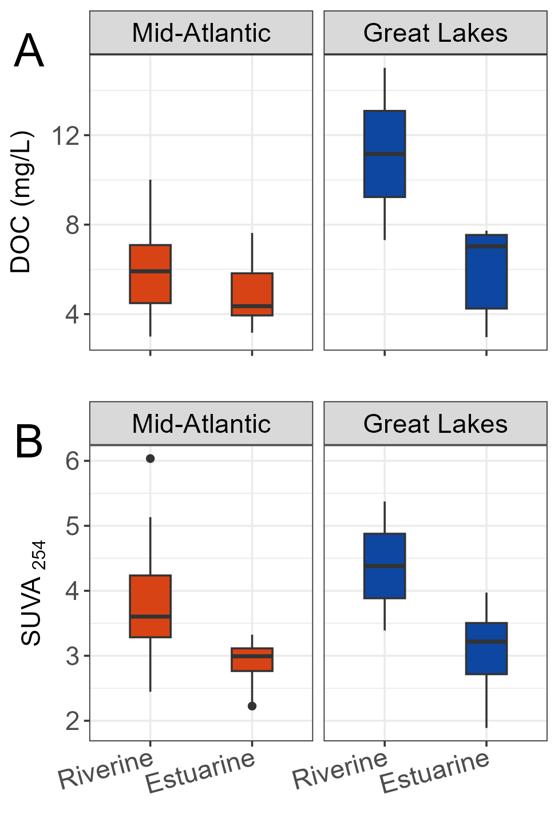Principal component analysis (PCA) was used to assess broad scale trends in the variability of PARAFAC components. Multivariate analysis of variance (MANOVA) was applied using the ‘*stats’* package to test differences across region and water type, followed by a multivariate pairwise *post hoc* analysis to assess differences within groups. For ultra-high resolution mass spectrometry data, non-metric multidimensional scaling (NMDS, *‘vegan’* version 2.6-4) (Oksanen et al., 2022) was applied to a Bray-Curtis dissimilarity matrix on Hellinger transformed peak intensities. While similar to PCA, NMDS does not assume linearity and is best suited for non-normal data, including FTICR-MS. Molecular indices were fitted (using the *envirofit* function) onto the NMDS ordination as vectors where p < 0.05. Permutational analysis of variance (PERMANOVA) was applied via *‘pairwiseAdonis’* (Martinez, 2017) to the Bray-Curtis dissimilarity matrix to assess differences across regions and water types..

**Figure 2:** Boxplots of A) Dissolved organic carbon concentrations (DOC, mg/L) and B) Specific UV absorbance (SUVA254) across the mid-Atlantic and Great Lakes regions.

**3. Results**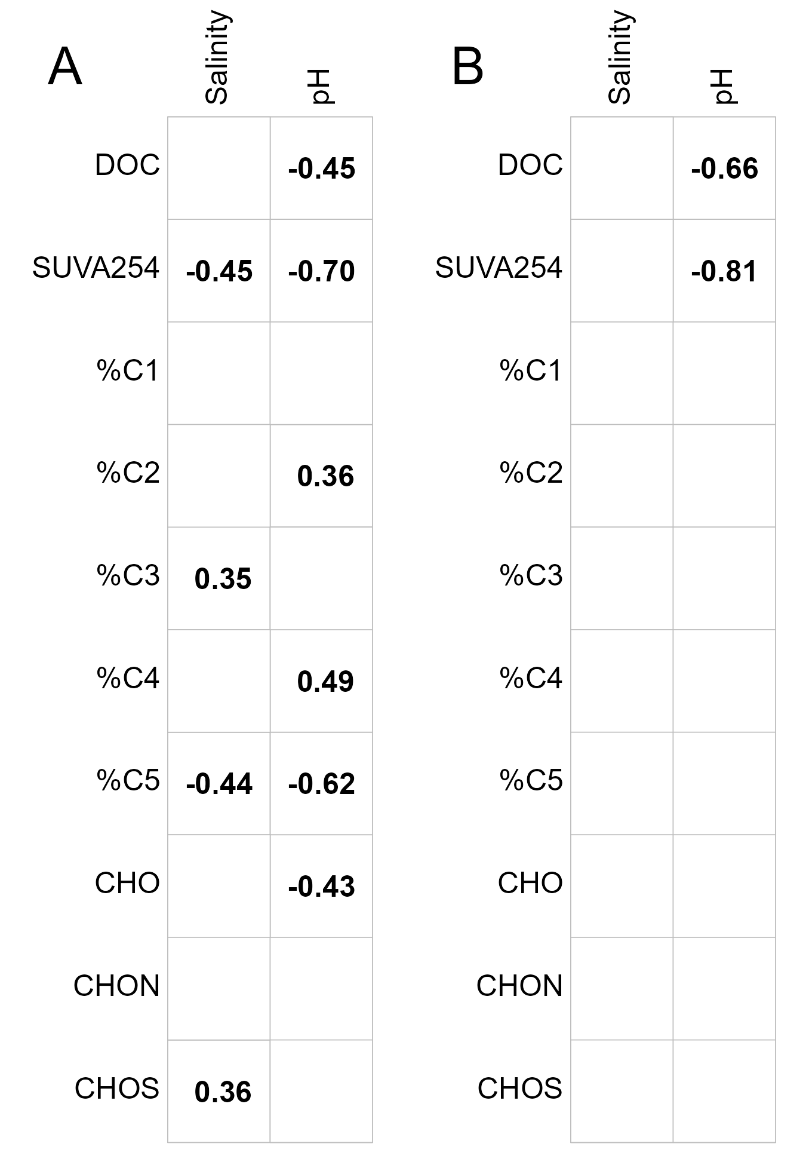

*3.1 Surface water chemistry across the mid-Atlantic and Great Lake regions*

During the August 2021 sampling period, DOC concentrations were significantly higher in the Great Lakes riverine samples (11 ± 5 mg/L) vs. Great Lakes estuarine (6 ± 2 mg/L) and the Mid-Atlantic region (averaging 6 ± 2 mg/L across the water types). These differences were supported by a two-way ANOVA that revealed a significant interaction between region and water type (df = 1, F = 5.85, p = 0.02).

**Figure 3:** Correlation matrix displaying Pearson’s correlation coefficient *r* for significant (p < 0.05) correlations between DOC and DOM compositional data with pH and salinity for the A) Mid-Atlantic and B) Great Lakes

In contrast to DOC, two-way ANOVA indicated that SUVA254 was significantly different among surface water types (df = 1, F = 17.39, p = 0.0001) and had no regional influence (df = 1, F = 1.42, p = 0.2). SUVA254, an indicator of DOM light absorption and aromaticity, was highest in riverine samples (3.8 ± 0.8) compared to estuarine samples (3.0 ± 0.5) (Figure 2b). Surprisingly, DOC and SUVA254 were not correlated (r = 0.06, p = 0.7).

Boxplots containing additional context for regional surface water chemistry parameters (salinity, pH, ORP, TDN, TSS) are provided in the Supporting Information (Figure S1). Of notable interest, DOC was unrelated to salinity in either the mid-Atlantic (Figure 3a) or Great Lakes (Figure 3b) region. SUVA254, on the other hand, exhibited strong inverse relationships with pH in both mid-Atlantic (Figure 3a, r = -0.70, p < 0.001) and Great Lakes (Figure 3b, r = -0.81, p < 0.001 ), which translated to a very strong correlation combined across both regions (r = –0.67, p < 0.001). Similar to SUVA254, pH strongly contrasted across water types, and was notably higher in estuarine (7.5 ± 0.3) compared to riverine water samples (6.9 ± 0.3) (Figure S1).

*3.2 Surface water dissolved organic matter composition across the mid-Atlantic and Great Lakes regions*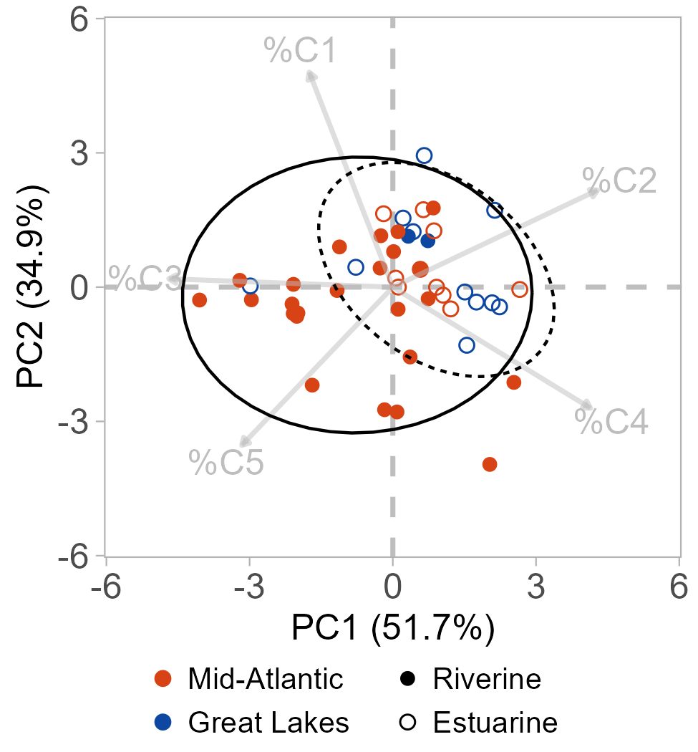

Dissolved organic matter fluorescence signatures were represented by 5 five discrete PARAFAC components described in Table 1 and revealed signatures that were most reflective of water type (riverine and estuarine waters) rather than any differences across the two regions. We observed spatial differences wholistically with a principal component analysis, which displayed a clustering of estuarine samples more positively along PC1 (52% of the total explained variation) that was driven primarily by a loss of terrestrial humic like components in favor of shifts to more microbial humic-like components (C2) and protein-like components (C4) (Figure 4, Figure S2). Riverine samples displayed much higher variability within PCA space (Figure 4). A MANOVA further confirmed surface water type as an indicator of DOM fluorescence signatures (df = 1, F = 5.01, p = 0.002) over the region (df = 1, F = 1.28 , p > 0.3), indicating minimal regional constraints on DOM fluorescence signatures traversing these estuarine and freshwater coastal domains during the sampling period.

**Figure 4:** Principal Component Analysis on the relative proportions of PARAFAC components. Samples are colored by region with open and closed circles by water type. Eclipses represent the 95% confidence region for riverine (solid) and estuarine (dashed) samples.

Similar to SUVA254, PARAFAC components C2, C4, and C5 displayed significant correlations with pH in the mid-Atlantic region (Figure 3a). Components C2 and C4 were each positively related to pH (C2: r = 0.35, p = 0.38; C2; C4: r = 0.48, p = 0.004), while C5 was inversely related to pH (r = -0.61, p < 0.001). This finding again highlight linkages between shifting surface water chemistry with DOM composition. Notably, this linkage was limited to the mid-Atlantic region as there were no observable trends between DOM PARAFAC components and water quality parameters in the Great Lakes region (Figure 3b).

**Table 2:** Table displaying the number of shared and unique formula by region, water type, and water type within each region

|  |  |  |
| --- | --- | --- |
| **Region** | | |
| *Mid-Atlantic* | *Shared* | *Great Lakes* |
| 2,740 (17%) | 12,530 (76%) | 1,092 (7%) |
| **Water Type** | | |
| *Riverine* | *Shared* | *Estuarine* |
| 1,197 (12%) | 12,920 (78%) | 1,555 (9%) |
| **Mid-Atlantic** | | |
| *Riverine* | *Shared* | *Estuarine* |
| 2,802 (18%) | 11,895 (78%) | 613 (4%) |
| **Great Lakes** | | |
| *Riverine* | *Shared* | *Estuarine* |
| 248 (2%) | 9,261 (68%) | 4,113 (30%) |

At the molecular level, as inferred by FTICR-MS, regional trends and differences across water types were less evident than those observed for the fluorescent DOM (Figure 5, Table 2). For instance, 76% of the 16,362 identified molecular formulae were shared among the two regions, and 78% were shared among riverine and estuarine water types (Table 2). It’s notable that in each case, the shared molecular formula accounted for on average >99% of the measured sample signal intensity across the dataset, indicating that unique formula identified to either region or system type represented a fraction of the DOM pool that was either low in concentration and/or a poorly ionizable fraction with limited sensitivity for FTICR-MS analysis. A comparison of van Krevelen diagrams (H/C vs O/C) also did not reveal any apparent clustering of unique peaks that could be directly attributed to either region or water source type (Figure S3A-B). Similar trends were observed when directly comparing riverine vs estuarine samples independently among the mid-Atlantic (Table 2, Figure S3C) and Great Lakes (Table 2, Figure S3D) regions.

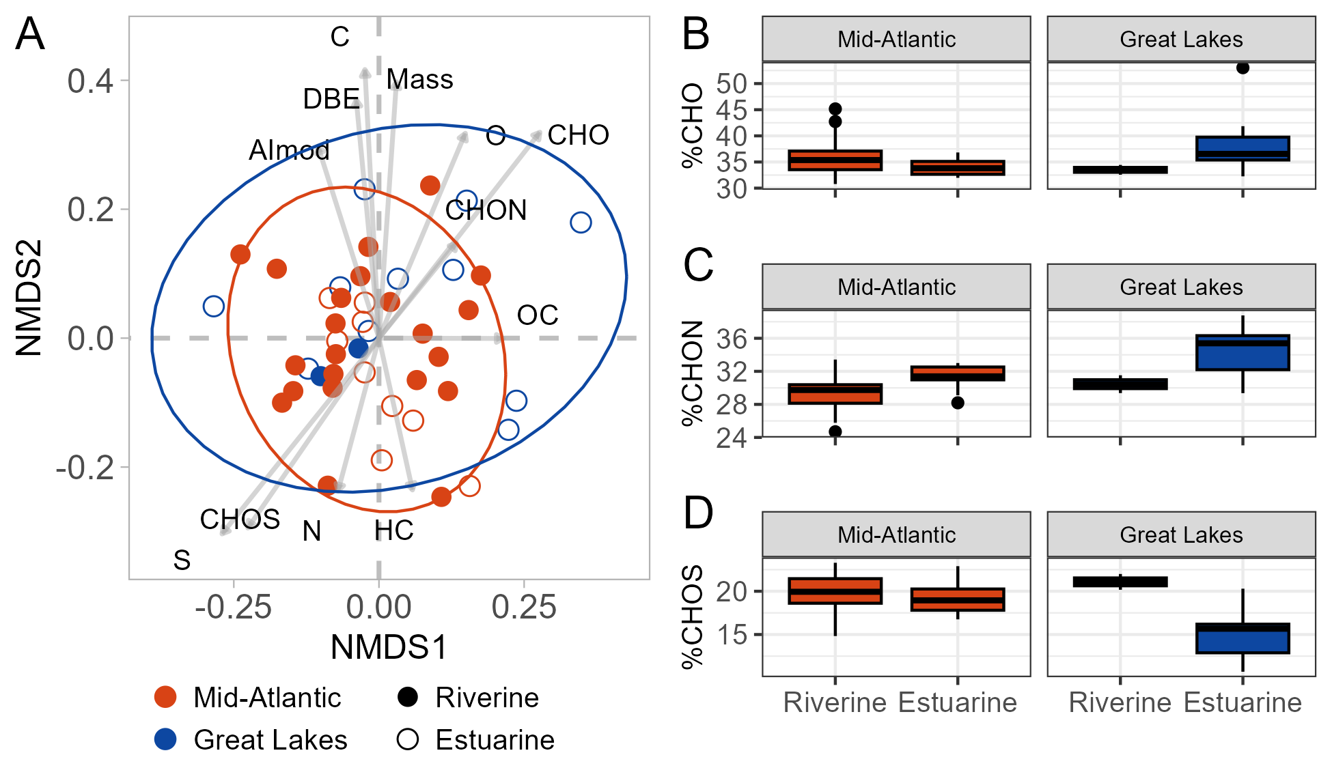This high degree of similarity across the dataset translated into similar average molecular properties where the molecular mass, carbon (C), aromaticity index (AImod), double bond equivalents (DBE), and nominal oxidation state of carbon (NOSC) each displayed no significant trend across region or surface water type (all p > 0.05, Figure S4). These bulk scale trends can again be observed more holistically through a multivariate NMDS where broad spatial similarity across the region and surface water was observed (Figure 5). Permutation multivariate analysis of variance (PerMANOVA) analysis further confirmed no significant distinction in bulk scale molecular trends across region or water type (region: df = 1, F = 1.9657, p = 0.09; water type: df = 1, F = 1.1463, p = 0.298).

**Figure 5**: A) Non-metric multidimensional scaling (NMDS) of FTICR-MS data where molecular properties were “envirofit” within NMDS space as vectors where p < 0.05. Eclipses represent the 95% confidence region for the mid-Atlantic (red) and Great Lakes (blue). Boxplots are displayed representing the relative proportion of molecular formula identified as B) CHO, C) CHON, and D) CHOS across the regions and water type.

Outside of the bulk scale trends, we looked independently at the elemental composition of FTICR-MS signals. Non-heteroatom compounds (CHO) represented around 35% of the identified molecular formula (Figure 5b), and two-way ANOVA did not confirm any linkage with region (df = 1, F = 0.6706, p = 0.4) or water type (df = 1, F = 0.0158, p = 0.9031). In contrast, two-way ANOVA revealed the proportion of nitrogen-containing compounds (CHON) were more strongly associated with water source type (df = 1, F = 8.5327, p = 0.007) over region (df = 1, F = 5.8408, p = 0.02). In estuarine samples, CHON represented 33 ± 3% of the identified formula compared to riverine samples (30 ± 2%). Similarly, two-way ANOVA revealed a significant interaction between region and water type (df = 1, F = 6.6265, p = 0.01) in explaining the proportion of S-containing compounds (CHOS). The primary differences among water type were observed in the Great Lakes region where CHOS was 21 ± 1% in riverine samples compared to 15 ± 3% in estuarine samples (Figure 5D).

**4. Discussion**

*4.1 Water optical properties were similar across regions but reflective primarily of water type*

Chromophoric dissolved organic matter (CDOM) across the two coastal domains was strongly mediated by surface water type and less by regional setting. Riverine inputs into coastal regions are generally enriched with aromatic and humic-like DOM signatures (Massicotte et al., 2017). This is further exemplified in this study, where SUVA254 values were statistically higher in riverine (4 ± 1) compared to estuarine samples (3.0 ± 0.5), and riverine samples were more enriched with fluorescent humic-like signatures (Figure 4). These SUVA254 values align with other measurements from freshwater endmembers along mid-Atlantic and Great Lake coastal transects (Minor and Stephens, 2008). The source of this aromatic-rich material in the riverine sites likely varies; however, localized sources are known contributors of DOM for many coastal TAIs. For instance, in the mid-Atlantic, tidal marshes are abundant along the fringes of the Delaware and Chesapeake Bays and supply highly aromatic, photochemically active DOM to the estuaries, particularly during late summer months (Tzortziou et al., 2008, 2011; Powers et al., 2018). Similarly, in the Great Lakes, outwelling from lake water intrusion into coastal wetlands is a prominent source of organic matter to the large lake systems (Bouchard, 2007). Given that our sampling design targets small, tidally-influenced, or seiche-influenced streams in coastal wetlands (rather than larger main stem rivers), we propose that these coastal wetlands are the primary source of the highly aromatic material consistently observed in our riverine samples, though we recognize that watershed sources of DOM may also be significant and warrants additional investigation.

The decrease in SUVA254 (Figure 2b) and shift to more protein and microbial humic-like fluorescence (Figure 4) in the estuarine waters is consistent with previous studies in coastal regions that sample longitudinally along river-to-estuary transects (Stephens and Minor, 2010; Cawley et al., 2014). In the Chesapeake Bay, CDOM exported from tidal marshes is highly prone to both microbial degradation and photochemical bleaching, both of which can decrease absorption coefficients and alter the presence of humic-like fluorescence (Stephens and Minor, 2010; Logozzo et al., 2021). Additionally, flocculation of DOM with increased mixing of fresh and saline waters can decrease DOM absorption coefficients and has been hypothesized to contribute to non-conservative behavior within the mid-Atlantic estuaries (Rochelle-Newall and Fisher, 2002). Alternatively, *in situ* primary productivity could be linked with the enriched protein-like signatures observed in the estuarine waters. This is supported by previous studies where increased amide signals and other DOM signatures from primary production have been observed in the mid-Atlantic estuaries (Stephens and Minor, 2010).

For this study, trends in the optical character were comparable across regions, noting similar less aromatic DOM signatures for estuarine sites in the Great Lakes region. This observation indicates commonalities in the biogeochemical processing of DOM, where photochemistry and microbially mediated processes are likely the primary drivers of DOM transformations across coastal regions (Stephens and Minor, 2010; Grunert et al., 2021). Photochemistry, for example, is an important sink for DOM in Great Lakes (Hiriart-Baer et al., 2008), and nutrient inputs from impaired estuaries can drive nearshore primary production and release of non-chromophoric DOM (Bellinger et al., 2016; Yurista et al., 2016; Zhou et al., 2016). However, differences in potential biogeochemical processing remain notable across the regions, most notably the lack of major ionic shift changes in freshwater estuaries that likely limit DOM losses through flocculation compared to saltwater estuaries. As such, this process may play only a secondary role in driving shifts in DOM chemistry when extrapolated more broadly across scales (Stephens and Minor, 2010).

*4.2 Molecular level DOM chemistry exhibited broad similarity across region and water type*

Ultra-high resolution mass spectrometry provided a snapshot overview of the molecular fingerprint across the regional coastal TAIs. We observed a broad similarity in the bulk scale molecular composition across the regions and surface water types (Figure 5, Table 2). The lack of major differences in molecular composition across riverine vs estuarine samples was surprising, given the clear differences in optical properties that indicate a reduction in overall aromaticity in the estuarine samples. We recognize methodological challenges with FTICR-MS where solid phase extraction and ionization biases can depress select DOM fractions (Li et al., 2017; Stücheli et al., 2018; Bahureksa et al., 2021; Nelson et al., 2022). However, in the mid-Atlantic region, a transition in molecular formulae is regularly reported along mainstem estuarine transects, which is typically characterized by a shift from low to high H/C ratios from the freshwater to saltwater endmembers (Sleighter and Hatcher, 2008; Osterholz et al., 2016; Powers et al., 2018). This increase in H/C ratios may partly be driven by a reduction in highly aromatic and condensed compounds. Such compounds can be preferentially degraded through photochemical processes (Stubbins et al., 2010). The higher H/C ratios also indicate more protein- and carbohydrate-like compounds that may be sourced through *in situ* biological activity and represent a more labile DOM pool (Benner, 2003; Landa et al., 2014). However, this study did not observe any significant differences in such molecular level signals across the riverine vs estuarine samples (Figure S4) that would identify such processes at the regional scale in these coastal TAIs.

In the Great Lakes region, limited observable trends in the bulk DOM composition were consistent with the mid-Atlantic regions. Such lack of observations was surprising as a sizable portion of DOM identified in Great Lakes open water columns are of terrigenous origin where microbial respiration is a primary sink for DOC (Urban et al., 2004; Cotner et al., 2004). Such signatures are sourced directly from wetlands within the local watershed where microbial reworking of the DOM within the water column can remove labile high H/C compounds. This can leave behind a proportionally higher condensed aromatic signature that is considered a more refractory subset of the DOM pool in large lake systems (Minor et al., 2012). It remains important to note that the broad similarities in molecular distributions observed across the mid-Atlantic and Great Lakes and water type in this study do not necessarily indicate similar structural dynamics (e.g., isomers); however, our results suggest a broad similarity of terrestrial signatures may be conserved across regional scales.

*4.3 Nitrogen and sulfur-containing DOM is reflective of shifts between riverine and estuarine waters*

While we observed limited regional trends when comparing bulk DOM molecular dynamics, a closer look at heteroatom-containing compounds revealed some systematic trends across regions and water type. The increase in N-containing formula (CHON) in estuarine waters (Figure 5b) is consistent with previous studies in both the mid-Atlantic and Great Lakes (Minor et al., 2012; Osterholz et al., 2016). This is complemented by a slight decreasing trend in total dissolved nitrogen (TDN) from riverine to estuarine waters (Figure S1). Nitrogen loadings in mid-Atlantic estuaries have varied, increasing from the early 1900s through the early 1990s with decreasing trends since the 2000s (Pan et al., 2021). Precipitation is a key driver of riverine N export through direct runoff in agricultural areas, and untreated wastewater contributes significantly to ammonium and free amino acid inputs to the bays (Moore et al., 2011; Pan et al., 2021). Such N- species represent around 85% of the N uptake by phytoplankton in the mid-Atlantic estuaries and also provide a consistent fuel source for heterotrophic communities. In the Great Lakes, small streams can also be outsized in nutrient contributions to the estuaries and fuel shifts in near-shore primary productivity (Mooney et al., 2020). Given such, we suspect the increased proportion of CHON formulae detected in the estuarine waters of the mid-Atlantic and Great Lakes coupled with the slight decreasing trend in TDN can likely be attributed to increased primary production and excretion of dissolved organic nitrogen or repackaging of terrestrial DOM into microbially derived DOM (Bronk et al., 1994; Pujo-Pay et al., 1997; Filippino et al., 2011; Asmala et al., 2014).

We look further at shifts in the sulfur-containing DOM (CHOS), noting that the diversity of CHOS compounds was significantly lower in the estuarine sites of the Great Lakes compared to the riverine sites despite no clear broader trend in region or water type (interaction term: df = 1, F = 6.62, p < 0.05; TukeyHSD, p < 0.05) (Figure 5c). The lower CHOS contrasts with Minor et al., 2012 which indicated an increased CHOS formula in Lake Superior with respect to its tributaries. This difference may be partly due to the proximity of our sampling, which occurred nearshore, where biogeochemical cycling from increased freshwater inputs may still be prominent rather than in open lake water. Furthermore, this may highlight the challenge with a regionally spatially distributed sampling design without paired river and estuarine endmembers, where within-region variability may account for some of the variability observed.

Additionally, no differences in CHOS by water type in the mid-Atlantic region were surprising, as dissolved organic sulfur represents an important component of biogeochemical cycles in saltwater estuaries. Tidal marshes are hotspots for biogeochemical cycling in the mid-Atlantic, with high rates of sulfate reduction and uptake of inorganic sulfur into the DOM pool under anaerobic conditions (Howarth and Teal, 1979; Francois, 1987; Ferdelman et al., 1991). In the late summer, these marshes provide the estuaries with a seasonal source of sulfur-rich DOM (Powers et al., 2018). Also, as previously noted, wastewater inputs are significant contributors of nutrient fluxes in the mid-Atlantic region, and previous studies have highlighted wastewater effluents for their enriched presence of sulfur-containing DOM that may be further relevant to the mid-Atlantic estuaries. These results highlight a complex interplay of local biogeochemical processes and potential anthropogenic influences that impact regional scale trends in N- and S-containing DOM in coastal waters.

*4.4 Transferability of DOM linkages with physicochemical characteristics across coastal TAIs*

The limited regional differences observed in surface water DOM chemistry between the mid-Atlantic and Great Lakes highlight the potential for broad upscaling DOM composition in coastal biogeochemical models. We looked more directly at such relationships between DOM and other water quality metrics to better assess commonalities in linkages across systems. Salinity, for instance, has historically been a reliable indicator of DOC and DOM shifts along coastal gradients at localized scales (Rochelle-Newall and Fisher, 2002; Stedmon and Markager, 2003; Stephens and Minor, 2010); however, such trends contrast between saltwater and freshwater systems. Whereas higher salinity in saltwater estuaries often represents decreased freshwater inputs, in the Great Lakes, higher conductivity (e.g., salinity) can an indicator for increasing freshwater inputs and terrigenous DOM to the lake systems, although differences in range between the rivers and lakes are often small (Chapra et al., 2012; Johnston and Brown, 2013). However, in this study, it is notable that salinity was poorly related to DOC and fluorescent DOM composition in both regions (Figure 3). This result was somewhat surprising as fluorescent DOM has been reported to behave more conservatively than DOC, driven by the biological production of non-fluorescent DOM at higher salinities (Chen et al., 2002). At the molecular level, correlations with salinity were also relatively weak in the mid-Atlantic (Figure 3a), but slightly positive relationships with N and S were consistent with with the notion of increased heteroatom signatures from primary production and transformations of DOM at higher salinities (Medeiros et al., 2017).

We might attribute some challenges to obtaining strong relationships between DOC and fluorescent DOM with salinity in both regions to the limitations associated with a regionally scaled sample design. While all samples were collected within fall period and presumably during similar hydrologic conditions, these samples still represent vast spatial coverage within the region, covering spans of vegetative and anthropogenic inputs across a range of salinities. This is particularly true of the Great Lakes, where limited samples were obtained from 4 of the 5 major lake systems in the region. Furthermore, variation in temporal sampling (e.g., tidal/seiche influence) that is known to influence export from coastal marshes (Bouchard, 2007; Tzortziou et al., 2008; Sager et al., 2018) may also negatively impact the establishment of strong and broad spatial linkages across salinity gradients.

In contrast to salinity, pH was strongly linked with SUVA254 (light absorption) in both the mid-Atlantic (Figure 3a, r = -0.70, p < 0.001) and Great Lakes (Figure 3b, r = -0.81, p < 0.001) while also linked with serval fluorescence components in the mid-Atlantic (Figure 3a) only. The increase in pH in estuarine waters is likely driven by multiple factors, including the removal of CO2 through primary production and the consumption of small organic acids delivered from riverine endmembers. The strong linkages between pH and SUVA254 across both regions highlight a tight coupling in biogeochemical processes driving losses of DOM light absorption potential (e.g., photodegradation, production of non-chromophoric compounds) from riverine to estuarine endmembers and those driving shifts in pH that remain consistent across the regions. The transferability in this trend across freshwater and saltwater systems is further exemplified as the strong relationship observed between SUVA254 and pH is maintained when considering the data set more holistically (r = -0.67, p < 0.001) rather than individually by region, as highlighted above. This result may indicate that a regionally transferable assessment of DOM dynamics over river to estuary gradients may be informed by indicators such as pH, however, it remains unclear with our sampling design if such trends are driven by within region patterns that were confounded across water types. Future studies should further employ additional longitudinal/paired studies across regional domains to further determine the robustness of pH as an indicator of DOM dynamics across scales.

**5. Conclusions**

In this study, we report results from a community-based effort to describe transferable trends in surface water DOM chemistry across saltwater mid-Atlantic and freshwater Great Lakes coastal TAIs. A snapshot of underlying optical and bulk scale DOM molecular properties during this short sampling period in the fall of 2021 highlighted a broad conservation of terrestrial-like signatures across both regions. However, the systematic evolution of molecular trends from riverine to estuarine endmembers at this scale followed similar trends as expected from studies that collect samples across more longitudinal estuarine gradients. Such trends were irrespective of weak relationships observed with conventional water quality indicators (e.g., salinity) but with notably stronger linkages with other indicators of chemical and biological activity (e.g., pH). Linkages between DOM composition and coastal biogeochemical fluxes remain a crucial knowledge gap in Earth system models, which need more systematic representation of downstream DOM sources and biogeochemical transformations across coastal gradients. Our study takes the first step in describing variability in surface water DOM composition across a scalable framework representative of small coastal streams and rivers along diverse coastal domains. This study highlights very clear linkages in DOM composition between riverine and estuarine endmembers that were broadly transferable between the fresh and saltwater systems, implying that biogeochemical processing of surface water DOM can likely be inferred across similarly representative tidal and large lake seiche-driven TAI domains. Future studies should expand across more unique spatial domains while incorporating more explicit hydrological conditions and temporal resolution.

**Data Availability**

The data used in this study is from the EXCHANGE campaign 1 community sampling effort and can be found at the Environmental System Science Data Infrastructure for a Virtual Ecosystem (ESS-DIVE) data repository (Pennington et al., 2023). Additional processed data is available in the Supporting Information. Scripts required to reproduce figures and statistical analyses are available at https://github.com/COMPASS-DOE/ec1_surfacewaterDOM_paper.

**Acknowledgments**

We thank the EXCHANGE Consortium members for their participation in the design, implementation, and collection of samples. We also acknowledge members of the COMPASS-FME team that conducted laboratory analyses for datasets used in this work. EXCHANGE and this research was supported by COMPASS-FME, a multi-institutional project supported by the U.S. Department of Energy (DOE), Office of Science, Biological and Environmental Research as part of the Environmental System Science Program. The Pacific Northwest National Laboratory is operated for DOE by Battelle Memorial Institute under contract DE-AC05-76RL01830.

**Consortia**

EXCHANGE Consortium

Silver Alford1, Michael P Back2, Vanessa Bailey3, Andrew H Baldwin1, Jade Bolinger4, Madison Bowe5, Maxim I. Boyanov6, Jacob A. Cianci-Gaskill4, Nathan A. Conroy7, Matthew J. Cooper8, Donnie Day9, Alex Demeo10, Kyle Derby11, Derek Detweiler10, Suzanne Devres-Zimmerman12, Erin Eberhard13, Keryn Gedan14, LeeAnn Haaf15, Khadijah K. Homolka5, Erin Johnson16, Kenneth M. Kemner6, Aliya Khan14, Matthew Kirwan10, Payton Kittaka17, Erika Koontz18, Adam Langley16, Riley Leff14, Scott Lerberg10, Allison M. Lewis19, Sairah Malkin20, Amy M. Marcarelli13, Steven E. McMurray4, Tyler Messerschmidt10, Taylor C. Michael2, Holly A. Michael21, Elizabeth C. Minor22, Brian Moye1, Thomas J. Mozdzer23, Allison N. Myers-Pigg5,9, Scott Neubauer24, Cooper G. Norris3, Edward J. O’Loughlin6, Opal Otenburg5, Andrea Pain20, Kaizad F. Patel3, Stephanie C. Pennington25, Michael Philben12, Evan Phillips18, Dannielle Pratt21, Peter Regier5, J. Alan Roebuck Jr.5, Lauren Sage16, Daniel Sandborn22, Stacy Smith26, Alex Smith10, Samina Soin-Voshell27, Bongkeun Song10, Amanda Sprague-Getsy21, Kari St Laurent28, Lorie Staver20, Alice Stearns18, Lucie Stetten6, Rebecca Swerida11, Ethan J. Theuerkauf29, Katherine Tully1, Rodrigo Vargas21, Nicholas D Ward5, Elizabeth Watson30, Coreen Weilminster27

1University of Maryland, College Park, MD. 2Kent State University, Kent, OH. 3Pacific Northwest National Laboratory, Richland, WA. 4Old Woman Creek National Estuarine Research Reserve, Huron, OH. 5Pacific Northwest National Laboratory, Sequim, WA. 6Argonne National Laboratory, Lemont, IL. 7Los Alamos National Laboratory, Los Alamos, NM. 8Central Michigan University, Institute for Great Lakes Research, Mount Pleasant, MI. 9University of Toledo, Toledo, OH. 10Virginia Institute of Marine Science, Gloucester Point, VA. 11Maryland Department of Natural Resources, Annapolis, MD. 12Hope College, Holland, MI. 13Michigan Technological University, Houghton, MI. 14George Washington University, Washington, DC. 15Partnership for the Delaware Estuary, Wilmington, DE. 16Villanova University, Villanova, PA. 17University of Minnesota, St. Paul, MN. 18Smithsonian Environmental Research Center, Edgewater, MD. 19Lawrence Berkeley National Laboratory, Berkeley, CA. 20University of Maryland Center for Environmental Science, Cambridge, MD. 21University of Delaware, Newark, DE. 22Large Lakes Observatory, University of Minnesota, Duluth, MN. 23Bryn Mawr College, Bryn Mawr, PA. 24Virginia Commonwealth University, Richmond, VA. 25Pacific Northwest National Laboratory, College Park, MD. 26Delaware State University, Dover, DE. 27Chesapeake Bay National Estuarine Research Reserve - Maryland, Annapolis, MD. 28Delaware Department of Natural Resources and Environmental Control, Dover, DE. 29Michigan State University, East Lansing, MI. 30Stony Brook University, Stony Brook, NY.

**Author Contributions (CRediT)**

JAR: Conceptualization, Data Curation, Formal Analysis, Investigation, Methodology, Software, Validation, Visualization, Writing - Original Draft Preparation, Writing - Review & Editing

AMP: Conceptualization, Data Curation, Project Administration, Resources, Supervision, Validation, Writing - Original Draft Preparation, Writing - Review & Editing

PR: Conceptualization, Visualization, Writing - Original Draft Preparation, Writing - Review & Editing

NDW: Conceptualization, Funding Acquisition, Project Administration, Resources, Supervision, Writing - Original Draft Preparation, Writing - Review & Editing

MJC: Conceptualization, Resources, Writing - Review & Editing

KMK: Conceptualization, Funding Acquisition, Writing - Review & Editing

AMM: Conceptualization, Resources, Writing - Review & Editing

ECM: Conceptualization, Resources, Writing - Review & Editing

MP: Conceptualization, Resources, Writing - Review & Editing

BKS: Conceptualization, Resources, Writing - Review & Editing

RV: Conceptualization, Resources, Writing - Review & Editing

JZ: Conceptualization, Writing - Review & Editing

EXCHANGE Consortium: Conceptualization, Investigation, Resources, Supervision

**References**

Asmala E., Autio R., Kaartokallio H., Stedmon C. A. and Thomas D. N. (2014) Processing of humic-rich riverine dissolved organic matter by estuarine bacteria: effects of predegradation and inorganic nutrients. *Aquat. Sci.* **76**, 451–463.

Bahureksa W., Tfaily M. M., Boiteau R. M., Young R. B., Logan M. N., McKenna A. M. and Borch T. (2021) Soil organic matter characterization by Fourier transform ion cyclotron resonance mass spectrometry (FTICR MS): A critical review of sample preparation, analysis, and data interpretation. *Environ. Sci. Technol.* **55**, 9637–9656.

Bailey V., Rowland J., Megonigal J., Troxler T., DeForest J. and Stover D. (2017) Research priorities to incorporate terrestrial-aquatic interfaces in earth system models. Workshop report, September 7-9, 2016.

Bartoli M., Nizzoli D., Zilius M., Bresciani M., Pusceddu A., Bianchelli S., Sundbäck K., Razinkovas-Baziukas A. and Viaroli P. (2020) Denitrification, Nitrogen Uptake, and Organic Matter Quality Undergo Different Seasonality in Sandy and Muddy Sediments of a Turbid Estuary. *Front. Microbiol.* **11**, 612700.

Bauer J. E., Cai W.-J., Raymond P. A., Bianchi T. S., Hopkinson C. S. and Regnier P. A. G. (2013) The changing carbon cycle of the coastal ocean. *Nature* **504**, 61–70.

Bellinger B. J., Hoffman J. C., Angradi T. R., Bolgrien D. W., Starry M., Elonen C., Jicha T. M., Lehto L. P., Seifert-Monson L. R., Pearson M. S., Anderson L. and Hill B. H. (2016) Water quality in the St. Louis River Area of Concern, Lake Superior: Historical and current conditions and delisting implications. *J. Great Lakes Res.* **42**, 28–38.

Benavides M., Martias C., Elifantz H., Berman-Frank I., Dupouy C. and Bonnet S. (2018) Dissolved organic matter influences N2 fixation in the new Caledonian lagoon (western tropical south pacific). *Front. Mar. Sci.* **5**.

Benner R. (2003) Molecular indicators of the bioavailability of dissolved organic matter. In *Aquatic Ecosystems* (eds. S. E. G. Findlay and R. L. Sinsabaugh). Elsevier. pp. 121–137.

Bouchard V. (2007) Export of Organic Matter from a Coastal Freshwater Wetland to Lake Erie: an Extension of the Outwelling Hypothesis. *Aquat. Ecol.* **41**, 1–7.

Bouillon S., Middelburg J. J., Dehairs F., Borges A. V., Abril G., Flindt M. R., Ulomi S. and Kristensen E. (2007) Importance of intertidal sediment processes and porewater exchange on the water column biogeochemistry in a pristine mangrove creek (Ras Dege, Tanzania). *Biogeosciences* **4**, 311–322.

Bronk D. A., Glibert P. M. and Ward B. B. (1994) Nitrogen uptake, dissolved organic nitrogen release, and new production. *Science* **265**, 1843–1846.

Canuel E. A. and Hardison A. K. (2016) Sources, Ages, and Alteration of Organic Matter in Estuaries. *Ann. Rev. Mar. Sci.* **8**, 409–434.

Cawley K. M., Yamashita Y., Maie N. and Jaffé R. (2014) Using Optical Properties to Quantify Fringe Mangrove Inputs to the Dissolved Organic Matter (DOM) Pool in a Subtropical Estuary. *Estuaries Coasts* **37**, 399–410.

Chapra S. C., Dove A. and Warren G. J. (2012) Long-term trends of Great Lakes major ion chemistry. *J. Great Lakes Res.* **38**, 550–560.

Chen R. F., Zhang Y., Vlahos P. and Rudnick S. M. (2002) The fluorescence of dissolved organic matter in the Mid-Atlantic Bight. *Deep Sea Res. Part 2 Top. Stud. Oceanogr.* **49**, 4439–4459.

Cory R. M., Harrold K. H., Neilson B. T. and Kling G. W. (2015) Controls on dissolved organic matter (DOM) degradation in a headwater stream: the influence of photochemical and hydrological conditions in determining light …. *Biogeosciences*.

Cotner J., Biddanda B., Makino W. and Stets E. (2004) Organic carbon biogeochemistry of Lake Superior. *Aquat. Ecosyst. Health Manag.* **7**, 451–464.

Creed I. F., Bergström A.-K., Trick C. G., Grimm N. B., Hessen D. O., Karlsson J., Kidd K. A., Kritzberg E., McKnight D. M., Freeman E. C., Senar O. E., Andersson A., Ask J., Berggren M., Cherif M., Giesler R., Hotchkiss E. R., Kortelainen P., Palta M. M., Vrede T. and Weyhenmeyer G. A. (2018) Global change-driven effects on dissolved organic matter composition: Implications for food webs of northern lakes. *Glob. Chang. Biol.* **24**, 3692–3714.

Del Vecchio R., Schendorf T. M. and Blough N. V. (2017) Contribution of Quinones and Ketones/Aldehydes to the Optical Properties of Humic Substances (HS) and Chromophoric Dissolved Organic Matter (CDOM). *Environ. Sci. Technol.* **51**, 13624–13632.

Eberhard E. K., Kane E. S. and Marcarelli A. M. (2023) Heterogeneity in habitat and nutrient availability facilitate the co-occurrence of N2 fixation and denitrification across wetland–stream–lake ecotones of Lakes Superior and Huron. *Biogeochemistry* **166**, 169–189.

Eiler A., Langenheder S., Bertilsson S. and Tranvik L. J. (2003) Heterotrophic bacterial growth efficiency and community structure at different natural organic carbon concentrations. *Appl. Environ. Microbiol.* **69**, 3701–3709.

Ferdelman T. G., Church T. M. and Luther G. W. (1991) Sulfur enrichment of humic substances in a Delaware salt marsh sediment core. *Geochim. Cosmochim. Acta* **55**, 979–988.

Filippino K. C., Mulholland M. R. and Bernhardt P. W. (2011) Nitrogen uptake and primary productivity rates in the Mid-Atlantic Bight (MAB). *Estuar. Coast. Shelf Sci.* **91**, 13–23.

Francois R. (1987) A study of sulphur enrichment in the humic fraction of marine sediments during early diagenesis. *Geochim. Cosmochim. Acta* **51**, 17–27.

Gao J., Liu G., Li X., Tang M., Cao X., Zhou Y. and Song C. (2022) Organic carbon quantity and composition jointly modulate the differentiation of nitrate reduction pathways in sediments of the Chinese eutrophic lake, Lake Chaohu. *Water Res.* **220**, 118720.

Grunert B. K., Tzortziou M., Neale P., Menendez A. and Hernes P. (2021) DOM degradation by light and microbes along the Yukon River-coastal ocean continuum. *Sci. Rep.* **11**, 10236.

Hiriart-Baer V. P., Diep N. and Smith R. E. H. (2008) Dissolved Organic Matter in the Great Lakes: Role and Nature of Allochthonous Material. *J. Great Lakes Res.* **34**, 383–394.

Howarth R. W. and Teal J. M. (1979) Sulfate reduction in a New England salt marsh1. *Limnol. Oceanogr.* **24**, 999–1013.

Johnston C. A. and Brown T. N. (2013) Water chemistry distinguishes wetland plant communities of the Great Lakes coast. *Aquat. Bot.* **104**, 111–120.

Kerr D. E., Brown P. J., Grey A. and Kelleher B. P. (2021) The influence of organic alkalinity on the carbonate system in coastal waters. *Mar. Chem.* **237**, 104050.

Koch B. P. and Dittmar T. (2016) From mass to structure: an aromaticity index for high‐resolution mass data of natural organic matter. *Rapid Commun. Mass Spectrom.* **30**, 250–250.

Koch B. P. and Dittmar T. (2006) From mass to structure: an aromaticity index for high‐resolution mass data of natural organic matter. *Rapid Commun. Mass Spectrom.* **20**, 926–932.

Kujawinski E. B. and Behn M. D. (2006) Automated analysis of electrospray ionization fourier transform ion cyclotron resonance mass spectra of natural organic matter. *Anal. Chem.* **78**, 4363–4373.

Landa M., Cottrell M. T., Kirchman D. L., Kaiser K., Medeiros P. M., Tremblay L., Batailler N., Caparros J., Catala P., Escoubeyrou K., Oriol L., Blain S. and Obernosterer I. (2014) Phylogenetic and structural response of heterotrophic bacteria to dissolved organic matter of different chemical composition in a continuous culture study: Bacterial diversity and dissolved organic matter. *Environ. Microbiol.* **16**, 1668–1681.

Li Y., Harir M., Uhl J., Kanawati B., Lucio M., Smirnov K. S., Koch B. P., Schmitt-Kopplin P. and Hertkorn N. (2017) How representative are dissolved organic matter (DOM) extracts? A comprehensive study of sorbent selectivity for DOM isolation. *Water Res.* **116**, 316–323.

Lin Zhang Y., Lou Zhang E., Liang Liu M., Wang X. and Qiang Qin B. (2007) Variation of chromophoric dissolved organic matter and possible attenuation depth of ultraviolet radiation in Yunnan Plateau lakes. *Limnology*  **8**, 311–319.

Logozzo L., Tzortziou M., Neale P. and Clark J. B. (2021) Photochemical and microbial degradation of chromophoric dissolved organic matter exported from tidal marshes. *J. Geophys. Res. Biogeosci.* **126**.

Lønborg C., Carreira C., Abril G., Agustí S., Amaral V., Andersson A., Arístegui J., Bhadury P., Bif M. B., Borges A. V., Bouillon S., Calleja M. L., Cotovicz L. C. Jr, Cozzi S., Doval M., Duarte C. M., Eyre B., Fichot C. G., García-Martín E. E., Garzon-Garcia A., Giani M., Gonçalves-Araujo R., Gruber R., Hansell D. A., Hashihama F., He D., Holding J. M., Hunter W. R., Ibánhez J. S. P., Ibello V., Jiang S., Kim G., Klun K., Kowalczuk P., Kubo A., Lee C.-W., Lopes C. B., Maggioni F., Magni P., Marrase C., Martin P., McCallister S. L., McCallum R., Medeiros P. M., Morán X. A. G., Muller-Karger F. E., Myers-Pigg A., Norli M., Oakes J. M., Osterholz H., Park H., Lund Paulsen M., Rosentreter J. A., Ross J. D., Rueda-Roa D., Santinelli C., Shen Y., Teira E., Tinta T., Uher G., Wakita M., Ward N., Watanabe K., Xin Y., Yamashita Y., Yang L., Yeo J., Yuan H., Zheng Q. and Álvarez-Salgado X. A. (2024) A global database of dissolved organic matter (DOM) concentration measurements in coastal waters (CoastDOM v1). *Earth Syst. Sci. Data* **16**, 1107–1119.

Martinez A. P. (2017) *pairwiseAdonis: Pairwise Multilevel Comparison using Adonis*.,

Massicotte P., Asmala E., Stedmon C. and Markager S. (2017) Global distribution of dissolved organic matter along the aquatic continuum: Across rivers, lakes and oceans. *Sci. Total Environ.* **609**, 180–191.

McIntyre A. M. and Guéguen C. (2013) Binding interactions of algal-derived dissolved organic matter with metal ions. *Chemosphere* **90**, 620–626.

Medeiros P. M., Seidel M., Gifford S. M., Ballantyne F., Dittmar T., Whitman W. B. and Moran M. A. (2017) Microbially-mediated transformations of estuarine dissolved organic matter. *Front. Mar. Sci.* **4**.

Medeiros P. M., Seidel M., Ward N. D., Carpenter E. J., Gomes H. R., Niggemann J., Krusche A. V., Richey J. E., Yager P. L. and Dittmar T. (2015) Fate of the Amazon River dissolved organic matter in the tropical Atlantic Ocean. *Global Biogeochem. Cycles* **29**, 677–690.

Megonigal J. P. and Neubauer S. C. (2009) Chapter 19: biogeochemistry of tidal freshwater wetlands in: Perillo GME, Wolanski E, Cahoon DR, Brinson MM (eds) coastal wetlands: an integrated ecosystem approach.

Minor E. C., Steinbring C. J., Longnecker K. and Kujawinski E. B. (2012) Characterization of dissolved organic matter in Lake Superior and its watershed using ultrahigh resolution mass spectrometry. *Org. Geochem.* **43**, 1–11.

Minor E. and Stephens B. (2008) Dissolved organic matter characteristics within the Lake Superior watershed. *Org. Geochem.* **39**, 1489–1501.

Mooney R. J., Stanley E. H., Rosenthal W. C., Esselman P. C., Kendall A. D. and McIntyre P. B. (2020) Outsized nutrient contributions from small tributaries to a Great Lake. *Proc. Natl. Acad. Sci. U. S. A.* **117**, 28175–28182.

Moore R. B., Johnston C. M., Smith R. A. and Milstead B. (2011) Source and delivery of nutrients to receiving waters in the Northeastern and Mid-Atlantic regions of the United States. *J. Am. Water Resour. Assoc.* **47**, 965–990.

Moran M., Wicks R. and Hodson R. (1991) Export of dissolved organic matter from a mangrove swamp ecosystem: evidence from natural fluorescence, dissolved lignir phenols, and bacterial secondary production. *Mar. Ecol. Prog. Ser.* **76**, 175–184.

Murphy K. R., Stedmon C. A., Graeber D. and Bro R. (2013) Fluorescence spectroscopy and multi-way techniques. PARAFAC. *Anal. Methods* **5**, 6557–6566.

Myers-Pigg A. N., Pennington S. C., Homolka K. K., Lewis A. M., Otenburg O., Patel K. F., Regier P., Bowe M., Boyanov M. I., Conroy N. A., Day D. J., Norris C. G., O’Loughlin E. J., Roebuck J. A. Jr, Stetten L., Bailey V. L., Kemner K. M., Ward N. D. and EXCHANGE Consortium (2023) Biogeochemistry of upland to wetland soils, sediments, and surface waters across Mid-Atlantic and Great Lakes coastal interfaces. *Sci Data* **10**, 822.

Nelson A. R., Toyoda J., Chu R. K., Tolić N., Garayburu-Caruso V. A., Saup C. M., Renteria L., Wells J. R., Stegen J. C., Wilkins M. J. and Danczak R. E. (2022) Implications of sample treatment on characterization of riverine dissolved organic matter. *Environ. Sci. Process. Impacts* **24**, 773–782.

Oksanen J., Simpson G., Blanchet F., Kindt R., Legendre P., Minchin P., O’hara R., Solymos P., Stevens M., Szoecs E., Wagner H., Barbour M., Bedward M., Bolker B., Borcard D., Carvalho G., Chirico M., De Caceres M., Durand S., Evangelista H., Fitzjohn R., Friendly M., Furneaux B., Hannigan G., Hill M., Lahti L., Mcglinn D., Ouellette M., Ribeiro C. E., Smith T., Stier A., Ter Braak C. and Weedon J. (2022) *Vegan: Community Ecology Package*.,

Osterholz H., Kirchman D. L., Niggemann J. and Dittmar T. (2016) Environmental Drivers of Dissolved Organic Matter Molecular Composition in the Delaware Estuary. *Front Earth Sci. Chin.* **4**.

Pan S., Bian Z., Tian H., Yao Y., Najjar R. G., Friedrichs M. A. M., Hofmann E. E., Xu R. and Zhang B. (2021) Impacts of multiple environmental changes on long‐term nitrogen loading from the Chesapeake bay watershed. *J. Geophys. Res. Biogeosci.* **126**.

Patel K. F. (2020) *kaizadp/fticrrr: FTICR-results-in-R*.,

Pennington S. C., Alford S., Back M. P., Bailey V., Baldwin A., Bolinger J., Bowe M., Boyanov M. I., Cianci-Gaskill J. A., Conroy N. A., Cooper M. J., Day D., Demeo A., Derby K., Detweiler D., Devres-Zimmerman S., Eberhard E., Gedan K., Haaf L., Homolka K. K., Johnson E., Kemner K. M., Khan A., Kirwan M., Kittaka P., Koontz E., Langley A., Leff R., Lerberg S., Lewis A. M., Malkin S., Marcarelli A. M., McMurray S. E., Messerschmidt T., Michael T. C., Michael H. A., Minor E. C., Moye B., Mozdzer T. J., Neubauer S., Norris C. G., O’Loughlin E. J., Otenburg O., Pain A., Patel K. F., Philben M., Phillips E., Pratt D., Regier P., Roebuck J. A. Jr, Sage L., Sandborn D., Smith S., Smith A., Soin-Voshell S., Song B., Sprague-Getsy A., St. Laurent K., Staver L., Stearns A., Stetten L., Swerida R., Theuerkauf E. J., Tully K., Vargas R., Ward N. D., Watson E., Weilminster C. and Myers-Pigg A. N. (2023) EXCHANGE Campaign 1: A community-driven baseline characterization of soils, sediments, and water across coastal Gradients.

Powers L. C., Luek J. L., Schmitt-Kopplin P., Campbell B. J., Magen C., Cooper L. W. and Gonsior M. (2018) Seasonal changes in dissolved organic matter composition in Delaware Bay, USA in March and August 2014. *Org. Geochem.* **122**, 87–97.

Pujo-Pay M., Conan P. and Raimbault P. (1997) Excretion of dissolved organic nitrogen by phytoplankton assessed by wet oxidation and 15N tracer procedures. *Mar. Ecol. Prog. Ser.* **153**, 99–111.

R Core Team (2023) *R: A language and environment for statistical computing. R Foundation for statistical Computing, Vienna, Austria*.,

Regier P. and Jaffé R. (2016) Short-Term Dissolved Organic Carbon Dynamics Reflect Tidal, Water Management, and Precipitation Patterns in a Subtropical Estuary. *Frontiers in Marine Science* **3**.

Rochelle-Newall E. J. and Fisher T. R. (2002) Chromophoric dissolved organic matter and dissolved organic carbon in Chesapeake Bay. *Mar. Chem.* **77**, 23–41.

Rounds S. A. and Wilde F. D. (2012) *Chapter A6 Section 6.6 Alkalinity and acid neutralizing capacity*. Version 3, Revised Jul 2006. eds. F. D. Wilde and D. B. Radtke, United States Geological Survey, Reston, VA.

Sager P., Richman S., Harris H. J. and Fewless G. (2018) Preliminary observations on the seiche-induced flux of carbon, nitrogen and phosphorus in a great lakes coastal marsh. *Coastal Wetlands*, 59–68.

Santos I. R., Burdige D. J., Jennerjahn T. C., Bouillon S., Cabral A., Serrano O., Wernberg T., Filbee-Dexter K., Guimond J. A. and Tamborski J. J. (2021) The renaissance of Odum’s outwelling hypothesis in “Blue Carbon” science. *Estuar. Coast. Shelf Sci.* **255**, 107361.

Sleighter R. L. and Hatcher P. G. (2008) Molecular characterization of dissolved organic matter (DOM) along a river to ocean transect of the lower Chesapeake Bay by ultrahigh resolution electrospray ionization Fourier transform ion cyclotron resonance mass spectrometry. *Mar. Chem.* **110**, 140–152.

Stedmon C. A. and Markager S. (2003) Behaviour of the optical properties of coloured dissolved organic matter under conservative mixing. *Estuar. Coast. Shelf Sci.* **57**, 973–979.

Stephens B. M. and Minor E. C. (2010) DOM characteristics along the continuum from river to receiving basin: a comparison of freshwater and saline transects. *Aquat. Sci.* **72**, 403–417.

Stubbins A., Spencer R. G. M., Chen H., Hatcher P. G., Mopper K., Hernes P. J., Mwamba V. L., Mangangu A. M., Wabakanghanzi J. N. and Six J. (2010) Illuminated darkness: Molecular signatures of Congo River dissolved organic matter and its photochemical alteration as revealed by ultrahigh precision mass spectrometry. *Limnol. Oceanogr.* **55**, 1467–1477.

Stücheli P. E., Niggemann J. and Schubert C. J. (2018) Comparison of different solid phase extraction sorbents for the qualitative assessment of dissolved organic nitrogen in freshwater samples using FT-ICR-MS. *J. Limnol.* **77**, 400–411.

Tagestad J., Ward N. D., Butman D. and Stegen J. (2021) Small streams dominate US tidal reaches and will be disproportionately impacted by sea-level rise. *Sci. Total Environ.* **753**, 141944.

Tolić N., Liu Y., Liyu A., Shen Y., Tfaily M. M., Kujawinski E. B., Longnecker K., Kuo L.-J., Robinson E. W., Paša-Tolić L. and Hess N. J. (2017) Formularity: Software for automated formula assignment of natural and other organic matter from ultrahigh-resolution mass spectra. *Anal. Chem.* **89**, 12659–12665.

Tzortziou M., Neale P. J., Megonigal J. P., Pow C. L. and Butterworth M. (2011) Spatial gradients in dissolved carbon due to tidal marsh outwelling into a Chesapeake Bay estuary. *Mar. Ecol. Prog. Ser.* **426**, 41–56.

Tzortziou M., Neale P. J., Osburn C. L., Megonigal J. P., Maie N. and Jaffé R. (2008) Tidal marshes as a source of optically and chemically distinctive colored dissolved organic matter in the Chesapeake Bay. *Limnol. Oceanogr.* **53**, 148–159.

Urban N. R., Apul D. S. and Auer M. T. (2004) Community respiration rates in lake superior. *J. Great Lakes Res.* **30**, 230–244.

Wang F., Sanders C. J., Santos I. R., Tang J., Schuerch M., Kirwan M. L., Kopp R. E., Zhu K., Li X., Yuan J., Liu W. and Li Z. (2021) Global blue carbon accumulation in tidal wetlands increases with climate change. *Natl Sci Rev* **8**, nwaa296.

Ward N. D., Bianchi T. S. and Medeiros P. M. (2017) Where carbon goes when water flows: carbon cycling across the aquatic continuum. *Frontiers in Marine*.

Ward N. D., Bianchi T. S., Osburn C. L. and Myers-Pigg A. (2023) Biogeochemical changes in estuaries. In *Climate Change and Estuaries* CRC Press, Boca Raton. pp. 113–142.

Ward N. D., Megonigal J. P., Bond-Lamberty B., Bailey V. L., Butman D., Canuel E. A., Diefenderfer H., Ganju N. K., Goñi M. A., Graham E. B., Hopkinson C. S., Khangaonkar T., Langley J. A., McDowell N. G., Myers-Pigg A. N., Neumann R. B., Osburn C. L., Price R. M., Rowland J., Sengupta A., Simard M., Thornton P. E., Tzortziou M., Vargas R., Weisenhorn P. B. and Windham-Myers L. (2020) Representing the function and sensitivity of coastal interfaces in Earth system models. *Nat. Commun.* **11**, 2458.

Weishaar J. L., Aiken G. R., Bergamaschi B. A., Fram M. S., Fujii R. and Mopper K. (2003) Evaluation of specific ultraviolet absorbance as an indicator of the chemical composition and reactivity of dissolved organic carbon. *Environ. Sci. Technol.* **37**, 4702–4708.

Wünsch U. J., Bro R., Stedmon C. A., Wenig P. and Murphy K. R. (2019) Emerging patterns in the global distribution of dissolved organic matter fluorescence. *Anal. Methods* **11**, 888–893.

Yamashita Y. and Jaffé R. (2008) Characterizing the interactions between trace metals and dissolved organic matter using excitation-emission matrix and parallel factor analysis. *Environ. Sci. Technol.* **42**, 7374–7379.

Yurista P. M., Kelly J. R. and Scharold J. V. (2016) Great Lakes nearshore–offshore: Distinct water quality regions. *J. Great Lakes Res.* **42**, 375–385.

Zhang H., Lauerwald R., Régnier P., Ciais P., Van Oost K., Naipal V., Guenet B. and Yuan W. (2022) Estimating the lateral transfer of organic carbon through the European river network using a land surface model. *Earth Syst. Dyn.*

Zhou Z., Guo L. and Minor E. C. (2016) Characterization of bulk and chromophoric dissolved organic matter in the Laurentian Great Lakes during summer 2013. *J. Great Lakes Res.* **42**, 789–801.