**Converting Teros soil electrical conductivity into salinity**

Fausto Machado-Silva

Department of Environmental Sciences

University of Toledo

Note: This is a draft for the proposed method for calculating soil salinity in line with methods from COMPASS synoptic sites

1. **Converting Terors EC to Pore water EC**

Note: METER recommends that σp not be calculated in soils with VWC < 0.10 m3/m3 using this method. So, you may use a filter VWC<0.10.

Pore Water EC (**σp**, unit: dS/m)

**σp = (εp * σb) / (εb −εσb=0)**

**εp**=80.3 − 0.37 × (Tsoil −20)

**σp**= bulk EC (dS/m) from TEROS

**εσb=0** = 4.1

**εb** = (2.887*10-9 * RAW3 − 2.080*10-5 * RAW2 + 5.276*10-2 * RAW − 43.39)2

VWC(m3/m3) = 6.771*10-10 * RAW3 - 5.105*10-6 * RAW2 + 1.302 10-2 * RAW - 10.848

1. **Converting Pore Water EC to Salinity**

I recommend use the relationship we get from our synoptic sites. See the following example:

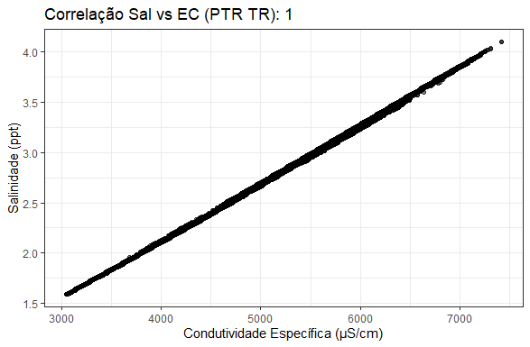

Call:

lm(formula = gw_salinity ~ gw_spec_cond, data = dat_wide)

Residuals:

Min 1Q Median 3Q Max

-0.034104 -0.011996 0.001496 0.012290 0.035573

Coefficients:

Estimate Std. Error t value Pr(>|t|)

(Intercept) -2.060e-01 5.101e-04 -403.9 <2e-16 ***

gw_spec_cond 5.781e-04 8.805e-08 6565.9 <2e-16 ***

---

Signif. codes: 0 ‘***’ 0.001 ‘**’ 0.01 ‘*’ 0.05 ‘.’ 0.1 ‘ ’ 1

Residual standard error: 0.01423 on 39727 degrees of freedom

Multiple R-squared: 0.9991, Adjusted R-squared: 0.9991

F-statistic: 4.311e+07 on 1 and 39727 DF, p-value: < 2.2e-16

References:

[20587_TEROS11-12_Manual_Web.pdf](https://publications.metergroup.com/Manuals/20587_TEROS11-12_Manual_Web.pdf?_gl=1*1o8ismg*_gcl_au*ODQ5Mjg2MzkuMTc0MzQzMzU5Nw..)

[Aquatroll_0096402.pdf](https://in-situ.com/en/pub/media/support/documents/0096402.pdf)

[2520 Salinity (Editorial Revisions, 2011) | PDF | Salinity | Seawater](https://www.scribd.com/document/472983454/2520-Salinity-Editorial-revisions-2011)