Objective:
This document serves as a guide for the installation and sampling of porewater in the Chesapeake Bay region Synoptic Sites. Porewater is collected for a variety of chemical analyses. Once collected, samples are processed at SERC.

Contents:
- Experimental Design
- Personal Protective Equipment
- Lysimeters
  - Lysimeter sampler unites
  - Lysimeter preparation
- Installation
  - Materials
  - Procedure
- Sample Collection
  - Materials
  - Field Procedure
  - Sample Prioritization Chart
- Corresponding Documentation
- References

I. Experimental Design:

Lysimeters will be installed to sample porewater in the Upland, Transition, and Wetland at depths of 10, 20, and 45 cm below the soil surface. At Sweethall Marsh a fourth zone in a marsh location will also be installed to include lysimeter sampling.
Three lysimeter nests containing the specific depths of 10, 20, and 45 cm will be installed equidistant from each other in each zone.
Chesapeake Bay Design:
- 9 lysimeters per zone; 3 or 4 zones per site
- Per Zone = 9 total: 3 replicates (A, B, C) including 10, 20, 45 cm depths
- Lysimeter clusters are labeled with garden stakes: GCW-TR-A; MSM-WC-C
- Samplers are labeled with colors: 10 cm = RED, 20 cm = ORANGE, 45 cm = BLACK

Lysimeter porewater was collected monthly during the growing season of 2022 and 2023. Starting in 2024 we began 4 porewater samplings per growing season (roughly every other month), except for at Sweethall, which we sampled monthly through 2024. Sweethall was established in 2023, so we continued monthly sampling to match the 2 year intensive collection. Sweet Hall Marsh also has four (4) zones, Wetland, Transition, Swamp (designate Upland in 2023) and Upland (designated Upland Control in 2023).

II. Personal Protective Equipment:

Close-toed shoes and long pants are required at all times when working at COMPASS sites. Wearing an orange safety vest is required during seasonal hunting months at applicable sites including MSM, SWH, and GCW. Lab gloves are required during the sampling process to decrease sample contamination, but also because some sample bottles are prepped with chemicals that could be irritating to skin.

III. Lysimeters:

- Lysimeter sampling units:

  - Lysimeter 1909L##-B01M3 7/8" O.D has a butyrate body with 1/8" O.D. polyethylene inside tubing. 1, 6, 12, 18, 24, 36, 48, and 60 in. lengths available. Ends in female luer connection. Length and ceramic type can be customized. 1909 uses one bar high flow ceramic (B01M3) which is 2.5 micron pore size
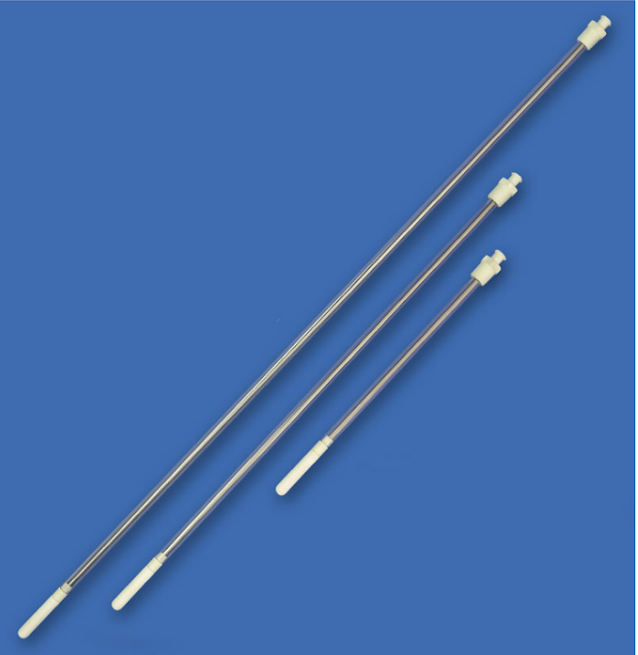
Figure 2.1. Lysimeters

  - COMPASS will use Lysimeters of 6, 12, and 24-inch lengths for the depth of 10, 20, and 45 cm (Figure 2.1).
- Lysimeter Preparation:

It is possible to install 1909 dry (without the below preparation), however, the following procedure is recommended. It is also recommended to discard the first 2 or 3 collected samples.

- First, the user must collect de-aired water. Uses DI water with a vacuum system.
- Using gloves, remove the plastic cover from the ceramic, and put the lysimeter in a pot with de-aired water, and save the plastic wrap and rubber band for later, as you will use them again. Try to avoid touching the ceramic with bare hands.
- Place the ceramic tip of the sampler into the de-aired water (Fig. 4a). It is imperative to not let the ceramic tip get wet on the inside! If water enters from both sides of the ceramic, air bubbles can be trapped inside the ceramic and the sampler will not work properly.
- Once the samplers are in de-aired water, connect the 1930 Locking Syringe to each via its luer-lock connection, pull the syringe back, and lock into place (Fig. 4b). This can also be done with other Vacuum Extraction Kits.
- Leave the samplers and syringes (or other Extraction Kit) to sit overnight.
- The next day, water should have collected into the Syringe. If so, the ceramic has been properly wetted. If not, check all connections and repeat steps 3-5.
- Once the ceramic tips have been fully wetted, replace the plastic bag over the ceramic tip securing with the rubber band.

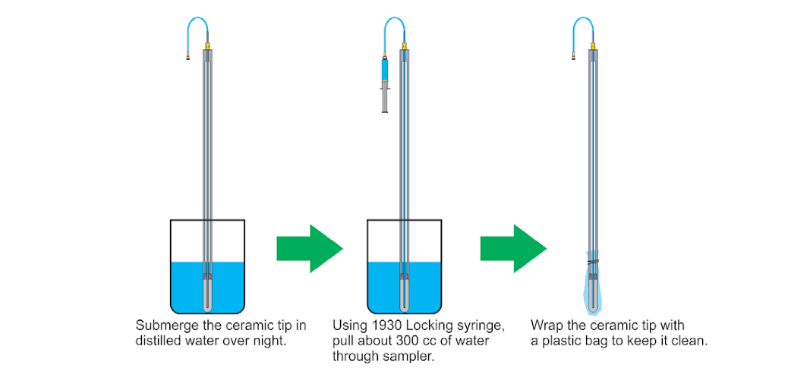

IV. Installation:

- Materials:
- Gloves
- Lysimeter (10, 20, 45 cm)
- Insertion tool – metal tube in compass shed
  - Get details on what kind of tube this is
- Bucket
- Locking Syringe
- Electrical tape
- Loom
- Sharpie
- Garden stake for labeling
- Procedure:

  - Identify the designated location of the lysimeter, clean the litter from soil and be sure that you do not touch the PVC portion of the sampler without gloves on.
  - Core out soil to the desired depth with the insertion tool. The desired depth must be at the middle of the ceramic unit.
  - Insert the Lysimeter gently in the whole.
  - Tamp soil firmly around the Lysimeter to prevent surface water from infiltrating the hole.

V. Sample Collection:

- Materials:
- Gloves
- 60mL syringe (2)
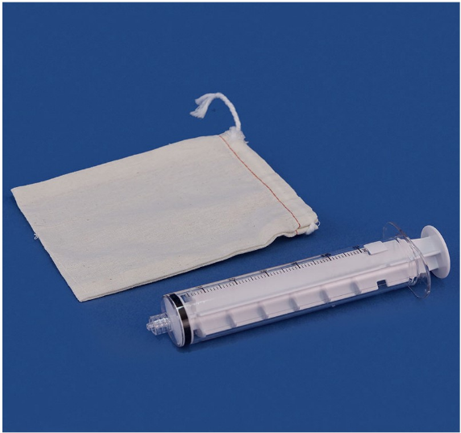
- 3-way stopcock (2)
- Labeled vials
- Cooler w/ice
- ZipLock bags
- Lunch boxes
- Ice backs for lunch boxes
- PW Bento box
- Kneeling pad
- Carboy with DI water
- DI water field bottle
- Measuring cup (at least 250mL)
- Field Procedure:

At MSM – stop at Beaverdam creek to get surface water samples before going to site

Set Up:

- Prepare each blue lunch box with one ice pack
- Put your gloves on
- Take ice packs, syringes, and bottle packs out to first zone
  - Order based on site:
    - GCW: Upland, Transition, Wetland
    - MSM: Upland, Transition, Wetland
    - SWH: Upland; Swamp; Transition; Wetland
    - GWI: Wetland; Transition; Upland
- Lay out the bottle packs next to each lysimeter
- Attach a syringe to the Lysimeter, pull out and lock
- Attach all syringes in one zone
- Go back to the first syringe in that zone and reset in order that you put them out
  - This clears out any air or water that was sitting in the tubing
- Attach all syringes
- Collect Surface water samples
  - You should already have gloves on
  - Field rinse bottles twice before filling
  - Close surface water bottles and take to analyze
- Set up a place to sit/table with porewater analysis kit
- Surface water samples:
  - Get sample bag and prepare vials in PW Bento
  - Rinse syringe once
  - Fill syringe and take:
    - DIC (~25mL)
      - Check sample vial label
      - Remove any air from syringe
      - Attach syringe filter & tubing
      - Dispense 1-2 mL to wet filter
      - Fill 24mL vial and over fill so it has a meniscus
      - Slowly pull tubing out of the vial
      - Cap the vial
      - There should be no headspace or bubbles!!
      - Turn the vial upside down to look for a bubble
      - If you have a bubble, open the vial and add some more water
    - H2S/Cl (5mL)
      - Check sample vial label
      - Remove tubing from filter / replace filter if needed
      - Attach a wide gauge needle (yellow or green) to the filter
      - Ensure there are no bubbles in the syringe / no air and if there is dispense it
      - Dispense ~1mL of through the filter and needle to flush it
      - Put needle into vial, under 5% ZnAc
      - Dispense 5mL of sample slowly into the vial
      - Cap and invert once to mix
    - DOC (at least 10mL)
      - Check sample vial label
      - Keep the filter on or get a new filter if needed
      - If new filter; wet the filter with 1-2 mL dispensed
      - Open DOC vial and dispense 30-35mL into the vial
    - FE (5mL)
      - Check sample vial label
      - Keep filter on or get a new filter if needed
      - Dispense 5mL into the pre-acidified scintillation vial
      - Close and mix sample in vial
    - Nutrients (at least 3mL)
      - Check sample vial label
      - Keep filter on or get a new filter if needed
      - Dispense 10mL into falcon tube
      - Close vial
    - Shakey GHG samples
      - Check sample vial label
      - 20mL sample + 20mL air
        - I usually do all three samples at once to save time
      - Close stopcock to the syringe
      - Shake for 3 mins
      - Remove water from syringe, by inverting syringe and dispensing the water through the stopcock
      - Put a needle on the end of the stopcock and syringe gas into evacuated exetainer
    - Check all sample vial labels; check vial cap tightness; place vials back into sample bag and put into lunch bag with ice pack until they can be put in the cooler
    - Check off on the porewater datasheet which samples you were able to get
- Porewater samples:
  - Go to first lysimeter set and take the first syringe
    - I go in order: WC-LysA-10cm then I do WC-LysA-20cm, etc.
  - When you take off the syringe; remove any air in the syringe; attach a filter
  - If you have 50-60mL:
    - DIC (~25mL)
      - Check sample vial label
      - Remove any air from syringe
      - Attach syringe filter & tubing
      - Dispense 1-2 mL to wet filter
      - Fill 24mL vial and over fill so it has a meniscus
      - Slowly pull tubing out of the vial
      - Cap the vial
      - There should be no headspace or bubbles!!
      - Turn the vial upside down to look for a bubble
      - If you have a bubble, open the vial and add some more water
    - H2S/Cl (5mL)
      - Check sample vial label
      - Remove tubing from filter / replace filter if needed
      - Attach a wide gauge needle (yellow or green) to the filter
      - Ensure there are no bubbles in the syringe / no air and if there is dispense it
      - Dispense ~1mL of through the filter and needle to flush it
      - Put needle into vial, under 5% ZnAc
      - Dispense 5mL of sample slowly into the vial
      - Cap and invert once to mix
    - DOC (at least 10mL)
      - Check sample vial label
      - Keep the filter on or get a new filter if needed
      - If new filter; wet the filter with 1-2 mL dispensed
      - Open DOC vial and dispense 30-35mL into the vial
    - FE (5mL)
      - Check sample vial label
      - Keep filter on or get a new filter if needed
      - Dispense 5mL into the pre-acidified scintillation vial
      - Close and mix sample in vial
    - Nutrients (at least 3mL)
      - Check sample vial label
      - Keep filter on or get a new filter if needed
      - Dispense 10mL into falcon tube
      - Close vial
    - Check off on the porewater datasheet which samples you were able to get from the lysimeter
  - If you have <40mL :
    - SKIP DIC!
    - H2S/Cl (5mL)
      - Check sample vial label
      - Remove tubing from filter / replace filter if needed
      - Attach a wide gauge needle (yellow or green) to the filter
      - Ensure there are no bubbles in the syringe / no air and if there is dispense it
      - Dispense ~1mL of through the filter and needle to flush it
      - Put needle into vial, under 5% ZnAc
      - Dispense 5mL of sample slowly into the vial
      - Cap and invert once to mix
    - DOC (at least 10mL)
      - Check sample vial label
      - Keep the filter on or get a new filter if needed
      - If new filter; wet the filter with 1-2 mL dispensed
      - Open DOC vial and dispense 30-35mL into the vial
    - FE (5mL)
      - Check sample vial label
      - Keep filter on or get a new filter if needed
      - Dispense 5mL into the pre-acidified scintillation vial
      - Close and mix sample in vial
    - Nutrients (at least 3mL)
      - Check sample vial label
      - Keep filter on or get a new filter if needed
      - Dispense 10mL into falcon tube
      - Close vial
    - Check off on the porewater datasheet which samples you were able to get from the lysimeter
  - Reattach the syringe once you finish all the samples and set it up to sample
  - Go to the next sample
  - After you have processed all the samples for the first round; go back and top off the DOC and Nutrient vials with the second syringe full.
- After you have the samples for a zone, make sure they are either on an ice pack or put into the cooler on ice.
- Go to the next zone and repeat.
- When you have finished all sampling, organize the porewater vials by sample type into bags
  - check the lids of the vials
  - Put in baggies in the cooler
  - When you return to Mathias put the samples away:
    - DIC in fridge (walk in on first floor)
    - DOC in fridge (walk in on first floor)
    - H2S in fridge (walk in on first floor)
    - FE in fridge (walk in on first floor)
    - Nutrients in freezer (walk in, in basement)

- Sample Prioritization Chart
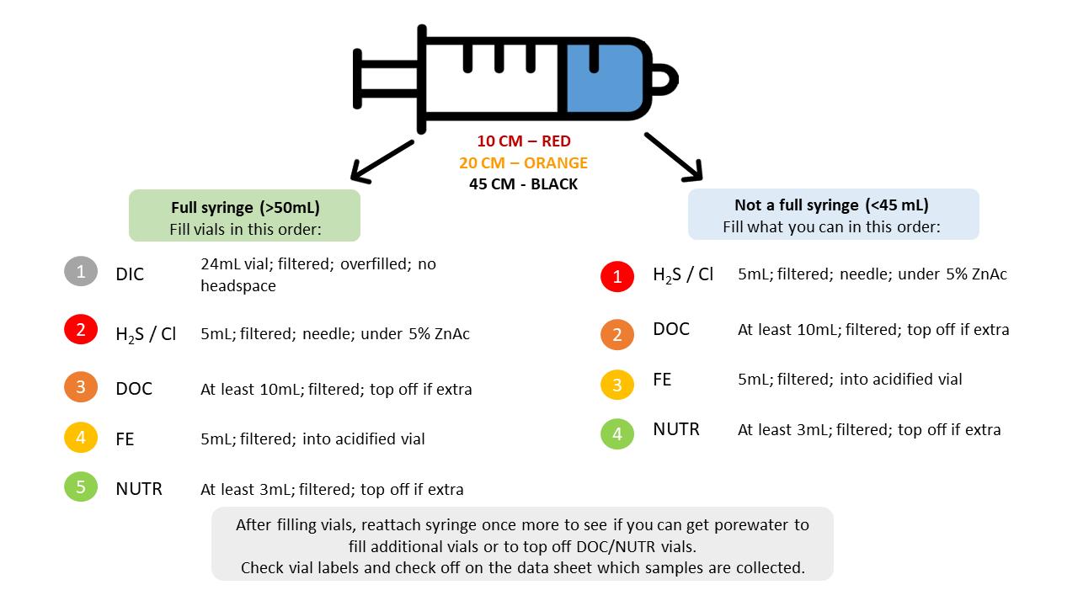

VI. Corresponding Documentation:

VII. References:

