**Sprint #3 – UI Prototypes (Mobile app)**

**User Story #157** – As a user, I want to access my account on the mobile version of the platform.

Landing page when opening the mobile app

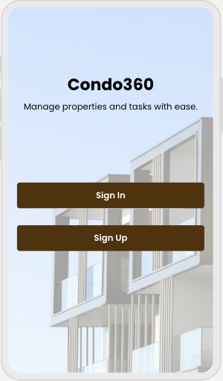

Sign Up page

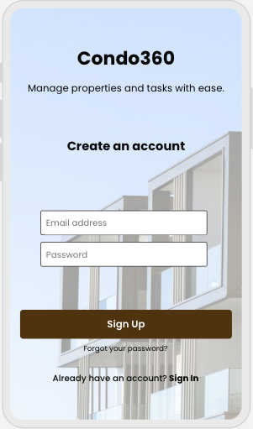

Sign In page

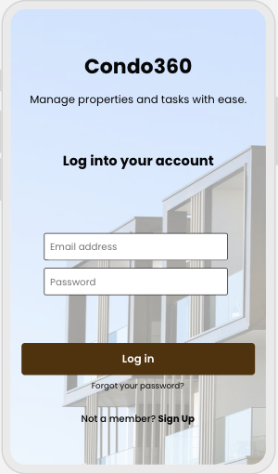

**User Story #161** – As a user, I want to access the details of my profile.

Profile page

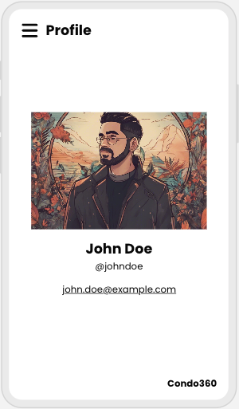

**User Story #163 –** As a condo management company, I want to access the details of my property from the mobile app.

Overview page for properties

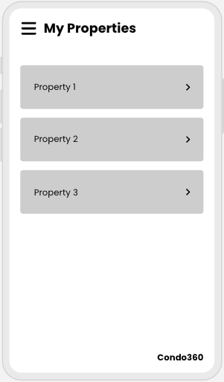

Details page for a property

