Setup
Download and open the “NHIN_CONNECT_Release_2_0_A020_Demonstration_ Scripts_InternalSelfTest_April_6_2009.zip” file. Extract all files into the same local directory. Copy the contents of the “Adapter” subdirectory to “C:\SelfTest” on the Adapter server and the contents of the “Gateway” subdirectory to “C:\SelfTest” on the Gateway server.

Adapter
1) Import the patient's documents into the local document repository:
a. Copy the “document.sql” file to C:\Program Files\MySQL\MySQL Server 5.0\bin on the server.
b. Start a Command Prompt window on the server.
c. Type the following commands:
cd “C:\Program Files\MySQL\MySQL Server 5.0\bin”
mysql -uroot -pNHIE-Gateway docrepository < document.sql

2) Copy the mpi.xml file to “C:\GlassfishESB\glassfish\domains\domain1\config”.
3) To create the patient's Consumer Preferences Profile document:
a. If your gateway’s Assigning Authority ID (organizationId) in the mpi.xml file is different from the Home Community ID ("localHomeCommunityId" in the gateway.properties file), on the Adapter Server, edit the gateway.properties file and change the "localHomeCommunityId" property to match the site’s Assigning Authority ID (“organizationId” in the mpi.xml file).
b. If GlassFish is not running, then start the Adapter application server. Access the Consumer Preferences Profile GUI at http://localhost:8080/ConsumerPreferencesProfileGUI/.
c. Uncheck the checkbox next to patient “Gallow Younger” and press the "Update" button.
d. After a few minutes, the message “Updated 1 patients” is displayed. Access the Consumer Preferences Profile GUI at http://localhost:8080/ConsumerPreferencesProfileGUI/ again.
e. Check the checkbox next to patient “Gallow Younger” and press the "Update" button again.
f. If your gateway’s Assigning Authority ID is different from the Home Community ID, on the Adapter Server, revert the "localHomeCommunityId" property to the Home Community ID.
g. On the Adapter server, log in to the MySQL Query Browser with the user name “nhincuser” and the password “nhincpass”. View the contents of the “document” table in the “docrepository” schema. Verify that the Consumer Preferences Profile document with the document ID of "D123401-XNHIN-CONSENT" is present.

Gateway
1) On the Gateway server, log in to the MySQL Query Browser with the user name “nhincuser” and the password “nhincpass”. View the contents of the “correlatedidentifiers” table in the “patientcorrelationdb” schema. Ensure that the table is empty. If values are present, click on the “Edit” button at the bottom of the screen, right-click on the data and select the “Delete Row(s)” menu option, then click on the “Apply Changes” button.
2) In the “SelfTest.properties” file, replace “<Gateway-IP>” with the IP of the Gateway server and “<Adapter-IP>” with the IP of the Adapter server.
3) Change the values of the following properties to the corresponding paths on the Gateway Server:
- NHINGatewayConfigDir: This should be equal to the value stored in the $NHINC_PROPERTIES_DIR environment variable on the Gateway server.
- SubscriptionDir: Set this property to the path of the directory containing the subscriptionList.xml file (e.g. C:\\GlassFishESB\\glassfish\\domains\\domain1\\config).

4) Change the IP address in each of the following properties to the IP address of the Adapter server:
- NHINAdapterConfigDir: This should be equal to the value stored in the $NHINC_PROPERTIES_DIR environment variable on the Adapter server (e.g. //192.168.0.104/ Projects/NHINC/current/Product/Production/Common/Properties). This directory must be shared and accessible from the Gateway server.
- MPIDir: Set this property to the path of the directory containing the mpi.xml file on the Adapter server (e.g. //192.168.0.104/glassfish/domains/domain1/config). This directory must be shared and accessible from the Gateway server.

5) Set the following properties as described:
- LocalHCID: the Gateway’s home community ID. This value should match the “localHomeCommunityId” property found in the gateway.properties file.
- LocalAA: the Gateway’s assigning authority ID. This value can be the same as the “localHCID” value.
- LocalHCDescription: a description of the agency
- LocalConfigDir: the location of the unzipped contents of the zip file
Please note that soapUI has a special use for the backslash character (“\”). This requires the use of two consecutive backslashes in paths, such as “\\\\192.168.25.157\\glassfish\\domains\\domain1\\config\\nhin”. SoapUI does allow the use of the standard slash (“/”), however, so the same path can be defined as “//192.168.25.157/glassfish/domains/domain1/config/nhin”.
6) Edit the “subscriptionList-subscribee.xml” file and replace “<Gateway-IP>” with the IP address of the Gateway server.
7) Install soapUI if it is not already installed. Go to “C:\Program Files\eviware\soapUI-{version#}\bin” and edit the soapui.bat file. Change the line starting with “set JAVA_OPTS” to the following:
set JAVA_OPTS=-Xms384m -Xmx512m -Dsoapui.properties=soapui.properties "-Dsoapui.home=%SOAPUI_HOME%\"
8) Launch soapUI and select the File -> Preferences option. Enter “300000” into the Socket Timeout field and press the “OK” button. Select the File -> Save Preferences menu option.
9) Load the “InternalSelfTest-soapUI-project.xml” project file. Within each of the eight test cases, there is a step called “Test Case Properties”. Change the path in the “Load from:” field to the path of the “SelfTest.properties” file. You can also press the button to the right of the “Load from:” field and navigate to the property file.

Criteria For Successful Tests
To execute the tests, simply expand the “InboundSelfTest” project node in soapUI, double click on the “SelfTest TestSuite” node, and then click on the green arrow on the sub window that is next displayed.
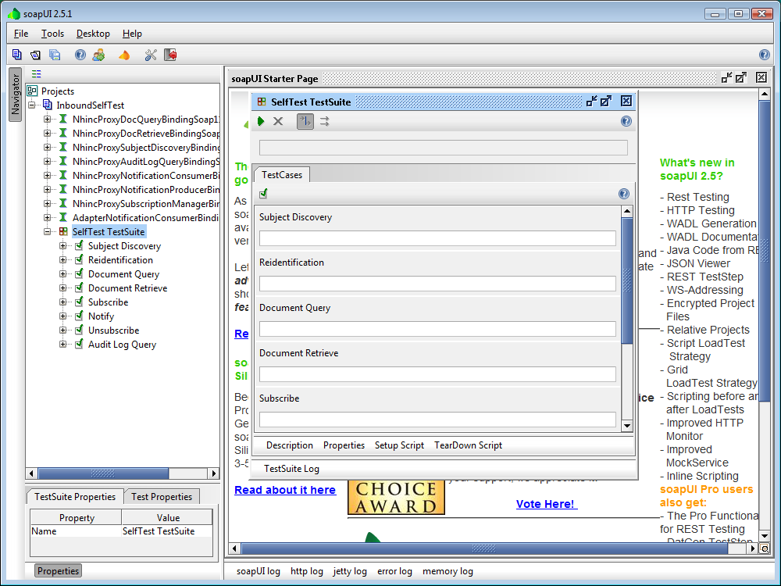
Most of the tests have built-in assertions that indicate whether a test has passed or failed. Here are some additional criteria:

Subject Discovery
- The response message contains a status of “Success”.
- A new correlation will be created on the Gateway server on the “patientcorrelationdb” schema in the “correlatedidentifiers” table containing the following data:
PatientAssigningAuthorityId | PatientId | CorrelatedPatientAssigningAuthorityId | CorrelatedPatientId
2.16.840.1.113883.3.200 | 500000000 | {your Gateway’s Assigning Authority ID} | D123401

Reidentification
- The response message contains the correct reidentified patient ID and assigning authority ID from the reidentification.xml file.

Document Query
- Two documents are successfully returned.

Document Retrieve
- The response contains the encoded document content.

Subscribe
- The subscriptionList.xml file on the Gateway server in C:\GlassFishESB\glassfish\domains\domain1\config\nhin contains a subscription record.

Notify

The following message is present at the end of the Glassfish log file segment from when the “Notify” test was run:

<?xml version='1.0' encoding='UTF-8'?><SOAP-ENV:Envelope xmlns:SOAP-ENV="http://schemas.xmlsoap.org/soap/envelope/"><SOAP-ENV:Body><ns1:Acknowledgement xmlns:msgns="urn:gov:hhs:fha:nhinc:adapternotificationconsumer" xmlns:ns1="urn:gov:hhs:fha:nhinc:common:nhinccommon"><ns1:message>Successful Document Notify</ns1:message></ns1:Acknowledgement></SOAP-ENV:Body></SOAP-ENV:Envelope>

Unsubscribe
- The subscriptionList.xml file on the Gateway server in C:\GlassFishESB\glassfish\domains\domain1\config\nhin contains no subscription records.

Audit Log Query
- The response message contains multiple audit log entries from the messages sent by the other tests.

