OpenSSO Overview
Contents
Setting up user accounts 2
Setting up Groups 4
Setting up Netbeans Project for OpenSSO Authentication 5
Using OpenSSO in Visual Web (JSF) Application 6
Setting up Circle of Trust for PEP to PDP Interactions 13

Setting up user accounts
1) Login as amadmin
2) Click on Access Control tab
3) Click on Realm (opensso created on install)
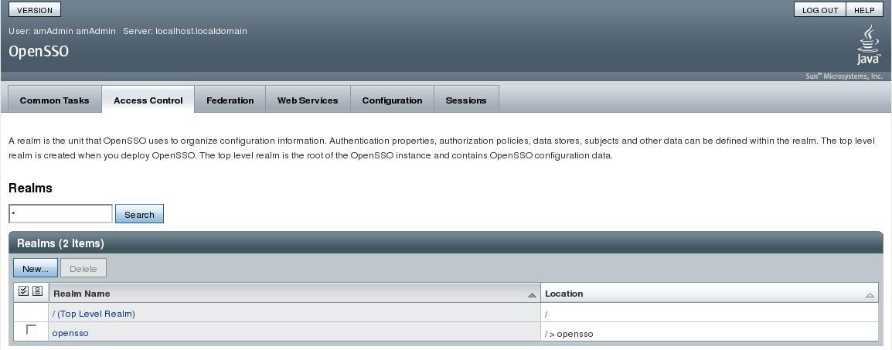
4) Click on Subjects tab (User maintenance screen)
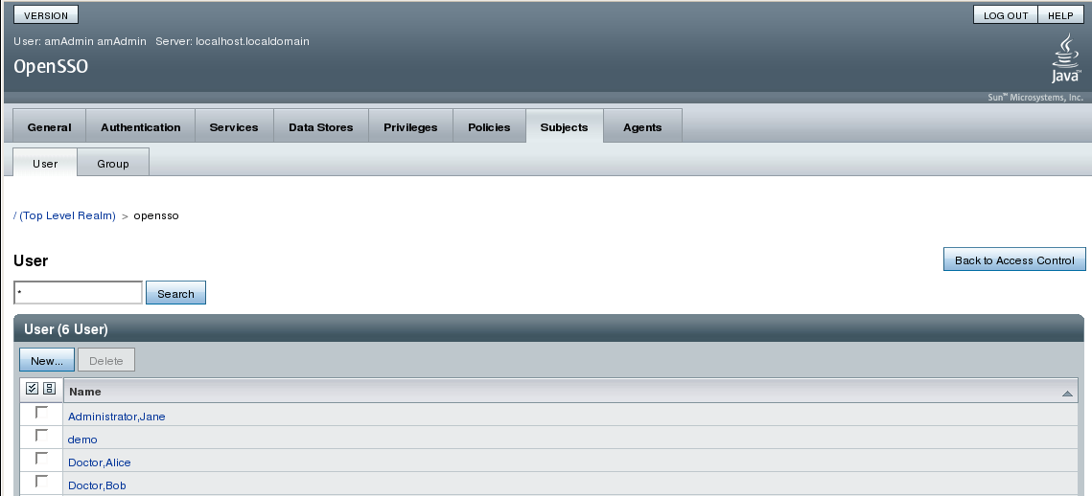
5) Click new to add user...
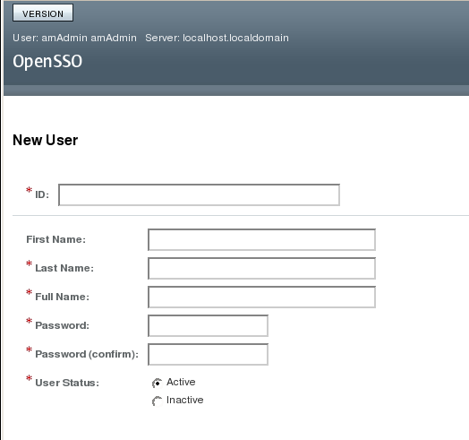
6) Save...
7) Associate User to a Group (click on user name in Subjects/User tab) use add remove listed to set group association and save..
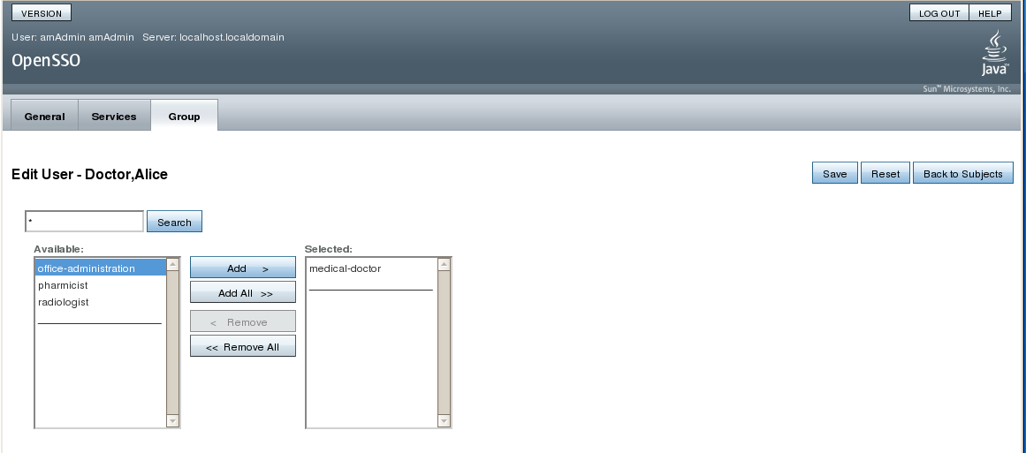

Setting up Groups
1) Login in as amadmin
2) Click on tabs Access Control > Subjects > Groups
3) Click on "New" Button
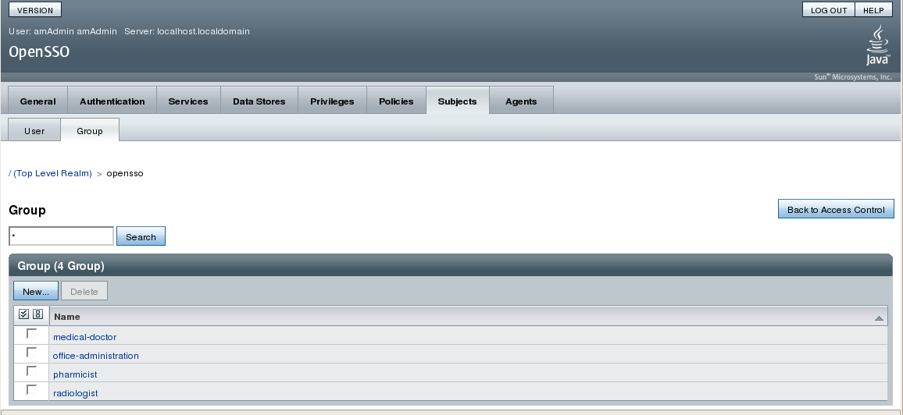
4) Enter in Group name and save...
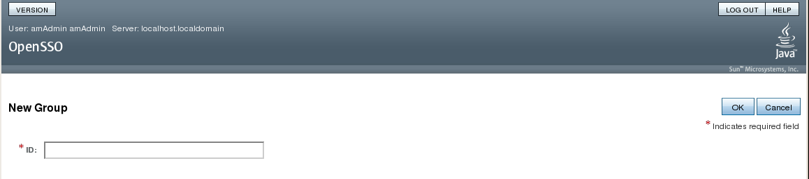

Setting up Netbeans Project for OpenSSO Authentication
1) Include openssoclientsdk.jar library
2) Create a folder under WEB-INF called classes and copy opensso property files into it.
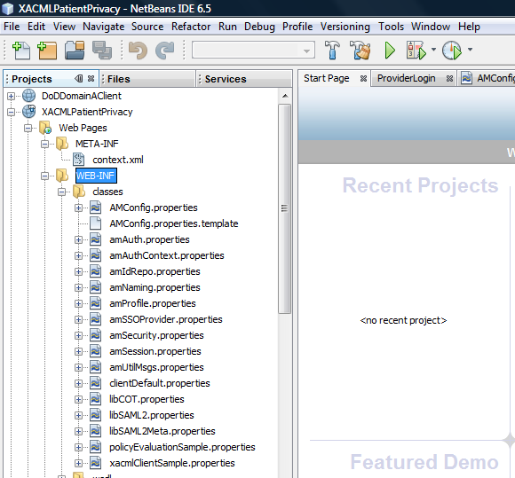
3) You only need to change the properties of the AMConfig.properties file identifying host port information for your environment. Save your changes...

Using OpenSSO in Visual Web (JSF) Application
1) Within your JSF login page implement the static class Login...
static class Login {

private String loginIndexName;
private String orgName;
private String locale;
private String user;
private String password;

Login(String user, String password, String loginIndexName, String orgName) {
this.loginIndexName = loginIndexName;
this.orgName = orgName;
this.user = user;
this.password = password;
}

Login(String user, String password, String loginIndexName, String orgName, String locale) {
this(user, password, loginIndexName, orgName);
this.locale = locale;
}

protected AuthContext getAuthContext()
throws AuthLoginException {
AuthContext lc = new AuthContext(orgName);
AuthContext.IndexType indexType = AuthContext.IndexType.MODULE_INSTANCE;
if (locale == null || locale.length() == 0) {
lc.login(indexType, loginIndexName);
} else {
lc.login(indexType, loginIndexName, locale);
}
debugMessage(loginIndexName + ": Obtained login context");
return lc;
}

private void addLoginCallbackMessage(Callback[] callbacks)
throws UnsupportedCallbackException {
int i = 0;
try {
for (i = 0; i < callbacks.length; i++) {
if (callbacks[i] instanceof TextOutputCallback) {
handleTextOutputCallback((TextOutputCallback) callbacks[i]);
} else if (callbacks[i] instanceof NameCallback) {
handleNameCallback((NameCallback) callbacks[i]);
} else if (callbacks[i] instanceof PasswordCallback) {
handlePasswordCallback((PasswordCallback) callbacks[i]);
} else if (callbacks[i] instanceof TextInputCallback) {
handleTextInputCallback((TextInputCallback) callbacks[i]);
} else if (callbacks[i] instanceof ChoiceCallback) {
handleChoiceCallback((ChoiceCallback) callbacks[i]);
}
}
} catch (IOException e) {
e.printStackTrace();
throw new UnsupportedCallbackException(callbacks[i], e.getMessage());
}
}

private void handleTextOutputCallback(TextOutputCallback toc) {
debugMessage("Got TextOutputCallback");
// display the message according to the specified type

switch (toc.getMessageType()) {
case TextOutputCallback.INFORMATION:
debugMessage(toc.getMessage());
break;
case TextOutputCallback.ERROR:
debugMessage("ERROR: " + toc.getMessage());
break;
case TextOutputCallback.WARNING:
debugMessage("WARNING: " + toc.getMessage());
break;
default:
debugMessage("Unsupported message type: " +
toc.getMessageType());
}
}

private void handleNameCallback(NameCallback nc)
throws IOException {
// prompt the user for a username
System.out.print(nc.getPrompt());
System.out.flush();
nc.setName(user);
}

private void handleTextInputCallback(TextInputCallback tic)
throws IOException {
// prompt for text input
System.out.print(tic.getPrompt());
System.out.flush();
//tic.setText((new BufferedReader(new InputStreamReader(System.in))).readLine());
}

private void handlePasswordCallback(PasswordCallback pc)
throws IOException {
// prompt the user for sensitive information
System.out.print(pc.getPrompt());
System.out.flush();
pc.setPassword(password.toCharArray());
}

private void handleChoiceCallback(ChoiceCallback cc)
throws IOException {
// ignore the provided defaultValue
System.out.print(cc.getPrompt());

String[] strChoices = cc.getChoices();
for (int j = 0; j < strChoices.length; j++) {
System.out.print("choice[" + j + "] : " + strChoices[j]);
}
System.out.flush();
//cc.setSelectedIndex(Integer.parseInt((new BufferedReader(new InputStreamReader(System.in))).readLine()));
}

protected boolean login(AuthContext lc)
throws UnsupportedCallbackException {
boolean succeed = false;
Callback[] callbacks = null;

// get information requested from module
while (lc.hasMoreRequirements()) {
callbacks = lc.getRequirements();
if (callbacks != null) {
addLoginCallbackMessage(callbacks);
lc.submitRequirements(callbacks);
}
}

if (lc.getStatus() == AuthContext.Status.SUCCESS) {
System.out.println("Login succeeded.");
succeed = true;

} else if (lc.getStatus() == AuthContext.Status.FAILED) {
System.out.println("Login failed.");
} else {
System.out.println("Unknown status: " + lc.getStatus());
}

return succeed;
}

protected void logout(AuthContext lc)
throws AuthLoginException {
lc.logout();
System.out.println("Logged Out!!");
}

static void debugMessage(String msg) {
System.out.println(msg);
}

}
2) From you login action (button) call for authentication by...
public String loginButton_action() {
// TODO: Process the action. Return value is a navigation
// case name where null will return to the same page.
String user = userName.getText().toString();
String pword = passWordField.getText().toString();

Login login = new Login(user, pword, "DataStore", "/");
String pagenav = "patientsearch";

try {

AuthContext lc = login.getAuthContext();
if (login.login(lc)) {
pagenav = "LocalPatientSearch";
getSessionBean1().setUserID(user);
try {
Providers px = getProviderInfo(user);
if (px == null) {
System.out.println("PX IS NULL");
pagenav = null;
} else {
getSessionBean1().setProviderIEN(px.getProviderien());
getSessionBean1().setProviderName(px.getUsername());
}
} catch (Exception lx) {
pagenav = null;
lx.printStackTrace();
}
} else {
System.out.println("LOGIN FAILURE");
pagenav = null;
}

} catch (Exception ex) {
System.err.println("Login:Error " + ex.getMessage());
}
return pagenav;
}

Setting up Circle of Trust for PEP to PDP Interactions
Review vaPep.xml, vaPep-x.xml, jerichoPdp.xml, sunPdp.xml
1) login as amadmin
2) Click on Federation tab...Scroll down to Entity Providers
3) Click on Import Entity button
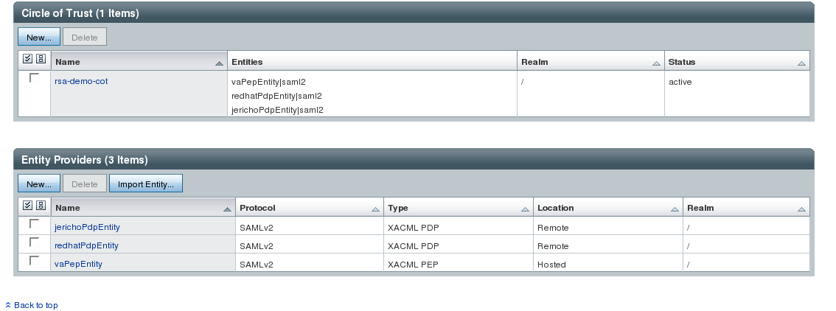
4) The PEP will have both meta and extended meta data files...you must import both at same time using below screen.
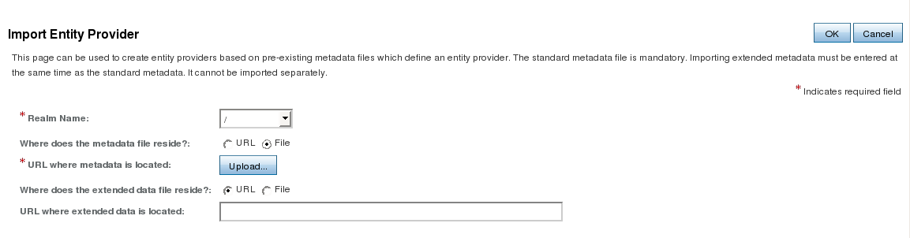
5) Upload PEP meta data file, browse and select file, click on Upload File button
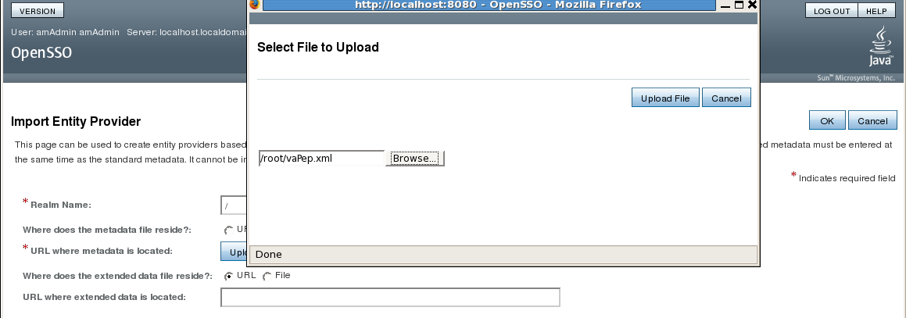
6) Upload Extended Meta-Data file
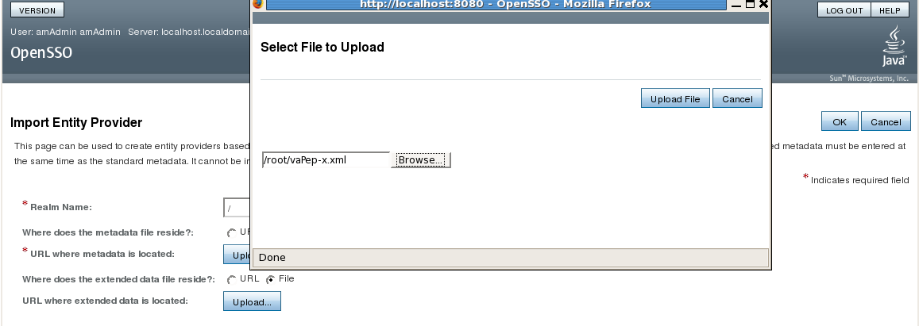
7) Click on OK button to create PEP entry
8) Repeat steps not including extended meta - data items to create you PDP entries.

9) Create Circle of Trust first click on NEW button in Circle of Trust table.
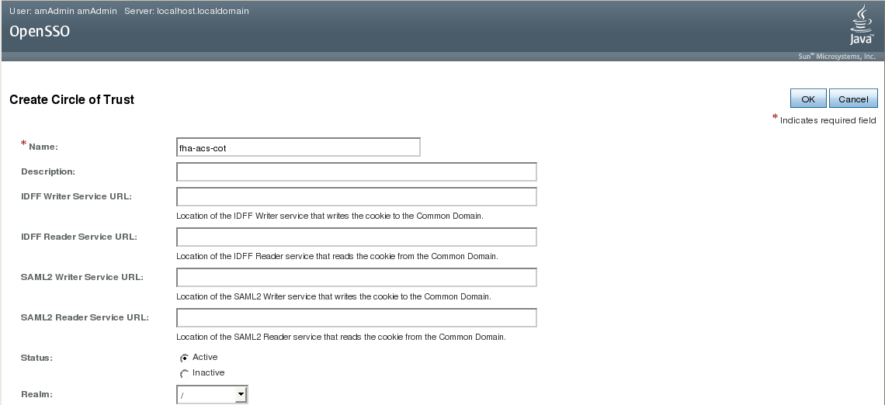
10) Enter name, select default realm of "/" and associated all PEP and PDP entities to it.
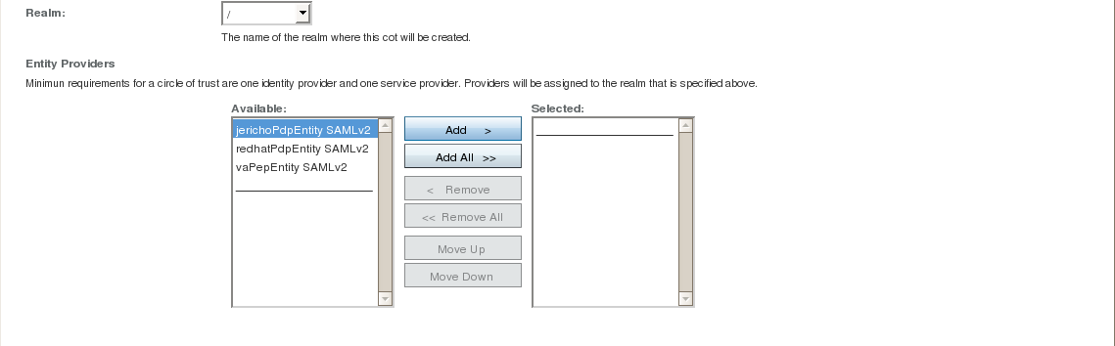
11) Click on OK button to save...

NOTE: The SAML issuer name must be same as entity name with meta data otherwise request-response will fail. The same entity name is need in call to XACMLRequestProcessor for both PEP and destination PDP.

