**Language**

**Instructions** (center, back color: white, duration: infinite)

**Practice** (list of 5 training examples)

Image Question Image Fixation

**Image1** duration 2000ms

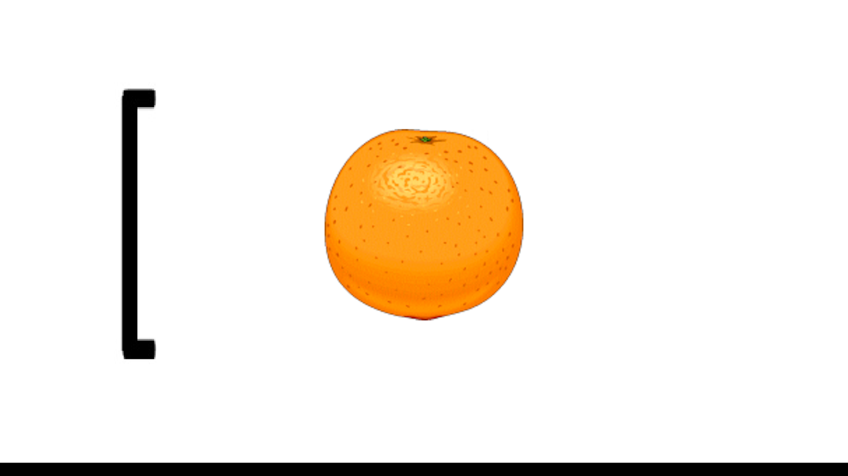

**Question1** duration 3000ms

**Image2** duration 2000ms

**FixationCross1** duration 5000ms

(…)

**Transition** (press p to redo the practice and t to move to trials)

**Ready** (starts the trial as soon as "5" is received)

**Countdown** duration 5000ms

**Trial**

**Bloc1** (list of 32 trials)

Image Question Image Fixation

**Image1** duration 2000ms

**Question** duration between [3000, 8000] ms

**Image2** duration 2000ms

**FixationCross** duration between [3000, 8000] ms

(…)

**Rest** duration until the experimenter start it over

**Ready** (starts the trial as soon as "5" is received)

**Countdown** duration 5000ms

**Bloc2** (list of 32 trials)

Image Question Image Fixation

**Image1** duration 2000ms

**Question** duration between [3000, 8000] ms

**Image2** duration 2000ms

**FixationCross** duration between [3000, 8000] ms

(…)

**Thanks** duration 10000ms

