**AMAZON**

Amazon.com, Inc., is an American multinational technology company based in Seattle that focuses on e-commerce, cloud computing, digital streaming, and artificial intelligence. It is considered one of the Big Four technology companies, along with Google, Apple, and Microsoft

🡪Type amazon.in in your browser

🡪Will take you to the web page as shown in below

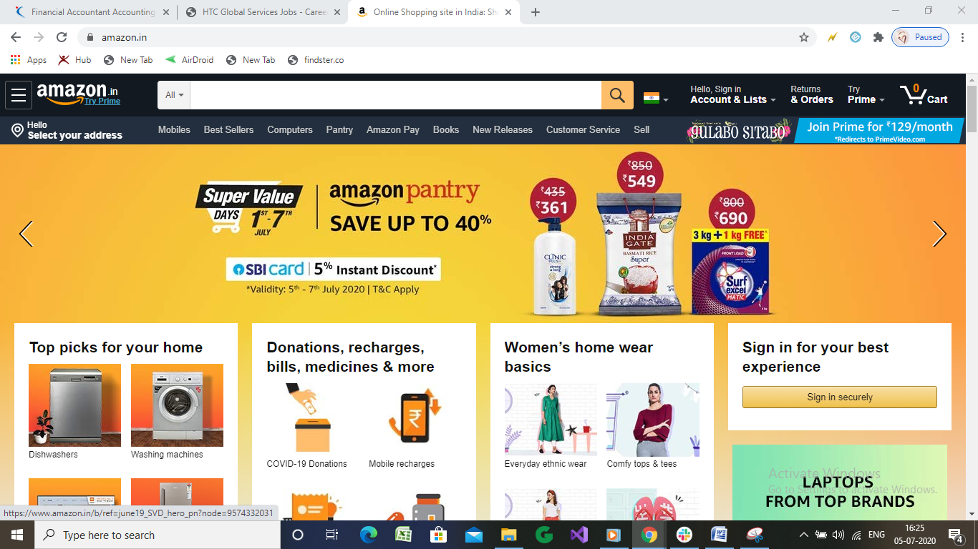

🡪Go to the 3 cross bars on top left and click it to see the diverse options in Amazon.

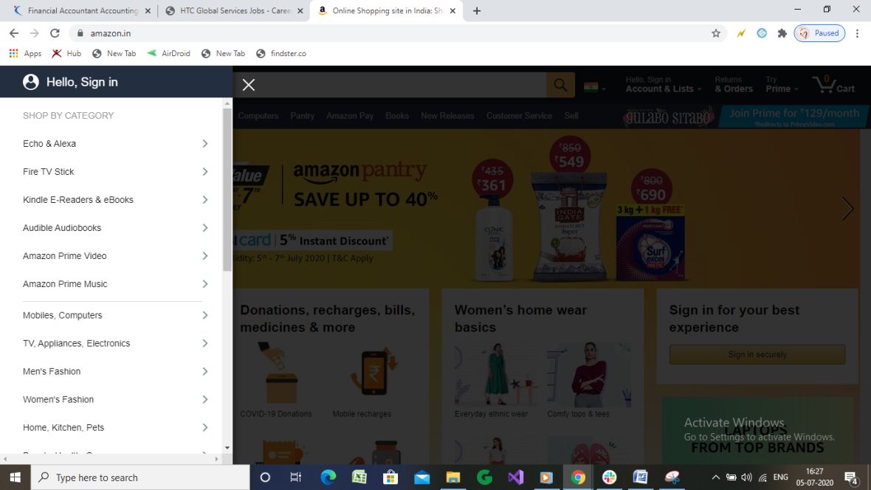

🡪”Shop by category” is the option which is the best feature in amazon, lets go to mobile and computers section.

🡪it again shown a sub menu presenting

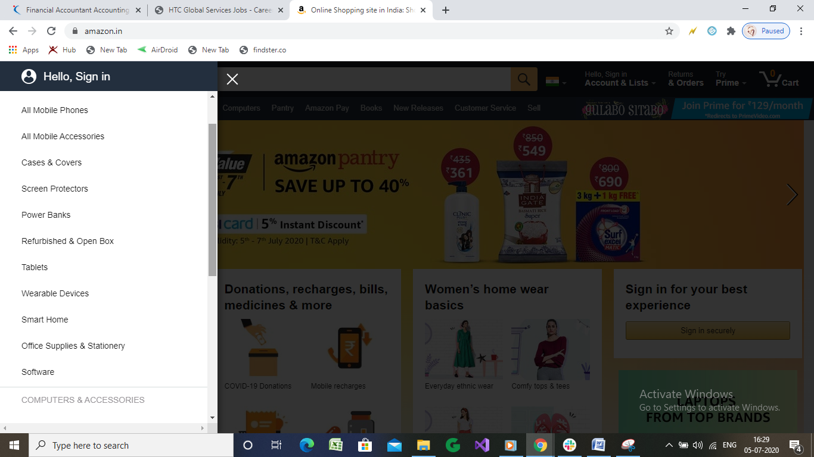

* Lets click on power bankers

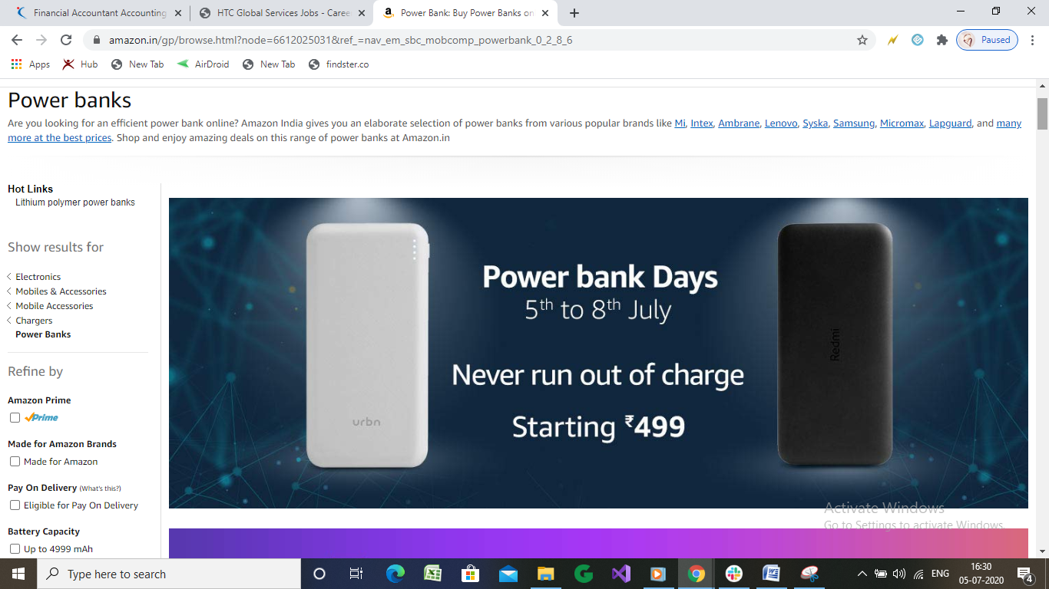

🡪 It given lot of filters on left side column, and when I scrolled down

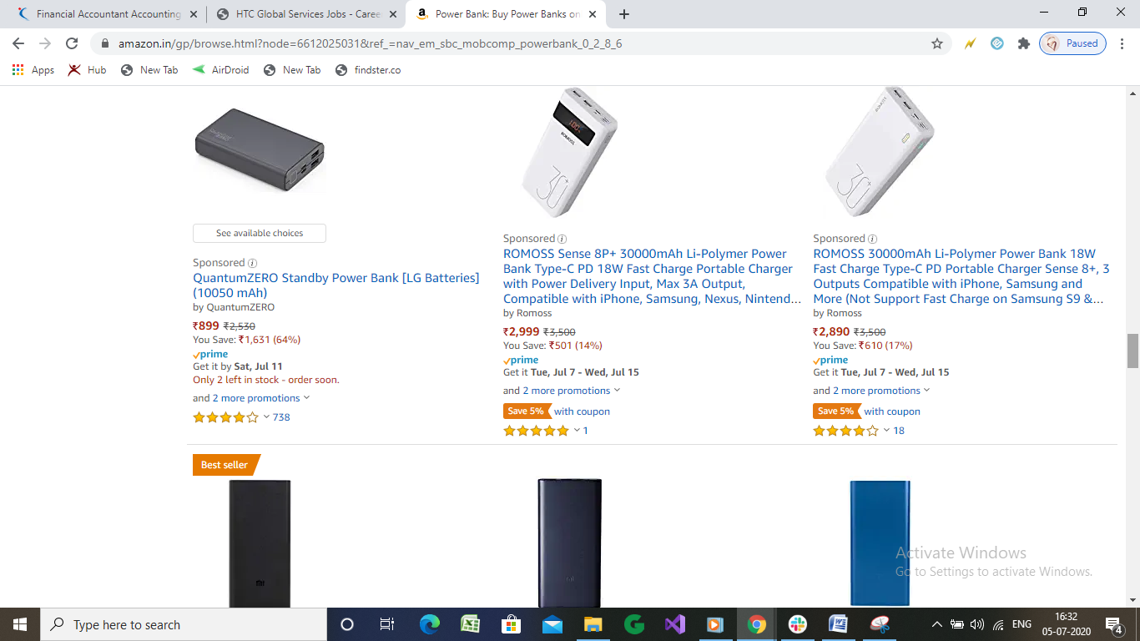

* I am going to order the quantum zero, so am clicking on that blue colored highlight letters

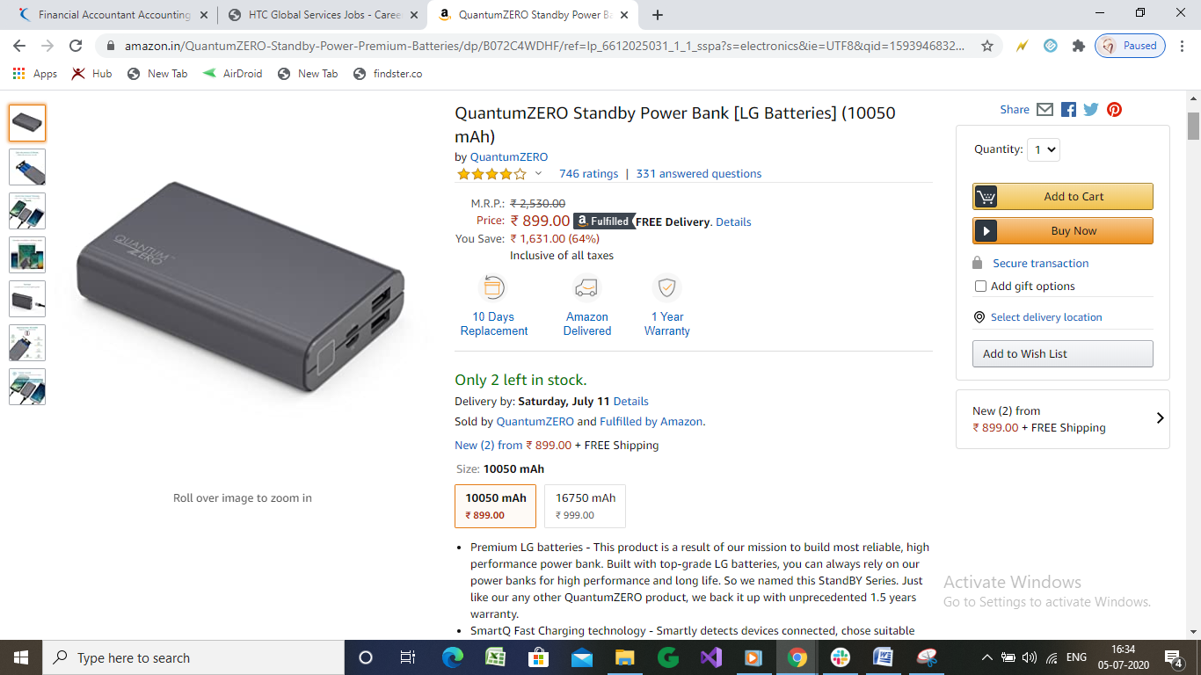

🡪I got the description of the product and the option to buy

🡪ii clicked on “ Buy NOW” BUTTON

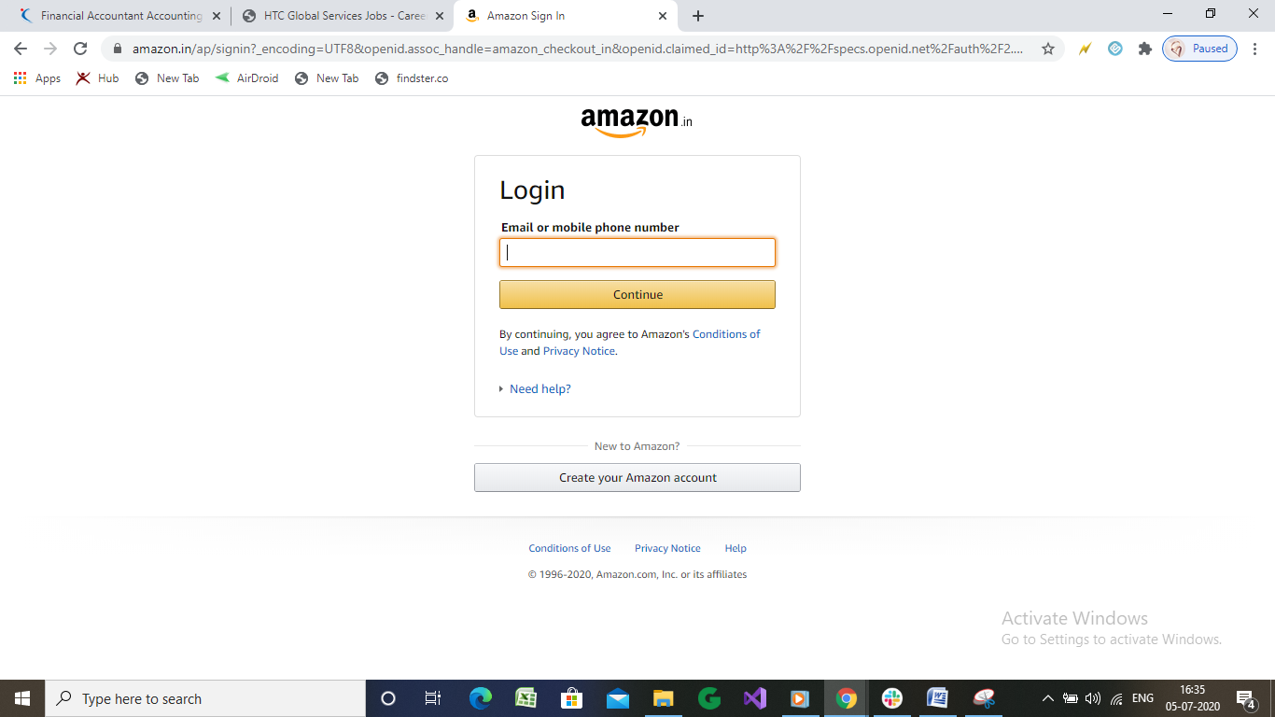

🡪Need to enter mobile number

🡪Asked for OTP which I have received on my number, entered it

🡪Requested to enter the delivery address

🡪PAYMENT OPTIONS NEED TO BE TAKE CARE OF

PLACED THE ORDER SUCCESSFULLY