**CHINGARI**

An alternate app proposed by Desi-Techies in India , after the Ban of Tiktok, which is one of the 59 China apps. Chingari is mainly focused on presenting short videos for entertaining the folks.

Let’s learn how to do the stuff in that app

🡪Type “chingari.io/trending” in your location bar and hit enter

--> Fallowing window will be pop up 

🡪 user can install the app on mobile from google store

🡪If user interested in fallowing anyown then he may click on the “Fallow”

While you watching videos 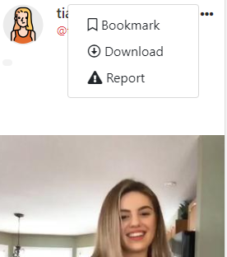these are the options available.

🡪It is not prepared for Desktops but only for mobile. However you can watch the videos through desktop by srolling down.

* You need to download it on your mobile and yu can access it on desktp by scanning QR code.

--