Messenger:

Facebook Messenger (commonly known as Messenger)[[8]](https://en.wikipedia.org/wiki/Facebook_Messenger#cite_note-8) is an American [messaging app](https://en.wikipedia.org/wiki/Messaging_app) and platform developed by [Facebook, Inc.](https://en.wikipedia.org/wiki/Facebook,_Inc." \o "Facebook, Inc.) Originally developed as Facebook Chat in 2008, the company revamped its messaging service in 2010, and subsequently released standalone [iOS](https://en.wikipedia.org/wiki/IOS" \o "IOS) and Android apps in August 2011 and standalone [Facebook Portal](https://en.wikipedia.org/wiki/Facebook_Portal" \o "Facebook Portal) hardware for Messenger-based calling in Q4 2018. Later on, [Facebook](https://en.wikipedia.org/wiki/Facebook" \o "Facebook) has launched a dedicated [website interface](https://en.wikipedia.org/wiki/Web_application) (Messenger.com), and separated the messaging functionality from the main Facebook app, allowing users to use the web interface or download one of the standalone apps. In April 2020, Facebook officially released Messenger for Desktop, which is supported on [Windows 10](https://en.wikipedia.org/wiki/Windows_10) and [macOS](https://en.wikipedia.org/wiki/MacOS" \o "MacOS) and distributed on [Microsoft Store](https://en.wikipedia.org/wiki/Microsoft_Store_(digital)) and [App Store](https://en.wikipedia.org/wiki/App_Store_(macOS)) respectively.

Users can send messages and exchange photos, videos, stickers, audio, and files, as well as react to other users' messages and interact with bots. The service also supports [voice](https://en.wikipedia.org/wiki/Voice_over_IP) and [video calling](https://en.wikipedia.org/wiki/Videotelephony). The standalone apps support using multiple accounts, conversations with optional [end-to-end encryption](https://en.wikipedia.org/wiki/End-to-end_encryption), and playing games.

Let’s have a look at the features available: 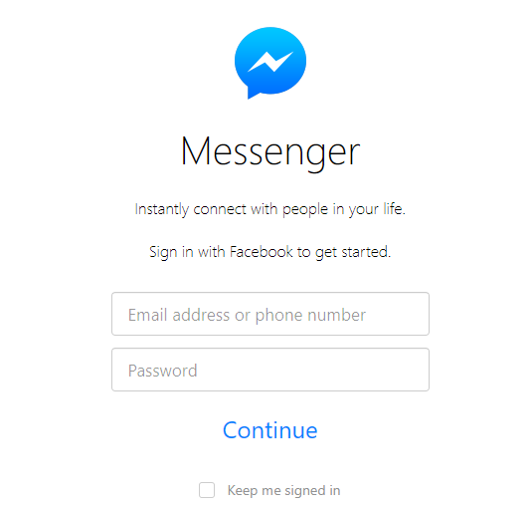

🡪This is the initial sign in window,

🡪 Enter you phone/email,

🡪Then password,

🡪Click on continue

Profile $ Settings & New room & Create Message calling options

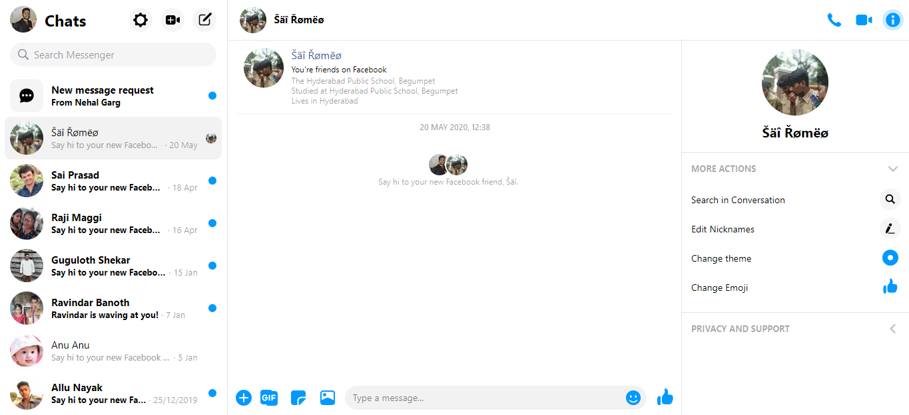Connections dash board chatting options like new message , GIF, documents, images and emoji

