**NAUKRI.COM**

🡪Once you enter “Naukri.com” in your browser, you will taken to the home page shown as

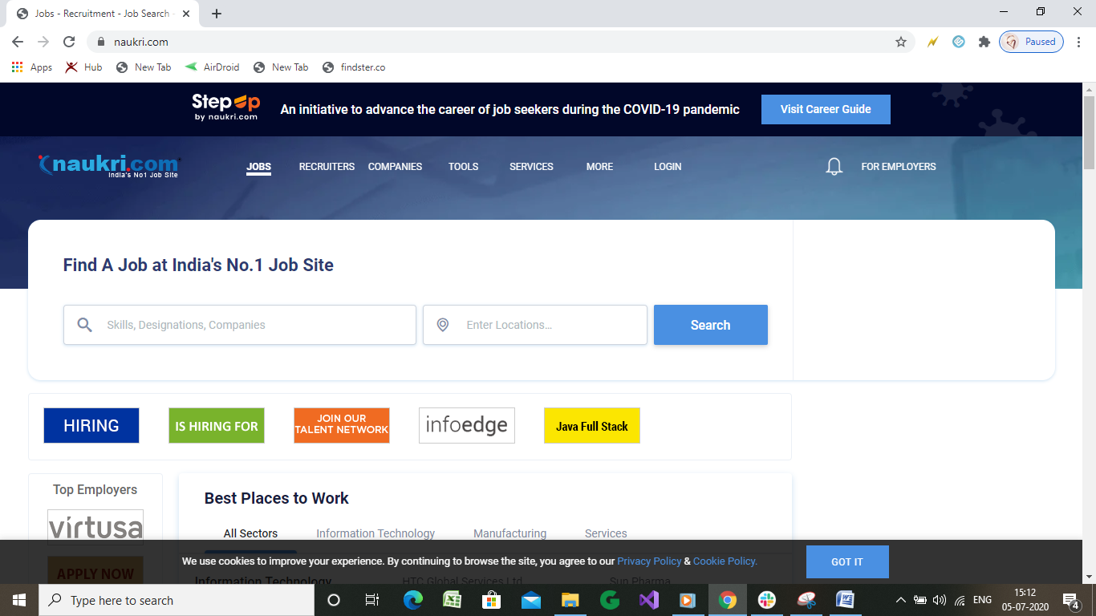

Lets explore the menu bar and options available

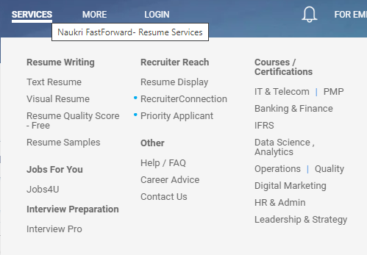

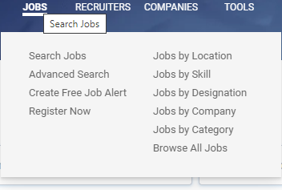

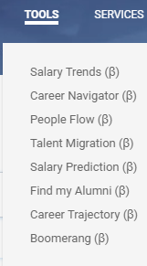

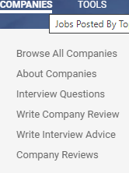

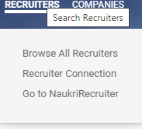

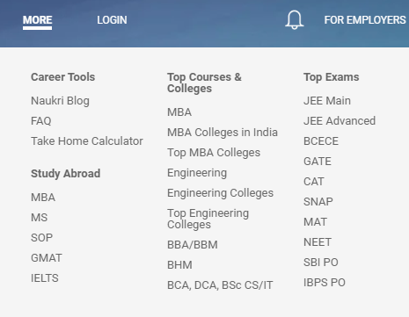

-🡪Ultimate feature is user can insert the keywords like skills, designation or company of a job and search a job at any location



🡪Industry wise categories also given in the same page



🡪 To watch the job Gallery



🡪let’s look how to apply for a job, when you search a job type the result will shown like this

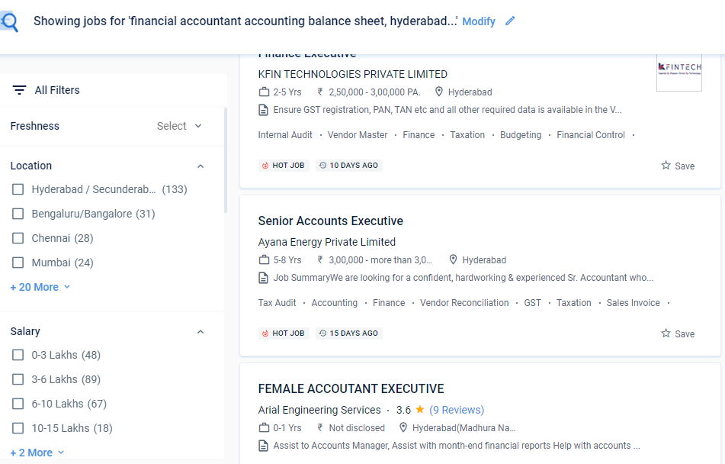🡪Clicking on a job will take you to new tab, where you have to execute the process according to the recruiter priority. You can apply by clicking on the apply button.

