Telegram:

Telegram is a cloud-based instant messaging and voice over IP service. Telegram client apps are available for Android, iOS, Windows Phone, Windows, macOS and Linux. Users can send messages and exchange photos, videos, stickers, audio and files of any type.

As of April 2020, Telegram has 400 million monthly active users.

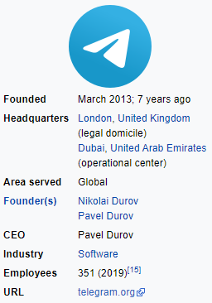

🡪When you installed the Telegram on your Desktop you will be shown up with the fallowing window

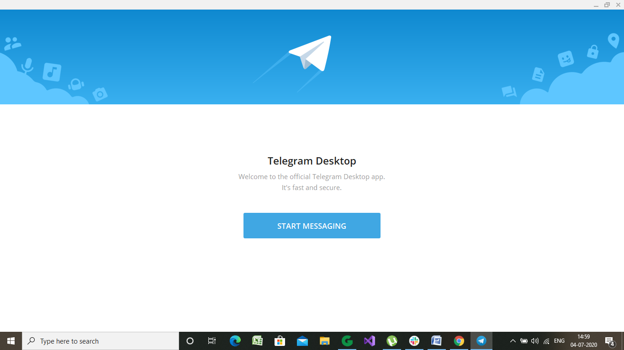

🡪Click on “start messaging”

* Enter your mobile number, then enter OTP you received
* You will be taken to the official telegram dashboard, as shown below

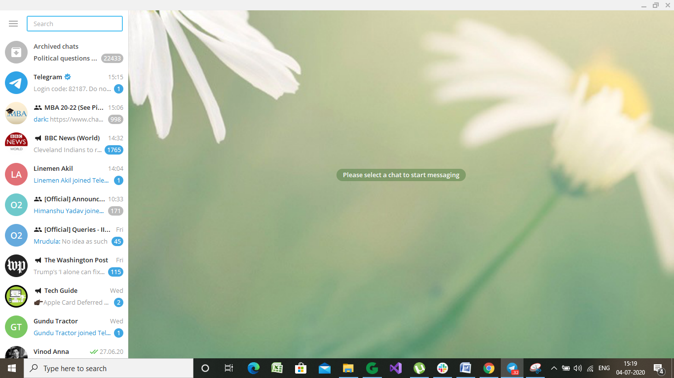

* You will be added with telegram official group named as “Telegram”, where your informed with the Corona helpdesk.

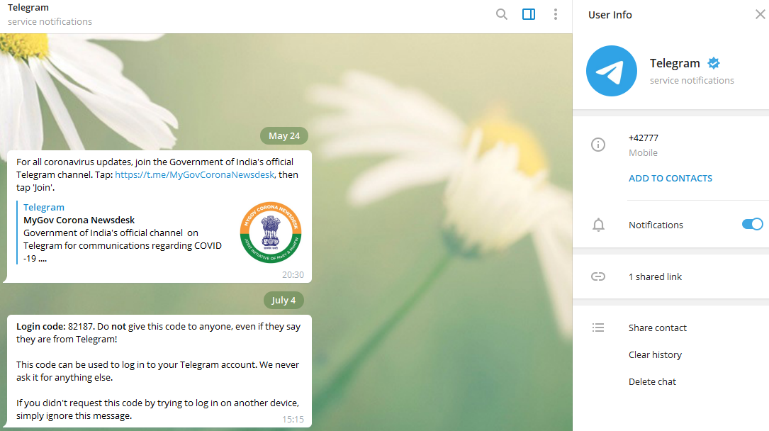

🡪 when you attempt to click on that link

gro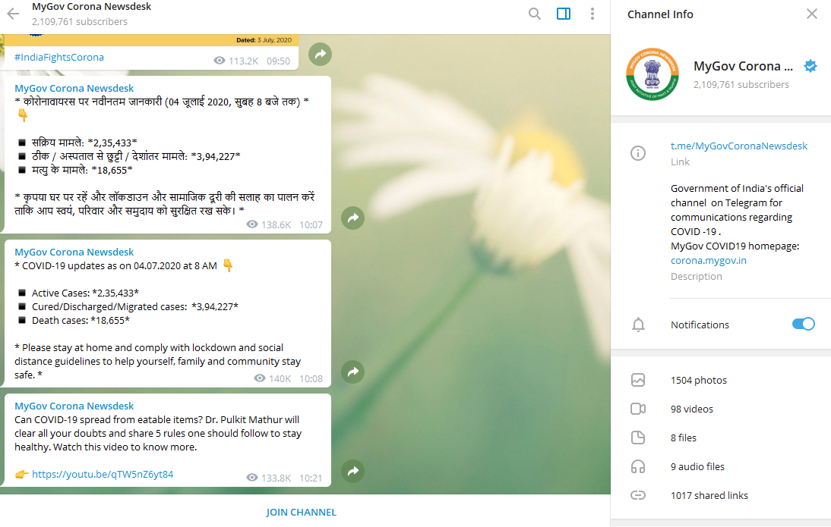

* You are directed to join the “My government Corona Newdesk” channel , by showing channel info.
* Lets explore the channel info in deep:

1)Channel description: Tells the purpose of Channel creation and certain rules were told. Link can be attached if any present.

2) Notifications: For muting or un muting the notifications, while receiving any message in the channel.

You can view and download the past history of channel such as

3) Photos:

4) Videos:

5) Files:

6) Audio Files:

7) Shared links

* Path to download a photo: Photos >click on image > click on 3 point at bottom right > save as.

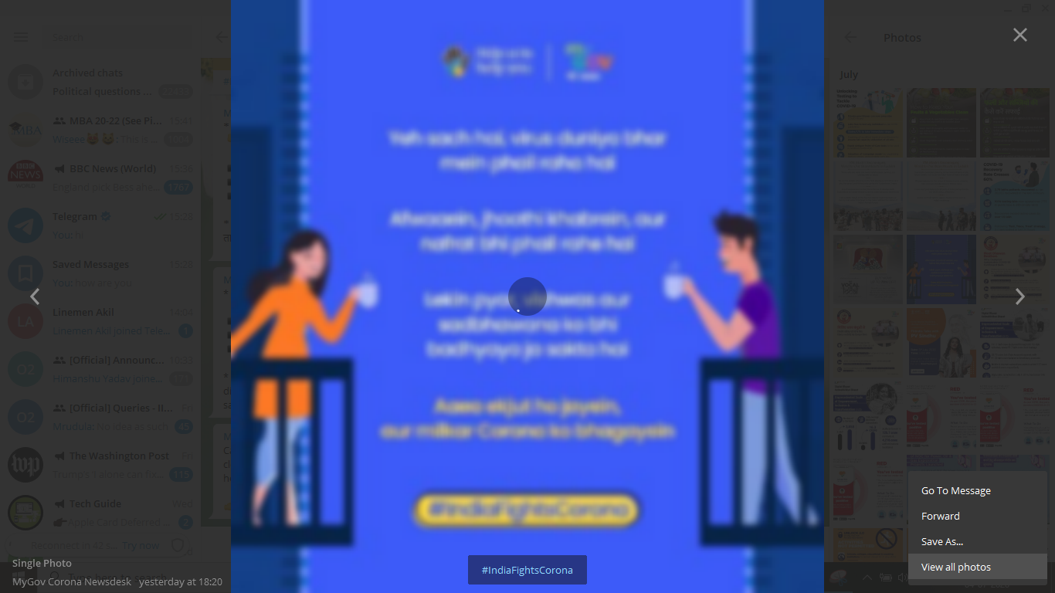

* There you see the options of :

Go to messages to revert back to the messages of that channel

Forward to send the same image to any other member

Save As.. to save the picture in your computer directory

View all Photos to view the album of that channel

\*Note: Same options were available to all the group info contents.

Till now you have learned to how to manage in a channel. Let’s explore more on the dashboard of telegram

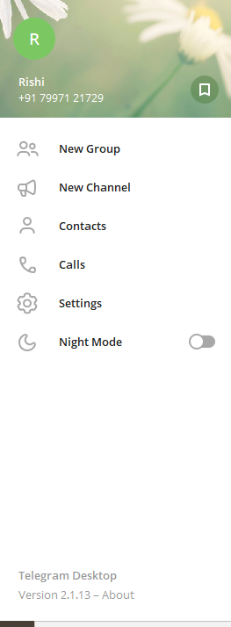

🡪You can type the name in search box, with whome you want to connect or else you can explore the telegram features buy clicking on “3 cross bar” on left most top.

* Instant while you clicked on it, you will show up with a panel shown on left

This is your profile you can click on it to open a chat box to send information to yourself.

To create a new group click>group name> add members up to 0.2m> create

To create a new channel click> Channel name> description> Invite the people to join in

Click the contacts to connect with your contacts on telegram

Click on it to make a call

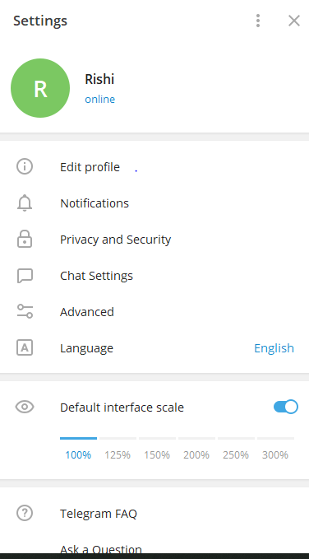

Customization of your profile is available here>

All the background turns black.

🡪Right side image shows the options available

In settings \*you can have a deep insight of each

In fallowed pictures..

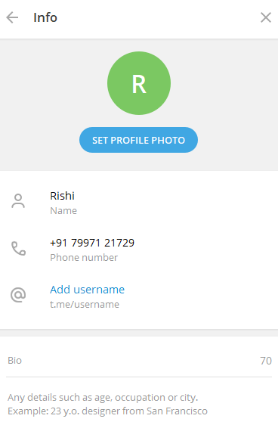

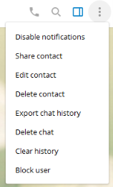

TO MAKE A CALL

To send a voice message

To attach the photos, audio, video and documents

Let’s have the look at what are all the options available while we are in chat window with a member or in chat with a channel

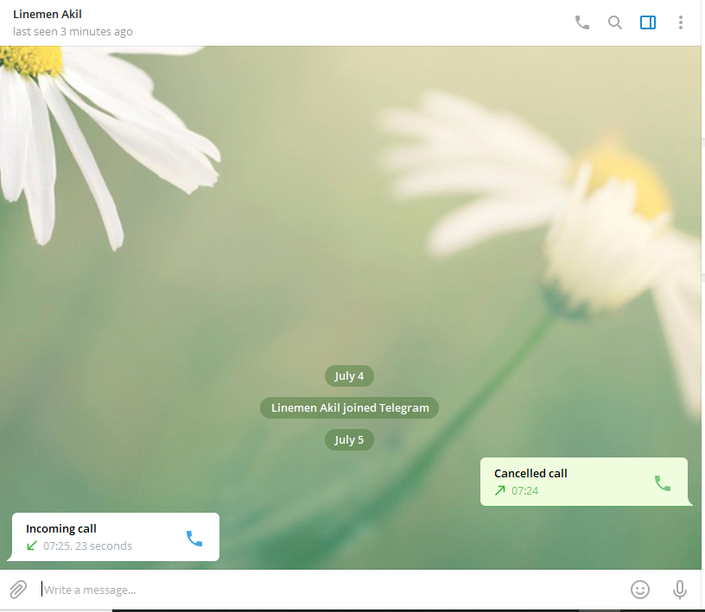To get emojis and stickers

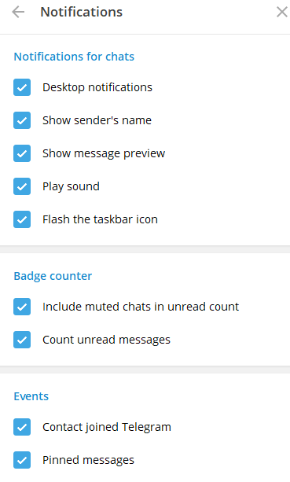

l

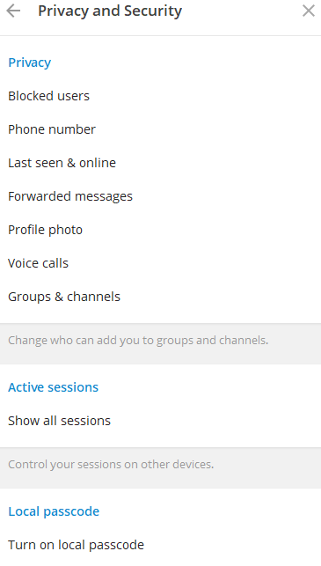

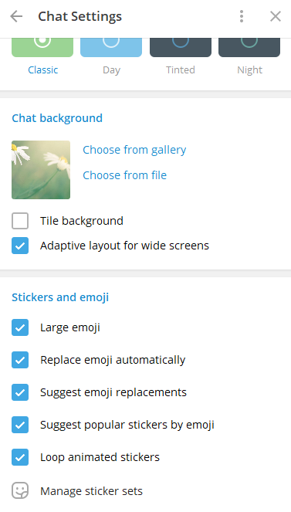

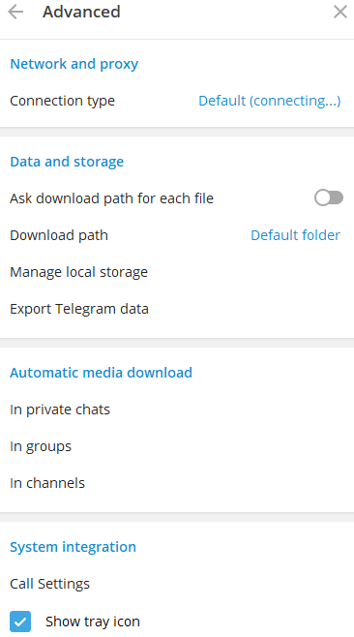

lkl