---

title: Duolingo review

author: Tristan.R

date: 2020-06-09

---

*By Tristan Reed*

*This is an educational website. Where you can learn languages. The more you learn the more you earn ( lingots and crowns) . You can buy power ups and new skills to learn. It is fun not addictive fun but fun that you like it. I rate it 4 out of 5.*

*Read on for an interview with Tristan Reed:*

>*Me: What is good about Duolingo

Tristan: Well I have at least learnt 250 new words and completed a few quests and it is fun to find out you have completed a quest

Me: Are there any bad things about duolingo

Tristan: Yes sometimes when you you have missed an apostrophe or something tiny like that it says you got it wrong when you wrote the right sentence

Me: That is it from Tristan*

[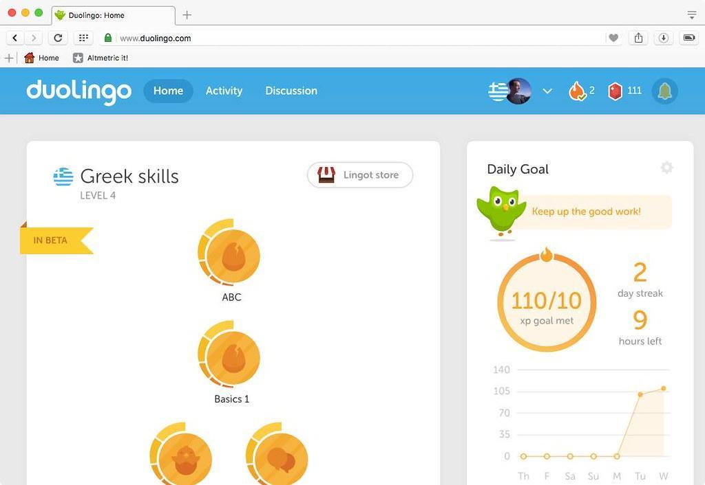](https://www.flickr.com/photos/dullhunk/29049422264)