# Linux内核实验

## 实验一

### 问题分析

内核模块和Makefile文件的基本结构如下：

//内核模块.c文件基本框架

​

#include<linux/module.h> //包含了对模块的结构定义以及模块的版本控制

​

MODULE_LICENSE("GPL"); //声明GPL版权

static __init module_init(void){ //加载模块

。。。。。。

}

​

static __exit module_exit(void){ //卸载模块

。。。。。。

}

module_init(module_init);

module_exit(module_exit);

//Makefile文件基本框架

​

ifneq ($(KERNELRELEASE),)

obj-m :=main.o //指定将要编译的内核模块列表（一些.o文件）

​

else

KERNELDIR ?=/usr/lib/modules/$(shell uname -r)/build //内核源代码位置

PWD := $(shell pwd)

default:

$(MAKE) -C $(KERNELDIR) M=$(PWD) modules //编译连接目标

endif

.PHONY:clean

clean:

-rm *.mod.c *.o *.order *.symvers *.ko

### helloworld源代码实现

helloworld.c:

#include<linux/module.h>

​

MODULE_LICENSE("GPL");

​

int __init hello_init(void)

{

printk("hello init\n"); //printk函数，而不是之前学的printf

printk("hello,world!\n");

return 0;

}

​

void __exit hello_exit(void)

{

printk("hello exit\n");

}

module_init(hello_init);

module_exit(hello_exit);

**makefile文件**

ifneq ($(KERNELRELEASE),)

obj-m := helloworld.o

else

KERNELDIR ?=/usr/src/kernels/5.10.0-4.25.0

PWD := $(shell pwd)

default:

$(MAKE) -C $(KERNELDIR) M=$(PWD) modules

endif

.PHONY:clean

clean:

-rm *.mod.c *.o *.order *.symvers *.ko

### 运行结果

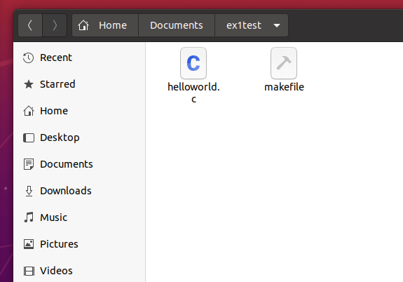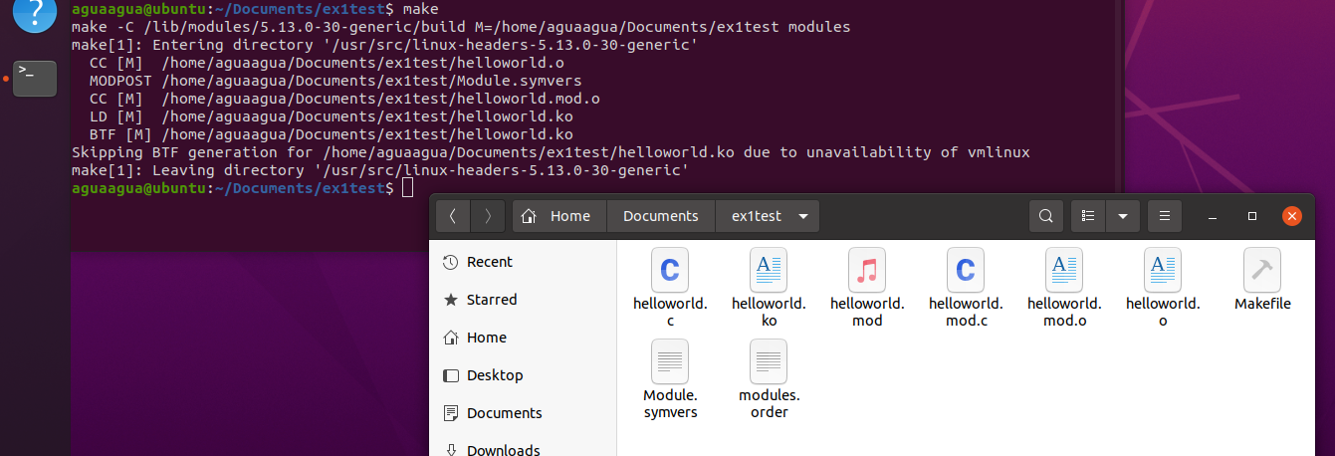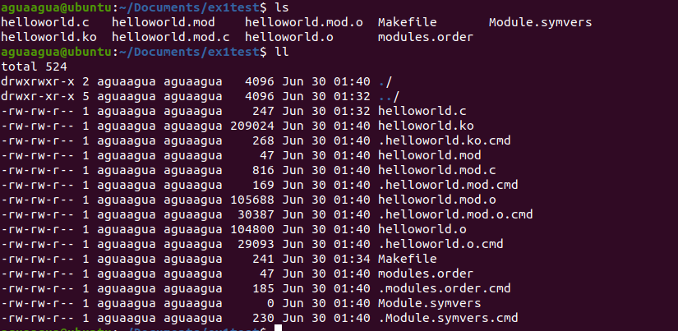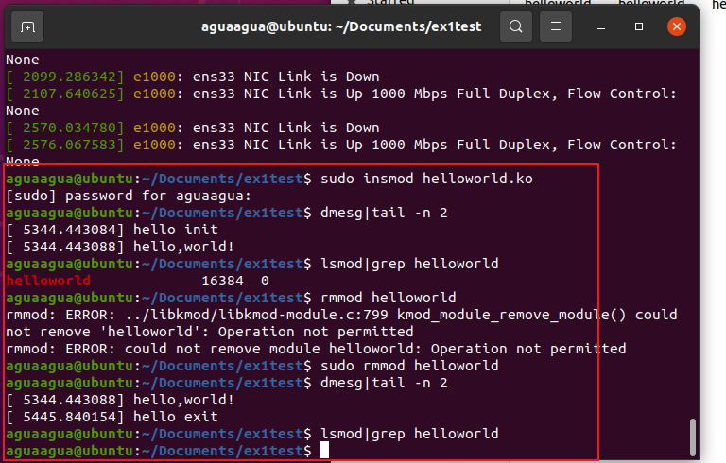

## 实验二

### 问题分析

使用kmalloc和vmalloc分配内存， 大小分别为1k和8k， 1m，64m，使用%p打印指针的内存地址。

### kmalloc源代码实现

**Kmalloc.c源代码**

#include<linux/slab.h>

#include<linux/init.h>

#include<linux/module.h>

#include<linux/kernel.h>

#define size 10

MODULE_DESCRIPTION("memory allocation ");

MODULE_AUTHOR("test");

MODULE_LICENSE("GPL");

int alloc_init(void)

{

void *pointer;

pointer = kmalloc(1024, GFP_KERNEL);

if(!pointer)

{ printk(KERN_ALERT" Faild ");

//report error

}

printk(" I got : %zu Byes\n", ksize(pointer));

printk(" Address : %p\n", pointer);

kfree(pointer);

pointer = kmalloc(8192, GFP_KERNEL);

if(!pointer)

{ printk(KERN_ALERT" Faild ");

//report error

}

printk(" I got : %zu Byes\n", ksize(pointer));

printk(" Address : %p\n", pointer);

kfree(pointer);

return 0;

}

void alloc_exit(void)

{

printk(KERN_ALERT"Time to exit");

}

module_init(alloc_init);

module_exit(alloc_exit);

**makefile文件**

MOD = kmalloc

KPATH :=/lib/modules/$(shell uname -r)/build

PWD :=$(shell pwd)

obj-m = $(MOD).o

all:

$(MAKE) -C $(KPATH) M=$(PWD) modules

clean:

$(MAKE) -C $(KPATH) M=$(PWD) clean

insmod: all

sudo rmmod $(MOD).ko; true

sudo insmod $(MOD).ko

log:

tail -f /var/log/messages

### kmalloc运行结果

使用makefile编译内核模块

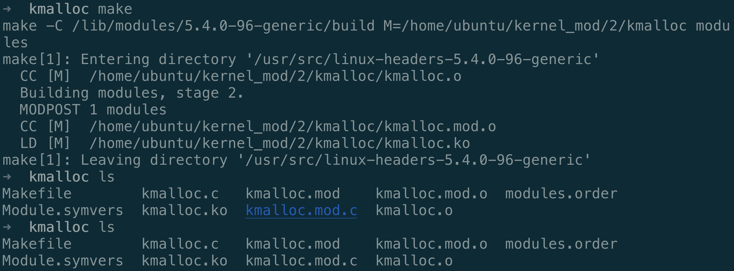

安装内核模块



dmesg显示内核信息

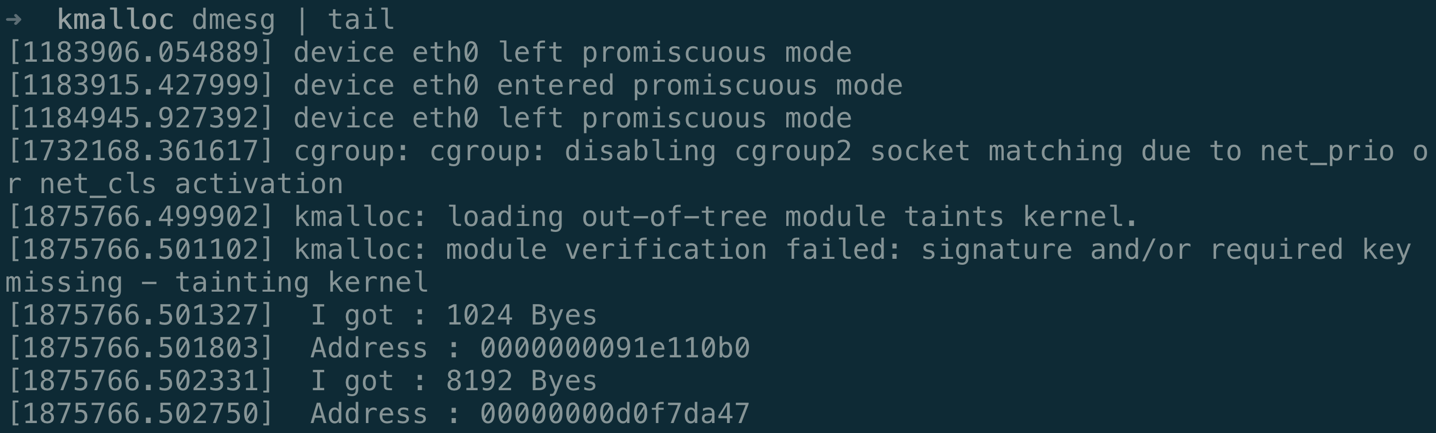

### vmalloc源代码实现

#include<linux/slab.h>

#include<linux/init.h>

#include<linux/module.h>

#include<linux/kernel.h>

#define size 10

MODULE_DESCRIPTION("memory allocation ");

MODULE_AUTHOR("test");

MODULE_LICENSE("GPL");

int alloc_init(void)

{

void *pointer;

// 8k

pointer = vmalloc(8192);

if(!pointer)

{ printk(KERN_ALERT" Faild ");

//report error

}

printk(" I got : %zu Byes\n", ksize(pointer));

printk(" Address : %p\n", pointer);

// 1m

pointer = vmalloc(1048576);

if(!pointer)

{ printk(KERN_ALERT" Faild ");

//report error

}

printk(" I got : %zu Byes\n", ksize(pointer));

printk(" Address : %p\n", pointer);

// 64m

// pointer = vmalloc(67108864);

pointer = vmalloc(6710886);

if(!pointer)

{ printk(KERN_ALERT" Faild ");

//report error

}

printk(" I got : %zu Byes\n", ksize(pointer));

printk(" Address : %p\n", pointer);

kfree(pointer);

return 0;

}

void alloc_exit(void)

{

printk(KERN_ALERT"Time to exit");

}

module_init(alloc_init);

module_exit(alloc_exit);

### vmalloc运行结果

使用Makefile编译模块

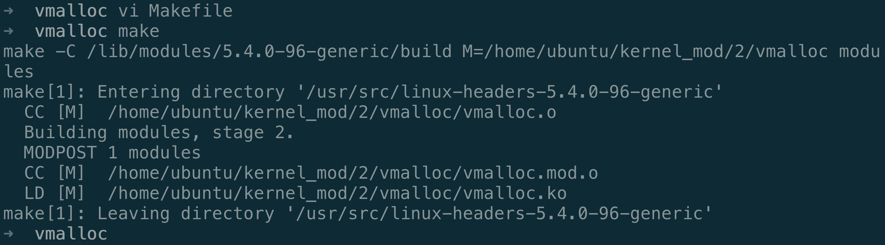



安装模块

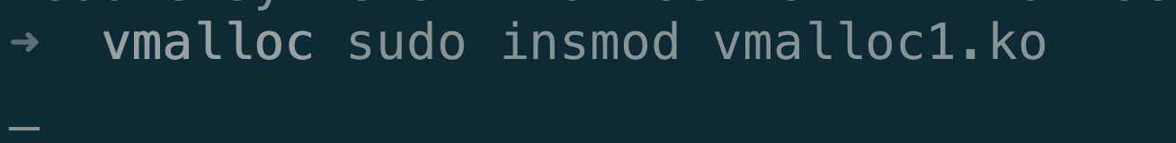

## 实验三

### 源代码

**创建并运行内核线程**

**kthread.c**

#include <linux/kthread.h>

#include <linux/module.h>

#include <linux/delay.h>

​

MODULE_LICENSE("GPL");

​

#define BUF_SIZE 20

​

static struct task_struct *myThread = NULL;

​

static int print(void *data)

{

while(!kthread_should_stop()){//接收kthread_stop传递的结束线程信号，如果内核线程中未用此函数，则kthread_stop使其结束。

printk("New kthread is running.");

msleep(2000);

}

return 0;

}

​

static int __init kthread_init(void)

{

printk("Create kernel thread!\n");

myThread = kthread_run(print, NULL, "new_kthread");//创建并启动一个线程

return 0;

}

​

static void __exit kthread_exit(void)

{

printk("Kill new kthread.\n");

if(myThread)

kthread_stop(myThread);//发送信号给myThread指向的线程，使之退出

}

​

module_init(kthread_init);

module_exit(kthread_exit);

**打印输出当前系统 CPU 负载情况**

**cpu_loadavg.c**

#include <linux/module.h>

#include <linux/fs.h>

​

MODULE_LICENSE("GPL");

​

char tmp_cpu_load[5] = {'\0'};

​

static int get_loadavg(void)

{

struct file *fp_cpu;

loff_t pos = 0;

char buf_cpu[10];

fp_cpu = filp_open("/proc/loadavg", O_RDONLY, 0);

if (IS_ERR(fp_cpu)){

printk("Failed to open loadavg file!\n");

return -1;

}

kernel_read(fp_cpu, buf_cpu, sizeof(buf_cpu), &pos);

strncpy(tmp_cpu_load, buf_cpu, 4);

filp_close(fp_cpu, NULL);

return 0;

}

​

static int __init cpu_loadavg_init(void)

{

printk("Start cpu_loadavg!\n");

if(0 != get_loadavg()){

printk("Failed to read loadarvg file!\n");

return -1;

}

printk("The cpu loadavg in one minute is: %s\n", tmp_cpu_load);

return 0;

}

​

static void __exit cpu_loadavg_exit(void)

{

printk("Exit cpu_loadavg!\n");

}

​

module_init(cpu_loadavg_init);

module_exit(cpu_loadavg_exit);

### 运行结果

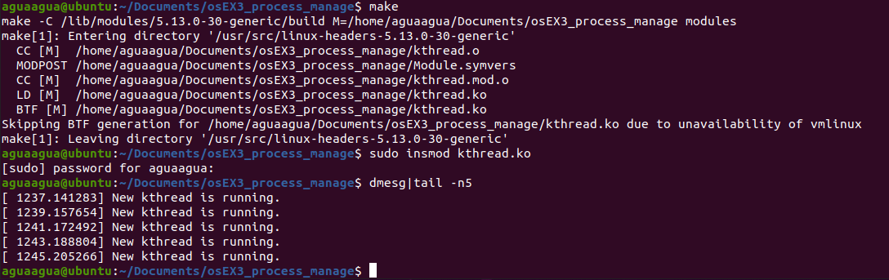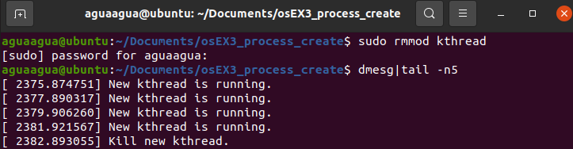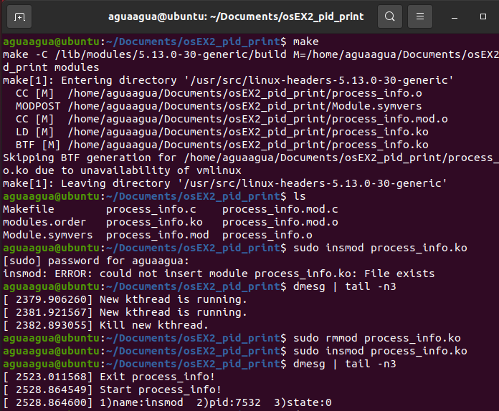

## 实验四

### 源代码

**Delay.c**

#include <linux/module.h>

#include <linux/workqueue.h>

#include <linux/delay.h>

MODULE_LICENSE("GPL");

static struct workqueue_struct *queue = NULL;

static struct delayed_work mywork;

static int i = 0;

//work handle

void work_handle(struct work_struct *work)

{

printk(KERN_ALERT "Hello World!\n");

}

static int __init timewq_init(void)

{

printk(KERN_ALERT "Start workqueue_test module.");

queue = create_singlethread_workqueue("workqueue_test");

if(queue == NULL)

{

printk(KERN_ALERT "Failed to create workqueue_test!\n");

return -1;

}

INIT_DELAYED_WORK(&mywork, work_handle);

for(;i <= 3; i++) {

queue_delayed_work(queue, &mywork, 5 * HZ);

ssleep(15);

}

return 0;

}

static void __exit timewq_exit(void)

{

flush_workqueue(queue);

destroy_workqueue(queue);

printk(KERN_ALERT "Exit workqueue_test module.");

}

module_init(timewq_init);

module_exit(timewq_exit);

**Makefile**

MOD = delay

KPATH :=/lib/modules/$(shell uname -r)/build

PWD :=$(shell pwd)

obj-m = $(MOD).o

all:

$(MAKE) -C $(KPATH) M=$(PWD) modules

clean:

$(MAKE) -C $(KPATH) M=$(PWD) clean

insmod: all

sudo rmmod $(MOD).ko; true

sudo insmod $(MOD).ko

log:

tail -f /var/log/messages

### 运行结果

编译内核模块

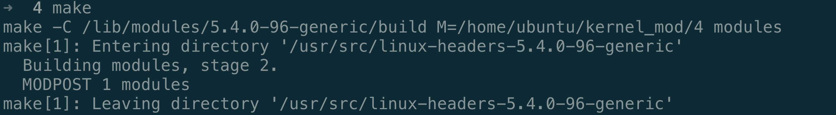

查看模块文件



安装内核模块



结果

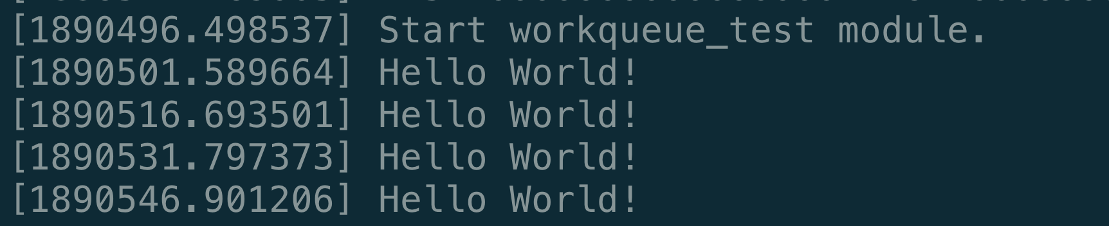

## 实验五

因为版本问题，两位同学的电脑都无法正常运行

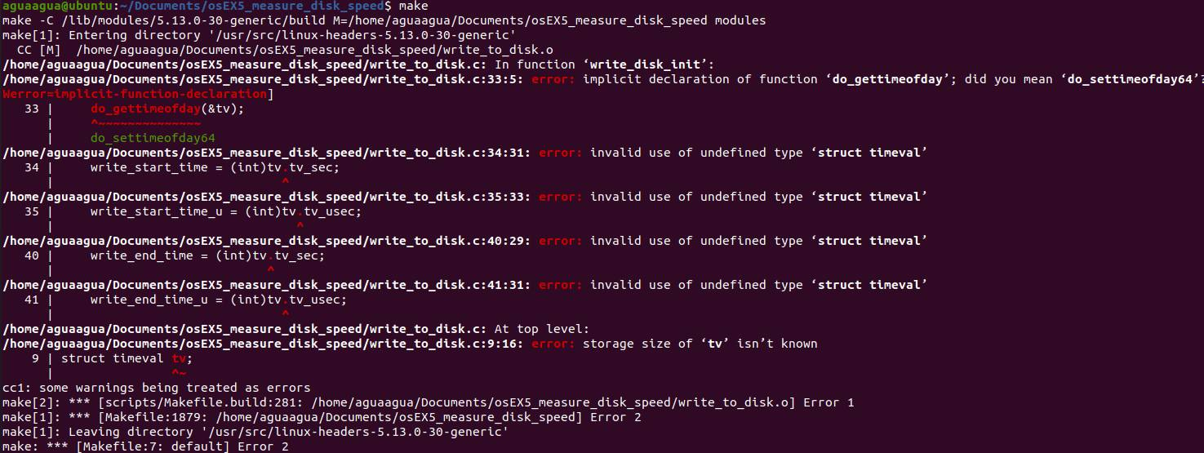

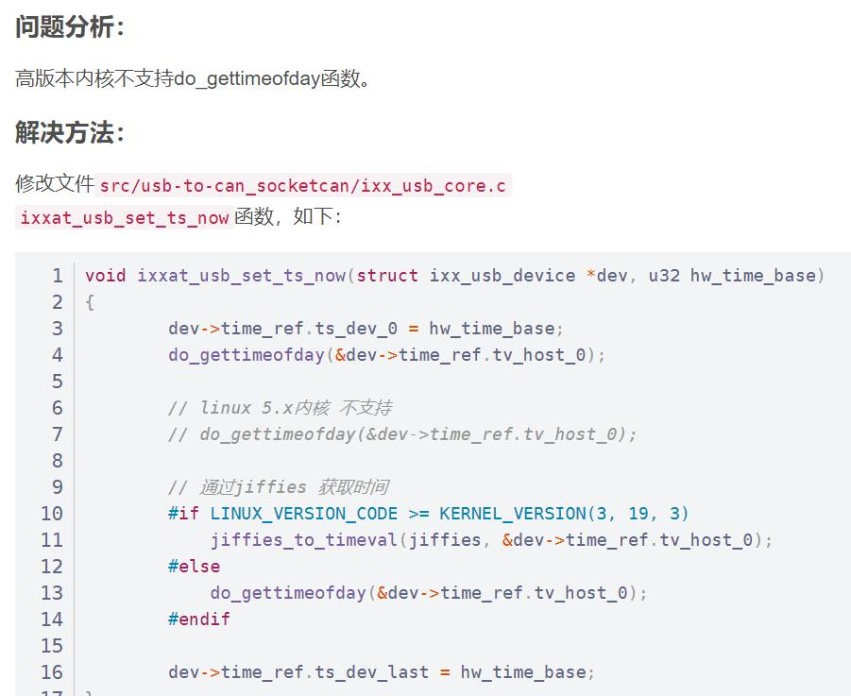

所以主要采取学习代码编思想的思路，进行代码编写

write_to_disk.c:

#include <linux/module.h>

#include <linux/fs.h>

#include <linux/rtc.h>

​

#define buf_size 1024

#define write_times 524288

​

MODULE_LICENSE("GPL");

​

struct timeval tv;

​

static int __init write_disk_init(void)

{

struct file *fp_write;

char buf[buf_size];

int i;

int write_start_time;

int write_start_time_u;

int write_end_time;

int write_end_time_u;

int write_time;

loff_t pos;

printk("Start write_to_disk module...\n");

for(i = 0; i < buf_size; i++)

{

buf[i] = i + '0';

}

fp_write = filp_open("/home/tmp_file", O_RDWR | O_CREAT,0644);

if (IS_ERR(fp_write)) {

printk("Failed to open file...\n");

return -1;

}

pos = 0;

do_gettimeofday(&tv);

write_start_time = (int)tv.tv_sec;

write_start_time_u = (int)tv.tv_usec;

for(i = 0; i < write_times; i++) {

kernel_write(fp_write, buf, buf_size, &pos);

}

do_gettimeofday(&tv);

write_end_time = (int)tv.tv_sec;

write_end_time_u = (int)tv.tv_usec;

filp_close(fp_write, NULL);

write_time = (write_end_time - write_start_time) * 1000000 + (write_end_time_u - write_start_time_u);

printk(KERN_ALERT "Writing to file costs %d us\n", write_time);

printk("Writing speed is %d M/s\n", buf_size * write_times / write_time);

return 0;

}

​

static void __exit write_disk_exit(void)

{

printk("Exit write_to_disk module...\n");

}

​

module_init(write_disk_init);

module_exit(write_disk_exit);

测试写速度

read_from_disk.c:

#include <linux/module.h>

#include <linux/fs.h>

#include <linux/rtc.h>

​

#define buf_size 1024

#define read_times 524288

​

MODULE_LICENSE("GPL");

​

struct timeval tv;

​

static int __init read_disk_init(void)

{

struct file *fp_read;

char buf[buf_size];

int i;

int read_start_time;

int read_start_time_u;

int read_end_time;

int read_end_time_u;

int read_time;

loff_t pos;

printk("Start read_from_disk module...\n");

fp_read = filp_open("/home/tmp_file", O_RDONLY, 0);

if (IS_ERR(fp_read)) {

printk("Failed to open file...\n");

return -1;

}

​

do_gettimeofday(&tv);

read_start_time = (int)tv.tv_sec;

read_start_time_u = (int)tv.tv_usec;

pos = 0;

for(i = 0; i < read_times; i++) {

kernel_read(fp_read, buf, buf_size, &pos);

}

do_gettimeofday(&tv);

read_end_time = (int)tv.tv_sec;

read_end_time_u = (int)tv.tv_usec;

filp_close(fp_read, NULL);

read_time = (read_end_time - read_start_time) * 1000000 + (read_end_time_u - read_start_time_u);

printk(KERN_ALERT "Read file costs %d us\n", read_time);

printk("Reading speed is %d M/s\n", buf_size * read_times / read_time);

return 0;

}

​

static void __exit read_disk_exit(void)

{

printk("Exit read_from_disk module...\n");

}

​

module_init(read_disk_init);

module_exit(read_disk_exit);

测试读速度：

## 实验六

## Register_newfs.c源代码

**Register_newfs.c**

#include <linux/module.h>

#include <linux/fs.h>

MODULE_LICENSE("GPL");

static struct file_system_type myfs_type =

{ .name = "myfs", .owner = THIS_MODULE, };

MODULE_ALIAS_FS("myfs");

static int __init register_newfs_init(void)

{

printk("Start register_newfs module...");

return register_filesystem(&myfs_type);

}

static void __exit register_newfs_exit(void)

{

printk("Exit register_newfs module...");

unregister_filesystem(&myfs_type);

}

module_init(register_newfs_init);

module_exit(register_newfs_exit);

**Makefile**

**MOD = register_newfs**

**KPATH :=/lib/modules/$(shell uname -r)/build**

**PWD :=$(shell pwd)**

**obj-m = $(MOD).o**

**all:**

**$(MAKE) -C $(KPATH) M=$(PWD) modules**

**clean:**

**$(MAKE) -C $(KPATH) M=$(PWD) clean**

**insmod: all**

**sudo rmmod $(MOD).ko; true**

**sudo insmod $(MOD).ko**

**log:**

**tail -f /var/log/messages**

### Register_newfs.c运行结果

编译模块

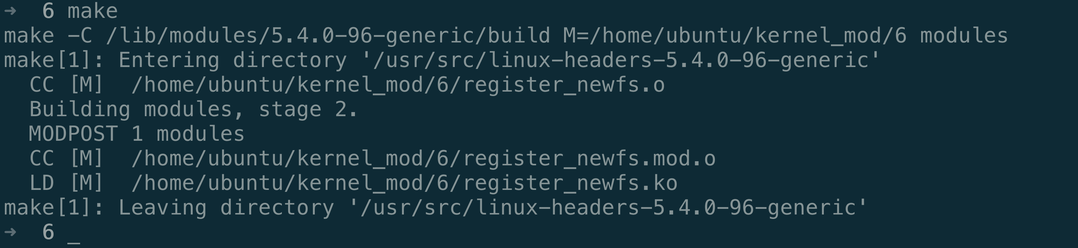

查看编译后的文件

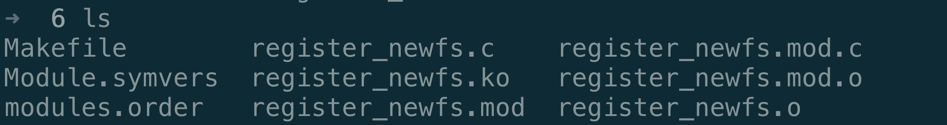

安装模块

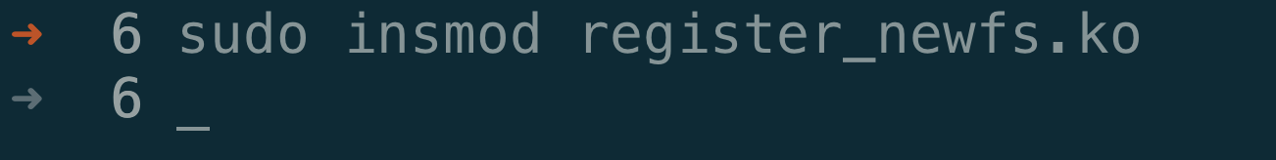

查看创建的文件系统

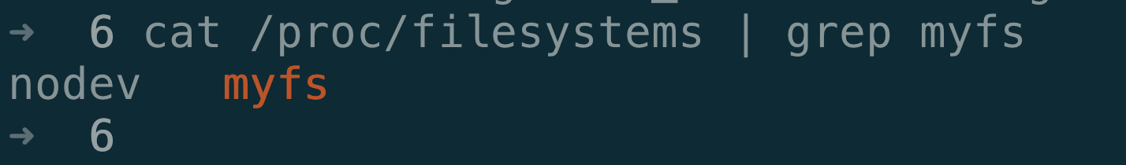

卸载模块



### Proc_mkdir.c源代码

#include <linux/module.h>

#include <linux/proc_fs.h>

MODULE_LICENSE("GPL");

static struct proc_dir_entry *myproc_dir;

static int __init myproc_init(void)

{

int ret = 0; printk("Start proc_mkdir module...");

myproc_dir = proc_mkdir("myproc",NULL);

if(myproc_dir == NULL)

return -ENOMEM;

return ret;

}

static void __exit myproc_exit(void)

{

printk("Exit proc_mkdir module...");

proc_remove(myproc_dir);

}

module_init(myproc_init);

module_exit(myproc_exit);

### Proc_mkdir.c运行结果

编译内核模块

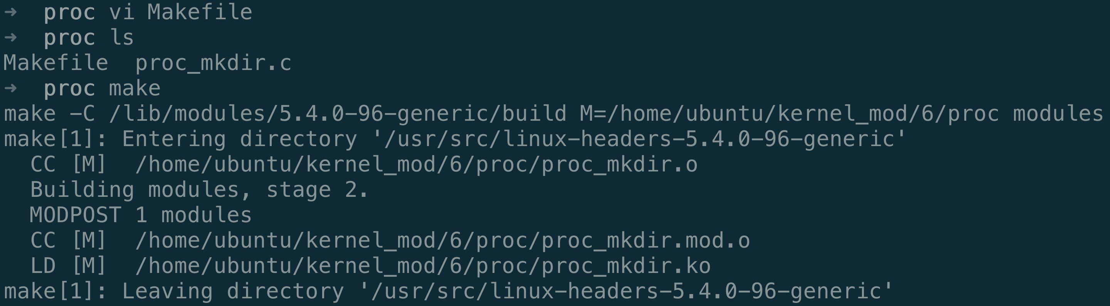

列出内核模块



安装内核模块



验证结果

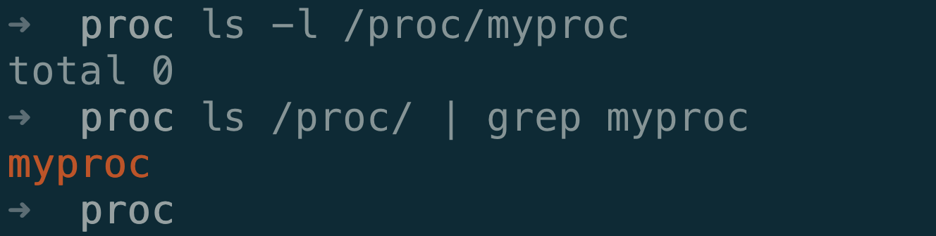

## 实验七

### 问题分析

编写 C 源码，基于 socket 的 UDP 发送接收程序，实现客户端与服务端的简单通信。客户端从命令行输入中读取要发送的内容，服务端接收后实时显示。

### 源代码实现

服务器端源代码如下（server.c）：

#include <stdio.h>

#include <string.h>

#include <sys/types.h>

#include <sys/socket.h>

#include <arpa/inet.h>

#include <unistd.h>#define PORT 40000

#define BUF_SIZE 1024

int main(void)

{

int sock_fd;

int len;

char buffer[BUF_SIZE];

struct sockaddr_in server_addr, client_addr;

if(-1 == (sock_fd = socket(AF_INET, SOCK_DGRAM, 0)) )

{

printf("Failed to create a socket!\n");

return 0;

}

//server information

memset(&server_addr, 0, sizeof(server_addr));

server_addr.sin_family = AF_INET;

server_addr.sin_port = htons(PORT);

server_addr.sin_addr.s_addr = htonl(INADDR_ANY);

if(-1 == bind(sock_fd, (struct sockaddr*)&server_addr, sizeof(server_addr)))

{

printf("Failed to bind the socket!\n");

return 0;

}

len = sizeof(client_addr);

//rec and print

while(1)

{

bzero(buffer, BUF_SIZE);

if(-1 != (recvfrom(sock_fd, buffer, BUF_SIZE, 0, (struct

sockaddr*)&client_addr, &len)) )

{

printf("The message received is: %s", buffer);}

}

return 0;

}

客户端源代码如下（client.c）：

#include <stdio.h>

#include <string.h>

#include <sys/socket.h>

#include <arpa/inet.h>

#include <unistd.h>

#define PORT 40000

#define BUF_SIZE 1024

int main(void)

{

int sock_fd;

char buffer[BUF_SIZE];

int size;

int len;

int ret;

struct sockaddr_in server_addr;

if(-1 == (sock_fd = socket(AF_INET, SOCK_DGRAM, IPPROTO_IP)) ){

printf("Failed to create a socket!\n");

return 0;

}

//server infomation

memset(&server_addr, 0, sizeof(server_addr));

server_addr.sin_family = AF_INET;

server_addr.sin_port = htons(PORT);

server_addr.sin_addr.s_addr = inet_addr("127.0.0.1");

bzero(buffer, BUF_SIZE);len = sizeof(server_addr);

//read from stdin and send to server

while(1){

printf("Please enter the content to be sent:\n");

size = read(0, buffer, BUF_SIZE);

if(size){

sendto(sock_fd, buffer, size, 0, (struct sockaddr*)&server_addr, len);

bzero(buffer, BUF_SIZE);

}

}

close(sock_fd);

return 0;

}

### 运行结果

