# Report

## Script Writing Question 1

Screen shots of source code in vim editor

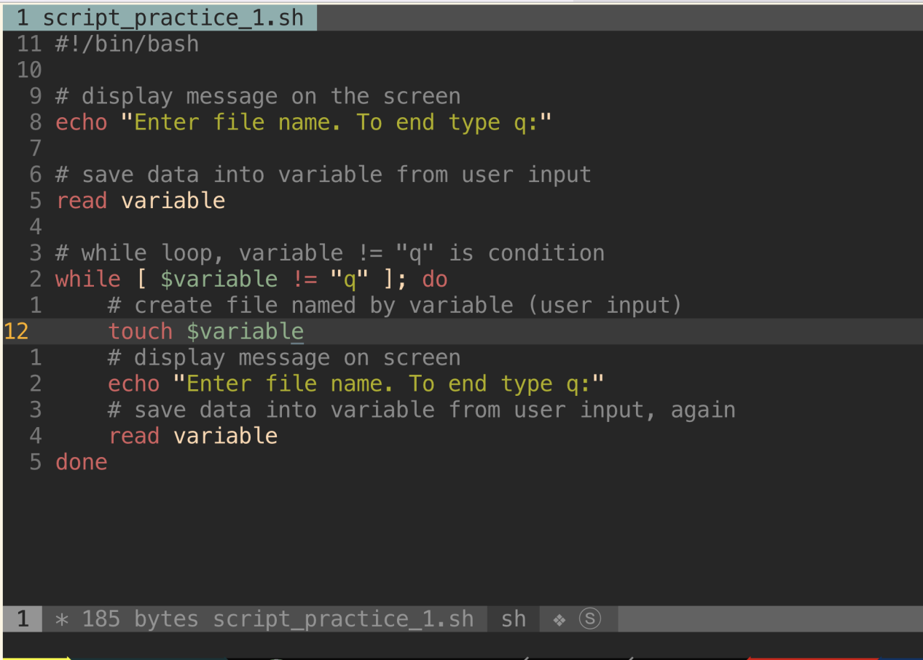

Script result

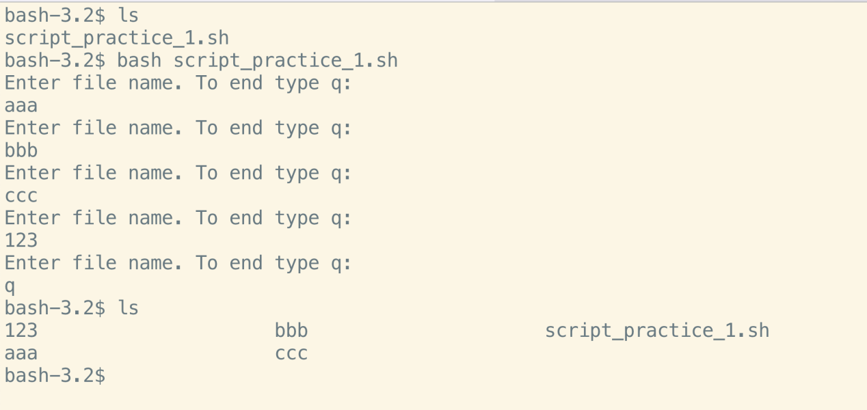

## Script Writing Question 2

Code:

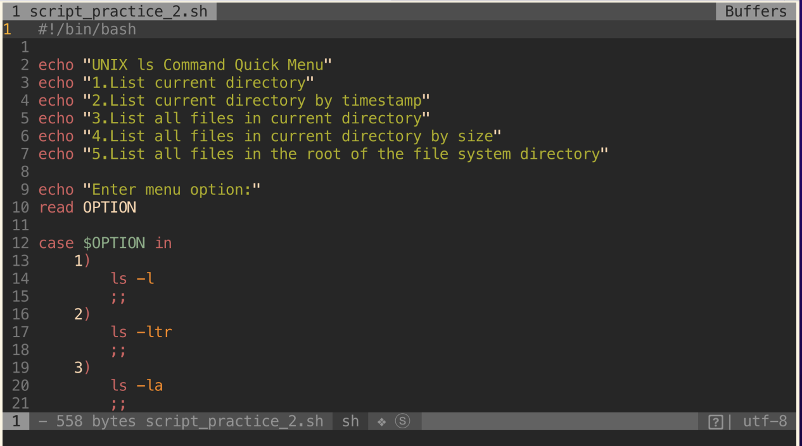

Result:

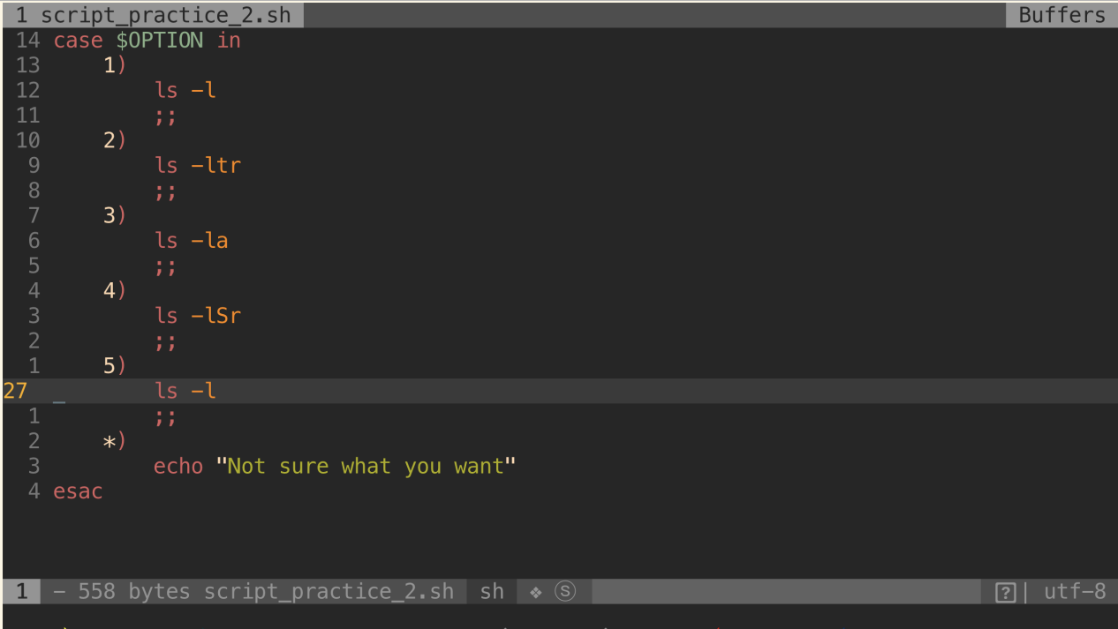

## Script Writing Question 3

What is parameter name that contains the script name: ____ $0

What is parameter name that contains the value blc: ____$1

Screen of vim

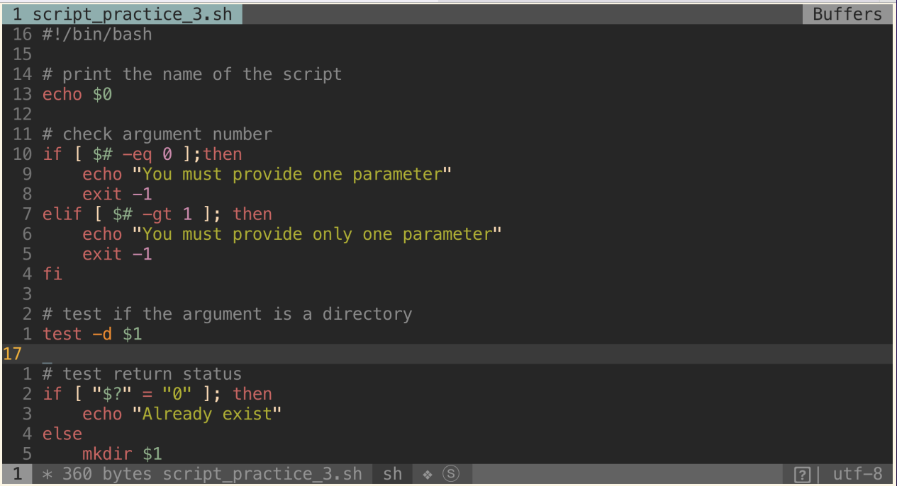

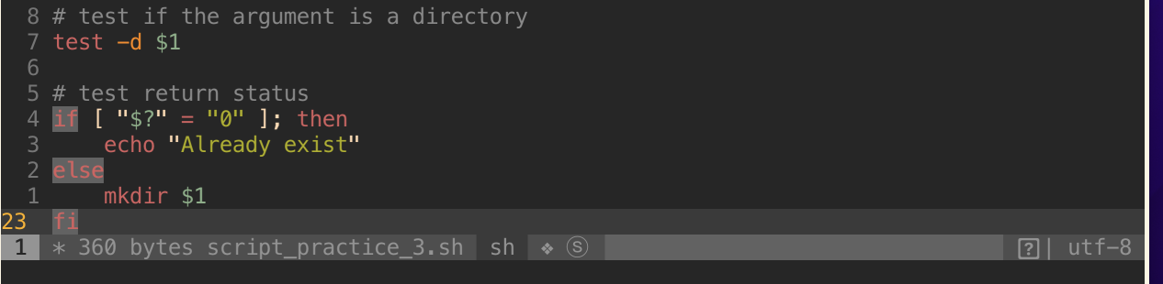

## Result

No arguments

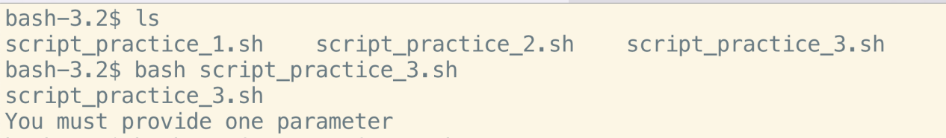

More than one arguments

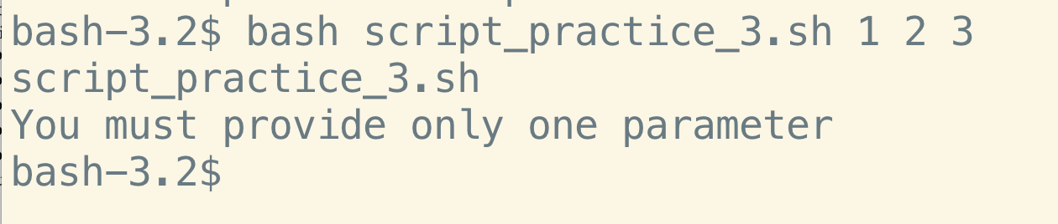

Pass one argument to script, the script successful create the directory

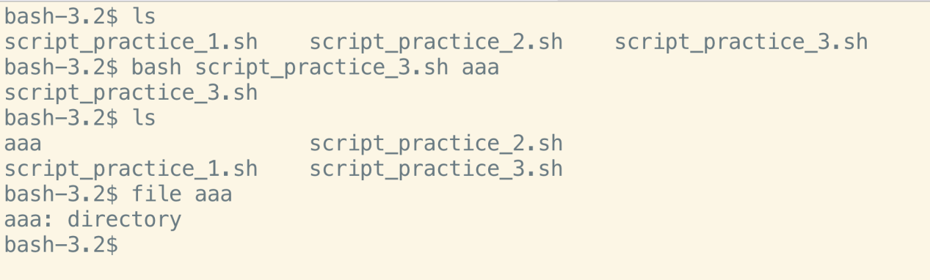

If we pass it again, error message shows

