# 实验报告

发送OSPF数据包代码如下:

import ipaddress

from scapy.all import *

from scapy.contrib.ospf import *

# eth_src=input("Ether src:").encode()

# eth_src = bytes(eth_src.strip())

#

# eth_dst=input("Ether dst:").encode()

# eth_dst=bytes(eth_dst.strip())

#

# ip_src=input("ip src:").encode()

# ip_src=bytes(ip_src.strip())

# print(len(ip_src))

# ip_dst=input("ip dst:").encode()

# ip_dst=bytes(ip_dst.strip())

eth_src=input("Ether src:")[0:18]

print(eth_src)

eth_dst=input("Ether dst:")[0:18]

print(eth_dst)

ip_src=input("ip src:")

ip_dst=input("ip dst:")

# print("\nPacket Info:")

# print("Ethernet layer")

# print("eth src:" + eth_src)

# print("eth dst:" + eth_dst)

# print("IP layer:")

# print("ip src:" + ip_src)

# print("ip dst:" + ip_dst)

packet = Ether(src=eth_src,dst=eth_dst)

packet = packet/IP(src=ip_src,dst=ip_dst)

packet = packet/OSPF_Hdr(src=ip_src)

packet/OSPF_Hello(router='172.17.2.2',backup='172.17.2.1')

# packet = Ether(src='00:06:28:b9:85:31',dst='01:00:5e:00:00:05')

# packet = packet/IP(src='172.17.2.2',dst='224.0.0.5')

# packet = packet/OSPF_Hdr(src='172.17.2.2')

# packet/OSPF_Hello(router='172.17.2.2',backup='172.17.2.1')

packet.show()

sendp(packet,iface='en0')

运行结果如下:

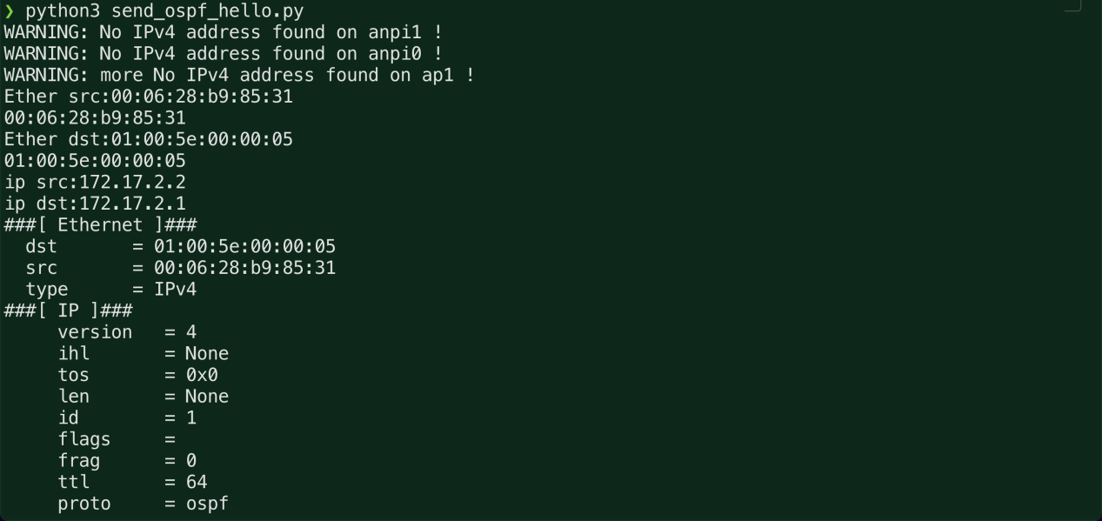

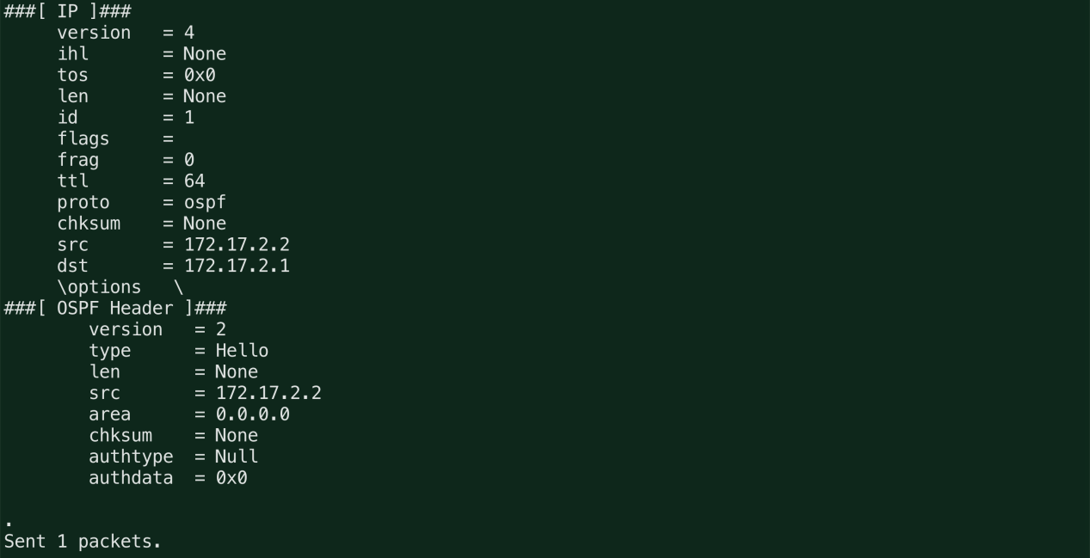

wireshark抓包情况

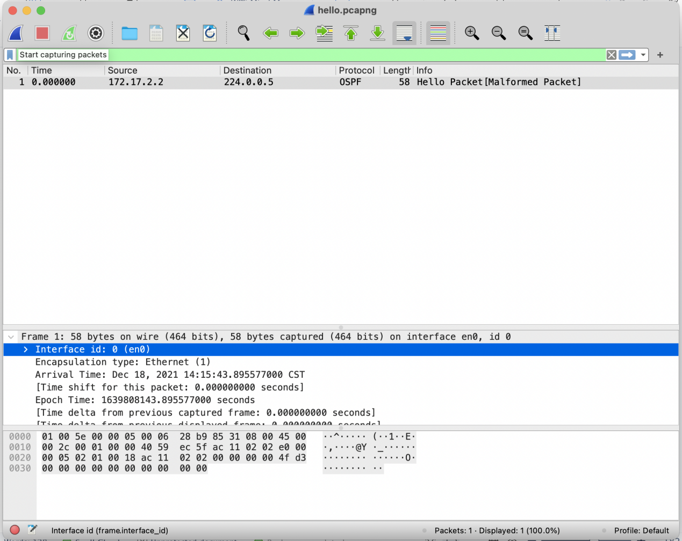

使用python脚本解析ospf的hello报文

