# Linux简单文件系统设计

## 项目概述

实现一个模拟的文件系统，实现创建，删除，打开读取，读写等操作。

## 项目分析

使用struct结构体创建数据结构构建超级快，文件信息，文件描述符信息。使用dir_index描述dir目录的信息，使用dir_len描述目录长度，使用data_index描述文件数据的位置。实现make_fs进行文件系统的创建，mount_fs进行文件系统的挂载，umount_fs进行文件系统的卸载，fs_open打开文件，fs_close关闭文件等方法。

## 项目实施

### 程序源代码

Disk.c

#include <stdio.h>

#include <stdlib.h>

#include <unistd.h>

#include <fcntl.h>

#include <string.h>

#include "disk.h"

/******************************************************************************/

static int active = 0; /* is the virtual disk open (active) */

static int handle; /* file handle to virtual disk */

/******************************************************************************/

int make_disk(char *name)

{

int f, cnt;

char buf[BLOCK_SIZE];

if (!name) {

fprintf(stderr, "make_disk: invalid file name\n");

return -1;

}

if ((f = open(name, O_WRONLY | O_CREAT | O_TRUNC, 0644)) < 0) {

perror("make_disk: cannot open file");

return -1;

}

memset(buf, 0, BLOCK_SIZE);

for (cnt = 0; cnt < DISK_BLOCKS; ++cnt)

write(f, buf, BLOCK_SIZE);

close(f);

return 0;

}

int open_disk(char *name)

{

int f;

if (!name) {

fprintf(stderr, "open_disk: invalid file name\n");

return -1;

}

if (active) {

fprintf(stderr, "open_disk: disk is already open\n");

return -1;

}

if ((f = open(name, O_RDWR, 0644)) < 0) {

perror("open_disk: cannot open file");

return -1;

}

handle = f;

active = 1;

return 0;

}

int close_disk()

{

if (!active) {

fprintf(stderr, "close_disk: no open disk\n");

return -1;

}

close(handle);

active = handle = 0;

return 0;

}

int block_write(int block, char *buf)

{

if (!active) {

fprintf(stderr, "block_write: disk not active\n");

return -1;

}

if ((block < 0) || (block >= DISK_BLOCKS)) {

fprintf(stderr, "block_write: block index out of bounds\n");

return -1;

}

if (lseek(handle, block * BLOCK_SIZE, SEEK_SET) < 0) {

perror("block_write: failed to lseek");

return -1;

}

if (write(handle, buf, BLOCK_SIZE) < 0) {

perror("block_write: failed to write");

return -1;

}

return 0;

}

int block_read(int block, char *buf)

{

if (!active) {

fprintf(stderr, "block_read: disk not active\n");

return -1;

}

if ((block < 0) || (block >= DISK_BLOCKS)) {

fprintf(stderr, "block_read: block index out of bounds\n");

return -1;

}

if (lseek(handle, block * BLOCK_SIZE, SEEK_SET) < 0) {

perror("block_read: failed to lseek");

return -1;

}

if (read(handle, buf, BLOCK_SIZE) < 0) {

perror("block_read: failed to read");

return -1;

}

return 0;

}

Disk.h

#ifndef _DISK_H_

#define _DISK_H_

/******************************************************************************/

#define DISK_BLOCKS 8192 /* number of blocks on the disk */

#define BLOCK_SIZE 4096 /* block size on "disk" */

/******************************************************************************/

int make_disk(char *name); /* create an empty, virtual disk file */

int open_disk(char *name); /* open a virtual disk (file) */

int close_disk(); /* close a previously opened disk (file) */

int block_write(int block, char *buf);

/* write a block of size BLOCK_SIZE to disk */

int block_read(int block, char *buf);

/* read a block of size BLOCK_SIZE from disk */

/******************************************************************************/

#endif

Fs.c

//

// Created by Ethan Lee on 2016/11/25.

//

#include <stddef.h>

#include <printf.h>

#include <memory.h>

#include <stdlib.h>

#include "fs.h"

#include "disk.h"

super_block* super_block_ptr; // Super block

file_info* dir_info; // Directory info

file_descriptor fd_table[MAX_FILE_DESCRIPTOR]; // File descriptor table

int make_fs(char *disk_name)

{

make_disk(disk_name);

open_disk(disk_name);

/* Initialize the super block */

super_block_ptr = (super_block*)malloc(sizeof(super_block));

if (super_block_ptr == NULL) return -1;

super_block_ptr->dir_index = 1;

super_block_ptr->dir_len = 0;

super_block_ptr->data_index = 2;

/* write the super block to disk (block 0) */

char buf[BLOCK_SIZE] = "";

// memset(void *b, int c, size_t len):

// writes len bytes of value c (converted to an unsigned char) to the string b.

memset(buf, 0, BLOCK_SIZE);

// memcpy(void *restrict dst, const void *restrict src, size_t n);

// copies n bytes from memory area src to memory area dst.

memcpy(buf, &super_block_ptr, sizeof(super_block));

// write super block to disk

block_write(0, buf);

free(super_block_ptr);

close_disk();

printf("make_fs()\t called successfully.\n");

return 0;

}

int mount_fs(char *disk_name)

{

if(disk_name == NULL) return -1;

open_disk(disk_name);

/* read super block */

char buf[BLOCK_SIZE] = "";

memset(buf, 0, BLOCK_SIZE);

// read the first block data from disk

block_read(0, buf);

memcpy(&super_block_ptr, buf, sizeof(super_block_ptr));

/* read directory info */

dir_info = (file_info*)malloc(BLOCK_SIZE);

memset(buf, 0, BLOCK_SIZE);

block_read(super_block_ptr->dir_index, buf);

memcpy(dir_info, buf, sizeof(file_info) * super_block_ptr->dir_len);

/* clear file descriptors */

int i;

for(i = 0; i < MAX_FILE_DESCRIPTOR; ++i) {

fd_table[i].used = false;

}

printf("mount_fs()\t called successfully: file system [%s] mounted.\n", disk_name);

return 0;

}

int umount_fs(char *disk_name)

{

if(disk_name == NULL) return -1;

/* write directory info */

int i, j = 0;

file_info* file_ptr = (file_info*)dir_info;

char buf[BLOCK_SIZE];

memset(buf, 0, BLOCK_SIZE);

char* block_ptr = buf;

// backup dir_info

for (i = 0; i < MAX_FILE; ++i) {

if(dir_info[i].used == true) {

memcpy(block_ptr, &dir_info[i], sizeof(dir_info[i]));

block_ptr += sizeof(file_info);

}

}

// write back to disk

block_write(super_block_ptr->dir_index, buf);

/* clear file descriptors */

for(j = 0; j < MAX_FILE_DESCRIPTOR; ++j) {

if(fd_table[j].used == 1) {

fd_table[j].used = false;

fd_table[j].file = -1;

fd_table[j].offset = 0;

}

}

free(dir_info);

close_disk();

printf("umount_fs()\t called successfully: file system [%s] umounted.\n", disk_name);

return 0;

}

int fs_open(char *name)

{

// try to find file

char file_index = find_file(name);

if(file_index < 0) { // file not found

fprintf(stderr, "fs_open()\t error: file [%s] does not exist.\n",name);

return -1;

}

// is fd avaliable(not used)

int fd = find_free_file_des(file_index);

if (fd < 0){

fprintf(stderr, "fs_open()\t error: exceed the maximum file descriptor number.\n");

return -1;

}

dir_info[file_index].fd_count++;

printf("fs_open()\t called successfully: file [%s] opened.\n", name);

return fd;

}

int fs_close(int fildes)

{

if(fildes < 0 || fildes >= MAX_FILE_DESCRIPTOR || !fd_table[fildes].used) {

return -1;

}

file_descriptor* fd = &fd_table[fildes];

dir_info[fd->file].fd_count--;

fd->used = false;

printf("fs_close()\t called successfully: file [%s] closed\n", dir_info[fd->file].name);

return 0;

}

int fs_create(char *name)

{

char file_index = find_file(name);

if (file_index < 0){ // Create file

char i;

for(i = 0; i < MAX_FILE; i++) {

// find a dir_info that not used for the new file

if(dir_info[i].used == false) {

super_block_ptr->dir_len++;

/* Initialize file information */

dir_info[i].used = true;

strcpy(dir_info[i].name, name);

dir_info[i].size = 0;

dir_info[i].head = -1;

dir_info[i].num_blocks = 0;

dir_info[i].fd_count = 0;

printf("fs_create()\t called successfully: file [%s] created.\n", name);

return 0;

}

}

fprintf(stderr, "fs_create()\t error: exceed the maximum file number.\n");

return -1;

} else { // File already exists

fprintf(stderr, "fs_create()\t error: file [%s] already exists\n",name);

return 0;

}

}

int fs_delete(char *name)

{

char i;

for(i = 0; i < MAX_FILE; ++i) {

if(strcmp(dir_info[i].name, name) == 0) {

char file_index = i;

file_info* file = &dir_info[i];

int block_index = file->head;

int block_count = file->num_blocks;

if(dir_info[i].fd_count != 0) { // File is currently open

fprintf(stderr, "fs_delete()\t error: file [%s] is currently open.\n",name);

return -1;

}

// Remove file information

super_block_ptr->dir_len--;

file->used = false;

strcpy(file->name, "");

file->size = 0;

file->fd_count = 0;

/* Free file blocks */

char buf1[BLOCK_SIZE] = "";

char buf2[BLOCK_SIZE] = "";

block_read(super_block_ptr->data_index, buf1);

block_read(super_block_ptr->data_index + 1, buf2);

while (block_count > 0){

if (block_index < BLOCK_SIZE){

buf1[block_index] = '\0';

} else {

buf2[block_index - BLOCK_SIZE] = '\0';

}

block_index = find_next_block(file->head, file_index);

block_count--;

}

dir_info[i].head = -1;

dir_info[i].num_blocks = 0;

block_write(super_block_ptr->data_index, buf1);

block_write(super_block_ptr->data_index + 1, buf2);

printf("fs_delete()\t called successfully: file [%s] deleted.\n", name);

return 0;

}

}

fprintf(stderr, "fs_delete()\t error: file [%s] does not exists\n", name);

return -1;

}

int fs_read(int fildes, void *buf, size_t nbyte)

{

if(nbyte <= 0 || !fd_table[fildes].used) {

return -1;

}

int i, j = 0;

char *dst = buf;

char block[BLOCK_SIZE] = "";

char file_index = fd_table[fildes].file;

file_info* file = &dir_info[file_index];

int block_index = file->head;

int block_count = 0;

int offset = fd_table[fildes].offset;

/* load current block */

while (offset >= BLOCK_SIZE){

block_index = find_next_block(block_index, file_index);

block_count++;

offset -= BLOCK_SIZE;

}

block_read(block_index, block);

/* read current block */

int read_count = 0;

for(i = offset; i < BLOCK_SIZE; i++) {

dst[read_count++] = block[i];

if(read_count == (int)nbyte) {

fd_table[fildes].offset += read_count;

return read_count;

}

}

block_count++;

/* read the following blocks */

strcpy(block,"");

while(read_count < (int)nbyte && block_count <= file->num_blocks) {

block_index = find_next_block(block_index, file_index);

strcpy(block,"");

block_read(block_index, block);

for(j=0; j < BLOCK_SIZE; j++, i++) {

dst[read_count++] = block[j];

if(read_count == (int)nbyte ) {

fd_table[fildes].offset += read_count;

return read_count;

}

}

block_count++;

}

fd_table[fildes].offset += read_count;

return read_count;

}

int fs_write(int fildes, void *buf, size_t nbyte)

{

if(nbyte <= 0 || !fd_table[fildes].used) {

return -1;

}

int i = 0;

char *src = buf;

char block[BLOCK_SIZE] = "";

char file_index = fd_table[fildes].file;

file_info* file = &dir_info[file_index];

int block_index = file->head;

int size = file->size;

int block_count = 0;

int offset = fd_table[fildes].offset;

/* load current block */

while (offset >= BLOCK_SIZE){

block_index = find_next_block(block_index, file_index);

block_count++;

offset -= BLOCK_SIZE;

}

int write_count = 0;

if (block_index != -1){

/* write current block */

block_read(block_index, block);

for(i = offset; i < BLOCK_SIZE; i++) {

block[i] = src[write_count++];

if (write_count == (int)nbyte || write_count == strlen(src)) {

block_write(block_index, block);

fd_table[fildes].offset += write_count;

if(size < fd_table[fildes].offset){

file->size = fd_table[fildes].offset;

}

return write_count;

}

}

block_write(block_index, block);

block_count++;

}

/* write the allocated blocks */

strcpy(block, "");

while(write_count < (int)nbyte && write_count < strlen(src) && block_count < file->num_blocks) {

block_index = find_next_block(block_index, file_index);

for(i = 0; i < BLOCK_SIZE; i++) {

block[i] = src[write_count++];

if(write_count == (int)nbyte || write_count == strlen(src)) {

block_write(block_index, block);

fd_table[fildes].offset += write_count;

if(size < fd_table[fildes].offset){

file->size = fd_table[fildes].offset;

}

return write_count;

}

}

block_write(block_index, block);

block_count++;

}

/* write into new blocks */

strcpy(block, "");

while(write_count < (int)nbyte && write_count < strlen(src)) {

block_index = find_free_block(file_index);

file->num_blocks++;

if (file->head == -1){

file->head = block_index;

}

if (block_index < 0){

fprintf(stderr, "fs_write()\t error: No free blocks.\n");

return -1;

}

for(i = 0; i < BLOCK_SIZE; i++) {

block[i] = src[write_count++];

if(write_count == (int)nbyte || write_count == strlen(src)) {

block_write(block_index, block);

fd_table[fildes].offset += write_count;

if(size < fd_table[fildes].offset){

file->size = fd_table[fildes].offset;

}

return write_count;

}

}

block_write(block_index, block);

}

fd_table[fildes].offset += write_count;

if(size < fd_table[fildes].offset){

file->size = fd_table[fildes].offset;

}

return write_count;

}

int fs_get_filesize(int fildes){

if(!fd_table[fildes].used){

fprintf(stderr, "fs_get_filesize()\t error: Invalid file descriptor.\n");

return -1;

}

return dir_info[fd_table[fildes].file].size;

}

int fs_lseek(int fildes, off_t offset)

{

if (offset > dir_info[fd_table[fildes].file].size || offset < 0){

fprintf(stderr, "fs_lseek()\t error: Can't set the file pointer beyond the file range.\n");

return -1;

} else if(!fd_table[fildes].used){

fprintf(stderr, "fs_lseek()\t error: Invalid file descriptor.\n");

return -1;

} else {

fd_table[fildes].offset = (int)offset;

printf("fs_lseek()\t called successfully.\n");

return 0;

}

}

int fs_truncate(int fildes, off_t length)

{

char file_index = fd_table[fildes].file;

file_info* file = &dir_info[file_index];

if(!fd_table[fildes].used){

fprintf(stderr, "fs_truncate()\t error: Invalid file descriptor.\n");

return -1;

}

if (length > file->size || length < 0) {

fprintf(stderr, "fs_truncate()\t error: Can't set the offset beyond the file range.\n");

return -1;

}

/* free blocks */

int new_block_num = (int) (length + BLOCK_SIZE - 1) / BLOCK_SIZE;

int i;

int block_index = file->head;

for (i = 0; i < new_block_num; ++i) {

block_index = find_next_block(block_index, file_index);

}

while (block_index > 0){

char buf[BLOCK_SIZE] = "";

if (block_index < BLOCK_SIZE){

block_read(super_block_ptr->data_index, buf);

buf[block_index] = '\0';

block_write(super_block_ptr->data_index, buf);

} else {

block_read(super_block_ptr->data_index + 1, buf);

buf[block_index - BLOCK_SIZE] = '\0';

block_write(super_block_ptr->data_index + 1, buf);

}

block_index = find_next_block(block_index, file_index);

}

/* modify file information */

file->size = (int)length;

file->num_blocks = new_block_num;

/* truncate fd offset */

for(i = 0; i < MAX_FILE_DESCRIPTOR; i++) {

if(fd_table[i].used == true && fd_table[i].file == file_index) {

fd_table[i].offset = (int)length;

}

}

printf("fs_truncate()called successfully.\n");

return 0;

}

char find_file(char* name)

{

char i;

for(i = 0; i < MAX_FILE; i++) {

if(dir_info[i].used == 1 && strcmp(dir_info[i].name, name) == 0) {

return i; // return the file index

}

}

return -1; // file not found

}

int find_free_file_des(char file_index)

{

int i;

for(i = 0; i < MAX_FILE_DESCRIPTOR; i++) {

if(fd_table[i].used == false) {

fd_table[i].used = true;

fd_table[i].file = file_index;

fd_table[i].offset = 0;

return i; // return the file descriptor number

}

}

fprintf(stderr, "find_free_file_des()\t error: no available file descriptor.\n");

return -1; // no empty file descriptor available

}

int find_free_block(char file_index)

{

char buf1[BLOCK_SIZE] = "";

char buf2[BLOCK_SIZE] = "";

block_read(super_block_ptr->data_index, buf1);

block_read(super_block_ptr->data_index + 1, buf2);

int i;

for(i = 4; i < BLOCK_SIZE; i++) {

if(buf1[i] == '\0') {

buf1[i] = (char)(file_index + 1);

block_write(super_block_ptr->data_index, buf1);

return i; // return block number

}

}

for(i = 0; i < BLOCK_SIZE; i++) {

if(buf2[i] == '\0') {

buf2[i] = (char)(file_index + 1);

block_write(super_block_ptr->data_index, buf2);

return i; // return block number

}

}

fprintf(stderr, "find_free_block()\t error: no available blocks.\n");

return -1; // no free blocks

}

int find_next_block(int current, char file_index){

char buf[BLOCK_SIZE] = "";

int i;

if (current < BLOCK_SIZE){

block_read(super_block_ptr->data_index, buf);

for(i = current + 1; i < BLOCK_SIZE; i++) {

if (buf[i] == (file_index + 1)){

return i;

}

}

} else {

block_read(super_block_ptr->data_index + 1, buf);

for(i = current - BLOCK_SIZE + 1; i < BLOCK_SIZE; i++) {

if (buf[i] == (file_index + 1)){

return i + BLOCK_SIZE;

}

}

}

return -1; // no next block

}

int main()

{

int i;

char* disk_name = "RootDir";

if(make_fs(disk_name) < 0) {

fprintf(stderr, "make_fs()\t error.\n");

}

if(mount_fs(disk_name) < 0) {

fprintf(stderr, "mount_fs()\t error.\n");

}

if(fs_create("test.txt") < 0) {

fprintf(stderr, "fs_create()\t error.\n");

}

/* fs_delete() test */

if(fs_delete("test.txt") < 0) {

fprintf(stderr, "fs_delete()\t error.\n");

}

if(fs_create("test.txt") < 0) {

fprintf(stderr, "fs_create()\t error.\n");

}

/* fs_write() test */

int fd1;

if((fd1 = fs_open("test.txt")) < 0) {

fprintf(stderr, "fs_open()\t error.\n");

}

int fd2;

if((fd2 = fs_open("test.txt")) < 0) {

fprintf(stderr, "fs_open()\t error.\n");

}

char str1[BLOCK_SIZE * 2];

for(i = 0; i < BLOCK_SIZE / 2; i++) {

str1[i] = 'a';

str1[i + BLOCK_SIZE / 2] = 'b';

str1[i + BLOCK_SIZE] = 'c';

str1[i + BLOCK_SIZE * 3 / 2] = 'd';

}

char str2[BLOCK_SIZE * 2];

for(i = 0; i < BLOCK_SIZE / 2; i++) {

str2[i] = 'e';

str2[i + BLOCK_SIZE / 2] = 'f';

str2[i + BLOCK_SIZE] = 'g';

str2[i + BLOCK_SIZE * 3 / 2] = 'h';

}

fs_write(fd1, str1, BLOCK_SIZE * 2);

fs_write(fd1, str2, BLOCK_SIZE * 2);

/* fs_lseek() test */

char str3[BLOCK_SIZE * 2];

for(i = 0; i < BLOCK_SIZE / 2; i++) {

str3[i] = 'i';

str3[i + BLOCK_SIZE / 2] = 'j';

str3[i + BLOCK_SIZE] = 'k';

str3[i + BLOCK_SIZE * 3 / 2] = 'l';

}

fs_lseek(fd2, BLOCK_SIZE * 2);

fs_write(fd2, str3, BLOCK_SIZE * 2);

/* fs_truncate() test */

fs_truncate(fd2, BLOCK_SIZE * 5 / 2);

char str4[BLOCK_SIZE * 3 / 2];

for(i = 0; i < BLOCK_SIZE / 2; i++) {

str4[i] = 'm';

str4[i + BLOCK_SIZE / 2] = 'n';

str4[i + BLOCK_SIZE] = 'o';

}

fs_write(fd2, str4, BLOCK_SIZE * 3 / 2);

if(fs_close(fd1) < 0) {

fprintf(stderr, "fs_close()\t error.\n");

}

if(fs_close(fd2) < 0) {

fprintf(stderr, "fs_close()\t error.\n");

}

if(umount_fs(disk_name) < 0) {

fprintf(stderr, "umount_fs()\t error.\n");

}

if(mount_fs(disk_name) < 0) {

fprintf(stderr, "mount_fs()\t error.\n");

}

if((fd1 = fs_open("test.txt")) < 0) {

fprintf(stderr, "fs_open()\t error.\n");

}

/* fs_read() Test */

char buf1[BLOCK_SIZE * 4] = "";

char val1[BLOCK_SIZE * 4];

for(i = 0; i < BLOCK_SIZE / 2; i++) {

val1[i] = 'a';

val1[i + BLOCK_SIZE / 2] = 'b';

val1[i + BLOCK_SIZE] = 'c';

val1[i + BLOCK_SIZE * 3 / 2] = 'd';

val1[i + BLOCK_SIZE * 2] = 'i';

val1[i + BLOCK_SIZE * 5 / 2] = 'm';

val1[i + BLOCK_SIZE * 3] = 'n';

val1[i + BLOCK_SIZE * 7 / 2] = 'o';

}

int fd3;

if((fd3 = fs_open("test.txt")) < 0) {

fprintf(stderr, "fs_open()\t error.\n");

}

if(fs_read(fd3, buf1, BLOCK_SIZE * 4) < 0) {

fprintf(stderr, "fs_read()\t error.\n");

} else {

printf("fs_read()\t called successfully.\n");

}

for (i = 0; i < BLOCK_SIZE * 4; ++i) {

if (buf1[i] != val1[i]) {

fprintf(stderr, "fs_read()\t error: Content [%d] error: [%c] and [%c].\n", i, buf1[i], val1[i]);

break;

}

}

/* fs_get_filesize() Test */

int file_size;

if((file_size = fs_get_filesize(fd1)) < 0) {

fprintf(stderr, "fs_get_filesize()\t error.\n");

} else {

printf("fs_get_filesize()\t called successfully: The file size is %d\n", file_size);

}

/* multiple file test */

char j;

int k;

for (j = 0; j < 63; ++j) {

/* create */

char* file_name = (char*)malloc(9);

char index[2];

index[0] = (char) (j + 48);

index[1] = '\0';

strcat(file_name, "test");

strcat(file_name, index);

strcat(file_name, ".txt");

fs_create(file_name);

/* write */

char str[BLOCK_SIZE * 64];

int fd_w = fs_open(file_name);

for(k = 0; k < BLOCK_SIZE * 64; ++k) {

str[k] = (char) (j + 48);

}

fs_write(fd_w, str, BLOCK_SIZE * 64);

/* read */

char buf[BLOCK_SIZE * 64];

int fd_r = fs_open(file_name);

fs_read(fd_r, buf, BLOCK_SIZE * 64);

for (k = 0; k < BLOCK_SIZE * 64; ++k) {

if (str[k] != buf[k]) {

fprintf(stderr, "fs_read()\t error: Content [%d] error: [%c] and [%c].\n", k, str[k], buf[k]);

break;

}

}

/* close */

fs_close(fd_w);

fs_close(fd_r);

memset(file_name, 0, 9);

free(file_name);

}

if(umount_fs(disk_name) < 0) {

fprintf(stderr, "umount_fs()\t error.\n");

}

return 0;

};

Fs.h

//

// Created by Ethan Lee on 2016/11/25.

//

#ifndef SIMPLEFILESYSTEM_FS_H

#define SIMPLEFILESYSTEM_FS_H

#define MAX_FILENAME_LEN 15

#define MAX_FILE_DESCRIPTOR 32

#define MAX_FILE 64

typedef enum { false, true } bool;

typedef struct

{

// Directory info

int dir_index;

int dir_len;

// Data info

int data_index;

} super_block;

/* file information */

typedef struct

{

bool used; // whether the file is being used

char name[MAX_FILENAME_LEN]; // file name

int size; // file size

int head; // first data block

int num_blocks; // number of blocks

int fd_count; // number of file descriptors using this file

} file_info;

/* file descriptor */

typedef struct

{

bool used; // whether the file descriptor is being used

char file; // file index

int offset; // read offset used by fs_read()

} file_descriptor;

int make_fs(char *disk_name);

int mount_fs(char *disk_name);

int umount_fs(char *disk_name);

int fs_open(char *name);

int fs_close(int fildes);

int fs_create(char *name);

int fs_delete(char *name);

int fs_read(int fildes, void *buf, size_t nbyte);

int fs_write(int fildes, void *buf, size_t nbyte);

int fs_get_filesize(int fildes);

int fs_lseek(int fildes, off_t offset);

int fs_truncate(int fildes, off_t length);

/* Helper function */

char find_file(char* name);

int find_free_file_des(char file_index);

int find_free_block(char file_index);

int find_next_block(int current, char file_index);

#endif //SIMPLEFILESYSTEM_FS_H

### 程序流程图

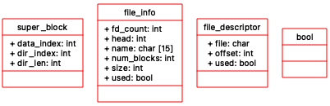

据结构

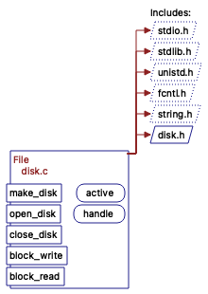 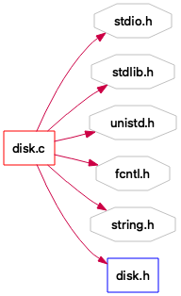

Disk.c头文件依赖情况

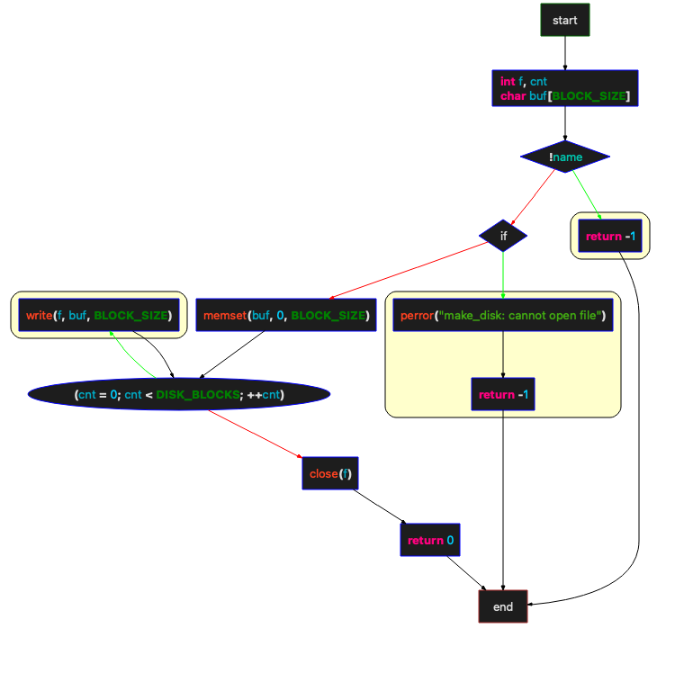

Make_disk函数流程图

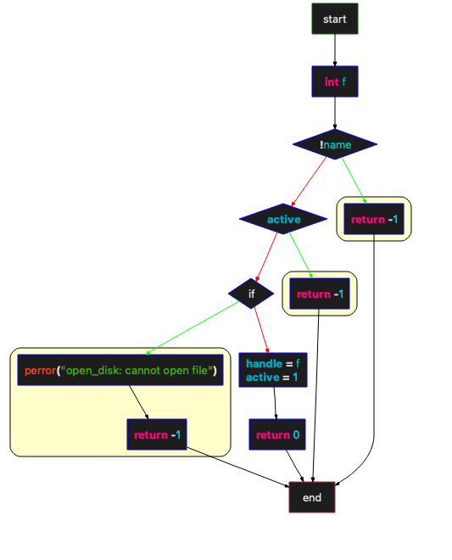

open_disk函数

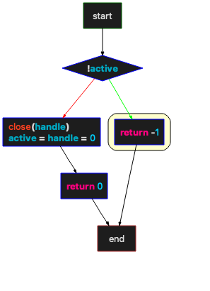

Close_disk函数流程图

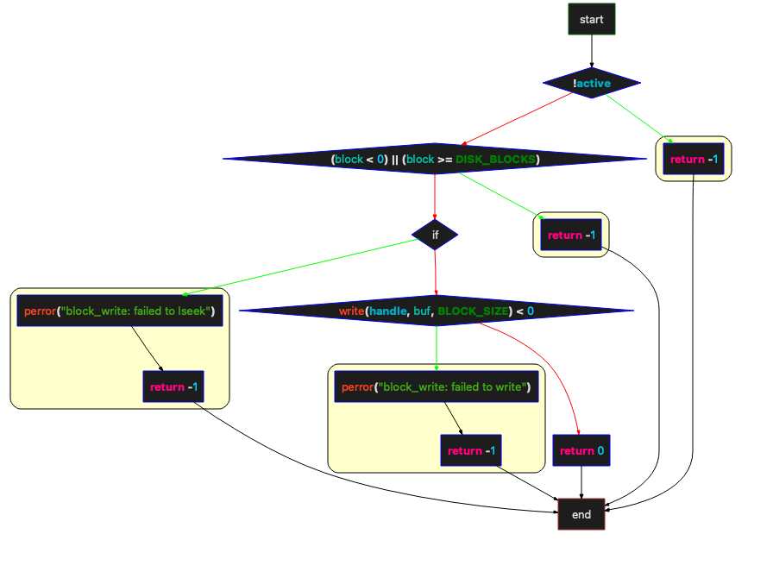

Block_write函数流程图

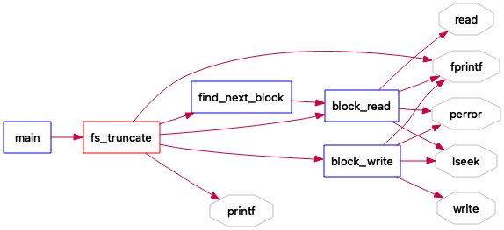

函数调用关系图

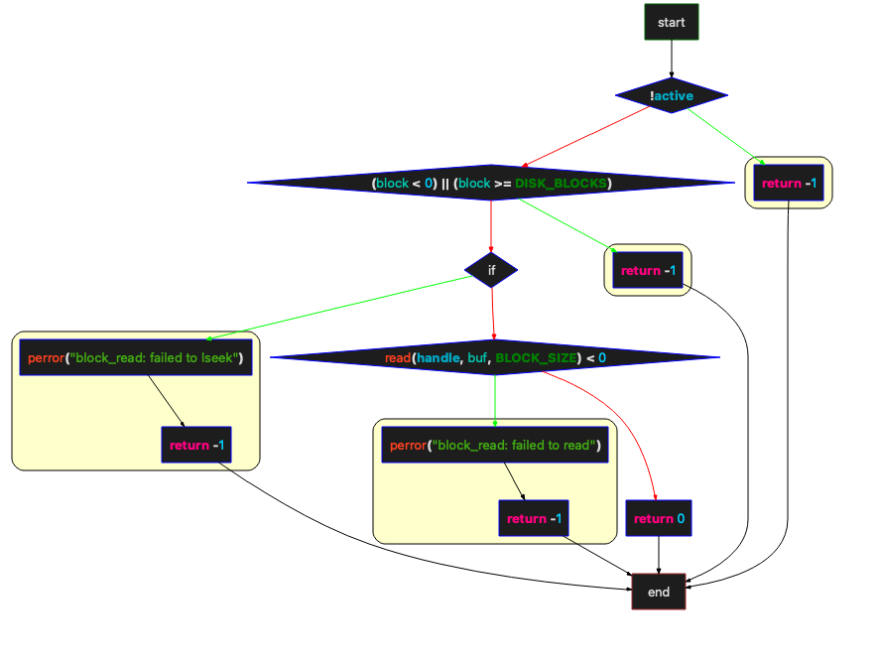

block_read函数流程图

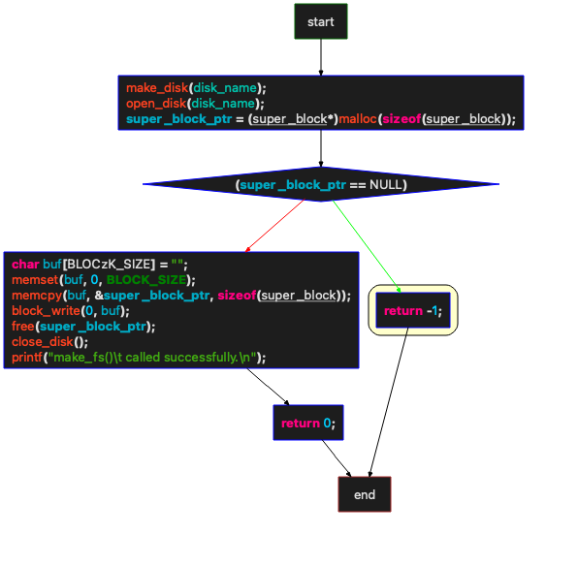

Make_fs函数流程图

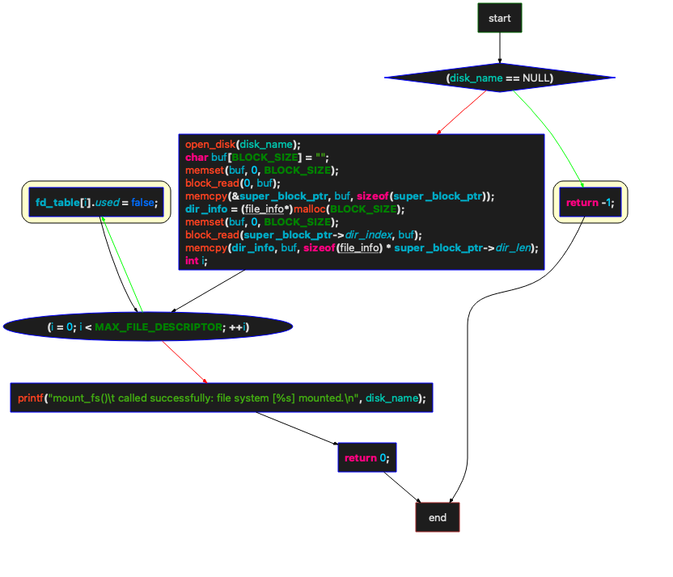

Mount_fs函数流程图

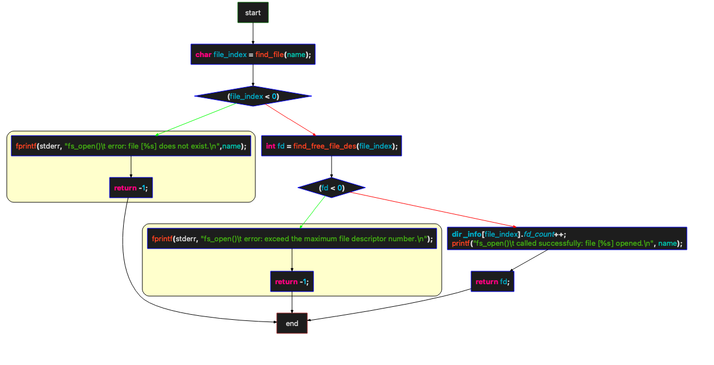

Fs_open函数流程图

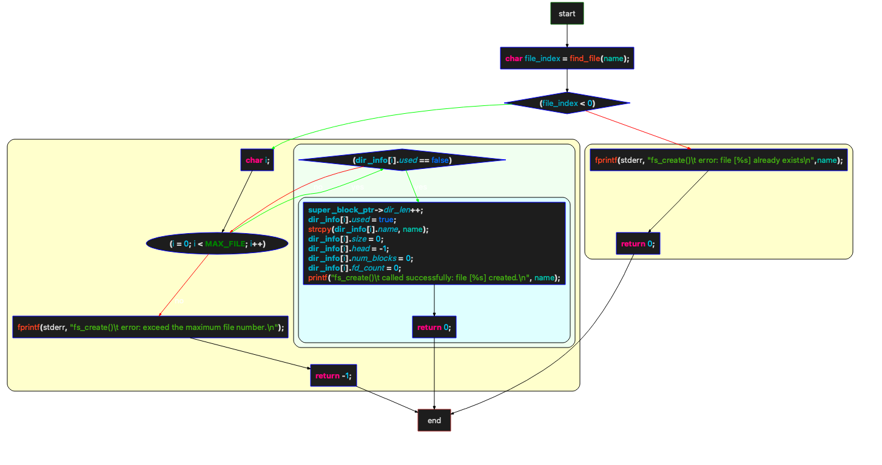

Fs_create

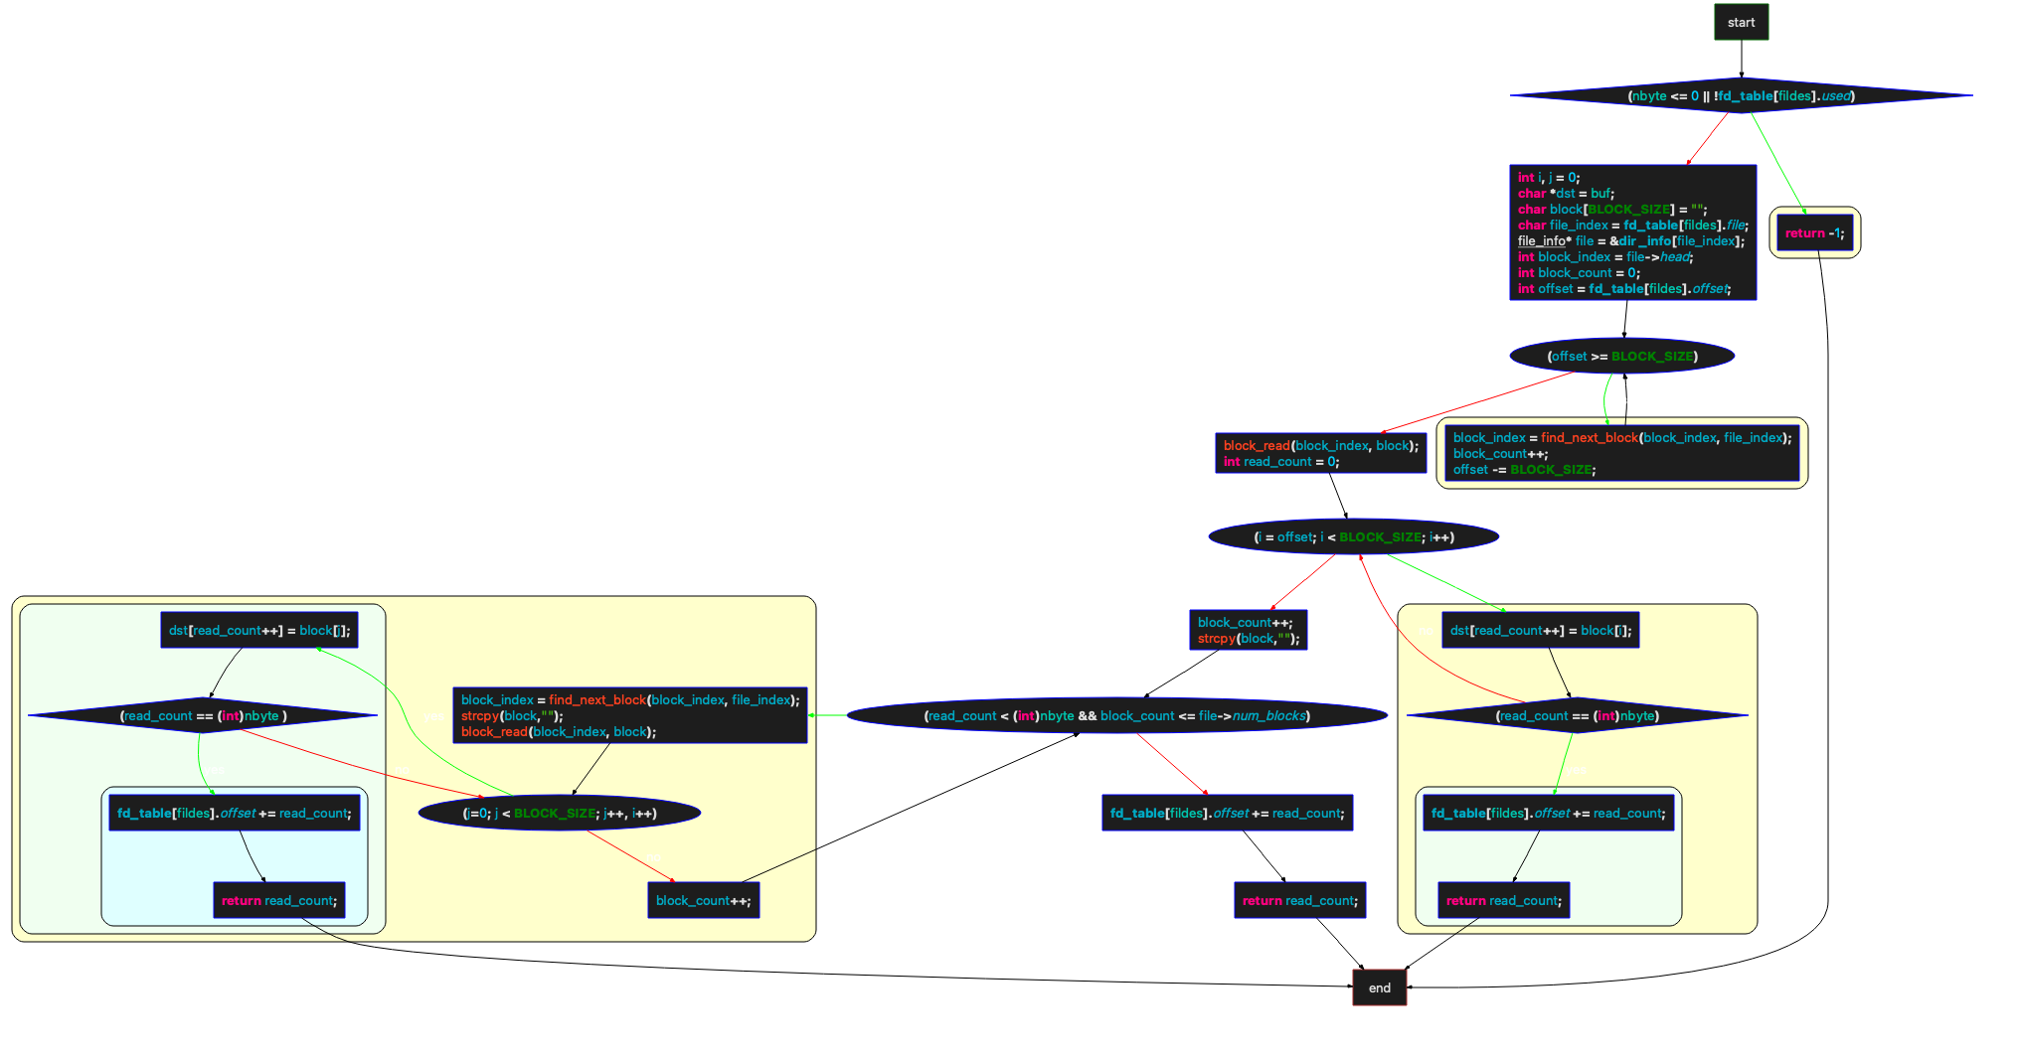

Fs_read

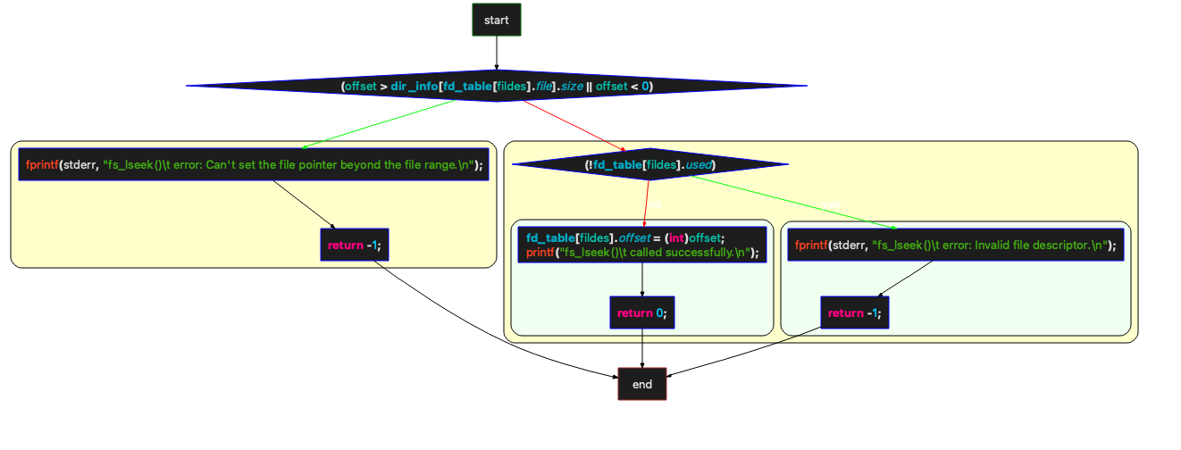

Fs_seek函数流程图

## 项目展示

### 测试代码

int main()

{

int i;

char* disk_name = "RootDir";

if(make_fs(disk_name) < 0) {

fprintf(stderr, "make_fs()\t error.\n");

}

if(mount_fs(disk_name) < 0) {

fprintf(stderr, "mount_fs()\t error.\n");

}

if(fs_create("test.txt") < 0) {

fprintf(stderr, "fs_create()\t error.\n");

}

/* fs_delete() test */

if(fs_delete("test.txt") < 0) {

fprintf(stderr, "fs_delete()\t error.\n");

}

if(fs_create("test.txt") < 0) {

fprintf(stderr, "fs_create()\t error.\n");

}

/* fs_write() test */

int fd1;

if((fd1 = fs_open("test.txt")) < 0) {

fprintf(stderr, "fs_open()\t error.\n");

}

int fd2;

if((fd2 = fs_open("test.txt")) < 0) {

fprintf(stderr, "fs_open()\t error.\n");

}

char str1[BLOCK_SIZE * 2];

for(i = 0; i < BLOCK_SIZE / 2; i++) {

str1[i] = 'a';

str1[i + BLOCK_SIZE / 2] = 'b';

str1[i + BLOCK_SIZE] = 'c';

str1[i + BLOCK_SIZE * 3 / 2] = 'd';

}

char str2[BLOCK_SIZE * 2];

for(i = 0; i < BLOCK_SIZE / 2; i++) {

str2[i] = 'e';

str2[i + BLOCK_SIZE / 2] = 'f';

str2[i + BLOCK_SIZE] = 'g';

str2[i + BLOCK_SIZE * 3 / 2] = 'h';

}

fs_write(fd1, str1, BLOCK_SIZE * 2);

fs_write(fd1, str2, BLOCK_SIZE * 2);

/* fs_lseek() test */

char str3[BLOCK_SIZE * 2];

for(i = 0; i < BLOCK_SIZE / 2; i++) {

str3[i] = 'i';

str3[i + BLOCK_SIZE / 2] = 'j';

str3[i + BLOCK_SIZE] = 'k';

str3[i + BLOCK_SIZE * 3 / 2] = 'l';

}

fs_lseek(fd2, BLOCK_SIZE * 2);

fs_write(fd2, str3, BLOCK_SIZE * 2);

/* fs_truncate() test */

fs_truncate(fd2, BLOCK_SIZE * 5 / 2);

char str4[BLOCK_SIZE * 3 / 2];

for(i = 0; i < BLOCK_SIZE / 2; i++) {

str4[i] = 'm';

str4[i + BLOCK_SIZE / 2] = 'n';

str4[i + BLOCK_SIZE] = 'o';

}

fs_write(fd2, str4, BLOCK_SIZE * 3 / 2);

if(fs_close(fd1) < 0) {

fprintf(stderr, "fs_close()\t error.\n");

}

if(fs_close(fd2) < 0) {

fprintf(stderr, "fs_close()\t error.\n");

}

if(umount_fs(disk_name) < 0) {

fprintf(stderr, "umount_fs()\t error.\n");

}

if(mount_fs(disk_name) < 0) {

fprintf(stderr, "mount_fs()\t error.\n");

}

if((fd1 = fs_open("test.txt")) < 0) {

fprintf(stderr, "fs_open()\t error.\n");

}

/* fs_read() Test */

char buf1[BLOCK_SIZE * 4] = "";

char val1[BLOCK_SIZE * 4];

for(i = 0; i < BLOCK_SIZE / 2; i++) {

val1[i] = 'a';

val1[i + BLOCK_SIZE / 2] = 'b';

val1[i + BLOCK_SIZE] = 'c';

val1[i + BLOCK_SIZE * 3 / 2] = 'd';

val1[i + BLOCK_SIZE * 2] = 'i';

val1[i + BLOCK_SIZE * 5 / 2] = 'm';

val1[i + BLOCK_SIZE * 3] = 'n';

val1[i + BLOCK_SIZE * 7 / 2] = 'o';

}

int fd3;

if((fd3 = fs_open("test.txt")) < 0) {

fprintf(stderr, "fs_open()\t error.\n");

}

if(fs_read(fd3, buf1, BLOCK_SIZE * 4) < 0) {

fprintf(stderr, "fs_read()\t error.\n");

} else {

printf("fs_read()\t called successfully.\n");

}

for (i = 0; i < BLOCK_SIZE * 4; ++i) {

if (buf1[i] != val1[i]) {

fprintf(stderr, "fs_read()\t error: Content [%d] error: [%c] and [%c].\n", i, buf1[i], val1[i]);

break;

}

}

/* fs_get_filesize() Test */

int file_size;

if((file_size = fs_get_filesize(fd1)) < 0) {

fprintf(stderr, "fs_get_filesize()\t error.\n");

} else {

printf("fs_get_filesize()\t called successfully: The file size is %d\n", file_size);

}

/* multiple file test */

char j;

int k;

for (j = 0; j < 63; ++j) {

/* create */

char* file_name = (char*)malloc(9);

char index[2];

index[0] = (char) (j + 48);

index[1] = '\0';

strcat(file_name, "test");

strcat(file_name, index);

strcat(file_name, ".txt");

fs_create(file_name);

/* write */

char str[BLOCK_SIZE * 64];

int fd_w = fs_open(file_name);

for(k = 0; k < BLOCK_SIZE * 64; ++k) {

str[k] = (char) (j + 48);

}

fs_write(fd_w, str, BLOCK_SIZE * 64);

/* read */

char buf[BLOCK_SIZE * 64];

int fd_r = fs_open(file_name);

fs_read(fd_r, buf, BLOCK_SIZE * 64);

for (k = 0; k < BLOCK_SIZE * 64; ++k) {

if (str[k] != buf[k]) {

fprintf(stderr, "fs_read()\t error: Content [%d] error: [%c] and [%c].\n", k, str[k], buf[k]);

break;

}

}

/* close */

fs_close(fd_w);

fs_close(fd_r);

memset(file_name, 0, 9);

free(file_name);

}

if(umount_fs(disk_name) < 0) {

fprintf(stderr, "umount_fs()\t error.\n");

}

return 0;

};

### 运行结果

使用 make进行编译

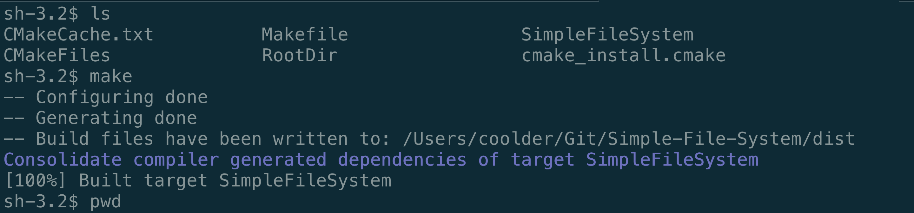

运行测试程序

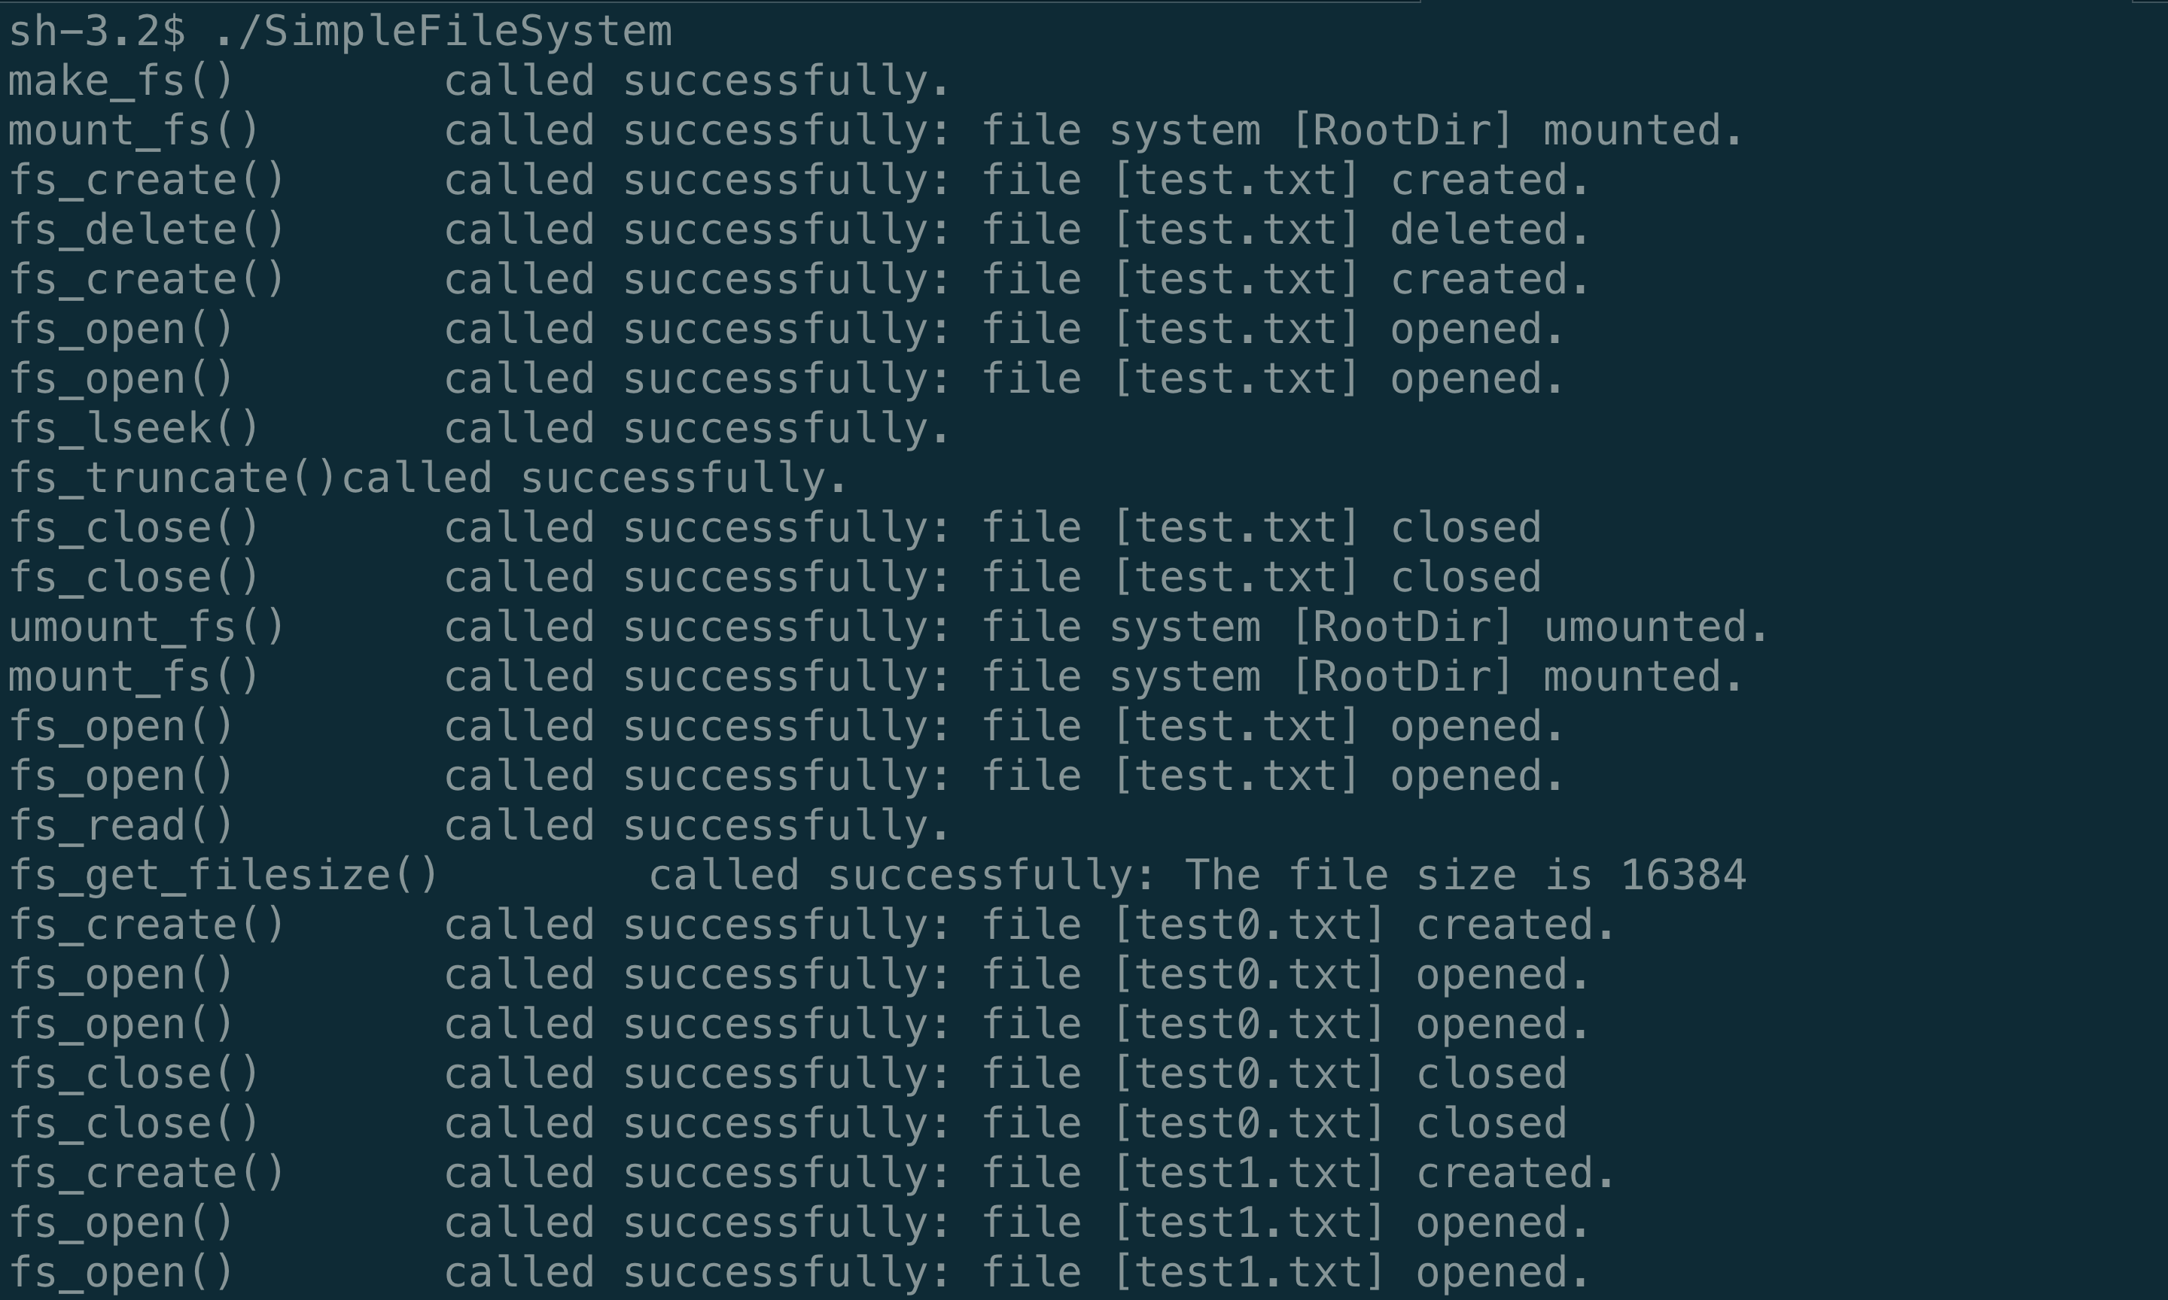

## 项目总结

通过使用C语言编写简单的文件系统，掌握了C语言的基本知识和一些高级用法如指针的指针和指针数组的转换，结构体数组和结构体指针的应用。学习到了超级块的数据结构在C语言中的体现，文件如何被创建，删除等。使用malloc分配的内存，使用完后必须要释放内存，否则会导致内存泄漏。