Embedded System Programming Course
Assignment 1
- Explain the complete compilation steps on the C program and explain what happens in each execution stage and provide a snapshot of each stage executed on your system?
Preprocessing, compilation, assembly and linking.
Preprocessing: This step completes macro definition expansion, header file expansion, conditional compilation, and so on, while removing comments from the code. Syntax is not checked here.
Compilation: This step checks the syntax and compiles the preprocessed file to an assembler file.
Assembly: This step assembles the file to generate the target binary.
Linking: Programs written in C need to rely on various libraries, so after compiling the library also need to link to the final executable program.
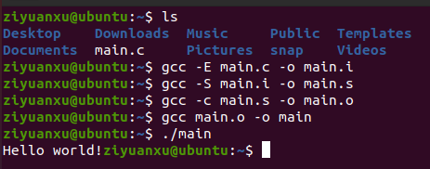

- Write a program to convert decimal to hexadecimal format in C
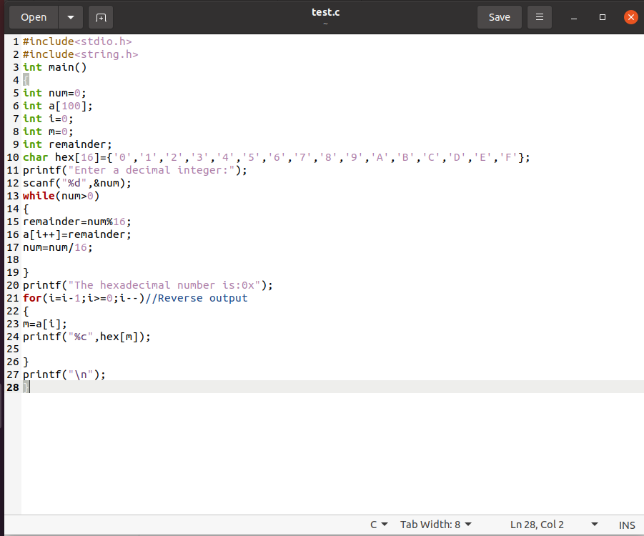
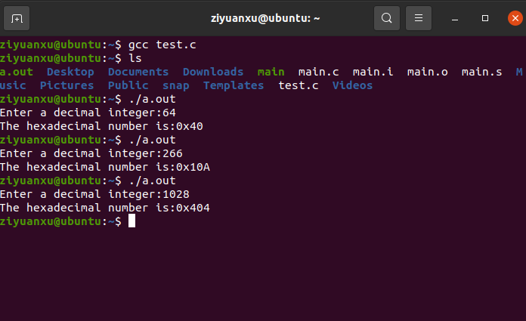

- What are pointers in C ? Demonstrate an example code to determine the understanding of double pointer in C?
A pointer is a variable that contains a memory address of another variable. A pointer variable is declared to some types like other variable, so that it will work only with data of given type. Just as integer variable can hold integer data only, pointer variable can point to one specific data type(for instance, integer pointer can only hold the address of integer data). Use of pointer: 1.dynamic memory allocation; 2.return multiple value from functions; 3. access the element of array; 4. increase the execution speed of program; 5. create complex data structure
A pointer to a pointer is called a double pointer.
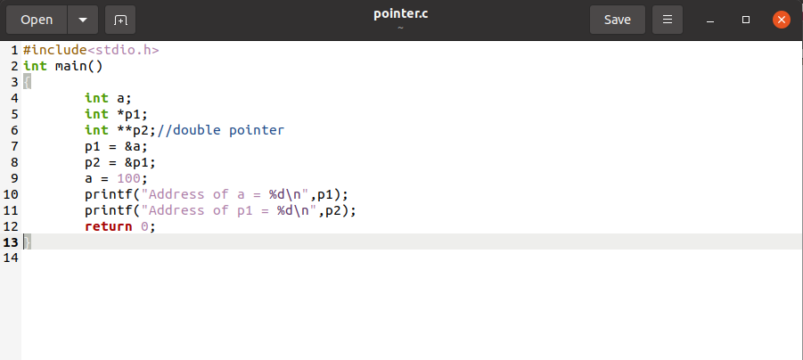
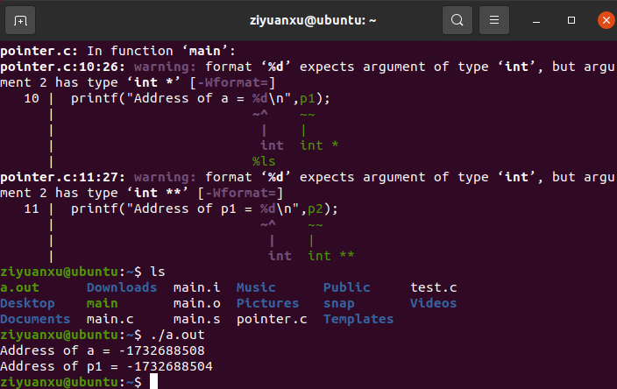

- What is a NULL pointer, and What is a Dangling pointer? Explain with a simple example code?
A null pointer is a type of pointer which points to nothing. We can define null pointer using constant NULL. A null pointer always contains value 0.
A pointer to a block of memory that is later freed by the system but still points to that block of memory is a "dangling pointer".
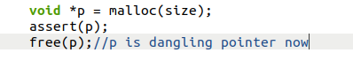
5.What is the difference between constant pointer and pointer to constant in C and explain with an example?
A constant pointer is a pointer to a constant. It can't point to a variable, it can't change what it points to, it can't change what it points to, but it's not a constant, it can change its value to point to another constant.
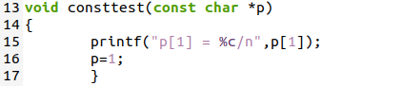
pointer to constant means that the pointer itself is constant. The address it points to is immutable, but the contents of the address can be changed by a pointer. The address it points to stays with it for the rest of its life span.
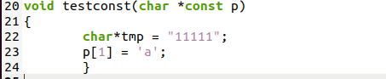

6.What are Storage classes in C ? Briefly explain each Storage class in C.

A storage class is a variable storage type, that is, what segment is a variable stored in memory. There are four types of storage classes in C: Automatic storage classes, Register storage classes, Static storage classes, External storage classes.
Automatic storage classes: The keyword auto is used to declare variable of automatic storage class. Storage: Memory. Default initial value: Unpredictable value. Scope: Local to the block in which the variable is defined. Life: Control remains within the block in which the variable is defined.
Register storage classes: The keyword register is used to declare a variable of the register storage class. Storage: CPU register. Default initial value: Garbage value. Scope: Local to the block in which the variable is defined. Life: Control remains within the block in which the variable is defined.
Static storage classes: The keyword static is used to declare variables of static storage class. Storage: Memory. Default initial value: 0. Scope: Local to the block in which the variable is defined. Life: Value of the variable remains b/w different function calls.
External storage classes: The keyword extern is used to declare the variables of external storage class. Storage: Memory. Default initial value: 0. Scope: Global. Life: As long as the program execution does not come to an end.

7. Explain Basics of Bit Manipulation for C Programming and write a program to
& bitwise AND
| bitwise inclusive OR
^ bitwise exclusive OR
~ ones complement
<< left shift
>> right shift
- Set a bit
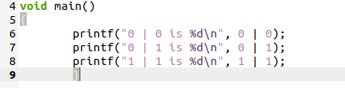
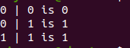
- Clear a Bit
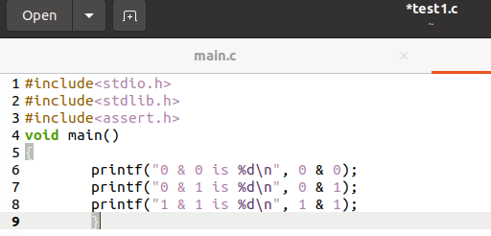
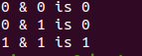
c. Toggle a bit
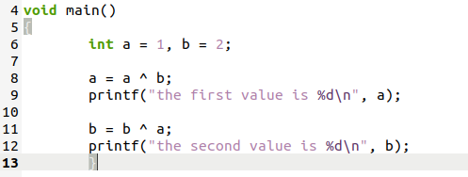
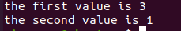

8. What are function pointers in C? Demonstrate your understanding with a simple program?
If a function is defined in a program, the system allocates a chunk of storage for the function code at compile time. The initial address of the storage is called the address of the function. And that's the address that the function name represents. Since it is an address we can define a pointer variable to hold it, and this pointer variable is called a function pointer variable.
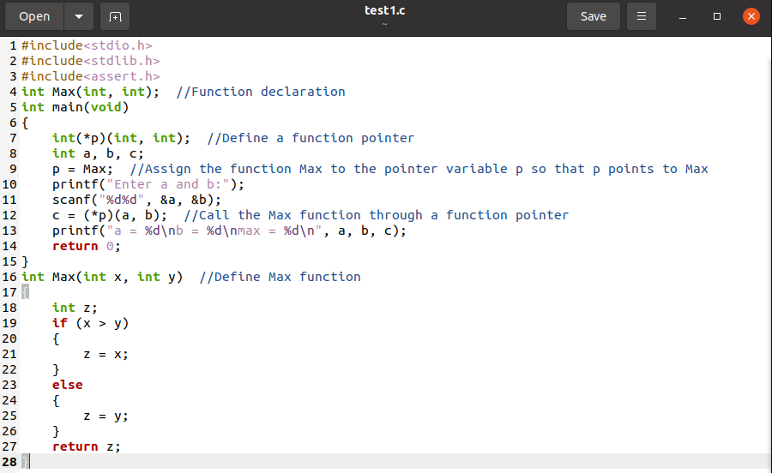
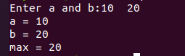

9. What is the volatile keyword?
The volatile keyword is a type specifier that declares type variables that can be changed by factors unknown to the compiler, such as the operating system, hardware, or other threads. When a variable declared by this keyword is encountered, the compiler no longer optimizes the code that accesses that variable, providing stable access to a particular add.

10. Implement your own sizeof() operator in C ?
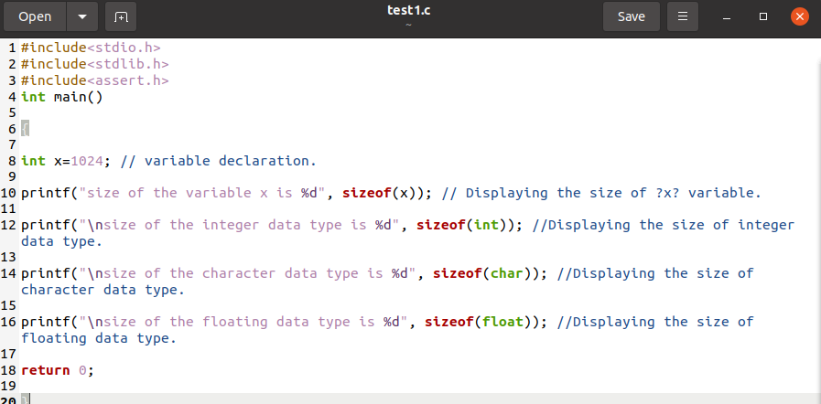

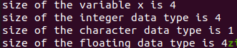

11. Write a program to implement your own memcpy (void * memcpy(void * dest, const void * src, size_t num)
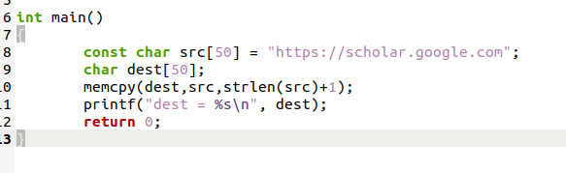
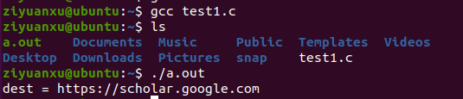

12. Write a program to demonstrate Bit rotation in C (Consider both Right and left rotation)
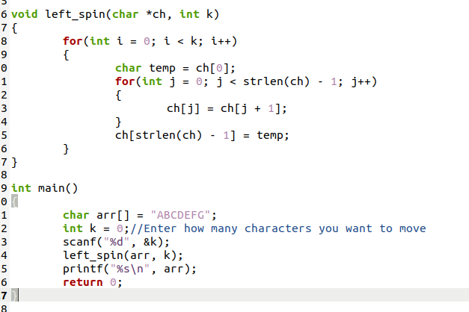
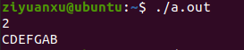
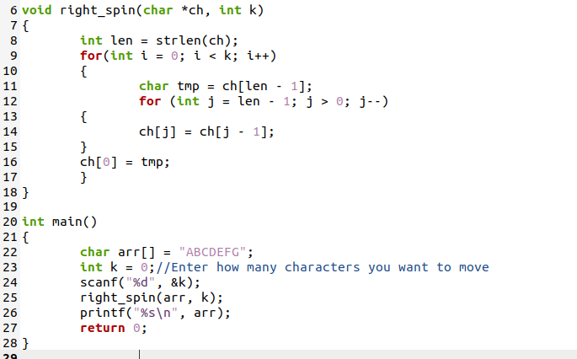
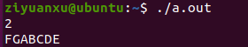

13. Differentiate between calloc() and malloc() and demonstrate using an example code?
Malloc () allocates a block of memory of a given size (in bytes), and returns a pointer to the beginning of the block. Malloc () does not initialize allocated memory. If we try to access the contents of the memory block before initialization, we will get segmentation errors or possibly garbage values.
Calloc () allocates memory and initializes the allocated block to zero. If we try to access the contents of these blocks, then we get 0.
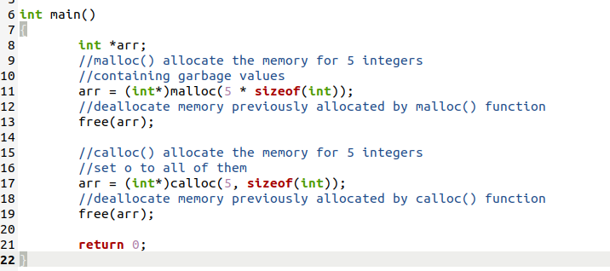

14. What is the difference between structure and union in C and demonstrate using an example code showing the difference between them?
Union allows several variables of different types to occupy a single block of memory. All members of the union have the same starting address, which overwrites each other.
Structures combine different types of data into a whole. Each member of the structure occupies its own memory.
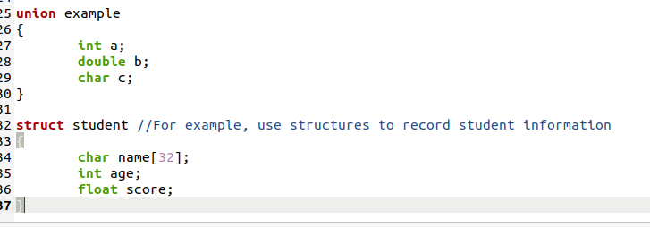

15. What does structure padding and padding in C explain with an example code?
Structure padding refers to the addition of one or more empty bytes between memory addresses to align the data in memory.
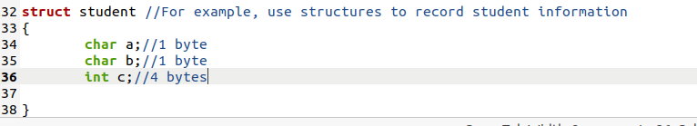
If it is a 32-bit processor, it can read four bytes at a time. In this structure, a and b can be accessed in one CPU cycle, while c occupies four bytes and can only be accessed in the next cycle. Thus, the entire structure takes up 8 bytes.

16. Differentiate between the macros and the functions in C.
Execution speed: macros execute faster, and functions have the extra cost of calling and returning.
The priority of the operator: macro arguments are evaluated in the context of the surrounding expression, and the precedence of the adjacent operators can produce unexpected results unless quoted. The function is evaluated only once when called, and the result of the evaluation of the expression is more predictable.
Parameters evaluated: Parameters are reevaluated each time they are used in a macro definition. Parameters are evaluated only once before being called by the function.
The parameter types: Macros are independent of the parameter types, as long as the operation on the parameter is legal. Function parameters are type dependent, and different parameters require different functions.

17. What is a double Linked List in C?
Double linked lists are based on single linked lists. Single linked lists are one-way, they have one head node, one tail node, and to access any node, you have to know the head node, you can't go backwards. Double linked lists add a pointer field that points to the front and back nodes of a node through two pointer fields. In this case, you can access its front and back nodes through any node in a double linked list.
In double linked list, the node contains data domain, there are two chain domain, one stores the address of the direct successor node, generally called the right chain domain; A storage direct precursor node address, commonly known as the left chain domain.

- Write a program to Insert in-between value nodes
- Write a program to delete values in-between node
#include <iostream>
#include <stdio.h>
#include <stdlib.h>

using namespace std;

typedef int ElemType;
/* A node of a double linked list containing one data field and two pointer fields */
typedef struct DoubleNode{
ElemType data;
struct DoubleNode * prev; // Points to a predecessor node
struct DoubleNode * next; // Points to a successor node
}DoubleNode,* DoubleLinkList;

DoubleLinkList InitDoubleLinkList()
{
DoubleLinkList dlLink;
dlLink = (DoubleLinkList)malloc(sizeof(DoubleNode));
if(dlLink == NULL)
cout << " Failed to apply for space!";
dlLink->next = NULL;
return dlLink;
}
void OutPut(DoubleLinkList dlLink)
{
DoubleLinkList temp = dlLink;
cout << "This double linked list is:";
while(temp->next != NULL)
{
temp = temp->next;
cout << temp->data << " ";
}
cout << endl;
}
/*void CreatDoubleLinkListHead(DoubleLinkList &dlLink,int length)
{
DoubleLinkList node = NULL;
for(int i = 0;i <length;i++)
{
node = (DoubleLinkList)malloc(sizeof(DoubleNode));
cout << "Enter" << i+1 <<"element:";
ElemType x;
cin >> x;
node->data = x;
node->next = dlLink->next;
dlLink->next->prev = node;
node->prev = dlLink;
dlLink->next = node;
}
}*/

void CreatDoubleLinkListTail(DoubleLinkList &head,int length)
{
DoubleLinkList node = NULL;
DoubleLinkList tail = head;
for(int i = 0;i < length;i++)
{
node = (DoubleLinkList)malloc(sizeof(DoubleNode));
cout << "Enter" << i+1 <<"element：";
ElemType x;
cin >> x;
node->data = x;

tail->next = node;
node ->prev = tail;
tail = node;

}
tail ->next = NULL;
}
void InsertNode(DoubleLinkList &dlLink,int pos,ElemType element)
{
DoubleLinkList node = (DoubleLinkList)malloc(sizeof(DoubleNode));
DoubleLinkList p = dlLink;
int j = 1;
while(j < pos)
{
p = p->next;
j++;
}
// In this case, p is the precursor node
node->data = element;

node->next = p->next;
p->next->prev = node;
p->next = node;
node->prev = p;
}
void DeleteNode(DoubleLinkList &dlLink,int pos)
{
DoubleLinkList p = dlLink;
DoubleLinkList deleteNode;
int j = 1;
while(j < pos)
{
p = p->next;
j++;
}
// In this case, p is the precursor node
deleteNode = p->next;
deleteNode->next ->prev = p;
p->next = deleteNode->next;
free(deleteNode);

}

int main()
{
DoubleLinkList dlLink = InitDoubleLinkList();
int length;
cout << " Please enter the length of the linked list:";
cin >> length;
// CreatDoubleLinkListHead(dlLink,length);
CreatDoubleLinkListTail(dlLink,length);
OutPut(dlLink);
cout << " Please enter the element to insert:";
int element;
cin >> element;
cout << " Please enter the location to insert:";
int pos;
cin >> pos;
InsertNode(dlLink,pos,element);
OutPut(dlLink);
cout << " Please enter the location of the element to be deleted:";
cin >> pos;
DeleteNode(dlLink,pos);
OutPut(dlLink);
return 0;
}

