《操作系统原理》实验报告

班级：
学号：
姓名：
教师：

实验2 进程调度

1．实验目的和要求
1) 理解进程调度
2) 掌握3种常见的调度算法

2．实验内容
实现FCFS，SPF，PSA。

实验过程
- 实验分析
Fcfs:系统将作业按照一次顺序进行调度，而不需要照顾后来的进程，直至进程时间用完。
PSA:处理器分配给就绪队列中优先级较高的进程，该进程便一直运行下去，直到进程运行结束或者该进程放弃处理器。
SJF:通过从就绪队列按估计时间最短的进程，作业时间短的作业优先进入处理器， 并为之分配cpu资源。
- 流程图

FCFS先来先服务算法
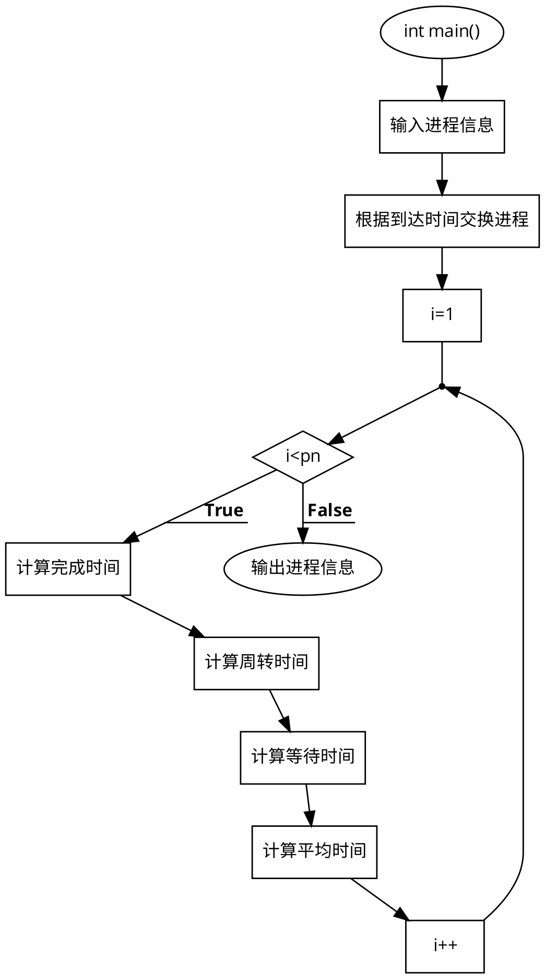

PSA优先级调度算法

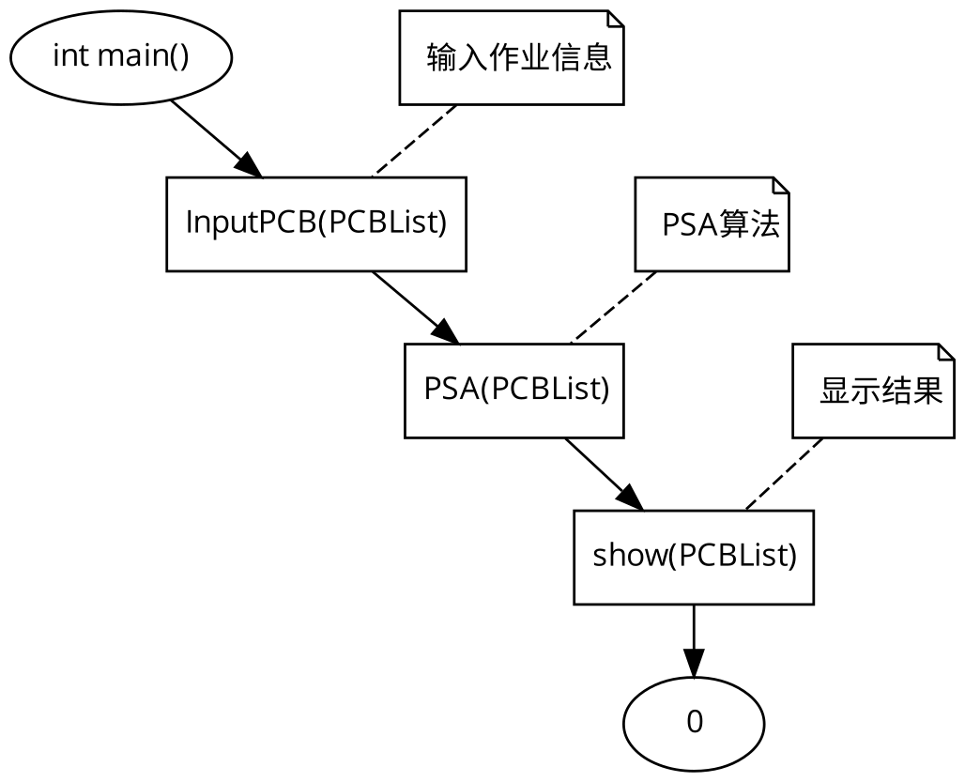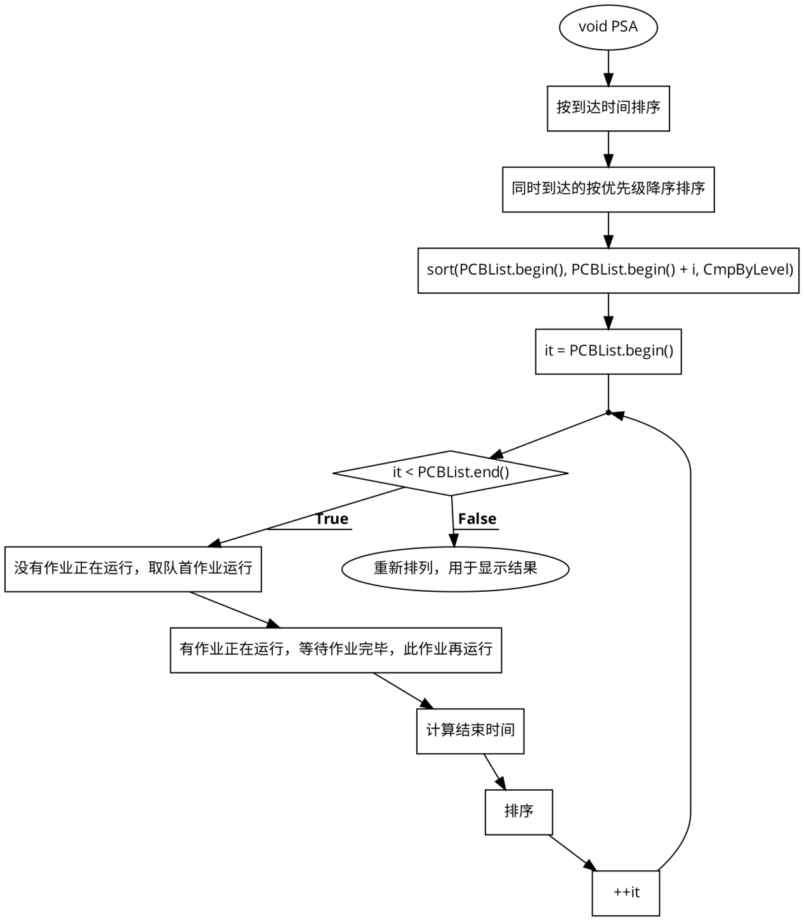

SJF短作业优先算法

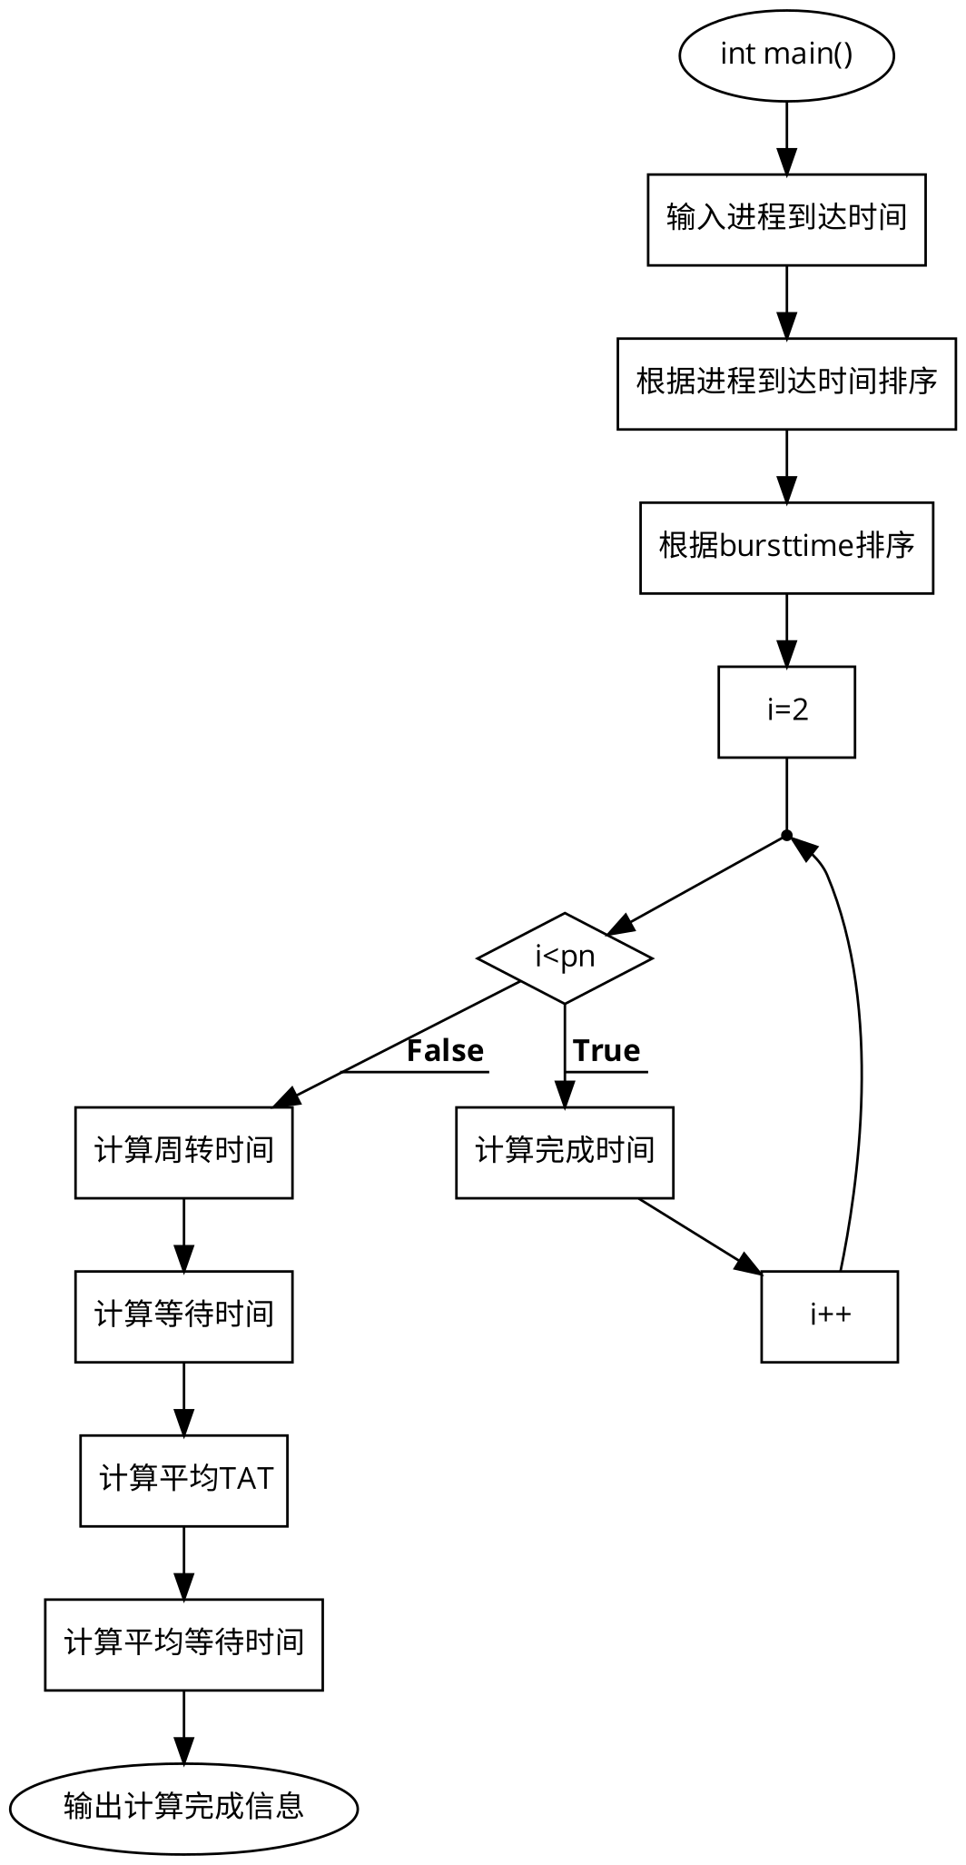

- 源代码

FCFS先来先服务

#include<stdio.h>
#include<stdlib.h>
int main()
{
int pn,pno[20],at[20],bt[20],i,tat[20],com[20],wt[20],temp,j;
float avg,avg2,avgtat,avgwt;
printf("Enter the number of process for FCFS SCHEDULING\n");
scanf("%d",&pn);
printf("Enter the process 1 by 1\n");
for(i=0;i<pn;i++)
scanf("%d",&pno[i]);
printf("Enter the process of Arrival time\n");
for(i=0;i<pn;i++)
scanf("%d",&at[i]);
printf("Enter the process burst time\n");
for(i=0;i<pn;i++)
scanf("%d",&bt[i]); //accepting burst time process number and arrival time from user

for(i=0;i<pn;i++)
{
for(j=i+1;j<pn;j++)
{
if(at[i]>at[j])
{
temp=at[i];
at[i]=at[j];
at[j]=temp;

temp=pno[i];
pno[i]=pno[j];
pno[j]=temp;

temp=bt[i];
bt[i]=bt[j];
bt[j]=temp;

}
}
} //sorting according to arrival time

com[0]=bt[0]+at[0];
tat[0]=bt[0];
wt[0]=0;
for(i=1;i<pn;i++)
com[i]=abs(com[i-1]+bt[i]); //completion time

for(i=0;i<pn;i++)
tat[i]=abs(com[i]-at[i]); //turn aroun time

for(i=0;i<pn;i++)
wt[i]=abs(tat[i]-bt[i]); //waiting time

for(i=0;i<pn;i++)
avg=avg+tat[i];

avgtat=avg/pn; //average TAT

for(i=0;i<pn;i++)
avg2=avg2+wt[i];

avgwt=avg2/pn; //average WT

printf("pno\tat\tbt\tcom\ttat\twt\t\n");
for(i=0;i<pn;i++)
{
printf("P%d\t%d\t%d\t%d\t%d\t%d\n",pno[i],at[i],bt[i],com[i],tat[i],wt[i]);
}

printf("ATAT= %f\nAWT= %f\n",avgtat,avgwt); //displaying every values

}

PSA优先调度算法

#ifndef PSA_H_
#define PSA_H_

#include <iostream>
#include <algorithm>
#include <iomanip>
#include <vector>

//作业结构体
typedef struct PCB
{
int ID; //标识符
int Level; //优先级
int ComeTime; //到达时间
int ServerTime; //服务时间
int FinishTime; //完成时间
int TurnoverTime; //周转时间
double WeightedTurnoverTime; //带权周转时间
}PCB;
void InputPCB(std::vector<PCB> &PCBList);
void PSA(std::vector<PCB> &PCBList);
void show(std::vector<PCB> &PCBList);
bool CmpByComeTime(const PCB &p1, const PCB &p2);

bool CmpByLevel(const PCB &p1, const PCB &p2);

#endif

void InputPCB(std::vector<PCB> &PCBList)
{
do {
PCB temp;
std::cout << "input id: ";
std::cin >> temp.ID;
std::cout << "input priority: ";
std::cin >> temp.Level;
std::cout << "input arrive time: ";
std::cin >> temp.ComeTime;
std::cout << "input server time: ";
std::cin >> temp.ServerTime;
PCBList.push_back(temp);

std::cout << "continue? Y/N: ";
char ans;
std::cin >> ans;
if ('Y' == ans || 'y' == ans)
continue;
else
break;
} while (true);
}

//PSA算法
void PSA(std::vector<PCB> &PCBList)
{
std::sort(PCBList.begin(), PCBList.end(), CmpByComeTime); //按到达时间排序

//同时到达的按优先级降序排序，决定首先运行的作业
int i = 1;
std::vector<PCB>::iterator it = PCBList.begin() + 1;
while ((*it).ComeTime == (*(it - 1)).ComeTime)
{
++i;
++it;
}
std::sort(PCBList.begin(), PCBList.begin() + i, CmpByLevel);

int FinishTime = -1;
for (it = PCBList.begin(); it < PCBList.end(); ++it)
{
if ((*it).ComeTime >= FinishTime) (*it).FinishTime = (*it).ComeTime + (*it).ServerTime;
else //有作业正在运行，等待作业完毕，此作业再运行
(*it).FinishTime = FinishTime + (*it).ServerTime;
(*it).TurnoverTime = (*it).FinishTime - (*it).ComeTime;
(*it).WeightedTurnoverTime = (double)(*it).TurnoverTime / (*it).ServerTime;
FinishTime = (*it).FinishTime;

//在一个作业运行期间，如果有其他作业到达，将他们按照优先级降序排列
i = 1;
while ((it + i) < PCBList.end() && (*(it + i)).ComeTime <= FinishTime)
++i;
std::sort(it + 1, it + i, CmpByLevel);
}

std::sort(PCBList.begin(), PCBList.end(), CmpByComeTime); //重新排列，用于显示结果
}

void show(std::vector<PCB> &PCBList)
{
int SumTurnoverTime = 0;
double SumWeightedTurnoverTime = 0;

std::cout.setf(std::ios::left);

std::cout << std::setw(20) << "id";
for (std::vector<PCB>::iterator it = PCBList.begin(); it < PCBList.end(); ++it)
std::cout << std::setw(5) << (*it).ID;
std::cout << std::endl;

std::cout << std::setw(20) << "priority";
for (std::vector<PCB>::iterator it = PCBList.begin(); it < PCBList.end(); ++it)
std::cout << std::setw(5) << (*it).Level;
std::cout << std::endl;

std::cout << std::setw(20) << "arrive time";
for (std::vector<PCB>::iterator it = PCBList.begin(); it < PCBList.end(); ++it)
std::cout << std::setw(5) << (*it).ComeTime;
std::cout << std::endl;

std::cout << std::setw(20) << "server time";
for (std::vector<PCB>::iterator it = PCBList.begin(); it < PCBList.end(); ++it)
std::cout << std::setw(5) << (*it).ServerTime;
std::cout << std::endl;

std::cout << std::setw(20) << "finish time";
for (std::vector<PCB>::iterator it = PCBList.begin(); it < PCBList.end(); ++it)
std::cout << std::setw(5) << (*it).FinishTime;
std::cout << std::endl;

std::cout << std::setw(20) << "avg turn over time";
for (std::vector<PCB>::iterator it = PCBList.begin(); it < PCBList.end(); ++it)
{
std::cout << std::setw(5) << (*it).TurnoverTime;
SumTurnoverTime += (*it).TurnoverTime;;
}
std::cout << std::endl;

std::cout << std::setw(20) << "weighted turn over time";
for (std::vector<PCB>::iterator it = PCBList.begin(); it < PCBList.end(); ++it)
{
std::cout << std::setw(5) << (*it).WeightedTurnoverTime;
SumWeightedTurnoverTime += (*it).WeightedTurnoverTime;;
}
std::cout << std::endl;

std::cout << "avg turn over time: " << (double)SumTurnoverTime / PCBList.size() << std::endl;
std::cout << "weighted turn over time: " << SumWeightedTurnoverTime / PCBList.size() << std::endl;
}

bool CmpByComeTime(const PCB &p1, const PCB &p2)
{
return p1.ComeTime < p2.ComeTime;
}

bool CmpByLevel(const PCB &p1, const PCB &p2)
{
return p1.Level > p2.Level;
}

主程序:
//main.cpp
#include "PSA.h"

int main()
{
std::vector<PCB> PCBList;

InputPCB(PCBList);

PSA(PCBList);

show(PCBList);

return 0;
}

SJF短作业优先算法
#include<stdio.h>
#include<stdlib.h>

int main()
{
int pn,pno[20],at[20],bt[20],i,tat[20],com[20],wt[20],temp,j;
float avg,avg2,avgtat,avgwt;
printf("Enter the number of process for SJF SCHEDULING\n");
scanf("%d",&pn);
printf("Enter the process 1 by 1\n");
for(i=0;i<pn;i++)
scanf("%d",&pno[i]);
printf("Enter the process of Arrival time\n");
for(i=0;i<pn;i++)
scanf("%d",&at[i]);
printf("Enter the process burst time\n");
for(i=0;i<pn;i++)
scanf("%d",&bt[i]); //accepting burst time process number and arrival time from user

for(i=0;i<pn;i++)
{
for(j=i+1;j<pn;j++)
{
if(at[i]>at[j])
{
temp=at[i];
at[i]=at[j];
at[j]=temp;

temp=pno[i];
pno[i]=pno[j];
pno[j]=temp;

temp=bt[i];
bt[i]=bt[j];
bt[j]=temp;

}
}
}

com[0]=bt[0]+at[0];

if(com[0]>at[pn-1])
{
for(i=1;i<pn;i++)
{
for(j=i+1;j<pn;j++)
{
if(bt[i]>bt[j])
{
temp=at[i];
at[i]=at[j];
at[j]=temp;

temp=pno[i];
pno[i]=pno[j];
pno[j]=temp;

temp=bt[i];
bt[i]=bt[j];
bt[j]=temp;

}
}
}
tat[0]=bt[0];
wt[0]=0;

for(i=1;i<pn;i++)
com[i]=abs(com[i-1]+bt[i]); //completion time
}
else
{
for(i=1;i<pn;i++)
{
for(j=i+1;j<pn;j++)
{
if(at[i]>at[j])
{
temp=at[i];
at[i]=at[j];
at[j]=temp;

temp=pno[i];
pno[i]=pno[j];
pno[j]=temp;

temp=bt[i];
bt[i]=bt[j];
bt[j]=temp;

}
}
}

com[1]=bt[1]+at[1];

for(i=2;i<pn;i++)
{
for(j=i+1;j<pn;j++)
{
if(bt[i]>bt[j])
{
temp=at[i];
at[i]=at[j];
at[j]=temp;

temp=pno[i];
pno[i]=pno[j];
pno[j]=temp;

temp=bt[i];
bt[i]=bt[j];
bt[j]=temp;

}
}
}

tat[0]=bt[0];
wt[0]=0;

for(i=2;i<pn;i++)
com[i]=abs(com[i-1]+bt[i]); //completion time
}

for(i=0;i<pn;i++)
tat[i]=abs(com[i]-at[i]); //turn aroun time
for(i=0;i<pn;i++)
wt[i]=abs(tat[i]-bt[i]); //waiting time

for(i=0;i<pn;i++)
avg=avg+tat[i]; //average TAT

avgtat=avg/pn;

for(i=0;i<pn;i++)
avg2=avg2+wt[i]; //average WT

avgwt=avg2/pn;

printf("pno\tat\tbt\tcom\ttat\twt\t\n");
for(i=0;i<pn;i++)
{
printf("P%d\t%d\t%d\t%d\t%d\t%d\n",pno[i],at[i],bt[i],com[i],tat[i],wt[i]);
}

printf("ATAT= %f\nAWT= %f\n",avgtat,avgwt); //displaying every values

}

- 实验结果
FCFS先来先服务算法
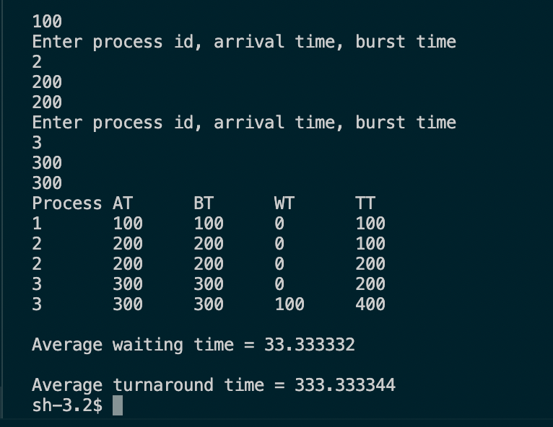

PSA优先级调度算法

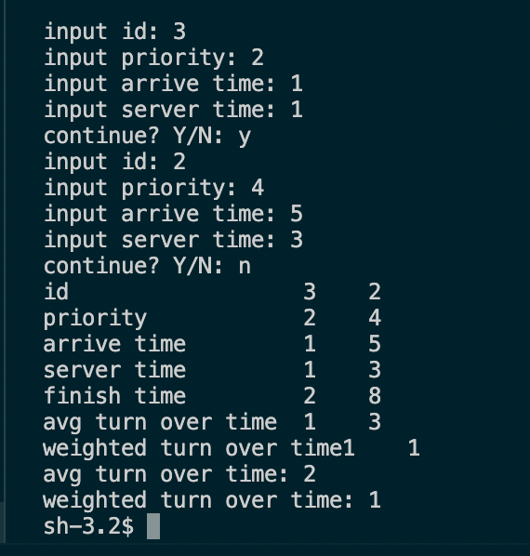

SJF短作业优先调度算法
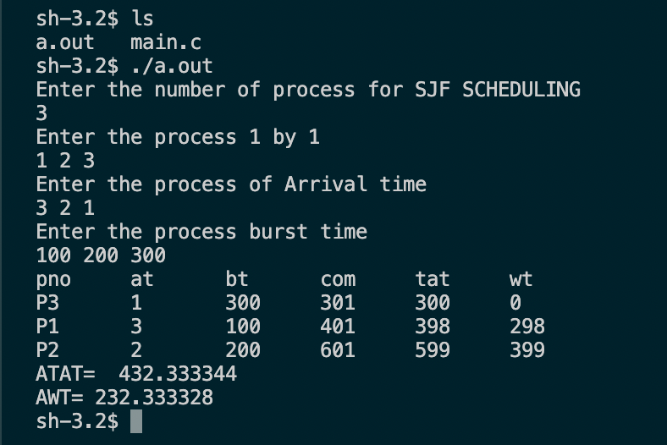

实验总结
通过本次实验掌握了C语言，C++语言的基本知识，包括指针和C++标注库以及起模版的应用。掌握了操作系统各种进程和作业的调度方法，如先来先服务，短作业优先，动态优先级调度。在编写程序的时候也遇到很多的错误和BUG，通过自己的不断调试和同学老师的帮助下最终完成了本次实验。

