**UCF Senior Design 1**



*Department of Electrical Engineering and Computer Science*

*University of Central Florida*

*Dr. Lei Wei*

*Initial Project and Group Identification Document*

*Divide and Conquer*

Group 29

Sandy Cline Photonics sandygcline@knights.ucf.edu

Ryan Heitz Computer Engineering rdheitz@knights.ucf.edu

Shane Zweibach Computer Engineering shanez1215@knights.ucf.edu

PROJECT NARRATIVE

In the modern era, where the pace of technical progress has been increasing exponentially, the radio spectrum that we depend on for communication is becoming increasingly crowded. Classic radio waves, cell phone antenna, TV, Wi-Fi, and Bluetooth signals all crowd the limited spectrum of radio frequencies that we have access to, and eventually we will run out of space (both in radio waves and physical space) for newer technologies. We see this in the cell phones. As 4G LTE has expanded to the point of becoming ubiquitous in most areas by 2018, carriers have been deprioritizing 3G, to the point where it is barely usable with modern website design and trends. A smaller example is accidently driving two different remote-control cars because there are a limited number of channels available.

In addition, these technologies are highly energy inefficient, and example being how Wi-Fi, Bluetooth, and cellular connectivity can quickly drain the modern smartphone battery, especially if the signal is weak or the user is jumping between multiple towers.

Thus, there is a need for a communication protocol that can be used for smaller, more single purpose devices with smaller batteries that does not use this spectrum. This technology would be primarily optical light/laser directed rather than relying on RF frequencies.

* Statement of motivation
* Discuss project goals and objectives
* Function of the project
* Reference any external input from customers or marketing analysis of competitive products or projects used to identify OUR project features.
* No numbers!
* Conceptual, and specific to project
* Identify project goals with adjectives

REQUIREMENT SPECIFICATIONS

* For the project as a whole
* Identify project constraints and related standards currently known (these develop naturally throughout the course of design) and reiterated in future documentation
* Use numbers!
* Answer how: many, often, high, long; what: values; when: events occur etc.
* The receiver shall be less than 10 lbs as it will be mounted on a glider.
* The receiver must be aerodynamic so as not to interfere with the flight path of the glider.
* The receiver must be somewhat durable as it may meet inclement weather.
* The receiver must be efficient in terms of power consumption as the glider will be untethered from the “light house”
* The glider must communicate with the light house by using lasers instead of RF communications
* The electronics onboard the glider must have a printed PCB.
* The sender/lighthouse must only use a single cord
* The glider must be able to communicate if there is a clear line of sight

HOUSE OF QUALITY

When building the product and meeting the requirements, we must decide what requirements go with each other and against each other. Listed below is a graph where we measure each of these values with respect to each other.

|  |  |  |  |  |  |  |
| --- | --- | --- | --- | --- | --- | --- |
|  |  | Dimensions | Accuracy | Range | Install time | Cost |
|  |  | - | + | + | - | - |
| Portability | + | ↑ |  |  | ↑ | ↑ |
| Power | - | ↓ | ↓ | ↑ |  | ↓ |
| Installation | + | ↑ |  |  | ↑ ↑ |  |
| Cost | - | ↓ | ↓↓ | ↓ |  | ↑ ↑ |

LEGEND

= no correlation

↑ = positive correlation

↑↑ = strong positive correlation

↓ = negative correlation

↓↓ = strong negative correlation

+ = high value

- = low value

PROJECT BLOCK DIAGRAM

* Be detailed
* Include prototype illustration
* Single diagram, or nested diagrams with increasing level of detail
* Separate block diagrams to differentiate between hardware and software parts and processes

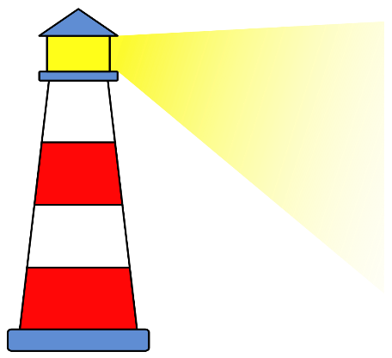

[This Photo](http://commons.wikimedia.org/wiki/File:Lighthouse_icon.svg) by Unknown Author is licensed under [CC BY-SA](https://creativecommons.org/licenses/by-sa/3.0/)

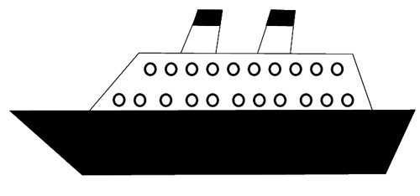

[This Photo](http://www.flickr.com/photos/bycp/5697748009/) by Unknown Author is licensed under [CC BY-NC](https://creativecommons.org/licenses/by-nc/2.0/)

“Light house”

Generates and sends message through light

To be acquired

“Ship”

Recieves, decodes, and interprets the message

To be acquired

Receiver

**Optics and Sensors**

Reads and digitizes data

Sandy

To be acquired

**Electronics and Circuits**

Interprets data and generates response

Ryan and Shane

To be acquired

**On-board hardware**

Carry’s out response generated by electronics and circuits

Ryan and Shane

To be acquired

Sender

Light

“The information provided for each block in the diagram should include:

1. Group member administratively responsible for the block.

2. Block name, which is descriptive of its function.

3. Block status: To be acquired - meaning the block will be purchased or donated Acquired - block has been donated or purchased

Research - block design approach is being investigated Design - block is currently being designed

Prototype - block is currently being prototyped Completed - block design is a finished prototype

4. Name each input and each output associated with each block.

5. Diagram Legend. The legend should expand all acronyms and describe all named entities in the block diagram by giving brief definitions.

Include any additional information that would increase the understanding of the block diagram. The use of identifier grouping and color may be helpful.”

ESTIMATE PROJECT BUDGET AND FINANCING

INITIAL PROJECT MILESTONE FOR BOTH SEMESTERS

DECISION MATRIX

* Projects under consideration vs. parameters that will help pick the project.
* E.g. : cost, sponsorship, familiarity with technology, educational goals, motivation