**UCF Senior Design 1**



*Department of Electrical Engineering and Computer Science*

*&*

*Center for Research and Education in Optics and Lasers*

*University of Central Florida*

*Dr. Lei Wei*

*Initial Project Identification Document:*

*Divide and Conquer*

Group 29

Sandy Cline Photonics sandygcline@knights.ucf.edu

Ryan Heitz Computer Engineering rdheitz@knights.ucf.edu

Shane Zweibach Computer Engineering shanez1215@knights.ucf.edu

PROJECT NARRATIVE

In the modern era, where the pace of technical progress has been increasing exponentially, the electromagnetic (EM) spectrum that we depend on for communication is becoming increasingly crowded. AM/FM radio waves, microwaves, UHF and VHF, Wi-Fi, and Bluetooth, are signals that permeate the space we are familiar with in a uniform fashion when the signal broadcasts ideally.

This project proposes a means of communication via infrared laser beam. Additionally, the system should auto-align the sending and receiving instruments to keep a strong signal between the sending and receiving units. If such an analog communication link can be established and maintained, then there exists a means to efficiently transfer data.

The bandwidth of this channel provides a platform wide enough for multiple applications. Currently, specialized imaging sensors are used on drones for agriculture and firefighting while optics help satellites take detailed images of our atmosphere in a myriad of spectrums for use in meteorology. The method of application will vary depending on the size and weight of a receiving module of the communication system.

The prototype solution seeks to provide a pair of micro-controlled optics and sensors that are specific to the bandwidth of infrared light that is accessible to users. The specific portion of the EM spectrum to be used is, as of yet to be determined. The project additionally seeks to prioritize simplicity, wise use of mass and materials and to work reliably at whatever scale can be achieved.

REQUIREMENT SPECIFICATIONS

* The receiver shall be less than 10 lbs.
* The receiver’s form factor must strive to prioritize a low profile.
* The receiving module should be well housed to protect the electronic and optic systems.
* The receiver must prioritize efficient use of energy.
* The communication link will reside within some range of infrared light
* Onboard electronics will be printed on PCB and secured to 3D-printable housing.
* Mainframe should have fiber-optic connectivity to other friendly “lighthouse” towers.
* The glider must be able to communicate if there is a clear line of sight, and resume communication when momentarily interrupted without issue.
* Batteries that power the receiver must be lightweight and provide sufficient throughput as needed.
* Mounting hardware should be easy and stick with adhesive to a smooth surface.
* Prototype will establish a basic link capable of modulating infrared light.
* Optics should be engineered to provide beam shaping of a semiconductor lasing in the infrared spectrum.
* Onboard conversion of the analog to digital data should meet Nyuist sampling requirements.
* CPU onboard receiver can interact with spectrometer for meteorological data, and process analysis and store this information locally, or transmit it back to a paired “lighthouse” through the infrared link.

HOUSE OF QUALITY

When building the product and meeting the requirements, we must decide what requirements go with each other and against each other. Listed below is a graph where we measure each of these values with respect to each other.

↑

↑

↑

↑

↑↑

↑

↑

|  |  |  |  |  |  |  |
| --- | --- | --- | --- | --- | --- | --- |
|  |  | Dimensions | Accuracy | Range | Install time | Cost |
|  |  | - | + | + | - | - |
| Portability | + | ↑ |  |  | ↑ | ↑ |
| Power | - | ↓ | ↓ | ↑ |  | ↓ |
| Installation | + | ↑ |  |  | ↑ ↑ |  |
| Cost | - | ↑ | ↓↓ | ↓ |  | ↑ ↑ |
| **Tasks for Engineering Requirements** | | < 8*8*8 inches | >95% | Light: 15 feet  Laser: 150 feet | < 20 minutes | < $150 |

LEGEND

= no correlation

↑ = positive correlation

↑↑ = strong positive correlation

↓ = negative correlation

↓↓ = strong negative correlation

+ = high value

- = low value

PROJECT BLOCK DIAGRAM

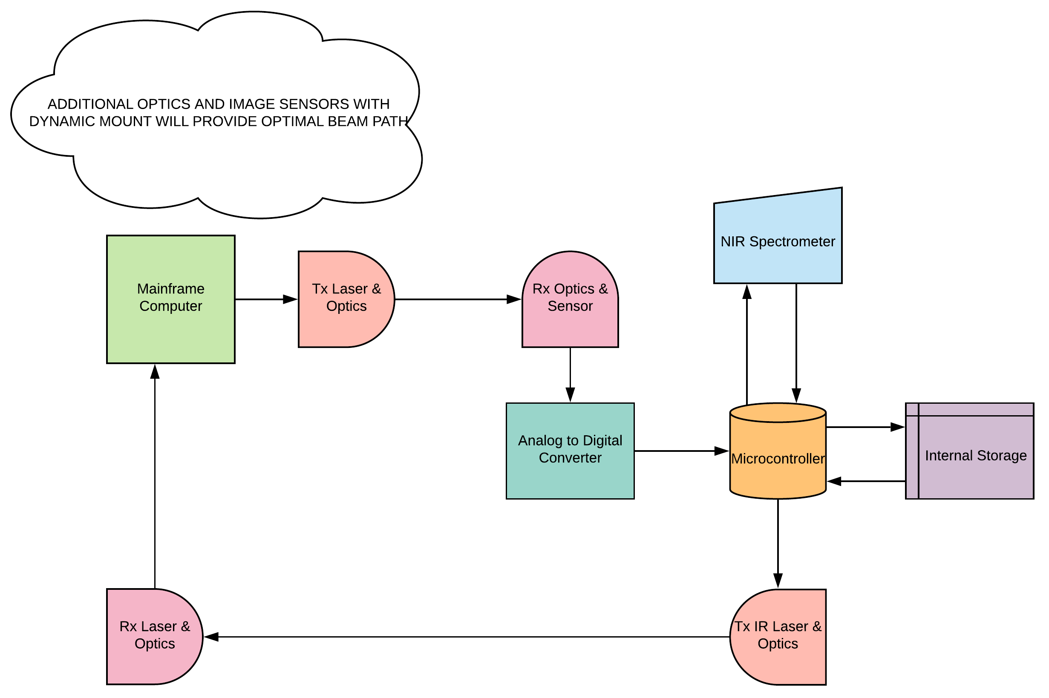

ESTIMATE PROJECT BUDGET AND FINANCING

In the chart below, we created a list of the possible parts we may need for this project, the amount of each part we may need, and the price of each individual part.

|  |  |  |
| --- | --- | --- |
| Project Budget | | |
| Component | **Quantity** | **Price** |
| Microcontroller | 1 | $40 |
| PCB | 2 | $80 |
| Sensor | 2 | $40 |
| Battery | 1 | $50 |
| Light Sources | 3 | $15 |
| Cables | 1 | $30 |
| Analog to Digital Converter | 1 | $20 |
| Total: $275 | | |

INITIAL PROJECT MILESTONE FOR BOTH SEMESTERS

|  |  |  |
| --- | --- | --- |
| Task | Time needed | Dates |
| Senior Design 1 | | |
| Develop Project Idea | 2 weeks | 8/20-9/2 |
| Submit Proposal | 1 week | 9/7-9/14 |
| Review Existing Projects | 2 weeks | 9/2-9/14 |
| Update Proposal | 1 week | 9/20-9/28 |
| First Draft | 7 weeks | 9/14-11/2 |
| Final Draft | 12 weeks | 9/14-12/3 |
| Research PCB | 1 weeks | 9/28-10/5 |
| Research Microcontrollers | 1 weeks | 10/5-10/12 |
| Research SolidWorks | 1 week | 10/12-10/19 |
| Research Wi-Fi | 1 week | 10/19-10/26 |
| Research Sensors | 1 week | 10/26-11/2 |
| Research Lasers | 1 week | 11/2-11/9 |
| Research Optics | 1 week | 11/9-11/16 |
| Research Light Sources | 1 week | 11/16-11/23 |
| Order Parts | 3 weeks | 12/3-12/24 |
| Build Prototype | TBD | TBD |
| Senior Design 2 | | |
| Test Prototype | TBD | TBD |
| Finalize Report | TBD | TBD |
| Finalize Presentation | TBD | TBD |
| Finalize Project | TBD | TBD |