Student API (PHP + MySQL)

A lightweight, schema-validated REST API for managing student records.
Supports JSON and XML responses, includes JSON Schema validation, and is fully testable via Postman.

Features
- Create, read, update, and delete (CRUD) student records
- Input validation using custom JSON Schema validator
- Prevention of duplicate student_id and rfid_uid
- Standardized JSON & XML responses
- Clean modular structure (schemas, utils, student endpoints)
- Fully compatible with Postman for testing
- Local and server-ready version

Folder Structure
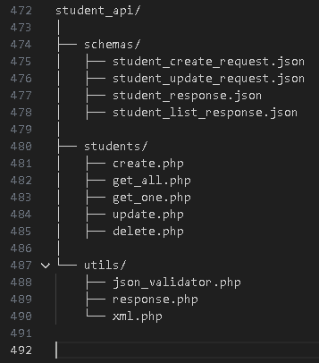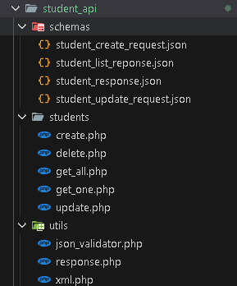

Requirements
- PHP 8+
- MySQL / MariaDB
- Apache / Nginx
- Postman (optional for testing)
- config/db_connection.php with your DB credentials
Example DB connection file:
<?php
$conn = new mysqli("localhost", "root", "", "your_database");
?>

Database Structure

Required table: student
CREATE TABLE student (
id INT AUTO_INCREMENT PRIMARY KEY,
student_id VARCHAR(50) NOT NULL,
full_name VARCHAR(255) NOT NULL,
course VARCHAR(100) NOT NULL,
year_level VARCHAR(50) NOT NULL,
rfid_uid VARCHAR(100) DEFAULT NULL,
created_at TIMESTAMP DEFAULT CURRENT_TIMESTAMP
);

API Endpoints

1. Create Student
POST /students/create.php
Body (JSON)
{
"student_id": "2025-001",
"full_name": "John Doe",
"course": "BSIT",
"year_level": "3",
"rfid_uid": "RFID12345"
}
Success Response
{
"status": "success",
"data": {
"id": 1,
"student_id": "2025-001",
"full_name": "John Doe",
"course": "BSIT",
"year_level": "3",
"rfid_uid": "RFID12345",
"created_at": "2025-01-01 10:00:00"
}
}

2. Get All Students
GET /students/get_all.php
Success Response
{
"status": "success",
"data": [
{
"id": 1,
"student_id": "2025-001",
"full_name": "John Doe",
"course": "BSIT",
"year_level": "3",
"rfid_uid": "RFID12345",
"created_at": "2025-01-01 10:00:00"
}
]
}

3. Get Single Student
GET /students/get_one.php?id=1
Success Response
{
"status": "success",
"data": {
"id": 1,
"student_id": "2025-001",
"full_name": "John Doe",
"course": "BSIT",
"year_level": "3",
"rfid_uid": "RFID12345",
"created_at": "2025-01-01 10:00:00"
}
}

4. Update Student
PUT /students/update.php?id=1
Body (JSON)
{
"student_id": "2025-001",
"full_name": "John Doe Updated",
"course": "BSIT",
"year_level": "4",
"rfid_uid": "RFID12345"
}
Success
{ "status": "success", "message": "Student updated" }

5. Delete Student
DELETE /students/delete.php?id=1
Success
{ "status": "success", "message": "Student deleted" }

JSON Schema Validation
All request bodies are validated using custom schemas from /schemas.
Examples include:

student_create_request.json
- Required: student_id, full_name, course, year_level
- Optional: rfid_uid
- Disallows additional properties

student_response.json
Defines how every student should look when returned from the API.

JSON & XML Support

The API automatically checks the Accept header:
Accept Header | Response Format
application/json | JSON
application/xml | XML

Example
Accept: application/xml

Testing With Postman
- Set request URL (e.g., http://localhost/student_api/students/create.php)
- Set method (POST/GET/PUT/DELETE)
- For POST/PUT: choose Body → Raw → JSON
- Add headers:
Content-Type: application/json
Accept: application/json

Deployment Notes
- This API works locally and on hosted servers
- Make sure the database credentials in db_connection.php match your hosting environment
- Set correct permissions for the PHP folders

