Bulgarian Diploma Thesis

Big Break! - Java Film Script Breakdown Tool

Vili-An Atanasova Doneva, 200200140

Student: Vili-An Atanasova Doneva, Date _________
signature

Supervisor: ____________________, Date _________
signature

Department of Computer Science, AUBG
Blagoevgrad, 2025

Declaration template for Senior Project and Diploma Thesis

Title: Big Break! - Java Film Script Breakdown Tool
Author: Vili-An Atanasova Doneva
Abstract:
Big Break! is a Java tool for automating film script breakdowns using Natural Language Processing (NLP). The software requires the user to input a script draft as a .txt file. Then, it generates a script breakdown – a file including the characters, props, set dressings, etc., of each scene. The program manages to do that by creating the initial training data through a rule-based baseline - bootstrapping labels using Regex patterns, token heuristics, and restricting rules. For character names, the program trains an NER model using the Maximum Entropy learning algorithm of the Apache OpenNLP NameFinderME. For props and set dressings, Big Break! mostly relies on OpenNLP’s POS Tagger and heuristic. After training the model and obtaining all the data, Big Break! relies on alias canonicalization, which standardizes the names, props, and set dressings (e. g. Nelly V.O. to Nelly) The program performs clustering, which uses the Levenshtein distance algorithm to merge the standardized cleaned data entries that belong to the same entity (e.g. Nelly and Nelly Smith). Big Break! uses Spring Boot, which builds a REST API to connect to its React frontend.
Declaration of authorship:
“The Senior Project/Bulgarian Diploma Thesis presented here is the work of the author solely, without any external help, under the supervision of Zachary Hutchinson. All sources, used in development, are cited in the text and in the Reference section.”
Author: Vili-An Atanasova Doneva
- Introduction

The main task of a 1st Assistant Director (AD) during a film’s pre-production process is to create a new script breakdown for each draft of the script and to discuss it with all the necessary departments. A script breakdown is a file with all the scene numbers, headings, locations, times of day, characters, props, set dressings, etc. that each scene includes. Script revisions can vary from 3-4 in small productions to 15+ in big productions before the start of the shooting and even more after. This wastes a lot of time reading revised pages and trying not to miss any important details. Having an already composed, editable breakdown, such as the Big Break! software, facilitates the process. This allows the 1st AD to focus on making the Director’s vision happen rather than being stuck in front of the screen.

The Big Break! software allows the user to input a .txt film script file. It divides the script into scenes and collects all their numbers, headings, locations, and times using regular expression (Regex) patterns and rules. Everything between two headings is treated as content, which is used for the actual Natural Language Processing (NLP). All the dependencies are managed with Maven.

All character, prop, and set dressing detections start obtaining initial training data through heuristics – Regex patterns, rules for what is considered a character name, bootstrapping labels, and confidence scores. This gives a good rule-based baseline that handles obvious names/props/set dressings cases, while machine learning (ML) can later focus on more ambiguous ones. The program creates a CSV file with the heuristics entries, which is helpful for the ML training.

For characters, the next step is to do sequence labelling using the pre-trained Named Entity Recognition (NER) model. It is run by the NameFinderME class in the Apache OpenNLP, which is an open-source NLP Java toolkit. It uses the Maximum Entropy algorithm internally to predict named entities like the character names. The program trains the NameFinderME using the NameSample text format to teach the model to recognize the beginning of the name (<START: character>), the inside of the name (<END>).

For props and set dressings, the program uses Parts-Of-Speech (POS) Tagger to determine the grammatical role of each word in the script. The POS Tagger also detects patterns of grammatical roles in a sentence (e.g. verb -> determiner -> noun). This allows heuristic rules to facilitate the detection of props and set dressings. Next, a second NER model is trained with NameFinderME for props and set dressings in mostly the same manner as characters.

For all three categories, the program performs clustering and alias canonicalization. Canonicalization standardizes the data by removing parentheticals and normalizes titles and maps the different entries together under one canonical name through heuristics. Clustering groups together all the character names or objects that belong to the same entity using the Levenshtein distance algorithm.

Big Break! uses the Term Frequency-Inverse Document Frequency (TF-IDF) algorithm and Cosine Similarity algorithm to group scenes by different similarities.

The program uses Spring Boot to connect through a REST API to the React frontend. Having the visual aspect of Big Break! would allow the user to easily interact with the software without burdening them with heavily technical processes.

The reason why I chose to pursue Big Break! as my senior project is majorly connected to my interest in film and my belief that technology can save time. The most prominent lesson I learned during my time in the film studio is that time and money are closely connected in a film production. Works like mine can help large films save time, money, and focus on the creative aspects of moviemaking.

- Specification of the Software Requirements and their Analysis

Functional Requirements

- The user will be able to choose only a .txt file.

- The user will be able to view each scene breakdown separately.

- The user will be able to view each scene number, heading, location, and time of day (if available).

- The system will be able to detect props and set dressings based on heuristic rules working with grammatical roles.

- The system will be able to train an NER model using Apache OpenNLP NameFinderMe to detect characters, props, and set dressings.

- The user will be able to view characters, props, and set dressings for each scene.

- The user will be able to sort the scenes based on certain similarities.

Non-Functional Requirements

- The system will be able to fall back to the rule-based extractor if the trained model is unavailable and inform the user.

- The system will allow users to edit entity labels and save changes using the UI controls.

Analysis of (Some for Now) Functional Requirements

The user will be able to view each scene number, heading, location, and time of day (if available).

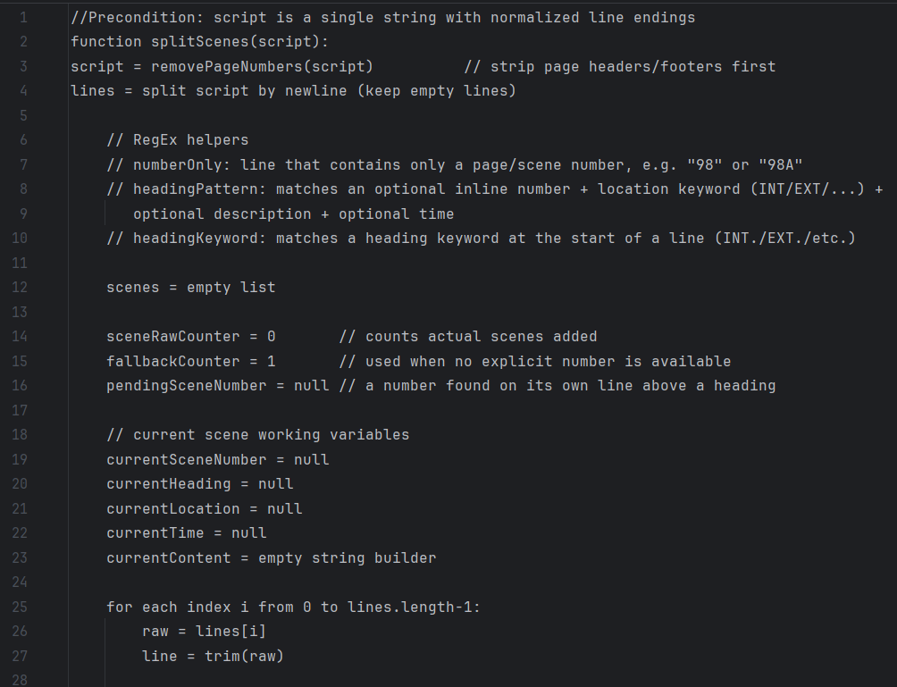
The extraction of the scene numbers, headings, locations, and times of day happens in the ScriptParser.java file, which separates all script scenes. It uses helper methods - loadScript (String filePath) to access the script .txt file and to normalize spaces and breaks, and removePageNumbers (String script) to remove page headers/footers and obvious page numbers. The primary method is List <Scene> splitScenes(String script). It calls all the other two methods, splits the scenes and returns a list of all scenes, filling up the Scene class constructor with scene order number (the actual number of the scene in the order they appear), scene script numbers (the scene number written in the script), headings, locations, and times (if available). In order to find the values, it uses Regex patterns and rules depending on the different types of headings – scene number on a separate line or a scene number inline with the heading. Here is a pseudocode explanation of the Regex patterns:
Figure 1: Explanation of the Regex patterns in splitScenes (String script)

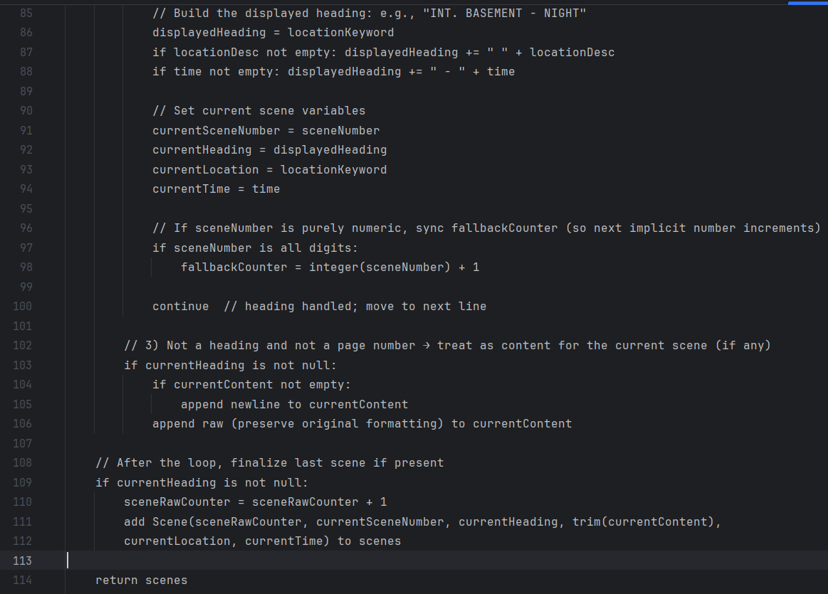
Pseudocode of adding a scene with the Scene constructor, incrementing the scene order number, and returning all the scenes:
Figure 2: Pseudocode of adding a scene and returning all the scenes
Later, all the obtained values (possibly, besides the scene order number) will be displayed in the UI.

The system will be able to detect props and set dressings based on heuristic rules working with grammatical roles.

The POS Tagger of Apache OpenNLP automatically determines grammatical roles. It once again uses the Maximum Entropy algorithm internally, e. g.:
String[] sentence = {“Elphaba”, “looked”, “in”, “the”, “mirror”, “.”};
String[] tags = posTagger.tag (sentence);
Result:
Elphaba/NNP (proper noun) looked/VBD (verb) in/IN (preposition) the/DT (determiner) mirror/NN (noun) ./.
After having the grammatical data, the software uses it as input to the heuristic rules that determine whether a noun is a prop or a set dressing. For example, if the noun is preceded by a manipulation verb (grab, pick up, take, etc.), then it is most probably a prop. However, if the previous word is a preposition (on, in, behind, etc.), then the noun is most probably part of the set dressing category. Adding a NameFinderMe NER model here will improve the performance further.

The system will be able to train an NER model using Apache OpenNLP NameFinderMe to detect characters, props, and set dressings.

For props and set dressings’ initial pre-processing, the system performs the steps from the previous requirement – POS Tagger and heuristic rules. For characters, the system initially also uses heuristics such as Regex patterns and rules about the number of uppercase tokens in the line compared to all and positions of cue-looking lines.
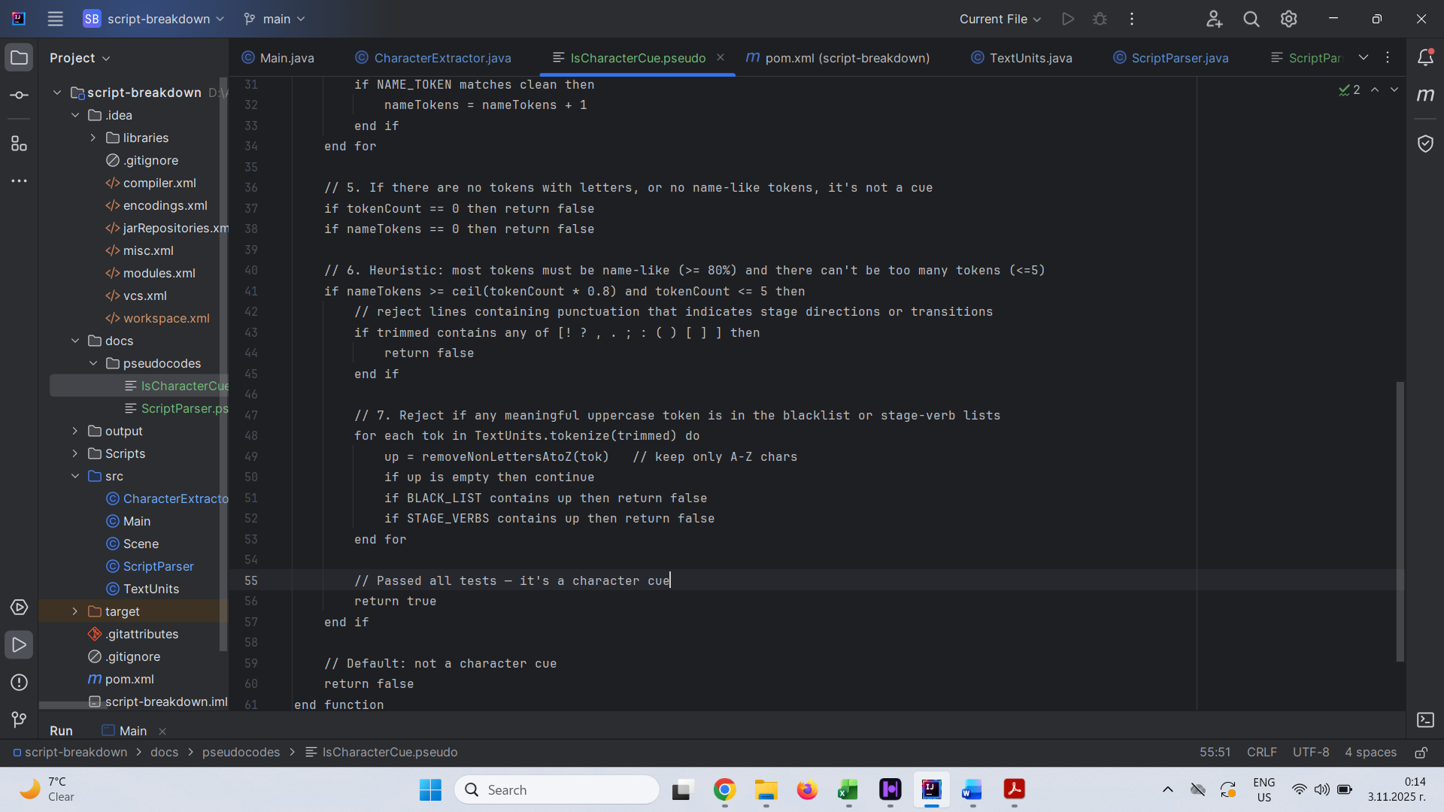
Pseudocode for part of isCharacterCue(String line) method that is mainly responsible for obtaining characters on the initial heuristics side:
Figure 3: Pseudocode for isCharacterCue (string line)

The pseudocode shows the main checks of whether the name tokens are at least 80% of all tokens in the line and whether the token count is less than or equal to five, so it could be considered a character cue line. In step 7 in Figure 3, the software ensures that each token in the line is not part of the BLACK_LIST or STAGE_VERB words. BLACK_LIST contains frequent movie sounds, movie slang, and non-name words such as are, in, a/an, etc. The STAGE_VERB set relates to words for camera movement that can be included in the original script.

The software saves the results of the pre-processing rules in a .train format file. NameSample text formatting will be added to the CharacterExtraction class so that the manual review after would edit the inaccurate <START:CHAR> / <END> tags. The tokenized sentence will be saved in the .train file. For clarity, here is an example of the NameSample format:
Her friend <START:CHAR> BOBBY <END> enters the room.

Next, NameFinderME is trained using most of the sentences of the .train file. Some of them are added to holdout files, which keep tokenized sentences for the evaluation of the model’s performance. The NameFinderME uses training parameters such as iterations and cutoff. The iteration value refers to the number of times the Maximum Entropy algorithm goes through the training data to evaluate its internal weights. The cutoff relates to the minimum number of times a feature (capitalization pattern, token sequence (e.g., neighboring tokens), grammatical role) shall appear to be used by the model.

NameFinderME also uses TokenNameFinderFactory to process these features by building configuration objects and feature generator chains. TokenNameFinderFactory is additionally used to convert the annotated NameSample tokens into numerical values for the machine learning algorithm to understand.

Moreover, NameFinderME uses TokenNameFinderEvaluator to measure the performance of the model on the holdout files. FMeasure gives precision, recall, and F1. Precision gives the ratio of the actual correct prediction to the total positives the model predicted:

$$Precision= \frac{True Positive}{True Positives+False Positive}$$

The recall value gives the ratio of the correct predictions to all predictions that should have come out positive:

$$Recall= \frac{True Positive}{True Positives+False Negatives}$$

The F1 score relates to the overall reliability of the system’s recognition. It represents a balance between precision and recall. It finds most entities, and they are mostly correct:

$$F1=2 × \frac{Precision ×Recall}{Precision+Recall}$$

Design of the Software Solution

Algorithms

Levenshtein (Edit) Distance
The Levenshtein (edit) distance algorithm measures the difference between two character sequences. In the program, the algorithm helps perform clustering of similar names, props, or set dressings together that likely refer to the same character or object. The algorithm processes the minimum number of changes needed to turn one string into another. The edits can be:
- Insertion (adding a character): “CAT” -> “COATS”
  - Distance = 2
- Deletion (deleting a character): “SARAH” -> “SARA”
  - Distance = 1
- Substitution (replacing a character): “MONEY” -> “HATER”
  - Distance = 4

Thresholds can be applied so the algorithm can cluster words with custom distances as part of the same group or exclude them. Here is the pseudocode of the most essential step of the Levenshtein distance algorithm – filling the matrix:
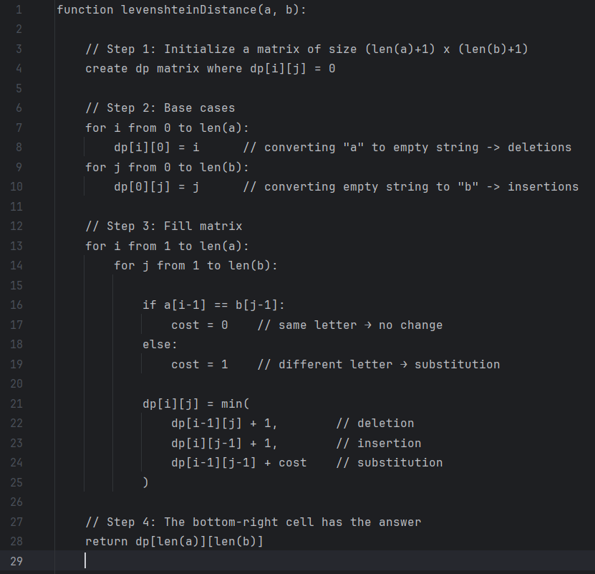
Figure 4: Pseudocode of the Levenshtein distance algorithm

To explain this piece of code, a is the sequence of characters for the string that the system is going to turn into the sequence of characters for the b string. So, the code starts by checking if the two currently compared characters are the same (lines 16-19). If the letters are the same, the cost of the change variable is 0. Similarly, if the letters are different, the change is 0. This variable is used only for substitution.
Table 1: Levenshtein distance algorithm example matrix
 | “” | C | A | T
“” | 0 | 1 | 2 | 3
C | 1 | 0 | 1 | 2
A | 2 | 1 | 1 | 2
T | 3 | 2 | 2 | 1

In the next few lines (21-25), the algorithm calculates dp corresponding to which operation – deletion, insertion, or substitution - would require the least number of edits. For deletion, the algorithm uses $dp[i-1][j] + 1$. This presents the option of deleting the current character of a – $[i-1]$ which leaves the system having to turn the sequence of characters up to $[i-1]$ in a to the sequence up to $[j]$ in b. The algorithm gets the value of the position above the current and adds cost 1 for the deletion.

The insertion in the algorithm follows similar logic – $dp[i][j-1] + 1$. The system needs to insert into the sequence of characters up to $a[i]$, the last character of the other string, which is $b[j]$. The algorithm removes the last character from b as a preparation to insert it into the a sequence – $[i][j-1]$. Finally, it adds one for the cost of insertion, which makes $dp[i][j-1] + 1$ the insertion formula.

Substitution follows the following formula using the cost variable previously mentioned - $dp[i-1][j-1] + cost$. It evaluates the cost to match a up to $[i-1]$ to b up to $[j-1]$. After, it adds the cost of turning $a[i]$into $b[j]$ that was evaluated in lines 16-19 of Figure 4.

For example, if comparing CAT and CUT as in Table 1, here are the values of the first letters’ comparison (“C” -> “C”):
Deletion: $dp\left[i-1\right]\left[j\right]+ 1=dp\left[1-1\right]\left[1\right]+1=dp\left[0\right]\left[1\right]+1=1+1=2$
Insertion: $dp\left[i\right]\left[j-1\right]+ 1=dp\left[1\right]\left[1-1\right]+1=dp\left[1\right]\left[0\right]+1=1+1=2$
Substitution: $dp\left[i-1\right]\left[j-1\right]+ cost=dp\left[1-1\right]\left[1-1\right]+0=dp\left[0\right]\left[0\right]+0=0+0=0$
The final “C” -> “C” distance: $dp\left[i\right]\left[j\right]=\min\left(2, 2, 0\right)=0$

All other character sequences are compared in the same manner. The last cell of the matrix table (can be seen in Table 1) represents the minimal number of edits needed to turn the entire sequence a to b. The algorithm has already explored all the different paths to determine each value of the matrix as the minimal edit cost. This makes the last value a product of all the minimal edits, resulting in having the ultimate value of the matrix as the total distance of changing a into b.

Jaro-Winkler similarity
Jaro-Winkler is an algorithm for measuring the similarity of two strings – character names. It considers the common letters and whether they fit in the same position in both words or not. Also, it boosts similarity if both strings have the same prefix up to a defined maximum length. The Jaro-Winkler output varies between 0 (completely different strings) and 1 (equal strings). It is based on the Jaro similarity algorithm, including the Winkler prefix adjustment. The time complexity of the algorithm is O (N * M), where N is the length of one string, and M is the length of the other.

The algorithm starts with lowercasing both of the strings, so they are easily comparable. It checks if the strings match completely and returns 1. However, in most cases, the algorithm continues. In order for the letters to match, they need to be in a similar position in both strings. This is why the algorithm calculates the maximum distance two characters (s1 and s2) could be apart, and still be considered a match:
$$matchDistance=\left\lfloor \frac{max(\left|s1\right|, \left|s2\right|)}{2}\right\rfloor - 1$$
To store the letter matches for both strings, two arrays are set. First, the algorithm loops through the characters of the first string. It sets the start and the end of the search in the other string:
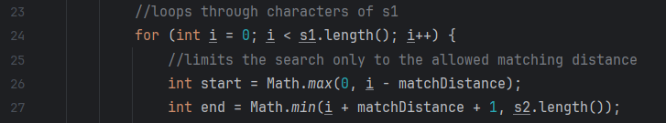
On line 26, for the start, it chooses the maximum value from 0 and the match distance subtracted from the current value. The end of the search is the minimum length of the second string and the current position, added to the match distance plus 1 (so it is included in the search).
Figure 5: Start and End Regarding the Match Distance

The second loop is to iterate through the second string. It checks if the character is already matched and if it is the same character. If true, the arrays are updated to record the match.

The characters which are not matched but not in the same position in both words are called transpositions. To find them, a new loop iterates through the first string. It skips if the character is not matched. If the match exists, it searches for another matched string in the other boolean array. If the characters are not the same, then the transposition count increases.

In order to find the Jaro similarity, the following formula is used:
$$\frac{1}{3}(\frac{m}{\left|s1\right|} + \frac{m}{\left|s2\right|} + \frac{m - t}{m})$$
- m is the number of all matching characters.
- t is half of the number of transpositions
- $\left|s1\right|$ and $\left|s2\right|$ are the lengths of both strings.
Then, the algorithm considers the prefix. A counter is set for the prefix letters that match both characters. Then, we loop through the first 4 characters or the shorter string if it contains fewer than 4 letters. Every time a match is made, the counter is increased.

This leads to the Jaro-Winkler similarity calculation:
$$SW = SJ + P * L * (1 - SJ)$$
- SW is the Jaro-Winkler similarity.
- SJ is the Jaro similarity.
- P is the scaling factor (0.1 by default).
- L is the length of the matching prefix, which should be up to a maximum of 4 characters.

Inheritance
I have planned to implement inheritance of an ExtractableItem parent class and Character, Prop, and SetDressing as children classes sharing a lot of similar data and methods. Here is a very basic visual of their relationship (Figure 11):
Figure 11: Inheritance

Pipeline
The pipeline in Big Break! represents the flow of data and processing stages from the raw script into structured information for all scenes, characters, props, and set dressing. Here are all the stages, summarizing their input, process, and output:
№ | Stage | Input | Process | Output
1 | Input | .txt script | Clean + normalize | Raw text
2 | Scene Split | Raw text | Regex parsing | List of scenes
3 | Extraction | Scene text | NER + heuristics | Items (characters, props, set dressings)
4 | Canonicalization | Raw items | Merge duplicates | Unified items
5 | Clustering | Item features | Similarity grouping | Entity clusters
6 | Output | Data model | Export / visualize | UI
Table 3: Pipeline
- Implementation

Why use Java?

The programming language I chose for the project is Java because it integrates Apache OpenNLP well as Apache is native to Java. It provides a lot pre-built models and tools for complicated or tiresome cases.

Java has a strong object-oriented design and has a class-based OOP structure. This helps with clean encapsulation for components like clustering, scene parsing, and NER. It also allows the use of interfaces and abstract classes.

Java runs faster than most of the interpreted languages for processing of large amount of text. It compiles to bytecode and runs on the JVM allowing for larger film scripts to be processed in a timely manner.

External frameworks / libraries

- Apache OpenNLP
Big Break! uses Apache OpenNLP for tokenization, POS tagging, and NER training API. However, it allows the exploration of intricate algorithms (such as the Levenshtein distance algorithm, TF-IDF, and the Cosine similarity algorithm), build heuristics on top of it, and train custom models (for the props and the set dressings).

What is more, it integrates very well with a Java + Maven project. As previously discussed, OpenNLP is Java-native and this provides stable, production-ready implementations for low-lever tasks. Having a standard library, decreases variability of homegrown tokenizers/taggers.

- React
Big Break! uses React for its frontend. One of the reasons is that React’s component model (buttons, lists, token-highlighters) can map directly the needed UI pieces.

React state + controlled components can show model prediction. They can also highlight low-confidence candidates, and allow the user to accept, edit, and delete.

React allows for clean separation between the frontend and the backend. React talks to it through REST endpoints. This helps Big Break! create a modern full-stack architecture.

- References

Carter. “Levenshtein Distance Explained.” YouTube, YouTube, 26 Jan. 2025, www.youtube.com/watch?v=eneSE4vVAOs.
“Class Levenshteindistance.” LevenshteinDistance (Apache Commons Text 1.14.0 API), commons.apache.org/proper/commons-text/apidocs/org/apache/commons/text/similarity/LevenshteinDistance.htm
codebasics. “Text Representation Using TF-IDF: NLP Tutorial For Beginners - S2 E6.” YouTube, YouTube, 17 Aug. 2022, www.youtube.com/watch?v=ATK6fm3cYfI.
Jurafsky, Dan, and James H. Martin. Speech and Language Processing an Introduction to Natural Language Processing, Computational Linguistics, and Speech Recognition with Language Models Daniel Jurafsky, James H. Martin. 3rd ed., Stanford University, 2025.
Starmer, Josh. “Cosine Similarity, Clearly Explained!!!” YouTube, YouTube, 30 Jan. 2023, www.youtube.com/watch?v=e9U0QAFbfLI.
Explain each aspect better
Explain exactly why pieces of pseudocode are there
Trie search algorithm
Linear search to compare
Object file names maybe

Scripts
List of user to check
Diagrams what uses what

Old woman filter

