





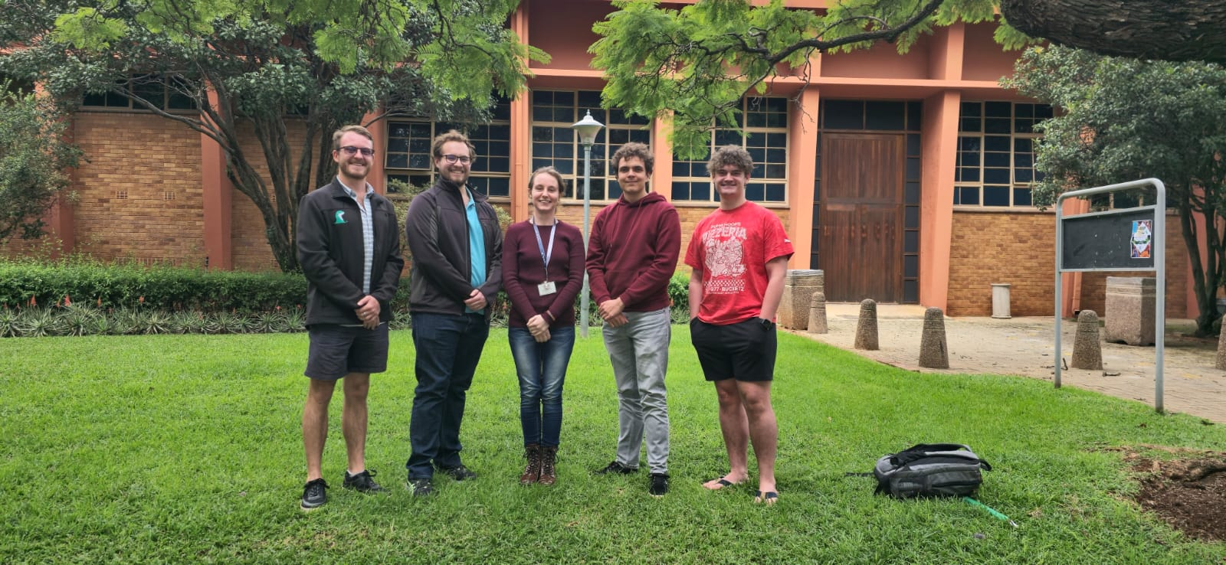

SuperLap Racing Line Optimization System
EPI-USE
Quintessential
Amber Ann Werner [u21457752]
Milan Kruger [u04948123]
Qwinton Knocklein [u21669849]
Sean van der Merwe [u22583387]
Simon van der Merwe [u04576617]

Testing Policy

Testing Scope & Levels
Level | Focus | Tools/Methods
Unit Testing | Individual functions (e.g: track image processing, RL reward function). | Pytest (Python), JUnit (Java).
Integration Testing | Interaction between services (e.g: track processor → RL engine). | Postman, Jest (API tests), Selenium (UI flows).
System Testing | End-to-end workflows (e.g: upload image → simulate → visualize). | Cypress, Robot Framework.
Performance Testing | Scalability (e.g: 50 concurrent users), RL training speed. | Locust (load testing), NVIDIA Nsight (GPU profiling).
Security Testing | Data encryption, auth vulnerabilities. | OWASP ZAP, SonarQube.
User Acceptance (UAT) | Real-world usability (by target users). | Beta releases, A/B testing.

Testing Types & Frequency
Test Type | Description | Frequency
Automated Regression | Validate existing features after updates. | On every Git commit (CI/CD).
Manual Exploratory | Unscripted UX/edge-case testing. | Before major releases.
Physics Validation | Compare AI racing lines against known heuristics (e.g: apex accuracy). | Per RL model update.
Hardware Compatibility | GPU/CPU performance benchmarks. | Quarterly.

Entry & Exit Criteria
Entry Criteria (Tests Start When):
- Requirements are documented (e.g: FR/NFRs).
- Code is merged to the test branch.
- Test environment mirrors production (GPU-enabled).
Exit Criteria (Tests Pass When):
- Unit/Integration: ≥90% code coverage (measured via Coveralls).
- Performance: <2s response time for track processing; RL training FPS ≥30.
- Security: Zero critical OWASP vulnerabilities.
- UAT: ≥80% positive feedback from beta testers.

Defect Management
- Severity Levels:
  - Critical (Crash/data loss): Fixed within 24h.
  - Major (Feature failure): Fixed in next sprint.
  - Minor (UI glitch): Backlogged for prioritization.
- Tracking: Jira/Linear with labels (bug, reproducible, blocker).

Environments
Environment | Purpose | Access
Development | Feature development. | Engineers only.
Staging | Pre-production (mirrors prod). | QA/Product Team.
Production | Live user-facing system. | Automated deployments only.

Test Data Management
- Realistic Datasets:
  - 10+ sample tracks (F1, MotoGP circuits).
  - Synthetic data from racing sims (Assetto Corsa).
- Anonymization: User-uploaded tracks scrubbed of metadata.

Compliance & Reporting
- Audits: Monthly test coverage/review meetings.
- Reports: Dashboards for:
  - Test pass/fail rates.
  - Performance trends (e.g: lap time prediction accuracy).

Policy Exceptions
- Emergency Fixes: Hotfixes may bypass some tests but require:
  - Post-deployment regression testing.
  - Retrospective review.

