





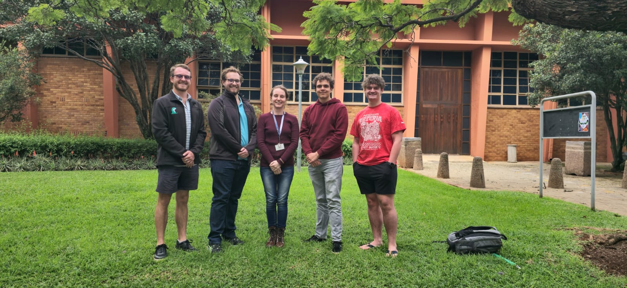

SuperLap Racing Line Optimization System
EPI-USE
Quintessential
Amber Ann Werner [u21457752]
Milan Kruger [u04948123]
Qwinton Knocklein [u21669849]
Sean van der Merwe [u22583387]
Simon van der Merwe [u04576617]

User Manual
[Needs to be created]

