USER MANUAL

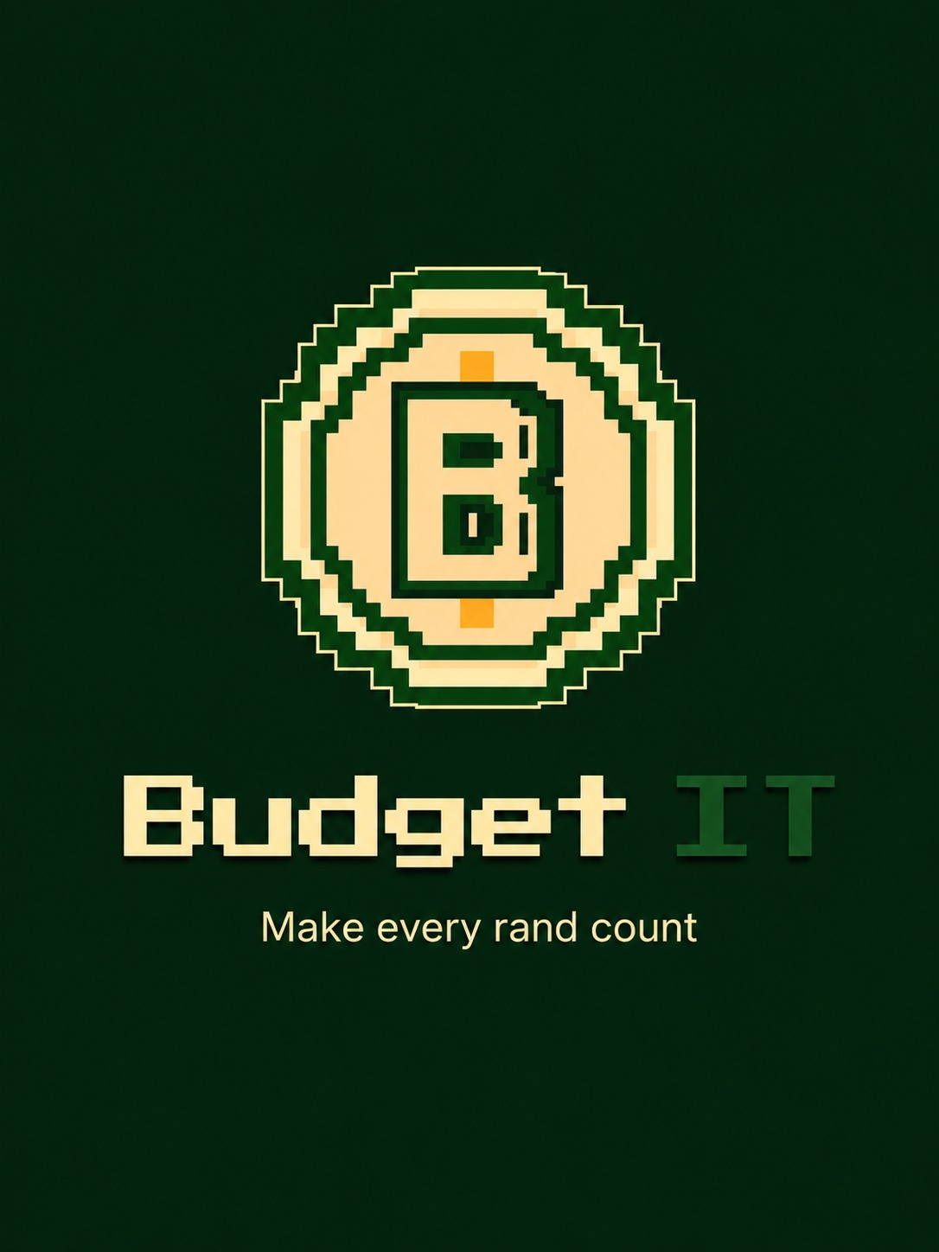by Dev OOPs
Version 1.1 | 30 September 2026
Budget IT is a mobile budgeting application for recording income/expenses, organising spending into budgets, importing bank statements, and aiming to help you understand your financial activity through reports and insights.
1. Getting started
Install the application using our apk link on our landing page[https://github.com/COS301-SE-2026/Mobile-Budgeting-App/deployments/github-pages]. On first launch, Budget IT opens the account access screen.
Recommended first-use sequence:
- Open Budget IT.
- Choose Login, Register, or Continue as Guest.
- Explore the Dashboard, Transaction Manager, and Budget Manager using the bottom navigation.
- Add your opening income and recent expenses, or import a supported bank statement.
- Create category budgets that match the way you plan to spend.
6. Create expense categories and budgets that match how you plan to spend.
7. Create a savings goal if you want to set money aside.
8. Return to the Dashboard and reports after adding enough data to see useful trends.
2. Account access and security
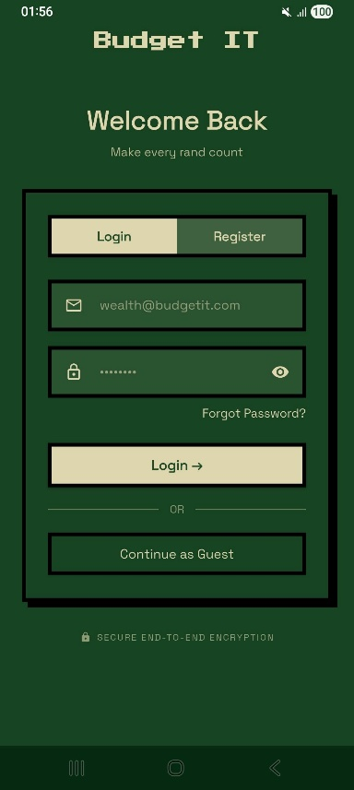
Register
- Open the Register tab.
- Enter your email address.
- Enter a password of at least eight characters and confirm it.
- Tap Register.
- Enter the six-digit verification code sent to your email address.
- Return to Login and sign in.
Log in
- Open the Login tab.
- Enter your email address and password.
- Tap Login.
Reset a forgotten password
- Tap Forgot? on the Login tab.
- Enter your email address and request a reset code.
- Enter the six-digit code.
- Choose and confirm a new password.
- Return to Login and use the new password.
Continue as Guest
Tap Continue as Guest to open the app without completing authentication.
Enable biometric locking

On a supported Android device, Budget IT can require fingerprint, face, or another device biometric when the app is reopened.

1. Accept the biometric prompt after a successful registration or login, or open Settings .
2. Find Biometric Lock under Security.
3. Tap the control to switch it on or off.
4. Complete the device authentication prompt when requested.

Biometric locking is available only when the device supports biometrics and has them configured. It does not replace the account password.

3. Navigate the app
Top Bar

Control | Purpose
Question mark | Open the Help Menu.
Sun or moon | Switch between light and dark mode.
Person | Open the Profile page.
Settings | Open the Settings page.

Bottom Navbar

Control | Purpose
Home | Open the Dashboard.
Money | Open Transaction Manager.
Pie chart | Open Budget Manager.
People | Opens friends page.

Use the bordered back-arrow button on secondary pages to return to the previous page.

4. Understand the Dashboard
The Dashboard provides a quick overview of your financial position. It becomes more useful as you record more transactions.
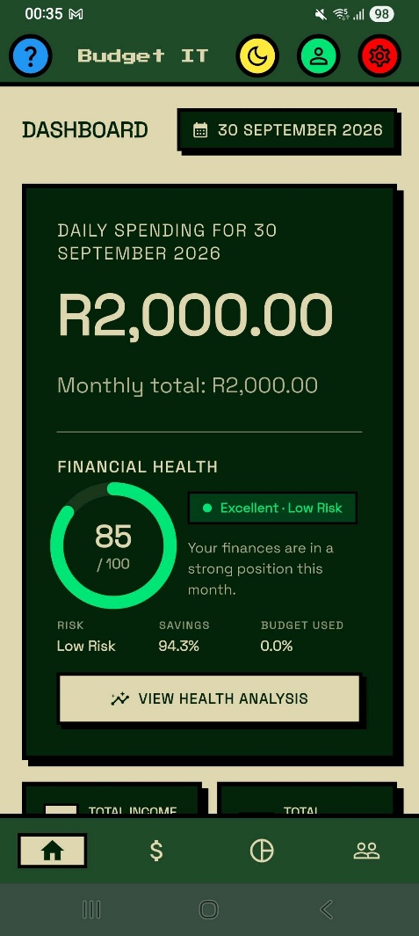
To use the Dashboard:
- Tap the Home icon.
- Review the balance and summary cards.
- Use the Dashboard date control to inspect another date where available.
- Scroll through graphical summaries, insights, predictions, and recent transactions.
- Tap an available report or insight action to open its detailed screen.Tap an available report or insight action to open its detail screen.
The Dashboard provides a quick view of your financial position. Its content becomes more useful as you record more transactions.

Dashboard information includes:
- Current balance based on recorded income and expenses.
- Quick statistics and spending summaries.
- Monthly spending trends.
- Financial insights and a financial health score.
- Predictive spending information when enough history is available.
- Recent transactions.
Not enough data? Some predictions and trends require a transaction history. Add or import transactions and revisit the Dashboard later.

5. Manage transactions
Open Transaction Manager by tapping the dollar sign icon.
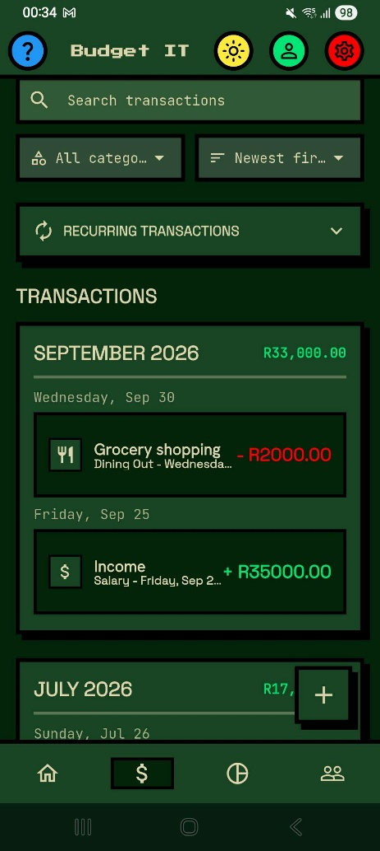

Add a transaction
- Tap the plus button at the bottom of Transaction Manager.
- Choose Add Transaction.
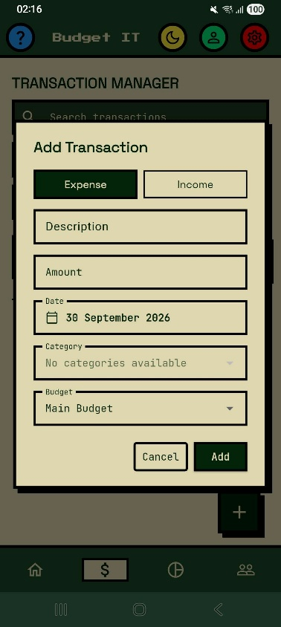
3. Select Income or Expense .
4. Enter a description and amount.
5. Select the date and category.
6. Select a budget if the transaction should belong to one.
7. Tap Add to save.
Field | What to enter
Description | A recognisable name such as Salary, Rent, or Groceries.
Amount | The transaction value.
Type | Income or expense.
Date | The date on which the transaction occurred.
Category | The category used for budgets and reports.
Budget | The budget to which the transaction should contribute, where applicable.

Search for a transaction
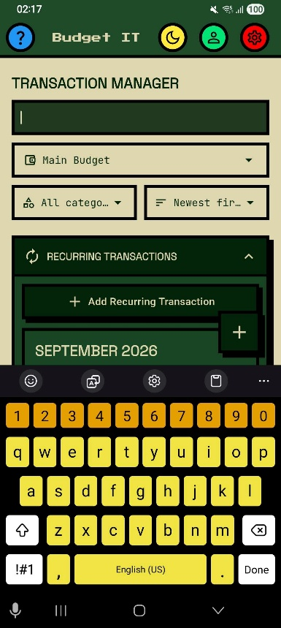
Type part of a description into Search for Transaction. Clear the search field to restore the full list.
Search, filter, and sort
- Type part of a transaction description or category into the search field.
- Use the budget dropdown to show All budgets or one selected budget.
- Use the category filter to show all categories or a particular category.
- Sort by newest, oldest, highest amount, lowest amount, or name.
- Active filters are highlighted. Return the controls to their All or default options to restore the full list.
Edit or delete a transaction
- Select the transaction you want to change.
- Update its available details and save.
- To remove it, click the red coloured dustbin icon and confirm the prompt.

NOTE : Expense transactions assigned to a budget category contribute to that budget's spent amount and report totals.

- Recurring transactions
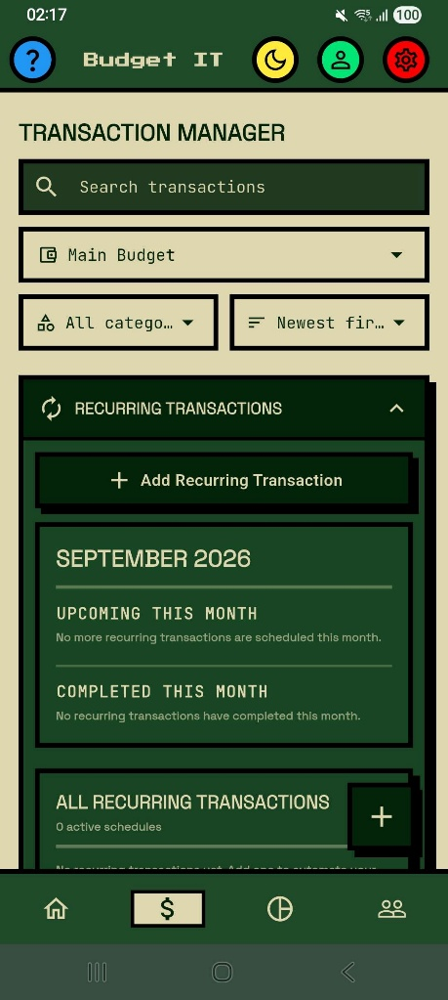
Recurring transactions are templates for entries that repeat on a schedule.

Create a recurring transaction
- Open Transaction Manager and expand the recurring transactions area.
- Choose the option to add a recurring transaction.
- Enter the description, amount, type, category, start date, and recurrence information requested by the form.

- Save the recurring transaction.
Note: Budget IT checks for due recurring items when the app starts. If the app was closed when an occurrence became due, that occurrence is created the next time the app opens. A monthly transaction scheduled for the 31st uses the last valid day in shorter months and returns to the 31st when possible.
Tap an existing recurring transaction to edit it. Deleting a recurring template stops future occurrences but does not remove transactions already created from it.

7. Import a bank statement
Budget IT can read supported PDF and CSV statement files and present detected transactions for review.
1. Open Transaction Manager and tap the floating plus button.
2. Choose Import Statement .
3. Tap Upload a statement and select a PDF or CSV file.
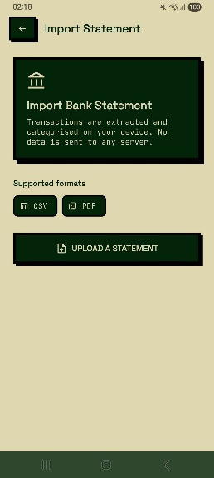
4. Wait while Budget IT reads the file and detects its layout.
5. If asked how the bank marks income and expenses, review the examples and select the rule that makes the previews correct.
6. On Review Transactions , inspect New Transactions and Possible Duplicates.
7. Tap a transaction to correct its name or select an existing app category.
8. Confirm that upward arrows represent income and downward arrows represent expenses.
9. Include or exclude possible duplicates as needed.
10. Tap Import to save the selected transactions.
11. Review the import summary and tap Done .
Understanding income and expense detection

Banks represent money in and money out differently. A statement might use:
- a `CR` suffix for income;
- negative values for expenses;
- separate debit and credit columns;
- a debit label
- positive and negative amount conventions.

Our Budget IT app may ask you to choose the correct rule when the statement is ambiguous. The transaction previews show the result before import. The selected rule can be remembered for future statements from the same bank.
Rows that may not be imported
- Existing transactions can be marked as possible duplicates.
- Opening balance, closing balance, totals, and other summary rows are ignored.
- Rows without a readable date or amount are skipped.
- A file that does not appear to contain a bank statement shows an error and is not imported.

Always review the preview. Nothing is added until you confirm the import.

Prevent duplicates: Compare Possible Duplicates with existing transactions and exclude entries that should not be imported twice.

8. Create and manage budgets
Budget Manager organises planned expense limits by category and period.
Create a budget
- Tap the pie chart icon on the bottom navbar.
- Tap the create a new budget button.
- Enter a budget name and amount.
- Select the requested period or category information.
- Tap Create.
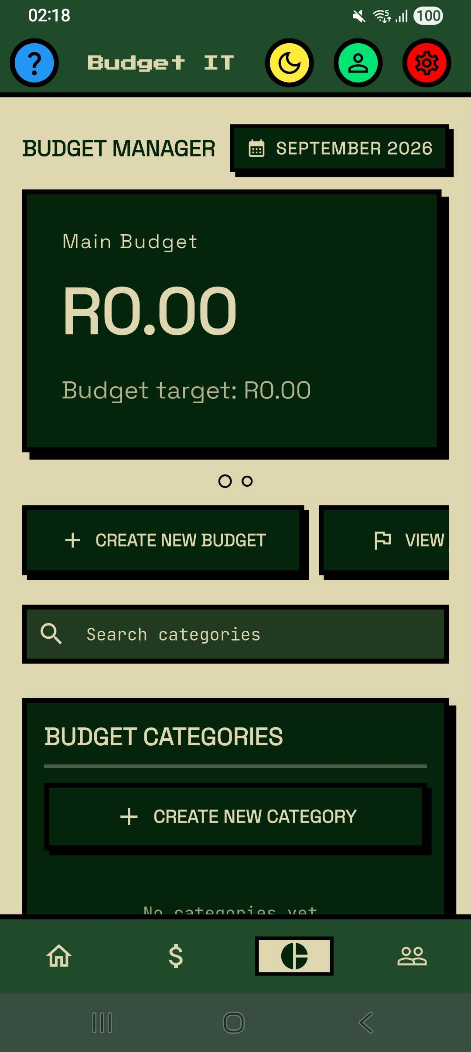

Use the main budget card

Swipe the main budget carousel when more than one budget exists. The dots below the card show the current position. Tap a main budget card to open its action menu:

- Edit Budget changes its name or limit.
- Share Budget shares it with a friend. You must add at least one friend first.
- Delete Budget removes it after confirmation.
Value | Meaning
Budget limit | The maximum amount planned for the selected period.
Spent | Qualifying expenses recorded against the category.
Remaining | The limit minus the amount spent.
Progress | A visual indication of how much of the limit has been used.

Add spending directly to a budget
- Open Budget Manager.
- Tap the required category.
- Under Quick Actions, tap Add Transaction.
- Enter the transaction details and save.
Use the budget detail actions to edit a limit or delete a budget that is no longer required.
Create and manage categories

1. Select the budget that should contain the category.
2. Tap Create New Category.
3. Enter a category name and select an icon.
4. Tap Create.

Use the edit action on a category tile to change its name or icon. Use delete and confirm the warning to remove an unused category. Category deletion can affect how existing transactions appear, so review associated transactions first.

9. Friends and sharing

Friends features require a registered, logged-in account.

Add a friend

1. Tap the people icon.
2. Copy or share the code shown under Your Friend Code.
3. To add someone, tap Add Friend by Code.
4. Enter the other person’s friend code and send the request.
5. Incoming requests appear under Requests. Tap the tick to accept or the cross to decline.
6. Accepted users appear under Your Friends.

If a request fails, check the code, your connection, and whether a request or friendship already exists.

Share a budget
1. Open Budget Manager and tap the main budget card.
2. Choose Share Budget.
3. Select an available friend and confirm.
If you have no friends, Budget IT asks you to add a friend before sharing.

10. Savings goals
Open Budget Manager and tap View / Add Goals.

Create a goal

1. Tap Create New Goal button.
2. Enter a goal name and target amount.
3. Choose its period.
4. Optionally select friends with whom to share it.
5. Tap Create.

Use the Goals filter to view progress, newest goals, or reached goals.

Allocate money
1. Tap Allocate on a goal.
2. Enter an amount up to the available surplus.
3. Confirm the allocation.

Available surplus is income minus expenses. An allocation is recorded as an expense so that the money leaves the spendable balance.

Review or reverse goal activity
Tap a goal to see its progress, members, and allocation history. Depending on the goal, you can:
- undo an allocation;
- release saved funds back as income;
- invite a friend;
- leave a shared goal; or
- review each member’s contribution.

When a member leaves a shared goal, money contributed by that member is returned to them as income.
Respond to a goal invitation
Invitations appear under Goal Invites on the Savings Goals page. Choose Join Goal to participate or Decline to reject the invitation. Members of a shared goal see the same overall progress and can contribute toward it.
10. Export financial reports
1. Open Budget Manager.
2. Swipe the action carousel to Export Report and open it.
3. Choose Export as PDF or Export as CSV .
4. Wait for the completion message.
5. Use the device’s file options to locate, open, or share the export.
PDF is suitable for reading and sharing. CSV is suitable for spreadsheet analysis. Store exported reports securely because they contain personal financial information.

Note: Reports summarise the information you entered. Check transaction dates, types, and categories if a total looks unexpected.

11. Insights and predictive spending and financial health.
Budget IT analyses transaction history to present patterns, projected spending, anomalies, and financial health information.
- Read the Dashboard insight cards for notable changes or patterns.
- Open the detailed insights screen for more information.
- Review projected spending only after enough historical data exists.
- Treat an anomaly as a prompt to inspect unusual activity, not proof that something is wrong.
- Use the financial health score and recommendations as general guidance.
The app may display Building your financial picture until enough transaction history exists.
Important: Budget IT supports personal tracking and planning. It does not replace professional financial, tax, or legal advice.

11. Switch the theme
Tap the sun or moon yellow icon. The app changes between light and dark mode immediately.
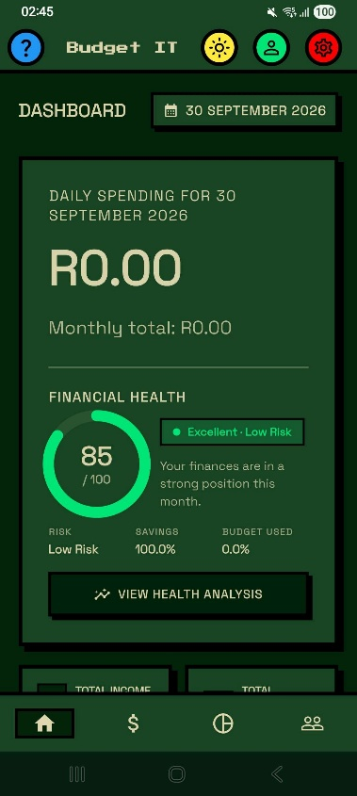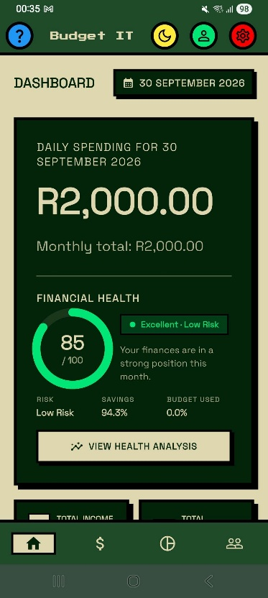
Dark mode Light mode

12. Help Menu
Tap the blue question mark icon. Expand a Quick Help item for instructions on adding a transaction, adding one to a budget, or viewing graphical reports.
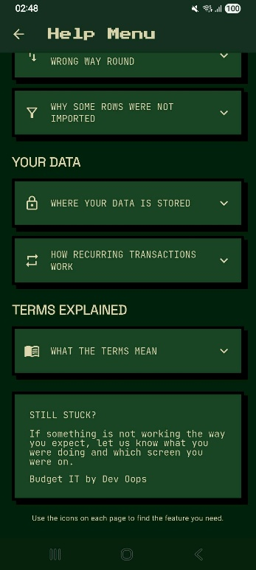
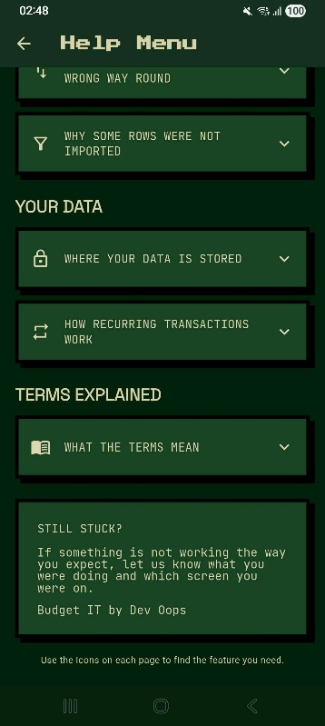

12. Privacy, data, and safe use
Budget IT stores transactions, budgets, categories, goals, and settings on the device. Statement parsing and AI category suggestions run on the device. Core budgeting, importing, and reporting can operate without an internet connection. Account, friend, and sharing features require access to their configured online services.

Signing out clears the account session but does not automatically delete financial data stored on the device.
Good practices:
- Protect your device with a passcode or a biometric lock.
- Use a unique password for your Budget IT account.
- Review imported entries before saving.
- Store exported PDF and CSV reports securely.
- Check transaction and budget totals regularly.

13. Troubleshooting
Problem | What to try
Cannot register | Complete all fields and use matching passwords of at least eight characters.
Verification code fails | Enter all six digits, use the newest code, or request another code.
Cannot log in | Check your details, complete verification, or use Forgot?.
Transaction is missing | Clear search, check its date, and confirm that add/import completed.
Budget total looks wrong | Check transaction category, amount, type, and date.
Import shows duplicates | Compare them with existing records and exclude repeated entries.
Reports are empty | Add transactions and select a period that includes their dates.
Prediction is unavailable | More history may be required; continue using the app and retry later.
Export fails | Retry and check device storage and file permissions.
Biometrics cannot be enabled | Confirm that the device supports biometrics and that a fingerprint, face, or device credential is configured.
Settings cannot be changed | Settings are still under development in the current build.

Budget IT Developed by Dev OOPs
2026

