KAIte (kīte), Teaching users to understand their relationship with generative AI

Team BlackBox
Er3te, PM / Designer
Henry Koch, Co-PM / Developer
Jaron, Developer Lead
Stephen, Co-Lead Developer
Ryan, Developer
Nick, Designer

Problem
AI makes errors, but it is hard to notice when you did not catch / correct it in its output. As generative AI continues to grow competent, it’s harder to spot errors in its output. One may not even know the errors in order to find them. Though we don’t always know what is an error. This proves even more true if it’s assumed the specific agent is correct. However, if users know the agent made an error, the user would have addressed it. If an AI tool inserted errors on purpose into its output, and asked users to find them before using the output then they would have a basis in regards to their ability to catch and fix errors for reflecting on and improving that skill. This would not only lead users to take more caution, but also provide a deeper understanding and recognition of AI and its patterns. Users need expertise about what is good use of AI: To not only understand its imperfection of causing errors but understand the information they are being given.

Reflecting on your agentic use can help improve your ability to use it, however, it's hard to remember how you're actually using them over time, the context of use, and if you are improving your ability to identify your usage of AI as a tool. This is because the human memory is limited and cannot recall specifics that well and is inconsistent. Computers have great recall and augment memory via search and the processing of past AI prompts and retain usage logs.

Building expertise takes time, experimentation, and reflection, and to build that expertise you need to do the first two things, which are already hard. Somewhere in the world, there are people who have taken the time and effort to gain expertise, created documents, recommendations, and research on how to use generative AI more effectively or may abstain on its use at all, depending. If users had access to research-based or expert advice and practices around using it, they might learn from such resources and obtain more knowledge. How might we help people use generative AI better in a way that helps them notice the flaws and issues in their agentic interactions – by adding known errors, doesn't cause ignorant dependence, is more collaborative, helps people notice what could be changed for the better (via expert advice/resources), and actually become more reflective by improving their agentic use?

Prior Solutions

Solution 1: Slime AI Agent
The Slime AI agent is an embedded AI agent that can show up in chat conversations within ChatGPT helping users reflect on how they use AI. It acts as an in the moment analyzing tool combined with providing summaries of how you use ChatGPT over time. It builds the summaries over time while the agent is active. The summary provides the user with an overview of the different ways the user has used AI. At the end of each conversation it suggests improvement to the way they use AI.

There are a few similarities between what Slime AI does and what our KAIte does. First and foremost it uses AI to analyze how a user interacts with AI. Second, it provides users with a profile overview of how they have interacted with AI, such as who led the conversation (AI vs human), and areas of work that the user has brought AI into. Third it offers suggested improvements at the end of each conversation to how the user interacts with AI. Those are the three greatest similarities between our agent and Slime.

Although there are a great deal of similarities between the two, there are also a couple of key differences. Slime works only in ChaptGPT gathering data solely from the user conversations within the platform. Slime doesn’t yet have a feature that can check with the user if the predictions from the agent actually match how the user was using AI. Finally while Slime has a single improvement/reflection question at the end of a conversation it doesn’t go into a full reflective conversation with the user.

So while there are a great deal of similarities between the two agents that make both agents useful, the key differences make a world of difference. They both use AI to help the user gain better habits with AI, it’s often hard to recall exactly how you used AI but with an agent to help you reflect it makes it much easier to do. They both show the users a summary overview, which can provide a better picture of how the user works with AI. Finally the both offer suggested improvements after a session. What really separates the two are the differences. First Slime only works within ChatGPT meaning that it only analyzes logs from there which narrows its ability to reflect on the users overall AI usage, while our agent is based in CollaborAITE it can analyze logs from most major AI platforms. Second Slime makes predictions about the AI habits of users but doesn’t have a way for the user to dispute those claims, while our agent confirms with the user that the predictions match what the users view of their AI usage is. Third, while Slime does prompt you to answer one improvement/reflective question at the end of every conversation it doesn’t go into a full reflective conversation, providing the user with fleeting reflection rather than a deep look into the user's habits.

See task flow diagram link [redacted].

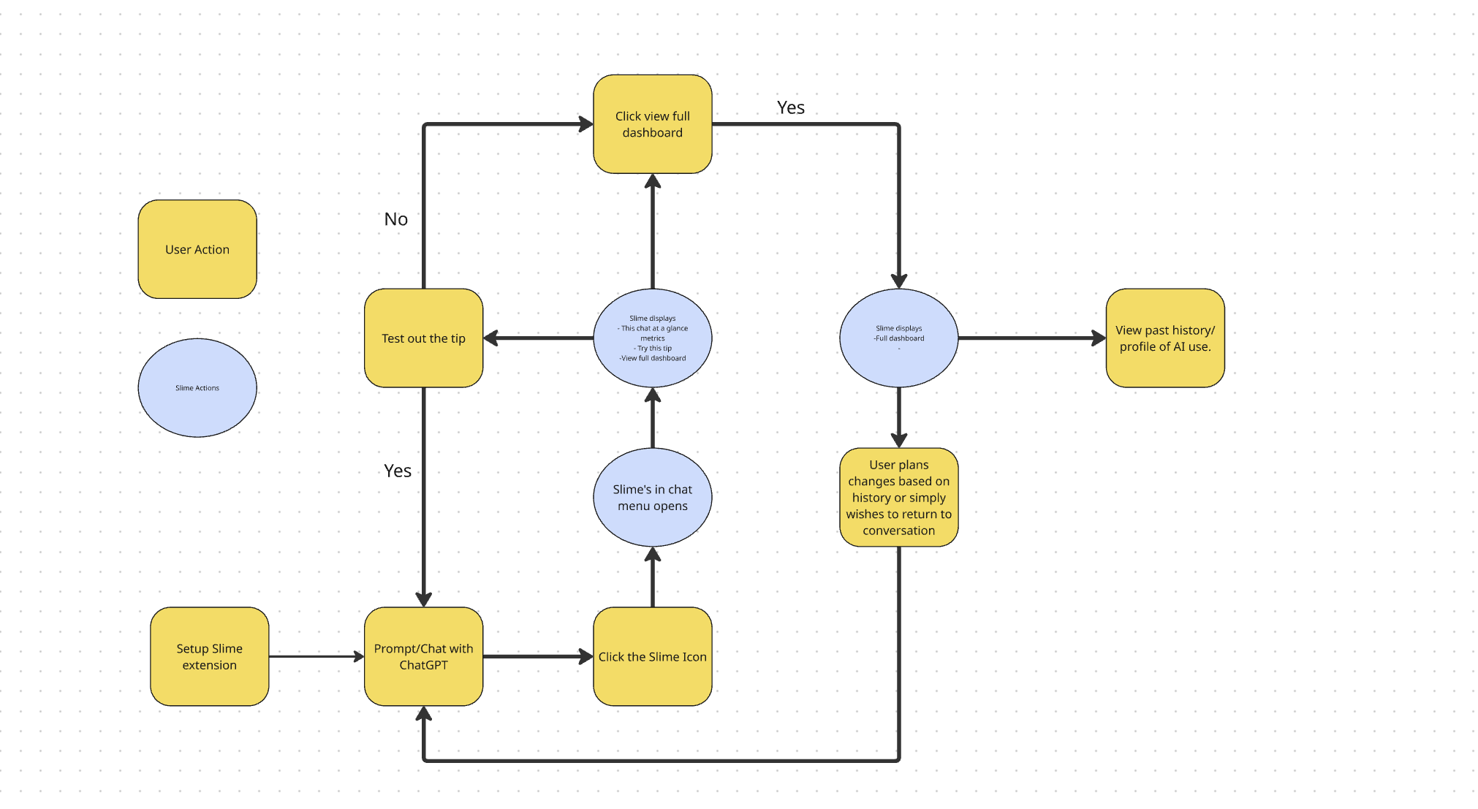

Solution 2: Claude Reflect
Claude Reflect is a feature that Anthropic added to their platform which is usable if you have the memory enabled on Claude. As Anthropic describes it, Claude members can use it to see their patterns and shape them, and build AI skills that match your original thinking. They are using it as a tool to figure out how best to integrate AI into users' daily life. It allows you to analyze patterns of usage for chunks as far out as one year’s time. It starts with a summary of how you used Claude, time spent on tasks, peak active hours, what you spent time working on. It also claims to help you build AI skills to support your work through their 4D AI fluency Framework, Delegation, Description, Discernment, and Diligence.

There are a good deal of similarities between Claude Reflect and our KAIte . They both create a summary of how the user has used AI over an extended period of time. To help the user learn it will ask reflective questions on your usage to help you decide how you want to use AI. Finally it will offer ways that you can improve your AI skills. While there are some similarities there are also some major differences.

The differences between Claude Reflect and our KAIte are however significant and impact how they work. The first major difference is that Claude Reflect only works within Claude and doesn’t provide a way to import other platforms' data. The second difference is that while it does provide reflective questions periodically, it doesn’t provide a deep reflective conversation with framing choices on how the user wants the conversation to go. The third difference is that it's curated to help you use Claude more effectively rather than how you want to use AI as a whole more effectively.

Although there are quite a few similarities between the two solutions, they have different outcomes. The similarities are that they both reflect on the user's AI usage, offer varying ways for the user to improve their usage, and ask reflective questions about their usage. All components that are used to make you think about and by thinking about improving the user’s AI habits. The difference however makes the outcomes entirely different. The primary difference is the scope of improvement for the two solutions, while Claude Reflect is primarily focused on helping you improve your skills in relation to Claude. Our KAIte offers ways you can improve your skills with AI in general, not with one specific platform.

See task flow diagram link [redacted].

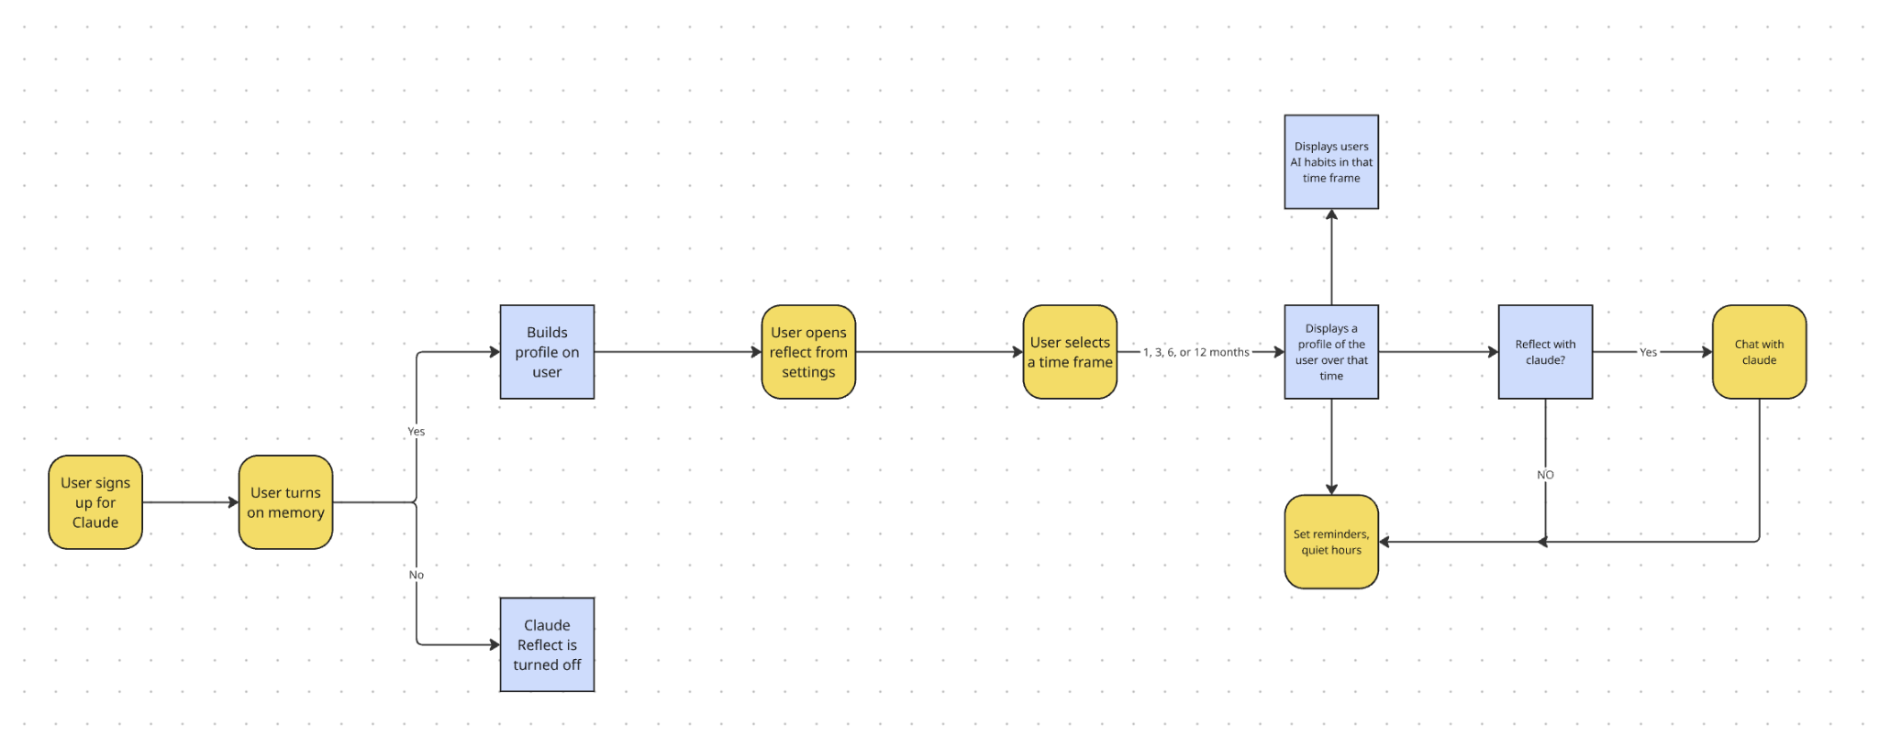

Solution 3: Riff
Riff is a reflection tool powered by AI, it works by embedding customizable chat bots into learning materials. The setup works in two steps. The first step is for educators to go to the creator dashboard and pass on certain information pertaining to the learning subject, where a custom chatbot will be created. The second step is to pass on the chatbot to learners through an embedded code, a QR code or link, which the student will then be asked socratic questions on the material to help lock in learning.

Like the other two solutions there are a few similarities between our agent and Riff. First as with the others it uses AI to enhance learning through reflection. The second similarity is that it enhances learning through a reflective conversation on the subject of learning. The third is that it gets embedded in a platform to help curate the learning of the subject in question. Despite the similarities of the two they have a couple major differences.

The differences between the two however set them apart from each other. The first major difference is that Riff is a reflection assistant on a broad range of topics and is not purely focused on AI. The second difference is that Riff can be embedded into varying platforms for use with different learning materials, whereas our agent is designed specifically for CollaborAIte. The final major difference is that Riff doesn’t show you an overview or build a profile on a user; it merely helps you reflect on material for learning purposes.

So in comparison although there are similarities between the two they have different uses and outcomes. Riff uses reflection as a tool to help you lock in materials you are trying to learn, whereas our agent uses reflection to improve your AI habits specifically. Riff is more easily portable and can be used on different platforms whereas our agent is incorporated into CollaborAIte. Finally Riff is purely a reflection conversation chatbot whereas with our agent we incorporate in a summary overview of the users habits along with a reflection conversation and an optional improvement page.

See task flow diagram link [redacted].

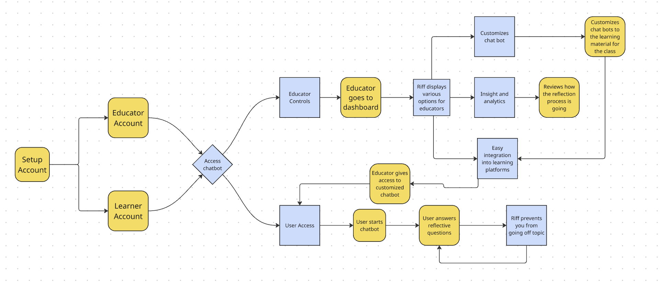

KAIte (kīte)
KAIte is an extension built off of the WeFlect AI reflection application to further explore users’ understanding of their relationship with generative AI. WeFlect begins the reflection process of analyzing imported generative AI interactive logs, and KAIte expands this with a testing playground for tracking and improving users’ agentic error catching abilities integrated with the University of Maine’s internal communication platform, CollaborAITE.

See task flow diagram link [redacted].

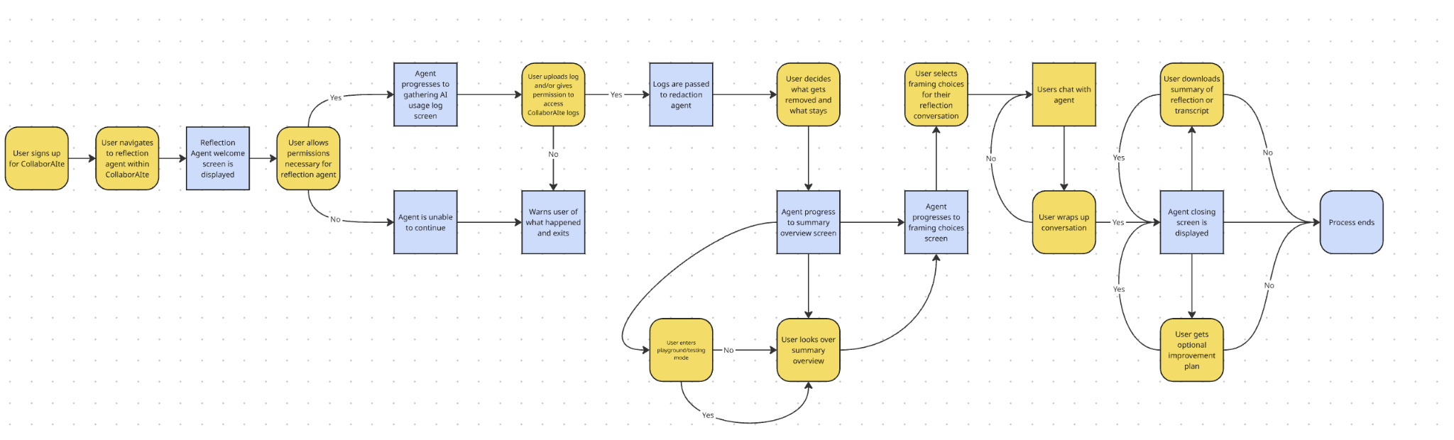

Given that generative AI is far from being error-free, KAIte helps students understand how to critically view their interactions with agents to speculate, identify, and resolve any potential errors. Users will be challenged to catch intentional errors created by the agent(s) and encouraged to find unintentional errors.

Users can receive an allotment of points obtained in respect to their capabilities in catching errors that can be redeemed for digital collectibles. Tracking improvement through a voluntary history of logs and managing the digital points and collectibles are tied to CollaborAITE’s user account system, encouraging consistency.

Consistency of users’ harnessing their skills to improve their agentic literacy helps them build the expertise, confidence, and wherewithal in their relationship with generative AI. Compared to the prior solutions, or lack thereof, KAIte is paving the way past a digital world of loose abilities to manage ones’ relationship with generative AI.

There will be an error-detection ability mode that the user can click during WeFlect’s reflection process that will bring them into an interactive mode that acts more like a regular general-use AI model but with intentional errors and data-collection on how they're handled.

