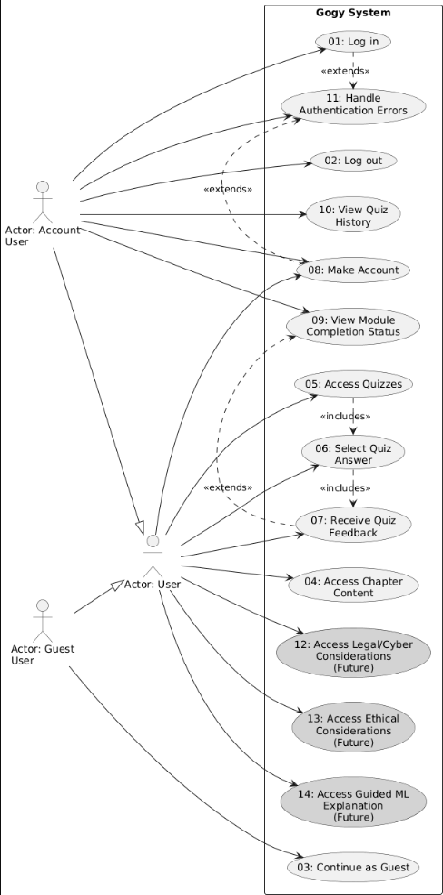

Use Case Tables - Updated Version

Use Case 01: Log In
Field | Details
Name/Title | Log In
ID | 01
Description | This allows the user to log in using Firebase Authentication to restore progress and access saved quiz results.
Precondition | ID 08 (Make Account) must be met.
Success Postcondition | ID 02 (Log Out) will be applicable. User gains access to saved quiz scores and completion tracking.
State Changes | Updates user object in AuthContext with Firebase user data (displayName, email, photoURL).

USER STEPS | SYSTEM RESPONSE
1. Go to "Account" button in upper right corner of Header component | 2. Launch the Firebase Authentication UI
3. Select login method (email/password or social login via Firebase) | 4. Firebase validates credentials against authentication database. If successful, AuthContext updates with user object and returns success. If not, Firebase returns error message (e.g., "Incorrect email or password", "User not found")
5. If Firebase returns an authentication error, display error message and revert to step 2. | 6. Load user's quiz history and completed modules from Firebase

Use Case 02: Log Out
Field | Details
Name/Title | Log Out
ID | 02
Description | This allows the user to log out of their account, ensuring account privacy and progress retention in Firebase.
Precondition | ID 08 (Make Account) and ID 01 (Log In)
Success Postcondition | None. NOTE: AN ACCOUNT IS NOT NEEDED TO USE GOGY. YOU CAN USE AS A GUEST, BUT NO PROGRESS WILL BE SAVED.
State Changes | Clears user object in AuthContext. Resets completedModules and selectedAnswers in AppContent state.

USER STEPS | SYSTEM RESPONSE
1. Click on "Account" in the upper right hand corner of the Header component | 2. Display Account details popup
3. Select "Sign out" | 4. Save any current quiz progress to Firebase user profile. Call Firebase Authentication logout method. Clear AppContent state. End user session and return to guest view.

Use Case 03: Continue as Guest
Field | Details
Name/Title | Continue as Guest
ID | 03
Description | Allows users to access educational content and quizzes without creating an account. Progress will not be saved between sessions.
Precondition | None
Success Postcondition | User can access all content but cannot save progress or view completion status.
State Changes | user in AuthContext remains null. completedModules tracking is disabled.

USER STEPS | SYSTEM RESPONSE
1. When Gogy loads, select "Continue as guest" option | 2. Load HomePage component without authentication
3. Navigate freely through content and quizzes | 4. Allow full access to content but disable progress persistence. Display notice that progress won't be saved.

Use Case 04: Access Chapter Content
Field | Details
Name/Title | Access Chapter Content
ID | 04
Description | View educational content for a specific learning module/chapter.
Precondition | None
Success Postcondition | User can access embedded quiz for the chapter (ID 06).
State Changes | Updates currentView in AppContent to 'chapter[N]' where N is the chapter number.

USER STEPS | SYSTEM RESPONSE
1. From HomePage, click on "Read Chapter" link in ModuleListItem component | 2. Call getChapterContent(chapterNum) helper function. Transition currentView state to chapter view. Render ChapterPage component with chapter title and sections.
3. Review chapter content sections | 4. Display chapter content with embedded quiz access button

Use Case 05: Access Quizzes
Field | Details
Name/Title | Access Quizzes
ID | 05
Description | Launch the quiz interface for a specific module. If logged in, display previous best scores with ability to retake.
Precondition | None
Success Postcondition | ID 06 (Select Quiz Answer), ID 07 (Receive Quiz Feedback)
State Changes | Updates currentView in AppContent to 'quiz[N]'. Initializes or loads selectedAnswers object.

USER STEPS | SYSTEM RESPONSE
1. Click "Take Quiz" button from ModuleListItem or ChapterPage component | 2. Call getQuizQuestions(quizNum) from QuizContent.js helper. Transition currentView to quiz state. If user is logged in, retrieve previous best score from Firebase.
3. View all quiz questions with multiple choice options | 4. Render Quiz component with QuizQuestion components for each question. Display previous best score if available.

Use Case 06: Select Quiz Answer
Field | Details
Name/Title | Select Quiz Answer
ID | 06
Description | Choose an answer option for a quiz question.
Precondition | ID 05 (Access Quizzes)
Success Postcondition | Answer is recorded and can be submitted for grading.
State Changes | Updates selectedAnswers object in AppContent state with mapping of questionIndex to selectedOptionIndex.

USER STEPS | SYSTEM RESPONSE
1. Click on one of the multiple choice options for a question | 2. Call handleAnswerSelect(questionIndex, optionIndex) in AppContent. Update selectedAnswers state object. Visually indicate selection (greyed out circle).
3. Repeat for all questions in the quiz | 4. Enable "Submit Quiz" button when all questions are answered

Use Case 07: Receive Quiz Feedback
Field | Details
Name/Title | Receive Quiz Feedback
ID | 07
Description | Receive detailed feedback for quiz answers, see score, and view completion status.
Precondition | ID 05 (Access Quizzes), ID 06 (Select Quiz Answer)
Success Postcondition | If perfect score (100%) and user is logged in, module completion status is updated (ID 09).
State Changes | Updates currentView to 'feedback'. If isPerfect is true and user is logged in, updates completedModules array in AppContent. Saves quiz score to Firebase user profile if logged in.

USER STEPS | SYSTEM RESPONSE
1. After answering all quiz questions, click the "Submit Quiz" button at the bottom of the Quiz component | 2. Call calculateQuizScore(questions, selectedAnswers) from QuizContent.js. This returns a QuizScore object containing: correct (number of correct answers), total (total number of questions), percentage (score as percentage 0-100), isPerfect (boolean indicating 100% score)
3. Review score percentage and detailed feedback for each question | 4. Render QuizFeedbackPage component displaying: Overall score percentage, Question-by-question review showing user's answer vs. correct answer, Explanation for incorrect answers (if implemented). If isPerfect is true and user is logged in: Update completedModules state in AppContent, Save score to Firebase user profile, Display success message
5. Click "Return to Home" or "Retake Quiz" buttons | 6. Handle navigation based on user selection (return to home or retake)

Use Case 08: Make Account
Field | Details
Name/Title | Make Account
ID | 08
Description | Allows the user to create an account using Firebase Authentication, which enables login/logout functionality and saves quiz attempts and results.
Precondition | None
Success Postcondition | ID 01 (Log In), ID 02 (Log Out), ID 09 (View Module Completion Status)
State Changes | Creates new user in Firebase Authentication. Updates user object in AuthContext with Firebase user data.

USER STEPS | SYSTEM RESPONSE
1. When you open Gogy, select the "Create Account" option. DO NOT select "Continue as guest" | 2. Launch Firebase Authentication UI for account creation
3. Choose authentication method: Option A: Enter email and password (Firebase handles validation), Option B: Select social login (Google, GitHub, etc.) | 4. Firebase Authentication validates credentials: Checks password strength requirements, Verifies email format, Ensures email is not already registered, Returns error messages if validation fails (e.g., "Email already in use", "Password too weak")
5. If Firebase returns validation errors, correct issues and retry | 6. Once Firebase confirms account creation: Save user credentials to Firebase Authentication system, Create user profile with displayName, email, photoURL, Initialize empty quiz history and completedModules array, Display "Account creation successful" message, Automatically log user in via AuthContext, Load HomePage with authenticated user state

Use Case 09: View Module Completion Status
Field | Details
Name/Title | View Module Completion Status
ID | 09
Description | Display visual indicators (completion stars) for modules where the user achieved a perfect quiz score (100%).
Precondition | User is logged in (ID 01). User has completed at least one quiz with 100% score (ID 07)
Success Postcondition | User can see their learning progress at a glance.
State Changes | None (reads from completedModules state in AppContent).

USER STEPS | SYSTEM RESPONSE
1. Navigate to HomePage component | 2. Retrieve completedModules array from AppContent state
3. Observe completion indicators on ModuleListItem components | 4. For each module in the list: Check if module.chapter exists in completedModules, If module.completed is true, render completion star/indicator on ModuleListItem, Display user's best score percentage

Use Case 10: View Quiz History (Logged In Users)
Field | Details
Name/Title | View Quiz History (Logged In Users)
ID | 10
Description | Access previous quiz attempts and scores from Firebase user profile.
Precondition | User is logged in (ID 01), has completed at least one quiz (ID 07)
Success Postcondition | User can track learning progress over time.
State Changes | None (reads from Firebase user profile data).

USER STEPS | SYSTEM RESPONSE
1. From HomePage, view "Best Score" badge on ModuleListItem for completed quizzes | 2. Query Firebase for user's quiz history
3. Click on quiz to see detailed attempt history (if implemented) | 4. Display best score percentage and completion status on each ModuleListItem
 | 5. Allow user to retake quiz to improve score

Use Case 11: Handle Authentication Errors
Field | Details
Name/Title | Handle Authentication Errors
ID | 11
Description | Gracefully handle Firebase Authentication errors and guide user to resolution.
Precondition | User attempting to log in (ID 01) or create account (ID 08)
Success Postcondition | User understands the error and can take corrective action.

USER STEPS | SYSTEM RESPONSE
1. Attempt authentication action that triggers error | 2. Firebase returns error code and message. AuthContext catches error and displays user-friendly message: auth/invalid-email: "Please enter a valid email address", auth/user-not-found: "No account found with this email", auth/wrong-password: "Incorrect password", auth/email-already-in-use: "An account with this email already exists", auth/weak-password: "Password must be at least 6 characters", auth/network-request-failed: "Network error. Please check your connection"
3. Read error message and follow suggested resolution | 4. Maintain user input where possible to avoid re-entry
5. Retry authentication | 6. Allow retry with corrected information

