CareerWise

Graduate career support: apply, track, grow

## Team Asynchronous

Brendon Price, Alex Newman-Hancock, Josh Deveau, Brady Dube, Kempton Maillett

# Problem

After graduating from college, computer science students often face a steep drop-off in structured support for navigating the job market. Without the institutional backing of college, such as career centers, faculty guidance, or peer networks, many find themselves isolated and uncertain about how to approach their job search. Throughout their academic career, there have been provided counselors, administrators, and even peers who were always readily available to answer questions to be had about the next phases of life, but as time under an institution ends, so does the assistance from counselors. The lack of accessible mentorship and reliable resources leaves graduates struggling to make informed decisions, build professional connections, and maintain momentum in their transition from academia to industry. How can we ensure that reliable resources as well as active mentorship are provided to graduates in need, throughout the entire career search process?

# Prior Solutions

## Solution 1: Leetcode

Leetcode is an online platform used to help improve coding skills. Leetcode lets you create a free account in which you can practice a variety of coding questions relating to different computer science principles. You can also view questions based on what companies are using them during interviews to more properly prepare. Leetcode also tracks your practice to help give a sense of accomplishment. They also have a discussion forum for people to talk about interviews, applying to certain companies, and help and answer coding problems. You can go to the interview tab where you can take mock assessments and answer practice questions or problem sets from real FAANG companies. You can also use their premade study plans to practice a variety of different languages, libraries, and different concepts.

Both CareerWise and LeetCode help computer science students and graduates prepare for the professional world by bridging the gap between academic learning and industry expectations. While LeetCode focuses on skill-building through coding challenges, CareerWise does so through mentorship and personalized guidance. Both platforms promote continuous growth by encouraging users to develop their skills, set goals, and track their progress toward becoming job-ready.

CareerWise will differ in the fact that it will focus less on practice problems and the technical aspect of the job search process and more on connecting users with guidance. CareerWise will focus on matching users with mentors that will be able to guide them through the transition from college to the job force. LeetCode has a ton of resources but lacks the personal connection. It can be hard to know where to start when first applying for jobs. We want users to have a resource to receive more guidance.

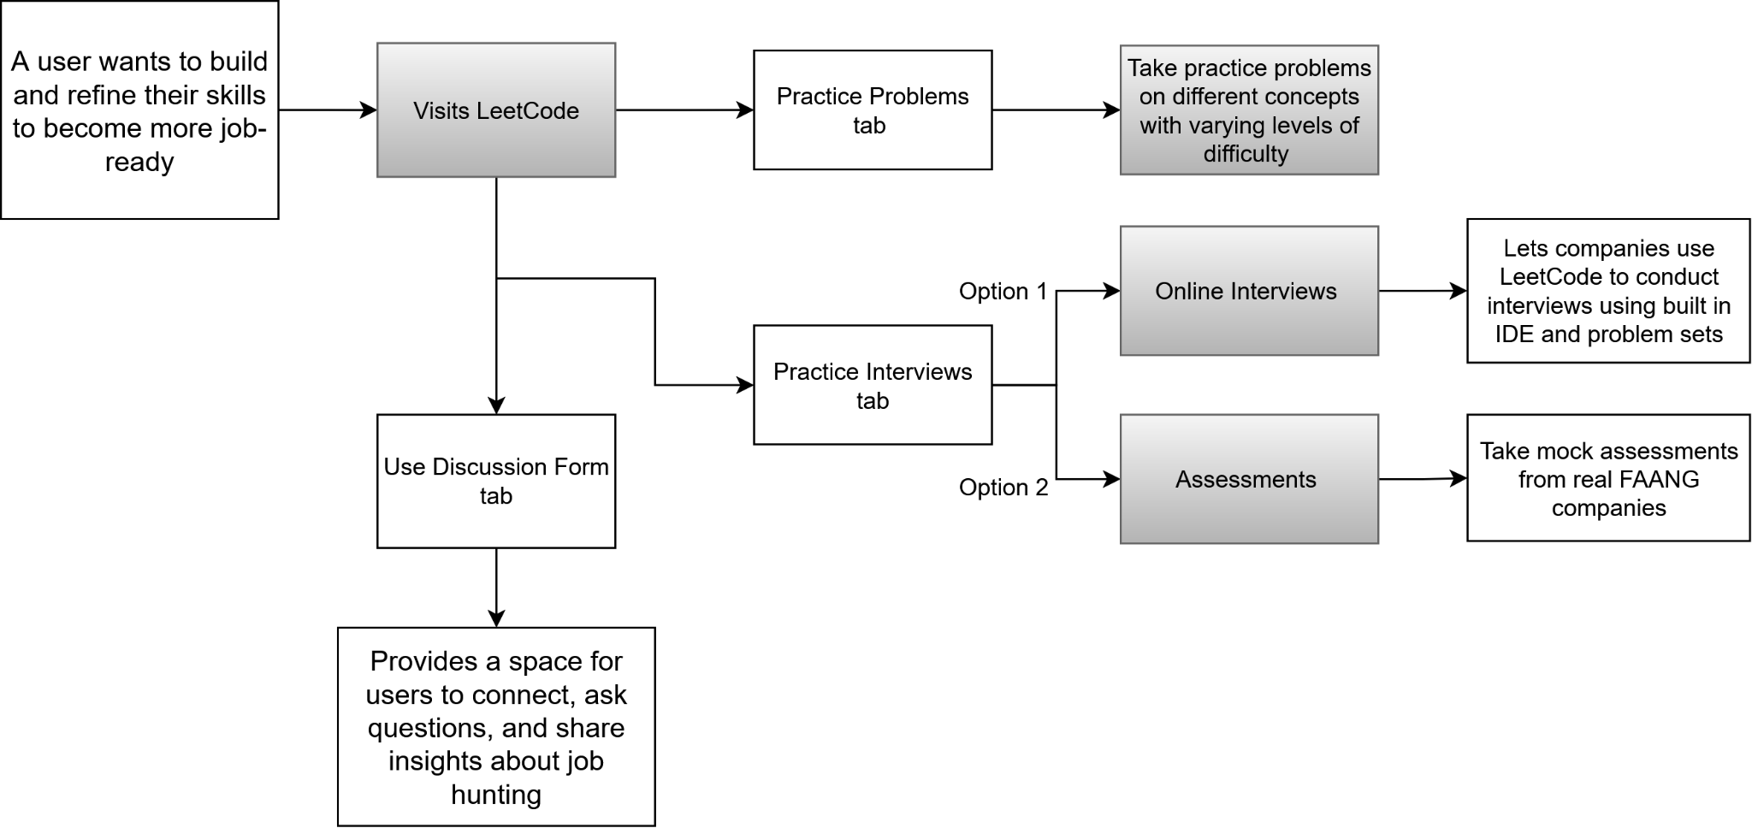

**Figure 1. Prior solution *LeetCode* task flow diagram.**

## 

## Solution 2: IGotAnOffer

IGotAnOffer is a website that provides a way for people seeking career growth to purchase meeting sessions with coaches that can help in career planning or job search, resume development, and interviews. While coaches come from a wide range of companies, most have worked with large tech companies. This solution has a unique implementation of pricing for coaching sessions; A user is required to buy “credits”, which is a non-expiring form of currency used to purchase 1-hour long coaching sessions. Pricing starts at $50/credit, but this is discounted the more a user purchases at once. Then, coaching sessions can cost between 2 and 5 credits. Upon visiting the website, users are presented with a large list of coaches, each presented alongside what major companies they have worked with and their credit pricing. Users can search for coaches by different services that can be provided, such as interview coaching, resume review, and salary negotiation.

The major aspect of IGotAnOffer that is similar to the app that Team A intends to create, CareerWise, is that it allows users to filter their search for help by the skills that they are interested in (e.g., resumes or interviews). The website then displays mentors that may or may not be helpful to the user. Another similarity is that, upon viewing a coach’s profile, a user is displayed with a schedule of available times the coach has. CareerWise is also intended to have schedule viewing functionality to make the process of connecting with mentors easier.

CareerWise will differ from this solution, however, in how desired skills are selected by the user. Whereas in IGotAnOffer the coach search is filtered by what experience the coach has, such as by their roles in companies or their provided service, CareerWise will collect information on the user’s experience; for example, a questionnaire will be offered where the user will input their computer science skillset, as well as interests and career goals. The application thus learns what mentor may be helpful.

## 

**Figure 2. Prior solution *IGotAnOffer* task flow diagram.**

## 

## Solution 3: MentorCruise

MentorCruise is a platform that provides a way for people such as computer science graduates to find and connect with a mentor for a multitude of purposes pertaining to career growth. The main application is a website that allows users to create an account and profile, and then search for available mentors. Users can filter their search for mentors by relevant skills (such as specific programming languages or software engineering disciplines), job titles, or companies that mentors have had experience with. To connect with a mentor, users need to send an application or book an introductory call, and the mentor needs to accept. Common prices for mentorships with MentorCruise seem to range from $150/month for “Lite” plans to over $1000/month for “Pro” plans, where the benefits of more expensive plans include more frequent calls and better “hands-on” support.

MentorCruise is similar to CareerWise because it creates a space for students to seek and obtain active mentorship. CareerWise will allow students to create a profile where they can record their career goals, and it will pair students with mentors/advisors by the student’s provided questionnaire information, consisting of their learned skills and their topics of interest. For example, a computer science graduate may want to mark Python as one of their skills and machine learning as a topic of interest, so that they could get paired with a mentor that has experience with machine learning jobs.

CareerWise is different from MentorCruise in the way that a specific purpose is promoted - the platform is targeted for graduates to aid them in their transition from academics to the workforce. In contrast, MentorCruise mentorships can be for many different purposes, including mentorships for startups, product design, and marketing. These kinds of purposes are often not actually relevant to recently graduated computer science students whose priorities are to secure jobs in the field. Another key difference is that MentorCruise offers subscription-based plans to meet with a mentor. Careerwise will focus on making student-mentor meetings possible, but payment should be settled outside the platform.

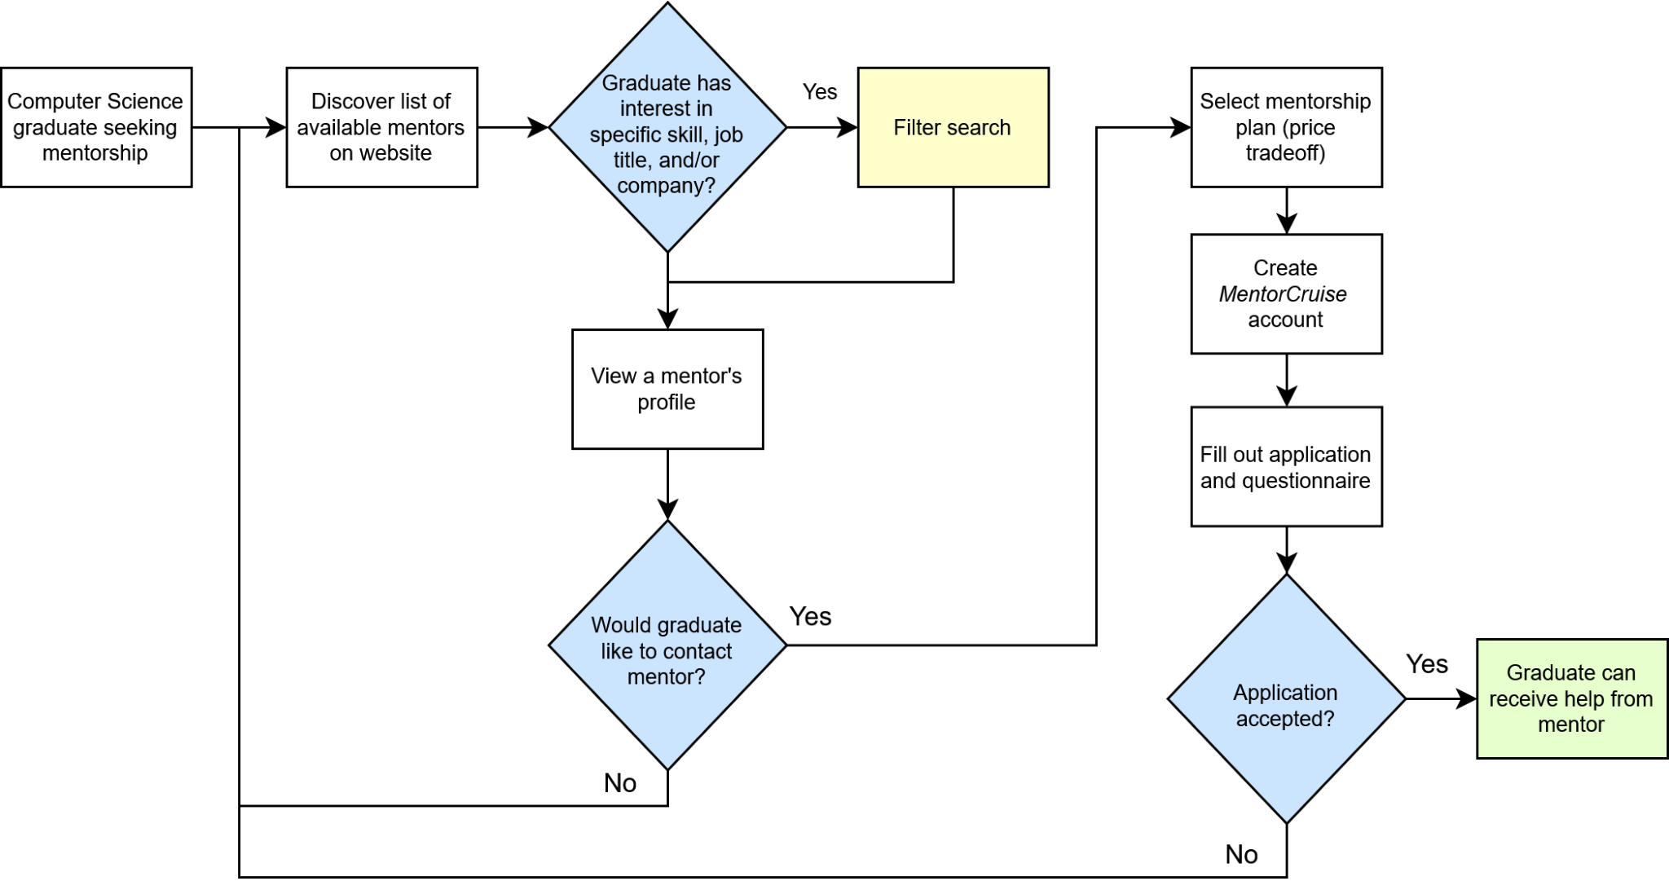

**Figure 3. Prior solution *MentorCruise* task flow diagram.**

# CareerWise

CareerWise is an app designed to help recent college graduates connect with mentors who can guide them as they begin their careers in the computer science industry. The platform aims to provide graduates with a strong support system during this transitional period. Users can create a custom profile that includes their experience, skills, and resume. They will also complete a questionnaire about their interests, desired career fields, and target companies. Based on these responses, CareerWise will match each user with a mentor whose profile they can view and connect with. Once paired, users can meet with their mentors, who will provide guidance and assign personalized tasks to support career development. Additionally, CareerWise includes discussion forums that allow users to connect with peers, share experiences, and build a professional community.

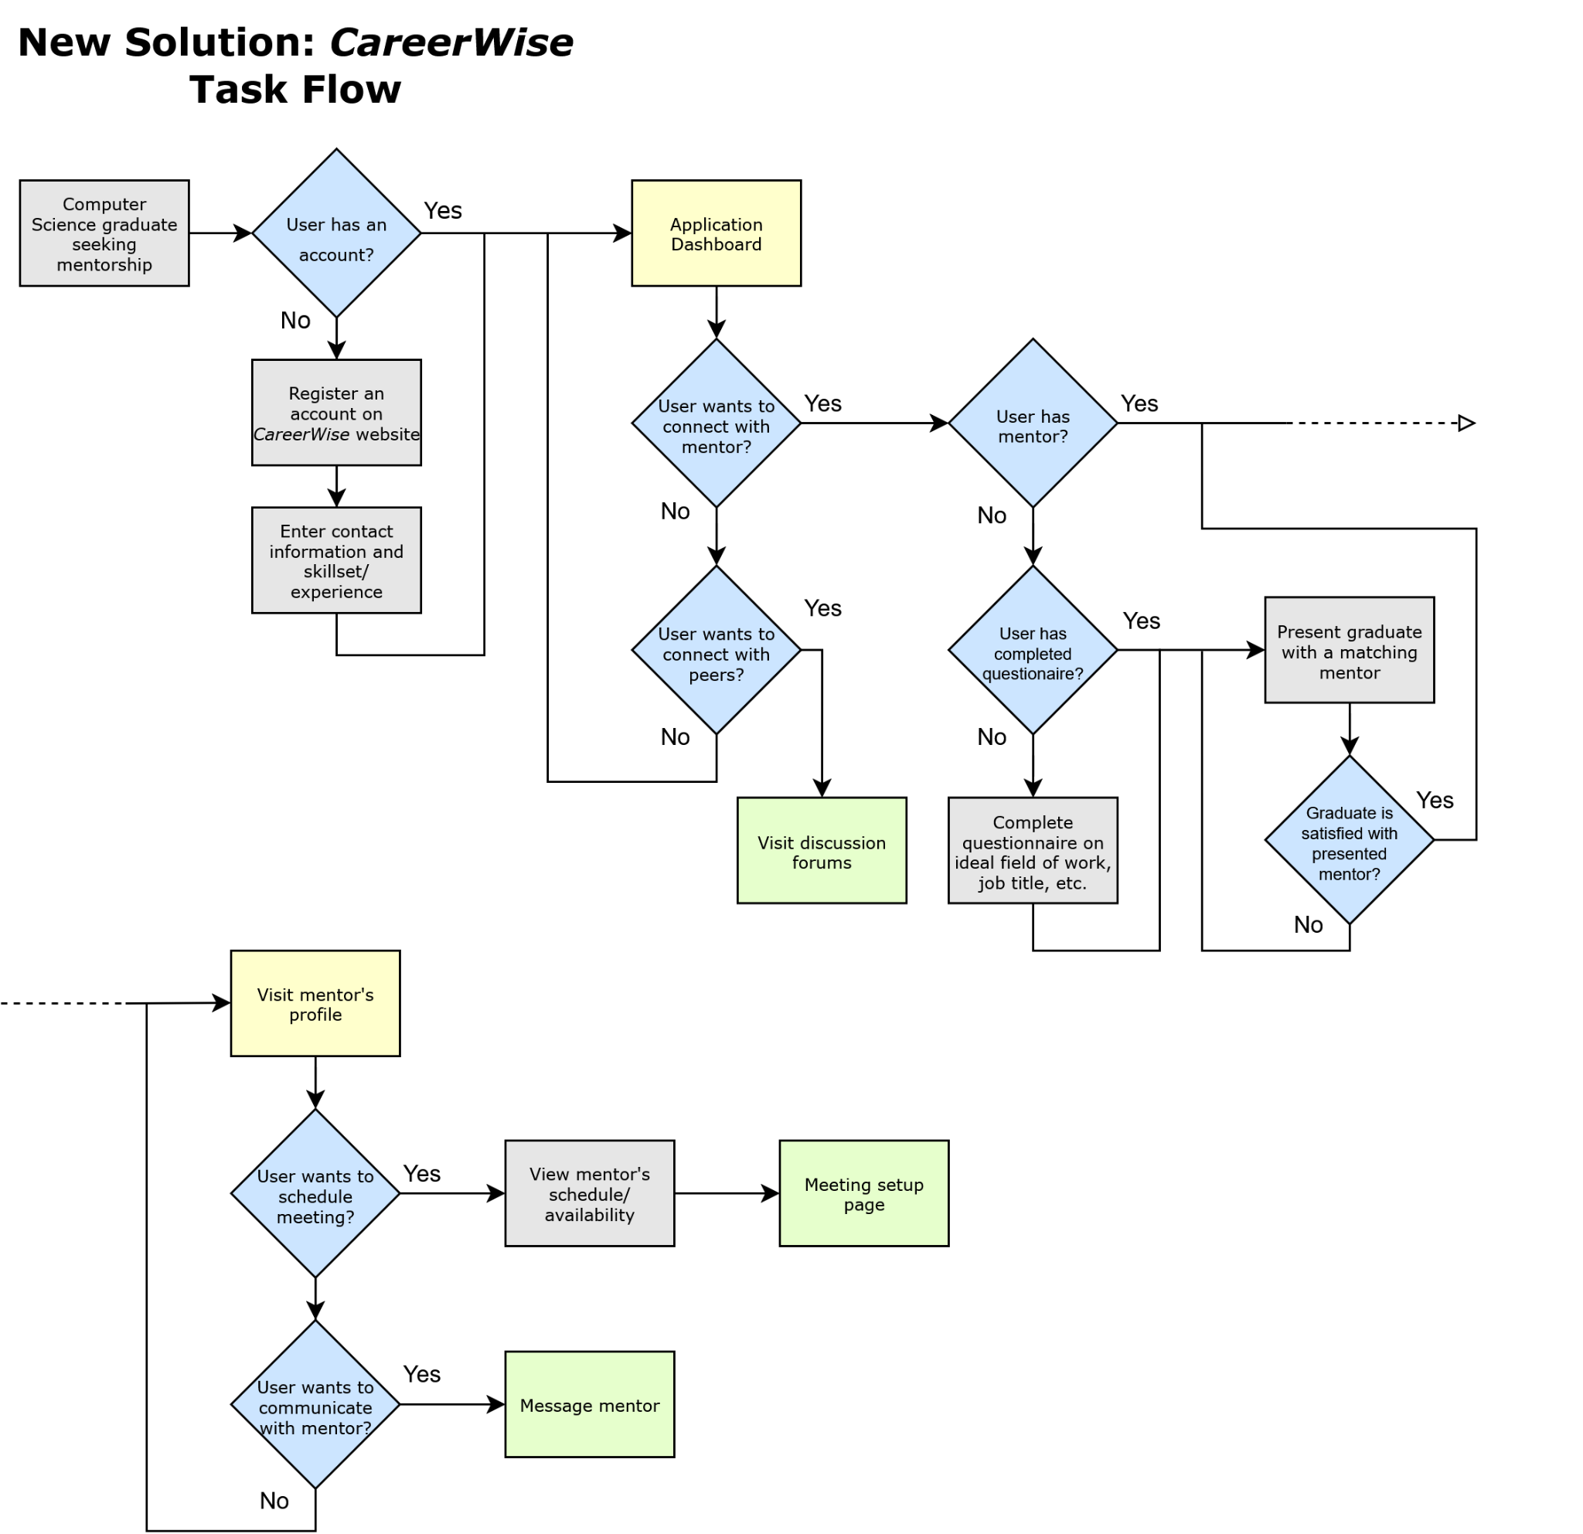

**Figure 4. Presented solution *CareerWise* task flow diagram.**

CareerWise is a straightforward and efficient way to transition a user into the corporate world. With emphasis on application organization and one to one assistance, CareerWise aims to benefit users by matching them with mentors who are best able to help them achieve their career goals.

To begin the CareerWise sign up process, the user should submit both general contact information as well as their skillset information as descriptively and honestly as possible. This information is later used for specific job search and mentor pairing, so it is to their benefit that it is both broad and honest.

After skills are established and information is known to the app as well as its administrators, we then lead the user into inputting their ideal field of work and job title. The application will display any company or position in a user-specific location to which the user can investigate, allowing them to pick a variety of jobs. Their choice of interest will then be used to line them up with the best fit mentor, further prioritizing the career of the graduate.

Oftentimes, computer science students, especially graduates, struggle to find guidance in such a vast workforce of computer influenced jobs. So, our one to one mentor page takes input from both the user and the registered mentor and lines up a nearly perfect match. With the ability to communicate and set up live meetings with mentors, users will receive the consistent help they need to find their dream job.

The addition of a schedule as well as meeting setup page, users will have access to their mentors availability while additionally putting in their own. This easy time comparison encourages efficiency for everyone.

To encourage non-stop improvement to CareerWise, there will be a reviews and discussion forum for analysis on specific mentors as well as the application in general. From here, we as a team can acknowledge the insight of our users and continuously improve the way we assist and guide both customers and mentors for future use.

One cause that CareerWise intends to address more effectively than other solutions is to present users with resources that are actually relevant to them. The app will prioritize the use of the user’s skill interests and career goals, which they can input into their profile, to direct them to mentors and resources that will be the most beneficial to them. This is in contrast with other solutions which present a user with too many different options and resources at once, making the help-searching process overwhelming.