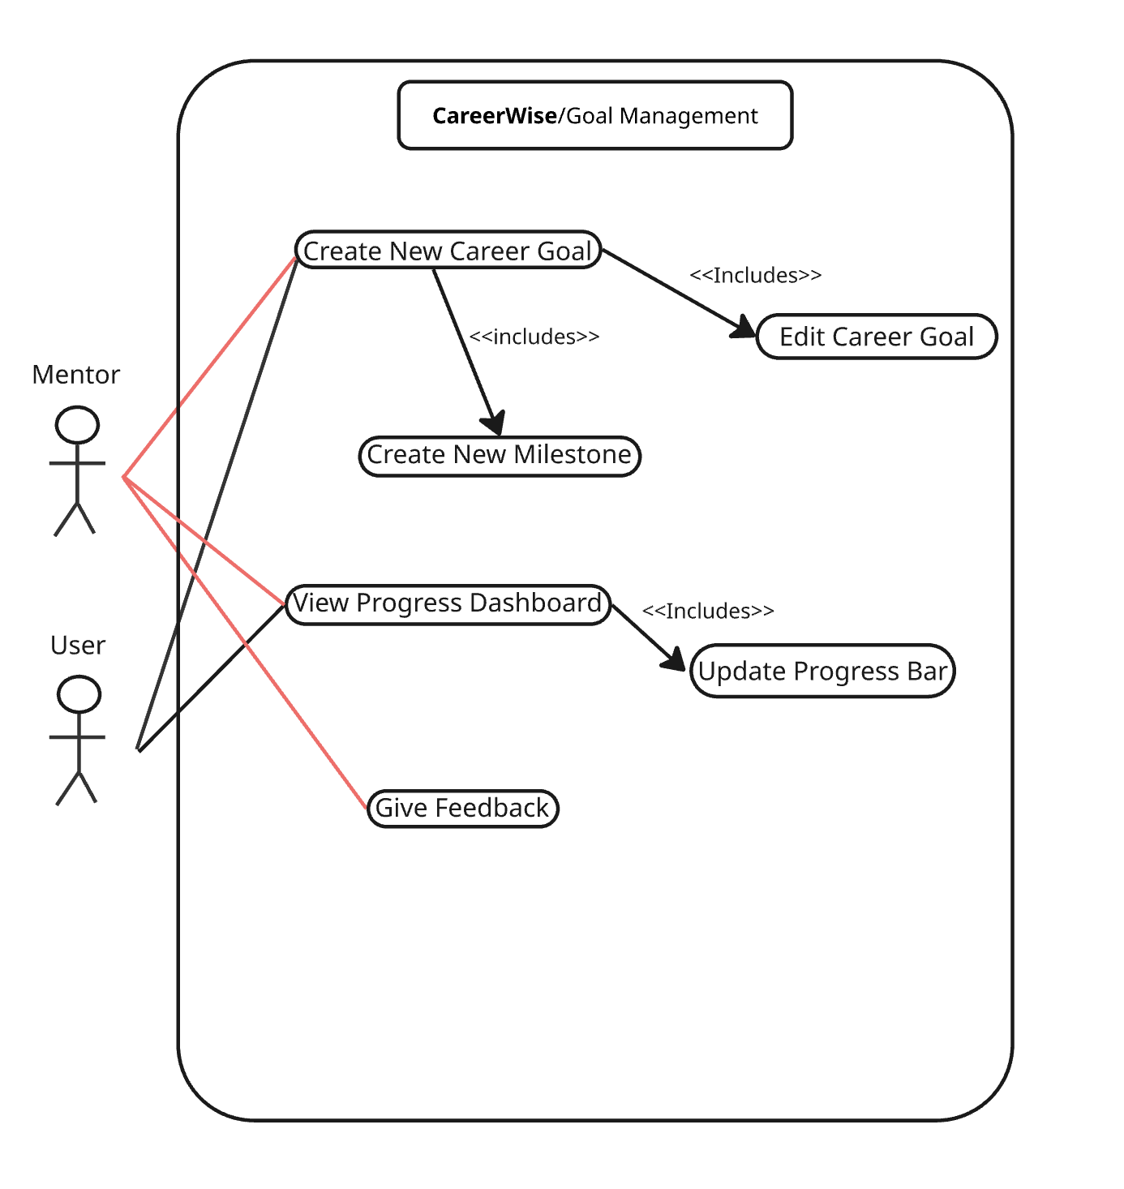

| **Name/Title:** | Create New Career Goal |
| --- | --- |
| **ID:** | 1 |
| **Description**: | Allows Users/Mentors to create a career goal specifying details like, title, description, category, target date, and optional milestones that will be displayed on the progress dashboard. Users and Mentors can create goals. |
| **Related Use Cases**: | Instance of: NA  Included by: NA  Inclusions: < 2 Create New Milestone> <4 Edit Career Goal> Extensions: NA |
| **Precondition**: | Users must be logged into the account and viewing the progress dashboard. |
| **Success Postcondition**: | Goal is added to the progress dashboard and set to 0% completion. |

| **USER STEPS**:  1. User enter the progress dashboard.  3. User clicks create new career goal  5. User enters details of the new goal and adds the goal. | **SYSTEM RESPONSE**:  2. System Displays progress Dashboard showing goals and completion %.  4. The system opens form to create a new career goal.  6. System displays new goal on dashboard and sets completion to 0% |
| --- | --- |

| **Name/Title:** | Create New Milestone |
| --- | --- |
| **ID:** | 2 |
| **Description**: | When a user is creating a career goal they have the option to include milestones to help gauge completion, and break the goal into more manageable steps |
| **Related Use Cases**: | Instance of: NA  Included by: <1 Create New Career Goal>  Inclusions: NA Extensions: NA |
| **Precondition**: | User must be logged in and inside the progress dashboard creating a new goal. |
| **Success Postcondition**: | Goal is added to the progress dashboard with 0% completion with milestones below unchecked. |

| **USER STEPS**:  1. User enters progress dashboard  3. User clicks create new career goal  5. User Opts to create milestones for career goal.  7. User adds milestones | **SYSTEM RESPONSE**:  2. System Displays progress Dashboard showing goals and completion %.  4.The system opens form to create a new career goal.  6.Lets user enter milestones with description for specific career goal.  8. Displays Associate milestones with career goal progress. |
| --- | --- |

| **Name/Title:** | View Progress Dashboard |
| --- | --- |
| **ID:** | 3 |
| **Description**: | Allows users to view all career goals and milestones in one location. Also enables users to edit goals and progress. |
| **Related Use Cases**: | Instance of: NA  Included by: NA  Inclusions: <5 Update Progress Dashboard> Extensions: NA |
| **Precondition**: | Users must be logged into their account and viewing the home page. |
| **Success Postcondition**: | Users can successfully view career goals and associated progress. |

| **USER STEPS**:  1. User Is viewing homepage  2. User clicks on progress dashboard | **SYSTEM RESPONSE**:  3. System Display progress dashboard page |
| --- | --- |

| **Name/Title:** | Edit Career Goal |
| --- | --- |
| **ID:** | 4 |
| **Description**: | This allows users to edit an already made career goal like, changing the description, adding milestones, and updating progress. |
| **Related Use Cases**: | Instance of: NA  Included by: <1 Create career goal>  Inclusions:NA Extensions: NA |
| **Precondition**: | The user has created a goal on the progress dashboard. |
| **Success Postcondition**: | The career goal displays corrected information and progress. |

| **USER STEPS**:  1. User enters the progress dashboard.  3. User edits a career goal.  5. User confirms edits. | **SYSTEM RESPONSE**:  2. System displays career goals and progress  4.System lets user change description and milestones.  6. System displays updated information on progress dashboard. |
| --- | --- |

| **Name/Title:** | Give Feedback |
| --- | --- |
| **ID:** | 5 |
| **Description**: | Mentors are able to give feedback on career goal. |
| **Related Use Cases**: | Instance of: NA  Included by: NA  Inclusions:NA Extensions: NA |
| **Precondition**: | Mentors have been assigned mentees, and those mentees have created career goals. |
| **Success Postcondition**: | Users can view feedback given by mentor on progress dashboard. |

| **USER STEPS**:  1. Mentors access their mentees progress dashboard.  3. Mentor Clicks give feedback on goal.  5. Mentor finishes feedback and submits | **SYSTEM RESPONSE**:  2. Systems displays mentor mentees progress on goals.  4.System prompts mentors to give feedback to users.  6.System displays feedback on goal inside of mentees progress dashboard |
| --- | --- |

| **Name/Title:** | Review application process |
| --- | --- |
| **ID:** | 7 |
| **Description**: | A graduate collaborates with a mentor to record job application deadlines and organize progress trackers for each job. The system displays individualized progress stages for each application, helping both users monitor and update status throughout the hiring process. |
| **Related Use Cases**: | Instance of: None  Included by: None  Inclusions: None Extensions: None |
| **Precondition**: | * At least one job application must be recorded in the system. * Graduate and mentor accounts must be linked. * The progress tracker module must be enabled for the graduate’s profile. |
| **Success Postcondition**: | * Each job application has an up-to-date progress tracker reflecting its current stage. * Both graduate and mentor can view and edit the tracker. * Notifications are triggered for key milestones or overdue stages. |

| **USER STEPS**:  1. Graduate accesses the dashboard and selects a job application  3. Graduate updates or reviews the current stage of the application  5. Mentor reviews the update and adds comments or suggestions  … (add more steps if needed) | **SYSTEM RESPONSE**:  2. System displays the visual progress tracker with all predefined stages  4. System saves the updated stage and logs the timestamp  6. System notifies the graduate of the mentors notes/updates  … (add more steps if needed) |
| --- | --- |

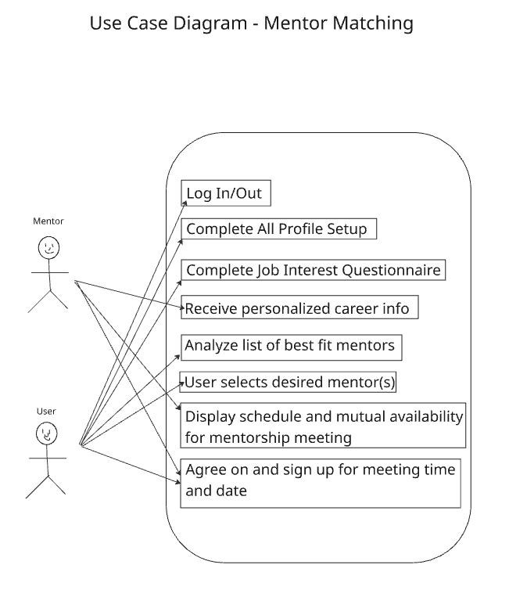

| **Name/Title:** | Match With Mentor |
| --- | --- |
| **ID:** | 8 |
| **Description**: | After completing their profile and career questionnaire, the Graduate User is matched with a mentor using CareerWise’s algorithm. The system presents mentor options, and the user can view profiles and initiate a connection. |
| **Related Use Cases**: | Instance of: None  Included by: None  Inclusions: None Extensions: None |
| **Precondition**: | * The user is logged into the CareerWise platform. * The user has completed their profile and career questionnaire. * The system has access to an active database of mentors. |
| **Success Postcondition**: | * The user is successfully matched with a mentor. * Mentor profile and contact options are accessible. * The user can begin scheduling meetings and receiving guidance. |

| **USER STEPS**:  1. Graduate User completes career questionnaire and profile  3. Graduate User views mentor profiles and selects a best-fit mentor  5. Mentor accepts or declines the request.  … (add more steps if needed) | **SYSTEM RESPONSE**:  2. CareerWise System analyzes user data and searches mentor databases then presents top mentor matches to the user  4. CareerWise System sends connection requests to selected mentors  6.CareerWise System confirms match and enables communication features.  … (add more steps if needed) |
| --- | --- |

| **Name/Title:** | Enter fields of interest |
| --- | --- |
| **ID:** | 9 |
| **Description**: | This use case enables graduates to express interest in specific job opportunities by submitting a Job Interests Form. The form captures job titles, companies, and application deadlines, and helps match graduates with roles aligned to their career goals. The system then tracks selected jobs for mentor and graduate review, supporting a guided application process. |
| **Related Use Cases**: | Instance of: None  Included by: None  Inclusions: None Extensions: None |
| **Precondition**: | * Graduates must have an active account and be logged into the system. * The graduate profile must be complete with relevant academic and career information. |
| **Success Postcondition**: | * Selected jobs are added to the graduate’s progress tracker. * Mentors receive visibility into graduate’s job interests for review and support. * Graduates can proceed with applications directly from the tracker. |

| **USER STEPS**:  1. Graduate logs into the system and navigates to the Job application process page.  3. Graduates enter job titles, companies, and application deadlines.  5. Graduate selects as many jobs as desired that fit their interests and goals  … (add more steps if needed) | **SYSTEM RESPONSE**:  2. System loads the Job Interests Form interface with editable fields  4. System validates input and displays a list of jobs in order of closest relation to user input, to furthest relation from user input  6. System adds jobs to progress tracker for both mentor and graduate review and application  … (add more steps if needed) |
| --- | --- |

| **Name/Title:** | Archive Mentorship |
| --- | --- |
| **ID:** | 10 |
| **Description**: | A mentee is able to archive (or “cancel”) an active mentorship. This will preserve history of communication with the mentor but will halt future payments. |
| **Related Use Cases**: | Instance of: None  Included by: None  Inclusions: None Extensions: None |
| **Precondition**: | User is logged in. |
| **Success Postcondition**: | User’s mentorship is archived and payments cease at the end of the billing period. |

| **USER STEPS**:  1. User clicks “My Account” in the website header.  3. User clicks “Archive my Mentorship.”  5. User re-enters their password.  6. User clicks “Yes, archive my mentorship.” | **SYSTEM RESPONSE**:  2. System opens the account settings page.  4. System opens dialog requiring yes/no confirmation.  7. System archives the mentorship. |
| --- | --- |

| **Name/Title:** | View Mentor Schedule |
| --- | --- |
| **ID:** | 11 |
| **Description**: | A user of the CareerWise system that has matched with a mentor may view their mentor’s schedule. This is a basic calendar view that displays their working hours, times that they are unavailable to meet, and times that they are available to meet. |
| **Related Use Cases**: | Instance of: None  Included by: None  Inclusions: None Extensions: 12 (Schedule Meeting) |
| **Precondition**: | User is logged in.  User has been matched with a mentor.  User is on application dashboard page. |
| **Success Postcondition**: | The user is presented with a basic view of their mentor’s schedule. |

| **USER STEPS**:  1. User clicks “View Mentor Schedule” on the application dashboard’s mentor section. | **SYSTEM RESPONSE**:  2. The system opens the mentor’s schedule page. |
| --- | --- |

| **Name/Title:** | Schedule Meeting |
| --- | --- |
| **ID:** | 12 |
| **Description**: | A user of the CareerWise system that has matched with a mentor may use their mentor’s schedule to schedule a meeting. |
| **Related Use Cases**: | Instance of: None  Included by: None  Inclusions: None Extensions: None |
| **Precondition**: | User is logged in.  User has been matched with a mentor.  User is on their mentor’s schedule page. |
| **Success Postcondition**: | Relevant/related state or conditions will result if the use case is completed successfully. Some Exceptions may result in the failure to meet the Success Postcondition. |

| **USER STEPS**:  1. User clicks day from drop-down menu  2. User clicks time from drop-down menu  4a. User returns to step 3.  4b. User clicks “Send Meeting Request.” | **SYSTEM RESPONSE**:  3a. System displays “Invalid/conflicing time selected.”  3b. “Send Meeting Request” button is enabled.  5. System closes the “request meeting” dialog.  6. System sends request to mentor. |
| --- | --- |